AI Customer Support Ticket Triage
Capstone Project Report
Rasika R

1. Problem Statement
Support teams receive a continuous stream of customer tickets that must be read, categorized, and prioritized before they can be routed to the right queue. Doing this manually does not scale and introduces delay. This project builds a system that reads a ticket's text and automatically predicts two things: its category (which team should handle it) and its urgency (how quickly it needs attention), while flagging uncertain predictions for a human to review rather than guessing blindly.

2. Approach
The system follows a standard supervised-learning pipeline, executed as two independent classification tasks sharing the same input text:
Stage | What it does | Implementation
1 | Collect labelled ticket data | Synthetic dataset generator (1,650 tickets)
2 | Clean text and define labels | Category: billing, technical, account, product. Urgency: high, medium, low
3 | Convert text to features | TF-IDF vectorization (separate vectorizer per target)
4 | Train classifiers | Two independent Logistic Regression models
5 | Evaluate | Accuracy, precision/recall/F1 per class, confusion matrix
6 | Deploy with review logic | Command-line tool + confidence-based human review queue

Category and urgency were modelled separately rather than as one combined model, since they are driven by different signals in the text: category depends on topic vocabulary ("refund", "crash", "login"), while urgency depends on tone ("URGENT", "no rush", "immediately") largely independent of topic. Keeping them as separate models also means either one can be retrained or improved without touching the other.

3. Dataset
No historical support-ticket data was available for this project, so a synthetic dataset of 1,650 tickets was generated programmatically, covering four categories (billing, technical, account, product) and three urgency levels (high, medium, low).
An initial version of the generator produced a dataset that both models classified with 100% accuracy. This was treated as a red flag rather than a result — a perfect score almost always signals an unrealistically easy dataset rather than a genuinely capable model. Investigation traced the cause to a bug: a batch of tickets intended to be ambiguous had their labels fixed once at generation time instead of assigned per occurrence, so they were not actually ambiguous to the model. After correcting this so ambiguous tickets receive a genuinely random label each time they appear, accuracy dropped to a more defensible 93–95% range, which is reported below.

4. Results
Both models were evaluated on a held-out test set (20% of the data, 330 tickets) that was not used for training:
Model | Accuracy | Macro F1 | Test set size
Category classifier | 95.5% | 0.955 | 330
Urgency classifier | 94.8% | 0.949 | 330

The category model performs strongly across all four classes, with most confusion occurring between the technical and product categories, which share some vocabulary (e.g. references to "reports" or "dashboard" features). The urgency model performs slightly lower, which is expected: urgency is a subtler signal carried by tone rather than distinct vocabulary, and the dataset's ambiguous tickets intentionally stress-test this.

5. Handling Low-Confidence Predictions
Rather than auto-routing every prediction, the system checks the model's confidence score for each ticket. Predictions below a 60% confidence threshold are routed to a manual review queue instead of a support team. On the test set, 23 of 330 tickets (7%) fell below this threshold — predominantly the deliberately ambiguous tickets, confirming the system correctly identifies which predictions it should not be trusted to make alone.
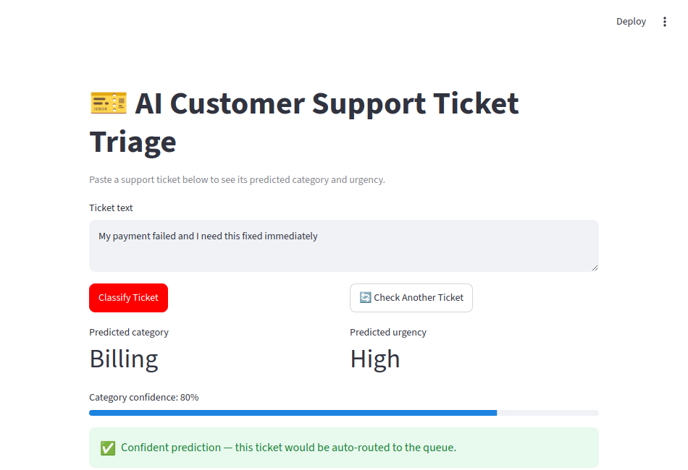
Figure 1: The Streamlit dashboard classifying a live ticket, with confidence score and routing decision shown.

6. A Known Limitation
Manual testing surfaced a specific, reproducible gap: the ticket "URGENT our whole team is blocked please escalate" was classified with only 46% category confidence and an incorrect category guess. Unlike most tickets, it contains no topic-specific words at all (no mention of billing, a technical issue, or an account) — only urgency language. This illustrates a general limitation of keyword-driven text classifiers: category prediction fundamentally requires some topic vocabulary to work from, and a ticket that omits it is genuinely ambiguous, to a human reader as well as to the model. The system correctly flagged this case for human review rather than guessing confidently and wrongly.

7. Iteration: Expanding Training Phrase Variety
An earlier version of the model showed a related but fixable issue: some clearly-categorizable tickets (e.g. "My payment failed and I need this fixed immediately") received unexpectedly low confidence, because the training data contained only 4 phrase variations per category. The model had too narrow a vocabulary to recognize the same intent expressed in slightly different words.
The training templates were expanded from 4 to 10 phrases per category, covering a wider range of real phrasing for the same underlying issues. After retraining, category accuracy improved from 95.2% to 95.5% and urgency accuracy from 93.9% to 94.8%. More importantly, confidence on the specific ticket above rose from 56% (flagged for review) to 80% (confidently auto-routed) — the kind of targeted improvement that a broad accuracy number alone would not reveal.

9. Personal Reflection
Three moments stood out most while building this project. The first was seeing the first trained models score a perfect 100% accuracy and initially feeling pleased, before realizing that a perfect score on a classification task is a warning sign, not an achievement — it meant the test data was not actually testing anything. Tracing that back to a labelling bug in the ambiguous-ticket generator, and fixing it so accuracy dropped to a defensible 93-95%, was the point where this stopped feeling like a tutorial exercise and started feeling like real evaluation work.
The second was testing the live tool with a ticket containing the word "asap" and watching it get classified as only medium urgency, despite being obviously urgent to a human reader. It was a concrete, reproducible example of a model being limited by the exact vocabulary it was trained on, rather than an abstract textbook point.
The third was adding the "Check Another Ticket" button to the dashboard after wanting a smoother way to test multiple tickets without retyping into the same box — and then finding that the first implementation of it broke with a Streamlit session-state error. Debugging that, and fixing it with a changing widget key instead of a direct value overwrite, was a small but genuine lesson in how a UI framework's state management works under the hood.

10. Conclusion and Next Steps
The system successfully automates category and urgency prediction for support tickets, with honest, held-out evaluation scores in the low-to-mid 90s, and includes a confidence-based safety net that defers uncertain cases to a human. The most valuable outcome of this project was not the accuracy figures themselves, but the process of catching and correcting an unrealistic 100% result, which reflects a evaluation discipline applicable to any machine-learning system.
Given more time, the next steps would be to:
- Replace the synthetic dataset with real, anonymized support tickets
- Compare TF-IDF features against sentence embeddings for both models
- Wrap the CLI tool in a simple web interface (Streamlit) for non-technical users
- Track model performance over time as new ticket types appear

Appendix: Tech Stack
Python, pandas, scikit-learn (TF-IDF, Logistic Regression), joblib for model persistence. Suggested next-stage stack: Streamlit for a UI layer, Git/GitHub for version control.

