What Is Climate Change And How Does Climate Change Affect Our Lives?

 Team Giratina 191180077-Yasin Mert Şahin 191180075-Ebru Sever 191180751-Lütfi Çağrı Ersöz 191180750-Mustafa Orhan

**ABSTRACT**

In this paper, the content and results of our completed project are examined.

# INTRODUCTION

Climate is the average weather in a place over many years. Climate change means long term shifts in temperatures and weather patterns, these shifts normally happen naturally but the rapid climate change we are now seeing is caused by humans using oil, gas and coal for their homes, factories and transport [1].

# METHODOLOGY

## K-means Clustering Algorithm

We did not use this algorithm in our project. Instead of this algorithm, we used linear regression for prediction.

## Regression Algorithm

Regression algorithms predict the output values based on input features from the data fed in the system. We used the Regression algorithm to predict glacier melt,sea level, temperature and carbon dioxide emissions in the coming years.

**4.3 Dimensionality Reduction**

The higher the number of features, the harder it gets to visualize the training set and then work on it. Dimensionality reduction is the process of reducing the number of random variables under consideration, by obtaining a set of principal variables.

## Classification Algorithm

The Classification algorithm is a Supervised Learning technique that is used to identify the category of new observations on the basis of training data. In Classification, a program learns from the given dataset or observations and then classifies new observations into a number of classes or groups.

# DATASETS

## Climate change (GreenHouse Gas Effects)

**https://www.kaggle.com/econdata/climate-change?select=climate_change.csv**

This dataset contains the gases that cause the greenhouse effect. It shows the measurements

of these gases, years between 1988 and 2008.

## Earth Surface Temperature Data

**Climate Change: Earth Surface Temperature Data | Kaggle**

The datasets presented here have been divided into three categories: Output data, Source data, and Intermediate data. The Berkeley Earth averaging process generates a variety of Output

data including a set of gridded temperature fields, regional averages, and bias-corrected station data. Source data consists of the raw temperature reports that form the foundation of our averaging system.

## Daily Sea Ice Extent Data

## Daily Sea Ice Extent Data | Kaggle

From The National Snow and Ice Data Center, this climate change dataset has information on the Earth’s cryosphere, and includes glacier, ice, snow and frozen ground data. The dataset has seven columns: year, month, day, extent, missing, source, and hemisphere. Extent refers to the area of the ocean that includes portions of sea ice.

## Global Average Absolute Sea

**Sea Level http://datahub.io/core/sea-level-rise (Global Average Absolute Sea Level Change,1880-2014)**

This data contains “cumulative changes in sea level for the world’s oceans since 1880, based on a combination of long-term tide gauge measurements and recent satellite measurements. It

shows average absolute sea level change, which refers to the height of the ocean surface, regardless of whether nearby land is rising or falling.

## Federal Firefighting Costs Data

**Federal Firefighting Costs | Kagg**

In this dataset, there are the number of fires between 1983-2020, the amount of affected area and the price contents of the damages caused.

## Atmospheric CO2 Data

(https://scrippsco2.ucsd.edu/data/atmospheric_co2/icecore_merged_products.html)

Atmospheric CO2 record based on ice core data before 1958, (Ethridge et. al., 1996; MacFarling Meure et al., 2006) and yearly averages of direct observations from Mauna Loa and the South Pole after and including 1958.

# EXPERIMENTS

1. Did the world temperatures increased over the years? Where are the places with the greatest temperatures changes? (Prediction: Will temperatures continue to rise?)

2.What will the future temperature be, especially in Turkey?

3. After the industrial revolutions, human activities have been the main reason of the climate change because of the burning of fossil fuels. What are the temperature changes after the year of the industrialization era?

4. What kind of change has been observed in greenhouse gas emissions after the industrial revolution?

5. What are the main reasons for the melting of glaciers? What are the consequences of the melting of glaciers?

6. What will be the state of the sea level in the coming years depending on the melting of the glaciers? (Prediction: Will sea level continue to increase?)

7. Is it possible for glaciers to melt completely due to climate change? If possible, when it can be predicted that it will completely melt?

8. Are increased temperatures and other climate-related changes associated with wildfires? (Analysis of the frequency of wildfires in places where average temperature is increasing.)

# RESULTS

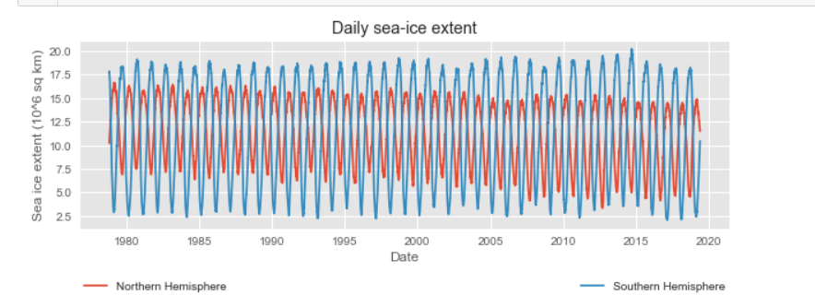

From this data we can see there are independent maximum and minimum for the northern and southern hemisphere data sets, as is to be expected from the change of season. In addition to this, there is on average more sea-ice in the southern hemisphere than the north.

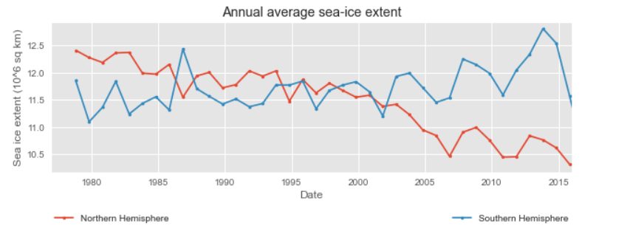

Here, we can observe the general trend that there has been a steady decrease in the extent of sea-ice in the northern hemisphere, the extent of sea-ice in the southern hemisphere was relatively constant until the early 2000s, and since then has been increasing, at first this seemed to be a very strange result. This has been known for some time and is due to a large number of complicated factors.

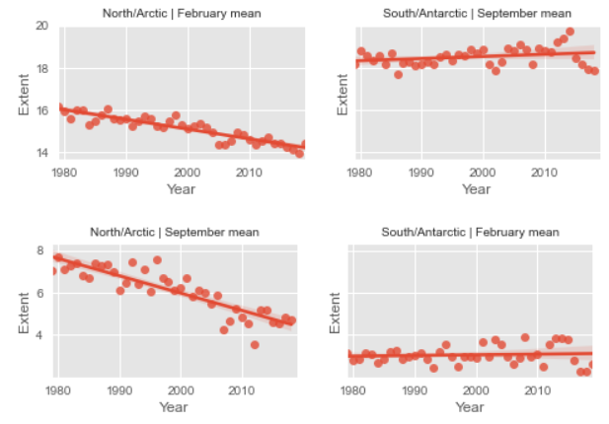

Observations: Arctic (Northern hemisphere) sea ice has a robust decreasing trend in both February (maximum extent) and September (minimum extent). Antarctic (Southern hemisphere) sea ice has a weakly increasing trend in both February (minimum extent) and September (maximum extent). The minimum sea ice extent annually for the Arctic is decreasing. Comparing the rates of change between the hemisphere, the Arctic sea ice is shrinking at a much faster rate than the weak increase in Antarctic sea ice.

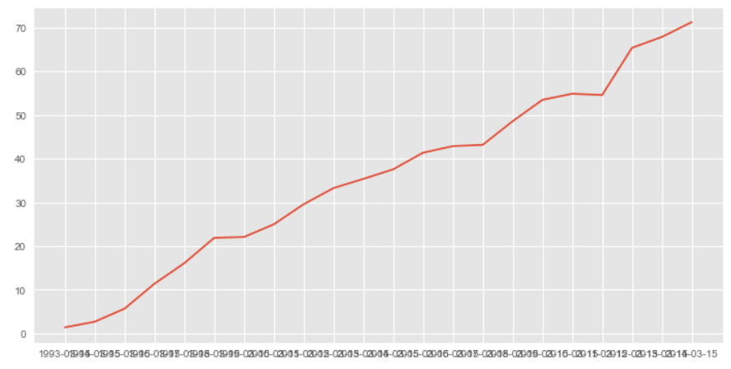

From this data we can see there are rising numbers of sea level.

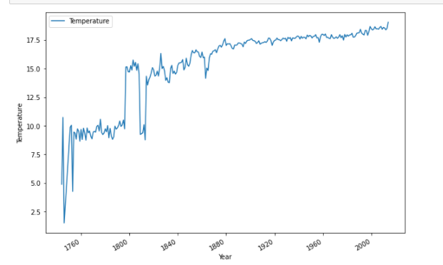

In this graph, we can see the temperatures by years since 1750. Especially since the years of 1820-1840, when the Industrial Revolution showed its effect, we can see that the temperature has been in a constant increase. It can be said that the reason for this is the development of the industry, the increase in CO2 emissions and the triggering of global warming.

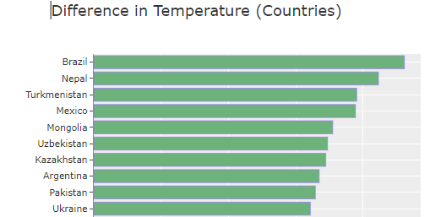

In this graph, we can see the 10 countries with the highest temperature differences. If we examine the causes of high temperature differences in these countries, the destruction caused by forest fires, air pollution, increasing global warming, the deterioration of the climate as a result, the damage to nature due to human activities, drought and the effect of the desert climate can be observed.

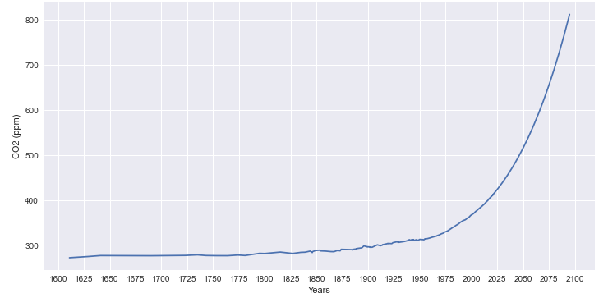

In this graph, it is seen how carbon dioxide emissions increased after the industrial revolution and what levels it will reach in 2100.[3]

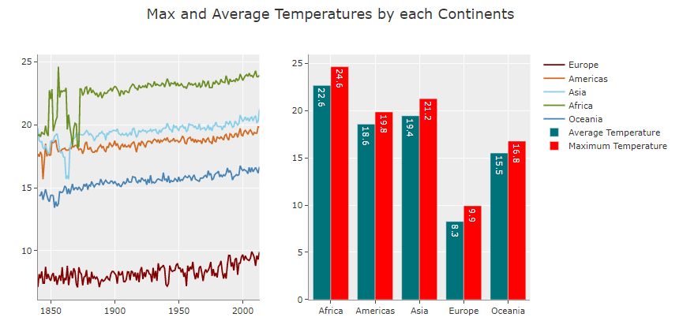

In this graph, we can see the temperature increases by continents since 1850. It can be deduced that the temperature generally tends to increase in every continent.[6]

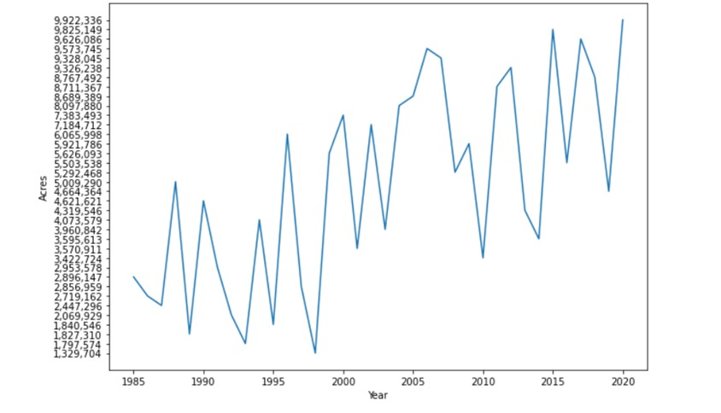

In this graph, we can see the amount of areas affected by forest fires by years. There has been a very high increase in the number of affected areas since 1985. This situation seriously threatens our ecosystem. Climate change can be shown as the main cause of these fires.[7]

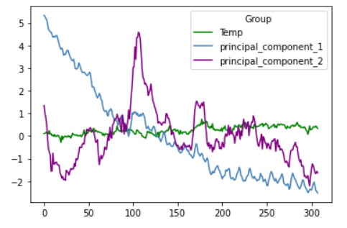

For this visualization, we use greenhouse gas effects dataset. The dataset has 8 different gasses in it so we wanted use dimensionality reduction method for reduce the number of columns to 2. We scaled the features in our data before applying PCA so the values has the standard deviation as 1 and mean as 0. Then we used other value in the dataset, that is temperature column, we got such a graph.

# CONCLUSIONS

First thing we need to acknowledge, there is climate change and we are just beginning to see its effects. So we don't say "If the sea level rises", we say "When the sea level rises".

What we are not entirely sure about is whether this rising will occur in our lifetime or in the lifetime of our grandchildrens.

But if we don't do something to stop it now, the effects will be much greater in the future.

# REFERENCES

[1]IPCC Sixth Assessment Report, Summary for

Policymakers.

**https://www.ipcc.ch/report/ar6/wg1/#SPM**

**B.D. Santer et.al., “A search for human influences on the**

**thermal structure of the atmosphere,”**

[2]Nature vol 382, 4 July 1996, 39-46

Wildfires: How are they linked to climate change?

https://www.bbc.com/news/58159451 November 23, 2021

[3] Macfarling Meure, C. et al., 2006: Law Dome CO2, CH4 and N2O ice core records extended to 2000 years BP. Geophysical Research Letters, 33.

[4]<https://www.economist.com/science-and-technology/2020/09/10/wildfires-will-be-more-common-in-a-warming-world?gclid=CjwKCAiA866PBhAYEiwANkIneGncS5qUWNGlifYIJPRCbrpBiUCSJ_X_0KnMgPdiM2f35TxcUln2XhoCa2AQAvD_BwE&gclsrc=aw.ds>

[5] <https://www.c2es.org/content/wildfires-and-climate-change/>

[6] <https://www.worlddata.info/global-warming.php>

[7] https://www.c2es.org/content/wildfires-and-climate-change/