|  |  |  |  |
| --- | --- | --- | --- |
| Yard: | {{shipyard_name}} | Att: |  |
| Owner: | {{vessel_owner_name}} | Rev: | {{revision}} |
| From: | {{prepared_by_name}} | Email: |  |
| Copy: | {{copy_to}} | Dir. phone |  |

|  |  |
| --- | --- |
| FRAMO AS, Norway  Phone: + 47 55 999000 |  |

subject: Anti-heeling quotation P-091-24, Cable layer vessel (not VFD).   
Hull . Class: NK <100kw.

Dear Sir/Madam,

We do appreciate your interest in Framo Anti-heeling system and are pleased to quote the following equipment on the next page(s).

Framo anti-heeling is installed in more than 3500 vessels. All systems are in-house produced and tested in Norway. Framo has over 80 years of experience in pump technology and thus have developed unique aftersales services with several offices abroad on all continents.

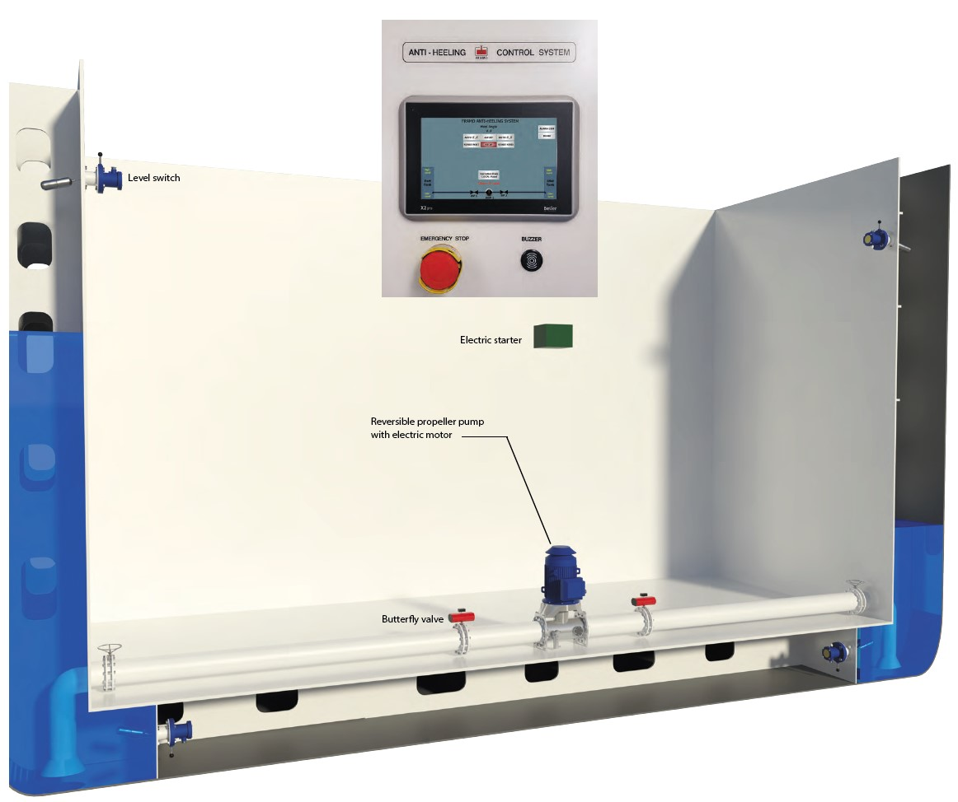Customer focus is our main mission.

**Scope of supply and price.**

|  |  |  |
| --- | --- | --- |
| {{#items}}{{index}} | {{qty}} of | {{description}}{{/items}} |

**Price: JPY 38000000,-**

**Terms & Conditions**

Price depends on all technical details settled.

## Terms of Payment

100% cash 45 days prior to shipment against Letter of Credit or APG.

## Delivery terms

DAP/CIF Yard, valid for delivery in 2023/24

## Delivery time

5 months Ex. Works from order (to be confirmed close to contract stage).

## Guarantee

12 months from ship delivery to Owner, or 18 months from equipment delivery to yard.

**General terms**

Otherwise according to Orgalime S2012 and S2012S

## Validity of quote

This quote is valid until 30.11.2024

We hope you find this quotation to meet your requirements and look forward to hear from you soon.

Best regards,

Framo AS



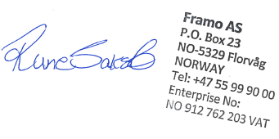

-----------------------------------------

Rune Sakslo

Sales & Projects Manager

Marine Pumping Systems