**ACKNOWLEDGEMENT**

We the developers of the project namely “Image Segmentation and Medical Imaging to find Nuclei using U-Net and Convolutional Neural Network”, with immense pleasure and commitment would like to present the Project. The development of this project has given us wide opportunity to think, implement and interact with various aspects of management skills as the new emerging technologies.

Every work that we complete successfully stands on the constant encouragement, good will and support of people around. We hereby avail this opportunity to express my gratitude to number of people who extended their valuable time, full support and cooperation in developing the project.

We express deep sense of gratitude towards our project guide Assistant Professor Jesal Desai for the support during the whole session of study and development. It is because of them, that we were prompted to do hard work, adopting new technologies.

**Regards,**

**Rishi Shah**

**Upasi Shah**

**ABSTRACT**

Recognizing the cells' nuclei is the beginning stage for the greater part of the investigations in light of the fact that the vast majority of the human body's 30 trillion cells contain a core brimming with DNA, the hereditary code that programs every cell. Distinguishing nuclei permits specialists to recognize every individual cell in an example, and by estimating how cells respond to different medicines, the analyst can comprehend the basic natural interaction at work. The cells' nuclei recognizing proof assignment is additionally sort of image segmentation. To accomplish this, we like to utilize deep learning algorithms. We have used U-Net which is having high speculation execution on smaller datasets. Furthermore, we assessed our technique on the dataset of data science bowl 2018 challenge. Deep learning might be unmistakably fit to handle these challenges as it offers a more domain agnostic approach combining both feature discovery and implementation to maximally segregate between the classes of revenue.

**Table of Contents**

**ACKNOWLEDGEMENT 1**

**ABSTRACT 2**

**TABLE OF CONTENTS 3**

1. **Project Definition4**

1.1 Definition 5

1.2 Objective5

1. **Project Introduction 6**

2.1 Introduction7

1. **Software and Hardware Specifications 8**

3.1 Software Specification9

3.2 Hardware Specification9

1. **Flow Chart10**

4.1 Flow diagram11

1. **Related Work 12**

5.1 Related Work13

1. **Dataset 14**

6.1 Dataset Information15

6.2 Dataset Pre-Processing16

1. **Building U-Net 17**

7.1 Network Architecture18

7.2 Training and Testing 20

1. **Results 21**

8.1 Results22

1. **Conclusion 23**

9.1 Conclusion24

1. **References 25**

10.1 References26

1. **Project Definition**

**1.1 Definition**

Identifying the cells’ nuclei is the starting point for most of the analyses because most of the human body’s 30 trillion cells contain a nucleus full of DNA, the genetic code that programs each cell. Identifying nuclei allows researchers to identify each individual cell in a sample, and by measuring how cells react to various treatments, the researcher can understand the underlying biological process at work.

**1.2 Objective**

* To advance in the Biomedical Imaging with the concepts of Deep Learning and CNN
* To attain >90% accuracy for prediction of masks.

1. **Project Introduction**

**2.1 Introduction**

By virtue of late advances in deep learning and computer vision inside the latest decade, deep learning has been logically utilized in the investigation of medical pictures. While the use of deep learning and computer vision has seen speedy move in various fields, it really faced a couple of troubles inside the medical imaging field. There have been various headway methods over time to beat these various troubles. Various methodology and procedures have been improvised to make to such challenges. One such method that will be examined in this survey will be the U-net, a deep learning strategy broadly received inside the medical imaging community.

For the current review, here we have been given a problem of finding nuclei from labelled images given form of mask and threshold for ease. The CNN model can easily solve this challenging task. On top of that, we have the specialized model architecture of CNN which is U-net. The prediction value of more than 95% is acceptable upon research and evaluation of model.

1. **Software and Hardware Specifications**

**3.1 Software Specification**

* Operating System: MacOS/Linux/Windows
* Python 3.7
* Jupyter Notebook/Google Colab
* Libraries
  1. **Hardware Requirements**
* Intel Core i7 9th Generation
* Memory: 32 GB
* Storage: 25 GB approx.
* Titan X GPU to train models

1. **Flow Chart**

**4.1 Flow Diagram**

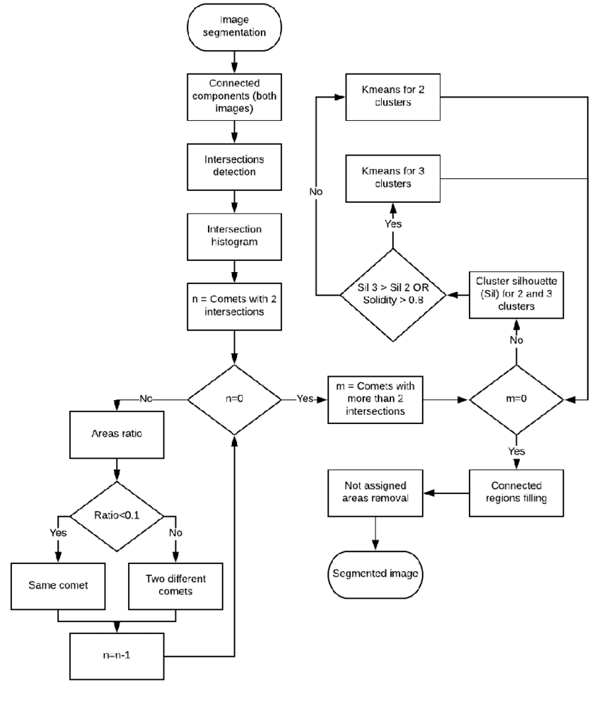

1. **Related Work**

**5.1 Related Work**

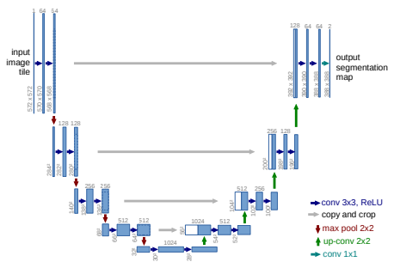U-net is a neural network architecture planned basically for image segmentation [1]. The fundamental construction of a U-net architecture comprises of two ways. The primary way is the contracting way, otherwise called the encoder or the examination way, which is like a customary convolution network and gives grouping data. [5] The second is an extension way, otherwise called the decoder or the combination way, comprising of up-convolutions and links with highlights from the contracting way. This extension permits the network to learn restricted characterization data. Moreover, the development way likewise expands the goal of the yield which would then be able to be go to a last convolutional layer to make a completely portioned image. [5] The subsequent network is practically balanced, giving it a u-like shape. The principle standard undertaking performed by most convolutional networks is to arrange the entire image into a solitary mark. Notwithstanding, grouping networks neglect to give pixel-level setting data which is truly necessary in medical image examination. While there have been past endeavours at segmentation errands, it wasn't until U-net by Ronneberger et al. [1] that there was a critical improvement in medical image segmentation execution. The U-net network was created dependent on crafted by Long, J et al. [4] utilizing completely convolutional networks.

**Fig. 1.** U-net architecture (model for 32x32 pixels in the most reduced goal). Each blue box compares to a multi-channel highlight map. The quantity of channels is signified on top of the container. The x-y-size is given at the lower left edge of the case. White boxes address replicated include maps. The bolts indicate the various tasks.

1. **Dataset**

**6.1 Dataset Information**

For the study, we have utilized the dataset from data science bowl 2018 challenge accessible online as Kaggle dataset vault. The dataset contains various divided cores images. The images were gained under an assortment of conditions and differ in the cell type, amplification, and imaging methodology (splendid field versus fluorescence). The dataset is intended to challenge a calculation's capacity to sum up across these varieties. Each image is addressed by a related ImageId. Documents having a place with an image are contained in an organizer with this ImageId.

Within Sub folders:

* images contain the image file.
* masks contain the segmented masks of each nucleus.

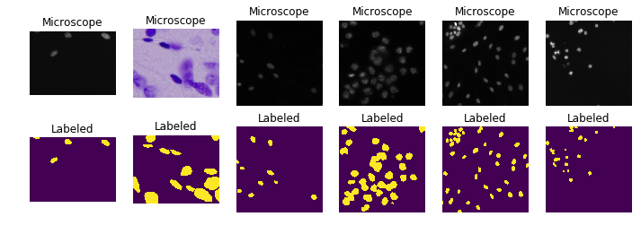

**Fig. 2.** Cells where we can see mixture of brightfield and fluorescence

**6.2 Dataset Pre-Processing**

We start with bringing in the necessary libraries. Get information in hdf5 format if accessible or convert unique pictures to hdf5 format. Burden from hdf5 on the off chance that it exists or the consequences will be severe assuming hdf5 doesn't exist, load unique pictures and make hdf5 and making the consolidated veil. After reshaping for standard tensors, we are all set. Getting and resizing train/test pictures and covers from memory, returned as in NumPy array format. Test irregular pictures after pre-handling can be acquired in the information representation part.

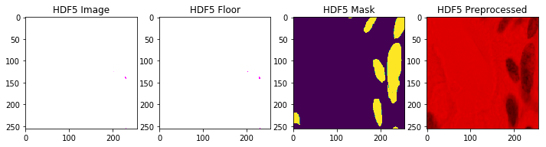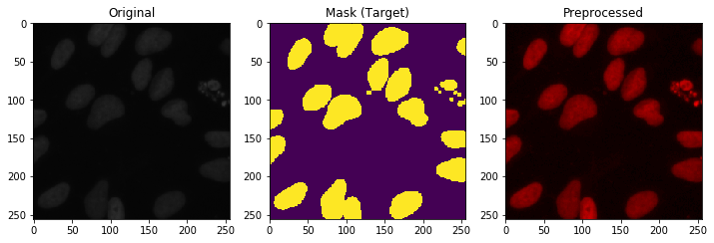

**Fig. 3.** Pre-processed images including hdf5 format image, floor, mask and added noise pre-processed image.

Data seems to be good. In hdf5 format, resizing introduces noise which seems to be corrected later in the pre-processing steps.

1. **Building U-Net**

**7.1 Network Architecture**

U-Net is a convolutional neural network that was made for biomedical picture segmentation at the Computer Science Department of the University of Freiburg, Germany. The network relies upon the completely convolutional network and its architecture was changed and loosened up to work with less planning pictures and to yield more careful segmentations. Segmentation of a 512 × 512 picture requires not actually a second on a high-performing GPU.

The U-Net architecture originates from the alleged "fully convolutional network" first proposed by Long and Shelhamer.

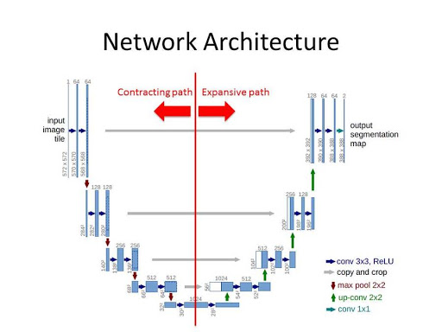The essential idea is to enhance a typical contracting network by progressive layers, where pooling exercises are replaced by up examining directors. Accordingly, these layers increase the goal of the yield. Moreover, a progressive convolutional layer would then have the option to sort out some way to gather an accurate yield subject to this data. [7]

**Fig. 4.** Network architecture of U-Net describing the contracting and expansive path.

One huge change in U-Net is that there are an enormous number of highlights coordinates in the up-testing part, which license the network to cause setting data to higher goal layers. As a result, the broad way is practically symmetric to the contracting part, and yields a u-shaped architecture. The network simply utilizes the considerable piece of each convolution with no completely related layers. To predict the pixels in the limit space of the image, the missing setting is extrapolated by mirroring the info picture. This tiling method is fundamental to apply the network to huge pictures, since regardless the goal would be confined by the GPU memory. [7,5]

**Fig. 5.** The intensity distributions to get a clear idea of groups formed in our dataset.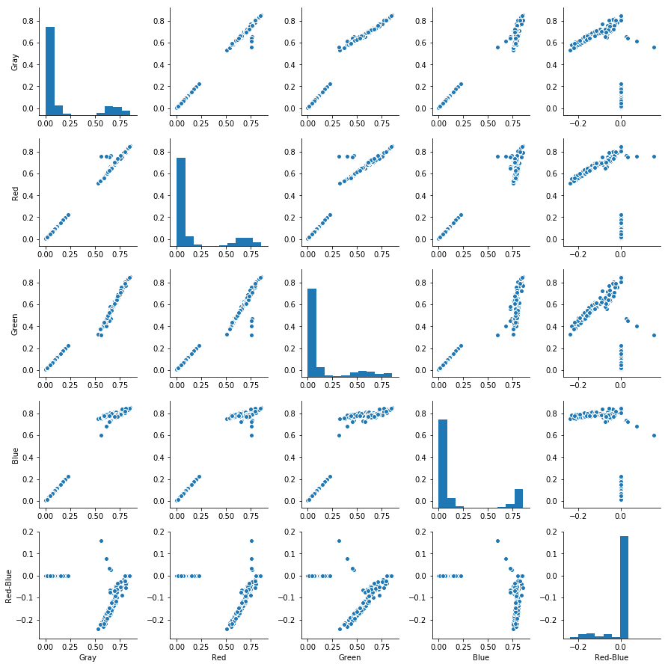

**7.2 Training and Testing**

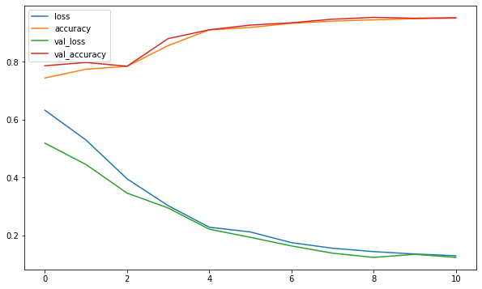Training this model on CPU is not recommended as it will take several hours or even several days to complete. The pre-trained weights are available on the repository. For the study, model was trained on Titan X GPU with 12GB of available memory for around 100 epochs without early stopping in batch_size of 16.

**Fig. 6.** Model evaluation plot after 100 no. of epochs to train our model.

Model was trained on two different scenarios. First, with numpy data without pre-processing. Second, with numpy data with pre-processing. the training and validation loss decrease rapidly at first but then slows down and the validation intersection over union coefficient settles around .80, which is not bad.

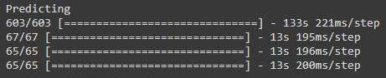

**Fig. 7.** Trained model to predict on test-images

1. **Results**

**8.1 Results**

* 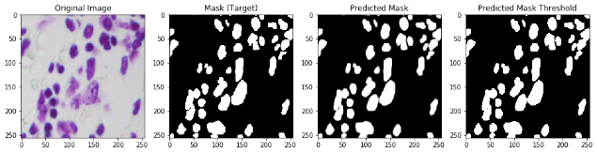The dataset was split into ratio of 90:10 where in the sanity checks for a random training, validation, and test data images are available with the original, mask (target), predicted mask and predicted mast threshold image. In total of 670/65 images, we performed the same task on few different samples and results are shown below.

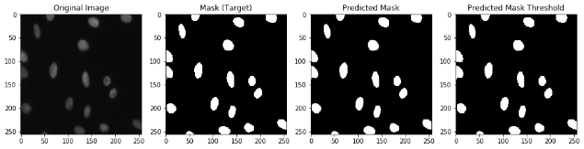**Fig. 8.** Sanity check on some random training samples

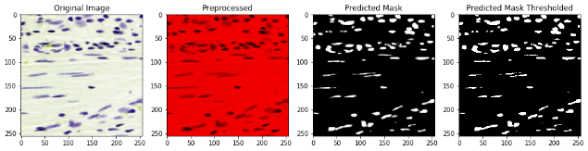**Fig. 9.** Sanity check on some random validation samples.

**Fig. 10.** Final results for test data.

1. **Conclusion**

**9.1 Conclusion**

* The eventual outcome from this pipeline is a fragmented picture with cells counted. It functions admirably as a first model and verification of idea but there is much opportunity to get better; for instance, a portion of the cells cover and get clustered together as one single cell, which additionally prompts under counting. Future post-handling using water shed techniques should assist with this. Further, other network architectures can be tested for improvisation of accuracy and optimization of resources. Some examples for the same can be R-CNN, U-Net++, etc.

**10. References**

**10.1 References**

[1] Ronneberger, O., Fischer, P., & Brox, T. (2015, October). U-net: Convolutional networks for biomedical image segmentation. In International Conference on Medical image computing and computer-assisted intervention (pp. 234-241). Springer, Cham.

[2] Janowczyk, A., & Madabhushi, A. (2016). Deep learning for digital pathology image analysis: A comprehensive tutorial with selected use cases. Journal of pathology informatics, 7.

[3] Litjens, G., Kooi, T., Bejnordi, B. E., Setio, A. A. A., Ciompi, F., Ghafoorian, M., ... & Sánchez, C. I. (2017). A survey on deep learning in medical image analysis. Medical image analysis, 42, 60-88.

[4] J. Long, E. Shelhamer, and T. Darrell, “Fully convolutional networks for semantic segmentation,” 2015, pp. 3431–3440

[5] Nahian Siddique, Paheding Sidike, Colin Elkin and Vijay Devabhaktuni, “U-Net and its variants for medical image segmentation: theory and applications”, 2011, 01118.

[6] Dataset source: https://www.kaggle.com/c/data-science-bowl-2018

[7] https://en.wikipedia.org/wiki/U-Net

[8] S. G. Armato, G. McLennan, L. Bidaut, M. F. McNitt-Gray, C. R. Meyer, A. P. Reeves, B. Zhao, D. R. Aberle, C. I. Henschke, E. A. Hoffman, et al. The lung image database consortium (lidc) and image database resource initiative (idri): a completed reference database of lung nodules on ct scans. Medical physics, 38(2):915–931, 2011.

[9] Ciresan, D.C., Gambardella, L.M., Giusti, A., Schmidhuber, J.: Deep neural networks segment neuronal membranes in electron microscopy images. In: NIPS. pp. 2852–2860 (2012)

[10] Dosovitskiy, A., Springenberg, J.T., Riedmiller, M., Brox, T.: Discriminative unsupervised feature learning with convolutional neural networks. In: NIPS (2014)

[11] Girshick, R., Donahue, J., Darrell, T., Malik, J.: Rich feature hierarchies for accurate object detection and semantic segmentation. In: Proceedings of the IEEE Conference on Computer Vision and Pattern Recognition (CVPR) (2014)

[12] He, K., Zhang, X., Ren, S., Sun, J.: Delving deep into rectifiers: Surpassing humanlevel performance on ImageNet classification (2015), arXiv:1502.01852 [cs.CV]

[13] Simonyan, K., Zisserman, A.: Very deep convolutional networks for large-scale image recognition (2014), arXiv:1409.1556 [cs.CV]

[14] LeCun, Y., Boser, B., Denker, J.S., Henderson, D., Howard, R.E., Hubbard, W., Jackel, L.D.: Backpropagation applied to handwritten zip code recognition. Neural Computation 1(4), 541–551 (1989)