**A**

**Project Report**

**On**

**"** **Image Segmentation and Medical Imaging to find Nuclei using U-Net and Convolutional Neural Network "**

**Prepared by**

Rishi Shah (18DCS110)

Upasi Shah (18DCS113)

**Under the guidance of**

Prof. Jesal Desai

Assistant Professor

A Report Submitted to

Charotar University of Science and Technology

for Partial Fulfillment of the Requirements for the

6th Semester Software Group Project-IV (CS349)

**Submitted at**

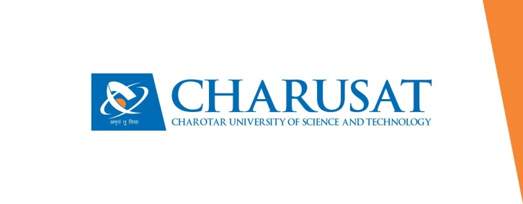

**Department of Computer Science and Engineering**

**Devang Patel Institute of Advance Technology and Research**

**At: Changa, Dist: Anand – 388421**

**APRIL 2021**