Game Design Document

Fill up the following document

1. Write the title of your project.

Pizza explosion

1. What is the goal of the game?

To jump over pizza toppings on the floor

1. Write a brief story of your game.

The baker is making a pizza but somrthing happened and it exploded. Now he has to and jump over the toppings on his way to make a new one

1. Which are the playing characters of this game?

* Playing characters are the ones who respond to the user based on the input from the user.
* Cars, monkeys, dinos, wizards, etc., are the playing characters in the game.

|  |  |  |
| --- | --- | --- |
| Number | Character Name | What can this character do? |
| 1 | baker | Jumps over the toppings |

1. Which are the Non-Playing Characters of this game?

* Non-Playing characters are the ones that don't have an action or behavior when the user interacts with the game.
* Hurdles, stones, bananas, coins, etc., are non-playing characters in the game.

|  |  |  |
| --- | --- | --- |
| Number | Character Name | What can this character do? |
| 1 | toppings | As obstacles |
| 2 | ground | Moving |
| 3 | Pizza slice | Gain points |

Draw your imagination of this game. What does this game look like?

* Draw the game either on your computer or on paper.
* Add images of the game scenes to show each of the playing and non-playing characters at least once.

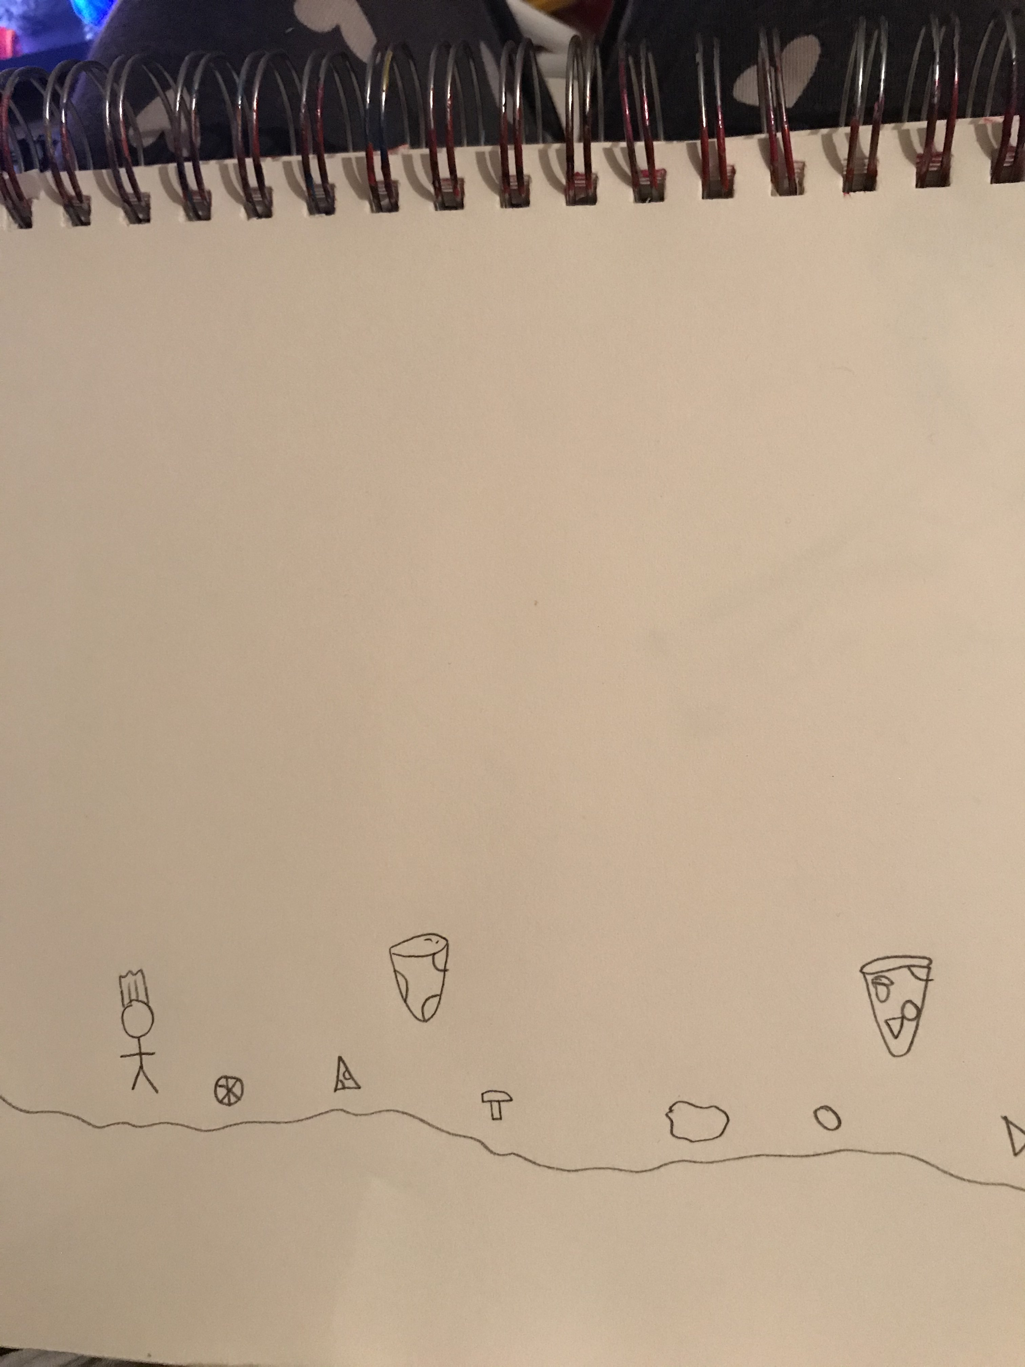

How do you plan to make your game engaging?

Use more player feedback by if you hit a pizza topping, you loose the game and have to restart but if you hit a pizza slice( they will be up in the air) then you will gain more points. There will also be sound effects for when you loose or gain a certain ammount of points.