1. Project Overview
Project name: Truth Trace
Project type: AI-based investigation support website
Main users: Investigators, supervisors, and system administrators
Truth Trace is a secure website that helps investigators:
- Compare a suspect’s statements from different interview sessions.
- Detect matching information, contradictions, missing details, and unclear information.
- Check statements against digital evidence.
- Display a confidence percentage with every result.
- Generate a complete investigation report.
The website is a decision-support system. It does not decide whether someone is guilty or innocent. The investigator must review the AI results and make the final decision.

2. Main Problem
Investigators may interview the same suspect several times. The suspect might change important details such as:
- Time, Location , People involved , Actions , Events
Manually comparing long statements takes a lot of time, and investigators may miss important differences.
Truth Trace uses AI and Natural Language Processing to compare the meaning of statements, even when different words are used.
For example:
- Statement 1: “I arrived at the mall at 8:00 PM.”
- Statement 2: “I reached the shopping centre at around eight in the evening.”
The system should understand that these statements have a similar meaning.
However:
- Statement 1: “I arrived at 8:00 PM.”
- Statement 2: “I arrived at 10:30 PM.”
The system should identify the time difference as a possible conflict.

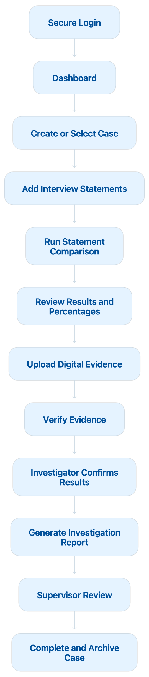

Recommended Languages and Technologies
Part | Recommended technology | Purpose
Website interface | HTML, CSS and JavaScript | Build the pages and user interface
Frontend framework | React | Create an interactive dashboard
Backend | Python 3.11 with FastAPI | Process requests and connect the website to the AI
AI and NLP | spaCy and Sentence Transformers | Extract details and compare statements
Database | PostgreSQL | Store users, cases, statements, evidence information, and logs
Security | JWT, RBAC, HTTPS and password hashing | Protect accounts and investigation data
Evidence integrity | SHA-256 | Detect changes to uploaded files
Reports | Python PDF library | Generate downloadable investigation reports

Website Display Languages
The interface should support:
- English
- Arabic

