

**Guidelines for PGPDSE FT Capstone Project – Interim Report**

**Project Group Info:**

|  |  |
| --- | --- |
| BATCH DETAILS | PGPDSE-FT Online Sep21 |
| TEAM MEMBERS | * RAVITEJA CHODAVARAPU * LEON MENDES * SUPRATICK MOHORAR * PRADEEPTA SAHOO |
| DOMAIN OF PROJECT | Finance & Risk Analytics |
| PROJECT TITLE | Loan Default Prediction using Machine Learning |
| GROUP NUMBER | 8 |
| TEAM LEADER | RAVITEJA CHODAVARAPU |
| MENTOR NAME | MR. JAYVEER NANDA |

Date: 12/06/2022

JAYVEER NANDA RAVITEJA CHODAVARAPU

Signature of the Mentor Signature of the Team Leader

**Abstract:**

One of the primary sources of income of a financial institution is through interests of loaned money. It’s quite tricky for a financial institution to sanction loans because they need to ensure that they get back the loaned amount along with the interests. The banks need a method where they can predict and ensure whether one can pay that amount back. To tackle such a reallife problem, we are building a machine learning model that can predict this with ease.

**Objectives:**

The objective of our project is to predict whether a loan will default or not based on objective financial data only and whether investors should lend to a customer or not. Data from 2007-2011 will be used because most of the loans from that period have already been repaid or defaulted on. With the above objective our aim is to develop a prediction model which assists the Bank to Understand the optimal credit limit and reduce NPA by classifying customer who are most likely to default and who will pay back the loan amount on time. The main objective is to build a machine learning model: o The prediction whether banks or investors should lend to a customer or not o The prediction of future traits o To Predict Optimal Credit Limit for customer’s o To reduce NPA (Non- performing Assets)

**Industry Review:**

Loans always been a crucial part of the banking industry. In the earlier days it was the social reputation and image which were determining factors of one being eligible for a loan. But as the industry grew and times move forward this technique of ‘trust’ soon turned into something we know as guarantee of collaterals. Needless to say with times, the eligibility criteria’s started getting more and more complex.

One thing that didn’t change in the industry from the very beginning is the practice of ensuring that the person/company pays back the loaned amount, whether it was the reputation, assets or cibil score.

Nowadays, organizations heavily rely on data and IT services for efficient internal and external operations making the promptness an important factor. The quicker a bank predicts one’s eligibility the quicker they can sanction the loans and quicker they can reel in another customer.

**Current practices in Industry:**

With changing times, the complexity of analysing what a person is worth or their assets are worth are getting quite tricky. People are slowly away from conventional investments and moving towards digitized one. These portfolios are getting tricky and difficult to analyse for the banks.

To build a machine learning model now for this problem we have to ensure that all possible criteria’s (that are available in the market right now) are included and also design the model in such a way that when new criteria’s come into play the model can be easily tweaked in the future.

**Problem Statement:**

If a model can identify credit-worthy customers that were not recognized by traditional credit scores, while minimizing their risk of default on the loans, this can be a lucrative niche market or micro-market, pushing higher the profit margin of the financial institution or investor. Although the prospect of more customers seems positive, it is important to be careful as to not lend to people that will default on the loan. Thus, a conservative approach and strict evaluation metrics were kept in mind throughout the project. The loan default prediction is a problem of binary classification (should the investor lend or not).

**Project Outcome:**

* By implementing the resultant models in the working dataset, we can get the rejection/approval list of all everyone who applied for loans in an accurate and efficient way.

**Dataset and Domain:**

**Data Dictionary:**

Real-time Loan dataset obtained from an organization.

The Data_Dictionary.xlsx consists of all the loans i.e., both approved and rejected ones.

The dataset has 39,717 records and 111 attributes

# Column Dtype

--- ------ -----

0 id int64

1 member_id int64

2 loan_amnt int64

3 funded_amnt int64

4 funded_amnt_inv float64

5 term object

6 int_rate object

7 installment float64

8 grade object

9 sub_grade object

10 emp_title object

11 emp_length object

12 home_ownership object

13 annual_inc float64

14 verification_status object

15 issue_d object

16 loan_status object

17 pymnt_plan object

18 url object

19 desc object

20 purpose object

21 title object

22 zip_code object

23 addr_state object

24 dti float64

25 delinq_2yrs int64

26 earliest_cr_line object

27 inq_last_6mths int64

28 mths_since_last_delinq float64

29 mths_since_last_record float64

30 open_acc int64

31 pub_rec int64

32 revol_bal int64

33 revol_util object

34 total_acc int64

35 initial_list_status object

36 out_prncp float64

37 out_prncp_inv float64

38 total_pymnt float64

39 total_pymnt_inv float64

40 total_rec_prncp float64

41 total_rec_int float64

42 total_rec_late_fee float64

43 recoveries float64

44 collection_recovery_fee float64

45 last_pymnt_d object

46 last_pymnt_amnt float64

47 next_pymnt_d object

48 last_credit_pull_d object

49 collections_12_mths_ex_med float64

50 mths_since_last_major_derog float64

51 policy_code int64

52 application_type object

53 annual_inc_joint float64

54 dti_joint float64

55 verification_status_joint float64

56 acc_now_delinq int64

57 tot_coll_amt float64

58 tot_cur_bal float64

59 open_acc_6m float64

60 open_il_6m float64

61 open_il_12m float64

62 open_il_24m float64

63 mths_since_rcnt_il float64

64 total_bal_il float64

65 il_util float64

66 open_rv_12m float64

67 open_rv_24m float64

68 max_bal_bc float64

69 all_util float64

70 total_rev_hi_lim float64

71 inq_fi float64

72 total_cu_tl float64

73 inq_last_12m float64

74 acc_open_past_24mths float64

75 avg_cur_bal float64

76 bc_open_to_buy float64

77 bc_util float64

78 chargeoff_within_12_mths float64

79 delinq_amnt int64

80 mo_sin_old_il_acct float64

81 mo_sin_old_rev_tl_op float64

82 mo_sin_rcnt_rev_tl_op float64

83 mo_sin_rcnt_tl float64

84 mort_acc float64

85 mths_since_recent_bc float64

86 mths_since_recent_bc_dlq float64

87 mths_since_recent_inq float64

88 mths_since_recent_revol_delinq float64

89 num_accts_ever_120_pd float64

90 num_actv_bc_tl float64

91 num_actv_rev_tl float64

92 num_bc_sats float64

93 num_bc_tl float64

94 num_il_tl float64

95 num_op_rev_tl float64

96 num_rev_accts float64

97 num_rev_tl_bal_gt_0 float64

98 num_sats float64

99 num_tl_120dpd_2m float64

100 num_tl_30dpd float64

101 num_tl_90g_dpd_24m float64

102 num_tl_op_past_12m float64

103 pct_tl_nvr_dlq float64

104 percent_bc_gt_75 float64

105 pub_rec_bankruptcies float64

106 tax_liens float64

107 tot_hi_cred_lim float64

108 total_bal_ex_mort float64

109 total_bc_limit float64

110 total_il_high_credit_limit float64

**Data Description:**

|  |  |
| --- | --- |
| **LoanStatNew** | **Description** |
| acc_now_delinq | The number of accounts on which the borrower is now delinquent. |
| acc_open_past_24mths | Number of trades opened in past 24 months. |
| addr_state | The state provided by the borrower in the loan application |
| all_util | Balance to credit limit on all trades |
| annual_inc | The self-reported annual income provided by the borrower during registration. |
| annual_inc_joint | The combined self-reported annual income provided by the co-borrowers during registration |
| application_type | Indicates whether the loan is an individual application or a joint application with two co-borrowers |
| avg_cur_bal | Average current balance of all accounts |
| bc_open_to_buy | Total open to buy on revolving bankcards. |
| bc_util | Ratio of total current balance to high credit/credit limit for all bankcard accounts. |
| chargeoff_within_12_mths | Number of charge-offs within 12 months |
| collection_recovery_fee | post charge off collection fee |
| collections_12_mths_ex_med | Number of collections in 12 months excluding medical collections |
| delinq_2yrs | The number of 30+ days past-due incidences of delinquency in the borrower's credit file for the past 2 years |
| delinq_amnt | The past-due amount owed for the accounts on which the borrower is now delinquent. |
| desc | Loan description provided by the borrower |
| dti | A ratio calculated using the borrower’s total monthly debt payments on the total debt obligations, excluding mortgage and the requested LC loan, divided by the borrower’s self-reported monthly income. |
| dti_joint | A ratio calculated using the co-borrowers' total monthly payments on the total debt obligations, excluding mortgages and the requested LC loan, divided by the co-borrowers' combined self-reported monthly income |
| earliest_cr_line | The month the borrower's earliest reported credit line was opened |
| emp_length | Employment length in years. Possible values are between 0 and 10 where 0 means less than one year and 10 means ten or more years. |
| emp_title | The job title supplied by the Borrower when applying for the loan.* |
| fico_range_high | The upper boundary range the borrower’s FICO at loan origination belongs to. |
| fico_range_low | The lower boundary range the borrower’s FICO at loan origination belongs to. |
| funded_amnt | The total amount committed to that loan at that point in time. |
| funded_amnt_inv | The total amount committed by investors for that loan at that point in time. |
| grade | LC assigned loan grade |
| home_ownership | The home ownership status provided by the borrower during registration. Our values are: RENT, OWN, MORTGAGE, OTHER. |
| id | A unique LC assigned ID for the loan listing. |
| il_util | Ratio of total current balance to high credit/credit limit on all install acct |
| initial_list_status | The initial listing status of the loan. Possible values are – W, F |
| inq_fi | Number of personal finance inquiries |
| inq_last_12m | Number of credit inquiries in past 12 months |
| inq_last_6mths | The number of inquiries in past 6 months (excluding auto and mortgage inquiries) |
| installment | The monthly payment owed by the borrower if the loan originates. |
| int_rate | Interest Rate on the loan |
| issue_d | The month which the loan was funded |
| last_credit_pull_d | The most recent month LC pulled credit for this loan |
| last_fico_range_high | The upper boundary range the borrower’s last FICO pulled belongs to. |
| last_fico_range_low | The lower boundary range the borrower’s last FICO pulled belongs to. |
| last_pymnt_amnt | Last total payment amount received |
| last_pymnt_d | Last month payment was received |
| loan_amnt | The listed amount of the loan applied for by the borrower. If at some point in time, the credit department reduces the loan amount, then it will be reflected in this value. |
| loan_status | Current status of the loan |
| max_bal_bc | Maximum current balance owed on all revolving accounts |
| member_id | A unique LC assigned Id for the borrower member. |
| mo_sin_old_il_acct | Months since oldest bank installment account opened |
| mo_sin_old_rev_tl_op | Months since oldest revolving account opened |
| mo_sin_rcnt_rev_tl_op | Months since most recent revolving account opened |
| mo_sin_rcnt_tl | Months since most recent account opened |
| mort_acc | Number of mortgage accounts. |
| mths_since_last_delinq | The number of months since the borrower's last delinquency. |
| mths_since_last_major_derog | Months since most recent 90-day or worse rating |
| mths_since_last_record | The number of months since the last public record. |
| mths_since_rcnt_il | Months since most recent installment accounts opened |
| mths_since_recent_bc | Months since most recent bankcard account opened. |
| mths_since_recent_bc_dlq | Months since most recent bankcard delinquency |
| mths_since_recent_inq | Months since most recent inquiry. |
| mths_since_recent_revol_delinq | Months since most recent revolving delinquency. |
| next_pymnt_d | Next scheduled payment date |
| num_accts_ever_120_pd | Number of accounts ever 120 or more days past due |
| num_actv_bc_tl | Number of currently active bankcard accounts |
| num_actv_rev_tl | Number of currently active revolving trades |
| num_bc_sats | Number of satisfactory bankcard accounts |
| num_bc_tl | Number of bankcard accounts |
| num_il_tl | Number of installment accounts |
| num_op_rev_tl | Number of open revolving accounts |
| num_rev_accts | Number of revolving accounts |
| num_rev_tl_bal_gt_0 | Number of revolving trades with balance >0 |
| num_sats | Number of satisfactory accounts |
| num_tl_120dpd_2m | Number of accounts currently 120 days past due (updated in past 2 months) |
| num_tl_30dpd | Number of accounts currently 30 days past due (updated in past 2 months) |
| num_tl_90g_dpd_24m | Number of accounts 90 or more days past due in last 24 months |
| num_tl_op_past_12m | Number of accounts opened in past 12 months |
| open_acc | The number of open credit lines in the borrower's credit file. |
| open_acc_6m | Number of open trades in last 6 months |
| open_il_12m | Number of installment accounts opened in past 12 months |
| open_il_24m | Number of installment accounts opened in past 24 months |
| open_il_6m | Number of currently active installment trades |
| open_rv_12m | Number of revolving trades opened in past 12 months |
| open_rv_24m | Number of revolving trades opened in past 24 months |
| out_prncp | Remaining outstanding principal for total amount funded |
| out_prncp_inv | Remaining outstanding principal for portion of total amount funded by investors |
| pct_tl_nvr_dlq | Percent of trades never delinquent |
| percent_bc_gt_75 | Percentage of all bankcard accounts > 75% of limit. |
| policy_code | publicly available policy_code=1 new products not publicly available policy_code=2 |
| pub_rec | Number of derogatory public records |
| pub_rec_bankruptcies | Number of public record bankruptcies |
| purpose | A category provided by the borrower for the loan request. |
| pymnt_plan | Indicates if a payment plan has been put in place for the loan |
| recoveries | post charge off gross recovery |
| revol_bal | Total credit revolving balance |
| revol_util | Revolving line utilization rate, or the amount of credit the borrower is using relative to all available revolving credit. |
| sub_grade | LC assigned loan subgrade |
| tax_liens | Number of tax liens |
| term | The number of payments on the loan. Values are in months and can be either 36 or 60. |
| title | The loan title provided by the borrower |
| tot_coll_amt | Total collection amounts ever owed |
| tot_cur_bal | Total current balance of all accounts |
| tot_hi_cred_lim | Total high credit/credit limit |
| total_acc | The total number of credit lines currently in the borrower's credit file |
| total_bal_ex_mort | Total credit balance excluding mortgage |
| total_bal_il | Total current balance of all installment accounts |
| total_bc_limit | Total bankcard high credit/credit limit |
| total_cu_tl | Number of finance trades |
| total_il_high_credit_limit | Total installment high credit/credit limit |
| total_pymnt | Payments received to date for total amount funded |
| total_pymnt_inv | Payments received to date for portion of total amount funded by investors |
| total_rec_int | Interest received to date |
| total_rec_late_fee | Late fees received to date |
| total_rec_prncp | Principal received to date |
| total_rev_hi_lim | Total revolving high credit/credit limit |
| url | URL for the LC page with listing data. |
| verification_status | Indicates if income was verified by LC, not verified, or if the income source was verified |
| verified_status_joint | Indicates if the co-borrowers' joint income was verified by LC, not verified, or if the income source was verified |
| zip_code | The first 3 numbers of the zip code provided by the borrower in the loan application. |

**Variable categorization:**

There are 87 numerical columns and 24 categorical columns

**Numerical Columns:**

[Index ['id',

'member_id',

'loan_amnt',

'funded_amnt',

'funded_amnt_inv',

'installment',

'annual_inc',

'dti',

'delinq_2yrs',

'inq_last_6mths',

'mths_since_last_delinq',

'mths_since_last_record',

'open_acc',

'pub_rec',

'revol_bal',

'total_acc',

'out_prncp',

'out_prncp_inv',

'total_pymnt',

'total_pymnt_inv',

'total_rec_prncp',

'total_rec_int',

'total_rec_late_fee',

'recoveries',

'collection_recovery_fee',

'last_pymnt_amnt',

'collections_12_mths_ex_med',

'mths_since_last_major_derog',

'policy_code',

'annual_inc_joint',

'dti_joint',

'verification_status_joint',

'acc_now_delinq',

'tot_coll_amt',

'tot_cur_bal',

'open_acc_6m',

'open_il_6m',

'open_il_12m',

'open_il_24m',

'mths_since_rcnt_il',

'total_bal_il',

'il_util',

'open_rv_12m',

'open_rv_24m',

'max_bal_bc',

'all_util',

'total_rev_hi_lim',

'inq_fi',

'total_cu_tl',

'inq_last_12m',

'acc_open_past_24mths',

'avg_cur_bal',

'bc_open_to_buy',

'bc_util',

'chargeoff_within_12_mths',

'delinq_amnt',

'mo_sin_old_il_acct',

'mo_sin_old_rev_tl_op',

'mo_sin_rcnt_rev_tl_op',

'mo_sin_rcnt_tl',

'mort_acc',

'mths_since_recent_bc',

'mths_since_recent_bc_dlq',

'mths_since_recent_inq',

'mths_since_recent_revol_delinq',

'num_accts_ever_120_pd',

'num_actv_bc_tl',

'num_actv_rev_tl',

'num_bc_sats',

'num_bc_tl',

'num_il_tl',

'num_op_rev_tl',

'num_rev_accts',

'num_rev_tl_bal_gt_0',

'num_sats',

'num_tl_120dpd_2m',

'num_tl_30dpd',

'num_tl_90g_dpd_24m',

'num_tl_op_past_12m',

'pct_tl_nvr_dlq',

'percent_bc_gt_75',

'pub_rec_bankruptcies',

'tax_liens',

'tot_hi_cred_lim',

'total_bal_ex_mort',

'total_bc_limit',

'total_il_high_credit_limit']

**Categorical Columns:**

[Index ['term',

'int_rate',

'grade',

'sub_grade',

'emp_title',

'emp_length',

'home_ownership',

'verification_status',

'issue_d',

'loan_status',

'pymnt_plan',

'url',

'desc',

'purpose',

'title',

'zip_code',

'addr_state',

'earliest_cr_line',

'revol_util',

'initial_list_status',

'last_pymnt_d',

'next_pymnt_d',

'last_credit_pull_d',

'application_type']

**Pre-Processing Data Analysis (count of missing/ null values, redundant columns, etc.)**

The dataset has missing values in most of the columns.

**Redundant Columns:**

**Before:**

# Column Dtype

--- ------ -----

0 id int64

1 member_id int64

2 loan_amnt int64

3 funded_amnt int64

4 funded_amnt_inv float64

5 term object

6 int_rate object

7 installment float64

8 grade object

9 sub_grade object

10 emp_title object

11 emp_length object

12 home_ownership object

13 annual_inc float64

14 verification_status object

15 issue_d object

16 loan_status object

17 pymnt_plan object

18 url object

19 desc object

20 purpose object

21 title object

22 zip_code object

23 addr_state object

24 dti float64

25 delinq_2yrs int64

26 earliest_cr_line object

27 inq_last_6mths int64

28 mths_since_last_delinq float64

29 mths_since_last_record float64

30 open_acc int64

31 pub_rec int64

32 revol_bal int64

33 revol_util object

34 total_acc int64

35 initial_list_status object

36 out_prncp float64

37 out_prncp_inv float64

38 total_pymnt float64

39 total_pymnt_inv float64

40 total_rec_prncp float64

41 total_rec_int float64

42 total_rec_late_fee float64

43 recoveries float64

44 collection_recovery_fee float64

45 last_pymnt_d object

46 last_pymnt_amnt float64

47 next_pymnt_d object

48 last_credit_pull_d object

49 collections_12_mths_ex_med float64

50 mths_since_last_major_derog float64

51 policy_code int64

52 application_type object

53 annual_inc_joint float64

54 dti_joint float64

55 verification_status_joint float64

56 acc_now_delinq int64

57 tot_coll_amt float64

58 tot_cur_bal float64

59 open_acc_6m float64

60 open_il_6m float64

61 open_il_12m float64

62 open_il_24m float64

63 mths_since_rcnt_il float64

64 total_bal_il float64

65 il_util float64

66 open_rv_12m float64

67 open_rv_24m float64

68 max_bal_bc float64

69 all_util float64

70 total_rev_hi_lim float64

71 inq_fi float64

72 total_cu_tl float64

73 inq_last_12m float64

74 acc_open_past_24mths float64

75 avg_cur_bal float64

76 bc_open_to_buy float64

77 bc_util float64

78 chargeoff_within_12_mths float64

79 delinq_amnt int64

80 mo_sin_old_il_acct float64

81 mo_sin_old_rev_tl_op float64

82 mo_sin_rcnt_rev_tl_op float64

83 mo_sin_rcnt_tl float64

84 mort_acc float64

85 mths_since_recent_bc float64

86 mths_since_recent_bc_dlq float64

87 mths_since_recent_inq float64

88 mths_since_recent_revol_delinq float64

89 num_accts_ever_120_pd float64

90 num_actv_bc_tl float64

91 num_actv_rev_tl float64

92 num_bc_sats float64

93 num_bc_tl float64

94 num_il_tl float64

95 num_op_rev_tl float64

96 num_rev_accts float64

97 num_rev_tl_bal_gt_0 float64

98 num_sats float64

99 num_tl_120dpd_2m float64

100 num_tl_30dpd float64

101 num_tl_90g_dpd_24m float64

102 num_tl_op_past_12m float64

103 pct_tl_nvr_dlq float64

104 percent_bc_gt_75 float64

105 pub_rec_bankruptcies float64

106 tax_liens float64

107 tot_hi_cred_lim float64

108 total_bal_ex_mort float64

109 total_bc_limit float64

110 total_il_high_credit_limit float64

**After:**

loan_amnt int64

funded_amnt int64

funded_amnt_inv float64

term object

int_rate object

installment float64

grade object

sub_grade object

emp_title object

emp_length object

home_ownership object

annual_inc float64

verification_status object

issue_d object

loan_status object

pymnt_plan object

purpose object

title object

addr_state object

dti float64

earliest_cr_line object

inq_last_6mths int64

mths_since_last_delinq float64

mths_since_last_record float64

open_acc int64

pub_rec int64

revol_util object

total_acc int64

initial_list_status object

out_prncp_inv float64

total_pymnt_inv float64

last_credit_pull_d object

collections_12_mths_ex_med float64

mths_since_last_major_derog float64

policy_code int64

application_type object

annual_inc_joint float64

dti_joint float64

verification_status_joint float64

acc_now_delinq int64

tot_coll_amt float64

tot_cur_bal float64

open_acc_6m float64

open_il_6m float64

open_il_12m float64

open_il_24m float64

mths_since_rcnt_il float64

total_bal_il float64

il_util float64

open_rv_12m float64

open_rv_24m float64

max_bal_bc float64

all_util float64

total_rev_hi_lim float64

inq_fi float64

total_cu_tl float64

inq_last_12m float64

acc_open_past_24mths float64

avg_cur_bal float64

bc_open_to_buy float64

bc_util float64

delinq_amnt int64

mo_sin_old_il_acct float64

mo_sin_old_rev_tl_op float64

mo_sin_rcnt_rev_tl_op float64

mo_sin_rcnt_tl float64

mort_acc float64

mths_since_recent_bc float64

mths_since_recent_bc_dlq float64

mths_since_recent_inq float64

mths_since_recent_revol_delinq float64

num_accts_ever_120_pd float64

num_actv_bc_tl float64

num_actv_rev_tl float64

num_bc_sats float64

num_bc_tl float64

num_il_tl float64

num_op_rev_tl float64

num_rev_accts float64

num_rev_tl_bal_gt_0 float64

num_sats float64

num_tl_120dpd_2m float64

num_tl_30dpd float64

num_tl_90g_dpd_24m float64

num_tl_op_past_12m float64

pct_tl_nvr_dlq float64

percent_bc_gt_75 float64

pub_rec_bankruptcies float64

tax_liens float64

tot_hi_cred_lim float64

total_bal_ex_mort float64

total_bc_limit float64

total_il_high_credit_limit float64

**Dealing with Null values:**

The dataset has multiple columns with 100% and the 2 columns have more than 50% of null values.

**Before**

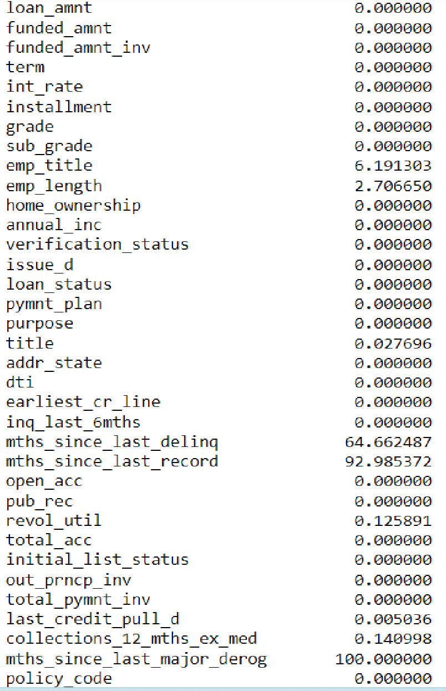

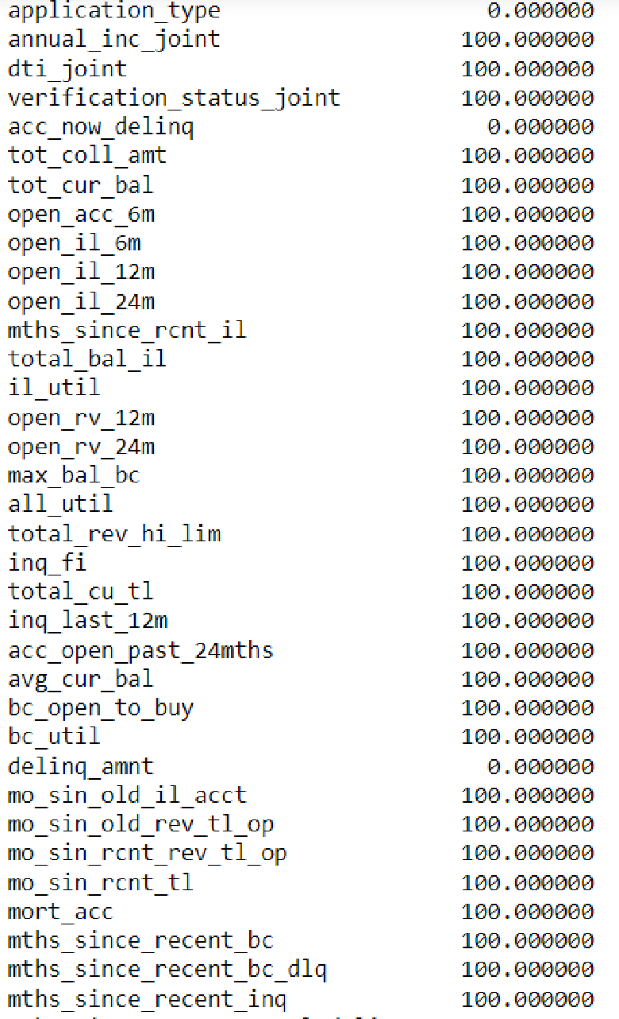

**After**

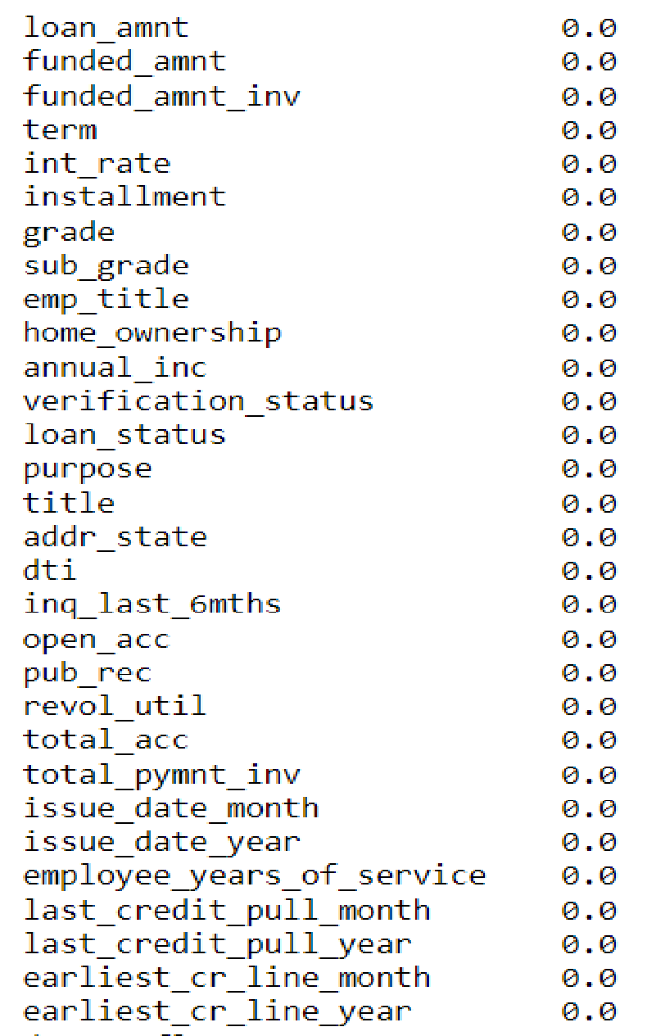

**Changing Datatypes:**

Changing the datatypes as required.

**Before:**

loan_amnt int64

funded_amnt int64

funded_amnt_inv float64

term object

int_rate object

installment float64

grade object

sub_grade object

emp_title object

emp_length object

home_ownership object

annual_inc float64

verification_status object

issue_d object

loan_status object

pymnt_plan object

purpose object

title object

addr_state object

dti float64

earliest_cr_line object

inq_last_6mths int64

open_acc int64

pub_rec int64

revol_util object

total_acc int64

initial_list_status object

out_prncp_inv float64

total_pymnt_inv float64

last_credit_pull_d object

collections_12_mths_ex_med float64

policy_code int64

application_type object

acc_now_delinq int64

delinq_amnt int64

tax_liens float64

**After:**

oan_amnt int64

funded_amnt int64

funded_amnt_inv float64

term int32

int_rate float64

installment float64

grade object

sub_grade object

emp_title object

home_ownership object

annual_inc float64

verification_status object

loan_status object

purpose object

title object

addr_state object

dti float64

inq_last_6mths int64

open_acc int64

revol_util float64

total_acc int64

total_pymnt_inv float64

issue_date_month int32

issue_date_year int32

employee_years_of_service float64

last_credit_pull_month Int64

last_credit_pull_year Int64

earliest_cr_line_month Int64

earliest_cr_line_year Int64

**UNIVARIATE & BIVARIATE ANALYSIS :**

**Analysis of Categorical Variables:**

In the below plots, each of the categorical variables are analysed individually**.**

**Loan Status:**

In the below plot, each distribution of the target variable is shown**.**

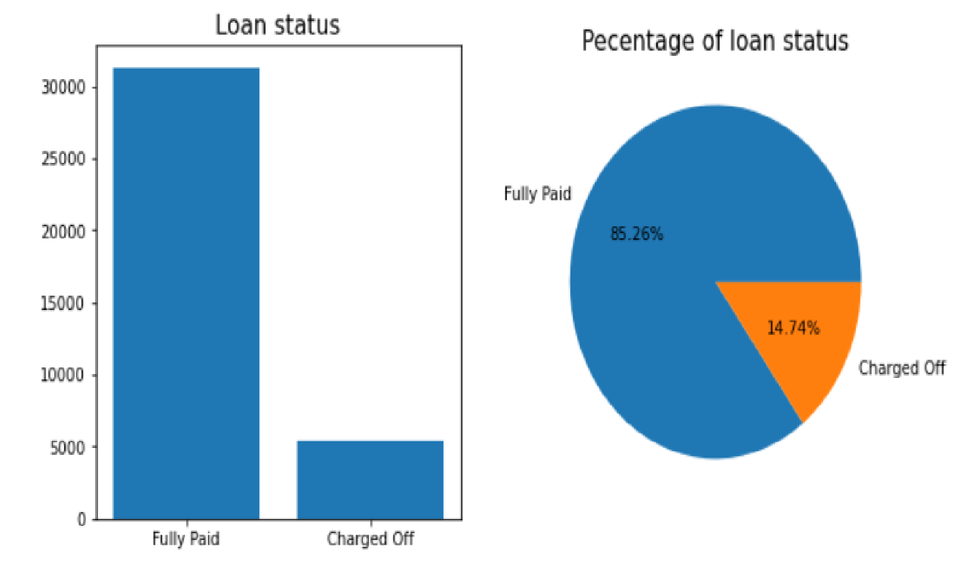

* From the above plot , we ca say that 14.46 % people are the loan defaulters.
* There are around 5232 people of total 36194 people who are loan defaulters.

**Loan Purpose:**

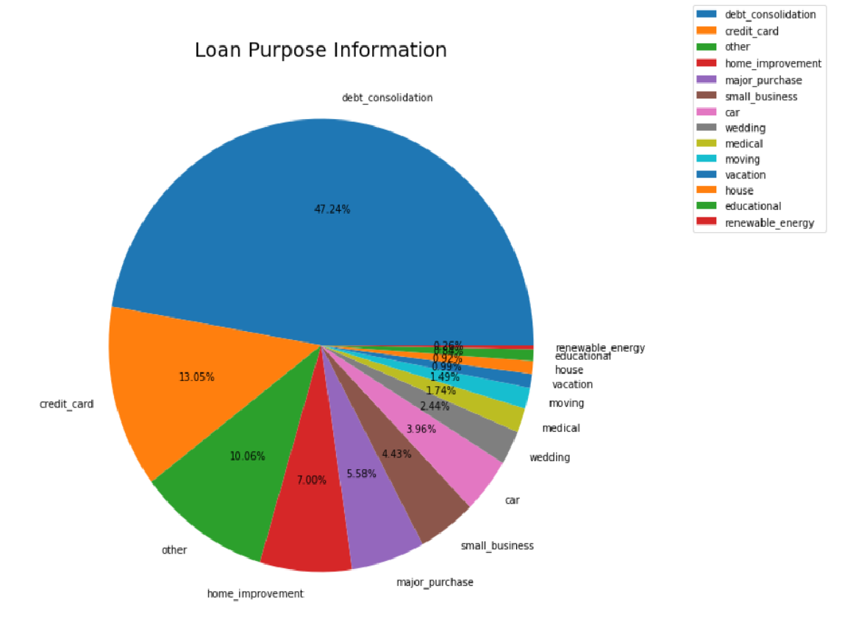

**Loan Defaulters:**

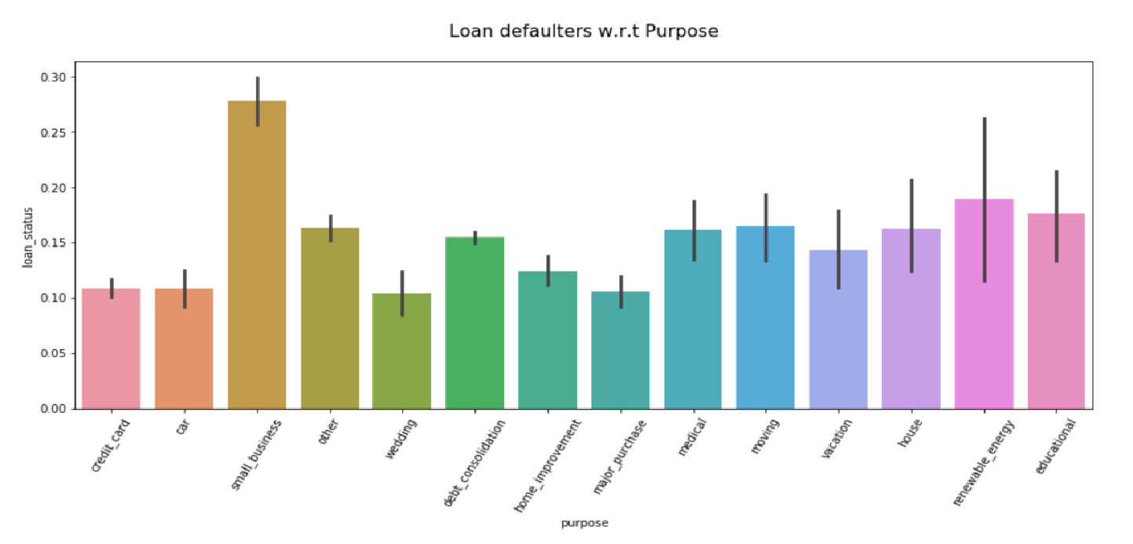

* Loans are taken for majority for debt consolidation, Other,Home improvement , major purchase & small buisiness purpose.
* From the bar plot, we can observe that the probability of persong being loan defaulter is more in small buisiness, Defaulter rate is more when person take loan for small business purpose.
* Defaulter Rate will depend on the Purpose of the loan.

**Term:**

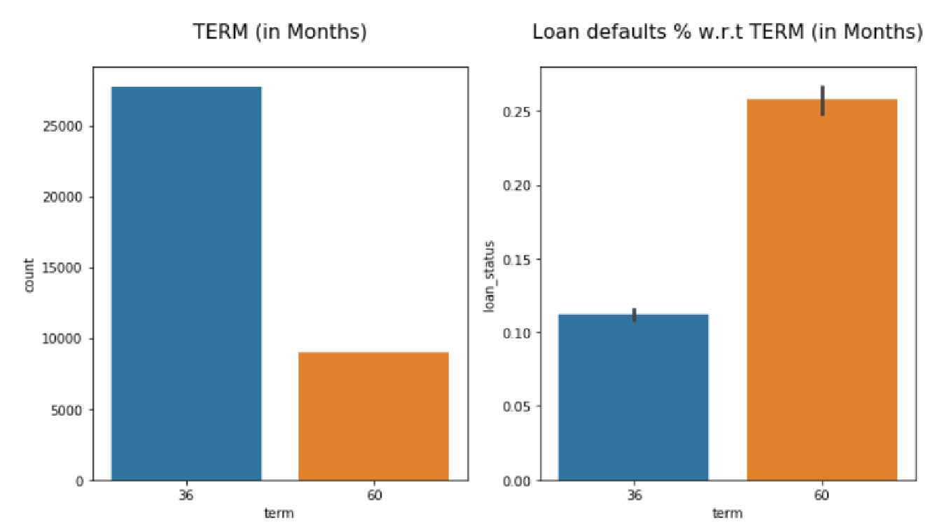

* In the givan dataset, we are having more number of people with term 36 months than 60 months.
* But The probability of loan getting defaulted is more for 60 months than 30 months.

**Grade:**

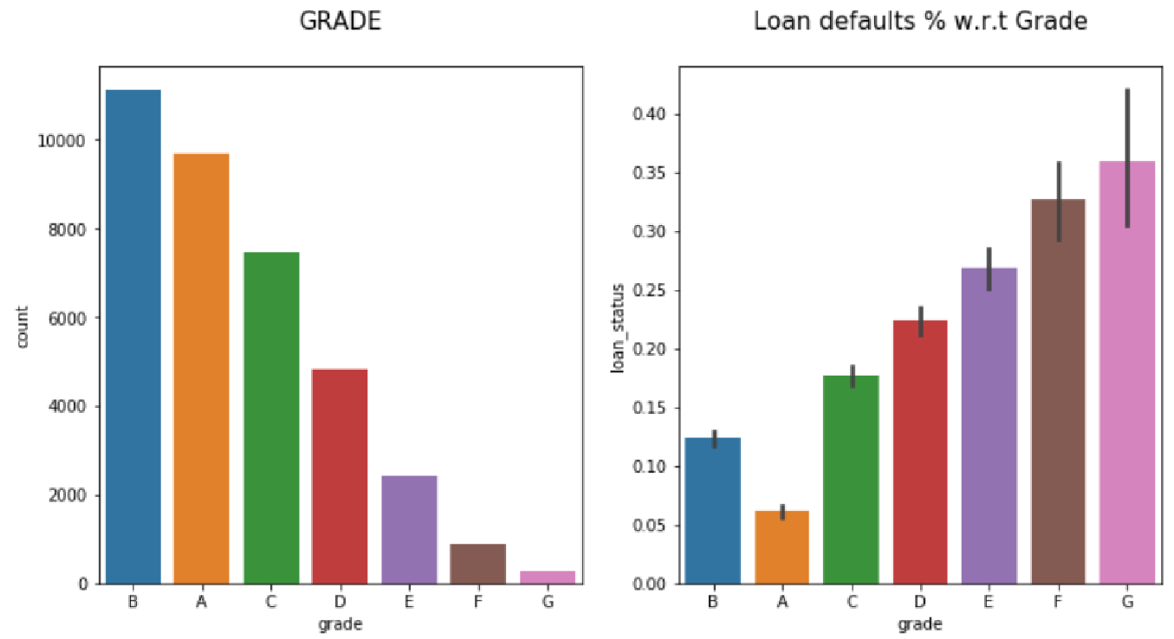

* There are more number of people with grade B.
* Defaulter rate is high with the grade G and less for grade A.

**Sub-Grade:**

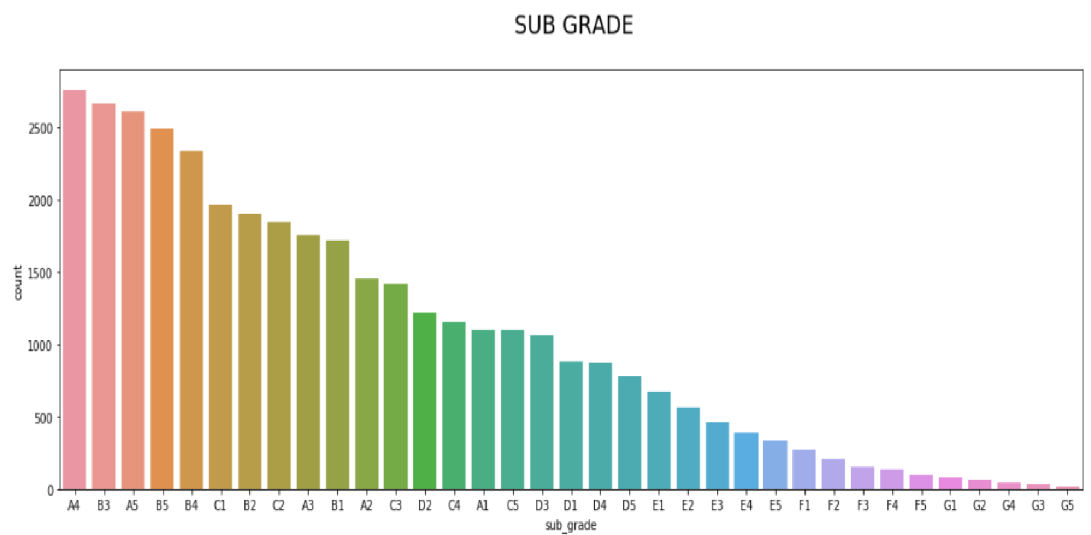

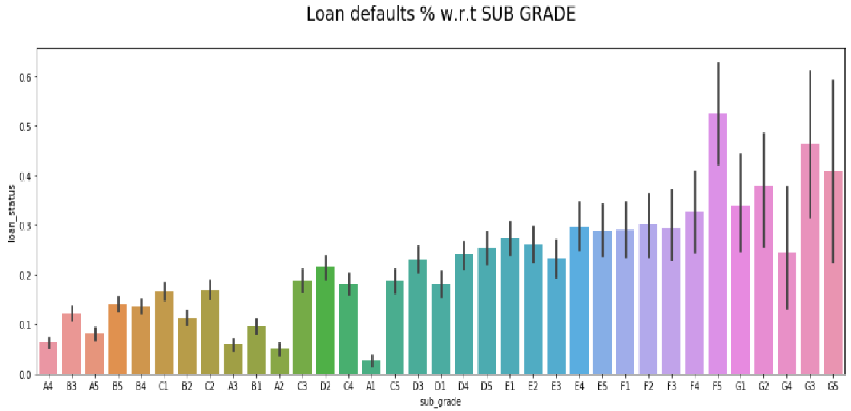

* There are more number of people with sub grade A4.
* Defaulter rate is increasing with the sub grade , loan defaulter rate is more for F5 grade and less for grade A1.
* Sub Grade is useful for further analysis.

**Home Ownership:**

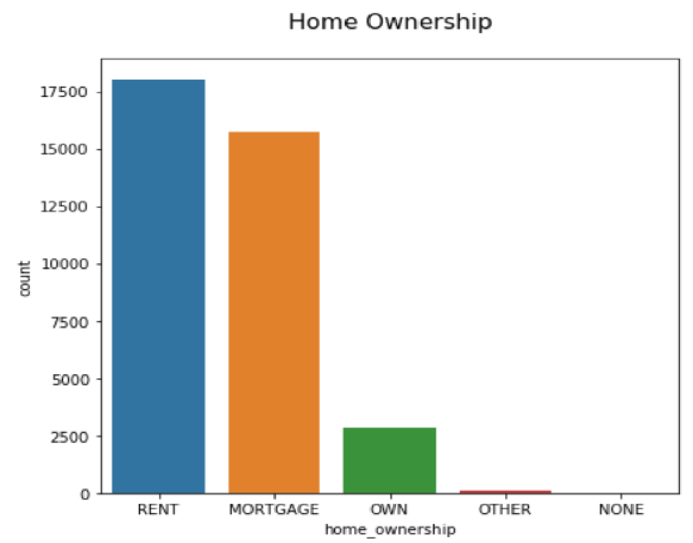

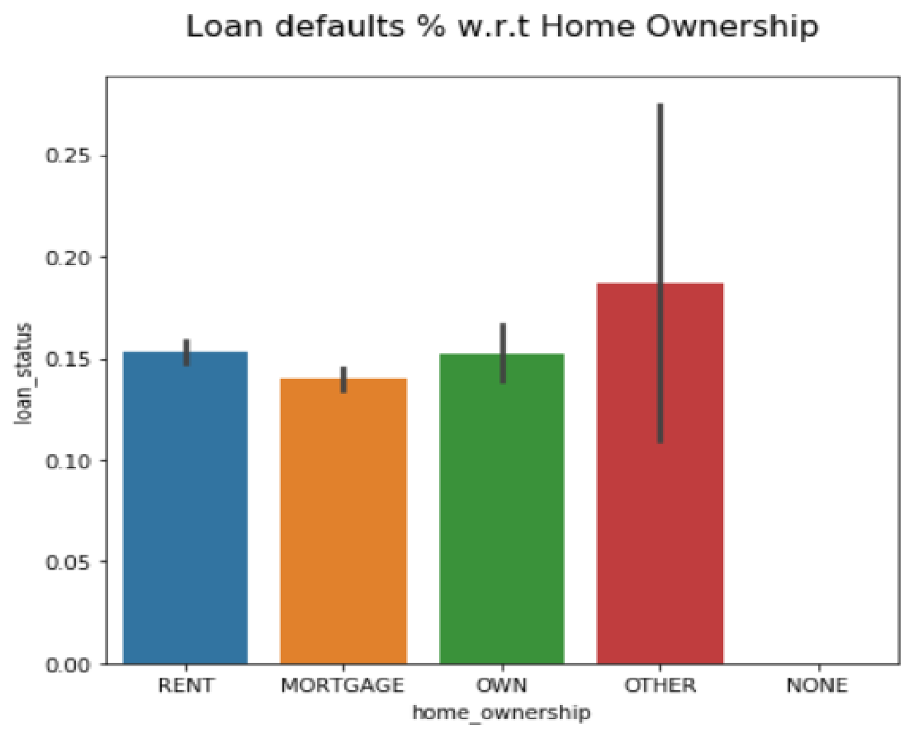

* Loan defaulter rate is almost constant for all the home ownerships, slightly more for OTHER home ownership.
* We can say that loan defaulters does not depends on home ownership.
* Home ownership is not useful for further analysis.

**Verification Status:**

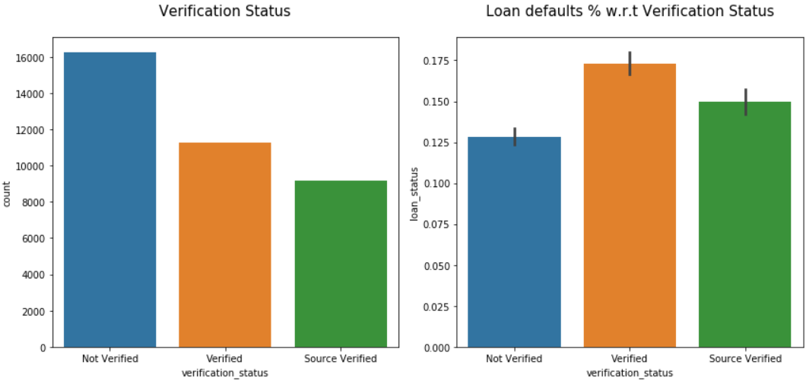

* In the given data ,There are more records for which the ststus is non verified.
* But the defaulter rate is more for verified status.

**Analysis of Numerical Variables:**

**Interest Rate:**

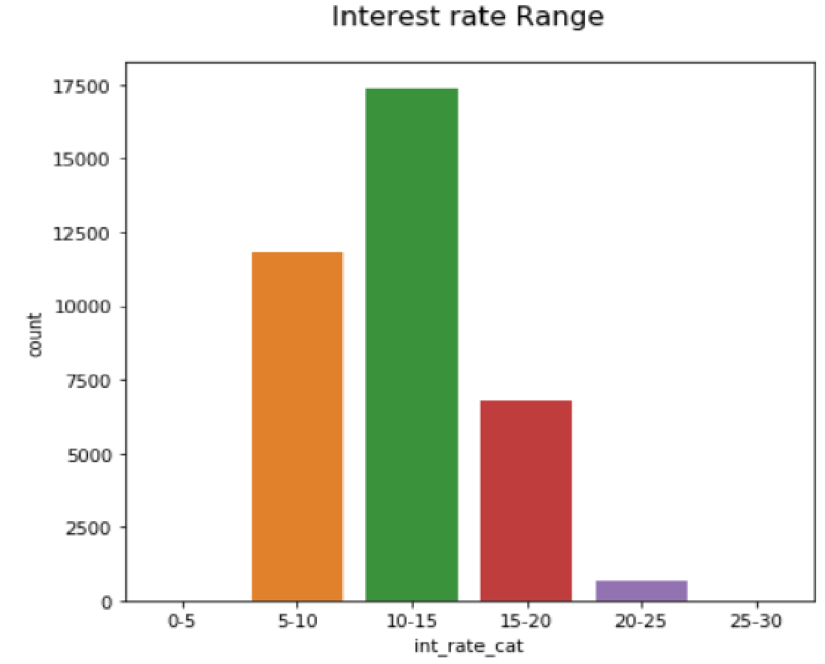

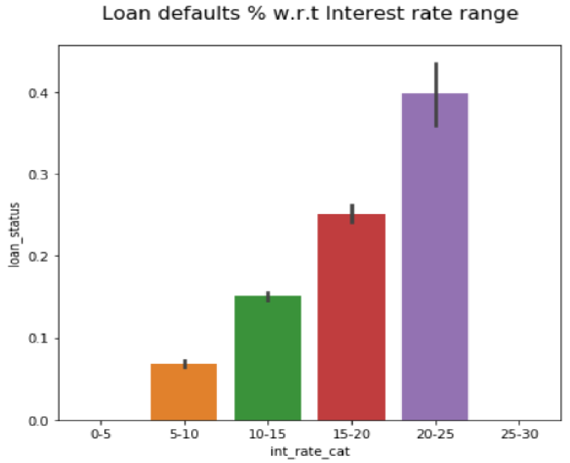

* There are more records with interest rate between 10-15%.
* The rate of loan defaulter is more for highest interest rate & less for lowest interest rate.

**Annual Income:**

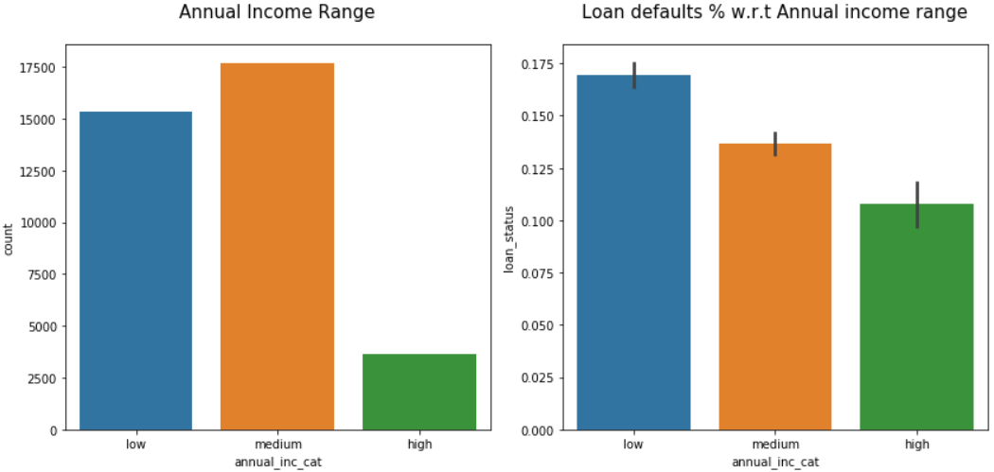

* Defaulter rate is increasing with the annual income value, defaulter rate will depend on loan amount.
* The annual income variable is useful for further analysis.

**Loan Amount:**

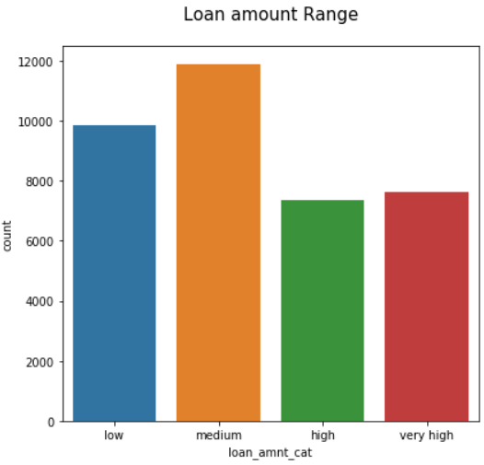

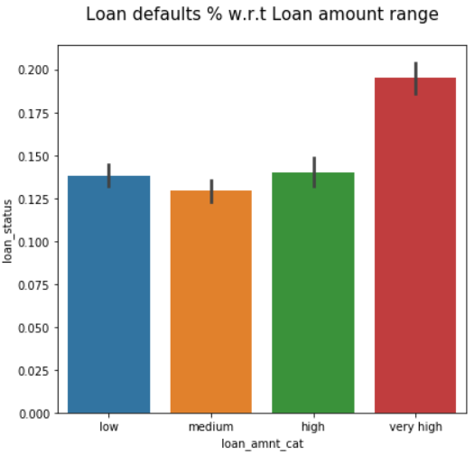

* Loan defaulter rate is increasing with loan amount range.
* This feature is useful for further analysis.

**Debt To Income Ratio:**

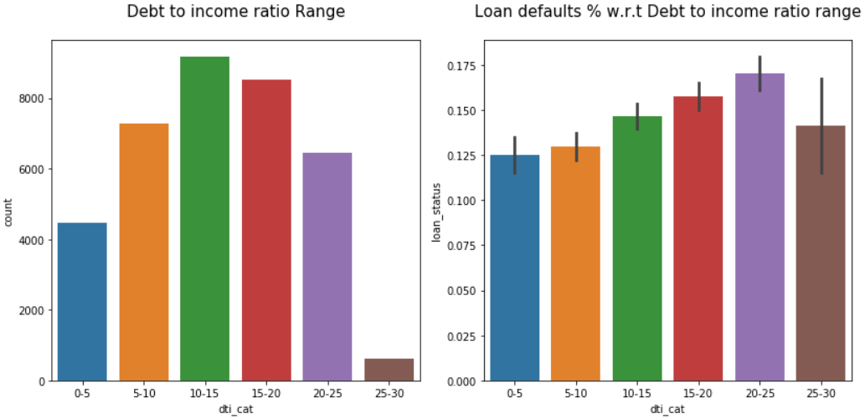

* Loan defaulter rate is increasing with the debt to income ratio.
* Debt to income ratio is useful for finding the loan defaulter.

**Revolving Line Utilisation Rate:**

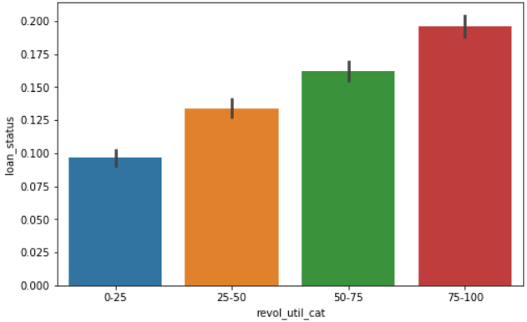

* Loan defaulter rate is increasing with the revolving line utilization rate.
* This is useful for finding the loan defaulter.

**Installments:**

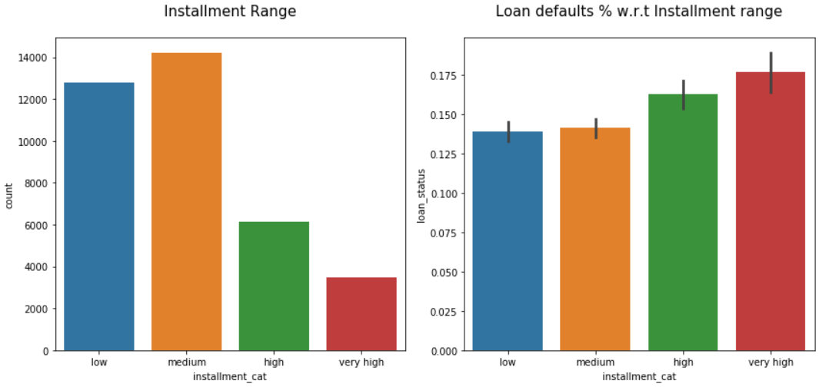

* Loan defaulter rate is increasing with the installment values.
* Dti is useful for finding the loan defaulter.

**Installments VS Loan Amount:**

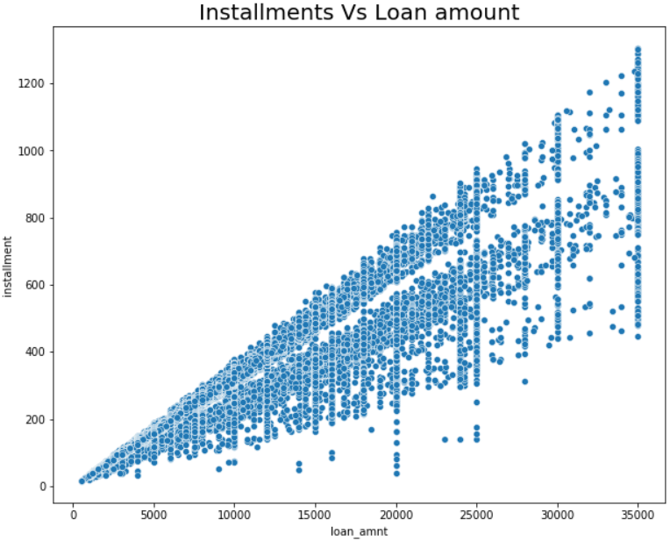

* It is obvious that if the loan amount is high, the installment amount will also be high.

**Annual Income VS Loan Amount:**

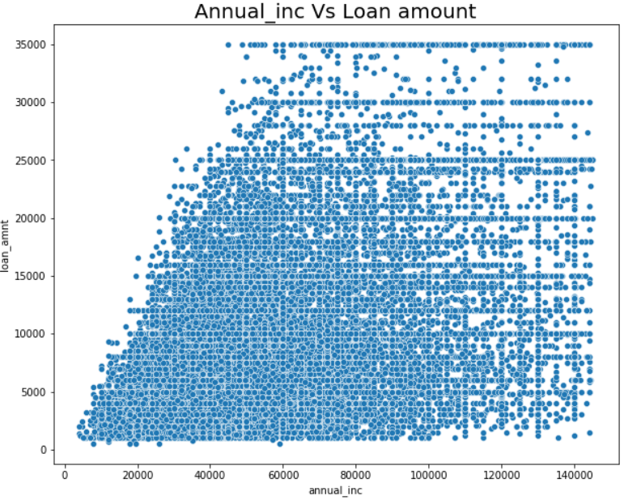

* People with annual income between 0 to 1,00,000 tend to apply more for loan.

**Loan Amount & Interest Rate:**

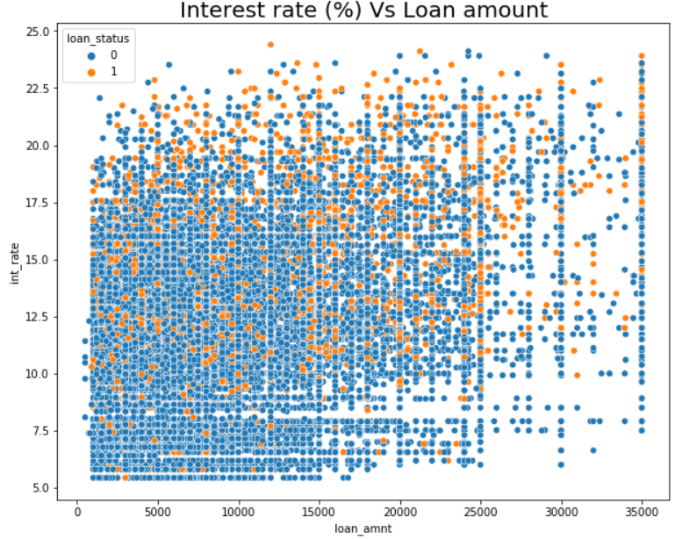

* Defaulters are present in all the amounts.

**MULTIVARIATE ANALYSIS :**

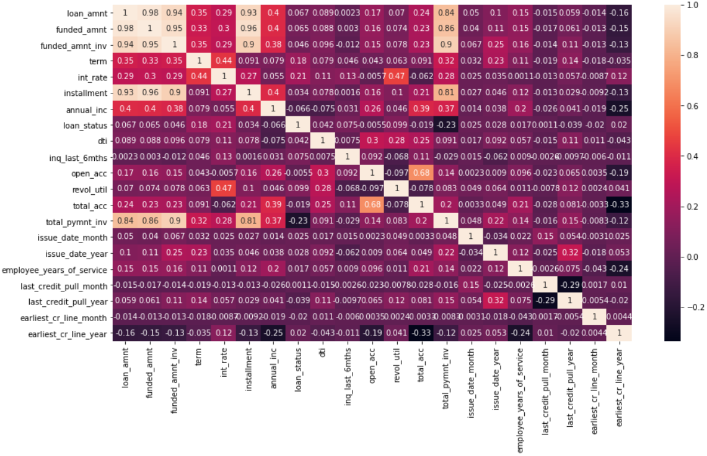

1. There is a strong correlation between loan amount and funded amount.
2. There is a strong correlation between loan amount and funded amount invested.
3. There is a strong correlation between loan amount and installment.
4. There is a strong correlation between installment and funded_amount,funded_amount_invested.
5. There is a strong correlation between total_pymnt_inv and total_amount,funded_amount , funded_amnt_inv.

**Pairplot:**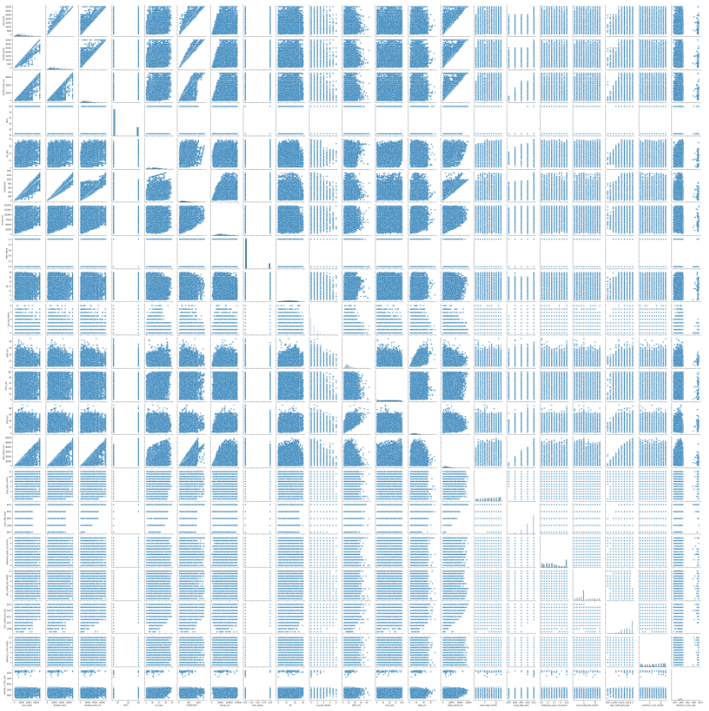

* The above pair plot shows the pairwise relationship between all the numerical variables.

**Model Building:**

**Assumptions Before Linear Regression (OLS):**

* Assumption on Dependent Variable: Target variable is numerical.
* Normality of target variable:
* It is apparent that the p-value is less than 0.05. So we have enough evidence to reject the null hypothesis.
* It can be concluded that the data is not normally distributed. So, we can do log transformation on the target variable.
* But first, the base model is built without log transformation.

**Train and Test data:**

The shape of X_train is: (133113, 72)

The shape of X_test is: (44371, 72)

The shape of y_train is: (133113,)

The shape of y_test is: (44371,)

**Assumptions for Logistic Regression:**

● The Output is a categorical variable which is ‘0’ and ‘1’.

● There is no multicollinearity in the data as we have checked for the correlation in heatmap and removed the columns that have an impact on multicollinearity. (treated accordingly beforehand)

**Logistic Regression:**

● We have used a logistic regression function in python LogisticRegression().

● We have fit and trained the model on the train dataset and checked the performance score of the train data.

**Training Data Performance:**

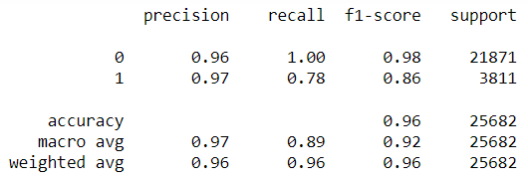

**F1 score : 0.8619**

**Test Data Performance:**

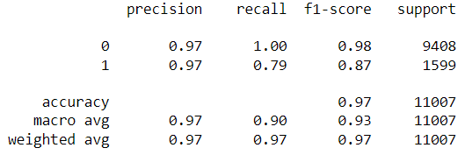

● As the next step we have predicted the values for the test dataset and checked the performance metrics to check for overfitting or underfitting.

**Auc: 0.8954163396127681**

**Recall: 0.7948717948717948**

**Precision: 0.970970206264324**

**f1_score: 0.87414030261348**

**Accuracy: 0.9667484328154811**

● The model is performing well on the train as well as the test data and it is neither overfitting nor underfitting.

● Using the f1_score function, we have got an f1_score of 0.87.

● The scores can further be improved by selecting the features using different techniques.

● The scores can be checked and compared against different supervised learning models.

**ROC-AUC Curve:**

We plotted the receiver operating characteristic(roc) curve for our model and we can see that our model is able to distinguish between positive and negative class data. And out AUC is also high.

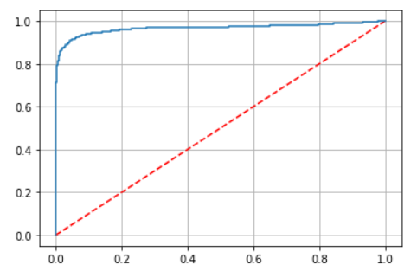

**Decision Tree:**

Applying decision tree classifier to the dataset.

**Train Data Performance:**

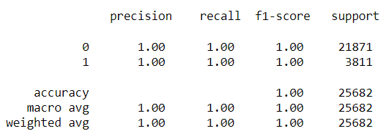

**F1 score : 1.0**

**Test Data Performance:**

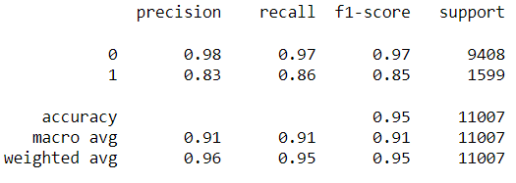

**F1 score of 0.8511.**

Overfitting can be seen in the model.

As compared to the previous model the F1 score has reduced a little from 0.87 to 0.85.

The mean of 10 fold cross validation for this model is 0.94.

To improve the decision tree based model, GridSearchCV was applied to obtain the best parameters. These parameters were then passed in the decision tree classifier to obtain the following results:

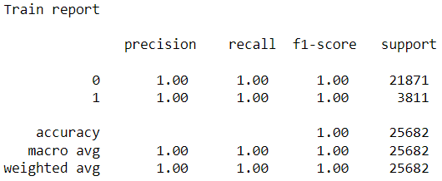

**F1 score: 1.0**

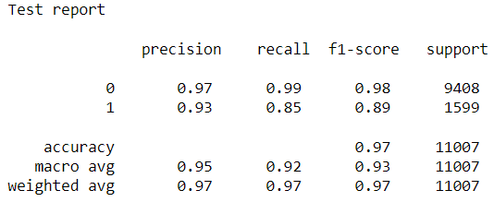

**F1 score: 0.88765**

Clearly overfitting can still be seen.

The mean of 10 fold cross validation for this model is 0.968. So, the mean of the cross validation score has increased by 2%.

Recall has increased by quite a margin as compared to the base (Logistic Regression) model.

**Ridge Classifier:**

**Train Data Performance:**

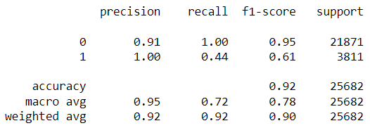

**Test Data Performance:**

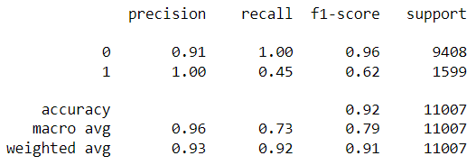

**Ridge Classifier CV:**

RidgeClassifierCV was used to give multiple alpha values, in the range 0 to 1, as an input to get the best value of alpha. The best alpha value was then used on the train and test data.

**Train Data Performance:**

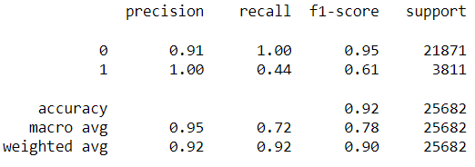

**Test Data Performance:**

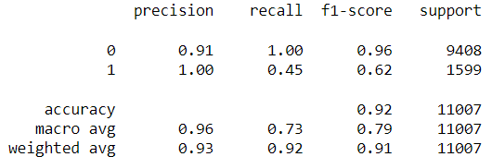

**K-Nearest Neighbors(KNN):**

KNN was applied to the dataset after scaling the attributes.

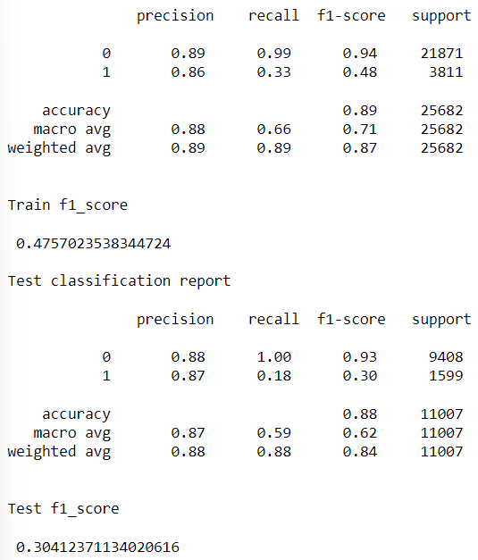

To improve the KNN base model, GridSearchCV was applied to obtain the best parameters. These parameters were then passed in KNN classifier to obtain the following results:

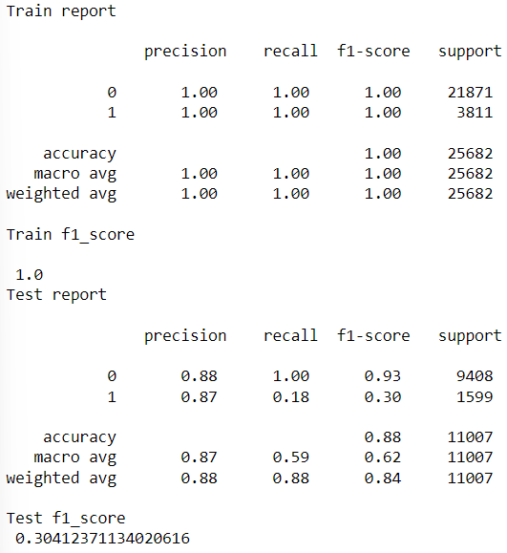

Grid search on KNN has led to the overfitting of data.

**Random Forest :**

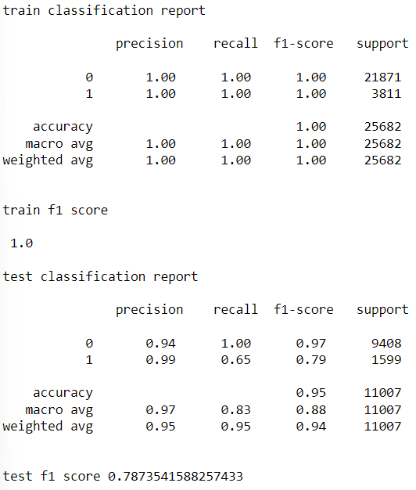

Overfitting can be seen here.

**Model Comparisons:**

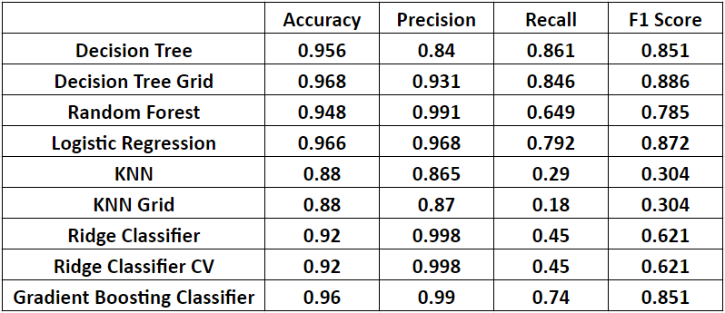

**Conclusion:**

To summarize our project, we can say that we have successfully created an efficient model which will determine whether a loan will be defaulted or not based on the bare minimum number of strong constraints.

We compared the results of our dataset by fitting on 8 models which included Logistic Regression, Decision Tree Classifier, Grid Search using Decision Tree, Ridge Classifier, KNN, Grid Search using KNN, Random Forest Classifier and Gradient Boosting.

Of these models except for Logistic Regression, Ridge Classifier, KNN and Gradient Boosting in all other models overfitting was observed. However, though KNN was not overfitting, it had a low recall and F1 score.

Among Logistic regression, Ridge classifier and Gradient boosting, Logistic regression returned the best results overall and hence we finalised it as our final model.

|  |  |
| --- | --- |
|  |  |