S20230010225

DBMS Lab assignment 3

Create table customer

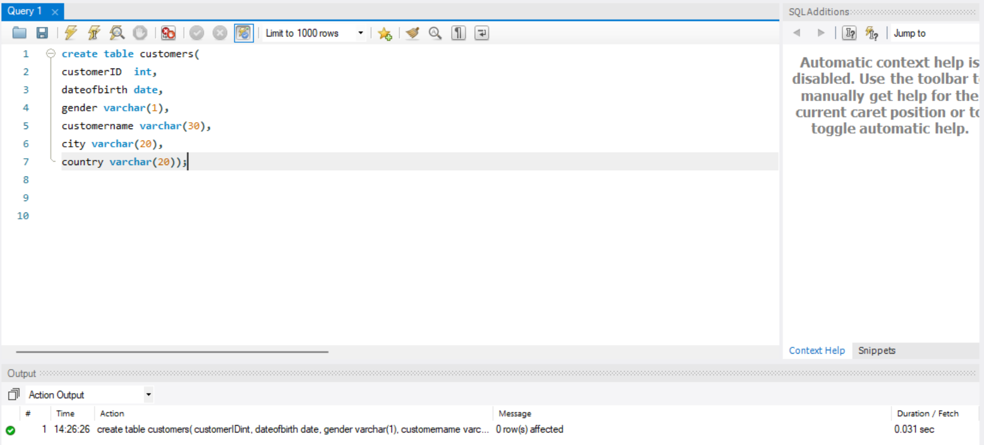

Create table products

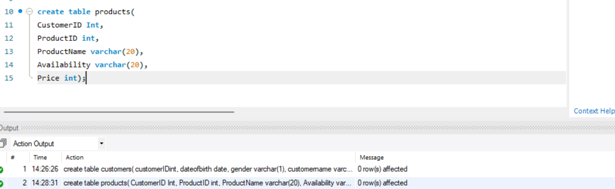

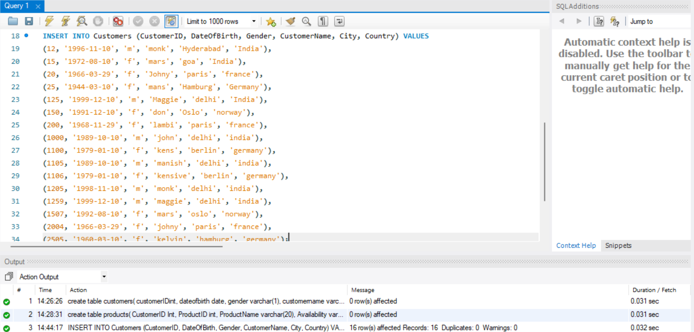

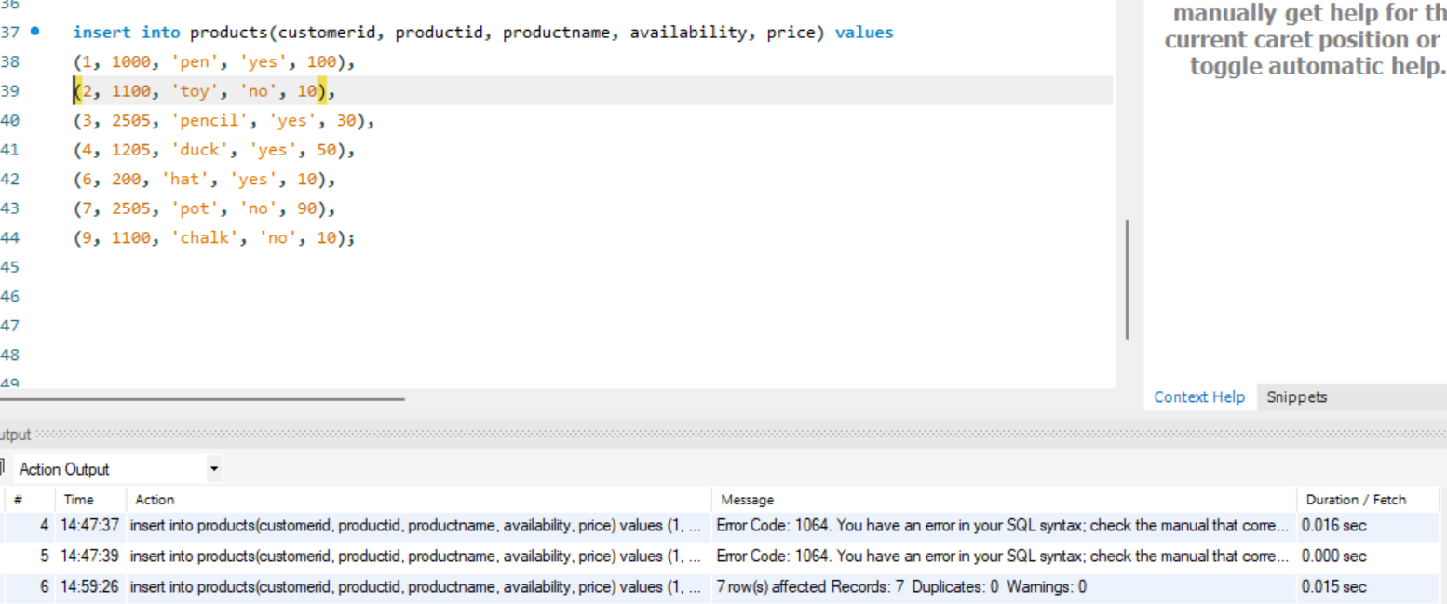

Inserting data into tables(above)

Q1-Q20

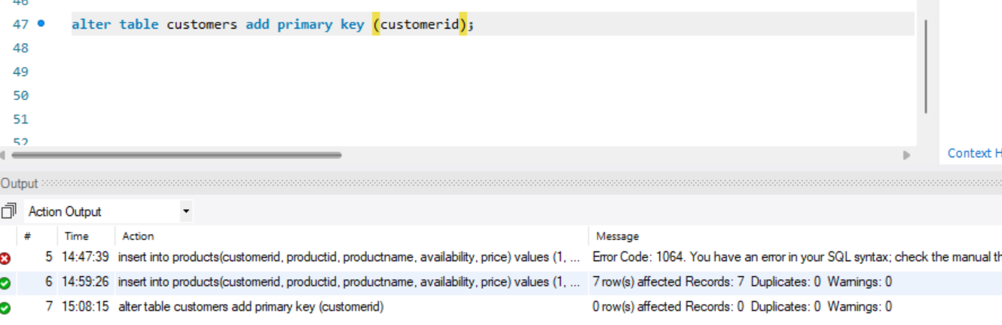

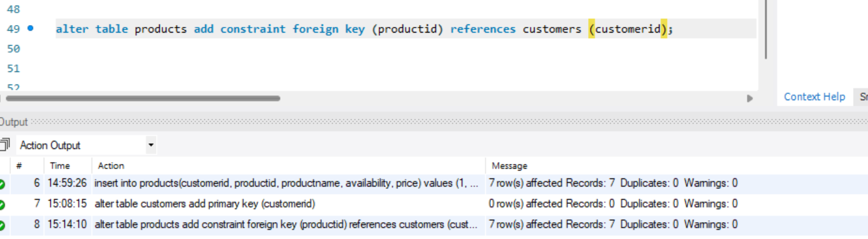

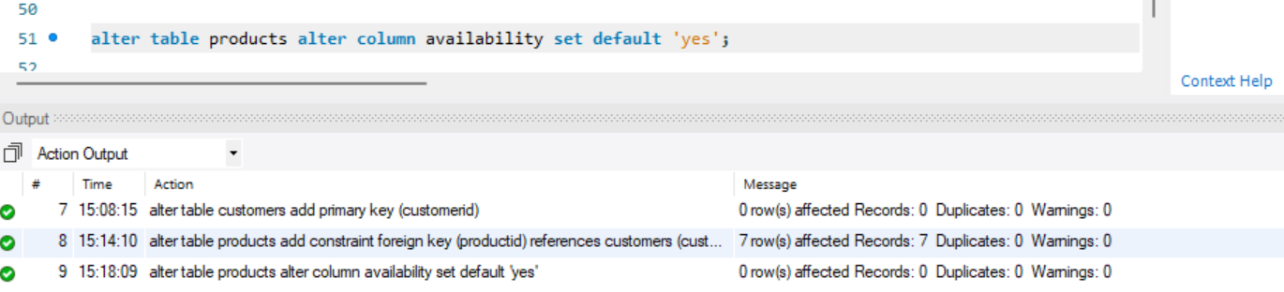

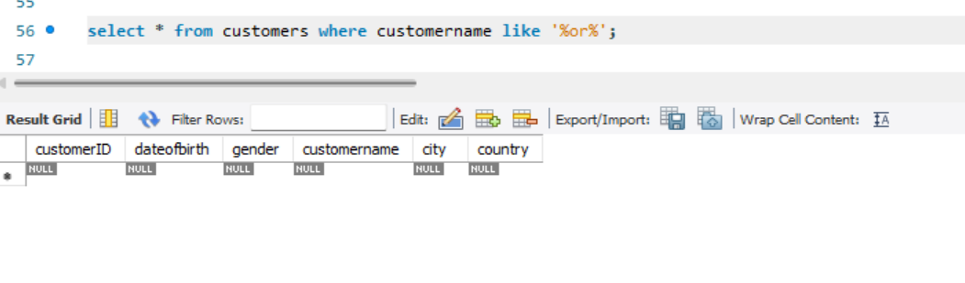

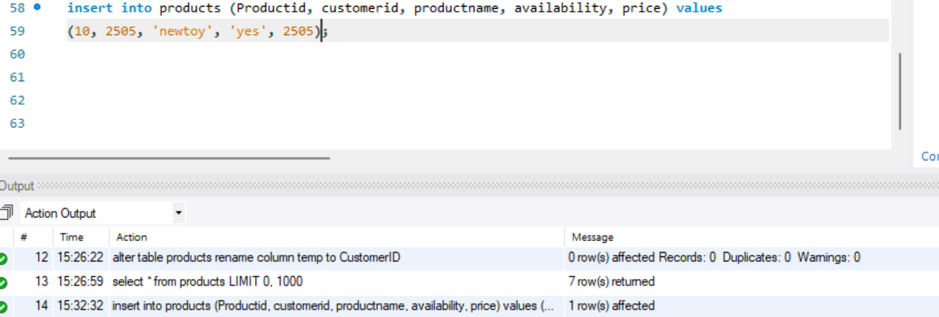

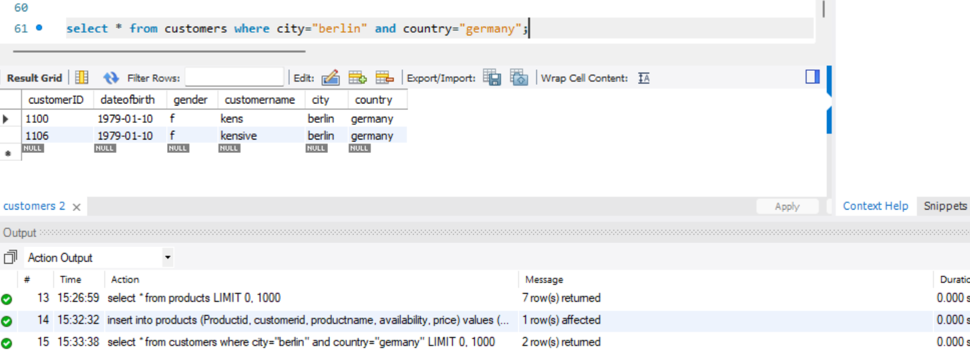

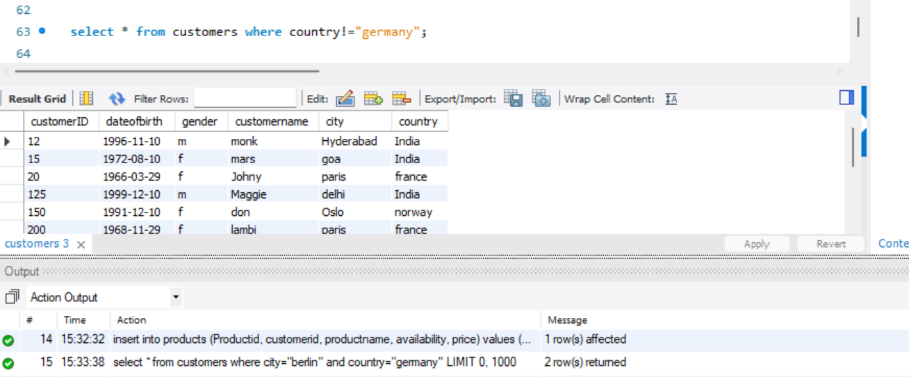

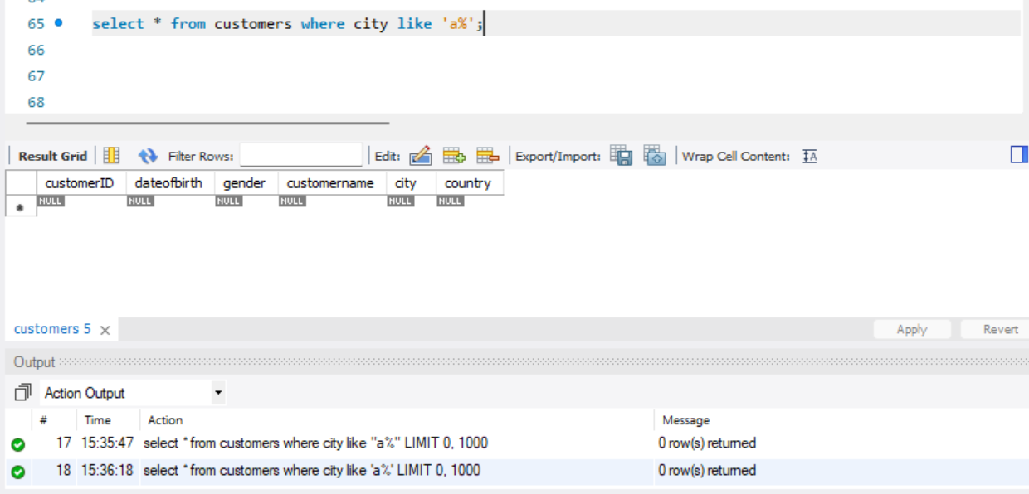

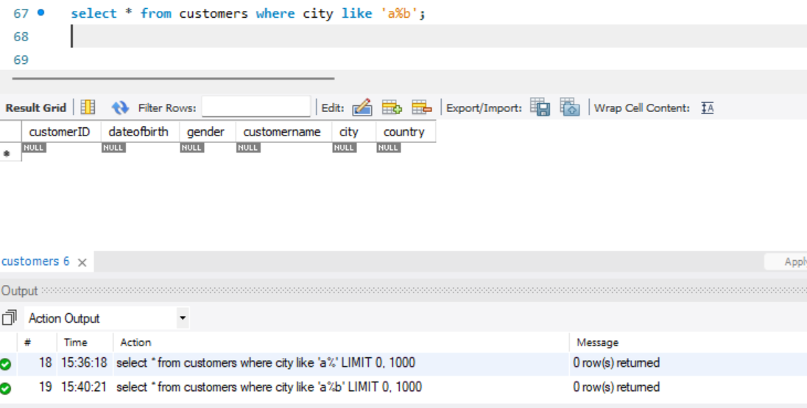

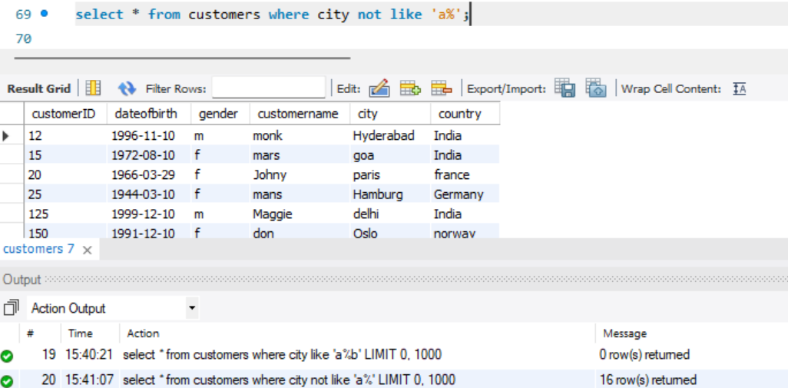

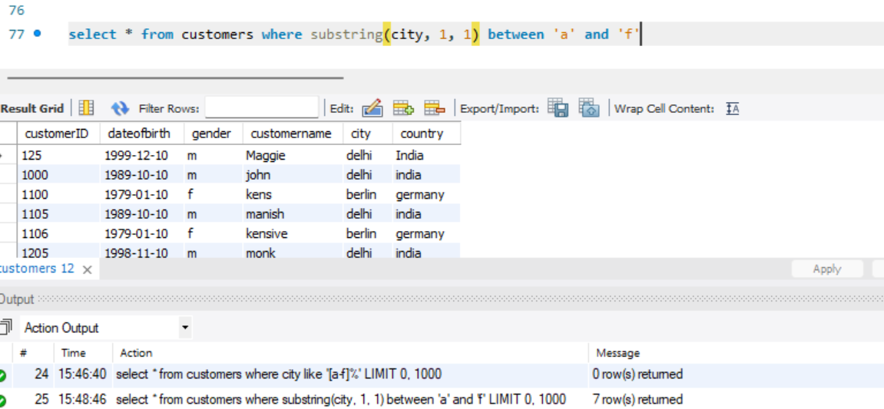

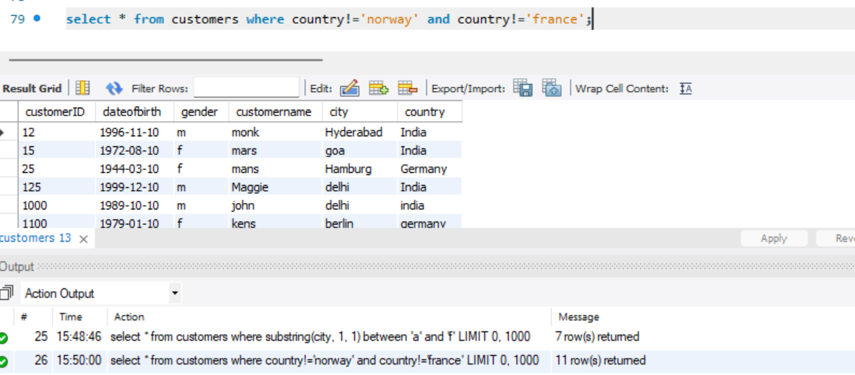

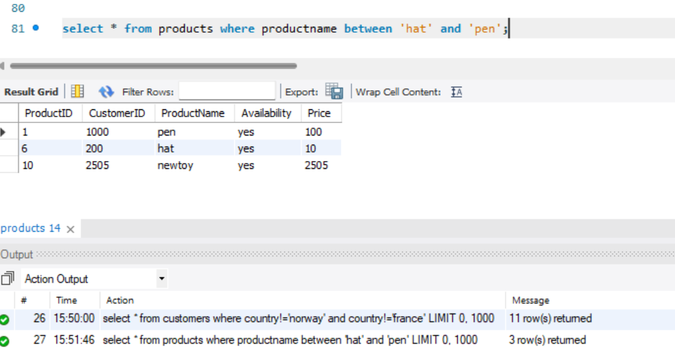

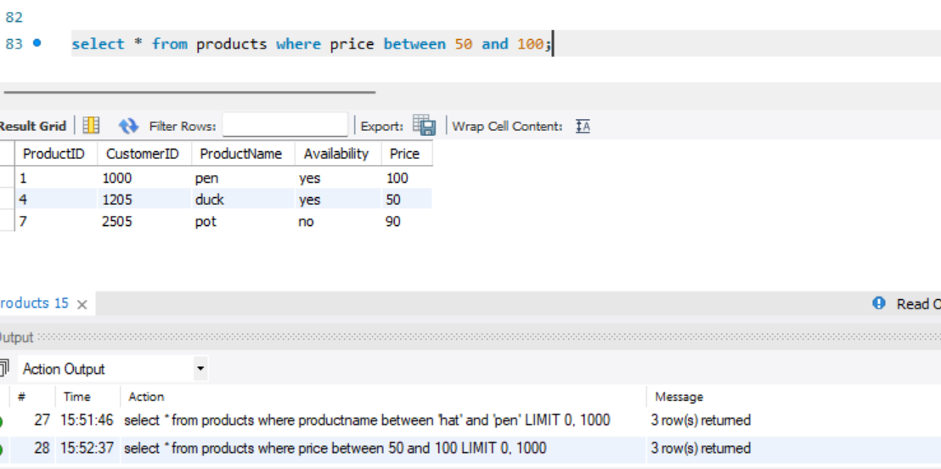

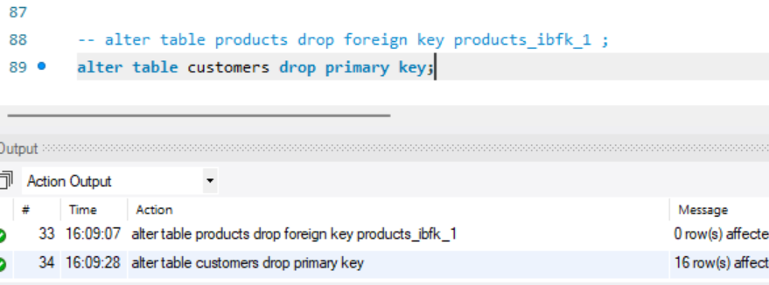

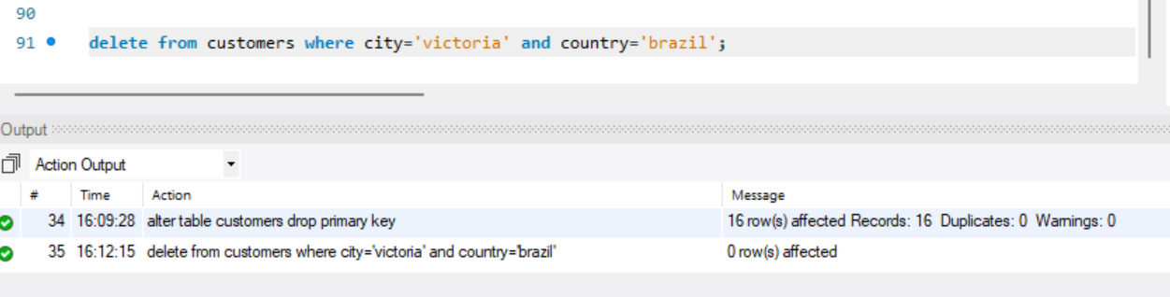

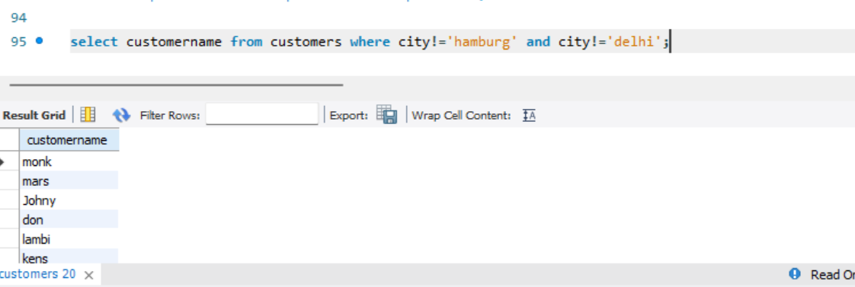

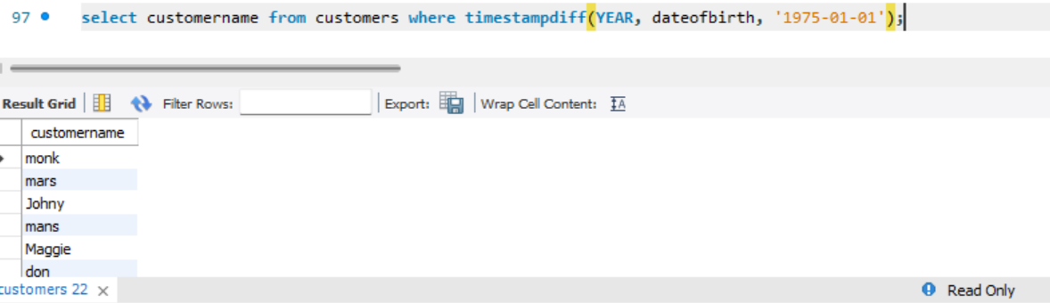

MY MYSQL CODE FOR THE ABOVE QUESTIONS:

create table customers(

customerID int,

dateofbirth date,

gender varchar(1),

customername varchar(30),

city varchar(20),

country varchar(20));

create table products(

CustomerID Int,

ProductID int,

ProductName varchar(20),

Availability varchar(20),

Price int);

INSERT INTO Customers (CustomerID, DateOfBirth, Gender, CustomerName, City, Country) VALUES

(12, '1996-11-10', 'm', 'monk', 'Hyderabad', 'India'),

(15, '1972-08-10', 'f', 'mars', 'goa', 'India'),

(20, '1966-03-29', 'f', 'Johny', 'paris', 'france'),

(25, '1944-03-10', 'f', 'mans', 'Hamburg', 'Germany'),

(125, '1999-12-10', 'm', 'Maggie', 'delhi', 'India'),

(150, '1991-12-10', 'f', 'don', 'Oslo', 'norway'),

(200, '1968-11-29', 'f', 'lambi', 'paris', 'france'),

(1000, '1989-10-10', 'm', 'john', 'delhi', 'india'),

(1100, '1979-01-10', 'f', 'kens', 'berlin', 'germany'),

(1105, '1989-10-10', 'm', 'manish', 'delhi', 'india'),

(1106, '1979-01-10', 'f', 'kensive', 'berlin', 'germany'),

(1205, '1998-11-10', 'm', 'monk', 'delhi', 'india'),

(1259, '1999-12-10', 'm', 'maggie', 'delhi', 'india'),

(1507, '1992-08-10', 'f', 'mars', 'oslo', 'norway'),

(2004, '1966-03-29', 'f', 'johny', 'paris', 'france'),

(2505, '1960-03-10', 'f', 'kelvin', 'hamburg', 'germany');

insert into products(customerid, productid, productname, availability, price) values

(1, 1000, 'pen', 'yes', 100),

(2, 1100, 'toy', 'no', 10),

(3, 2505, 'pencil', 'yes', 30),

(4, 1205, 'duck', 'yes', 50),

(6, 200, 'hat', 'yes', 10),

(7, 2505, 'pot', 'no', 90),

(9, 1100, 'chalk', 'no', 10);

alter table customers add primary key (customerid);

alter table products add constraint foreign key (productid) references customers (customerid);

alter table products rename column ProductID to temp;

alter table products rename column CustomerID to ProductID;

alter table products rename column temp to CustomerID;

select * from products;

select * from customers where customername like '%or%';

alter table products alter column availability set default 'yes';

insert into products (Productid, customerid, productname, availability, price) values

(10, 2505, 'newtoy', 'yes', 2505);

select * from customers where city="berlin" and country="germany";

select * from customers where country!="germany";

select * from customers where city like 'a%';

select * from customers where city like 'a%b';

select * from customers where city not like 'a%';

select * from customers where city like 'a%' or city like 'c%' or city like 's%';

select * from customers where substring(city, 1, 1) between 'a' and 'f'

select * from customers where country!='norway' and country!='france';

select * from products where productname between 'hat' and 'pen';

select * from products where price between 50 and 100;

select CONSTRAINT_NAME from INFORMATION_SCHEMA.TABLE_CONSTRAINTS WHERE TABLE_NAME='products';

alter table products drop foreign key products_ibfk_1 ;

alter table customers drop primary key;

delete from customers where city='victoria' and country='brazil';

select productname from products where price<=50;

select customername from customers where city!='hamburg' and city!='delhi';

select * from customers;

select customername from customers where timestampdiff(YEAR, dateofbirth, '1975-01-01');