S20230010225 DBMS

LAB 5 SCREENSHOTS

Create tables for practice problems

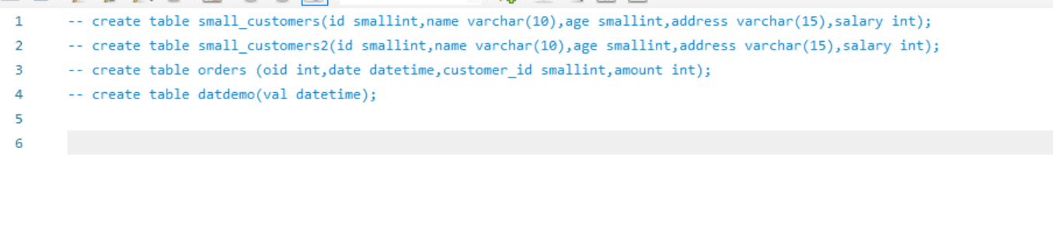

PG1 Q1

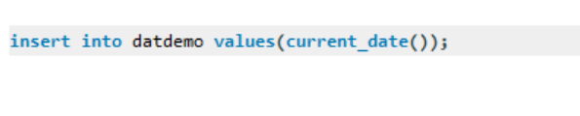

PG1 Q2

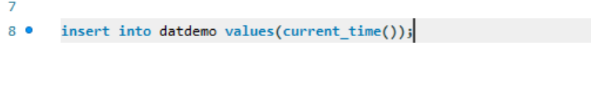

PG1 Q3

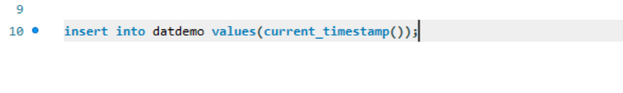

PG1 Q4

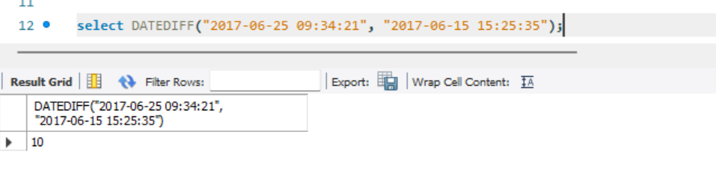

PG1 Q5

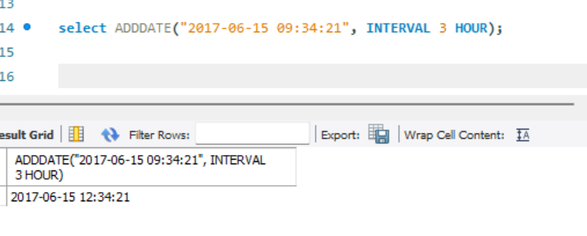

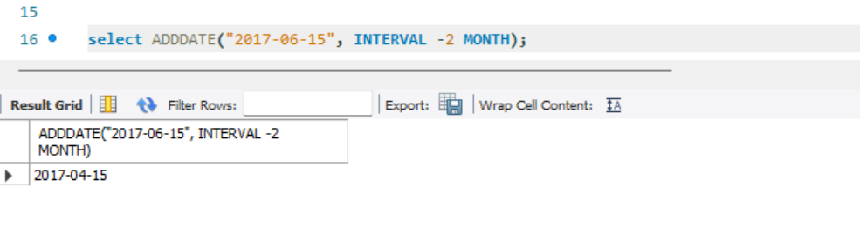PG 1 Q6

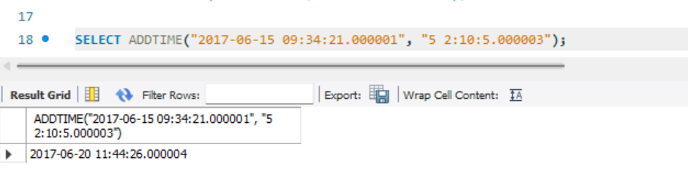

All questions on page 1 are finished

PG3 Q1

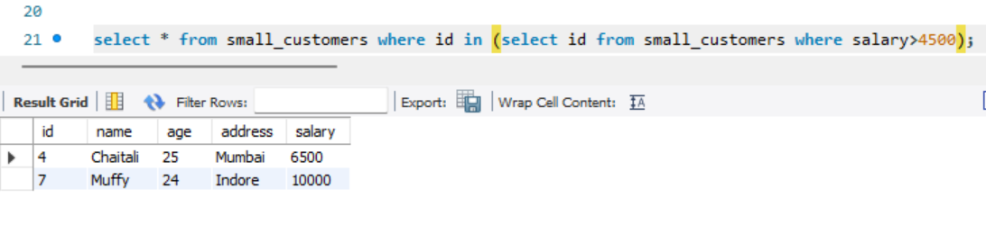

Pg3 q2



PG3 q3



PG3 Q4

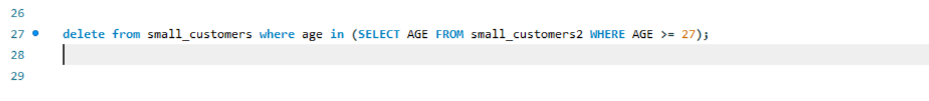

PG4 Q1

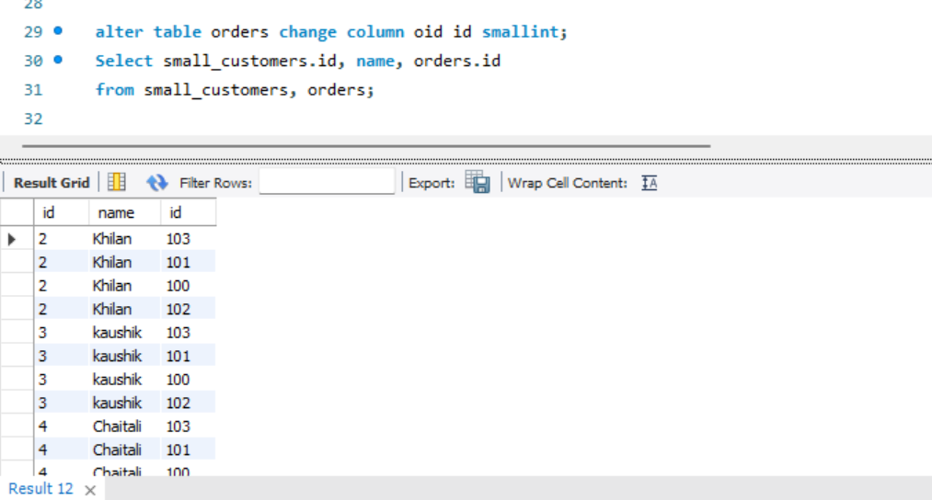

PG4 Q2

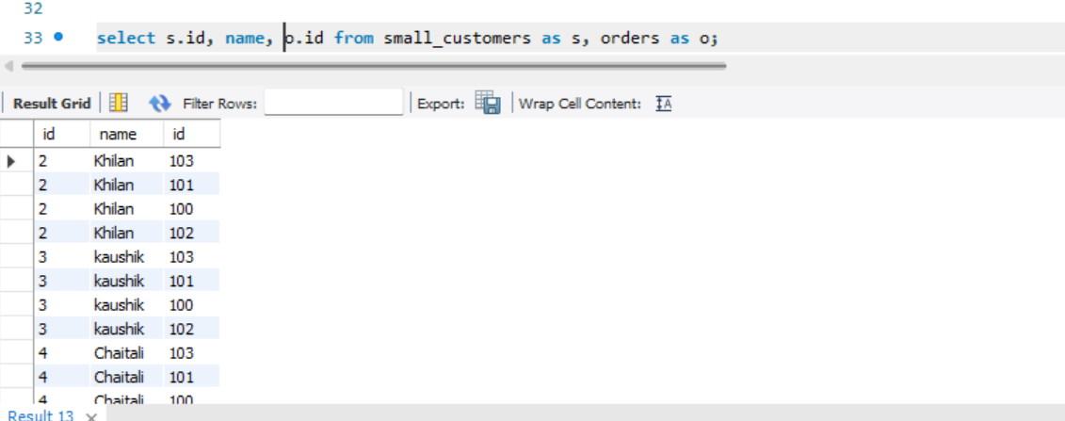

PG4 Q3

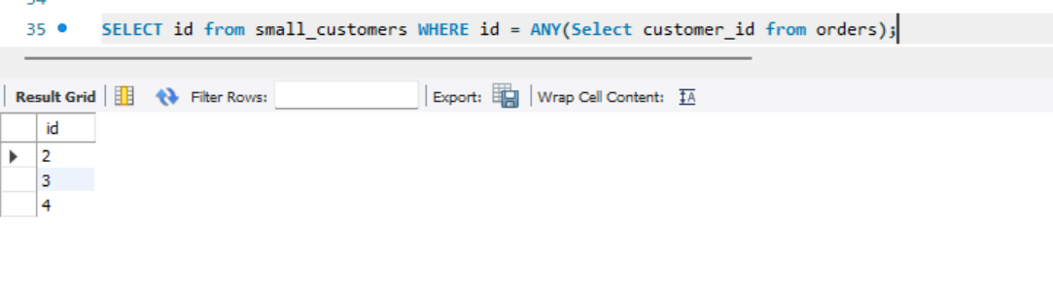

Test for empty relations:

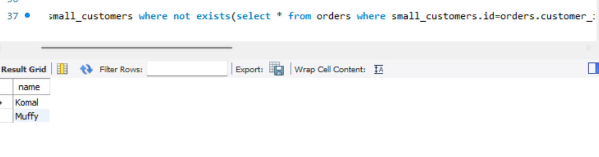

Joins:

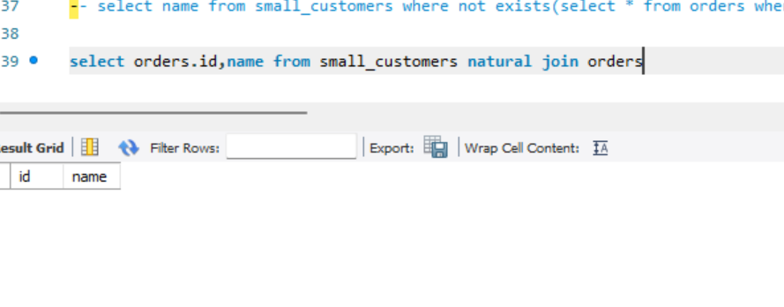

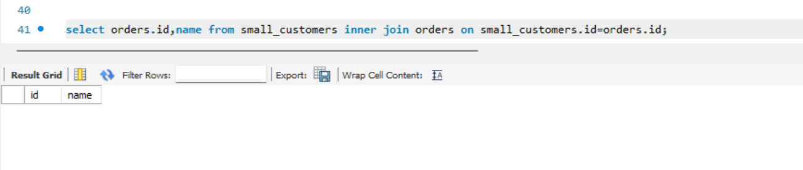

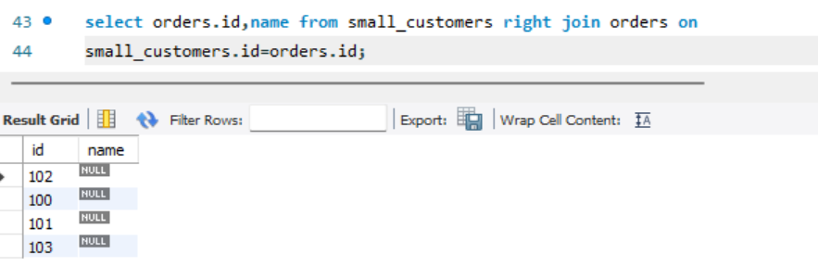

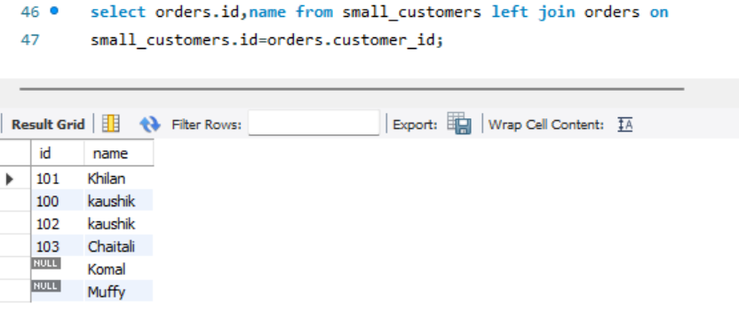

# Questions:

Q1

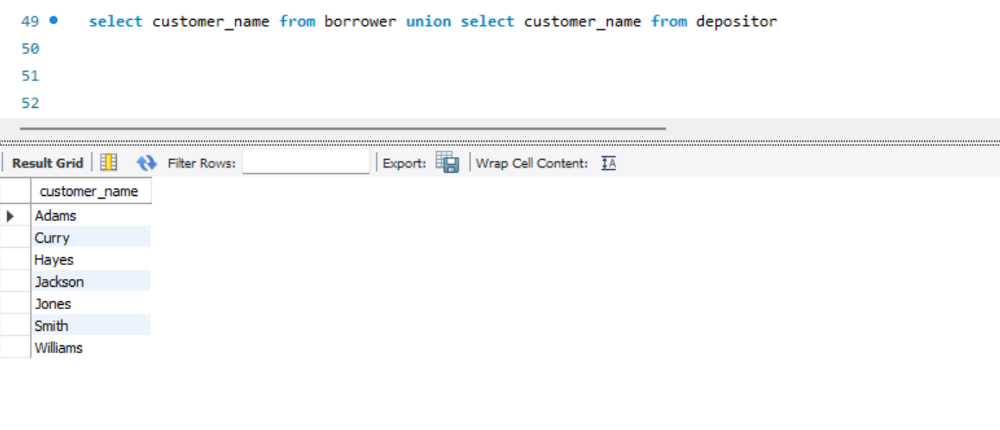

Q2

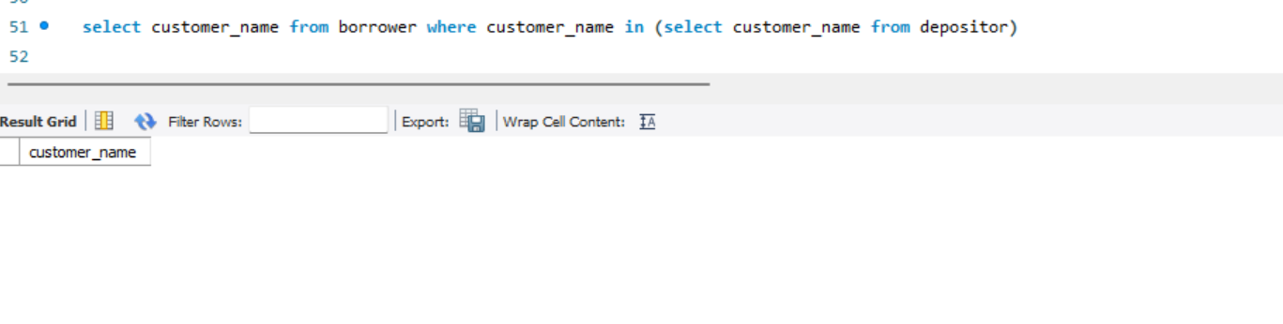

Q3

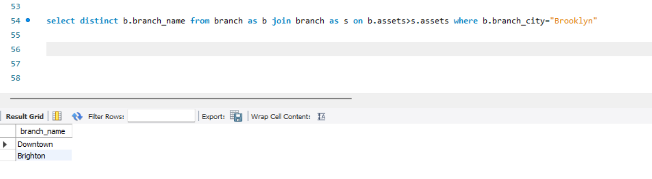

Q4

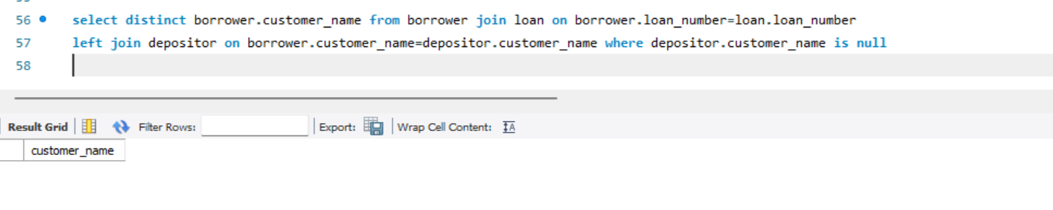

Q5

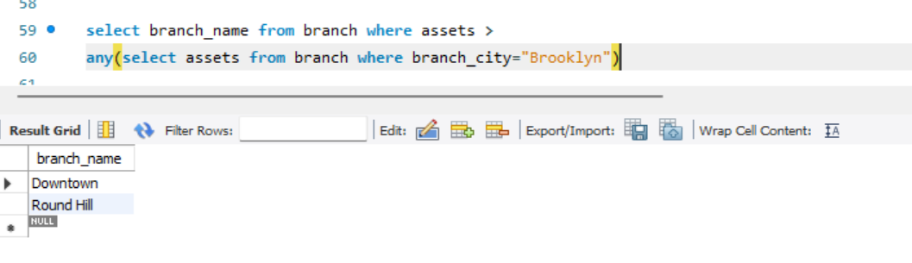

Q6

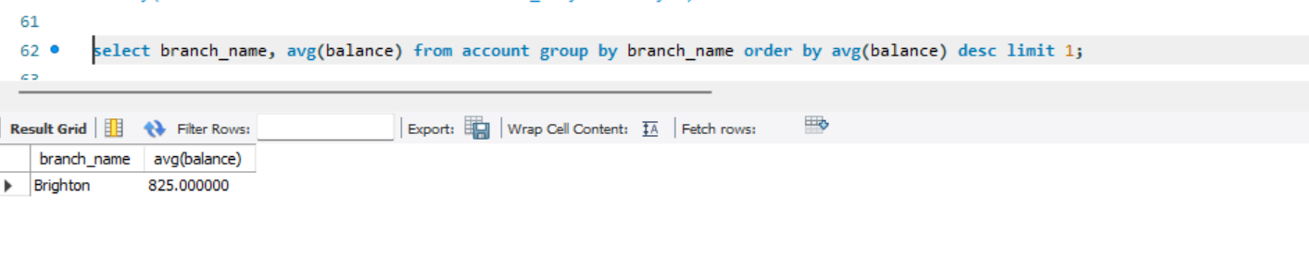

Q7

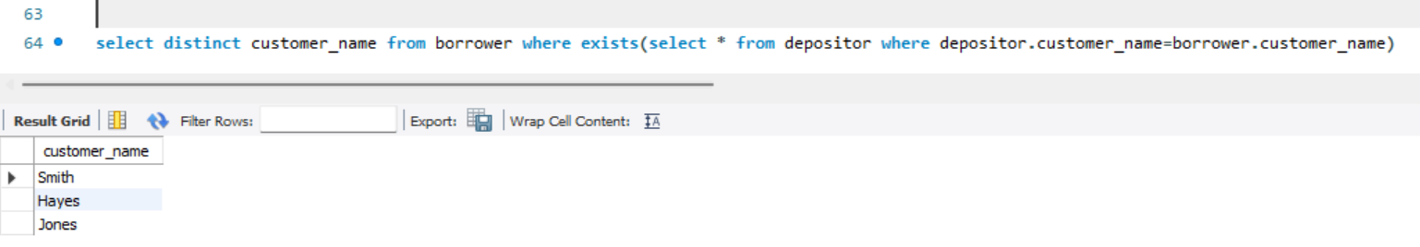

Q8

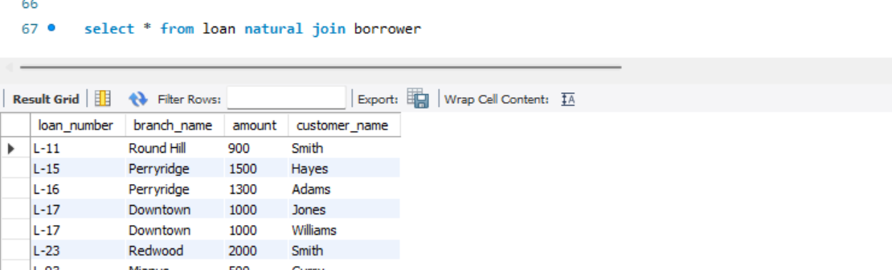

Q9

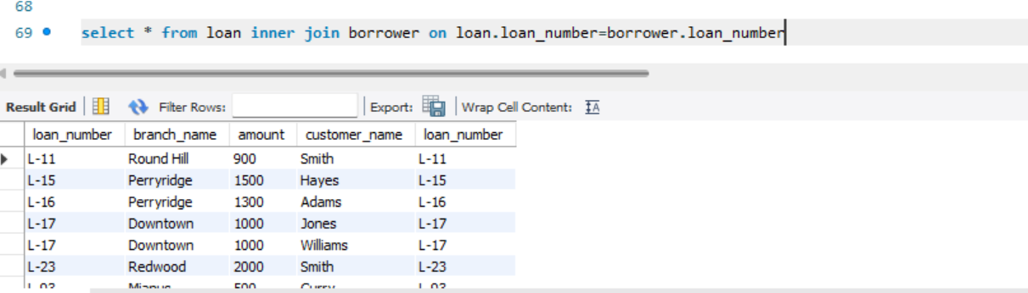

Q10

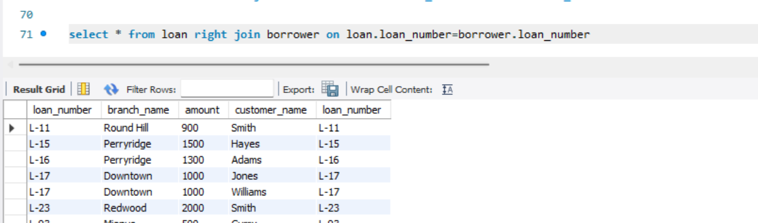

Q11

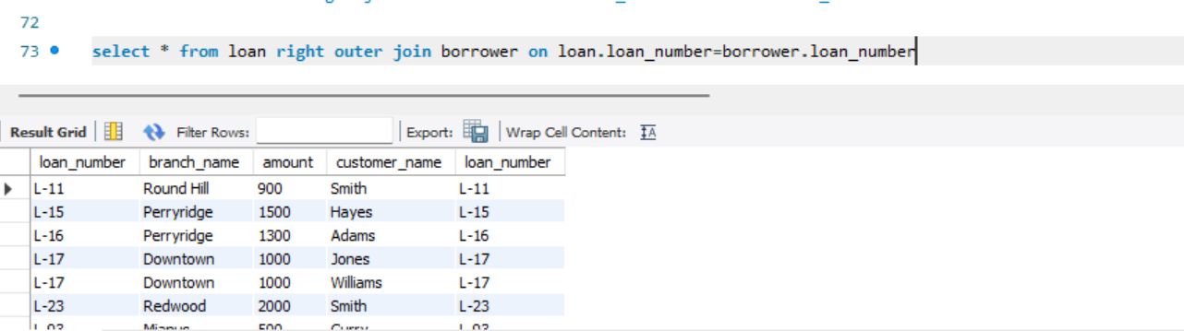

Q12

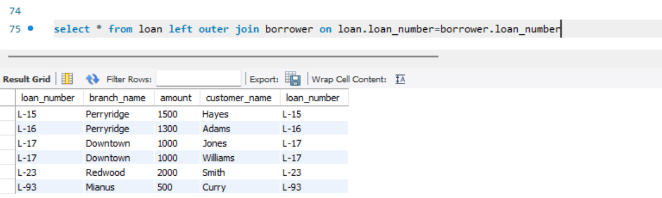

Q13

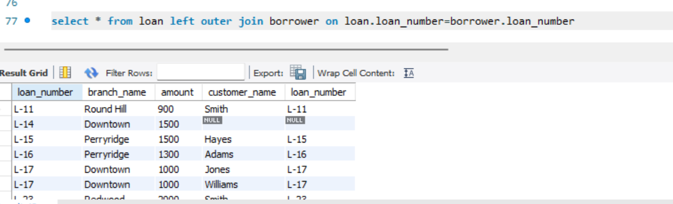

Q14

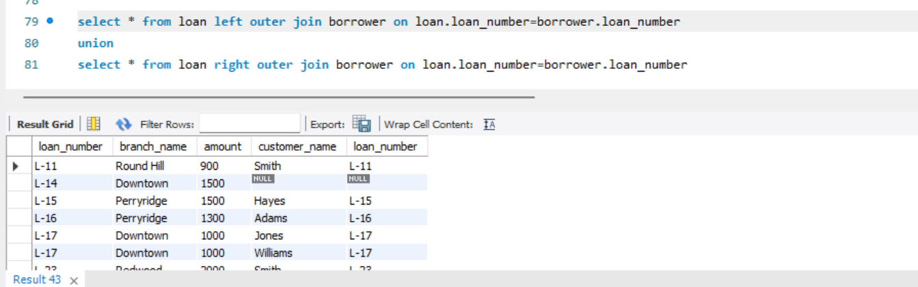

SQL QUERY: Please uncomment each query before running:

-- create table small_customers(id smallint,name varchar(10),age smallint,address varchar(15),salary int);

-- create table small_customers2(id smallint,name varchar(10),age smallint,address varchar(15),salary int);

-- create table orders (oid int,date datetime,customer_id smallint,amount int);

-- create table datdemo(val datetime);

-- insert into datdemo values(current_date());

-- insert into datdemo values(current_time());

-- insert into datdemo values(current_timestamp());

-- select DATEDIFF("2017-06-25 09:34:21", "2017-06-15 15:25:35");

-- select ADDDATE("2017-06-15 09:34:21", INTERVAL 3 HOUR);

-- select ADDDATE("2017-06-15", INTERVAL -2 MONTH);

-- SELECT ADDTIME("2017-06-15 09:34:21.000001", "5 2:10:5.000003");

-- select * from small_customers where id in (select id from small_customers where salary>4500);

-- insert into small_customers2 select * from small_customers where id in (select id from small_customers);

-- update small_customers set SALARY = SALARY * 0.25 where age in (select age from small_customers2 WHERE age >= 27);

-- delete from small_customers where age in (SELECT AGE FROM small_customers2 WHERE AGE >= 27);

-- alter table orders change column oid id smallint;

-- Select small_customers.id, name, orders.id

-- from small_customers, orders;

-- select s.id, name, o.id from small_customers as s, orders as o;

-- SELECT id from small_customers WHERE id = ANY(Select customer_id from orders);

-- select name from small_customers where not exists(select * from orders where small_customers.id=orders.customer_id)

-- select orders.id,name from small_customers natural join orders

-- select orders.id,name from small_customers inner join orders on small_customers.id=orders.id;

-- select orders.id,name from small_customers right join orders on

-- small_customers.id=orders.id;

-- select orders.id,name from small_customers left join orders on

-- small_customers.id=orders.customer_id;

-- select customer_name from borrower union select customer_name from depositor

-- select customer_name from borrower where customer_name in (select customer_name from depositor)

-- select distinct b.branch_name from branch as b join branch as s on b.assets>s.assets where b.branch_city="Brooklyn"

-- select distinct borrower.customer_name from borrower join loan on borrower.loan_number=loan.loan_number

-- left join depositor on borrower.customer_name=depositor.customer_name where depositor.customer_name is null

-- select branch_name from branch where assets >

-- any(select assets from branch where branch_city="Brooklyn")

-- select branch_name, avg(balance) from account group by branch_name order by avg(balance) desc limit 1;

-- select distinct customer_name from borrower where exists(select * from depositor where depositor.customer_name=borrower.customer_name)

-- select * from loan natural join borrower

-- select * from loan inner join borrower on loan.loan_number=borrower.loan_number

-- select * from loan right join borrower on loan.loan_number=borrower.loan_number

-- select * from loan right outer join borrower on loan.loan_number=borrower.loan_number

-- select * from loan left outer join borrower on loan.loan_number=borrower.loan_number

-- select * from loan left outer join borrower on loan.loan_number=borrower.loan_number

-- select * from loan left outer join borrower on loan.loan_number=borrower.loan_number

-- union

-- select * from loan right outer join borrower on loan.loan_number=borrower.loan_number