S20230010225 LAB6(DBMS)

## Scerenshots and queries

Derived tables 1

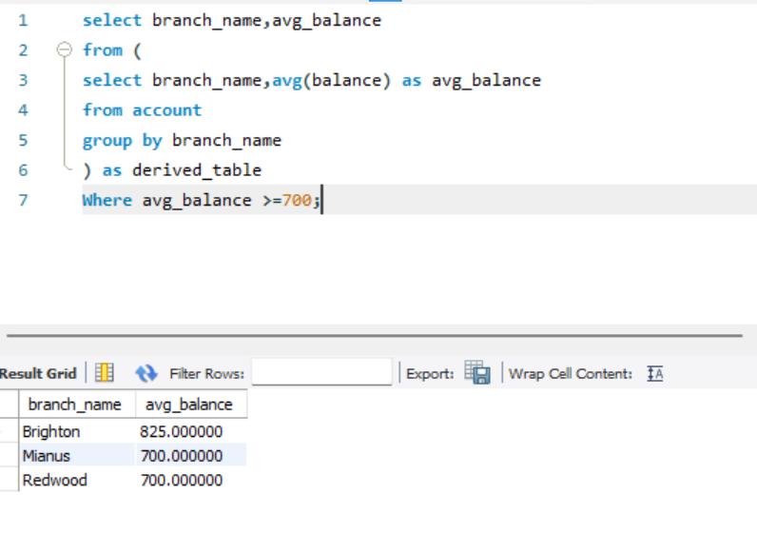

Derived tables 2

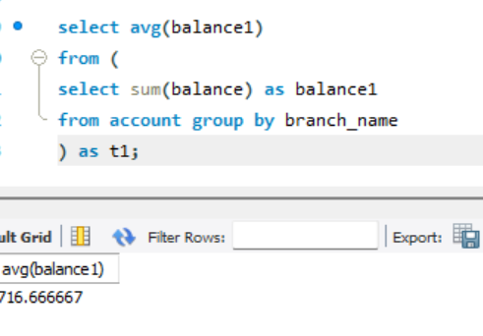

Views cretaion

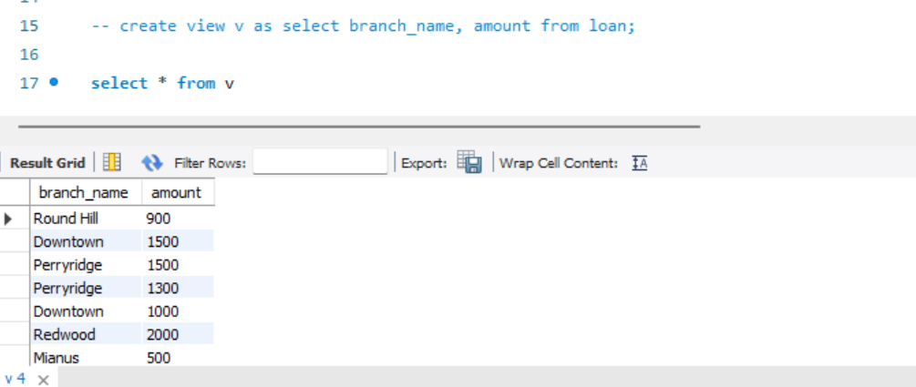

Views deletion, updation

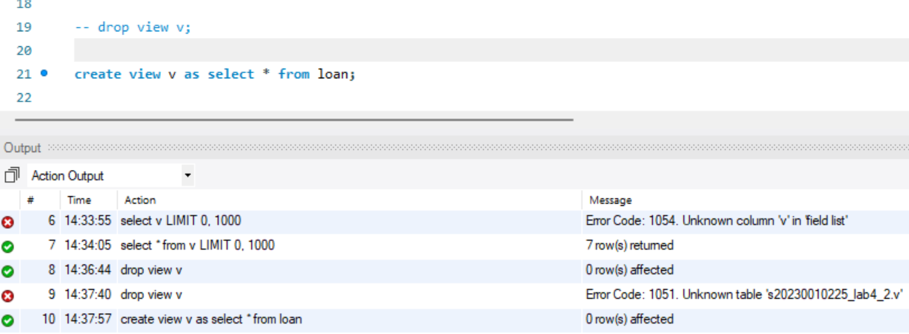

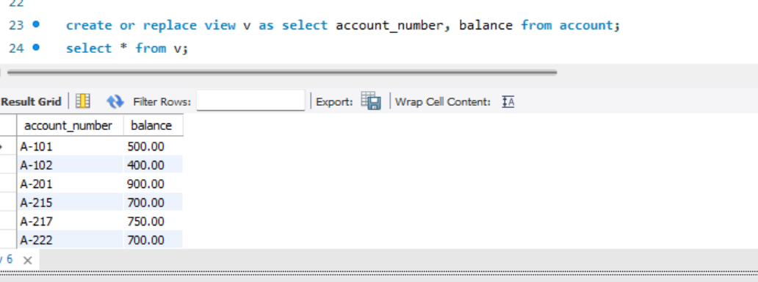

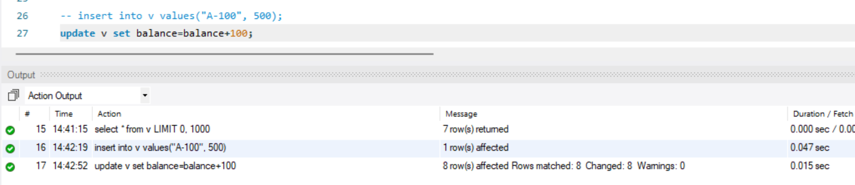

Practice questions(ungraded ones)

1.

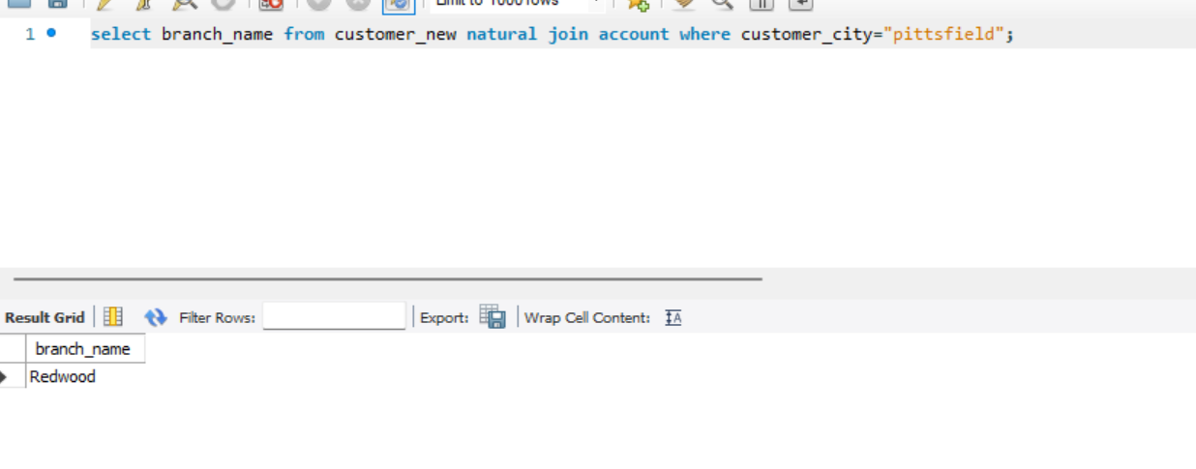2.

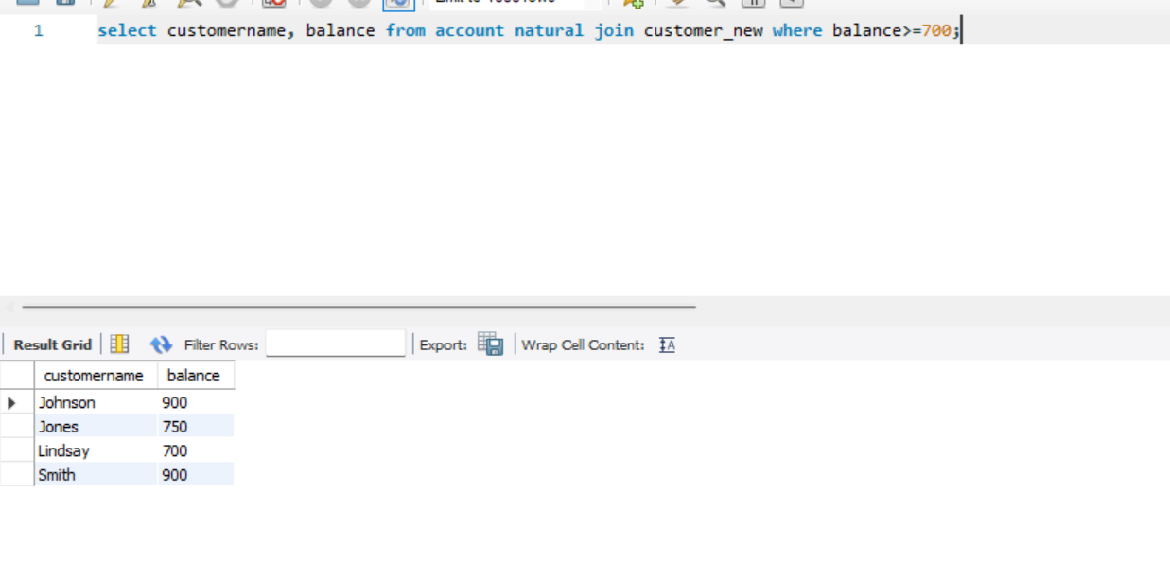

3.

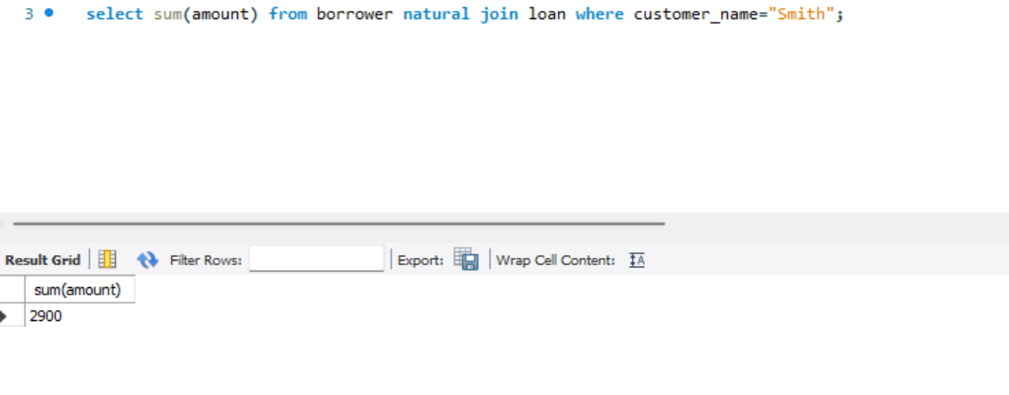

4.

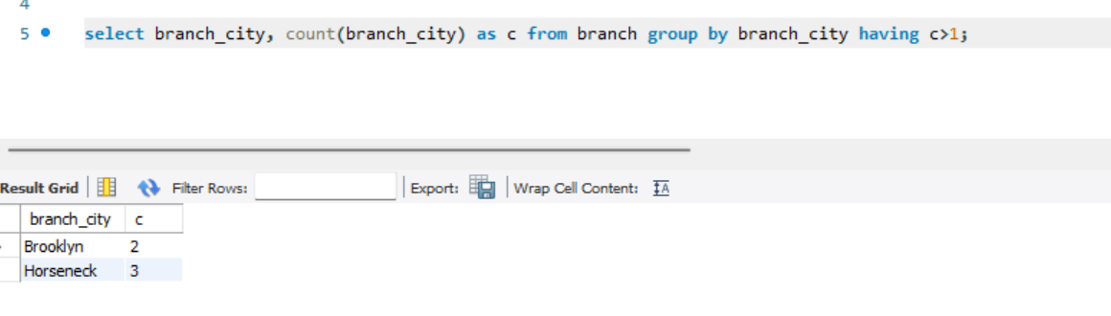

5.

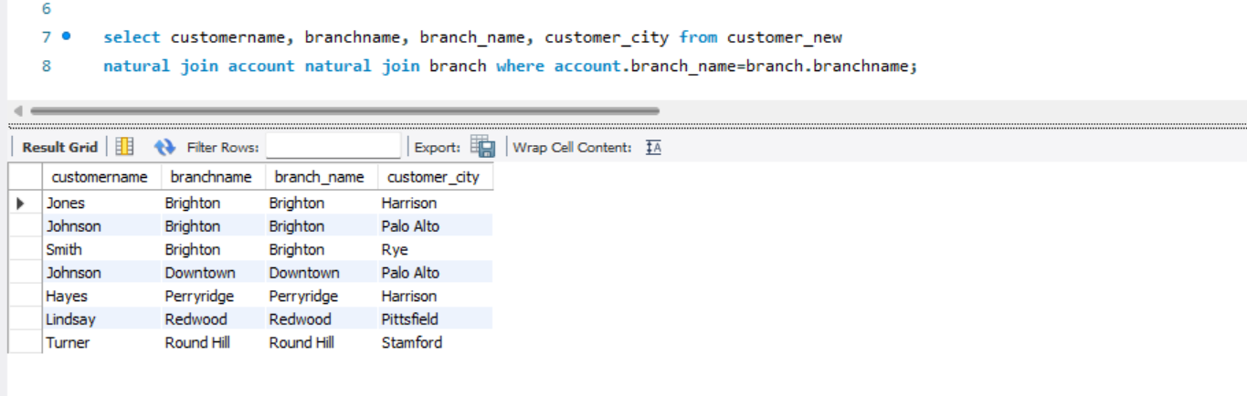

6.

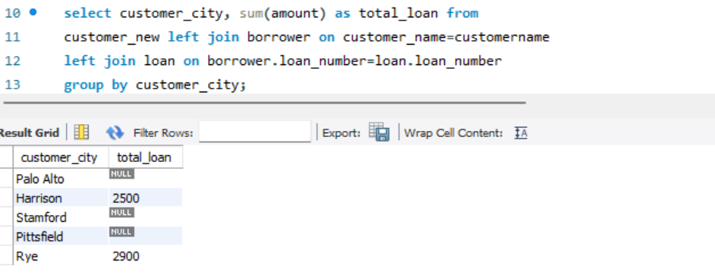

7.

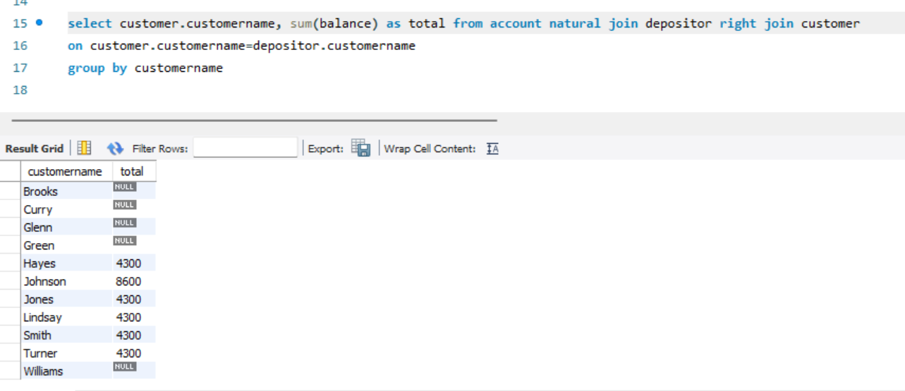

8.

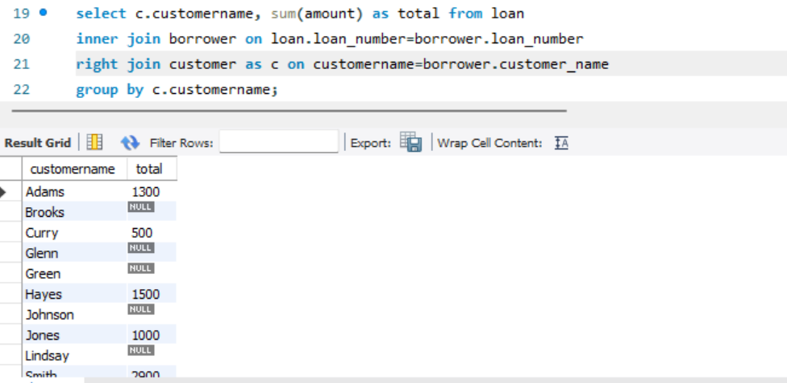

9.

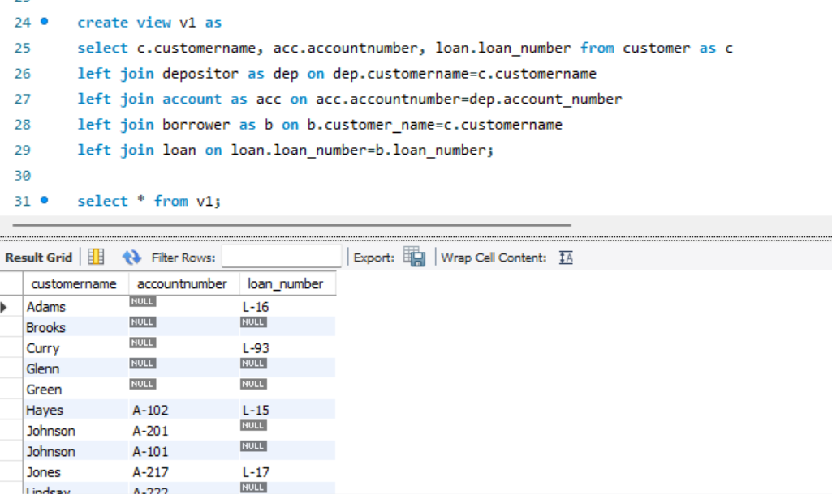

10. Question is unclear.

Assignment questions part 1:

Q1;

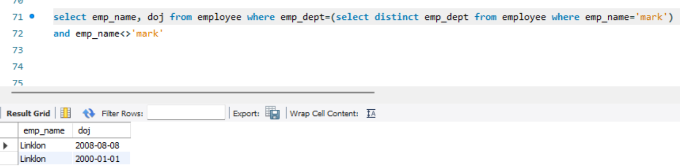

Q2

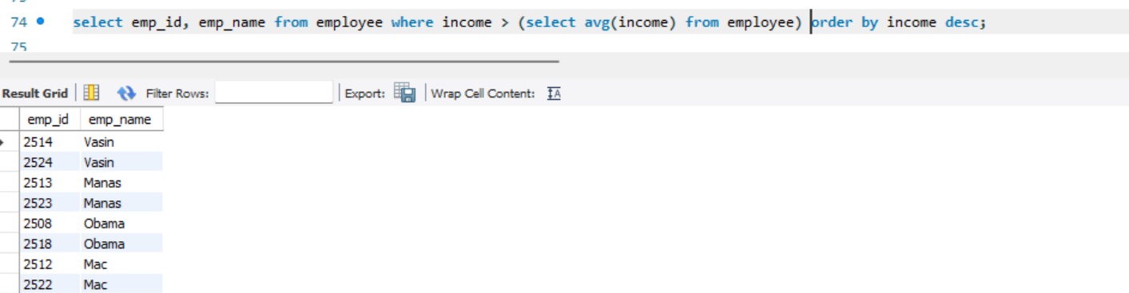

Q3

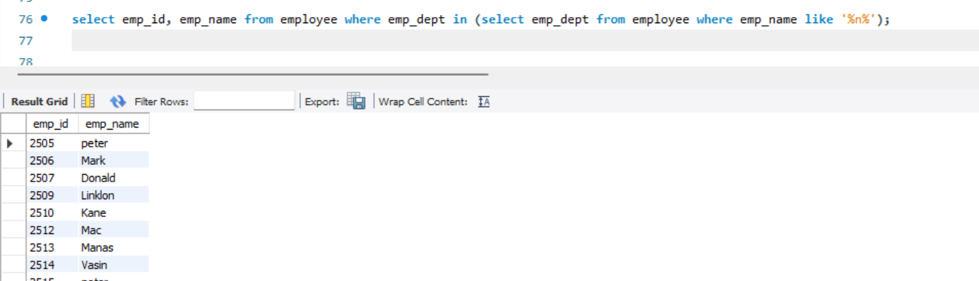

Q4

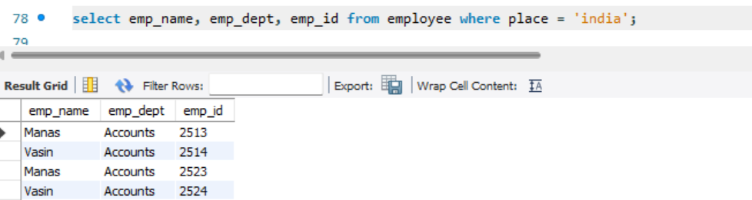

Q5

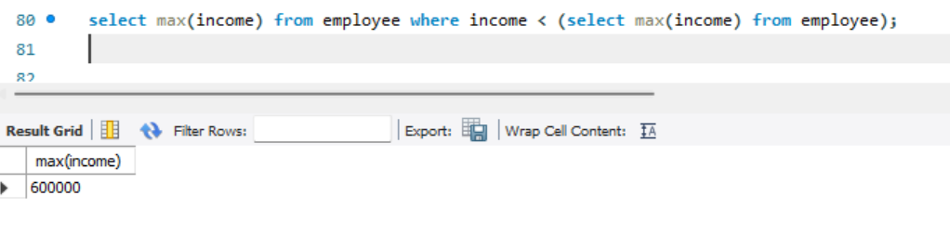

Assignment questions part 2(1-10)

Create table:

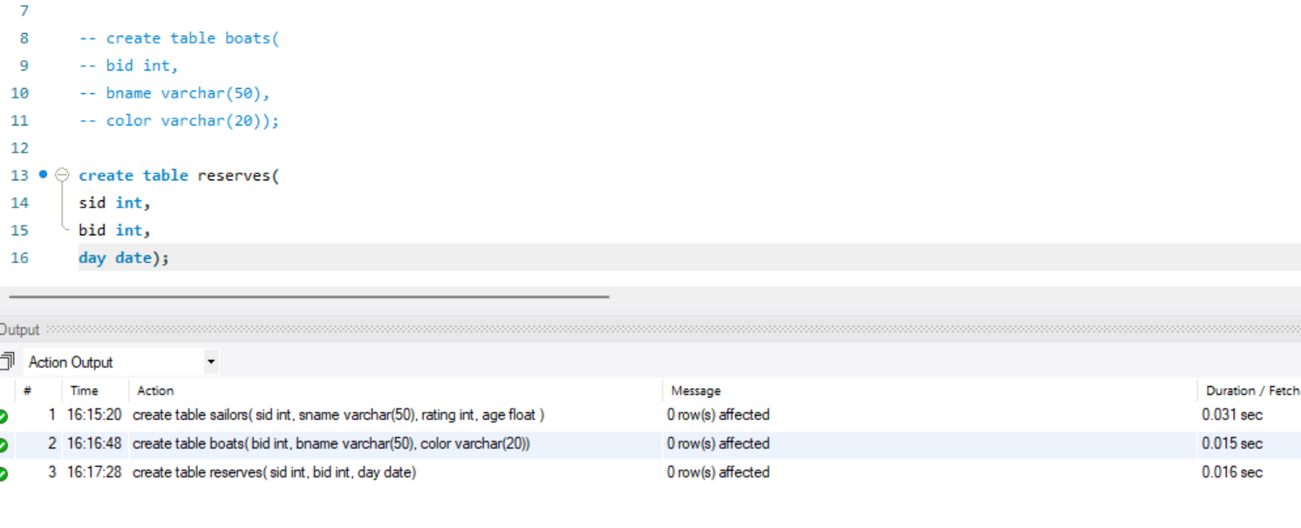

Insert into sailors

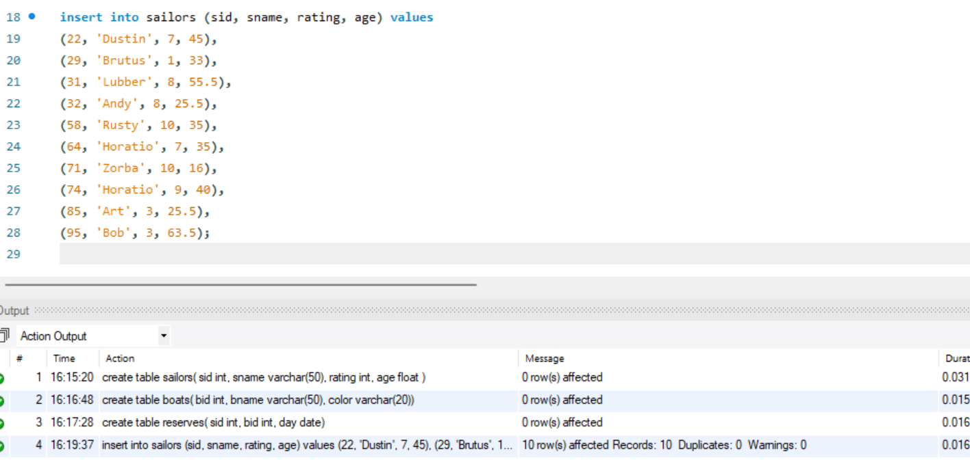

Insert into boats

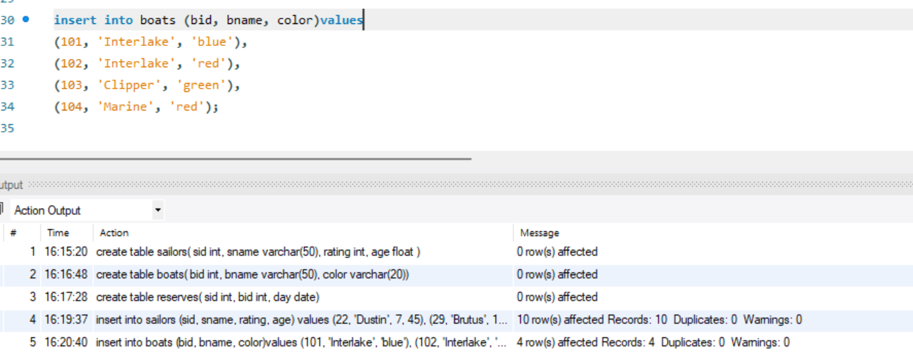

Insert into reserves

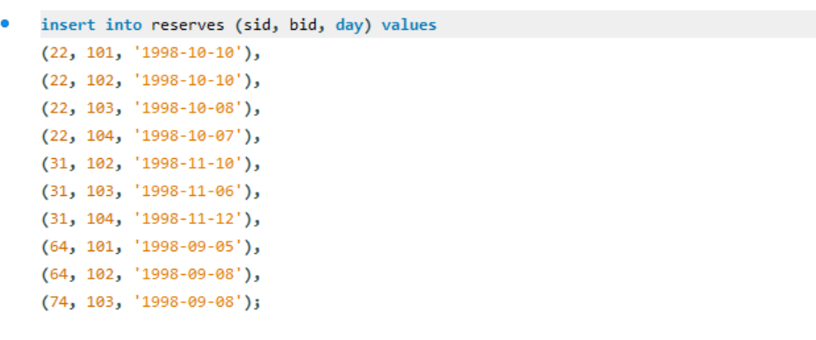

Q1

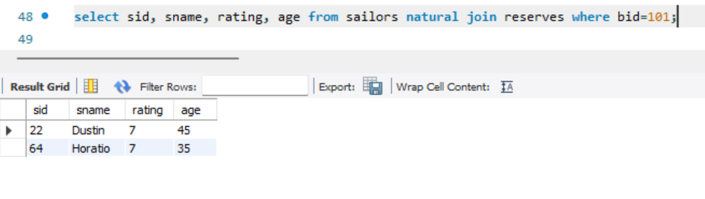

Q2

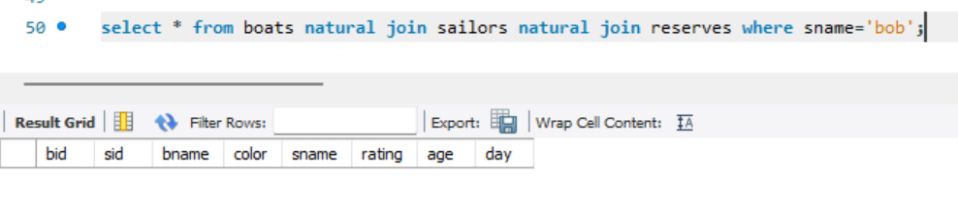

Q3

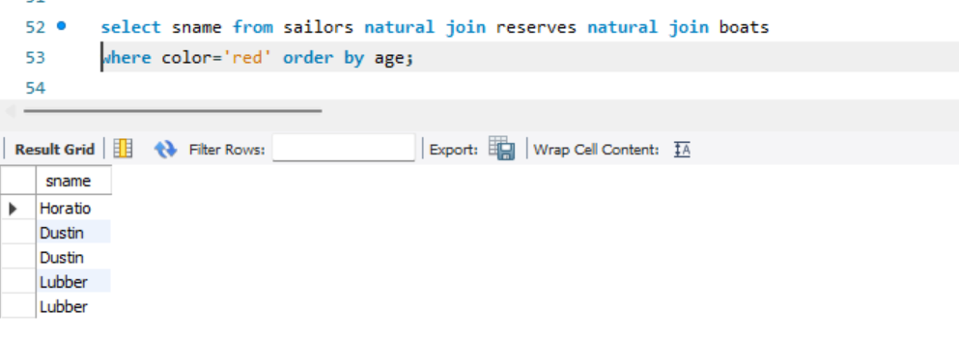

Q4

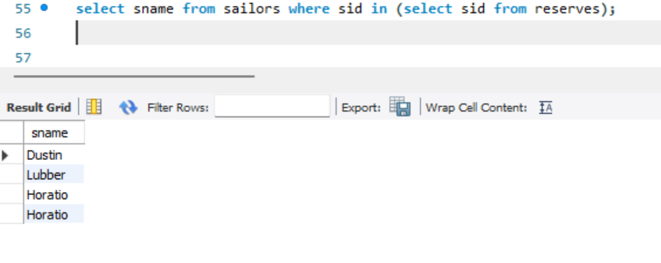

Q5

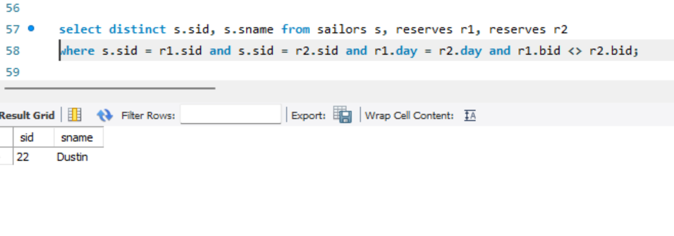

Q6

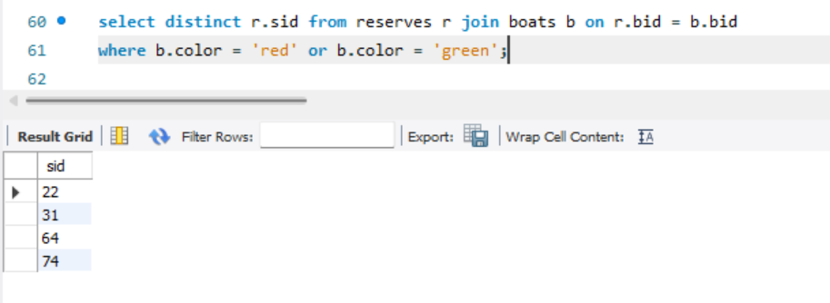

Q7

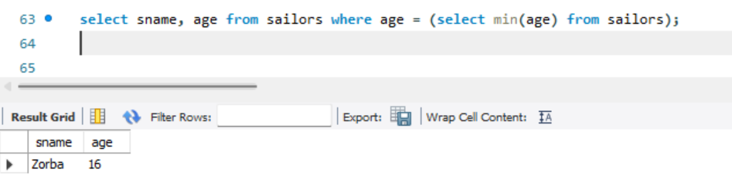

Q8

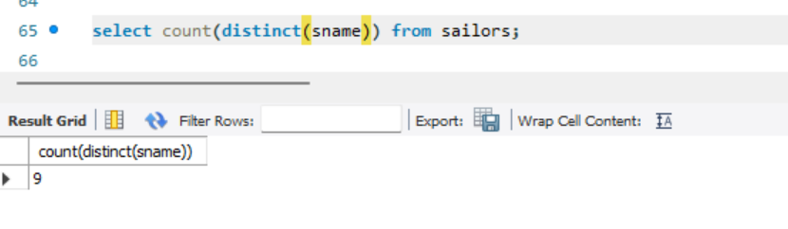

Q9

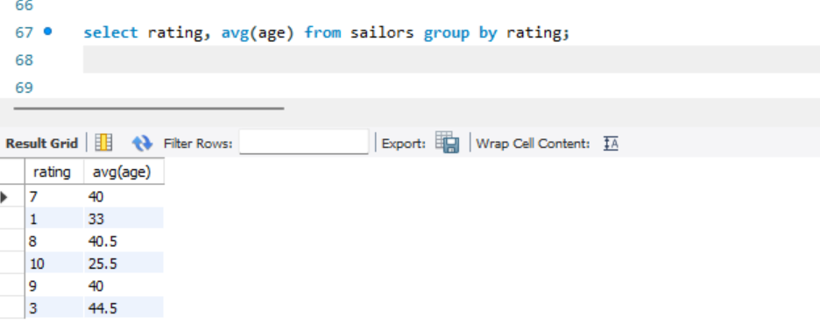

Q10

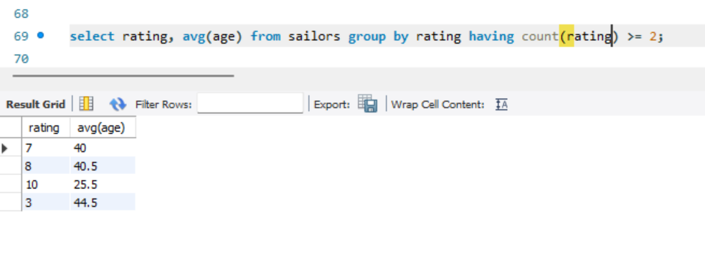

SQL code:

-- create table sailors(

-- sid int,

-- sname varchar(50),

-- rating int,

-- age float

-- );

-- create table boats(

-- bid int,

-- bname varchar(50),

-- color varchar(20));

-- create table reserves(

-- sid int,

-- bid int,

-- day date);

-- insert into sailors (sid, sname, rating, age) values

-- (22, 'Dustin', 7, 45),

-- (29, 'Brutus', 1, 33),

-- (31, 'Lubber', 8, 55.5),

-- (32, 'Andy', 8, 25.5),

-- (58, 'Rusty', 10, 35),

-- (64, 'Horatio', 7, 35),

-- (71, 'Zorba', 10, 16),

-- (74, 'Horatio', 9, 40),

-- (85, 'Art', 3, 25.5),

-- (95, 'Bob', 3, 63.5);

-- insert into boats (bid, bname, color)values

-- (101, 'Interlake', 'blue'),

-- (102, 'Interlake', 'red'),

-- (103, 'Clipper', 'green'),

-- (104, 'Marine', 'red');

-- insert into reserves (sid, bid, day) values

-- (22, 101, '1998-10-10'),

-- (22, 102, '1998-10-10'),

-- (22, 103, '1998-10-08'),

-- (22, 104, '1998-10-07'),

-- (31, 102, '1998-11-10'),

-- (31, 103, '1998-11-06'),

-- (31, 104, '1998-11-12'),

-- (64, 101, '1998-09-05'),

-- (64, 102, '1998-09-08'),

-- (74, 103, '1998-09-08');

-- select sid, sname, rating, age from sailors natural join reserves where bid=101;

-- select * from boats natural join sailors natural join reserves where sname='bob';

-- select sname from sailors natural join reserves natural join boats

-- where color='red' order by age;

-- select sname from sailors where sid in (select sid from reserves);

-- select distinct s.sid, s.sname from sailors s, reserves r1, reserves r2

-- where s.sid = r1.sid and s.sid = r2.sid and r1.day = r2.day and r1.bid <> r2.bid;

-- select distinct r.sid from reserves r join boats b on r.bid = b.bid

-- where b.color = 'red' or b.color = 'green';

-- select sname, age from sailors where age = (select min(age) from sailors);

-- select count(distinct(sname)) from sailors;

-- select rating, avg(age) from sailors group by rating;

-- select rating, avg(age) from sailors group by rating having count(rating) >= 2;

-- select emp_name, doj from employee where emp_dept=(select distinct emp_dept from employee where emp_name='mark')

-- and emp_name<>'mark'

-- select emp_id, emp_name from employee where income > (select avg(income) from employee) order by income desc;

-- select emp_id, emp_name from employee where emp_dept in (select emp_dept from employee where emp_name like '%n%');

-- select emp_name, emp_dept, emp_id from employee where place = 'india';

-- select max(income) from employee where income < (select max(income) from employee);

Ungraded queires:

-- select customername, balance from account natural join customer_new where balance>=700;

-- select sum(amount) from borrower natural join loan where customer_name="Smith";

-- select branch_city, count(branch_city) as c from branch group by branch_city having c>1;

-- select customername, branchname, branch_name, customer_city from customer_new

-- natural join account natural join branch where account.branch_name=branch.branchname;

-- select customer_city, sum(amount) as total_loan from

-- customer_new left join borrower on customer_name=customername

-- left join loan on borrower.loan_number=loan.loan_number

-- group by customer_city;

-- select customer.customername, sum(balance) as total from account natural join depositor right join customer

-- on customer.customername=depositor.customername

-- group by customername

-- select c.customername, sum(amount) as total from loan

-- inner join borrower on loan.loan_number=borrower.loan_number

-- right join customer as c on customername=borrower.customer_name

-- group by c.customername;

-- create view v1 as

-- select c.customername, acc.accountnumber, loan.loan_number from customer as c

-- left join depositor as dep on dep.customername=c.customername

-- left join account as acc on acc.accountnumber=dep.account_number

-- left join borrower as b on b.customer_name=c.customername

-- left join loan on loan.loan_number=b.loan_number;

-- select * from v1;