Abstract of Trading Case Assessment case study:
As part of this case study ,the user can upload any excel and stored in the data folder. When the user clicks on the execute button the application reads the excel which has details of the trades information and contracts information and analyse the trades and contracts in the given excel and try to generate a MTM report which can be downloaded .it also provided total amount of MTM value for that day.
- Python – application logic implementation
- Streamlit – User Interface
- Excel – the worksheet which has information of the trades executed and the future contracts.
Attached the below screenshots for your reference for 5 scenarios.
Scenario 1: when all the information for the both the worksheet is provided correctly.
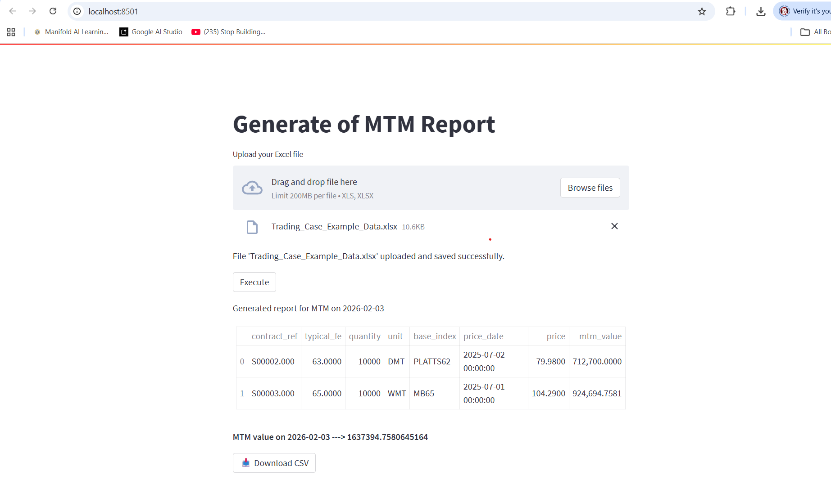

Scenario 2: when invalid worksheet information is provided in the excel

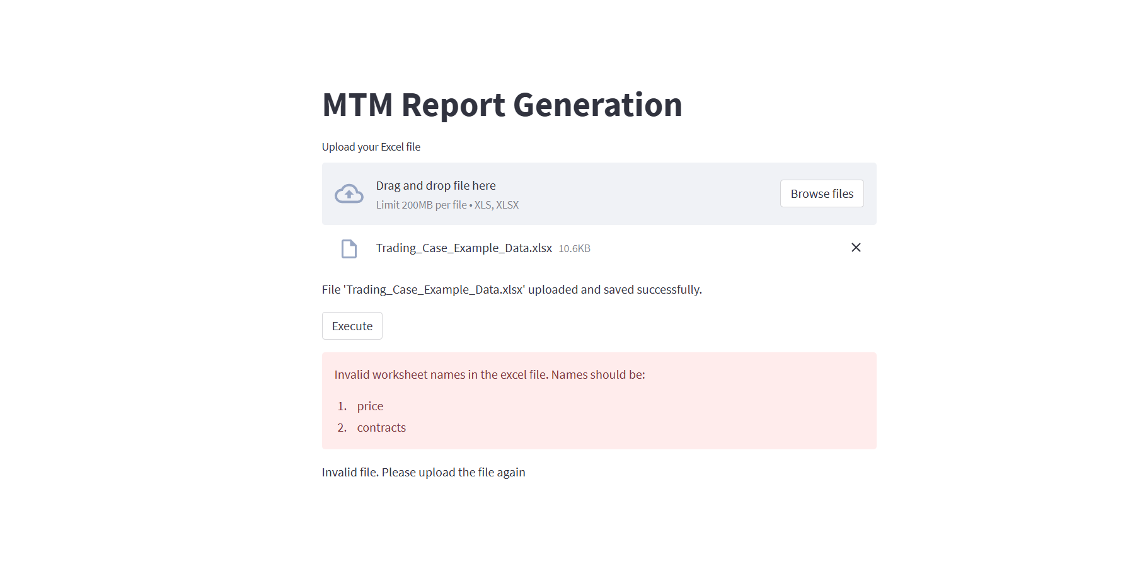
Scenario 3: when the contracts worksheet is provided with empty excel.
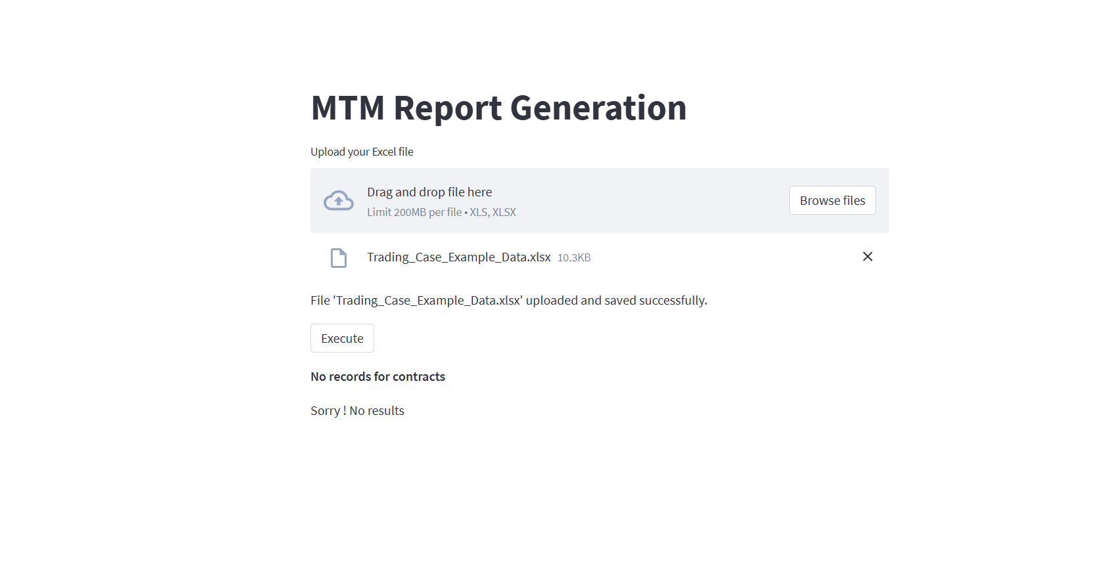
Scenario 4: when the price worksheet is provided with empty excel.
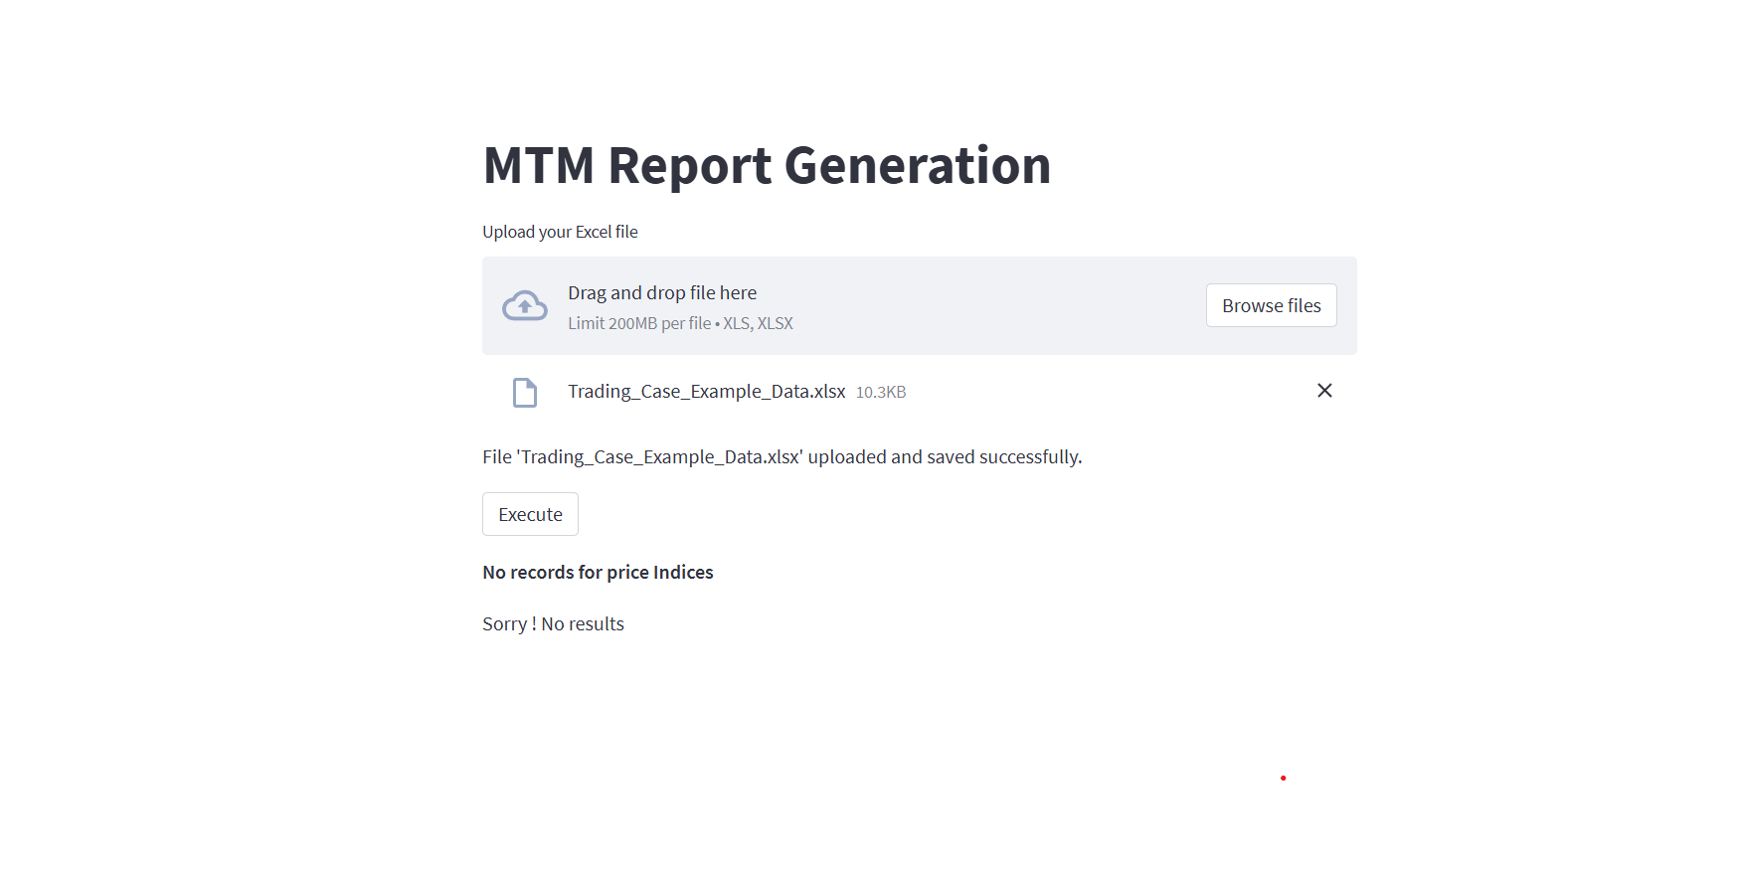
Scenario 5: when the empty worksheets are provided with in excel.

