Institutional Profiles Under a Common Prudential Framework: Evidence from Brazilian Credit Cooperatives and Banks
Arthur Gomes Neryª, Thiago de Oliveira Victorino^{b} and Rodrigo Lima Rangel^{c}
ªOrganization of Brazilian Cooperatives (OCB System), Brasília, Brazil, ORCID [0000-0000-0000-0000], arthurgomesqq@gmail.com; ^{b}Organization of Brazilian Cooperatives (OCB System) and Department of Administration, University of Brasilia, Brasília, Brazil, ORCID [0000-0000-0000-0000], [email]; and ^{c}Organization of Brazilian Cooperatives (OCB System), Brasília, Brazil, ORCID [0000-0000-0000-0000], [email]
Award category: Best Young and Emerging Scholar Paper
Abstract
In Brazil, a credit cooperative that grows past a size threshold computes capital, leverage and risk under the same prudential methodology as a commercial bank. We use this setting, which no previous study has exploited, to ask whether the cooperative form retains distinct balance-sheet characteristics. Using a quarterly panel of every full-methodology institution from 2017 to 2024, 130 singular credit cooperatives and 144 banks, we relate ten measures of capital, performance, stability and balance-sheet structure to a cooperative dummy. The estimates control for size and time and are repeated on a matched sample, on the region of common support and across five comparison groups. Three results emerge. First, cooperatives of comparable size allocate more of their assets to credit than banks nationally, earn a higher return on assets at lower cost, and show lower return volatility. Second, capital differs modestly in level and markedly in dispersion. The mean gap comes largely from small banks that barely intermediate and hold capital ratios above fifty percent, and it roughly halves against deposit-funded banks. Among thinly capitalised institutions, cooperatives hold more capital than banks and provision no less. Third, lower provisioning and narrower margins, two differences often reported, disappear once the comparison group is restricted to banks. These conditional differences suggest that a benchmark calibrated on the average institution may describe the locally lending cooperative poorly, which bears on institutional resilience and on the territorial role of cooperative lenders.
Keywords: credit cooperatives; prudential regulation; Basel; proportionality; Brazil.
JEL: G21, G28, P13.

1 Background
Prudential regulation has converged on a common template. Basel III supplies the architecture for capital, leverage and risk measurement, and national supervisors adapt it to local conditions (Basel Committee on Banking Supervision, 2011). Brazil sorts authorised institutions into five segments for the proportional application of prudential rules (Conselho Monetário Nacional, 2017a); Figure 1 shows how cooperatives and other institutions divide between the two methodologies. Segments 1 to 4 apply the full methodology, while Segment 5 comprises institutions with total exposure below 0.1 percent of GDP that opt for a simplified method of computing minimum capital, under Resolution 4.194/2013 until February 2018 and Resolution 4.606/2017 thereafter (Conselho Monetário Nacional, 2013c, 2017b). Commercial, multiple, investment and exchange banks are excluded from S5 at any size. Membership of S5 therefore follows from the choice of methodology, and an institution that stops using the simplified method is reassigned to S4. Institutions outside S5 apply the Patrimônio de Referência capital definition, minimum requirements and risk-weighted-asset computation of Resolutions 4.192 and 4.193 of 2013 and, from 3 January 2022, of Resolutions 4.955 and 4.958 (Conselho Monetário Nacional, 2013a, 2013b, 2021a, 2021b). Loan classification and minimum provisioning follow Resolution 2.682/1999 throughout the window, since its expected-loss successor took effect only in 2025 (Conselho Monetário Nacional, 1999, 2021c).
A credit cooperative that grows past the threshold, or declines the simplified option, therefore computes capital under the same definition, minimum ratios, standardised risk weights and provisioning rules as a commercial bank. A few requirements differ by segment: the liquidity ratios and the systemic buffer apply to S1 only, and the Basel leverage ratio to S1 and S2 (Conselho Monetário Nacional, 2015a, 2017c, 2017d, 2021b). Those segments contain banks only, and excluding the eleven banks whose modal segment is S1 or S2 changes no significant coefficient by more than two percent.
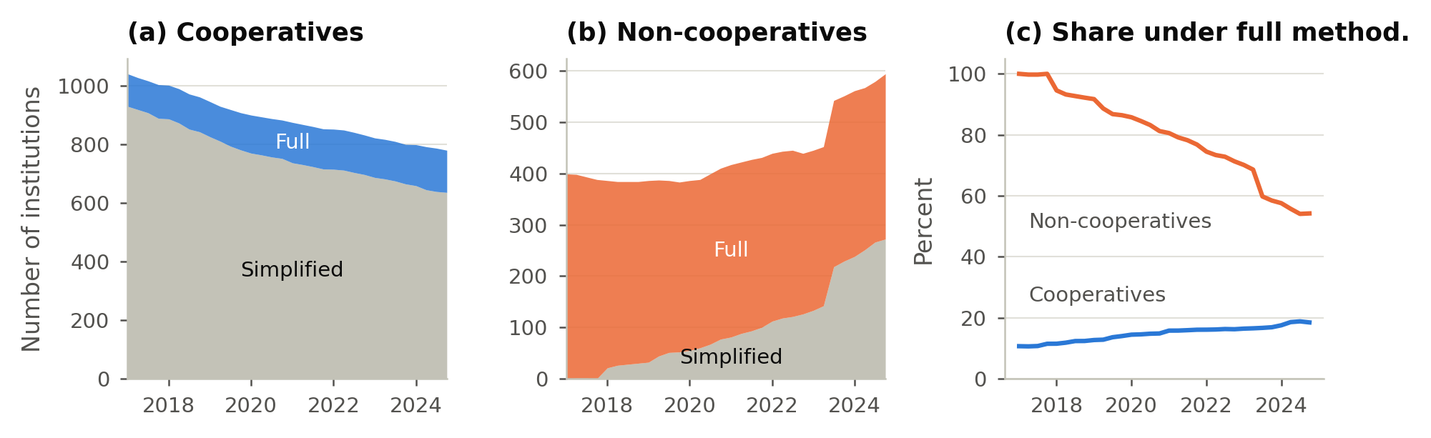
Figure 1. Institutions by prudential methodology, 2017 to 2024
Panel (c) is the share under the full methodology. The 2023 step in panel (b) is the entry of payment-institution conglomerates.
Credit cooperatives are member-owned deposit-taking institutions that lend mostly to their members. They are organised under Complementary Law 130/2009 and Resolution 4.434/2015, which classifies them as plena, clássica or de capital e empréstimo according to the operations they may conduct (Brasil, 2009; Conselho Monetário Nacional, 2015b). Resolution 5.051/2022 consolidated the cooperative rules from January 2023, restating that classification and replacing the minimum-capital articles of the 2015 resolution (Conselho Monetário Nacional, 2022). Cooperatives held about six percent of system assets at the end of 2024 and 6.3 percent a year later, and their share has risen in every year since 2020 (Banco Central do Brasil, 2025, 2026). Much of the sector belongs to integrated systems in which central cooperatives supply liquidity facilities, consolidated risk management and a single supervisory interface to their affiliates.
Cooperatives are the part of the regulated system that lends locally and has grown fastest. If the prudential benchmark reflects an average institution that does not lend, it measures cooperatives against a standard drawn from a different kind of institution. Whether it does is the question we ask, and the answer bears on institutional resilience and on the territorial role of cooperative lenders.

1.1 Theoretical framework and predictions
Prudential capital regulation exists to internalise the externalities that a financial institution's failure imposes on depositors, on the payment system and on the public safety net (Basel Committee on Banking Supervision, 2011). It also offsets the moral hazard that deposit guarantees introduce into the institution's choice of leverage (Diamond & Dybvig, 1983). One reading of this rationale is a representation argument, in which the supervisor acts on behalf of small, dispersed depositors who cannot monitor a leveraged intermediary. In a credit cooperative the depositor is also a member with a residual claim and a governance right, and in the integrated systems a central body supplies consolidated monitoring. The monitoring problem is therefore likely to be partly internalised, while the systemic externality of failure and the moral hazard of a public guarantee remain. A capital template written for one form may thus bind, when applied to another, on a margin that does not carry the risk it was designed to price.
Brazil's segmentation sorts institutions by size and international activity (Conselho Monetário Nacional, 2017a), and the international surveys of proportionality record size, complexity and business model as the criteria in use, none based on organisational form (Basel Committee on Banking Supervision, 2019; Castro Carvalho et al., 2017). Where supervisors adapt the framework to financial cooperatives, the adaptation concerns the capital treatment of member shares and the arrangements within networks, while supervisory powers remain those applied to commercial banks (Coelho et al., 2019). Responsive regulation (Ayres & Braithwaite, 1992; Baldwin & Black, 2008) treats the structure of the regulated industry and the motivations of its firms as inputs to how a regime engages them. Organisational form and network membership then become candidate calibration margins, and the profile of each form decides whether they point to lighter treatment or closer scrutiny. This paper provides that profile.
Ownership offers a reason to expect the two forms to differ under a common methodology. A cooperative cannot raise outside voting equity as needed, so its capital is an endowment of retained earnings accumulated across member generations (Fonteyne, 2007). Basel III admits the member shares of mutuals and cooperatives as common equity under criteria adapted to their legal form (Basel Committee on Banking Supervision, 2011). However, the shares remain redeemable claims of members and cannot be placed with outside investors. The member's claim carries the five property-rights problems that Cook (1995) sets out: free-rider, horizon, portfolio, control and influence costs, which together weaken the incentive to build capital beyond what member service requires. In Hansmann's terms the claim is tied to use of the institution, so capital accumulation is instrumental to member credit (Hansmann, 1996).

1.2 Comparison groups in the cooperative banking literature
Besides the proportionality work above, two strands of the literature reviewed by McKillop et al. (2020) bear on this paper. The first concerns capital, profitability and stability. Hesse and Čihák (2007) find in a cross-country panel that cooperative banks are more stable than commercial banks. They attribute the result to the lower volatility of cooperative returns, which more than offsets lower profitability and capitalisation. Iannotta et al. (2007) and Beck et al. (2009) find that ownership structure predicts risk and performance across European banks and within Germany, and Becchetti et al. (2016) and Ferri et al. (2014) show that it shapes lending. Cuevas and Fischer (2006) set out the tension between member orientation and prudential templates written for investor-owned banks. The second is Brazilian. Bressan et al. (2011) apply the PEARLS system to Brazilian credit cooperatives and model their insolvency risk, and Carvalho et al. (2015) analyse the exit and failure of Brazilian credit unions. The Central Bank has compared cooperatives with private banks on the behaviour of newly captured clients (Banco Central do Brasil, 2020). None of these studies compares cooperatives with banks under a common prudential methodology, which is the setting we use here.
A further question is asked less often: which institutions the comparison group contains. Regulatory populations are defined by legal category and can include institutions with little economic resemblance to a bank. Of the 483 non-cooperative institutions under the full methodology in Brazil, 158 report a median credit-to-assets ratio of zero and a median ratio of funds raised to assets of zero.

1.3 Study design and contribution
We compare cooperatives with banks across a ladder of comparison groups defined on the regulator's own categories. We also correct two features of the source data that distort the rate variables, and we separate sector-wide differences from differences within regional markets. The window opens in 2017Q1, the first quarter with segment reporting under Resolution 4.553, so the paper cannot speak to the crisis-period lending that Becchetti et al. (2016) and Ferri et al. (2014) study.

2 Aims
We ask whether organisational form leaves a measurable imprint on the balance sheet once the prudential methodology is common to both forms, and how far the answer depends on choices the analyst makes. Section 1.1 leads us to expect cooperatives to hold less regulatory capital than banks of comparable size, in a narrower band than a population that can issue equity on demand. Because the member's claim is a claim on use, we also expect them to lend a higher share of assets. On profitability and efficiency the framework does not commit to a sign. Surplus returned through pricing would depress the return on assets, while the cost discipline of a focused retail model would raise it. The framework does predict lower return volatility. A cooperative that prices to members can absorb shocks through the surplus it would otherwise return, which Hesse and Čihák (2007) identify as the source of cooperative stability. For provisioning and the intermediation margin it gives no reason to expect a difference. Minimum provisions are fixed by a regulatory AA to H rating grid (Conselho Monetário Nacional, 1999), independent of ownership, so a difference on either is more likely to reflect the composition of the comparison group.
We make no prediction on the second question, which concerns method: which institutions form the comparison group, how cumulative accounting flows are converted into rates, and how a matched estimator is weighted.

3 Methods

3.1 Data and classification
We construct an institution-level quarterly panel from IF.data, the public statistical repository of the Central Bank of Brazil. The summary financials, the segmentation file, the asset composition file and the income statement are merged on institution code and reporting date. Each source is deduplicated on the institution-quarter key before merging, keeping the most complete record, and the raw panel runs from 2014Q1 to 2024Q4. All tables and figures are the authors' calculations from the IF.data files.
The panel is IF.data's prudential-conglomerate report, and every row carries its reporting level. Of the banks, 87 report as consolidations and 57 individually, and some switch within the window. All cooperatives report individually; each bank takes its modal level, which is used below as a comparison-group parameter.
We classify institutions on the Central Bank's consolidation type, tipo de consolidado bancário (tcb). The code b3S marks a singular credit cooperative and b3C a central cooperative or confederation. Consolidation type is a regulatory attribute and is stable over time; assigning each institution its modal tcb makes cooperative status time-invariant by construction. Central cooperatives are excluded, since they are wholesale entities that supply liquidity and risk management to affiliated singulars and carry high capital for structural reasons. By contrast, classification by name would place the sector's own banks, Banco Cooperativo Sicredi and Banco Sicoob, both b1 commercial banks, in the cooperative group.

3.2 Comparison groups
The cooperative side is always the singular retail cooperatives under the full methodology. The comparison side is a reported parameter, defined on the regulator's consolidation type and never on an outcome. The ladder has four rungs, and a fifth comparison keeps the bank group but matches on macro-region as well as size (Section 4.3).
- All non-cooperatives: every full-methodology institution outside the b3 family.
- Banks, the primary group: b1 commercial and multiple banks with a commercial portfolio and b2 multiple and investment banks.
- Commercial: b1 banks only.
- Structural: b1 banks with strictly positive deposits in every quarter of their presence in the sample, defined ex ante.
Each rung can further be restricted to banks reporting individually. Of the 339 institutions in the broad group outside the bank rung, 335 are non-banking, and 158 institutions, almost all of them non-banking, have a median of zero credit and zero funds raised (Figure 2). Their presence makes the credit and funding differentials mechanical, but we still report the broad group because its divergence from banks is one of our results.
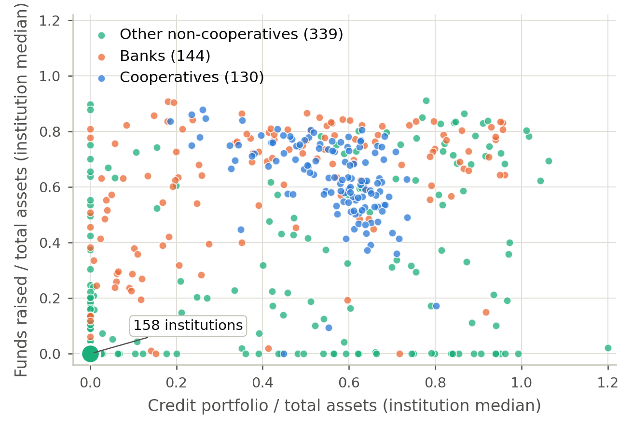
Figure 2. Credit and funding ratios of full-methodology institutions
Institution medians over 2017 to 2024. The marker at the origin stands for 158 institutions. Values above 1.2 are drawn at 1.2.

3.3 Outcomes and two measurement corrections
We study eight quarterly outcomes, defined in Table 1, and add two stability outcomes measured at the institution level over its full-methodology quarters: the standard deviation of annualised quarterly return on assets and the z-score, the distance-to-insolvency measure used by Hesse and Čihák (2007). Both require at least eight quarters, which leaves 105 cooperatives and 137 banks, and the cooperatives dropped are late entrants to the full methodology. Because the unit is the institution, these two outcomes are estimated on one row per institution, with mean log assets as the size control, no quarter effects, HC3 standard errors and a wild bootstrap over institutions.
Two features of IF.data affect how the quarterly outcomes are constructed. First, income flows accumulate within the semester. Financial institutions in Brazil draw up balance sheets semiannually, in June and December (Lei 4.595/1964), and the IF.data income fields reset at each date. The median ratio of the fourth-quarter to the first-quarter value is between 2.2 and 2.3 for every income field and close to one for balance-sheet stocks. Read as quarterly flows, the fields make return on assets a one-quarter return in odd quarters and a two-quarter return in even ones. We de-cumulate within each semester and annualise, which scales the return on assets coefficient by about 2.7 and leaves every stock-based coefficient unchanged. Second, the intermediation result is reported net of loan loss provisions, because the expense subtotal (b) contains line (b5), Resultado de Provisão para Créditos de Difícil Liquidação, so (c) = (a) + (b) partly reproduces the provisioning result under another name. We compute the margin gross of (b5), and the cost-to-income denominator likewise.
The provisioning ratio is the stock of provisions constituted under Resolution 2.682/1999 over gross credit. The minimum provision is a step function of the AA to H rating assigned to each operation, so the ratio reflects how the institution classifies its book and is a weak proxy for realised delinquency.
Table 1. Outcome definitions
Outcome | Construction
Basel capital ratio | Índice de Basileia as reported by BACEN, in percentage points
Leverage | Total liabilities / total assets
Return on assets | 4× (quarterly net income, line (j) de-cumulated within the semester) / total assets
Intermediation margin | 4×[(c)−(b5)] / total assets, de-cumulated within the semester
Cost-to-income | [|(d3)| + |(d4)|] / [(c)−(b5) + |(d2)|], de-cumulated within the semester
Credit portfolio / assets | Credit portfolio / total assets
Provisioning ratio | Stock of provisions under Res. 2.682/1999 / gross credit
Funding ratio | Captações (funds raised) / total assets
Return volatility | S.d. of annualised quarterly return on assets over the institution's full-methodology quarters (at least eight)
Z-score | [mean return on assets + mean (1−leverage)] / s.d. of return on assets (at least eight quarters)
IF.data lines: (a) intermediation revenue, (b) intermediation expense, carried as a negative, (c) = (a) + (b) intermediation result, (b5) loan-loss provision result within (b), (d2) fee income, (d3) personnel expense, (d4) administrative expense, (j) net income.

3.4 Specifications, matching and inference
For each outcome we estimate the coefficient on a cooperative dummy under four specifications: the unconditional difference in means, log total assets and quarter fixed effects, coarsened exact matching (Iacus et al., 2012) with the same controls, and the same controls on the region of common support in log assets. Cooperative status does not vary within an institution, so it is collinear with any institution fixed effect. The estimates are conditional correlations, and we do not present them as causal effects of organisational form.
The coarsened-exact-matching estimand weights control units so that the treated-to-control ratio is equal within every stratum (Iacus et al., 2012). OLS on the matched sample does not recover it, since unweighted strata are implicitly weighted by their control counts. We report the weighted estimand and the unweighted matched-sample regression together. We coarsen on size quintile and control for region. Region-exact matching would leave too few controls: cooperatives concentrate in the South and banks in the Southeast, so region-exact strata leave an effective control sample of about eighteen institutions by the Kish measure, against seventy-six under size coarsening. Region-exact estimates are reported as a second parameter (Section 4.3).
Standard errors are clustered by institution, since cooperative status is assigned at the institution level and observations are serially correlated (Abadie et al., 2023; Cameron & Miller, 2015). Inference from clustered standard errors is unreliable when few clusters are treated (MacKinnon & Webb, 2017), as in the system-by-system estimates. We therefore compute a restricted wild cluster bootstrap with Rademacher weights for every coefficient (Cameron et al., 2008). In simulations on our design with six treated clusters, the clustered test rejects a true null 16 percent of the time at a nominal 5 percent level. The wild bootstrap comes closer to the nominal level and is correctly sized at one percent. System-level estimates report the number of treated clusters, and quantile coefficients carry intervals from an institution bootstrap. Several outcomes are right-skewed, so we report the conditional median alongside the conditional mean.
We classify each outcome by an explicit rule, reported in the last column of Table 2. An outcome is null unless it is significant at five percent, with one sign, in all four specifications. A significant outcome is stable if it stays significant under every winsorisation rule, varies by less than a factor of two across those rules, and has an average quantile coefficient between the twentieth and eightieth percentiles of at least half the conditional mean. Otherwise it is stable in sign: the direction holds, but the tails or the shape of the distribution drive the magnitude.

4 Results
The analysis sample contains 130 singular cooperatives and 144 banks, 7,234 institution-quarters, from 2017Q1 to 2024Q4. Ninety percent of cooperative observations fall inside the common support region of log assets (Figure 3), against forty-eight percent of bank observations. About half the bank population therefore has no cooperative counterpart at any size. Matching and trimming bring the standardised difference in log assets from −0.72 to close to zero. Unconditional means and medians are in the online appendix.
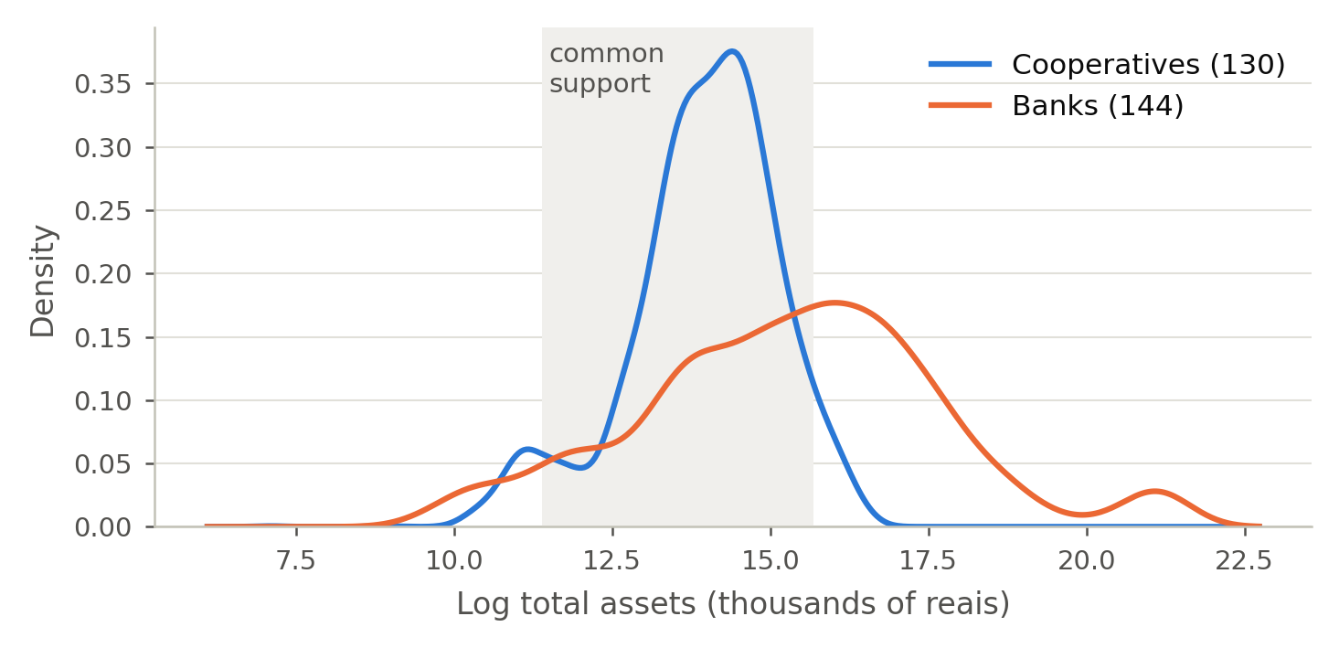
Figure 3. Log total assets, cooperatives and banks

4.1 The cooperative differential
Table 2 reports the coefficient on the cooperative dummy under the four specifications, together with the conditional median counterpart of the second column and the retention ratio ρ = |β_{trim}| / |β_{raw}|.
Table 2. Cooperative differential against banks
Outcome | (1) Raw | (2) Controls | (3) CEM | (4) Trim | Median (2) | ρ | Tier
Basel capital ratio (pp) | -8.19*** | -15.77*** | -17.50*** | -14.21*** | -2.18 | 1.73 | stable in sign
Leverage | 0.0561** | 0.1220*** | 0.1046*** | 0.0813*** | 0.0283 | 1.45 | stable in sign
Return on assets | 0.0181*** | 0.0215*** | 0.0179*** | 0.0159*** | 0.0171 | 0.88 | stable
Cost-to-income ratio | -0.6025*** | -0.7923*** | -0.8385*** | -0.7522*** | -0.1796 | 1.25 | stable in sign
Credit portfolio / assets | 0.1654*** | 0.1881*** | 0.1701*** | 0.1780*** | 0.2448 | 1.08 | stable
Provisioning ratio | 0.0020 | -0.0012 | 0.0010 | 0.0009 | 0.0236 |  | null
Intermediation margin | -0.0003 | -0.0190 | -0.0107 | -0.0171 | 0.0203 |  | null
Funding ratio | 0.0461 | 0.0887** | 0.0536 | 0.0330 | -0.0247 |  | null
Return on assets volatility | -0.0110*** | -0.0189*** | -0.0175*** | -0.0170*** | -0.0133 | 1.55 | stable
Z-score | 4.20*** | 6.32*** | 6.14*** | 6.20*** | 7.58 | 1.48 | stable
Standard errors clustered by institution, HC3 for the last two rows; * p<0.05, ** p<0.01, *** p<0.001, confirmed by a wild cluster bootstrap. Median (2): conditional median of column (2). rho = |b_trim|/|b_raw|. Tier: see Section 3.4.
Five of the eight quarterly outcomes keep their sign and significance across all four specifications and every winsorisation rule, including no winsorisation. Their retention ratios are above one, except for return on assets, which keeps most of its raw value. A size-composition artefact would shrink as size is held more tightly, so this pattern points away from that explanation. However, trimming also narrows the control set, and the ratio is not a formal test. By the rule of Section 3.4, credit intensity, return on assets and return volatility are stable. Capital, leverage and cost-to-income are stable in sign, while provisioning, the margin and funding are null. The capital coefficient should not be read at face value: under controls its conditional mean is about seven times its conditional median, because the mean mostly reflects the upper tail of the bank distribution, as we show below.
Cooperatives allocate a larger share of the balance sheet to credit, by nearly a fifth of total assets under controls and by more at the conditional median. The differential moves little across the four columns and changes by less than one percentage point across winsorisation rules. Cooperatives also earn a higher return on assets, by about two percentage points under controls and somewhat less at the conditional median, a large gap by the standards of the banking literature. Their intermediation margin is indistinguishable from that of banks, so the higher return appears to come from lending volume and lower cost.
Cooperatives operate at lower cost, although the size of the difference is fragile. The controlled coefficient roughly triples between tight winsorisation and none, because the denominator approaches zero for banks that barely intermediate. Trimming the bank-quarters whose operating income is below 0.5 percent of assets, none of them cooperative, reduces the coefficient by about a tenth. We rely on the conditional median, whose bootstrap interval excludes zero.
The capital result requires the most care. Unconditionally, the median cooperative is better capitalised than the median bank, and Figure 6 shows the cooperative median above the bank median for most of the window. Yet the size-controlled mean differential is large and negative in every column of Table 2. Figure 4 reconciles the two: the cooperative coefficient is positive at the bottom of the conditional capital distribution and negative at the top, and it crosses zero near the fortieth percentile. Its bootstrap interval lies above zero at the twenty-fifth percentile, includes zero at the median and lies well below zero at the seventy-fifth. Averaged over the twentieth to eightieth percentiles, the differential is about a third of the conditional mean (quantile coefficients for the six main outcomes are in the online appendix). Unconditionally, 14 percent of bank-quarters exceed a Basel ratio of 50 percent, against 1 percent of cooperative-quarters. At equal size, what mainly separates the two groups is dispersion: residualised on size and quarter, the standard deviation of the capital ratio among cooperatives is about a third of the bank figure (online appendix), and the shaded bands of Figure 6 show the same contrast in every quarter.
We examine two possible explanations of the bank upper tail. The first is reporting level. The tail sits among the banks that report individually, whose ninetieth percentile is far above that of the consolidations. The controlled gap against them is about four times the gap against the consolidations and has the same sign-crossing shape. Against the consolidations the gap is marginal, with a positive median coefficient (online appendix). The second is business model. Requiring a bank to be deposit-funded in every quarter, the structural rung, roughly halves both the share of bank-quarters above 50 percent and the estimated mean gap, which remains significant (Figure 5). The evidence is consistent with the bank upper tail being concentrated among small standalone banks with little risk-weighted exposure. Against banks that lend and take deposits, the capital difference consists of a modest gap in level and a large gap in dispersion.
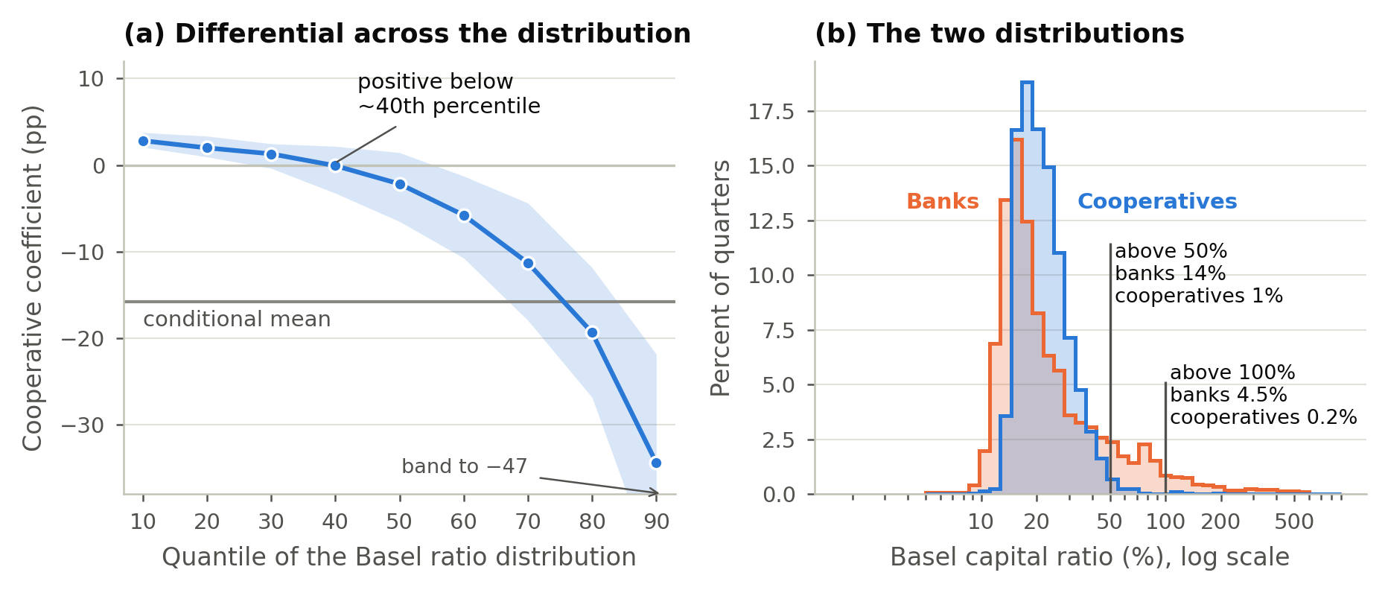
Figure 4. The capital ratio across the distribution
Panel (a): quantile regression coefficients with a 95 percent institution-bootstrap band, and the conditional mean. Panel (b): Basel ratio before winsorisation, on a log scale; values below 5 percent are drawn at 5, and bar heights are percent of each group's quarters.
The same pattern holds for the other outcomes. Averaged over the twentieth to eightieth percentiles, the differential is of similar size to the conditional mean for credit intensity and return on assets, so for those two the mean describes the typical institution. For leverage and cost-to-income it is little more than a third of the mean, and both change sign inside the distribution. At equal size, cooperatives are the more homogeneous group on every outcome, with residual standard deviations between a tenth and a half of the bank figure. Leverage and capital are closely correlated among cooperatives, and we treat the two as a single result.
Cooperative returns are also less volatile. At comparable size cooperatives show a lower standard deviation of return on assets and a higher z-score, in all four designs and on every national bank rung. Because the two measures share the standard deviation of return on assets, we treat them as one result, with volatility as the primary measure. Together with the return on assets result, this means that cooperatives earn higher and less volatile returns on the same intermediation margin.

4.2 Comparison-group dependence
Figure 5 re-estimates every outcome on five rungs: the broad group, banks, banks within macro-region, commercial banks and structural banks. Return on assets, cost-to-income and return volatility keep their sign on every rung and hold at one percent on all of them except the within-region comparison, where the first two hold at five percent. Credit intensity holds at one percent on the four national rungs and is not distinguishable from zero within region (Section 4.3). Dropping the sector's two cooperative-owned banks changes every coefficient by 1.3 percent or less, apart from the provisioning coefficient, which stays within 0.0002 of zero. Two results that appear against the broad group disappear against banks.
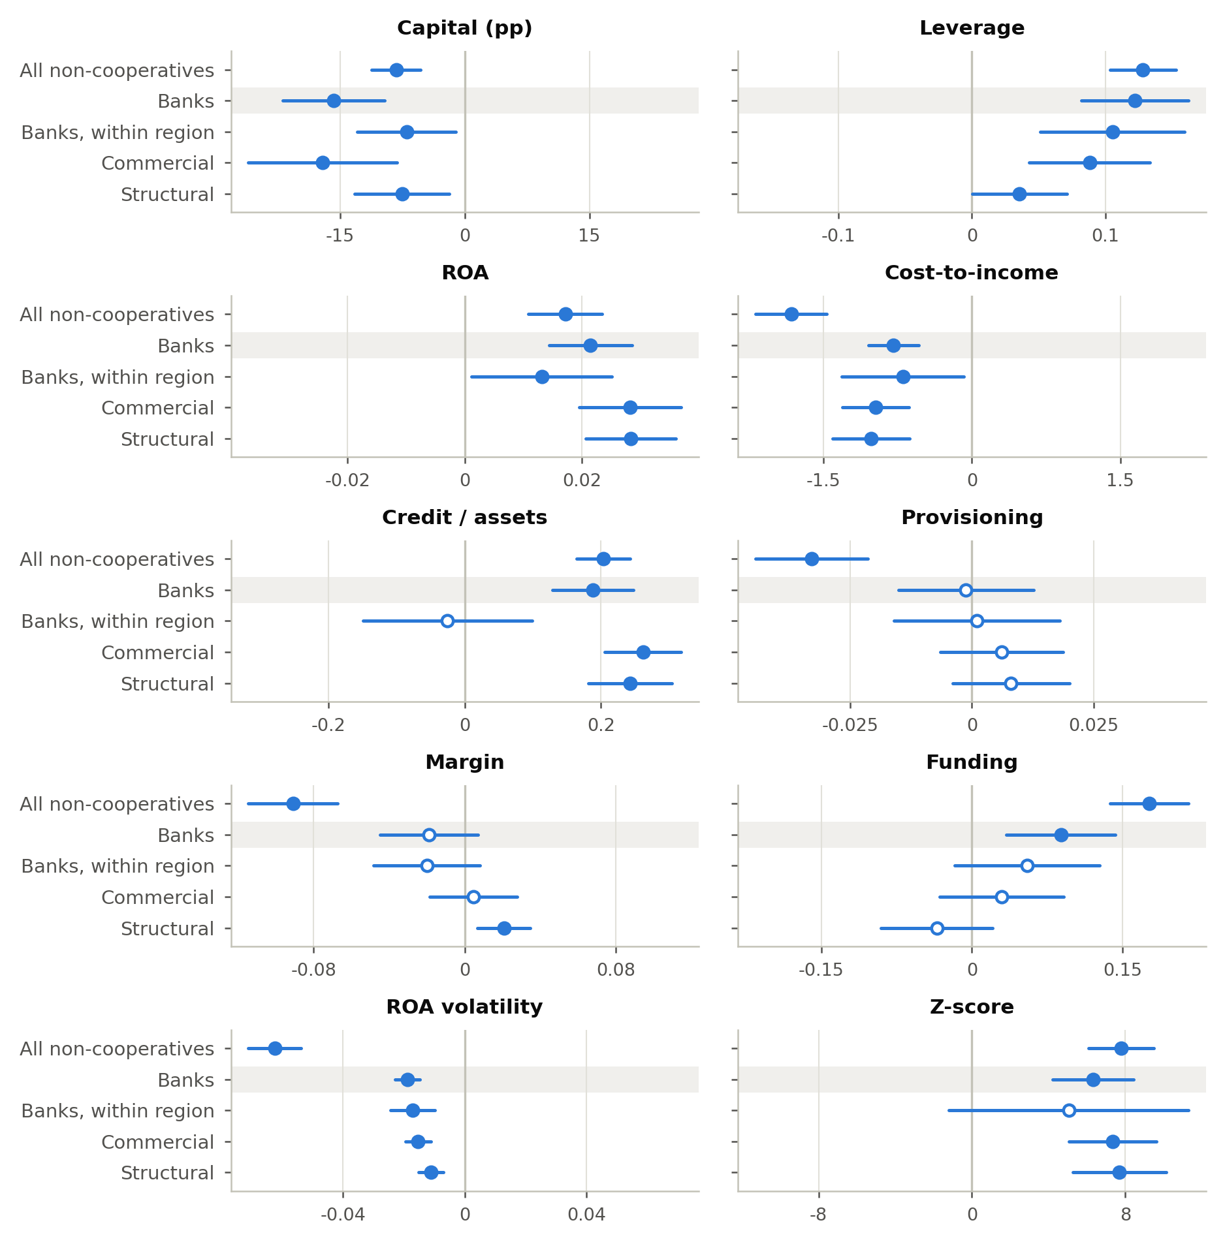
Figure 5. Cooperative coefficient by comparison group
Controlled specification; the within-region rung also matches on macro-region. Intervals are 95 percent, clustered by institution (HC3 for the stability outcomes). Filled markers: p < 0.05. Shaded: banks, the primary group.
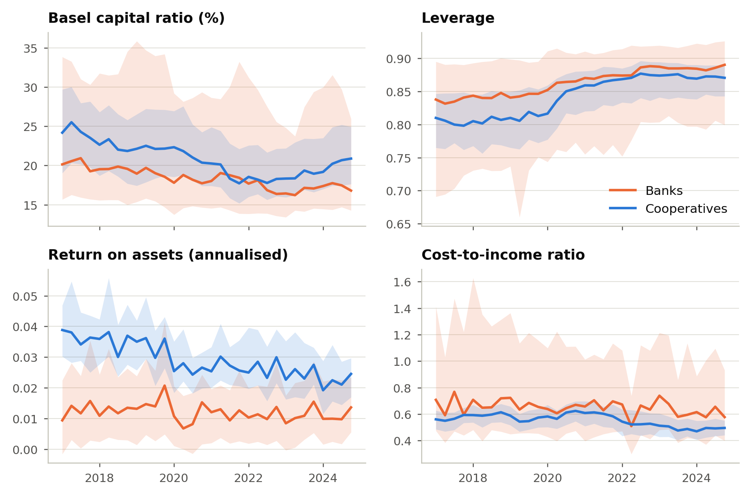
Figure 6. Medians and interquartile ranges, 2017 to 2024
Against all non-cooperatives, cooperatives appear to provision less, significant at one percent in all four specifications, while against banks the coefficient is close to zero. The broad-group gap comes from the non-banking lenders, whose provisioning ratios are nearly three times those of banks and cooperatives; the institutions that do not lend barely enter, since fewer than five percent of their quarters carry the ratio. At the conditional median the sign reverses, with cooperatives provisioning more, and under the tightest winsorisation rule the mean coefficient also turns positive and significant. Supervisory concern attaches to capital, so we also split the sample into terciles of the Basel ratio, and no tercile shows cooperatives provisioning less. Cut on the unconditional ratio, the differential is not distinguishable from zero in the bottom and top terciles and is positive and significant in the middle tercile, where the largest share of cooperative quarters sits; cut on the ratio residualised on size and quarter, no tercile differs. Because minimum provisions are a step function of the AA to H rating of each operation, the result most likely describes how the two groups classify their books.
The intermediation margin behaves in the same way. It is large and highly significant against the broad group, whose non-banking members report intermediation margins several times those of banks and cooperatives relative to assets. Against banks it is small and insignificant, and against structural banks it turns positive and significant. Its sign depends on the comparison group, so we keep it as a null. The funding ratio is significant in one of four specifications and reverses sign at the conditional median, so we do not report it as a finding.

4.3 Credit intensity within and across regional markets
Matched on size alone, cooperatives allocate a substantially larger share of assets to credit than comparable banks, significant at one percent in every specification. Matched also on macro-region, the differential is small and not distinguishable from zero under any coarsening scheme. Cooperatives thus lend more than the national bank population, while within regional markets the difference cannot be told apart from zero. However, which estimate is the parameter of interest depends on an assumption we cannot test. If cooperatives concentrate where they do for reasons internal to member-based finance, region is a mediator and the size-only estimate is the parameter. If regional market structure is heterogeneity unrelated to form, region is a confounder and credit intensity is a null. We report the two as distinct parameters, the sector-wide and the within-market differential, and label every claim by the comparison it rests on.
Two cautions apply. The within-region estimates are imprecise, since region-exact strata leave an effective control sample of eighteen. The within-market null may therefore reflect low power as much as the parameter itself (Figure 5 shows the intervals). In addition, macro-region is a coarse proxy for market, and the relevant distinction is probably rural credit, which a credit-modality measure would capture. Return volatility survives the within-region comparison, while the z-score, which shares its denominator, does not. We read the pair as one result whose within-market status is uncertain.

4.4 Network-level heterogeneity
The online appendix splits the cooperative side by system. Sicredi and Sicoob account for all but seven of the cooperatives, so the split describes those two networks and cannot test network affiliation as such. Cooperatives in both networks hold less regulatory capital than comparable banks, significant under the bootstrap in each. The six independents rest on five treated clusters, three of which supply nearly all the quarters. Their capital estimate is positive and cannot be separated from noise. In addition, their return on assets shows why the bootstrap matters: it is overwhelmingly significant under clustered errors and only just significant under the bootstrap.
The split locates the pooled capital differential in the two large networks without explaining it. With five independent cooperatives, we cannot tell whether independents differ or are simply too few to detect. A network backstop is one candidate explanation, since a cooperative with centralised liquidity and consolidated risk management behind it may run a thinner individual cushion. The networks also differ in the size, geography, business mix and governance of their affiliates, and the split cannot separate the backstop from these. Provisioning is insignificant in every system.

4.5 Selection into the analysis sample
The full-methodology restriction equalises the regulatory environment, but it also selects the sample. The cooperatives we observe are the largest in the country, about a tenth of all cooperatives recorded in the panel. Fifty-one singular cooperatives are observed under the simplified methodology before they adopt the full methodology during the window. We compare those future adopters with cooperatives that never adopt, on pre-adoption quarters only and conditioning on size and quarter. The two groups show no difference in leverage, but adopters were less credit-intensive (−0.068, p = 0.002) and marginally less profitable, which runs against our findings. They were also marginally leaner, which runs with them. As a result, selection likely biases the credit and profitability estimates towards zero and, if anything, the efficiency estimate marginally away from it.

4.6 Sensitivity checks
The online appendix reports the conditional medians and the specification without the eleven S1 and S2 banks, which moves no significant coefficient by more than two percent. In addition, it reports a split at the January 2022 replacement of the 2013 capital rules. Every surviving result keeps its sign and significance in both subperiods, and provisioning and the margin remain null in both. Magnitudes are roughly a fifth smaller after 2022, so the comparison under a common methodology holds across the methodology's own revision. Four winsorisation rules, re-estimation on the rows where provisioning is observed, and dropping the six cooperatives that revert to the simplified methodology leave every surviving sign unchanged. The weighted and unweighted matched-sample estimates differ by less than the sampling error; the largest difference is for the capital ratio, where the weighted estimand is two percentage points larger.

5 Discussion
The surviving results suggest a focused retail lender. A cooperative in the full-methodology population channels a high share of its assets into member credit and runs that operation at low cost. It earns a solid return on assets on intermediation spreads similar to those of banks, and it sits in a narrow band of the capital distribution. This profile is consistent with a member-service orientation in which capital accumulation is a means to member credit (Fonteyne, 2007).
Our results agree with Hesse and Čihák (2007) on two of the three bank-level differences they report, lower capitalisation at comparable size and lower return volatility. They differ on the third. In their sample cooperative stability came with lower profitability, whereas in this population cooperatives are both more profitable and less volatile, on margins indistinguishable from those of banks. The difference may reflect our population, which is restricted to the largest cooperatives and to a common prudential methodology.
For supervision, the relevant combination is capital and provisioning taken together. At the thin end of the capital distribution, where prudential concern would attach, cooperatives hold more capital than comparable banks and provision no less, while the finding that they provision more holds only in the middle of the capital distribution. The data also show that cooperatives lack the highly capitalised upper tail that banks exhibit. Several differentials that look large at the mean are differentials in dispersion, so we give the conditional median and the quantile profile as much weight as the conditional mean.
Three analyst choices determined whether headline results existed. The first is the comparison group, which as “all non-cooperatives” imports some 160 institutions that neither lend nor raise funds. The second and third are reading IF.data income fields as quarterly flows and estimating the matched comparison by unweighted OLS on the matched sample. Each is a natural reading of the source material. Some of the disagreements in the literature may reflect different comparison groups.

5.1 Limitations
Six limitations bound the claims. Because cooperative status is time-invariant, the estimates are conditional correlations. The full-methodology restriction selects the largest cooperatives, and the results generalise only to that subpopulation. The provisioning ratio is an accounting variable and does not measure delinquency. The stability outcomes are institution-level statistics on a subsample, estimated without quarter effects. Most systems are too thinly represented for separate inference, and the network backstop hypothesis needs consolidated network data that IF.data does not carry. The mediator question in Section 4.3 also needs a market measure finer than macro-region, and IF.data's credit-modality modules, which carry rural credit, are the natural next step. Finally, we attempted a within-institution design around the adoption of the full methodology and do not report one. Adoption is driven by growth, growth moves every balance-sheet ratio continuously, and pre-adoption trends run through the adoption date without a break, so the threshold crossing does not identify a regime effect.

6 Contributions and Implications
This paper characterises cooperative behaviour under full Basel-style regulation in a large emerging market, on the full population of full-methodology institutions. The substantive contribution is this profile, together with two nulls that correct claims the same data appear to support under a looser comparison group. The methodological contribution is a protocol that defines peers on the regulator's own categories, reports a ladder of comparison groups, and separates sector-wide from within-market differences. It also states how cumulative flows were converted to rates, reports the matched estimand, and prints treated cluster counts beside system-level p-values. Each step is inexpensive, and in our data each changed at least one conclusion.
Our results bear on two margins of proportionality beyond size (Conselho Monetário Nacional, 2017a). Because the evidence is descriptive, we frame both as questions. The first is organisational architecture, since the capital differential is a property of the two large networks. If the backstop hypothesis is right, a proportional framework might treat an integrated network and its backstop as the unit for parts of the capital and liquidity assessment, as Coelho et al. (2019) report for the French cooperative groups. If the differential reflects the affiliates' size, geography or business mix, that suggestion does not follow. The second is the calibration of the benchmark itself. A benchmark set against the average full-methodology institution may describe the cooperative configuration poorly, because that average comes from a distribution whose upper region cooperatives do not inhabit. Section 1.1 indicates why a lighter requirement does not follow automatically. The representation rationale weakens for a member-owned, network-monitored cooperative, but the systemic-externality and public-guarantee rationales still apply, so thinner capital may call for closer supervisory attention as well as for relief.
For the cooperative movement, the difference between the two forms persists under a common prudential methodology, in a narrower form than a loose comparison suggests. Our evidence does not support a case resting on cooperatives provisioning more conservatively than banks. A case resting on cost at the median, return on assets and return stability holds against every definition of a bank we tried. One resting on credit intensity holds against the national bank population but has not been shown within regional markets.

7 Key References
Abadie, A., Athey, S., Imbens, G. W., & Wooldridge, J. M. (2023). When should you adjust standard errors for clustering? Quarterly Journal of Economics, 138(1), 1–35. https://doi.org/10.1093/qje/qjac038
Ayres, I., & Braithwaite, J. (1992). Responsive regulation: Transcending the deregulation debate. Oxford University Press.
Baldwin, R., & Black, J. (2008). Really responsive regulation. Modern Law Review, 71(1), 59–94. https://doi.org/10.1111/j.1468-2230.2008.00681.x
Banco Central do Brasil. (2020). Cooperativas de crédito versus bancos privados: comportamento após a captura de novos clientes (Estudo Especial No. 91/2020). Banco Central do Brasil.
Banco Central do Brasil. (2025). Panorama do Sistema Nacional de Crédito Cooperativo: data-base dezembro de 2024.
Banco Central do Brasil. (2026). Panorama do Sistema Nacional de Crédito Cooperativo: data-base dezembro de 2025.
Basel Committee on Banking Supervision. (2011). Basel III: A global regulatory framework for more resilient banks and banking systems. Bank for International Settlements.
Basel Committee on Banking Supervision. (2019). Proportionality in bank regulation and supervision: A survey on current practices. Bank for International Settlements.
Becchetti, L., Ciciretti, R., & Paolantonio, A. (2016). The cooperative bank difference before and after the global financial crisis. Journal of International Money and Finance, 69, 224–246. https://doi.org/10.1016/j.jimonfin.2016.06.016
Beck, T., Hesse, H., Kick, T., & von Westernhagen, N. (2009). Bank ownership and stability: Evidence from Germany [Working paper]. Deutsche Bundesbank.
Brasil. (2009). Lei Complementar nº 130, de 17 de abril de 2009. Dispõe sobre o Sistema Nacional de Crédito Cooperativo. Diário Oficial da União. https://www.planalto.gov.br/ccivil_03/leis/lcp/lcp130.htm
Bressan, V. G. F., Braga, M. J., Bressan, A. A., & Resende Filho, M. de A. (2011). Uma aplicação do sistema PEARLS às cooperativas de crédito brasileiras. Revista de Administração (RAUSP), 46(3), 258–274. https://doi.org/10.1590/S0080-21072011000300005
Cameron, A. C., Gelbach, J. B., & Miller, D. L. (2008). Bootstrap-based improvements for inference with clustered errors. Review of Economics and Statistics, 90(3), 414–427. https://doi.org/10.1162/rest.90.3.414
Cameron, A. C., & Miller, D. L. (2015). A practitioner's guide to cluster-robust inference. Journal of Human Resources, 50(2), 317–372. https://doi.org/10.3368/jhr.50.2.317
Carvalho, F. L. de, Diaz, M. D. M., Bialoskorski Neto, S., & Kalatzis, A. E. G. (2015). Exit and failure of credit unions in Brazil: A risk analysis. Revista Contabilidade & Finanças, 26(67), 70–84. https://doi.org/10.1590/1808-057x201411390
Castro Carvalho, A. P., Hohl, S., Raskopf, R., & Ruhnau, S. (2017). Proportionality in banking regulation: A cross-country comparison (FSI Insights on Policy Implementation No. 1). Bank for International Settlements, Financial Stability Institute.
Coelho, R., Mazzillo, J. A., Svoronos, J.-P., & Yu, T. (2019). Regulation and supervision of financial cooperatives (FSI Insights on Policy Implementation No. 15). Bank for International Settlements, Financial Stability Institute.
Conselho Monetário Nacional. (1999). Resolução nº 2.682, de 21 de dezembro de 1999. Critérios de classificação das operações de crédito e regras para constituição de provisão. Banco Central do Brasil. https://www.bcb.gov.br/pre/normativos/res/1999/pdf/res_2682_v2_L.pdf
Conselho Monetário Nacional. (2013a). Resolução nº 4.192, de 1º de março de 2013. Metodologia para apuração do Patrimônio de Referência. Banco Central do Brasil.
Conselho Monetário Nacional. (2013b). Resolução nº 4.193, de 1º de março de 2013. Apuração dos requerimentos mínimos de Patrimônio de Referência, de Nível I e de Capital Principal e adicional de Capital Principal. Banco Central do Brasil.
Conselho Monetário Nacional. (2013c). Resolução nº 4.194, de 1º de março de 2013. Metodologia facultativa simplificada para apuração do requerimento mínimo de Patrimônio de Referência por cooperativas de crédito. Banco Central do Brasil.
Conselho Monetário Nacional. (2015a). Resolução nº 4.401, de 27 de fevereiro de 2015. Requerimentos mínimos de liquidez de curto prazo (LCR). Banco Central do Brasil.
Conselho Monetário Nacional. (2015b). Resolução nº 4.434, de 5 de agosto de 2015. Constituição, autorização para funcionamento, funcionamento, alterações estatutárias e cancelamento de autorização para funcionamento das cooperativas de crédito. Banco Central do Brasil. https://normativos.bcb.gov.br/Lists/Normativos/Attachments/48507/Res_4434_v8_P.pdf
Conselho Monetário Nacional. (2017a). Resolução nº 4.553, de 30 de janeiro de 2017. Segmentação do conjunto das instituições financeiras para fins de aplicação proporcional da regulação prudencial. Banco Central do Brasil. https://normativos.bcb.gov.br/Lists/Normativos/Attachments/50335/Res_4553_v2_L.pdf
Conselho Monetário Nacional. (2017b). Resolução nº 4.606, de 19 de outubro de 2017. Metodologia facultativa simplificada para apuração do requerimento mínimo de Patrimônio de Referência Simplificado (PRS5). Banco Central do Brasil. https://normativos.bcb.gov.br/Lists/Normativos/Attachments/50454/Res_4606_v5_P.pdf
Conselho Monetário Nacional. (2017c). Resolução nº 4.615, de 30 de novembro de 2017. Razão de Alavancagem. Banco Central do Brasil.
Conselho Monetário Nacional. (2017d). Resolução nº 4.616, de 30 de novembro de 2017. Requerimento mínimo de liquidez de longo prazo (NSFR). Banco Central do Brasil. https://normativos.bcb.gov.br/Lists/Normativos/Attachments/50474/Res_4616_v1_O.pdf
Conselho Monetário Nacional. (2021a). Resolução nº 4.955, de 21 de outubro de 2021. Metodologia para apuração do Patrimônio de Referência. Banco Central do Brasil.
Conselho Monetário Nacional. (2021b). Resolução nº 4.958, de 21 de outubro de 2021. Requerimentos mínimos de Patrimônio de Referência, de Nível I e de Capital Principal e adicional de Capital Principal. Banco Central do Brasil.
Conselho Monetário Nacional. (2021c). Resolução nº 4.966, de 25 de novembro de 2021. Conceitos e critérios contábeis aplicáveis a instrumentos financeiros e provisão para perdas esperadas. Banco Central do Brasil.
Conselho Monetário Nacional. (2022). Resolução nº 5.051, de 25 de novembro de 2022. Dispõe sobre a organização e o funcionamento de cooperativas de crédito. Diário Oficial da União, 28 de novembro de 2022, Seção 1, pp. 25–28.
Cook, M. L. (1995). The future of U.S. agricultural cooperatives: A neo-institutional approach. American Journal of Agricultural Economics, 77(5), 1153–1159. https://doi.org/10.2307/1243338
Cuevas, C. E., & Fischer, K. P. (2006). Cooperative financial institutions: Issues in governance, regulation, and supervision (World Bank Working Paper No. 82). The World Bank.
Diamond, D. W., & Dybvig, P. H. (1983). Bank runs, deposit insurance, and liquidity. Journal of Political Economy, 91(3), 401–419. https://doi.org/10.1086/261155
Ferri, G., Kalmi, P., & Kerola, E. (2014). Does bank ownership affect lending behavior? Evidence from the Euro area. Journal of Banking & Finance, 48, 194–209. https://doi.org/10.1016/j.jbankfin.2014.05.007
Fonteyne, W. (2007). Cooperative banks in Europe: Policy issues (IMF Working Paper No. WP/07/159). International Monetary Fund. https://doi.org/10.5089/9781451867237.001
Hansmann, H. (1996). The ownership of enterprise. The Belknap Press of Harvard University Press.
Hesse, H., & Čihák, M. (2007). Cooperative banks and financial stability (IMF Working Paper No. WP/07/2). International Monetary Fund. https://doi.org/10.5089/9781451865660.001
Iacus, S. M., King, G., & Porro, G. (2012). Causal inference without balance checking: Coarsened exact matching. Political Analysis, 20(1), 1–24. https://doi.org/10.1093/pan/mpr013
Iannotta, G., Nocera, G., & Sironi, A. (2007). Ownership structure, risk and performance in the European banking industry. Journal of Banking & Finance, 31(7), 2127–2149. https://doi.org/10.1016/j.jbankfin.2006.07.013
MacKinnon, J. G., & Webb, M. D. (2017). Wild bootstrap inference for wildly different cluster sizes. Journal of Applied Econometrics, 32(2), 233–254. https://doi.org/10.1002/jae.2508
McKillop, D., French, D., Quinn, B., Sobiech, A. L., & Wilson, J. O. S. (2020). Cooperative financial institutions: A review of the literature. International Review of Financial Analysis, 71, 101520. https://doi.org/10.1016/j.irfa.2020.101520

Appendix A. Reproducibility
All results come from one script run against the public IF.data bulk files, with every comparison group, coarsening, winsorisation rule and sensitivity check as a parameter. Tables are generated from the results files. The online appendix holds the remaining tables.

The segment label is revised semiannually, so five full-methodology cooperative-quarters still carry the S5 label in transition. The sample follows the reported methodology.
Provisioning is observed for nearly all cooperative-quarters and for about five in six bank-quarters. The missing bank-quarters are concentrated among the low-credit institutions the ladder is designed to remove, and in 2023, when coverage falls to about two thirds for banks.
A further five cooperatives carry simplified-methodology quarters only after their first full-methodology quarter and are excluded from the pre-adoption comparison. With one adopter that also reverts, they are the six reverters discussed below. Including them leaves the sign of every coefficient reported here unchanged.

