
Contract ¹: | 35169
Acronym: | SUDDEN
Project Title: | SMEs Undertaking Design of Dynamic Ecosystem Networks
Consortium: | - THE UNIVERSITY OF MANCHESTER (UM)  - JOHANNES KEPLER UNIVERSITAET LINZ (JKU)  - APIF MOVIQUITY S.A. (MOV)  - EXODUS A.E. (EX)  - DIBO DIAMANTWERKZEUGE GMBH (DIBO)  - SCHNEEGANS-SILICON GMBH (SG)  - GWS PRODUKTION HANDEL SERVICE GMBH (GWS)  - AUTOMOTIVE SOLUTIONS GMBH (AS)
Contract Start Date: | 01.09.2006 |  | Contract Termination Date: |  | 31.08.2009
Deliverable Title:

Developer Notes

Version History
Version | Comments, Changes, Status | Author(s)
0.9 | Initial Version | Matthias Neubauer, JKU
1 | Updated | Georg, JKU
3 | Updated Base (basic classes, gui) & TF modules  Updated description of basic data classes for Actors (Organisations, Processes, ...) these are now in the Base package and made persistent using hibernate in a generic manner. | Matthias, JKU  Georg, JKU  Thomas, JKU
4 | ASN related structures based on SM, and TM base impl. | JKU Team
6 | Chapter on HBO <-> CP | JKU
7 & 8 | Linking, Annotations | JKU
9 | Integration of EX modules | JKU, EX

Introduction
This is a living document which should be used beside “SUDDEN Eclipse Installation Instruction” (1_installingInstruction.doc) and “Introduction to Spring and the SUDDEN project structure” (2_Spring_SUDDEN_Intro.doc). It contains additional information targeted towards software developers.

General Notes on the SUDDEN framework

SUDDEN Configuration

    - Important configuration files:
- src/main/java/biz/sudden/package-info.java
- src/main/resources/biz/sudden/spring/rootContext.xml
- src/main/resources/biz/sudden/spring/”subsystem”/context.xml
- WebContent/WEB-INF/dispatcher.xml
- WebContent/WEB-INF/faces-config.xml
Below sundry notes on each file can be found.

package-info.java
The biz.sudden.baseAndUtility.connectable package requires package-info.java to ensure correct functionality. Each class which implements biz.sudden.baseAndUtility.connectable.Connectable.java has to define a respective MetaValue in package-info.java (e.g. @MetaValue (targetEntity = biz.sudden.baseAndUtility.domain.Process.class, value="process"))
Note: Connectable is an interface used with some basic data types. Please take a look.

rootContext.xml
rootContext.xml is a central configuration file. It integrates the context.xml files of the subsystems (by importing them) and defines beans for the data source, session factory, transaction manager and for the repository template. These beans are referenced by beans defined in context.xml files of subsystems. Currently also domain objects of subsystems, which represented by an “annotated Class” are defined in rootConext.xml.

context.xml
Each subsystem defines its beans for concrete services and repositories in its context.xml (e.g. -> found in src/main/resources/baseAndUtility/context.xml)

dispatcher.xml
dispatcher defines beans for the web user interface.

faces-config.xml
feaces-config defines navigation rules between different web pages. Currently there is one faces-config.xml for all subsystems.

General issues

    - Basic classes in biz.sudden.baseAndUtility!
Please take a look (in order to understand what is already there!) at the classes available in this package and its subpackages. These classes provide base functionality of interest for each other sub-system. Classes in baseAndUtility therefore have to contain JAVA DOC descriptions.

    - Naming conventions:
- Naming of bean ids. (To avoid naming conflicts between beans of different subsystems, bean ids should be declared as following: “packageName.beanId”, e.g. <bean id = “baseAndUtility.assocRepository”..../>)

    - Hibernate
We are using Annotations for the hibernate mapping. Therefore domain objects defined in domain packages of subsystems have to be annotated.

    - GUI approach
Each subsystem should define its “web-pages” in WebContent/biz/sudden/subsystemname (e.g. jspx for baseAndUtility.connectable -> WebContent/biz/sudden/baseAndUtility), whereas the general GUI frame should be provided by WebContent/biz/sudden/userInterface/gui. As described above, icefaces allows you to define navigation rules between “web-pages” in the faces-config.xml.

Please note that links also have to be resolved by these navigation-rules. There exist an “index.jsp” (JSP) in the web folder, which redirects to “WEB-INF/index.jspx” (JSF) file. All “jspx” files reside in “WEB-INF” folder, so no direct linking (via “a href ...”) works.

Please follow this pattern due to link to another jspx page:

<ice:form>
<ice:commandLink value=”This is a link” action=”baseAndUtility” />
</ice:form>

Note that “commandLinks” have to be surrounded by “<ice:form>” tags. The string in the “action” parameter is matched against “faces-config.xml”

<navigation-rule>
<from-view-id>/WEB-INF/index.jspx</from-view-id>
<navigation-case>
<from-outcome>baseAndUtility</from-outcome>
<to-view-id>/WEB-INF/biz/sudden/baseAndUtility/overview_mane.iface</to-view-id>
</navigation-case>
<navigation-rule>

Like shown above, the “<ice:commandLink”> tag with the action”baseAndUtiltity” within “WEB-INF/index.jspx” links to “/WEB-INF/biz/sudden/baseAndUtility/overview_mane.iface”.

    - Adapted domain classes
In order to use shared domain classes, we recommend the usage of the ADAPTER pattern due to simulate multiple-inheritance. On the one hand there exist a set of domain classes in each context which should be used by different subsystems (e.g. “User”, etc.), whereas each subsystem is able to use these domain objects in their own context (e.g. use a specific domain object in a inheritance hierarchy).
The idea is that each subsystem manages the domain objects it needs itself, whereas all common objects (which reside in the “base”) should be adapted. The example below shows the functionality of this approach. “Process.java” is a domain class which resides in the base because it should be used in different subsystems.
In order to use that “Process” class in a specific subsystem with the possibility to use inheritance (e.g. “ProcessAdapter” should inherit from “CommunicationItem”) each subsystem has to define an adapter, where the Process-specific attributes (like processName) are forwarded to the original Process. This is realized through an attribute “adapted” which holds a reference to “Process” in our example. In addition to the possibility of multiple-inheritance this approach also allows each subsystem to control all of their domain classes within the subsystem.
public class Process {

private String processName;

public String getProcessName() {
return processName;
}

public void setProcessName(String processName) {
this.processName = processName;
}
}
Process.java (resides in base)
ProcessAdapter.java (resides in an arbitrary subsystem)
public class ProcessAdapter extends CommunicationItem {
private Process adapted;

public Process getAdapted() {
return adapted;
}

public void setAdapted(Process adapted) {
this.adapted = adapted;
}

public String getProcessName() {
return this.adapted.processName;
}

public void setProcessName(String processName) {
this.adapted.processName = processName;
}
}

    - Generic Repository
According to the article “don't repeat the dao” (URL: http://www.ibm.com/developerworks/java/library/j-genericdao.html) we are using a generic approach for our repositories. This avoids defining common create/retrieve/update/delete again and again.

Classes of concern for this approach:
- biz.sudden.baseAndUtility.repository.generic.GenericRepository.java
-> interface which defines CRUD methods in a generic way
- biz.sudden.baseAndUtility.repository.hibernate.generic.GenericRepositoryImpl.java
→ concrete hibernate implementation of the interface, which serves as base class for hibernate repositories of the subsystems.

Current project state (implementation view)

BaseAndUtility

Common domain objects
Common domain objects for all subsystems should be defined within the baseAndUtility.domain package. Subsystems can use, adapt or inherit domain objects.

Currently following common domain objects are defined:
- Actor
- Organisation
- Manufacturer
- User
- (Process; is this domain object in use?)

For these classes, a TopicMap oriented approach to handle flexible connections between these is implemented. Take a look in the following section about general information. Services are provided by the SM sub-system that allow to connect actors (organisations, manufacturers), processes and items (products). SM-interfaces for allowing “dynamic” (I.e. Runtime) rewiring of connections between instances of these classes are provided.
For these classes also hibernate mappings are done and will be available soon. Ergo in BaseAndUtility a service that handles the CRUD methods for these classes has been implemented. TAKE A LOOK at these and use them instead of providing your own implementation. These classes are essential and used all over the system, by multiple coders.

BaseAndUtility.connectable
Currently SUDDEN includes a “baseAndUtility.domain.connectable” package, which provides methods to associate domain objects. The logic to associate domain objects is similar to the “association logic” of Topic Maps (Basic Topic Map information can be retrieved from http://www.ontopia.net/topicmaps/materials/tao.html (The TAO of Topic Maps)).

An Association contains a concrete Association type and at least an Association role. An Association role represents the link between an Association and a Connectable (comparable to Topic in a Topic Map), whereas an Association role also consists of an Association role type. Note that Connectable is an interface. Domain objects can implement this interface and “associate” themselves with other domain objects implementing the Connectable interface. The usage of an interface also avoids problems regarding multiple inheritances. The given Figure below depicts the described approach.

Generally, subsystems of the SUDDEN System shall use this approach to represent associations between domain objects within and across subsystems.

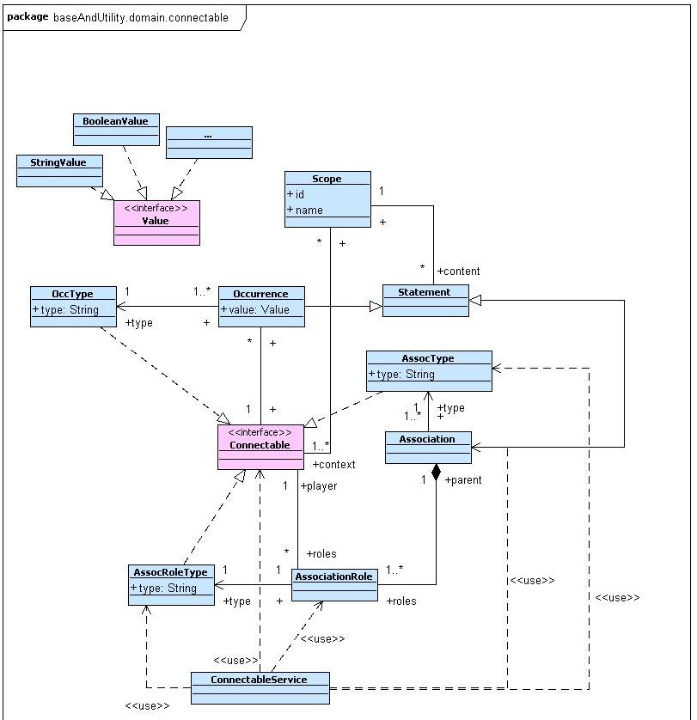
Compared to the first draft, we have implemented the remaining topic map concepts [Occurrence, Scope]. A scope defines the valid context of statements, whereas Statements are Occurrences and Associations. An Occurrence defines the link to a resource.

ServiceManagement

The given figure below, depicts the adapted data view for the ServiceManagement subsystem. Input / Output relations for a Process will be implemented using baseAndUtility.domain.connectable. Also relations (Part, Input, Alternative, Variant) between concrete Items will be implemented using baseAndUtility.connectable.
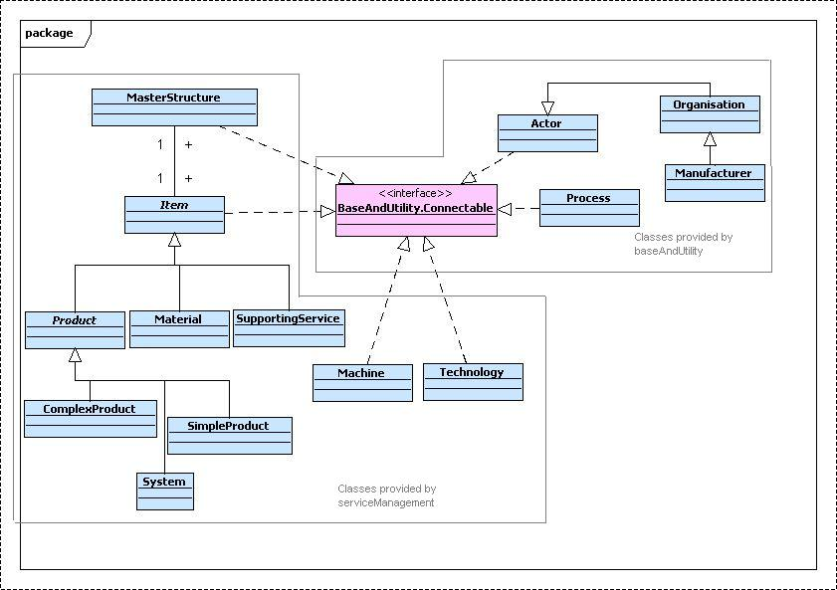
SM-DataView

Linking Service Management Concepts with Kurt's Excel
(where that excel is presenting sheets with concrete values for Parts , Technologies, ...).

Capabilities tell what an organisation is able to do (e.g. manufactures motors).
Competences tell how good an organisation performs (e.g. is ISO9000 certified; has a mark of '7' for “leadership”).

Basic Content is given through the instances_competence_map_data...Excel Sheet from Kurt.

It appears that based on input from the end-users the following concepts should be linked within the Service Management sub-system:

Original name
in Kurt's Excel
Organisation |  |  |  |  | Master Data
<provides> | Product-part or Service |  |  |  | Product value creating view
 | <made> | Material |  |  | materials
 |  | <processed> | Technique (Technology) |  | Material processing
 |  |  | <realised> | Machine | machinery

Legend:
1 Topic (Connectable)
<is associated with>
N Topics (Connectable)

Organisation is mainly maintained in User Organisation Management the others by Service management. The importance of these concepts is highlighted by the fact that these are stored in the baseAndUtility package (since almost all modules use it).

The 1 to N association indicated above is a constraint mainly due to the User interface.

The idea of the “customers product view” is stripped away here. The initial intention of that excel sheet was to highlight the products sold to an OEM whereas the “product part or Service“ view (product-value creating view) shows what the organisation under concern is actually providing for that product part or service (i.e. Other stuff is outsourced).
However we might insert “products sold” information directly into the organisation. I.e. it is part of UOM and not of Service management

Rather new is also that in contrast to the detailed design each registered organisation is responsible by itself to enter the associations given above, declaring what it does, with what material and how (which technology).

Content of the Concepts ....

Organisation .... master data stuff.
(customers product view (removed) .... what an organisation sells to customers and for which parts/services is a supplier listed with an OEM)
Product (esp. Production of a tangible part (i.e. product) and Service) ... what an organisation is capable of providing; A Classification of parts and to some extend sub-parts.
Material ... what basic material (in contrast to parts) an organisation uses to create a product part (I.e. there are no materials for services).
Technology (Technique) ... how (e.g. through cutting) does a supplier “transform” the material into a product part; Please note that this technology does not contain process related information!
Machine ... Informative Fields for describing a machine. Additional Information (text fields) for users.

Performance Measurement based on Topic Maps

The following image shows in an “informal” approach all Enterprise Evaluation Profile (EEP) concepts in context. An enterprise evaluation profile (named so to better distinguish it from a network evaluation profile; but conceptually the same as an performance evaluation profile described in D4.2) is a nested structure of EnterpriseEvaluationProfile (EEP) classes associated with other EEP classes or CompetenceDimensions (currently; however through discussion with Victor this might change to Competence or CompetenceValueIndicator). The association is of type e.g. WeighedSum and the top EEP is in role result where the sub-EEP and the CompentenceDimensions are in a certain role which corresponds to the weights attached used by the WeightedSum function.

Following the general ideas of the TopicMap approach a few currently not implemented concepts are needed: Scope and Occurrence (+2 “helper”). An occurrence is a typed resource for a Topic (I.e. Connectable). This means for a CompetenceDimension “FaultParts” you could attach an Occurrence of the Type “parts per million” (ppm) for each Company. This means that for each company an occurrence “points” to the CompetenceDimension “FaultParts”. A Scope defines the valid context of Occurrences and Associations respectively. Therefore you can use scope as a kind of filter for “Occurrences” and “Associations” (not needed here). With respect to our example there would be a scope BMW, and a scope GWS whereas each scope contains an occurrence of type “ppm” for “FaultParts”.

The same can be applied for the “other side” I.e. the BO (=the requirements side). Here (from a TopicMap point of view), some occurrences of type ppm with value 2,4, 5 are attached to a class “FaultParts” which subclasses CompetenceDimension which in turn implements Connectable. These occurrences are associated with scopes defined through BOs. So '5' is the only visible occurrence when BO123 is “the current context”. Or 2 is the only ppm visible when current context is BMW.
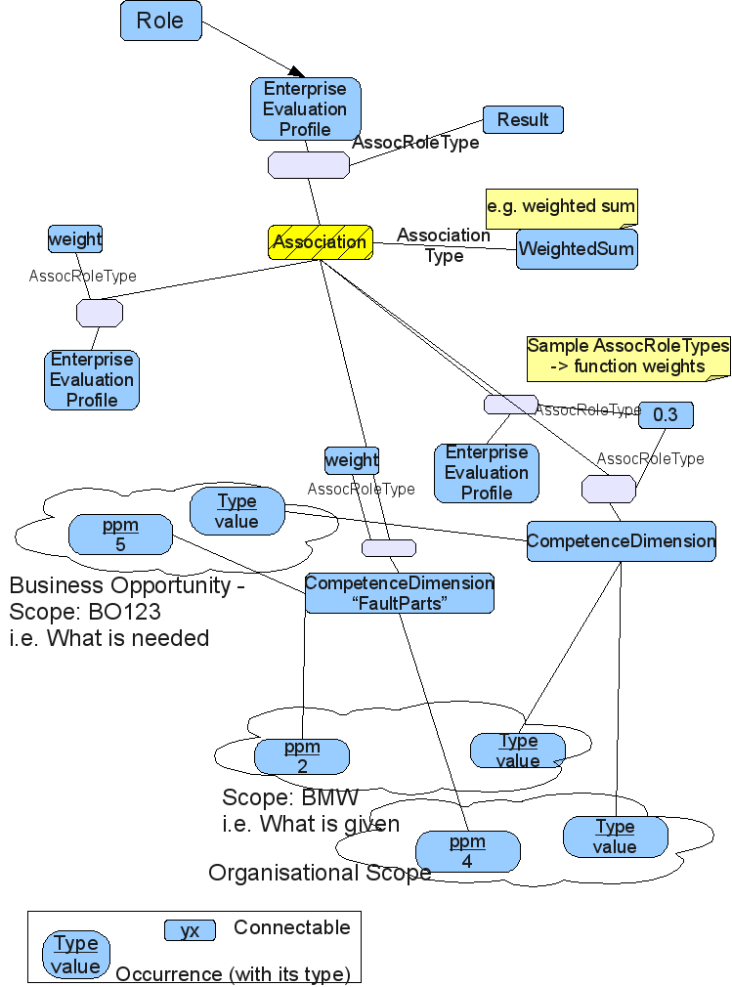

Conceptualisation of Linking for Collaborative Planning

Each project is started through the specification of a Business Opportunity. This “object” holds basic information related to the “vision/goals” of the project (including targeted costs, number of pieces sold p.a.). The Object responsible for holding project specific information generated in later stages is the case-file. In the first two phases of the sudden process/scenario (see Detailed Design Deliverable 4.2) the available information is vague and automatic decomposition to generate an Abstract Supplier Network (ASN) used by team formation is hardly possible. However in phases 3,4 more automation will be applied through the HBO module. HBO and CF will work interactively: whenever automation is possible HBO takes the lead when not CF.

The ASN brings together capabilities (what services / product-parts an organisation provides) and competences (how good an organisation performs). It also includes some sort of sequence derived from a Work Breakdown Structure (WBS) which stores process related information (ie. Which parts have to be available before being able to build a larger part).

When an automatic generation is not possible, Collaborative Planning supports a core team in manually generating such an ASN. The Performance Measurement sub-system allows to collaboratively design and attach Enterprise Evaluation Profiles and Network Evaluation Profiles to enrich the ASN structure with competence related minimum/maximum/desired performance information. The manual process also does not use the WBS (work-breakdown-structures which are stored and managed in the Templates module) since the users implicitly organise the work by working on the ASN.

In later stages of the overall process HBO might be triggered to decompose further details and bring forward further team members. CP will be dominating in the first two stages and HBO will be dominating later on in the lifecycle. Yet it is their interplay which will give strength to the system (ie prompting users for certain aspects of the design they have forgotten to consider, such as the acoustic properties of a car door, etc.). It is not imply that CP does first two stages, HBO does stage 3 and 4, but rater, that CP is used to organise ideas and gather missing information for HBO, whilst HBO works with the inputs from CP and with the knowledge encoded in ontologies and knowledge structures to create an abstract supply network from a business opportunity.

Implementing Linking across SW Modules

Introduction
In SUddEN a link is defined as a „connection between domain objects and top level (domain independent, platform given) objects either in unidirectional or bidirectional way“. Users are enabled to connect different objects, allowing them to navigate between bits of information back and forth. The underlying idea behind this technique is to offer a flexible way for users to transparently connect concepts which have been identified as being of relevance for each for a user (group). For example users might link a “performance indicator” (domain object) with a message in a public „Forum“. Message is a top level object. A top level object is similar to a domain object but provided by the base system and hence everybody can assume its presence.
A link always has a „source“ and a „target“ object (where these can be domain or top level objects). The „source“ denotes the beginning, whereas the „target“ denotes the end of a connection. Also of relevance is the „target type“. Each subsystem has to define which domain classes are linkable (e.g. a subsystem defines the domain classes „Communication Object“ and „Forum“ as “target type”).

User View
The following steps have to be executed by the user when
establishing a link:
- User clicks on a prepared JSF-button or JSF-commandlink (see below figure 1 for a code snippet). This component must provide a reference to the source (domain) object.
- A popup appears which shows all possible target types
- After selecting one target type all available target objects with the desired target type are shown
- After selecting one object the link is created
navigating along a link:
- User clicks on a JSF-button or JSF-commandlink which is shown within a web page
- User is shown the target of the link (a web page which shows the target object in any way)

Architecture
The SUddEN architecture is based on Spring and JSF (this standard is implemented by IceFaces). There are different architectural levels: repository-level (for data object storage and retrieval), service-level (for implementing the business logic), user-interface-level (for visualisation; divided into controller and view).
Linking requires to implementation effort on all the different levels. For usage of linking only jsf controllers, jspx pages (views) and spring configuration files have to defined in the subsystem's implementation.
The main part for Linking at the JSF level is the class „RootLinkController“ which is integrated into the Spring framework with the bean id „rootLinkController“.

Link source
From the source point of view there have to be two JSF components defined:
- A commandLink or commandButton which is used to show possible target objects
(link creation)
- A commandLink or commandButton which is used to navigate to the target object
(link navigation)

Link creation
In order to use the link creation functionality it is necessary to include the following code-snippet in the jspx page:
There the EL-expression “#{rootLinkController.link}” refers to a method which requires the source object (which is retrieved from “<f:param ... value='obj.property' ”) and shows a popup with possible target object types.
<ice:commandButton value="Link" actionListener="#{rootLinkController.link}">
<f:param name="link" id="link" value="#{comm.communication}" />
</ice:commandButton>
Figure 1: JSF command button definition for link creation

Link Navigation
In order to use the link navigation functionality it is necessary to include the following code-snippet in the jspx page:

<ice:selectOneMenu id="selectOneMenu" value="#{rootLinkController.selectedItem}" valueChangeListener="#{rootLinkController.changeItem}"
partialSubmit="true" immediate="true" binding="#{rootLinkController.selectOneMenu}" >
<f:param name="sourceObject" id="sourceObject" value="#{comm.communication}" />
<f:selectItems id="slctdItem" value="#{rootLinkController.linkentries}"/>
</ice:selectOneMenu>
Figure 2: JSF component definition for link navigation

Where:
- EL-expression “#{rootLinkController.selectedItem}” is a String denoting the currently selected Item (as an ID)
- EL-expression “#{rootLinkController.changeItem}” is the ActionListener which is fired when
a item within the dropbox is selected (in this case the link is called immediately)
- EL-expression “#{comm.communication}” is an example here (from the CollaborativePlanning subsystem), this value should denote the domain source object
- EL-expression “#{rootLinkController.linkentries}” refers to the method which returns all available links for the domain source object

Link target
The Spring configuration files have to be adjusted at several places for link target definition. The main entry point for linking is defined in the “rootContext.xml” file. The bean with id “rootLinkService” manages all custom link-target bean definitions which have to be defined in turn in the “context.xml” of the respective subsystems. The following figure shows the definition of the rootLinkService-bean, text with grey background is a sample subsystem link target bean definition.
For adding a link target functionality, a reference to the bean defined in subsystem specific “context.xml” just behind the grey color text has to be added.

The figure below shows a bean definition which reside within a subsystem's context.xml. The bean definition can be copied directly into the context.xml of a subsystem, where the grey colored text has to be customized.
<bean id="rootLinkService"
class="biz.sudden.baseAndUtility.service.RootLinkService" >
<property name="targetServices">
<list>
<ref bean="designCoordination.collaborativePlanning.targetService" />
</list>
</property>
</bean>
Figure 3: Declaration of rootLinkService in rootContext.xml
In this example a bean definition for the target domain type „Communication“, which is managed at the JSF level of the controller „CpController“, the description is „Communication in Forum“. In case of link navigation the navigation-rule with the „from-outcome“ value „showcontributions“ is triggered and the property „selectedcontribution“ is set in „CpController“ before rendering of the page.
<bean id="designCoordination.collaborativePlanning.targetService"
class="biz.sudden.designCoordination.collaborativePlanning.service.CollaborativePlanningTargetService">
<property name="targetTypes">
<list>
<bean class="biz.sudden.baseAndUtility.web.controller.domain.JsfLink">
<property name="domainClass"
value="biz.sudden.designCoordination.collaborativePlanning.domain.Communication" />
<property name="controller"
value="biz.sudden.designCoordination.collaborativePlanning.web.controller.impl.CpController"/>
<property name="description" value="Communication in Forum" />
<property name="viewID" value="showcontribution" />
<property name="parameterValuesPairs">
<bean class="biz.sudden.baseAndUtility.web.controller.domain.ParameterNameValuePair">
<property name="parameter" value="selectedContribution" />
<property name="parameterValue" value=" " />
</bean>
</property>
</bean>
</list>
</property>
</bean>
Figure 4: Declaration of target service in the specific context.xml
The following parts have to be adapted to the specific target:
- bean id:
is a unique id for the linking target bean definition of a subsystem. Do not forget to add a reference to this bean to the “rootLinkService” in rootContext.xml
For customization of the JSF Link class the following property values need to be adapted:
- domainClass:
the value of this property is a fully qualified class name as a String value, which refers to the linkable target class (e.g. “Communication”, “Forum” or “BusinessOpportunity”
- controller:
the value of this property is a fully qualified class name (string), which refers to the JSF-controller which is responsible for showing the content of a target object. Attention: if you have a controller which not only manages domain objects of the desired target type, but also a complicated net of objects connected with this target object (like tree structures, graphs, etc.), please consider writing a dedicated controller for showing only the contents of the target object
- description:
is a human readable description of the target class (as String value). It is shown in the first popup which is shown to the user who wants to create a link (possible target types)

- parameterValuesPairs:
the „parameter“ property value is the property of the controller (defined above), which should be set in case of navigation. (i.e.: in the example the „setSelectedContribution“ method of „CpController“ is called). The type of property has to correspond to the class defined in „domainClass“.
- viewId:
value of „<from-outcome>“ in the “faces-config.xml” file. This viewID is used to navigate to the appropriate JSPX page. An appropriate navigation case has to be inserted in that config file in the following form:
<navigation-case>
<from-outcome>showcontributions</from-outcome>
<to-view-id>.../showContributions.jspx</to-view-id>
</navigation-case>
Figure 5: Definition of navigation in "faces-config.xml"

In the class which is referenced by the property “Controller” within the custom bean definition, a method called “getLinkableTypeSelectionPopup” has to be implemented. (This method is called with the aid of Java reflection with the “RootLinkController”.
This method return a object of type “PanelPopup” and has two parameters from type JsfLink and RootLinkController. The method itself is liable to return a IceFaces Popup which shows the linkable objects and makes them clickable. (you can look at such a method in
“biz.sudden.designCoordination.collaborativePlanning.web.controller.impl.CpController”)
The easiest way to display all available link target objects is to define an IceFaces tree-component with the appropriate target objects as leaves.
By means of the “jsfLink” parameter you can get all informations defined in the custom Spring configuration. (see figure 4). Within the popup you have to define an ActionListener which removes the popup from the UI and links the objects chosen by the user together by means of the parameter “rootLinkController” and the contained method “linkTogether”.
During the following development efforts it planned to offer a “standard implementation” (e.g. an abstract class) which shows all objects of the desired “link target” to disburden subsystem developers of implementing low-level GUI elements.

Linking Visual Example
The example below shows link creation and navigation. This example shows linking between an inbox object and a forum entry.
The following screenshot shows the button which allows the creation of a link

After pressing the button a popup appears which contains all available link target types. The definition of these types are obtained from the different subsystem's Spring configurations shown above.
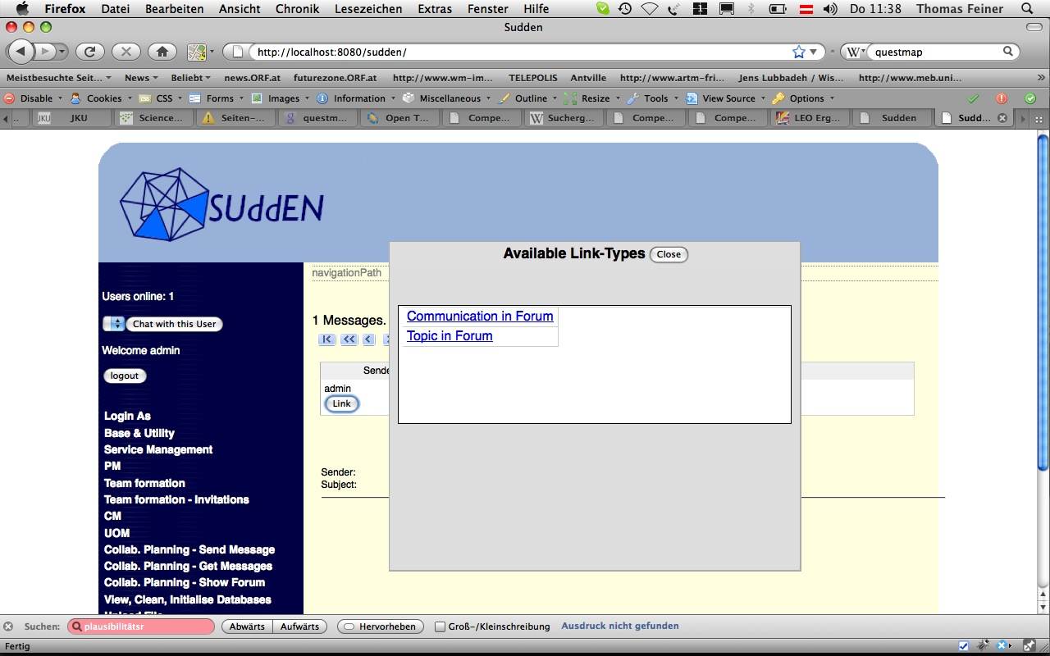Figure 6: Showing available link target types

After selecting a target type a further popup appears, which shows all available objects of that type.
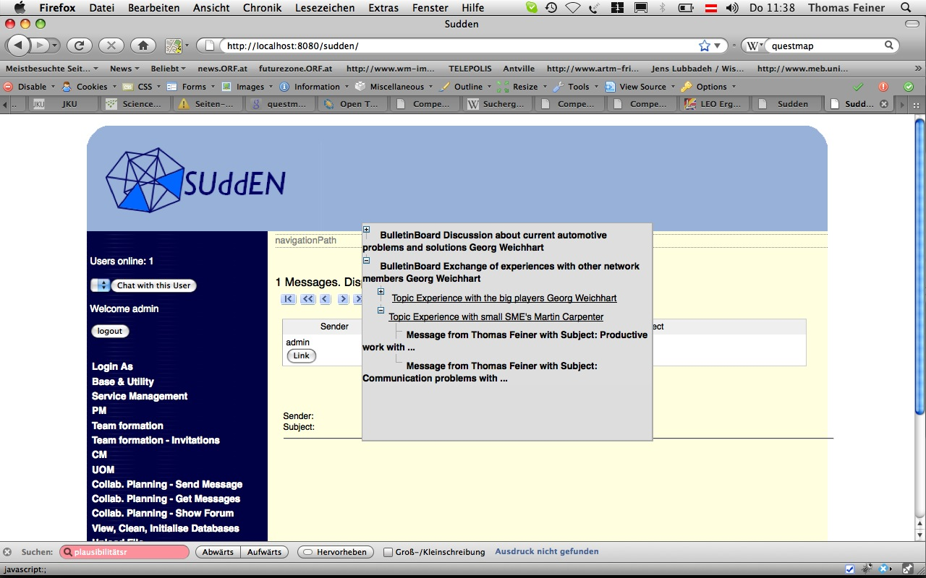Figure 7: Showing available target objects

After selecting a target object the link is created, which is shown as a hyper-link in the screen shot below.
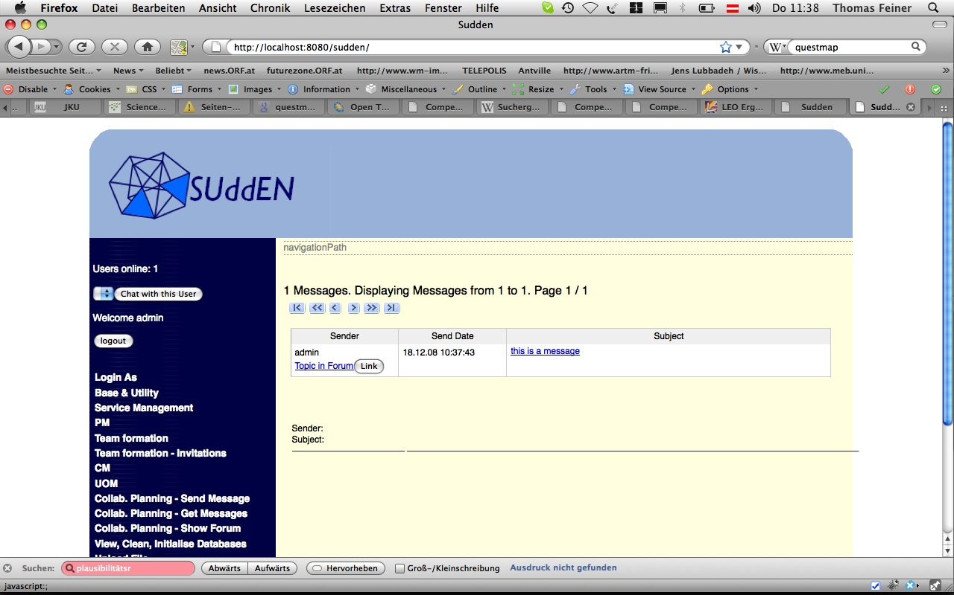Figure 8: Showing the created link within the link source object

Navigating the link shows the linked target object

JADE Agent Platform integration

A first implementation of a SPRING-JADE gateway has been provided and documented (java-doc). For testing this gateway a pingpong agent system has been implemented. The following files are part of the implementation and contain also further java doc!

- WebContent/WEB-INF/dispatcher.xml contains specifications of the Controller which is the interface to the Web-based GUI.
- WebContent/biz/sudden/designCoordination/teamFormation/pingpong.jspx provides the ICEFaces implementation of the GUI. It uses the controller specified above.
- src/main/resources/biz/sudden/spring/designCoordination/teamFormation/context.xml holds the specification of the jadeService (and its renderManager) that provides the link between controller and jade platform.
- src/main/java/biz/sudden/designCoordination/teamFormation/web/controller contains the Controller Implementations
- src/main/java/biz/sudden/designCoordination/teamFormation/service contains the classes that provide the service interface and interfaces/objects for communication between gui and agent
- src/main/java/biz/sudden/designCoordination/teamFormation/service/impl contain the service and agent-gui communication object implementation
- sudden/src/main/java/biz/sudden/designCoordination/teamFormation/domain/pingpong contain the implementation of the agent system

By running the project within Eclipse, or netbeans you find yourself at the frontpage and there you can click on TF which brings you to the TF module's page. You can start agents and play ping pong.
Take a look there the web-gui is !!dynamically updated!! when ever the agent's have news!
The following figure provides an overview between the conceptual elements and their implementation/specification/declaration.

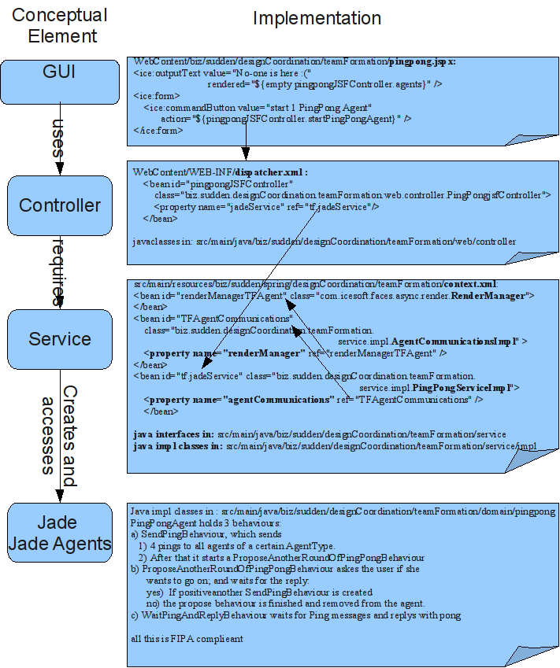

Coordination Fit

Description of functionality
The primary purpose of the Coordination Fit (CF) submodule is to take a given abstract supply network and candidate team(s) for that network and analyse how well the team functions as a team.

This evaluation complements the individual evaluation of the competences of partners against roles provided by the performance management subsystem and enables the true combined worth of teams to be more accurately judged.

The utility of the evaluation provided by this module can be seen in phase three of the scenario of innovation where an existing team invites a set of suppliers to join it in producing initial prototypes for a car. In this case the addition of the a priori best suppliers may well not produce the best team. For example the logistical distance between these suppliers and existing team members might be high.

The need to compare the teams generated by bottom up team formation – which often contain differing role structures and lack detailed evaluation data attached to each role – is another motivation for the development of this subsystem.

To summarize the CF module is responsible for establishing the degree of “coordination fit” – the degree to which the processes and activity dependencies within a partner fit with those from the other partners from the prospective team. In that sense it will offer externally the following functionality

 | Functionality | Description
1 | Evaluate coordination fit for team | The coordination fit module takes a team and produces results/metrics that show how well the processes of that team fit together

In order to produce the evaluation results the CF module will offer internally the following functionality (features) to the end users:

 | Functionality | Description
2 | Input-Output Analysis. | This analysis will examine if the selected team is able to work as a team or not. It will be based on the Coordinator fit parameters provided of each specific selected partner together with the team (e.g. if we receive a blacklist for each partner then we will be able to see if the selected team is willing to collaborate or not.)
3 | Total cost analysis | This analysis will calculate the overall expected cost of the selected team to work together. The resulted cost maybe expressed with a range of values e.g. (minimum value, maximum value, estimated value)
4 | Total Duration analysis | This analysis will calculate the overall expected duration of the selected team to work together. The resulted duration maybe expressed with a range of values e.g. (minimum value, maximum value, estimated value)
5 | Critical path analysis | This analysis will identify the critical path of the selected network.
6. | Quality of collaboration analysis | This will examine the quality of collaboration expected for the selected team by analyzing historical, closed collaboration records for the involved team members.

Input required

- A full potential team assigned for each task of an ASN (partners related to tasks) and the control flow of the overall network.

- Coordination Fit Parameters such us:
  - Cost per task for the specific partner allocated. This will be given with a set of maximum 3 values as follows: a) minimum value, b) maximum value, c) estimated value.
  - Duration per task for the specific partner allocated. This will be given with a set of maximum 3 values as follows: a) minimum value, b) maximum value, c) estimated value.
  - Other parameters related to the partner (e.g. blacklist of companies that the partner would like to avoid collaboration for this task etc).

- Parameters related with the quality of collaboration such us:
  - Recent Feedback Ratings that a partner has received from the other partners after the end of a specific collaboration (eBay-like ratings)
  - In-budget ratings of previous closed BOs where specific partners were involved
  - In-time ratings of previous closed BOs where specific partners were involved

Output produced
- Input-Output Analysis: Will raise a “Valid-Invalid” flag for the selected team. A “Valid-Invalid” decision will be produced when for example one partner of the selected team is listed within the Blacklist of another partner of the same team.

- Total Cost Analysis: Will output the overall expected logistical cost to be incurred by the selected team. The resulted cost will be expressed again with a set of maximum 3 values as follows: a) minimum value, b) maximum value, c) estimated value.

- Total Duration Analysis: Will output the overall expected duration of the selected team to work together. The resulted duration will be expressed again with a set of maximum 3 values as follows: a) minimum value, b) maximum value, c) estimated value

- Critical path analysis. The critical path within the network of companies will be detected. For that analysis the estimated value of each task will be used as an input.

- Total Collaboration Quality analysis. Will output overall expected quality ratings for the collaboration of the selected team. These rating will consist of 3 numbers:
  - a) an overall collaboration rating based on Recent Feedback Partner Ratings. In order to calculate this rating all partner dependencies (bilateral collaborations needed) will be extracted from the ASN. For each dependency between two partners we will search the Resent Feedback Ratings (if any) that the one partner awarded the other. The worst number of the two will be the collaboration rating of each dependency. The weighted average of all collaboration ratings of all dependencies withing this specific ASN will give us the overall collaboration rating for the selected team.
  - b) an overall in-budget efficiency rating based on historical data. In order to calculate this rating for each extracted dependency between two partners (pair of partners) we will search for historical BOs where the same pair of partners collaborated together. The average in-budget rating (=final budget vs estimated budget) of the moste recent historical BOs where the partners collaborated will characterize each dependency. The weighted average of all in-budget ratings of all dependencies withing this specific ASN will give us the overall in-budget efficiency rating for the selected team.

  - c) an overall in-time efficiency rating based again on historical data. The calculation will be done with the same algorithm as in b).

Below, in the “Interfaces with other modules” section you can see a detailed analysis of the interfaces between the CF module and the other modules of SUDDEN platform. There you can also see a detail analysis of the data structure used for each Input and output.

Internal architecture
Internally, the architecture of the Coordination fit module is depicted in the following figure:

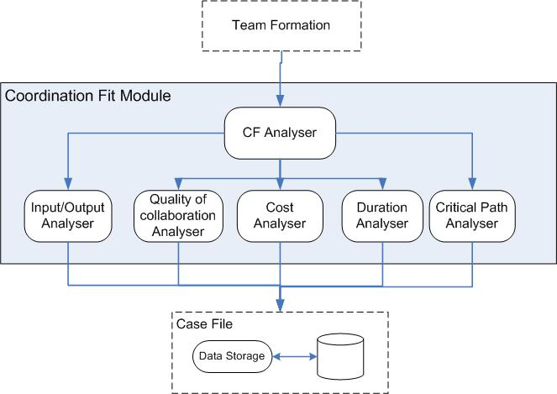
Figure 9: CF Internal Architecture

Interfaces with other modules
The CF module will be invoked by the TF module. The TF module will send the CF module a SUDDEN team able to implement a specific ASN and some other required inputs and the CF module will return a Coordination Fit “rate” for this specific team.

Interface | CF_TF_ver1 (biz.sudden.evaluation.coordinationFit.service.CoordinationFitService)
Description | Allows the evaluation of a full potential team assigned for a specific ASN and the control directed flow linking the partners of this team.
Operations | Operation: evaluate  Description: This operation will be used to evaluate a team potentially able to execute an ASN and its potential control flow for this specific ASN, for evaluation of the fitness of its members.  The method will return either a “valid” or a “invalid” message depending on the outcome of the input/output analysis. Together with the “valid”/”invalid” message will also return the total cost, the total duration and the critical path of the network will be send back to the TF module. Also if the evaluation was not able to be completed an error message (exception) will be produced (occur) and returned.  Input parameters: a concrete supply network  (biz.sudden.designCoordination.teamFormation.dataStructures.ConcreteSupplyNetwork)  Returns: the evaluation results (biz.sudden.evaluation.coordinationFit.service.CoordinationFitResult)

The CF module will invoke the data storage module to obtain the required data, in order to evaluate a ASN.

Interface | CF_DS_ver1 (biz.sudden.evaluation.coordinationFit.service.CoordinationFitDataProvider)
Description | Provides information about a supplier.
Operations | Operation: getBlacklistFor  Description: This operation will be used to retrieve the blacklist for a supplier so that the CF module can perform the input output analysis. The method will return a set of suppliersIDs.  Input parameters: a SupplierID as a string value  Returns: the set of blacklisted suppliers for this specific supplier.  Operation: getMinCostFor  Description: This operation will be used to retrieve the minimum cost for a supplier so that the CF module can perform the total cost analysis. The method will return a double precision number representing the cost.  Input parameters: a SupplierId as a string value and a ServiceId to specify the supplied service.  Returns: the minimum cost as a double number  Operation: getEstimatedCostFor  Description: This operation will be used to retrieve the estimated cost for a supplier so that the CF module can perform the total cost analysis. The method will return a double precision number representing the cost.  Input parameters: a SupplierId as a string value and a ServiceId to specify the supplied service.  Returns: the estimated cost as a double number  Operation: getMaxCostFor  Description: This operation will be used to retrieve the maximum cost for a supplier so that the CF module can perform the total cost analysis. The method will return a double precision number representing the cost.  Input parameters: a SupplierId as a string value and a ServiceId to specify the supplied service.  Returns: the maximum cost as a double number  Operation: getMinDurationFor  Description: This operation will be used to retrieve the minimum duration that a supplier needs so that the CF module can perform the total duration analysis. The method will return a long number representing the duration in seconds.  Input parameters: a SupplierId as a string value and a ServiceId to specify the supplied service.  Returns: the minimum duration as a long number  Operation: getEstimatedDurationFor  Description: This operation will be used to retrieve the estimated duration that a supplier needs so that the CF module can perform the total duration analysis. The method will return a long number representing the duration in seconds.  Input parameters: a SupplierId as a string value and a ServiceId to specify the supplied service.  Returns: the estimated duration as a long number  Operation: getMaxDurationFor  Description: This operation will be used to retrieve the maximum duration that a supplier needs so that the CF module can perform the total duration analysis. The method will return a long number representing the duration in seconds.  Input parameters: a SupplierId as a string value and a ServiceId to specify the supplied service.  Returns: the maximum duration as a long number

Usage Scenario
The following scenario describes the sequence of steps and demonstrated when in the scenario the CF module can be invoked.
- Business opportunity owner (BOO) creates a new BO

- TF generates candidate teams

- BO Owner though an interface developed by TF select interesting teams ????

- TF sends selected/all teams to Team Ranking (TR)

- TR ranks the candidate teams vs. the role structure and returns synchronously the results to TF.

- BO Owner though an interface developed by TF select interesting teams for CF evaluation

- For these selected teams TF asks from the API developed by Matthias to ask all team members regarding their metrics (cost, duration etc). The members return the metrics asynchronously.

- When TF gathers the complete information package, it sends it to CF.

- CF receives interesting teams and its metrics, calculates and returns results synchronously.

- TF updates the interface which show the BO, the teams, the CF results and the TR ranks.

- BOO selects one team for this interface.

Implementation Timeplan
In order to arrive to the first draft version of the CF module the following timeplan (task and delivery date) has been developed:

1. Algorithms of CF (implemented & committed) (10/10/2008)

2. Dummy implementation for TF classes (Martin) (14/10/2008)

By 'dummy implementation' we mean classes that implement the agreed interfaces between components in a way that can be used at runtime for unit testing. They could be constructed in a hard-coded way using java code or defined in xml using spring.

3 CF adapted to use dummy implementation for TF classes (1 7/10/2008) - input required: 2

4. Set up and run unit tests for CF using dummy implementation for TF (17/10/2008)

5. TF UI implementation using dummy implementation for TF and TR classes (24 /10/2008): input required: 2

6. Real Implementation for TF classes (Martin) - (21/10/2008)

7 . CF finalized using real implementation for TF classes (31/10/2008) : Input required: 6

8. NotificationService (Thomas) - (31/10)

9. Set up and run unit tests for CF using real implementation for TF (7/11/2008)

10 . TF UI implementation using real implementation for TF and TR classes (7/11/2008) : Input required: 6, 7 and 8

Execution Feedback

Description of functionality
The primary purpose of the Execution Feedback (EF) module is to give the ability to its users to provide feedback to the overall system regarding the performance of a chosen team of suppliers during the execution of the planned business opportunity.

In that sense the EF module will be responsible to inform the overall SUDDEN platform regarding
- the performance of both the network and the suppliers involved at a certain executed BO.
EF module is also responsible to raise alarms when:
- a specific supplier illustrates substandard performance
- the overall network shows bad performance

The feedback produced by EF can be used to trigger several actions:

- To update the stored competences of suppliers in accordance with their actual performance
- To alter the coordination mechanism followed to organise the supply network.
- To identify potential problems with the performance of a specific supplier.

It is important to clarify here that the Execution Feedback module is not responsible for the real-time monitoring of the execution of a selected supply network. Execution monitoring is irrelevant to the project and also it is a service for which the users of SUDDEN claimed that it is of less importance for them. Instead, the purpose of the Execution Feedback module is to gather and store all the performance parameters that arise during execution and that can be of value for the selection/formation of a future supply network. For that reason, the Execution Feedback module will offer an interface to the users to enter all these important performance parameters.

In principle the monitoring of the performance of both the network and the suppliers within it can be performed automatically on a frequent time scale. The current designs for Sudden however envisage a slower, less automatic feedback loop based on observed performance on 6 monthly cycles.

To conclude the EF module offer the following functionality to the outside world:

 | Functionality | Description
1 | Enter/Update Performance metrics at execution time. | With this use of this function the user will be capable of entering/updating information related to the performance, at execution time, of the overall network and all the involved suppliers.
2. | Raise performance alarm | EF module is also responsible to raise alarms when:  - a specific supplier illustrates substandard performance.  - The overall network illustrates substandard performance.  The alarm message will be send to the owner of a business opportunity through the appropriate interface.

Input required
The input required is:

- Data regarding all the BOs that are “resolved” and that are at “execution-time” phase (e.g. estimated total cost, total duration etc)
- Date regarding all the teams finally assigned for each one of these BOs (estimated duration of partner A for BO X)

We envisage that all this information should be stored and managed within the centralized “case file”. So practically, the EF module should have a well established interface to access the overall “case file” in order to retrieve all data per executed BO. This interface is detailed below.

Output produced
- The EF module is responsible to gather and transfer to the “Case file” performance metrics as they produced during enactment of a specific BO.
- It is also be responsible to raise alarms when the real metrics turn out to be at great variance with the estimated ones. Examples of alarms can be:
  - For BO 1 partner 1 is delayed by 10 days
  - BO1 total cost is 10% more than the estimated one
  - Etc

Internal architecture
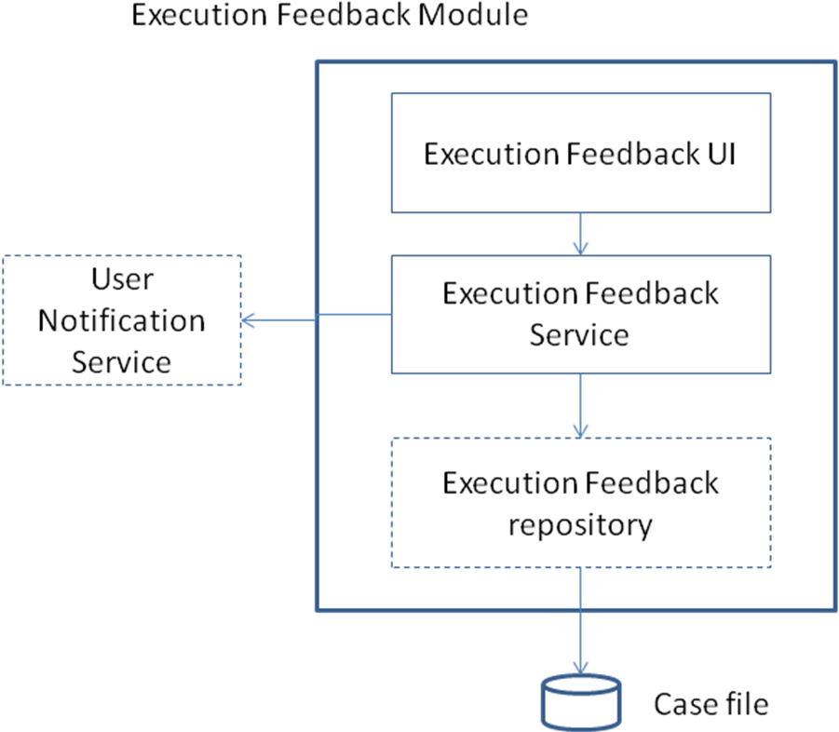

Interfaces with other modules
The EF module will retrieve all data required from the centralized “Case File” module. Therefore an interface should exist between the EF module and the centralized “Case File”.

Interface | EF_CaseFile_ver1 (…)
Description | Allows the transportation of data relevant to a certain enacted Business Opportunity.
Operations | Operation: loadSupplierBusinessOpportunities  Description: Loads all the active business opportunities for the given supplier.  Input parameters: the supplierId as a string value  Returns: the list of business opportunities (as list of values that at least contain the business opportunity id and a descriptive name of each business opportunity).  Operation: loadBusinessOpportunityDetails  Description: Loads the details of business opportunities.  Input parameters: the business opportunity id as a string value  Returns: the details of the business opportunity. The details must at least contain the business opportunity name, description, state, owner user etc.  Operation: loadServicesProvidedBySupplier  Description: Loads all the services provided by the supplier to any active business opportunity.  Input parameters: the supplierId as a string value  Returns: the list of services (as list of values that at least contain the serviceid,service name (or description), business opportunity id and business opportunity description).  Operation: loadActualServiceMetricsForSupplier  Description: Loads the service metrics provided by a supplier for a specific business oportunity.  Input parameters: the supplierId as a string value, the business opportunity Id as string value, the service id as a string value  Returns: the list of metrics as set of key value pairs.  Operation: loadExpectedServiceMetricsForSupplier  Description: Loads the expected service metrics provided by a supplier for a specific business oportunity.  Input parameters: the supplierId as a string value, the business opportunity Id as string value, the service id as a string value  Returns: the list of metrics as set of key value pairs.  Operation: storeActualServiceMetricsForSupplier  Description: Stores the service metrics provided by a supplier for a specific business oportunity.  Input parameters: the supplierId as a string value, the business opportunity Id as string value, the service id as a string value, the list of metrics as set of key value pairs.  Returns: nothing

The EF module will notify the owner of a business opportunity in the case of a performance alarm. Therefore an interface should exist between the EF module and the centralized “Notification Service”.

Interface | EF_NS_ver1 (…)
Description | Allows the notification of a specific user about a specific alarm.
Operations | Operation: sendNotification  Description: Sends a notification to a user.  Input parameters: the user id as a string value and the message  Returns: nothing.

User interface

The EF module needs to collect performance data from the user, therefore it provides a number of user interfaces including:

User Interface | List of services
Description  Operations | Displays a list of services that have been executed and are missing real-time performance metrics per business opportunity as shown in Screenshot 1.  The user will have the ability to select a service in order to provide the performance metrics for this service. By selecting the ‘Enter metrics’ button (Error: Reference source not found)  The use will also have the ability to click on the business opportunity name hyperlink in order to see the BO details.  The user will also have the ability to click on the service name hyperlink in order to see the service details.

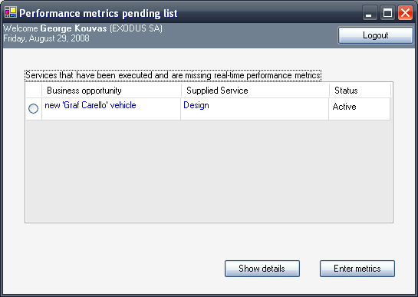
Screenshot 1

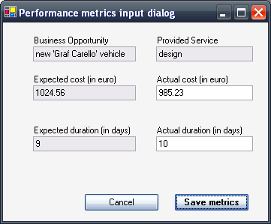
Screenshot 2

Legacy System Integration

Description of functionality
The general functionality of the Legacy System Integration (LSI) module is to provide a common interface to execute operations in several and heterogeneous Enterprise Information Systems (EIS). In more detail, this includes the following functions:

- To hide from the rest of the SUDDEN application the complexity of managing and connecting to heterogeneous EIS.
- To provide with (Web Service and EJB) interface to all the EIS configured in the System.
- To validate requests in order to avoid unnecessary calls to EIS.
- To transform the input or output messages.
In general the LSI operates in a so-called response mode. As such it does not own a particular process, but participates in those of the calling subsystems and where integration with 3rd party systems is required.

To conclude the LSI module offer the following functionality to the outside world:

 | Functionality | Description
1 | Validate LSI request | This functionality will be used in order to validate different integration requests.
2. | Obtain Connection | This functionality will be used to execute the enterprise operation, which will be executed in an EIS
3. | Execute Operation | This functionality will be used to execute the enterprise operation, which will be executed in an EIS

Usage Scenario

The idea is to modify and deploy an open source connector such as "Apache Service mix" (see more here http://servicemix.apache.org/) to allow SUDDEN platform to be integrated with third systems operated by the end users of the SUDDEN platform.

We decided to use Apache Servicemix as the means to publish an event from SUDDEN platform and also as the means to allow users to send an event to SUDDEN platform.

More specifically, we will implement the scenario where the SUDDEN platform integrates thought Servicemix with a workflow management system in order to:
a) Automatically opens a new task for the user
b) Receives progress report for a specific task from a user

In more detail, we will implement the following use case:

When a team is allocated to execute a specific BO (result of TF module) a new event (message) will be published through Servicemix. The users who are already connected to ServiceMix thought their legacy systems will receive this message.

In our scenario this message will carry information about a specific task of a certain BO (e.g. the owner, the deadline and possibly its estimated cost).

The legacy system of the owner of this task(in our case the worklfow system) will receive this message and it will start a workflow to implement the task, open a task in a management tool etc (basically it can do whatever the user wants)

Reversely at execution time, when the user wants to report regarding the status of his task, he will be able to send automatically from its internal task managing utility and through servicemix an appropriate message (event) to SUDDEN EF module.

Now, In the case where the user either does not operate an internal system to manage his task or if he does not like to use it, then he will have the alternative to use a web based form utility with which he will be able to report on the status of his tasks manually.

Input required
A general precondition: for every EIS that could be integrated with SUDDEN and for every operation per EIS, we should have defined XML-Schemas against which the integration requests will be validated.

Additionally, the following input is required by the Legacy System Integration module:
- EIS where to execute the operation.
- Operation to be executed.
- XML document representing a request to the EIS.

Output produced
The following output is produced by the Legacy Integration:
XML document representing the EIS response to the execution of the requested operation

Internal architecture
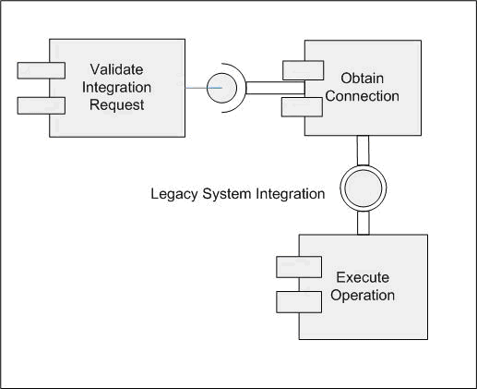
Validate Integration Request (Integration Request message)

This Functionality will be used in order to validate different integration requests.
Input messages can be validated to XML-Schemas defined for each EIS and each operation.
If needed messages can be transformed using a XSLT defined for each EIS and each operation.

LSI sub-Component: Obtain_Connection (ConnectionType)
This component will be used to obtain the connectors through a connections pool managed by a factory. This process returns the appropriated adapter (connection) according our necessities of business. We have decided to use an existing commercial connector based on the standard JCA and/or web services.

The invocation and the used adapters always must fulfill the specification of the Common Client Interface. The connectionType will be the name of the factory that we have already configured in our application server.
Preconditions are:
a) The factory must be configured in order to invoke EISs properly.
Invocation Frequency: whenever we need a communication and we don’t have any connection in memory ready to be used.

LSI sub-Component: Execute_Operation(global_process_ID, Operation_To_Do)
This operation will be used to execute the enterprise operation, which will be executed in an EIS. The operation will use the connection, which has been returned by the Factory above mentioned, in order to access to the selected environment. The Common Client Interface (CCI) supports a common client API across heterogeneous EIS. So, we should define the operation, which we want to execute, according to this specification.

The type of communication will be synchronous like client/server or request/response. Although, it can also be an asynchronous request, but in this case, we should define the “Connection Event Listener” in order to perform the callback for the adapter; for example enterprise operations, the status of the connection instance and the connection-pool maintenance.

Preconditions are:
a) We must have a connection (adapter), so we have to invoke the factory in order to obtain the appropriate adapter
b) Previously, we have to define the operation that we want to execute.

Post Conditions are:
- After executing the operation we must destroy the connection in order to allow the factory to manage the pool of connections.

The Invocation Frequency is estimated to be once per execution of each operation.

There are three components more, although there are not related directly with the communication between the Sudden system and the Legacy System. They are closer to the management and the control of the connectors.
- ConnectionManager: To manage connections and transactions in a managed environment.
- ManagedConnectionFactory: it is used to decide and return the connection object that is suitable to the client.
- ConnectionEventListener: Each connection instance is associated with this interface. This is used by the application server to get information from a connection instance and manage the connection pool. This is also used to control the callback of the operation, as we have commented above.

Apache ServiceMix
In order to develop the LSI module we will build on top of the Apache ServiceMix open source connector. Apache ServiceMix is an open source ESB (Enterprise Service Bus) that combines the functionality of a Service Oriented Architecture (SOA) and an Event Driven Architecture (EDA) to create an agile, enterprise ESB.
Apache ServiceMix is an open source distributed ESB built from the ground up on the Java Business Integration (JBI) specification JSR 208 and released under the Apache license. The goal of JBI is to allow components and services to be integrated in a vendor independent way, allowing users and vendors to plug and play.

Features
ServiceMix is lightweight and easily embeddable, has integrated Spring support and can be run at the edge of the network (inside a client or server), as a standalone ESB provider or as a service within another ESB. You can use ServiceMix in Java SE or a Java EE application server.
ServiceMix uses ActiveMQ to provide remoting, clustering, reliability and distributed failover.
ServiceMix is completely integrated into Apache Geronimo, which allows you to deploy JBI components and services directly into Geronimo. ServiceMix is being JBI certified as part of the Geronimo project.
Other J2EE application servers ServiceMix has been integrated with include JBoss, JOnAS with more to follow.
For more information see here: http://servicemix.apache.org/home.html

