Notice board Composition - design

Introduction

This document addresses the design of the bottom up methods for virtual organisation formation within the context of the crosswork project. In doing so it uses the design methodology from the MaBE project.
Currently this document should read together with the noticeboard composition - reasoning requirements and the formal definitions for process representation documents.

Requirements

The basic requirement here is that the system take a specification of a project and output a team which can fulfill this project. The further requirement imposed within this document is that the formation of the virtual organisation (VO henceforth) be done in a manner which minimises the amount of central control required.

At first sight this may appear to be a somewhat arbitrary, self imposed handicap. However there are some good reasons to consider this style of VO formation , and a discussion of them can be found within X.

One very important implication of doing VO formation in a bottom up manner, is that the solutions can be considered as growing from the initial solution towards a complete solution. The solutions passed through on the way to a complete solution are referred to as partial solutions.
A more formal and thorough discussion of this, with examples, can be found within Y.

Clearly extremely important to the detailed design of such a system is the format in which the project requirements are specified. It has been agreed that they will be rendered into some formalised form, avoiding the system having to interpret informally specified projects. However the details of this form have not been specified. A short discussion of a possible high level structure thus follows.

Three separate classes of information can be identified:
(1) What the virtual organisation is required to produce, and what it is given to start with;
(2) Other information about the project - eg how much of the given component might be required, which company wants the product etc;

(3) Any externally imposed constraints - eg a given company must provide a given component, the product must be produced within a given time scale/cost etc.

Of these (2) is identified as the project worth information since it enables each of the companies within the system to decide if a project is interesting for them or not. For instance they might not wish to work with a given supplier, or on small scale projects.

(1) is represented by two sets of resources - those the VO is given to start with and those it is meant to produce as an output. Informally each of these is represented as a set of sets of types from an ontology, together with constraints on their attribute values.

Clearly the details of this, and indeed the process representations used throughout the system merit some in depth discussion. However the choice of process representation is largely independent of the actual design. Therefore they are presented in depth within the a separate document.

This technique can be used to cover situations mentioned in (3) whereby the VO must contain a given company. The other situations in (3) involve constraints imposed on the final VO with respect to quality of service criteria. If the set of criteria is defined within an ontology then such constraints can be represented straightforwardly.

In summary the input information is taken to comprise: a required process (often simply an input and output state), some worth information and possibly some quality of service constraints.

Design & Diagrams

Following the MaBE structure stage 1 involves identifying (external) actors and identifying use cases based on these. The resulting diagram follows.
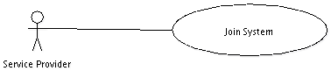
This diagram is clearly rather sparse and of limited utility. Since the system is mainly concerned with the distributed interaction of agents within the system as opposed to control from outside of the system, this is to be expected.

Therefore I will next illustrate a use case diagram from the point of view of an independent component within the system. This involves the assumption that each person is represented within the system by an agent, but as mentioned in the introduction this is taken as an initial assumption within this document.
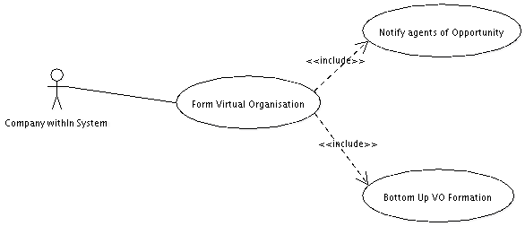

These diagrams require some textual expansion:

Join System

Goal: A company wishes to enter the system, in order to participate in virtual organisation formation.

Primary Actor: Someone capable of providing a service towards future virtual organisations.

Other Stakeholders: the agents already within the system

Pre conditions:
(1) The company has configured an agent (with possible human involvement) so that it can participate in virtual organisation formation to their satisfaction. Details of the exact information required here will be discussed later.
It should also be noted that the distributed nature of the system means that the companies are, to a large extent, free to decide the exact amount and nature of information they provide.
(2) The company passes on criteria for entry into the system agreed upon by it's membership, eg Quality criteria.

Post conditions: the company can participate in VO formation within the system.

Notify Agents of Opportunity

Goal: An agent within the system has discovered a potentially promising contract to tender for and wishes to make knowledge of it available within the system

Primary actor: someone with knowledge of an opportunity, perhaps a speculative future possibility.

Pre conditions:
(1) An opportunity ,or potential future opportunity, has been located by an agent in the group.

Post Conditions:
The other agents are made aware of the opportunity and virtual organisation formation attempts commence.

Bottom Up VO Formation

Goal: A VO formation opportunity has been identified and now a relevant VO needs to be created.
Primary Actors: The agents within the system

Post Conditions: VO's are formed between the agents within the system without any explicit form of central control (this last requirement is taken as a given as discussed in the introduction.).

Abstract Interaction Model

The next stage is to identify roles within the use cases above and the interactions between them at an abstract level. The enter system use case features only a single role - that of the people specifying the information to configure their operation in the system and is thus ignored in the following.

The notify agents of opportunity use case contains two or three roles:
(1) The agent with the information,
(2) The agents who need to get the information,
and potentially (3) The method of providing it.

The interactions are clear when stated at this abstract level.

However clearly this will not suffice to specify the system. Therefore the following role diagrams go into more detail and feature some indications of likely interactions specified at an abstract level.
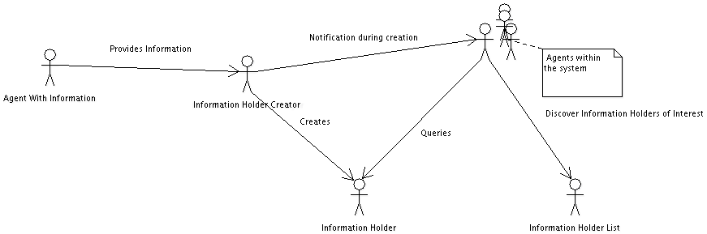

This diagram deals with the commencement of the formation of a VO as well as with some of the querying that happens subsequent to this.

It starts when some agent within the grouping discovers the opportunity for VO formation. The next stage within this diagram is to create a role to hold this information. In general it would be possible to distribute even this stage and for all communications to be broadcasts. However this seems impractically cumbersome.

The information holder is then created, with a notification to any agents the creator believes are likely to be interested in it's existence being sent. For instance they might register with it to be notified of a broad class of potentially interesting notice boards, or indeed potentially of all.

Subsequent to this the agents within the system can query the noticeboard to get detailed information about the opportunity it concerns. They can discover the noticeboards either through being notified about them or through querying some kind of list of active noticeboards.

Bottom Up VO Formation Roles
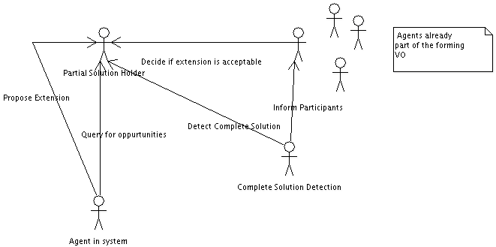

This diagram deals with bottom up formation in terms of roles. Basically it works through the aggregation of partial solutions within a partial solution holder. A partial solution is ,in this case, a set of companies which can perform some subset of the tasks required of the eventual VO.

Agents within the system then query the partial solution holder to identify opportunities, and if they identify an opportunity of interest to them they propose an extension to the existing partial solution. Once this happens they propose an extension.

The agents already within the partial solution then have to decide if this extension is acceptable to them. If it is the extension happens, otherwise it doesn't. Finally some method is required to identify when the virtual organisation is of sufficient size to comprise a complete solution, and the participants within this complete solution have to be notified.

Role Relationships

The following groupings of roles seems plausible based on the diagrams above:
(1) Information Holder Creator, Information Holder List
(2) Information Holder, Partial Solution Holder, Complete Solution Detector.

Performing a preliminary examination of where agents might be required within this system it is easy to identify the agents for the companies as needing to be agents. They are autonomous reasoning units which both participate in numerous conversation and need to reason to a great extent during their operation.
It is important to realise that here the term agent does not imply that it's operations are fully automated. Instead it is taken to comprise a combination of fully automated and user driven operations. However since there is no difference to the system between these modes of operation the design can happily ignore such issues.

The case of the grouping of (2) is a bit less clear. While it does have to participate in many conversations, there is nothing within it which requires any great intelligence. However having it be an agent provides both easy communication and , as will be seen, offers some potential for exploring interesting avenues later.
Since this has been identified as an agent it will henceforth be referred to as a noticeboard agent. Some additional roles relating to coordinating conversations will accrue to it and these will be examined later.

The grouping under (1) is less clear again. Certainly the noticeboard creation part could quite happily be created as a standard piece of software. However the noticeboard information list is traditionally represented in agent systems by a DF agent.
So there seem to be two options - (a) to keep the combination of roles and make this an agent, (2) to put the list into the standard DF, or a custom designed one, and then to make the noticeboard creator a piece of software.
While there seems to be no great technical argument either way (a) does seem to be more in line with the rest of the system and so will be used.

(4) Tasks

In this section the tasks required to perform the abstract interactions within the role diagrams above are examined in more detail. Since the tasks correspond closely to the abstract notes within the role diagrams I shall also assign them to roles here.
For these purposes I shall consider the system to contain: Company Agents, Notice Board Agents and a notice board creator agent. The roles assigned to these agents were discussed above.

(i) Notice Board creation

Pre Condition: A company agent has identified a potential opportunity to form a virtual organisation and has the information required.

Effect : A notice board is created with the relevant information. Agents considered to have a strong likelyhood of being interested in the noticeboard have been contacted.

Description: This splits neatly into three subtasks: (ia) is the subtask of providing the noticeboard creator with the relevant information, (ib) that of creating the noticeboard and (ic) that of contacting the people thought likely to be interested.
To describe (ia) further requires identifying the types of information under discussion and (ib) is a straightforward factory pattern like operation. (ic) involves a simple form of matchmaking. While this can get involved, here it is merely used to indicate possibilities so a very loose matching algorithm can be utilised.

(ii) Querying Noticeboards

Pre Condition: A company agent has identified a notice board it wants more information from.
Effect: The required information is provided by the notice board to the company agent.

Description: This task again splits into several subtasks: (iia) the identification of the notice boards to query for setup information, (iib) the identification of noticeboards to query for partial solution information, (iic) a query for the setup information and (iid) a query about the partial solutions on a noticeboard.

Of these (iia) is interesting since it is wholly controlled by the company agent concerned this leaves the with a lot of leeway to decide which noticeboards to query. For instance one agent might wish to query every noticeboard in case they need a particular type of contribution from them whilst another might only be interested in noticeboards which do a certain type of product.
This problem is clearly closely related to (ic) -> the above describes a query driven approach to it whereas (ic) is a subscription based approach. The flexible matchmaking algorithms are required by both.
It is worth noting that these two tasks do not need to be implemented in any complex manner since at worst the agents can simply query ever noticeboard. However if possible it would be nice to have the system run more efficiently than this.

(iib) is part of the reasoning required of the company agents in the system. It is therefore covered within the reasoning requirements document.

(iic) is a simple query/respond mechanism and the main decision here is what information to put here. This isn't so simple as will be discussed later. In particular the information provided here has to be rich enough for the agents to decide if they are interested in a project or not when performing (iib).

(iid) is considerably more complex than (iic) since it touches on issues such as the way the company agents store the processes they are capable of. Essentially this involves the agents being able to discover if one of their processes would be a good match for a gap in the partial solution.
The current query method operates by subscriptions and some detail is presented within the noticeboard reasoning requirements document

(iii) Extension proposal

Pre conditions: A company agent has identified a potentially promising opportunity for it to extend a partial solution.
Effect: The solution is checked for acceptability by the existing members of the forming VO and subsequently it is either rejected or the extended solution is placed on the notice board.

Description: This splits into two main subtasks: (iiia) proposing the extension and (iiib) verifying it. (iiia) is in itself pretty simple, with the main issue relating to the representation method chosen for the partial solutions.
(iiib) is genuinely complex potentially involving the notice board coordinating a negotiation between the proposer and the agents already within the virtual organisation. At it's simplest level however it can be done in several ways, for instance by the notice board agent contacting each of the agents within the virtual organisation with the proposed extension and allowing it iff they all agree to it. An alternative , allowing for slightly more sophistication, would be for the existing members to give the notice board agent a single answer. This would allow them to choose their preferred voting system.

(iv) Detect Complete Solution
Pre Conditions: A complete partial solution has formed on the notice board.
Effect: This is detected and the companies concerned are informed of this.
Description: The complexity of this task is strongly dependent on the process representation used on the noticeboard. If using the one described below it is quite simple.

Of these subtasks:
(iic),(iid),(iiib) and (iv) involve the noticeboard;
(ib) and (ic) the notice board creator and
(ia),(iia),(iib),(iiia) and (iiib) the company agents.

The final stage in the MaBE design process is meant to involve specifying the communications between the agents in terms of actual ACL messages. This is deferred here however since it seems that a story board walkthrough of the systems operation, and the various interaction protocols involved might help to clarify what is going on within the system.
Also the forms of representation used for the data within this system are extremely important to it's operation and so they have to be specified and discussed here.

1 Start up Diagram
Noticeboard Creator
1: create noticeboard; knowledge
3: Contact likely
interested agents

Agent with knowledge
of a potential opportunity
2: Create NoticeBoard; knowledge

Utility Information

Initial
Solution
G
I
?

Created noticeboard

This diagram is similar to the role diagram for set up given with concrete structures instead of the roles. The other main difference is the further clarification of the set up information on the notice board. Briefly this contains:
Utility Information: This contains information allowing the agents to determine how much the project is worth to them. For example the company offering the project, how much of the finished is it likely to require etc.

and

The required goal: This illustrates the process the company needs doing. There is an assumption made here (due to the nature of the domains under consideration) that this can be defined as a transformation from a starting state to a finished state.
Each of the states is represented by a collection of constrained resource sets.

The representation and using of the utility information simply requires that the agents agree on some ontology to use to represent it. Representing the required goal is however rather more involved, and the process representation document attached contains an in depth discussion of it.
2 Expansion of partial solutions
(i) An initial expansion

G
I
?
G
I
?
Agent
A
M
Utility Information
Notice Board Agent
Initial
Solution
1: Query For
Information

AgentA
2 Possibility
Detected

3 Extend Partial
Solution

This illustrates the initial expansion of a partial solution on a noticeboard. The querying for possibilities/deciding which ones are of interest is one of the main areas of reasoning required of the company agents within the system. Also the choice of which queries/subscriptions to allow is a design decision of considerable import.
For discussion of this see sections (1) and (2) of reasoning demands within the notice board requirements document.

In the diagram above Agent A has noticed that it can go from state M to G. It therefore simply requires some agent to be capable of going from I to M to complete the solution and the partial solution above is posted.

The formal intent of this filled transition is that the agent expects itself to be capable of delivering a transition between the two states it connects.

(ii) A later expansion

AgentA
G
I
Agent
A
M
Agent
B
G
I
?
G
I
?
Agent
A
M
Utility Information
Notice Board Agent
Initial
Solution
1 Extend Partial
Solution
2 Trigger Extension
Protocol

4 Acceptable
Extension
3 Negotiation

AgentB

This diagram shows the process of B further extending the partial solution that A has started to extend. The querying of the noticeboard by B & the identification of the possibility happens in a similar manner to that in (i) above and so is not shown here.
The main area of interest here is what happens after the noticeboard receives the extension request. In this case it immediately notifies the existing 'owners' of the partial solution and a negotiation takes place to verify if it is acceptable or not.
This is discussed within detail in in the Notice Board Composition - links and requirements document.

(iii) Complete Solution Noticed
G
I
Agent
A
M
Agent
B
G
I
?
G
I
?
Agent
A
M
Utility Information
Notice Board Agent
Initial
Solution
Detailed Negotiation:
How they plan to work
together.
AgentB
AgentA

Potential Complete
Solution located:
Inform agents

The way the system works here is that the noticeboard spots every partial solution as it becomes complete and then informs the owners of the partial solution of this fact. A complete partial solution can be identified simply as one with all transitions 'claimed'.

The important note here is that the systems outputs more than one team, with no attempt made to optimise the individual teams. This comes about since the system merely tries to facilitate the formation of virtual organisations within a group rather than to produce a single virtual organisation to do a given task.
However if the system is being used within a context where the main goal is to produce a single virtual organisation then clearly some form of optimisation will be required. The following ideas seem logical ways to integrate quality of service criteria into the system:

(1) During step (ii) when considering an extension, have the agents (or an external body) perform an approximate performance measure check and reject the extension if it is going to eg clearly take too long/be too expensive etc.
Clearly the system will still produce multiple solutions when run in this manner, but it should do so more efficiently.

(2) Aggregate the teams as they form and rank them against each other, proposing the best team. This will generate the most efficient team if run for long enough. Indeed since the efficiency is considered at the level of whole teams this will produce better results than considering optimisation at the level of individual companies.
The major disadvantage is that you don't know when you've found the best team so don't know when to stop. This problem is intrinsic to this kind of unguided bottom up search, and indeed is highly problematic even for guided/incremental improvement based search algorithms.

