NoticeBoard system agent designs 06_03

Purpose

To complement the noticeboard system design document by providing a documentation of the technical decisions relating purely to the implementation of the agent system for the noticeboard system.

The design document referred to above concentrates initially on the internal design of the noticeboard systems main algorithm. This document also contains a set of use cases and some identification of the responsibilities of the agents within the system.

This document will therefore focus on the detailed design of the protocols within the system, and of the ontological constructs used to support these protocols.

The 'UML' within this document is purposefully non standard in places since I'm documenting agent message exchanges/protocols & ontology structures.

The agents

Briefly there are three types of agents:
The Noticeboard Factory agent - this is responsible for two main services. One is the creation of new noticeboards , the second is acting as a DF service for noticeboards.
The Noticeboard Agents – each of these is responsible for coordinating the development of teams to solve a given problem.

The Process Provider Agents – each of these is responsible for a (set of) processes which they volunteer to the noticeboards thus building up teams which can provide the required processes.

Of these the internal behavior of the noticeboard factory agent and the noticeboard agents are fixed and thus can be specified – where sensible this will be documented here, although the algorithms behind the noticeboard agents for instance are documented within the separate noticeboard design document.

The internal behaviors of each process provider agent are however much more fluid and so aren't specified here. However they also provide the actual 'intelligence' within the system and thus have decisions to make which drive the protocols.
These decision points will be noted within each protocol where they occur. Some notes as to plausible decision criteria have been made within the design document.

The System

The system has the following set up:
    - 1 Noticeboard Factory agent
    - N Noticeboard agents
    - M Process provider agents

Each noticeboard is open to any one of the process provider agents.
A noticeboard agent is created for every new business opportunity noticed within the system. They then exist until a team has been identified to fulfill that business opportunity.
In principle they might subsequently retain a role through some form of cased based reasoning but this is not initially addressed.
As noted above Every process provider agent corresponds to a set of processes as opposed to a single fixed process. Indeed they are in principle not even committed to a fixed set of processes but are allowed to opportunistically propose modified processes when the possibility presents itself.

The Protocols

1 Create Noticeboard Protocol

Participants: The noticeboard factory agent (passive), A process provider agent (Active)

Purpose: Given the information required to define a noticeboard to enable the creation of a noticeboard with that information. As a secondary purpose to inform any process provider agents appropriately registered with the noticeboard agent of the creation of the noticeboard.

Protocol/Sequence Diagram

Really a bit of a mix between the two. It's a combination of a FIPA request & the inform part of a subscribe protocol.

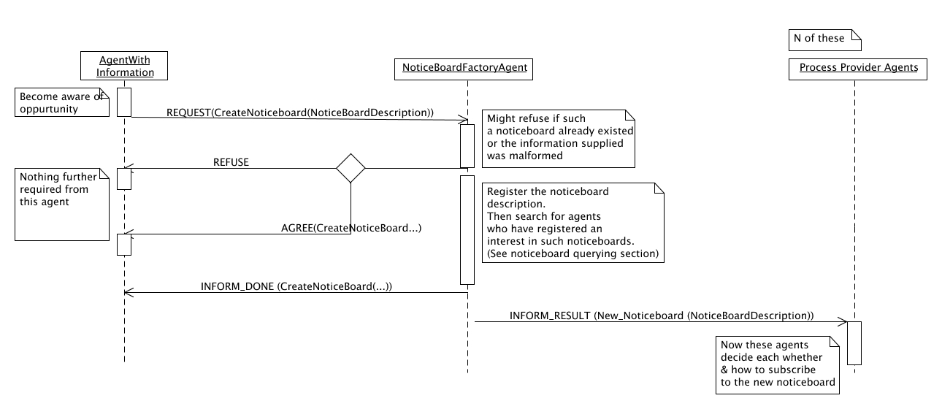
Here the Initial Process contains:
(a) The goal state (expressed using constrained resource sets)
(b) The initial state ('''')
(c) A set of predefined declared capabilities
(To do – define these in an ontology)

Later it might contain richer constraints as/when the Crosswork project agrees on what these are going to be.

The utility information is defined by:
(a) Who is requesting the project in question,
(b) How much of it is being requested (might be an estimate),
(c) The cost expected (if this exists)
(d) Anything else really – but nothing I can think of.

This is expressed within quite a simple set of ontology structures.

(To do – express in a proper ontology structure etc.).

The noticeboard descriptions are stored internally within the noticeboard factory agent.
2 Query For Noticeboards

Participants – The noticeboard factory agent (in it's capacity as a DF for noticeboards) and a process provider agent.

Purpose – To allow process provider agents to locate noticeboards of interest to them

Protocol – This is a simple FIPA Query_Ref protocol, or alternatively a FIPA Subscribe protocol. Hence I won't give a diagram for it. Of more importance is the structure of the queries involved & the information returned within the responses.
(ie how much of each noticeboard agent to reveal in response.).

Queries which have been subscribed to the noticeboard factory are checked against each new noticeboard as it is created.

The queries are done using identifying referential expressions of the form (All/Any ?x) (various predicates about x are true.). Therefore to specify the queries it suffices to fully specify the possible predicates.

Permissible Predicates

This is not designed as an exclusive set of predicates – others might prove to be useful and added later.

NoticeBoard(x) – true iff the variable x is a noticeboard

Produces/RequiresAbstractTypes(x,y/Set of Strings ) –
true iff the noticeboard x contains a type compatible with every type within y in it's goal/initial state respectively. Here each member of y is a string corresponding to the type name of some concept from a product ontology.
A type z is considered compatible to a type y' from y if is of a type equal to y' or is a subtype of y'. The subtype comparisons are made possible since the types concerned are considered to come from within an ontology.

Produces/RequiresConstrainedTypes (x, y/Set of Constrained Resource Types) – as for the predicates above but here you are looking for compatible resources rather than equal abstract resources.
Compatibility between constrained types here means that the type from y is more general than the type it is matched against. The more/less general comparison between constrained types is defined in detail within the detailed design documentation but also corresponds to the natural idea.

RequiredByCompany(x, Company Names/Set of strings)) – true iff the process required is being requested by a company within the set of companies within the predicate.

CreatedSince(x, t) – here t denotes some date (down to seconds at least). This is used to avoid detecting noticeboards which you have already located. On a related topic, the subscription service offers a natural way for agents to be notified as new, relevant noticeboards are created, potentially avoiding the use of this predicate.

Example Query:
The following is an example of the types of queries likely to be used:
(All ?x) (Noticeboard (x) & ProducesAbstractType(x, Wheel) & CreatedSince(x, t))

Which requests the return of all the noticeboards created since the time t which involve the production of some form of wheel. This query is then encapsulated within an appropriate Query_Ref or Subscribe message.

Method:
The queries are matched against the Noticeboard descriptions within the noticeboard factory agent and for each matched noticeboard the full noticeboard description is returned to the agent making the query.
The full description is returned since this enables the agents to decide if they are (in principle) interested in the project without querying the noticeboard agent itself. This should hopefully minimise the number of messages sent within the system.

(3) Queries for Potential Extensions

NB It would in principle be possible for this stage to be reduced to simply learning every potential extension available on the noticeboard. However much as with the queries to do with new noticeboards, some filtering systems are in place to ensure that the agents can avoid detailed querying of noticeboards in which they lack even a potential interest.
These queries therefore operate in two stages – the initial queries detect potential extensions using simply the ontological datatypes involved (no constraints are considered.). Once such a match is detected the complete information relating to each of the matched potential extensions is returned for the agent to check for whether it can provide a complete match.
Participants: A noticeboard agent and a process provider agent

Purpose: To allow the process provider agent to detect promising potential extensions within the partial solutions of the noticeboard agent

Protocol: As with the queries for promising noticeboards described above these queries use a combination of the Query_Ref/Subscription protocols together with IRE's and appropriate predicates.

Queries which have been subscribed to a noticeboard are checked against each new potential extension as it is created.

Predicates:
As above this is not intended to be a complete list but merely to indicate some predicates which could prove to be useful. As can be seen several of the predicates from the noticeboard querying can be reused within this context. This is not so surprising since the reused predicates are those which query the initial process on the noticeboard.

PotentialExtension(x) – true iff x is a potential extension within a partial solution of the noticeboard being queried.

Requires/ProducesAbstractTypes(x,y/Set of Strings) – true iff (the potential extension) x contains types compatible with all of the the abstract type(s) within y, within it's set of types required/produced respectively.
To query for potential extensions containing type t1 OR type t2 either use an OR conjunctive within the query or use multiple queries.
A type z is considered compatible to a type y' from y if is of a type equal to y' or is a subtype of y'. The subtype comparison is made possible since the types concerned are considered to come from within an ontology.

Produces/RequiresConstrainedTypes (x, y/Set of Constrained Resource Types) – as for the predicates above but here you are looking for compatible resources rather than equal abstract resources.
Compatibility between constrained types here means that the type from y is more general than the type it is matched against. The more/less general comparison between constrained types is defined in detail within the detailed design documentation but also corresponds to the natural idea.

ContainsPotentialExtensionsFrom(x,y/Set of strings) – true iff x contains potential extensions from each of the company within the list of strings represented by y.
This is probably more likely to be used to allow for a blacklist effect in combination with a NOT command. It is anticipated that agents might usually prefer to apply such blacklisting in a private manner – this is entirely possible and the option to externalise such queries is simply provided for convenience.

CreatedSince(x, t) – here t denotes some date (down to seconds at least). This is used to avoid detecting noticeboards which you have already located. On a related topic, the subscription service offers a natural way for agents to be notified as new, relevant noticeboards are created, potentially avoiding the use of this predicate.
An example query might look like this:
(All ?x) (PotentialExtension(x) & ProducesAbstractType(x, {Bolt, Nut}) & NOT (ContainsPotentialExtensionFrom(x,{CompanyWeHate}))

Note While many of the predicates are reused from the querying from noticeboards, these queries have quite different purposes. The query for a noticeboard attempts to locate the type of project to which we might be able/like to contribute to.
The query for a potential extension attempts to locate an actual opportunity for the agent to contribute some process to the noticeboard concerned.

Hence the abstract types used in a query for potential extensions are in correspondence to those the agent can produce/consume but those used when querying for noticeboards aren't.
(eg if an agent produced specialised wheels for a given type of car they would query for noticeboards relating to that type of car but for potential extensions relating to the type of wheel.).

These queries intentionally avoid forcing the process provider agents to externalise the set of processes they provide. To do so is not problematic for the case of agents with a fixed set of processes. However if we wish to allow the agents to modify the set of processes they provide, perhaps to the extent of creating new processes, based on the opportunities available then this is important.
However when an agent has a few fixed processes to contribute then it is useful to permit it to externalise each of these processes, and this is made possible through the queries using constrained resource types.

Usage Scenario -
    - An agent has located a promising noticeboard
    - It decides at a general level what type of process it might wish to contribute to the noticeboard
    - Based on this it formulates a query for potential extensions
(For instance if it wishes to be informed of any potential extension involving the production of bolts in the noticeboard it might subscribe to it using: (All ?x) (PotentialExtension(x) & ProducesAbstractType(x, {Bolt})).).
    - The noticeboard locates a matched answer – either in response to a direct query (when an empty answer is possible) or when a newly created potential extension has matched a subscribed query.
    - It returns the matched potential extension to the agent who did the subscription/query; this uses the matched potential extension concept(s) described within the ontology section below together with the result concept from FIPA SL.
Multiple matches to a query might be detected simultaneously and thus need to be returned in the same message. In this case the result slot of the result concept contains each of these matches within a set.
    - The agent then checks whether it can (when the constraints are considered) and wishes to propose a declared capability towards each potential extension. It then proposes extensions where it wishes to -> this triggers the propose extension protocol which is dealt with next.

(4) The proposal of extensions

Participants: A noticeboard agent, a process provider agent proposing an extension to some partial solution (the proposer) and finally those process provider agents who are already part of this extension (the existing agents).
Purpose: For the existing agents to determine whether the extension proposed by the proposer is acceptable to them. This is done through a process of negotiation

Protocol: The following diagram outlines the protocol followed here.

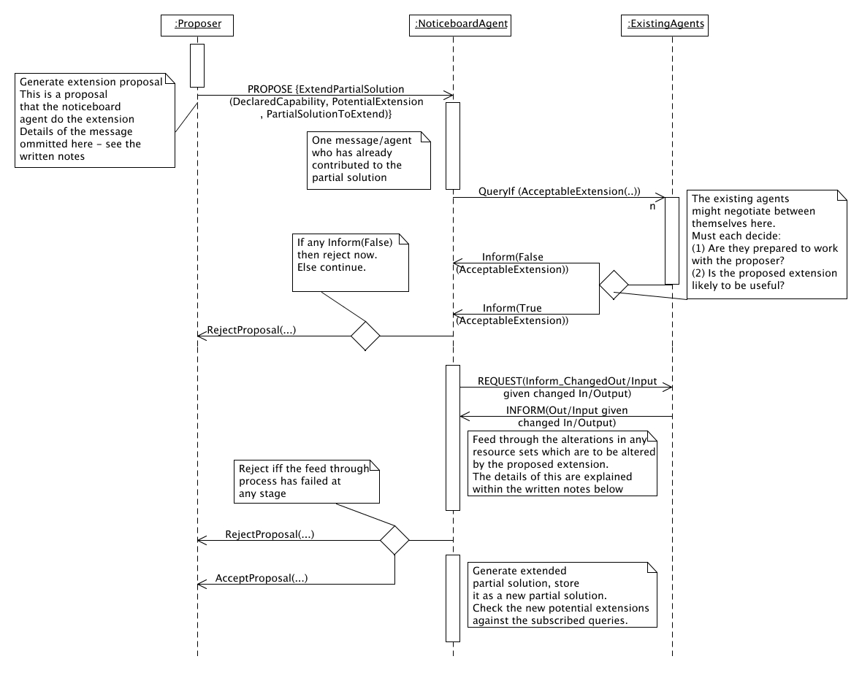

Technical Notes

The following notes should serve to clarify some aspects of the above protocol(s) not fully specified within the diagram.

    - The initial message in the protocol is a PROPOSE message containing an Action concept which has the Noticeboard agent as the actor and an Extend Partial Solution Action as the action.
As well as the potential extension being extended, the declared capability and the potential extension the action also contains:
(a) A list of which resource sets within the potential extension are being produced by the declared capability
(b) A list of which resource sets within the potential extension are being consumed by the declared capability
(c) Where the declared capability produces/consumes either a more/less general type of resource set than is present within the potential extension a note of which resource set it has matched to and what this set must be changed to
A brief discussion of the reasons for the need for (a) – (c) is included below.
    - Whilst deciding whether or not to accept a proposed extension the agents might consider:
(a) The name of the agent who has proposed the extension
(b) Whether or not the feel the declared capability to be a useful contribution to the partial solution
(c) Whether or not they've seen a declared capability which they simply prefer to the proposed declared capability
(See notes below for an interesting potential problem with this.).
(d) If timing constraints exist the noticeboard agent might use test the partial solution against them
    - The process referred to in the above diagram as the 'feed through' process must be executed.
(a) This starts with the noticeboard agent identifying the agents with declared capabilities within the partial solution which use constrained resource sets modified within the proposed extension.
Where more than one constrained resource set is used by the same agents declared capability it is contacted about all of them at the same time.
(b) It then contacts each of these with a Request message containing an action requesting to be informed of any changes this now wishes to make to it's declared capability within the partial solution.
This contains both all of the altered resource types that agent's declared capability connects to and those unchanged (but with a distinction I think.).
(b) Each of these agents then:
(i) Refuses – one of the changes is such that the agent cannot propose any compatible declared capability. This ends the feed forwards thing – the noticeboard agent informs the agent proposing the extension of this.
(perhaps there should be negotiation here)
OR:
(ii) The agent returns an Inform indicating what declared capability it is now suggesting along with explicit notes of which resource sets need to be changed.
If no new resource sets need to be changed then the algorithm terminates here. Otherwise the noticeboard agent takes the newly changed resource sets and performs this algorithm for each of them.
This eventually terminates when the final output state is reached (and very likely before then.). When it does terminate (and has been successful) then each of the newly changed resource sets is noted and this information is used to build the new partial solution.

Non Technical Notes:
Some areas of the above protocol(s) might initially seem somewhat odd. Indeed if the system operated by simple equality between constrained resource sets it would be since it would be.

However the system operates on the assumption that the process provider agent can control the manner in which the resources within the declared capability match to those within the potential extension.

For instance if the potential extension had a free resource of: MetalBox(:Volume (fromRange(10,20))), and a company is proposing to produce: AluminiumBox(:Volume (fromRange(15,18))), then this is typically allowed unless some other agents already in the partial solution complain.
However the resource set within the partial solution obviously then must be updated to reflect this change, or teams might be formed which cannot ever function. Incidentally the other direction is also allowed – here a company can produce a more general type of concept than is needed. This is also recorded to give the greatest possible flexibility when forming teams.

An effect of this flexibility is that there is no way for the noticeboard agent to link the resource sets in the declared capability to those within the potential extension. Hence this must be done by the agent concerned and this information supplied to the noticeboard agent along with the extension request.

However the need to update the resources within the partial solution does not simply stop with those resources which have been directly altered. If some of the processes within the partial solution have a functional dependency between their input and output resources and used/produced one of the resources which has been changed then the resources they input/output might also need changing.
eg if a process simply painted a plank with any length, then if the potential range of sizes of planks fed into it were to change then the set of output resources would have to change correspondingly.

Since this process could then feed into other process(es) which again have functional I/O dependencies this must be processed iteratively.

Another area of interest is created as a side effect of allowing each agent to reject proposals. This is a natural analogue to search truncation within standard search algorithms. However since it operates on a distributed and subjective basis within this system, problems with social intransigence can be encountered. This is seemingly potentially quite problematic but is difficult to avoid.
eg: Let there be four processes, A,B,C and D each controlled by agents AgA, AgB , AgC and AgD respectively. Further assume that ABC and ABD are potential complete solutions and AgA prefers ABC to ABD but AgB prefers ABD to ABC.

Now if AB-, -BD and A-C are partial solutions on the noticeboard then a request by C to extend AB- will be refused by B but a request by D to extend it will be refused by A.
Thus you can have a situation where neither ABD or ABC are approved but where all of the agents concerned would prefer either partial solution to no solution at all.

This is probably best dealt with through the careful design of the heuristics governing when proposed extensions are declined.

(5) Complete Solution Detected

Participants: A noticeboard agent (as a coordinator), a set of process provider agents who have all contributed a complete partial solution.

Purpose: To see if the complete solution which has formed is in fact fully viable.

Protocol: Within the context of the Crosswork system once a complete solution has been located the following actions must be performed.
        - Each agent within the complete solution must choose which concrete process they propose to use in correspondence to their commitment
        - The combination of the processes must be matched against any constraints placed upon the process

In fact both of these aspects are dealt with by the workflow composition module within the context of Crosswork. So no protocol happens when a complete solution is located. The behavior of the noticeboard agent in relation to complete solutions is simply to aggregate them as they appear and then, after some fixed timescale, to send the best few teams discovered onto workflow formation.

Outside of Crosswork this section could become considerably more elaborate. In particular it would be (in principle!) desirable to allow the agents to choose which concrete process they are each going to use through a process of negotiation.

This process could work through a process similar to negotiation search which was proposed in which was based on Lander's original PhD. This works with configuration problems: the example given in the PhD is a steam engine system with various parts (eg pump) each represented by an agent.
These agents are then assumed to share various parameters which must lie within certain ranges if their component is to work. The co - configuration of the parameters then proceeds through a process of the agents suggesting possible parameter values and them informing the other agents when clashes are detected.

For noticeboard composition each of the constrained resource sets would be a parameter and the agents would suggests values for them (the constraints allow for the expression of ranges of values). This could probably be mediated on a separate section of the noticeboard itself.
The big advantage of choosing the concrete processes in this manner is that it allows the agents to consider what the other agents are proposing when deciding exactly which process to propose themselves.

This allows for some very flexible behavior from the agents which is quite desirable in the fuller context. In this context they might also be considering various things like how to share the money between them and the like.

TO DO: Perhaps document the java classes within the most current noticeboard algorithm agent (if this is possible without going into excessive detail about the algorithm itself.

Implementation Plan

Current Status: have (i) an implementation of the basic algorithm running using Java objects & with no type system being considered,
    - A simple agent system using the old algorithm which illustrates how the constraints might be dealt with.
Plan:
      - Extend (i) into an agent system whilst keeping the constraints out of it (just representing the types as strings). This should (hopefully!) not take too long.
Once the constraints aren't being used then many of the aspects of the above system relating to the alteration of type sets can be safely ignored.
      - Extend this to use the type system and all of the above stuff.
Appendix – Ontology Structures

This section contains class diagrams for the ontological structures needed to run the noticeboard system. As such it concentrates on several aspects:
    - The agent actions & predicates specific to the systems operation
(a) Create Noticeboard
(b) ExtendPartialSolution
(c)
(d)
    - The data structures used in communicating about the building up of the partial solutions.
(For a fuller description of the internal data structures see the internal design document.).
This includes
(a) The information used to define a noticeboard at the Noticeboard factory/when creating a noticeboard.
(b) The information used to externalise a potential extension which has been matched to a query.
(c) The constrained resource set structures used to define states within the system.

Noticeboard Definition

The following conceptual structure defines the information used to define a noticeboard at the Noticeboard factory level. Hence it is used when:
    - Creating a noticeboard
When it is sent within the CreateNoticeboard action and
    - Querying to locate interesting noticeboards
When it is the data queried and is used when matches to a given query have been located.

It (purposefully) does not contain any information relating to the potential extensions available on the noticeboard. The slots on the description itself are added only after the noticeboard has been created and should perhaps also be linked.
(All of the associations below are simple slot based containment.).
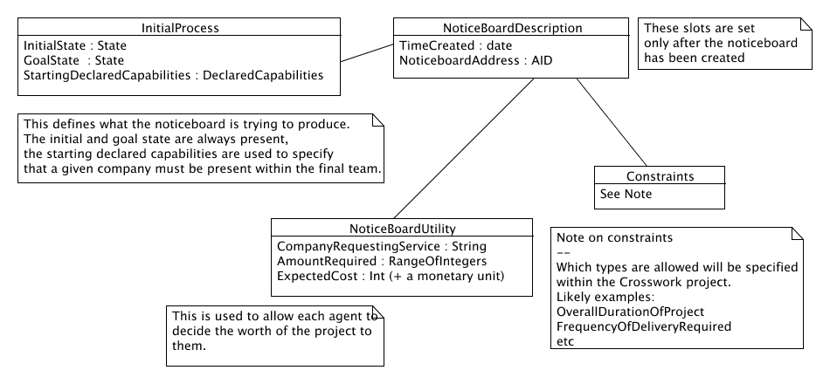

Create Noticeboard Action

This is an agent action with a single slot which contains a noticeboard definition concept.

Extend Partial Solution Action

This is an agent action used when proposing that the noticeboard agent extend a partial solution using a given declared capability. In this case the message is a Propose that the noticeboard agent perform one of these actions.
It is also used in the requests to the agents within the potential extension as to whether they are prepared to accept the extension. In this case it is used within an Query_If message using a predicate AcceptableExtension() which contains a single extend partial solution action and is true iff the extension within the predicate is acceptable to the agent answering the message.

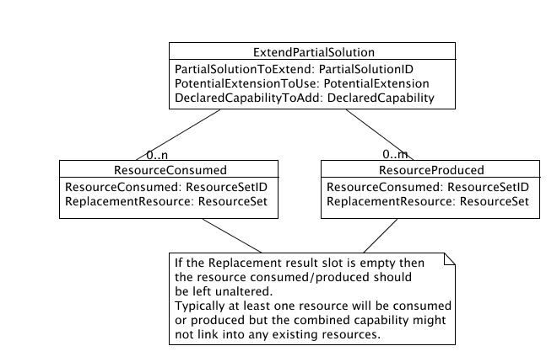

Potential Extension

Potential extensions are generated from partial solutions to indicate where an agent might be able to add a new declared capability into the potential extension. They are extracted from the state/partial order structuring within the partial solution by summing the sets of resources free/required at each state whilst regarding the restrictions induced from the partial order between the states.
Details of this process can be found within the detailed algorithm documentation.

Each potential extension thus consists of:
    - The set of constrained resources free in the potential extension.
    - The set of constrained resources which need to be produced by the potential extension.
    - The set of agents who have contributed declared capabilities to the potential extension
The exact sets of resources need to be returned to allow the agent to see whether it's capabilities can match into the potential extension. The set of agents who have already contributed is returned so that the agents can take this into consideration when they decide whether or not to contribute a process (and which process to contribute).

Finally it must be possible to refer back from the potential extension to the partial solution. This requires the following information to be present:
    - which partial solution the potential extension was generated from
    - an indication of which state each of the constrained resources came from.

It should be noted that the internal representation of potential extensions within the noticeboard system differs from this external representation in a few minor respects.
(In particular it uses Java classes and some of the ID's are replaced by more direct pointers.).

The first two of these are easy to understand while the reason for the third is discussed in the propose extension protocol section. The above discussion is summarised in the diagram below.

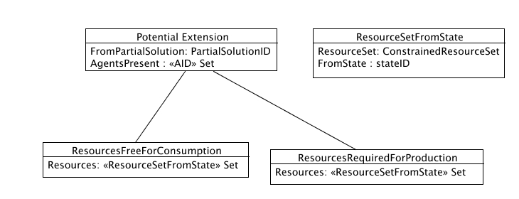

In fact this could be any agent which is aware of a new opportunity to form a virtual organisation. For instance a specialised agent might watch an electronic market and flag up new opportunities as they became available. For convenience the process provider agents are considered to initiate it here.
S. Lander and V. Lesser, “Understanding the role of search among heterogeneous agents” Proceedings of the international joint conference on artificial intelligence I, January 1993

