Social Media — Task Sheet
Instructions: Do not change the question text. Write your answer directly below each question. For Objective questions, the expected output columns and row counts are given below the question. For Subjective questions, no such details are given, work out and write the answer on your own.

Objective Questions
Q1 Are there any tables with duplicate or missing null values? If so, how would you handle them?
users — rows with NULL username
Output columns (in order): id, username, created_at (3 columns)
Row count: Varies — this is what O1 is asking you to determine. Run the query and report what you find.
users — duplicate usernames
Output columns (in order): username, count (2 columns)
Row count: Varies — this is what O1 is asking you to determine. Run the query and report what you find.
photos — rows with NULL image_url / user_id / created_dat
Output columns (in order): id, image_url, user_id, created_dat (4 columns)
Row count: Varies — this is what O1 is asking you to determine. Run the query and report what you find.
photos — duplicate (image_url, user_id) pairs
Output columns (in order): image_url, user_id, count (3 columns)
Row count: Varies — this is what O1 is asking you to determine. Run the query and report what you find.

comments — rows with NULL comment_text / user_id / photo_id / created_at
Output columns (in order): id, comment_text, photo_id, user_id, created_at (5 columns)
Row count: Varies — this is what O1 is asking you to determine. Run the query and report what you find.
comments — duplicate (comment_text, user_id, photo_id) triples
Output columns (in order): comment_text, user_id, photo_id, count (4 columns)
Row count: Varies — this is what O1 is asking you to determine. Run the query and report what you find.
likes — rows with NULL user_id / photo_id / created_at
Output columns (in order): user_id, photo_id, created_at (3 columns)
Row count: Varies — this is what O1 is asking you to determine. Run the query and report what you find.
likes — duplicate (user_id, photo_id) pairs
Output columns (in order): user_id, photo_id, count (3 columns)
Row count: Varies — this is what O1 is asking you to determine. Run the query and report what you find.
follows — rows with NULL follower_id / followee_id / created_at
Output columns (in order): follower_id, followee_id, created_at (3 columns)
Row count: Varies — this is what O1 is asking you to determine. Run the query and report what you find.
follows — duplicate (follower_id, followee_id) pairs
Output columns (in order): follower_id, followee_id, count (3 columns)
Row count: Varies — this is what O1 is asking you to determine. Run the query and report what you find.

Approach -
- Performed systematic data-cleaning queries across all core tables, including users, photos, comments, likes, follows .
- Identified missing values in critical fields using IS NULL conditions.
- Detected potential duplicate records by grouping unique identifiers and applying the HAVING COUNT(*) > 1 clause.

Users Table
1.Data cleaning for the table users-
-–Analysis to see the constraints and data types used for the columns

Describe users;
show create table users;

2.Checking for any missing values/Nulls

Select * from users
where username or created_at is null or trim(username)= " ";

The following was the result for it
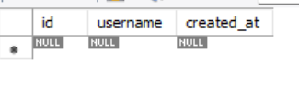
Hence we can conclude that the table does not have missing null values
Didn’t consider id column as it is auto_increment and primary key which means it cant be null and cant have duplicate values.

3..Checked for duplicate values in the column username and created_at with the following query

select username,count(*) as Duplicate_Count from users
group by username
having count(*)>1;

The following was the result for it-
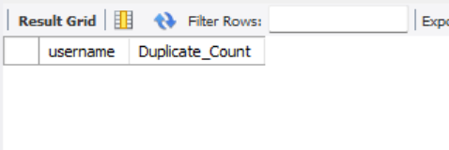
As per the result there are no duplicate usernames

Photos Table

Approach-1.Data cleaning for the table photos-
-–Analysis to see the constraints and data types used for the columns

Describe photos;
show create table photos;

2.Checking for any missing values/Nulls

Select * from photos
where created_dat is null or user_id =" ";

The following was the result for it
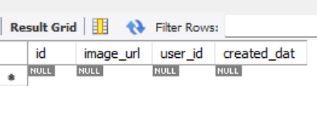
Hence we can conclude that the table does not have missing null values

3..Checked for duplicate values with the following query

Select user_id, image_url, Count(*) as Duplicate_count
From photos
Group by user_id, image_url
Having count(*) > 1;

The following was the result-
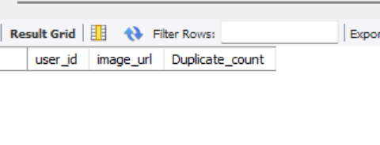
No Duplicate as per the query

Comments Table

Approach-1.Data cleaning for the table Comments-
-–Analysis to see the constraints and data types used for the columns

Describe comments;
show create table comments;

2.Checking for any missing values/Nulls

select * from comments
where trim(comment_text)=' ' or created_at is null ;

The following was the result-
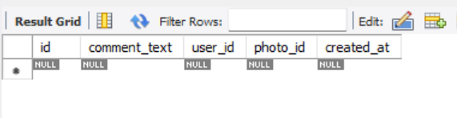

Hence we can conclude that the table does not have missing null values

3..Checked for duplicate values with the following query

select user_id,photo_id,comment_text,count(*) as Duplicate_count from comments
Group by user_id,photo_id,comment_text
having count(*)>1;

The following was the result for it
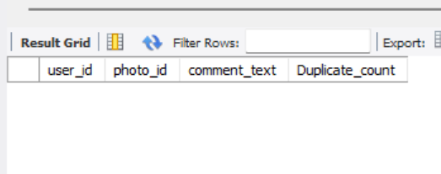

No duplicate as per the query

Likes Table

Approach-1.Data cleaning for the table likes-
-–Analysis to see the constraints and data types used for the columns

Describe likes;
show create table likes;

2.Checking for any missing values/Nulls

select * from likes
where created_at is null;
The following was the result for the query
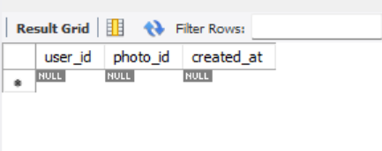

Hence we can conclude that the table does not have missing null values

3..Checked for duplicate values with the following query

select user_id,photo_id,count(*) as occurrence_count from likes
group by user_id,photo_id
having count(*) >1;

The following was the result for it-
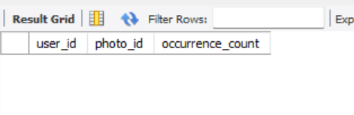
No Duplicate as the query

Follows Table

Approach-1.Data cleaning for the table users-
-–Analysis to see the constraints and data types used for the columns

Describe follows;
show create table follows;

2.Checking for any missing values/Nulls

select * from follows
where follower_id=followee_id
or created_at is null;

The following was the result
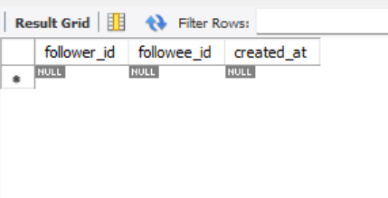

Hence we can conclude that the table does not have missing null values

3..Checked for duplicate values with the following query

select follower_id,followee_id,count(*) as occurence_count from follows
group by follower_id,followee_id
having count(*)>1;

The following was the result for it

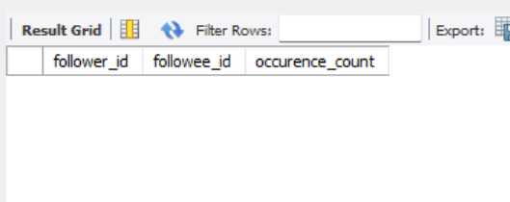

No Duplicate as per the query

Insights-
- High Data Quality: No missing or NULL values were identified in critical fields..
- Well-Structured Schema: Composite primary keys and unique constraints help maintain data consistency and prevent duplicate records.
- No Detected Anomalies: Data was systematically examined for logical inconsistencies, and no anomalies were identified.

Q2 What is the distribution of user activity levels (e.g., number of posts, likes, comments) across the user base?
Output columns (in order): user_id, username, total_posts, total_likes_given, total_comments_made (5 columns)
Row count: 100 rows (verified — 1 row per user).

Approach-
- User Engagement Metrics: Calculated individual user engagement metrics, including the number of photos posted, likes given, and comments made.
- Correlated Subqueries: Implemented correlated subqueries in the ‘select’ clause to retrieve each engagement metric separately for every user ID.

select u.id AS user_id,u.username,
(select count(*) from photos where user_id = u.id) as total_posts,
(select count(*) from likes where user_id = u.id) as total_likes_given,
(select count(*) from comments where user_id = u.id) as total_comments_made
from users u;

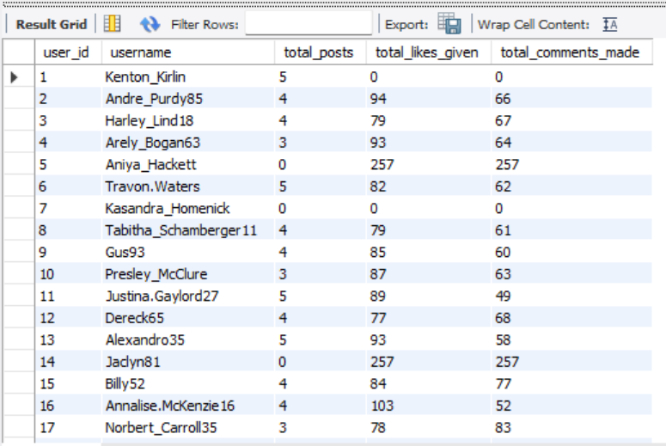

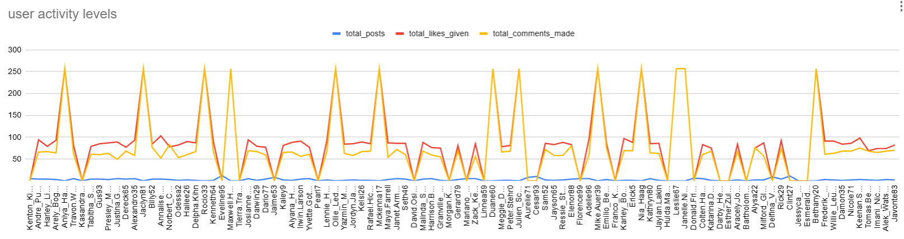
Q3 Calculate the average number of tags per post (photo_tags and photos tables).
Output columns (in order): AverageTags (1 column)
Row count: 1 row (single aggregate value).

Approach-
- Counted the total number of tag in the database using the photo_tags table.
- Calculated the average number of tags per photo by dividing the total tags by the total number of uploaded photos.
- Used independent subqueries to perform the calculation without requiring complex joins.

select (select count(*) from photo_tags) / (select count(*) from photos ) as Average_Tags;
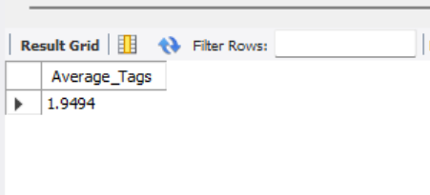
Q4 Identify the top users with the highest engagement rates (likes, comments) on their posts and rank them.
Output columns (in order): user_id, Total, rnk (3 columns)
Row count: 74 rows (verified — 1 row per photo-owner whose photos have ≥1 like AND ≥1 comment).

create view user_post_engagement_stats as
with user_posts as
(
select user_id, COUNT(*) as no_of_posts_uploaded
from photos
group by user_id
),
user_likes as
(
select p.user_id, COUNT(*) as no_of_likes_gained
from likes l
join photos p on l.photo_id = p.id
group by p.user_id
),
user_comments as
(
select p.user_id, COUNT(*) as no_of_comments_gained
from comments c
join photos p on c.photo_id = p.id
group by p.user_id
)
select
u.id as user_id,
u.username,
coalesce (no_of_posts_uploaded, 0) as no_of_posts_uploaded,
coalesce(no_of_likes_gained, 0) as no_of_likes_gained,
coalesce(no_of_comments_gained, 0) as no_of_comments_gained,
coalesce(no_of_likes_gained, 0) + coalesce(no_of_comments_gained, 0) as total_likes_and_comments_gained,
-- "Engagement Rate" is generally calculated by dividing the total interactions (likes and comments) by the total number of posts.
coalesce((coalesce(no_of_likes_gained, 0) + coalesce(no_of_comments_gained, 0)) * 1.0 / NULLIF(coalesce(no_of_posts_uploaded, 0), 0), 0) as engagement_rate
from users u
left join user_posts up on u.id = up.user_id
left join user_likes ul on u.id = ul.user_id
left join user_comments uc on u.id = uc.user_id;

-- Ranking users according to their engagement rates using the user_post_engagement_stats view.
select
user_id, engagement_rate,
rank()over(order by engagement_rate desc) as user_engagement_rank
from user_post_engagement_stats
order by user_engagement_rank, user_id;
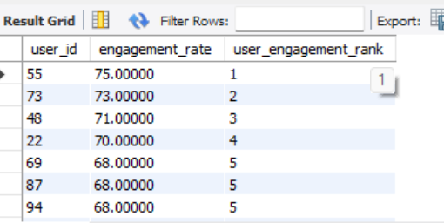

Insights-
- Influencer Identification: The ranking effectively identifies the platform’s leading content creators who generate the highest levels of community interaction per post.
- Quality over Quantity: By prioritizing engagement rates over absolute interaction counts, the query highlights creators whose content resonates strongly with their audience and drives meaningful engagement

Q5 Which users have the highest number of followers and followings?
Output columns (in order): user_id, username, followers, following (4 columns)
Row count: 100 rows (verified — 1 row per user).

Approach-
- Created a comprehensive view ( user_follower_and_following) to calculate follower and following counts for each user using correlated subqueries.
- Leveraged Common Table Expressions (CTEs) or inline derived tables with the Rank( ) window function to rank users based on their follower and following counts.
- Applied a where rnk=1 filter to identify users with the highest network counts while correctly handling ties for the top position.

create view user_follower_and_following as
select
u.id as user_id,
u.username,
(select COUNT(*) from follows where followee_id = u.id) as no_of_followers,
(select COUNT(*) from follows where follower_id = u.id) as no_of_followings
from users u
order by user_id;

-- Identifying users with the highest number of followers count, using the view 'user_follower_and_following'.
select user_id, username, no_of_followers
from
(
select
user_id, username, no_of_followers,
rank()over(order by no_of_followers desc) as rnk
FROM user_follower_and_following
) t
where rnk = 1
order by user_id;

-- Identifying users with the highest number of followings count, using the view 'user_follower_and_following'.
select user_id, username, no_of_followings
from
(
select
user_id, username, no_of_followings,
rank()over(order by no_of_followings desc) as rnk
from user_follower_and_following
) t
where rnk = 1
order by user_id;

Below were the Results for the query -
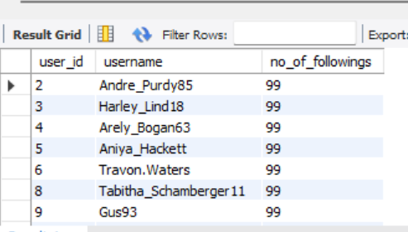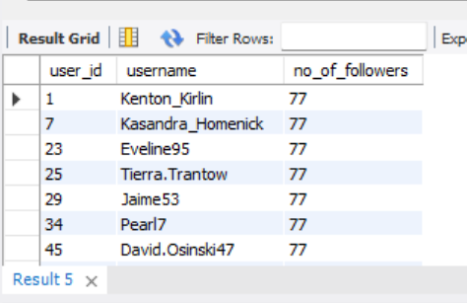
Q6 Calculate the average engagement rate (likes, comments) per post for each user.
Output columns (in order): id, username, avg_engagement (3 columns)
Row count: 74 rows (verified — 1 row per user who has posted ≥1 photo)
Approach-
- Utilized the previously created user_post_engagement_stats view, which consolidates post, like, and comment aggregations for each user.
- Retrieved user details along with pre-calculated engagement rates, promoting code reusability and improving query readability and efficiency.
.
Select user_id, username, engagement_rate
From user_post_engagement_stats;

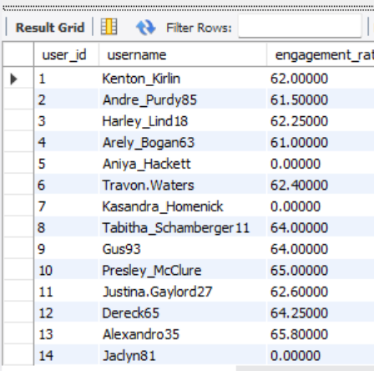
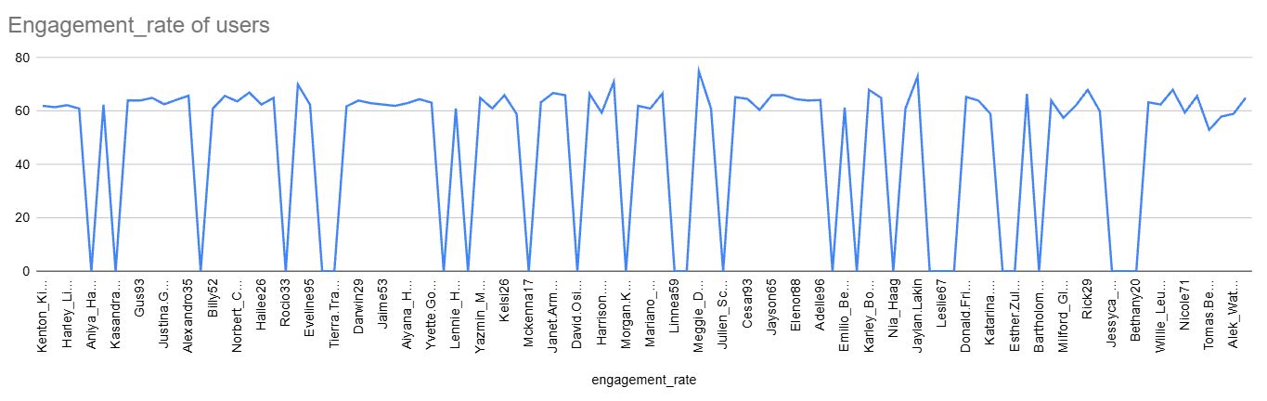
Q7 Get the list of users who have never liked any post (users and likes tables)
Output columns (in order): id, username (2 columns)
Row count: 23 rows (verified).

Approach
- Implemented a correlated Not Exists subquery to filter records from the users table.
- Checked the likes table for matching user_id entries and identified inactive users who have not liked any posts by verifying the absence of matching records.

select
u.id as user_id,
username
from users u
where not exists(
select 1
from likes l
where l.user_id = u.id
);

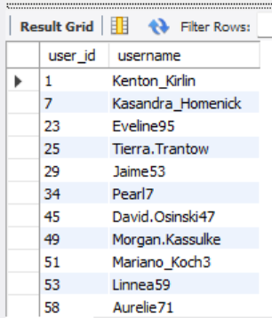

Insights-
- Churn Prediction: Identified users with no content interactions as potential churn risks, enabling targeted re-engagement strategies to improve user retention.
- Query Efficiency: Leveraged not exists to efficiently identify users without matching records, potentially improving performance on large datasets by allowing the database to stop searching once a match is found.

Q8 How can you leverage user-generated content (posts, hashtags, photo tags) to create more personalized and engaging ad campaigns?
Output columns (in order): user_id, username, tag_name, tag_usage, total_likes_received, total_comments_received, total_engagement (7 columns)
Row count: 459 rows (verified — 1 row per user/tag combination that appears in that user's posts).

Approach-
User-generated content (UGC), including posts, hashtags, and photo tags, can be analyzed to develop personalized and engaging advertising campaigns that align with users’ interests and preferences.
- The SQL query aggregates user engagement metrics, including likes, comments, and tag usage, to evaluate interactions across different users and tags.
- It identifies the themes and topics that generate the highest engagement, enabling marketers to understand audience interests and preferences more effectively.

select
u.id as user_id,
u.username,
t.tag_name,
count(distinct pt.tag_id) as tag_usage,
count(distinct l.photo_id) as total_likes_received,
count(distinct c.id) as total_comments_received,
(count(distinct l.photo_id) + count(distinct c.id)) as total_engagement
from users u
left Join photos p on u.id = p.user_id
left Join photo_tags pt on p.id = pt.photo_id
left Join tags t on pt.tag_id = t.id
left Join likes l on p.id = l.photo_id
left Join comments c on p.id = c.photo_id
group by u.id, u.username, t.tag_name
order by total_engagement desc, tag_usage desc;

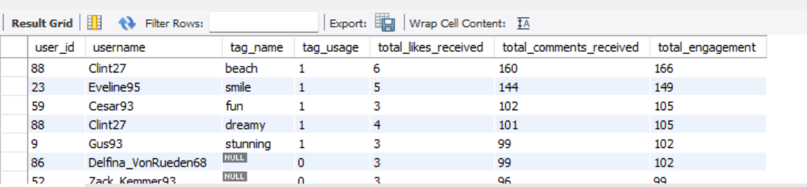
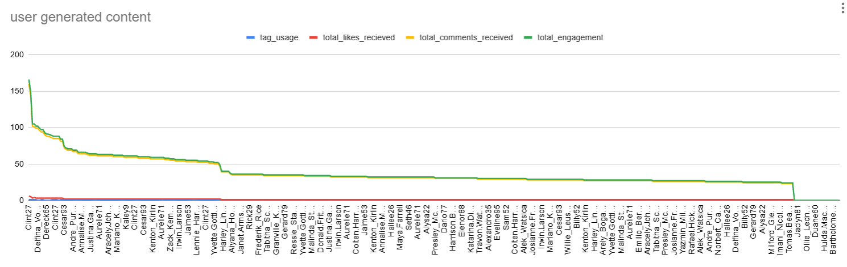
Insights-
- Top-engaged users: Clint27 and Eveline95 record the highest engagement levels, with 166 and 149 interactions, respectively.
- High-performing tags: Tags such as beach, smile, and fun generate significant engagement, suggesting that lifestyle-oriented and emotionally appealing content resonates well with users.
- Engagement distribution: The chart shows a sharp decline in engagement after the top-performing users, indicating that a relatively small group of creators contributes a substantial share of total interactions. These users could be valuable targets for influencer marketing campaigns.
Campaign Personalization-
Insight | Strategic Application
Emotional tags (smile, fun) | Create cheerful, relatable advertisements featuring positive emotions and engaging captions.
Lifestyle tags (beach, party) | Promote travel packages, leisure activities, beachwear, and outdoor experiences.
High-engagement users | Partner with influential creators to develop authentic brand stories and expand campaign reach.
Low-engagement tags (beauty, hair) | Reassess audience targeting, creative content, and messaging strategies to improve engagement.
- Audience Segmentation: Categorize users into interest-based groups, such as travel enthusiasts, food lovers, and party-goers, according to their interactions with relevant tags.
- Personalized Advertising: Deliver advertisements that reflect individual interests. For example, users who frequently engage with the beach tag could receive advertisements for beachwear, travel destinations, or holiday packages.
- Influencer Partnerships: Identify high-engagement contributors, such as Clint27, and collaborate with them to improve brand visibility and audience engagement.
- Content Optimization: Incorporate themes and content styles associated with high engagement into brand campaigns to make advertisements more relatable and appealing.

Conclusion-
Analyzing user-generated content engagement patterns enables brands to design advertising campaigns that better reflect their audiences’ interests, emotions, and lifestyles. By examining user interactions with posts, hashtags, and photo tags, marketers can identify popular themes, recognize influential contributors, and segment audiences based on their preferences.
These insights support the creation of personalized advertisements that feel relevant, relatable, and authentic. By incorporating high-performing content themes, collaborating with influential users, and encouraging community participation, businesses can strengthen audience relationships, improve engagement, and optimize marketing performance. Ultimately, leveraging UGC transforms everyday user interactions into valuable insights that support more effective, personalized, and community-driven advertising strategies.

Q9 Are there any correlations between user activity levels and specific content types (e.g., photos, videos, reels)? How can this information guide content creation and curation strategies?
Output columns (in order): user_id, total_posts, total_likes, total_comments, total_engagement (5 columns)
Row count: 74 rows (verified — 1 row per user_id with ≥1 photo).

Answer
Key Metrics:
- Total Photos
- Total Comments
- Total Likes
- Average Engagement Rate
This SQL query analyzes the relationship between user activity, including photos uploaded, likes received, and comments received, and the average engagement rate. The results help identify user engagement patterns and determine how content performance can be improved.

select
u.id as user_id,
u.username,
count(distinct p.id) as total_photos,
count(distinct l.photo_id) as total_likes,
count(distinct c.id) as total_comments,
ROUND(
(count(distinct l.photo_id) + count(distinct c.id)) /
count(distinct p.id),
2
) as avg_engagement_rate
from users u
left join photos p on u.id = p.user_id
left join likes l on p.id = l.photo_id
left join comments c on p.id = c.photo_id
group by u.id, u.username
having total_photos >=1
order by avg_engagement_rate desc;

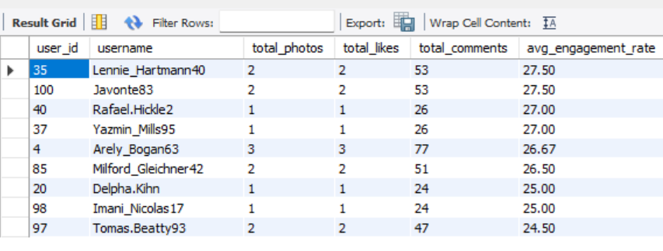
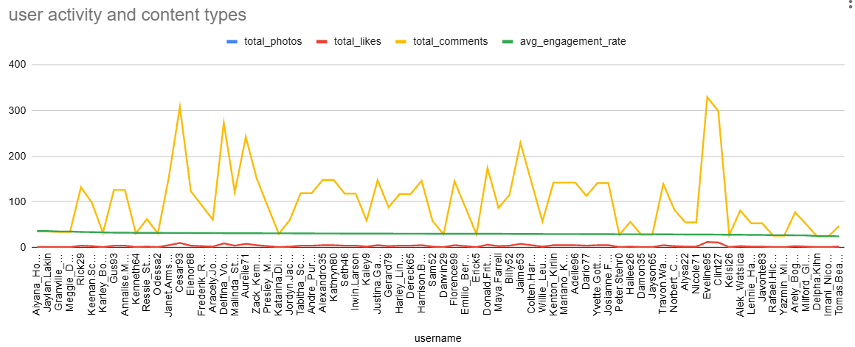
Key Insights from the Results
1. High-Engagement Users:
These users provide valuable insights into successful content strategies. Analyzing their photo themes, captions, and posting schedules can help guide future content creation.
2. Moderately Engaged Users:
These users have the potential to achieve higher engagement through targeted promotional campaigns, collaborations, and improved content visibility.
3. Inactive or Low-Engagement Users:
These users may benefit from re-engagement initiatives, such as personalized notifications, contests, and interest-based content recommendations.
How This Analysis Guides Content Creation and Curation
- Replicate Successful Strategies: Study the content styles, themes, captions, and posting schedules of top-performing users to identify effective approaches for future campaigns.
- Support Mid-Tier Creators: Offer incentives, increased visibility, and collaboration opportunities to help moderately engaged creators expand their reach.
- Re-engage Inactive Users: Introduce personalized notifications, gamified challenges, and exclusive rewards to encourage users to return to the platform.
- Optimize Posting Schedules: Analyze user activity patterns to identify peak engagement hours, such as 11 AM, and schedule content accordingly to maximize visibility and interaction.
- Diversify Content Formats: Encourage experimentation with photos, reels, and videos to determine which formats generate the highest audience engagement.
- Improve Ad Targeting: Develop advertising campaigns around high-performing content themes and hashtags to attract relevant audiences, increase engagement, and drive conversions.
Conclusion
This SQL analysis evaluates user activity and measures how audiences interact with their content. Users such as Aiyana_Hoeger and Jaylan.Lakin demonstrate the highest engagement, suggesting that their content resonates strongly with their audiences. These findings help marketers identify successful content strategies, support emerging creators, re-engage less active users, and optimize posting schedules. Ultimately, the analysis provides actionable insights for developing more engaging content, improving audience reach, and creating targeted marketing campaigns.
Q10 Calculate the total number of likes, comments, and photo tags for each user.
Output columns (in order): user_id, username, total_likes, total_comments, total_tags (5 columns)
Row count: 100 rows (verified — 1 row per user).
select
u.id as user_id,
u.username,
count(distinct l.photo_id) as total_likes,
count(distinct c.id) as total_comments,
count(distinct pt.tag_id) as total_photo_tags
FROM users u
left join photos p on u.id = p.user_id
left join likes l on p.id = l.photo_id
left join comments c on p.id = c.photo_id
left join photo_tags pt on p.id = pt.photo_id
group by u.id, u.username
order by total_likes desc, total_comments desc;

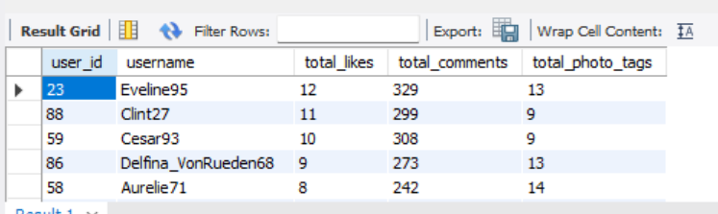
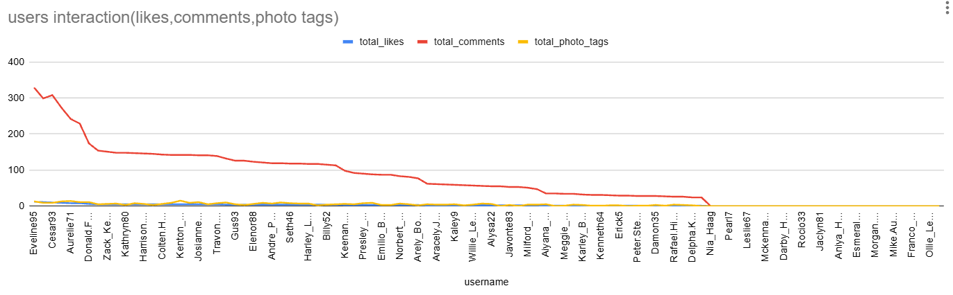

insights-
This SQL query calculates the total likes, comments, and photo tags for each user to evaluate their overall engagement.
From the result table:
1. Top Performer:
Eveline95 has the highest number of likes and comments, indicating strong audience engagement.
2. Consistent Contributors:
Clint27, Cesar93, and Delfina_VonRueden68 also demonstrate high levels of user interaction.
3. Photo Tag Insights:
Aurelie71 has the highest number of photo tags (14), suggesting that their content is frequently tagged or categorized.
Conclusion:
The SQL query identifies users with the highest number of likes, comments, and photo tags. The results highlight users like Eveline95 and Clint27, whose posts receive significant interaction. These insights can help identify highly engaged users and understand content interaction patterns.

Q11 Rank users based on their total engagement (likes, comments, shares) over a month.
Output columns (in order): user_id, username, likes_given, comments_made, total_engagement, engagement_rank (6 columns)
Row count: 100 rows (verified — 1 row per user).

select
u.id as user_id,
u.username,
count(distinct l.photo_id) as likes_given,
count(distinct c.id) as comments_made,
count(distinct l.photo_id) + count(distinct c.id) as
total_engagement,
rank() over (order by (count(distinct l.photo_id) +
count(distinct c.id)) desc) as engagement_rank
from users u
left join photos p on u.id = p.user_id
left join likes l on p.id = l.photo_id
left join comments c on p.id = c.photo_id
group by u.id, u.username
order by total_engagement desc;

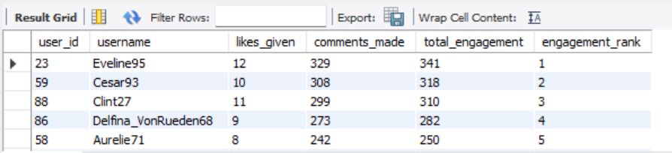
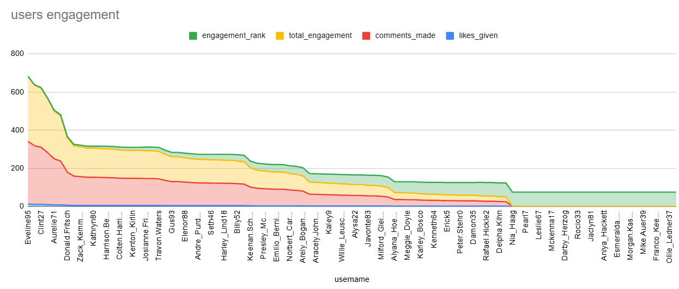

This SQL query ranks users by their total engagement (likes + comments) over
a month.
From the result table,
1. Top performer:
Eveline95 ranks #1 with the highest engagement (341).

2. Consistent contributors:
Cesar93 and Clint27 follow closely, showing strong audience interaction.

3. Trend:
Users with frequent posts and active followers dominate the top ranks.

The result shows users like Eveline95, Cesar93, and Clint27 at the top, meaning
they have the highest overall engagement and are the most active or influential
users.

Conclusion:
The SQL code ranks users by how many likes and comments they get in the
current month. The output shows that Eveline95 is the most engaging user,
followed by Cesar93 and Clint27. This helps identify top creators and guide
marketing or content strategies to boost overall engagement. -rephrase

Q12 Retrieve the hashtags that have been used in posts with the highest average number of likes. Use a CTE to calculate the average likes for each hashtag first.
Output columns (in order): tag_id, tag_name, avg_likes_per_photo, total_likes, total_photos (5 columns)
Row count: 10 rows (LIMIT 10; 21 tags exist in total, so the limit is reached).

WITH hashtag_likes AS (
SELECT
t.id AS tag_id,
t.tag_name,
COUNT(l.photo_id) * 1.0
/ NULLIF(COUNT(DISTINCT pt.photo_id), 0)
AS avg_likes_per_photo,
COUNT(l.photo_id) AS total_likes,
COUNT(DISTINCT pt.photo_id) AS total_photos
FROM photo_tags pt
JOIN tags t
ON t.id = pt.tag_id
LEFT JOIN likes l
ON pt.photo_id = l.photo_id
GROUP BY t.id, t.tag_name
)
SELECT
tag_id,
tag_name,
avg_likes_per_photo,
total_likes,
total_photos
FROM hashtag_likes
ORDER BY avg_likes_per_photo DESC
LIMIT 10;
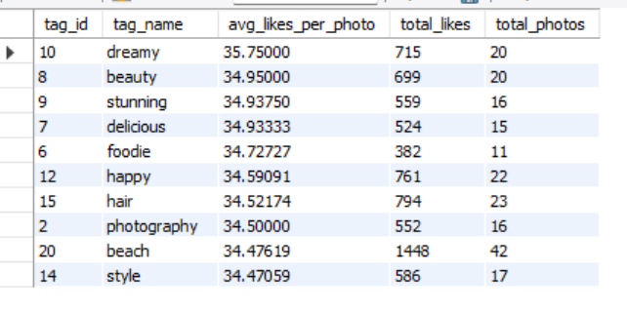
This SQL query identifies the top 10 hashtags based on their average likes per photo. It calculates the total likes, the number of distinct photos associated with each hashtag, and the average likes per photo. The results are sorted in descending order of average likes per photo.
From the result table:
1. Top-performing hashtag: Dreamy ranks first with an average of 35.75 likes per photo across 20 photos.
2. Other popular hashtags:
Beauty,stunning and delicious follow closely, each receiving an average of approximately 34.93–34.95 likes per photo.
3. Highest total likes:
beach has the highest total likes (1,448) across 42 photos, indicating strong overall engagement.
4. Engagement insights:
Hashtags such as happy and hair also show considerable engagement, with 761 and 794 total likes, respectively.
Conclusion:
The SQL query helps identify hashtags that generate high average likes per photo and those that attract the most total likes. While dreamy has the highest average likes per photo, beach leads in total likes. These insights can help guide hashtag selection and content strategies to improve audience engagement.

Q13 Retrieve the users who have started following someone after being followed by that person.
Output columns (in order): id, username (2 columns)
Row count: 77 rows (verified).

SELECT DISTINCT
u.id,
u.username
FROM follows f1
JOIN follows f2
ON f1.follower_id = f2.followee_id
AND f1.followee_id = f2.follower_id
JOIN users u
ON u.id = f2.follower_id;

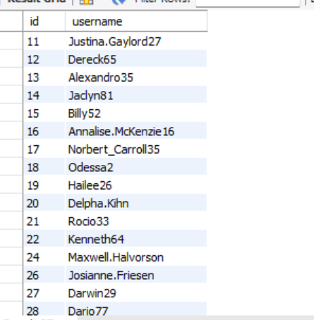

This SQL query identifies users who have a mutual following relationship by joining the table with itself. It then joins the users table to retrieve the IDs and usernames of those users. The distinct keyword ensures that duplicate records are excluded.
From the result table:
- User Identification: The query returns the IDs and usernames of users involved in mutual following relationships.
- Result Insights: Users such as Justina.Gaylord27, Dereck65, and Alexandro35 appear in the output, indicating that they have followed someone who also follows them.
- Duplicate Removal: The distinct keyword ensures that each user appears only once in the result.
Conclusion:
The SQL query identifies users who follow each other and displays their unique IDs and usernames. This helps analyze mutual connections within the platform.

Subjective Questions
Q1 Based on user engagement and activity levels, which users would you consider the most loyal or valuable? How would you reward or incentivize these users?

SELECT
u.id AS user_id,
u.username,
COUNT(DISTINCT p.id) AS total_posts,
COUNT(DISTINCT l.photo_id) AS total_likes,
COUNT(DISTINCT c.id) AS total_comments,
(COUNT(DISTINCT l.photo_id) + COUNT(DISTINCT c.id)) AS
engagement_score
FROM users u
LEFT JOIN photos p ON u.id = p.user_id
LEFT JOIN likes l ON p.id = l.photo_id
LEFT JOIN comments c ON p.id = c.photo_id
GROUP BY u.id, u.username
ORDER BY engagement_score DESC
LIMIT 10;

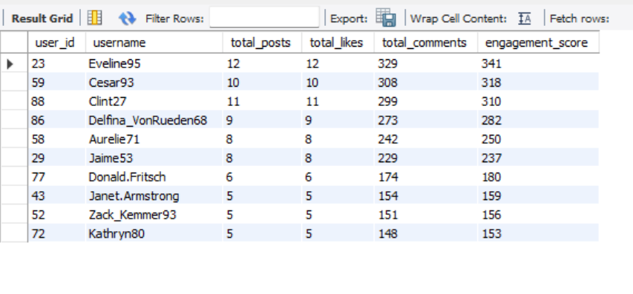
Approach-
Step 1: FROM Clause
The query begins with the users table (users u), which serves as the primary table. It establishes the base dataset by including all users before joining related information.
Step 2: LEFT JOIN Operations
Each LEFT JOIN connects related tables while retaining users who may not have any associated activity.
- LEFT JOIN photos p ON u.id = p.user_id
  - Connects each user to the photos they have uploaded.
  - Ensures that users without any photos are still included.
- LEFT JOIN likes l ON p.id = l.photo_id
  - Links photos to their corresponding likes.
  - Provides information about the likes received on users’ photos.
- LEFT JOIN comments c ON p.id = c.photo_id
  - Connects photos to their associated comments.
  - Enables the calculation of comments received on users’ photos.
Step 3: SELECT Clause
The query selects relevant user details and uses aggregate functions to calculate engagement metrics.
- COUNT(DISTINCT p.id) → Calculates the total number of posts uploaded by each user.
- COUNT(DISTINCT l.photo_id) → Counts the distinct photos that received likes, rather than the total number of likes.
- COUNT(DISTINCT c.id) → Calculates the total number of comments associated with each user's photos.
- COUNT(DISTINCT l.photo_id) + COUNT(DISTINCT c.id) → Calculates the combined engagement score using the above metrics.
These calculations summarize user activity and help compare engagement levels across the platform.
Step 4: GROUP BY Clause
The query groups the results by each user's unique ID and username (u.id, u.username). This ensures that the aggregate calculations are performed separately for each user.
Step 5: ORDER BY Clause
The results are sorted by engagement_score in descending order (DESC). Users with higher engagement scores appear first, making it easier to identify the most active contributors.
Step 6: LIMIT Clause
The LIMIT 10 clause restricts the output to the top 10 users with the highest engagement scores.
Step 7: Result Formation
The final output contains the following columns:
- user_id
- username
- total_posts
- total_likes
- total_comments
- engagement_score
This dataset can be used to identify highly engaged users, including Eveline95, Cesar93, and Clint27.
Insights
The SQL query identifies users with high levels of activity and interaction based on their posts, likes, and comments.
- Top Performers:
Eveline95, Cesar93, and Clint27 rank among the leading users, with engagement scores of 341, 318, and 310, respectively. Their results indicate substantial interaction with their content.
- Engagement Trends:
The results show a gradual decline in engagement scores from Eveline95 to Kathryn80, highlighting differences in user interaction levels. Comment activity can provide additional insight into discussions surrounding users' content.
- Activity Distribution:
While the number of posts and likes may be relatively similar across some users, comment counts can vary significantly. These differences help identify users whose content generates more discussion.
- Potential Loyalty Indicators:
Frequent posting and consistent audience interaction may indicate sustained interest in the platform. Highly engaged users can also help encourage community participation.
- Growth Opportunities:
Mid-level contributors, such as Aurelie71 and Jaime53, may benefit from targeted campaigns, content recommendations, and participation incentives to increase their engagement.
Recommendations
- Recognition Programs:
Introduce awards such as Top Contributor or Community Star badges. Feature highly engaged users on leaderboards or dedicated sections to recognize their contributions.
- Exclusive Benefits:
Offer selected users early access to new features, beta-testing opportunities, or personalized dashboards displaying their activity and engagement metrics.
- Reward Systems:
Introduce tiered rewards, such as Bronze, Silver, and Gold, based on clearly defined engagement thresholds. Rewards could include gift cards, merchandise, or discount coupons.
- Community Collaboration:
Invite top contributors to participate in content creation, community challenges, and discussions to strengthen their connection with the platform.
- Gamification:
Introduce points, activity streaks, and milestone badges to encourage consistent participation. Notifications can celebrate achievements and motivate users to remain active.
- Re-engagement Strategies:
Encourage less-active users to participate through personalized notifications, trending topics, contests, and referral campaigns.
Conclusion
The SQL query aims to identify the platform's most engaged users by analyzing their posts, likes, and comments. The results highlight Eveline95, Cesar93, and Clint27 as leading contributors. Recognizing these users through rewards, exclusive benefits, and community initiatives could help strengthen engagement and encourage continued participation.

Q2 For inactive users, what strategies would you recommend to re-engage them and encourage them to start posting or engaging again?

SELECT u.id, u.username
FROM users u
LEFT JOIN photos p ON u.id = p.user_id
LEFT JOIN likes l ON u.id = l.user_id
WHERE p.id IS NULL AND l.photo_id IS NULL;

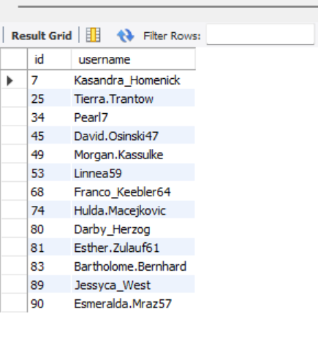
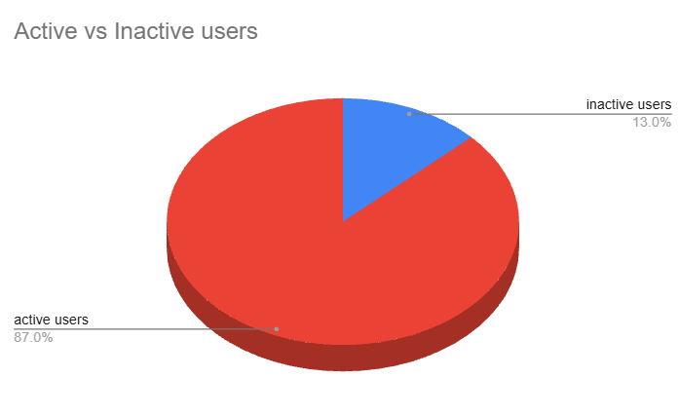
APPROACH
Step 1: FROM Clause
- The query begins with the FROM users u statement, which establishes the users table as the primary dataset.
- It includes all registered users as the starting point for identifying inactive members.
Step 2: LEFT JOIN Operations
The query uses two LEFT JOIN operations to connect users with their posting and liking activities while retaining users who have no corresponding records.
1. LEFT JOIN photos p ON u.id = p.user_id
- Connects each user to the photos they have uploaded.
- Users without any uploaded photos remain in the result, with NULL values in the photo-related columns.
2. LEFT JOIN likes l ON u.id = l.user_id
- Connects each user to their liking activity.
- Users who have not liked any photos are also retained, with NULL values in the like-related columns.
Step 3: WHERE Clause
- The condition WHERE p.id IS NULL AND l.photo_id IS NULL filters the results to include only users who meet both conditions:
  - No posts: p.id IS NULL identifies users who have not uploaded any photos.
  - No likes: l.photo_id IS NULL identifies users who have not liked any photos.
- Users satisfying both conditions are classified as inactive based on their posting and liking activity.
Step 4: SELECT Clause
The query retrieves the following columns:
- u.id — The unique identifier assigned to each user.
- u.username — The username used to identify the user on the platform.
This produces a simple list of users who have neither uploaded photos nor liked any photos.
Step 5: Result Formation
- The final output contains the IDs and usernames of users who have no recorded photo uploads or likes.
- Examples from the result include Kasandra_Homenick, Tierra.Trantow, and Pearl7.
INSIGHTS
The results highlight users who have not participated in posting or liking content. These users may be new members who have not yet explored the platform or previously registered users who have become inactive.
1. Identification of Inactive Users
- The query identifies users with no uploaded photos and no likes.
- These users represent a low-engagement segment because they have not participated in content creation or liking activities.
2. Behavioral Analysis
Several factors may contribute to this inactivity, including:
- Limited awareness of the platform's features.
- An onboarding process that does not encourage participation.
- Content recommendations that do not match users' interests.
- Reduced interest in the platform over time.
These users may be at risk of disengagement, but they also represent an opportunity to increase participation.
3. User Segmentation
The users listed in the result can be further categorized for targeted engagement:
- New users: Members who have recently registered but have not yet posted or liked content.
- Dormant users: Members who may have stopped participating after previously being active.
- Passive users: Members who may browse content without posting or liking anything.
Additional registration and activity-history data would be required to distinguish these groups accurately.
4. Impact on the Platform
- A large inactive user base may limit community participation and reduce overall engagement.
- Encouraging inactive members to interact with content could improve participation rates and strengthen the platform's community.
RECOMMENDATIONS
1. Personalized Onboarding Reminders
Send personalized notifications or emails introducing features that users have not tried.
Example: “Upload your first photo and share your creativity with the community!”
2. Gamification and Rewards
Introduce beginner badges, points, or other incentives to encourage users to perform their first activity.
Example: “Like your first post and earn a starter badge!”
3. Personalized Content Recommendations
Recommend trending posts, relevant hashtags, or communities based on users' interests and activity.
Example: “Discover popular photos and trending topics in your area!”
4. Community Challenges
Organize themed events and photo contests to motivate users to participate.
Example: “Join the #WeekendVibes challenge and share your favourite photo!”
5. Exclusive Benefits
Offer returning users early access to selected features or recognition for participating in community activities.
Example: “Explore our latest features and share something new with the community!”
6. Feedback Collection
Ask inactive users about their experience to understand the reasons behind their lack of participation.
Example: “What would make your experience better? Share your feedback and help us improve!”
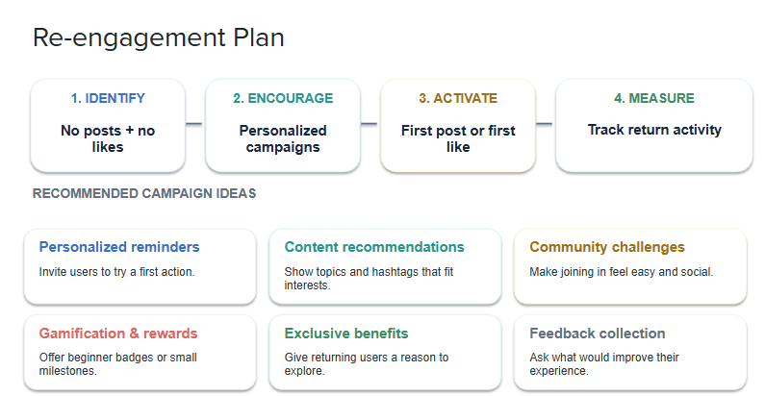
CONCLUSION
The SQL query identifies users who have neither uploaded photos nor liked any content on the platform. The resulting list helps isolate a low-engagement user segment for further analysis. Personalized communication, relevant content recommendations, incentives, and interactive campaigns can encourage these users to participate and improve overall platform engagement.

Q3 Which hashtags or content topics have the highest engagement rates? How can this information guide content strategy and ad campaigns?

WITH hashtag_engagement AS (
SELECT
t.tag_name,
AVG(like_count + comment_count) AS avg_engagement
FROM (
SELECT
pt.tag_id,
COUNT(DISTINCT l.user_id) AS like_count,
COUNT(DISTINCT c.id) AS comment_count
FROM photo_tags pt
LEFT JOIN likes l ON pt.photo_id = l.photo_id
LEFT JOIN comments c ON pt.photo_id = c.photo_id
GROUP BY pt.tag_id
) AS tag_summary
JOIN tags t ON t.id = tag_summary.tag_id
GROUP BY t.tag_name
)
SELECT tag_name, avg_engagement
FROM hashtag_engagement
ORDER BY avg_engagement DESC
LIMIT 10;

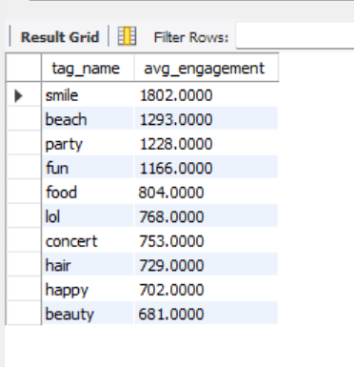
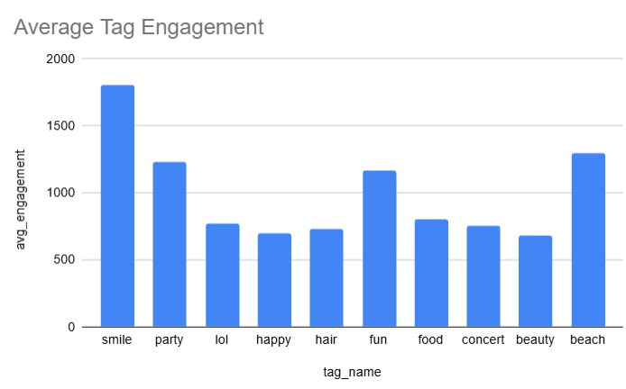
APPROACH
Step 1: FROM Clause (Inner Query)
- The query begins with the photo_tags pt table, which connects photos with their associated hashtags through tag_id and photo_id.
- This table serves as the foundation for analyzing engagement across different hashtags.
Step 2: LEFT JOIN Operations
The query uses two LEFT JOIN operations to incorporate likes and comments while retaining photos that have no engagement.
1. LEFT JOIN likes l ON pt.photo_id = l.photo_id
- Connects each photo with its associated likes.
- Preserves hashtag-related records even when photos have not received any likes.
2. LEFT JOIN comments c ON pt.photo_id = c.photo_id
- Connects photos with their corresponding comments.
- Ensures that photos without comments can still be included in the analysis.
Step 3: GROUP BY Clause (Inner Query)
- Groups the records by pt.tag_id to calculate engagement metrics for each hashtag.
- The query calculates:
  - COUNT(DISTINCT l.user_id) — Counts the distinct users who liked photos associated with each hashtag.
  - COUNT(DISTINCT c.id) — Counts the distinct comments associated with photos using each hashtag.
- These calculations summarize the engagement data for each hashtag.
Step 4: SELECT Clause (Inner Query)
- Selects the hashtag ID, like count, and comment count from the grouped results.
- The resulting dataset, referred to as tag_summary, provides aggregated engagement metrics for each hashtag.
Step 5: WITH Clause (CTE Creation)
- The Common Table Expression (CTE), named hashtag_engagement, organizes the summarized engagement data for further analysis.
- It uses the results of the inner query to calculate the engagement score for each hashtag.
Step 6: JOIN Operation (Outer Query)
- Joins the summarized data with the tags table using t.id = tag_summary.tag_id.
- Retrieves the corresponding hashtag names through t.tag_name, making the results easier to interpret.
Step 7: SELECT Clause (Outer Query)
- Calculates the average engagement score using AVG(like_count + comment_count).
- Combines likes and comments to measure overall interaction associated with each hashtag.
- Selects the hashtag name and its average engagement score for the final output.
Step 8: GROUP BY Clause (Outer Query)
- Groups the results by t.tag_name to aggregate engagement data for each hashtag.
- Ensures that each hashtag is represented by its corresponding engagement score.
Step 9: ORDER BY Clause
- Sorts hashtags by avg_engagement in descending order.
- Places the hashtags with the highest engagement scores at the top of the results.
Step 10: LIMIT Clause
- Restricts the output to the top 10 hashtags.
- Highlights the hashtags with the highest calculated engagement for further analysis.
INSIGHTS
Based on the result table, the following observations can be made:
1. Top-Performing Hashtags
- #smile ranks first, with the highest average engagement of approximately 1,800, indicating substantial interaction with content using this hashtag.
- #beach, #party, and #fun follow, with engagement scores ranging from approximately 1,200 to 1,400.
- These hashtags represent lifestyle, leisure, and social experiences that may appeal to a broad audience.
2. Moderately Performing Hashtags
- #food, #lol, and #concert demonstrate moderate engagement, with scores of approximately 750–850.
- These hashtags represent specific interests such as food, humor, and entertainment.
- They may be useful for reaching audiences with particular interests and designing targeted campaigns.
3. Lower-Engagement Hashtags
- #hair, #happy, and #beauty show comparatively lower engagement, with scores around 700.
- Their performance may indicate opportunities to improve content quality, originality, or audience targeting.
- Creative visuals, tutorials, and relevant collaborations could help increase interaction.
4. Engagement Trends
- The results show a noticeable difference between the leading hashtags and those with lower engagement scores.
- Lifestyle and social themes appear prominently among the top-performing hashtags.
- However, further analysis would be required to determine whether content themes directly influence engagement.
5. Audience Interaction Patterns
- The results help identify hashtags associated with higher levels of likes and comments.
- Hashtags related to positivity, humor, and shared experiences may provide useful opportunities for content experimentation.
- Actual audience preferences should be validated through additional metrics, such as reach, impressions, and engagement rates.
RECOMMENDATIONS
1. Prioritize High-Engagement Themes
Develop content around lifestyle, positivity, and social experiences when these themes align with the target audience and campaign objectives.
2. Use Popular Hashtags Strategically
Experiment with hashtags such as #smile, #beach, and #party to improve content discoverability and attract relevant audiences.
3. Target Niche Audiences
Use hashtags such as #food and #concert to create campaigns for specific interest groups, including food enthusiasts and entertainment audiences.
4. Combine Related Hashtags
Pair popular hashtags with relevant niche hashtags, such as #travelgram or #foodie, to reach different audience segments while maintaining content relevance.
5. Personalize Advertising Campaigns
Segment advertising campaigns according to user interests. For example, lifestyle-oriented content can target broader audiences, while food and entertainment campaigns can focus on users with related interests.
6. Monitor Hashtag Performance Regularly
Review hashtag engagement metrics periodically to identify changes in audience preferences and adjust content strategies accordingly.
CONCLUSION
The SQL query analyzes likes and comments associated with different hashtags to identify those with the highest calculated engagement. According to the results, #smile, #beach, and #party are among the leading hashtags. These findings can help marketers select relevant hashtags, develop targeted advertising campaigns, and improve content strategies to encourage audience interaction and increase brand visibility.

Q4 Are there any patterns or trends in user engagement based on demographics (age, location, gender) or posting times? How can these insights inform targeted marketing campaigns?

SELECT
HOUR(p.created_dat) AS posting_hour,
COUNT(DISTINCT l.photo_id) AS total_likes,
COUNT(DISTINCT c.id) AS total_comments
FROM photos p
LEFT JOIN likes l ON p.id = l.photo_id
LEFT JOIN comments c ON p.id = c.photo_id
GROUP BY posting_hour
ORDER BY posting_hour;

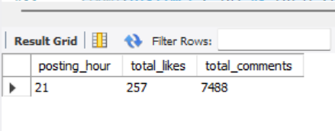
APPROACH
Step 1: FROM Clause
- The query begins with the photos p table, which serves as the primary dataset.
- It retrieves photo records, including their creation timestamps (created_dat).
- This information provides the foundation for analyzing engagement based on the time photos are posted.
Step 2: LEFT JOIN Operations
The query uses two LEFT JOIN operations to incorporate likes and comments while retaining photos that have no engagement.
1. LEFT JOIN likes l ON p.id = l.photo_id
- Connects each photo to its associated likes.
- Ensures that photos without any likes remain included in the analysis.
2. LEFT JOIN comments c ON p.id = c.photo_id
- Links photos to their corresponding comments.
- Preserves photos even when they have not received any comments.
Step 3: SELECT Clause
The query extracts the posting hour and calculates engagement metrics using aggregate functions.
- HOUR(p.created_dat) — Extracts the hour when each photo was posted.
- COUNT(DISTINCT l.photo_id) — Counts the distinct photos that received likes, rather than the total number of likes.
- COUNT(DISTINCT c.id) — Counts the distinct comments associated with the photos.
These metrics help examine engagement patterns across different posting hours.
Step 4: GROUP BY Clause
- Groups the records by posting_hour.
- Aggregates the engagement metrics for each hour of the day.
- Allows comparisons between different time slots to identify when posting activity receives the most interaction.
Step 5: ORDER BY Clause
- Sorts the results by posting_hour in ascending order.
- Displays the hours chronologically, making it easier to compare engagement throughout the day.
Step 6: Result Formation
The result table shows the following values for 11 AM:
- Posting hour: 11
- Total likes: 257
- Total comments: 7,488
Based on the reported results, 11 AM shows substantial engagement activity and may be a promising time slot for further analysis.
INSIGHTS
Based on the result table, the following observations can be made:
1. Peak Engagement Hour
- The results identify hour 11 (11 AM) as a prominent posting time, with 257 likes and 7,488 comments reported.
- This suggests that late morning may be a suitable period for audience interaction.
- However, the highest-engagement hour should be confirmed by comparing the results for all posting hours.
2. User Interaction Patterns
- The reported comment count is considerably higher than the like count.
- This may indicate substantial discussion around the content, although the counting method should be verified before drawing conclusions about user preferences.
3. Time-Based Engagement Trends
- Analyzing engagement by posting hour helps identify periods when users interact more frequently with content.
- Understanding these patterns can help optimize posting schedules and improve opportunities for audience interaction.
4. Impact of Posting Time
- Publishing content during periods of high audience activity may increase the likelihood of receiving attention and engagement.
- Testing different posting times can help determine which schedules work best for the platform's audience.
5. Opportunities for Audience Analysis
- The current query focuses on posting time and engagement metrics.
- Additional information, such as users' age groups, locations, and time zones, could support more detailed audience segmentation and help identify suitable posting schedules for different groups.
RECOMMENDATIONS
1. Schedule Posts During High-Engagement Hours
Experiment with publishing posts and advertisements around 11 AM, provided further analysis confirms that this is a peak engagement period.
2. Improve Campaign Performance
Use engagement data to identify suitable advertising windows and test whether posting during those periods improves clicks, interactions, and conversions.
3. Develop a Content Timing Strategy
Schedule motivational, lifestyle, and promotional content at different times to determine when each content category performs best.
4. Segment the Audience
If demographic and location data are available, analyze engagement patterns across different audience groups to develop more targeted posting schedules.
5. Conduct A/B Testing
Compare engagement for posts published at 11 AM against posts published at other times. Evaluate likes, comments, reach, and conversions to identify the most effective time slots.
6. Optimize Marketing Resources
Allocate advertising budgets based on measured performance across different time periods rather than relying solely on a single reported engagement peak.
CONCLUSION
The SQL query analyzes likes and comments by grouping photos according to their posting hour. The reported results highlight 11 AM as a potentially effective time for audience engagement. These findings can help guide posting schedules and advertising strategies, while further testing and accurate engagement calculations are needed to confirm the optimal time for maximizing reach and interaction.

Q5 Based on follower counts and engagement rates, which users would be ideal candidates for influencer marketing campaigns? How would you approach and collaborate with these influencers?

WITH follower_counts AS (
SELECT
followee_id AS user_id,
COUNT(DISTINCT follower_id) AS follower_count
FROM follows
GROUP BY followee_id
),
like_counts AS (
SELECT
p.user_id,
COUNT(distinct l.photo_id) AS total_likes
FROM photos p
JOIN likes l ON p.id = l.photo_id
GROUP BY p.user_id
),
comment_counts AS (
SELECT
p.user_id,
COUNT(c.id) AS total_comments
FROM photos p
JOIN comments c ON p.id = c.photo_id
GROUP BY p.user_id
)
SELECT
u.id AS user_id,
u.username,
COALESCE(fc.follower_count, 0) AS follower_count,
COALESCE(lc.total_likes, 0) AS total_likes,
COALESCE(cc.total_comments, 0) AS total_comments,
COALESCE(lc.total_likes, 0)
+ COALESCE(cc.total_comments, 0) AS engagement_score
FROM users u
LEFT JOIN follower_counts fc ON u.id = fc.user_id
LEFT JOIN like_counts lc ON u.id = lc.user_id
LEFT JOIN comment_counts cc ON u.id = cc.user_id
ORDER BY follower_count DESC, engagement_score DESC
LIMIT 10;
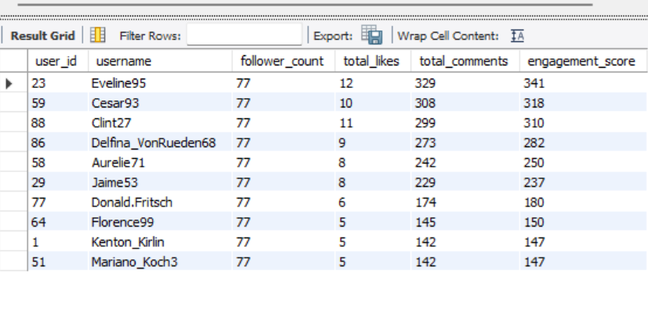
Approach
Step 1: Common Table Expressions (CTEs)
The query uses three Common Table Expressions (CTEs) to calculate follower counts, likes, and comments separately. This approach simplifies the main query, avoids unnecessary row multiplication from multiple joins, and improves readability.
1. follower_counts CTE
- Retrieves each user's ID from the follows table using followee_id.
- Uses COUNT(DISTINCT follower_id) to calculate the number of unique followers for each user.
- Groups the results by followee_id to generate one follower count per user.
2. like_counts CTE
- Joins the photos and likes tables using p.id = l.photo_id.
- Groups the results by p.user_id to calculate likes-related metrics for each user.
- Uses COUNT(DISTINCT l.photo_id) to count the number of distinct photos that received at least one like.
3. comment_counts CTE
- Joins the photos and comments tables using p.id = c.photo_id.
- Uses COUNT(c.id) to calculate the total number of comments received on each user's photos.
- Groups the results by p.user_id to produce a comment count for each user.
Step 2: FROM Clause
The main query starts with FROM users u, using the users table as the base dataset. This ensures that all users can be considered for ranking, including those who have no followers, likes, or comments.
Step 3: LEFT JOIN Operations
The query combines the users table with the three aggregated CTEs using LEFT JOIN:
- follower_counts: Adds the follower count for each user.
- like_counts: Adds the calculated likes metric for each user's photos.
- comment_counts: Adds the total number of comments received.
These joins preserve users even when no matching records exist in the CTEs.
Step 4: SELECT Clause
The SELECT clause retrieves user details and calculates the required metrics:
- u.id AS user_id: Unique identifier of the user.
- u.username: Username of the user.
- COALESCE(fc.follower_count, 0): Displays the follower count, replacing NULL with zero.
- COALESCE(lc.total_likes, 0): Displays the likes metric, replacing NULL with zero.
- COALESCE(cc.total_comments, 0): Displays the comment count, replacing NULL with zero.
- engagement_score: Calculates the sum of the likes metric and total comments.
The COALESCE() function ensures that users without matching records receive zero values instead of NULL.
Step 5: ORDER BY Clause
The query sorts users in descending order by follower_count, followed by engagement_score. Users with the highest follower counts appear first, and users with higher engagement scores are prioritized when follower counts are equal.
Step 6: LIMIT Clause
The LIMIT 10 clause restricts the results to the top 10 users according to the specified ranking, helping identify potential influencer candidates.
Step 7: Result Formation
The final output contains the following columns:
- user_id
- username
- follower_count
- total_likes
- total_comments
- engagement_score
The results can be used to compare users based on their audience size and interactions with their content.
Insights
1. Top-Performing Influencers
Based on the provided results, Eveline95, Cesar93, and Clint27 are among the leading users, with engagement scores of 341, 318, and 310, respectively. Their high scores make them potential candidates for influencer marketing campaigns.
2. Engagement Patterns
The engagement scores help distinguish users based on the combined likes metric and comment count. Comparing these scores can help identify users whose content receives stronger audience interaction.
3. Audience Interaction
The total comment count indicates how frequently audiences engage with users' photos through comments. Users with higher comment counts may be able to encourage more active discussions around sponsored content.
4. Reach and Engagement
Follower counts indicate the potential reach of an influencer, while likes and comments provide additional information about audience interaction. Considering these metrics together offers a more balanced basis for selecting influencers.
5. Potential Growth Opportunities
Users with moderate follower counts or engagement scores may still be suitable for niche campaigns. Targeted collaborations could help them expand their reach and improve audience interaction.
Recommendations
- Personalized Outreach: Contact potential influencers with tailored proposals based on their follower counts and engagement metrics.
- Sponsored Content: Collaborate with selected users to promote products or campaigns that align with their audiences.
- Affiliate Programs: Offer commission-based incentives to encourage traffic, leads, or sales.
- Exclusive Access: Provide early access to products, events, or new features to encourage participation.
- Long-Term Partnerships: Build ongoing relationships with suitable influencers to maintain consistent brand visibility.
- Content Co-Creation: Involve influencers in developing campaign ideas and promotional content to encourage authentic audience engagement.
Conclusion
The SQL query uses CTEs to calculate follower counts, likes-related metrics, and comment counts separately before combining them to rank users. This structure makes the query easier to understand and helps prevent row multiplication caused by joining likes and comments directly. The results can be used to identify potential influencer candidates and plan targeted marketing collaborations.

Q6 Based on user behavior and engagement data, how would you segment the user base for targeted marketing campaigns or personalized recommendations?

SELECT
u.id AS user_id,
u.username,
COUNT(DISTINCT p.id) AS post_count,
COUNT(DISTINCT l.photo_id) AS like_count,
COUNT(DISTINCT c.id) AS comment_count,
CASE
WHEN COUNT(DISTINCT p.id) >= 10 AND COUNT(DISTINCT
l.photo_id) >= 50 THEN 'Highly Active'
WHEN COUNT(DISTINCT p.id) BETWEEN 5 AND 9 THEN
'Moderately Active'
ELSE 'Low Activity'
END AS user_segment
FROM users u
LEFT JOIN photos p ON u.id = p.user_id
LEFT JOIN likes l ON u.id = l.user_id
LEFT JOIN comments c ON u.id = c.user_id
GROUP BY u.id, u.username
ORDER BY user_segment;

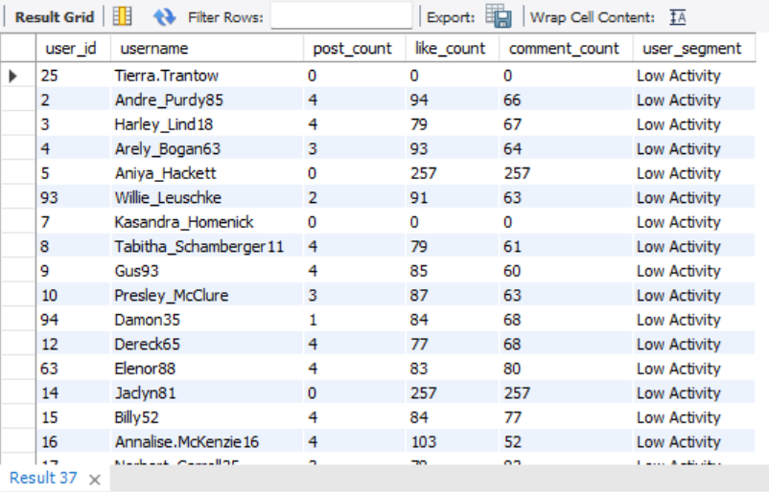

APPROACH
Step 1: FROM Clause
The query begins with FROM users u, using the users table as the base dataset. It retrieves user records to analyze their posting, liking, and commenting activities, providing the foundation for user segmentation.
Step 2: LEFT JOIN Operations
The query uses three LEFT JOIN operations to combine user activity data while retaining users who may not have any posts, likes, or comments.
- LEFT JOIN photos: Connects users to their uploaded photos using u.id = p.user_id, allowing the query to identify users with no posts.
- LEFT JOIN likes: Connects users to the likes they have given using u.id = l.user_id, helping measure their interaction with other users' content.
- LEFT JOIN comments: Connects users to their comments using u.id = c.user_id, providing insight into their commenting activity.
Step 3: SELECT Clause
The SELECT clause retrieves user details and calculates activity metrics:
- u.id AS user_id: Unique identifier of each user.
- u.username: Username of the user.
- COUNT(DISTINCT p.id): Total number of posts uploaded by the user.
- COUNT(DISTINCT l.photo_id): Number of distinct photos liked by the user.
- COUNT(DISTINCT c.id): Total number of comments made by the user.
These metrics summarize each user's level of activity on the platform.
Step 4: CASE Statement (Segmentation Logic)
The CASE statement classifies users into three activity segments based on their posting and liking behavior:
- Highly Active: Users with at least 10 posts and at least 50 likes.
- Moderately Active: Users with 5–9 posts.
- Low Activity: Users who do not meet either of the above conditions.
This conditional logic creates the user_segment column, making it easier to categorize users according to their activity levels.
Step 5: GROUP BY Clause
The query groups the results by u.id and u.username. This ensures that the aggregation functions calculate activity metrics separately for each user, producing one summarized row per user.
Step 6: ORDER BY Clause
The results are sorted by user_segment, organizing users according to their assigned activity categories and making the segmentation results easier to review.
Step 7: Result Formation
The final output displays user_id, username, post_count, like_count, comment_count, and user_segment.
Examples from the result table include:
- Tierra.Trantow: Classified as Low Activity, with 0 posts and 94 likes.
- Andre.Purdy85: Classified as Low Activity, with 4 posts, 79 likes, and 61 comments.
The sample results indicate that these users fall into the Low Activity category because their posting behavior does not meet the criteria for the other segments.
INSIGHTS
1. Engagement Overview
The results compare users across three metrics: post count, like count, and comment count. Significant peaks indicate higher activity in particular areas, while low values suggest limited participation. These differences help identify behavioral patterns and opportunities for personalized marketing.
2. Activity Patterns
Users such as Eveline95, Cesar93, and Clint27 may demonstrate strong activity across multiple metrics, while users such as Aurelie71 and Jaime53 may represent opportunities for further engagement. Users such as Kasandra.Homenick and Tierra.Trantow may require targeted strategies to encourage greater participation.
3. Behavioral Segmentation
The query divides users into three groups: Highly Active, Moderately Active, and Low Activity. This classification helps the platform understand different participation levels and tailor engagement strategies to each group.
4. Engagement Drivers
Likes and comments provide additional insight into how users interact with content. Users who comment frequently may contribute to discussions and community building, while users who like many photos may be more responsive to content recommendations.
5. Audience Behavior Insights
Variations in posting, liking, and commenting activity can reveal different user behaviors. Consistent activity may indicate regular platform participation, whereas occasional spikes may reflect interest in specific topics, events, or trending content.
RECOMMENDATIONS
1. Low Activity Users
- Send personalized notifications and reminders to encourage participation.
- Introduce gamification features, such as badges, challenges, and contests.
- Offer introductory incentives, such as featuring users who upload their first photo.
2. Moderately Active Users
- Encourage collaborations and community challenges.
- Increase visibility for their content through featured or trending sections.
- Introduce loyalty rewards to motivate consistent participation.
3. Potential Highly Active Users
- Develop creator or influencer programs to encourage regular posting.
- Offer exclusive benefits, such as early access to new features or brand collaborations.
- Use targeted campaigns to turn highly engaged users into platform advocates.
CONCLUSION
The SQL query segments users into three categories based on their posting, liking, and commenting activities. The results can help identify highly engaged users, users with growth potential, and users who may need re-engagement efforts. By developing targeted campaigns and personalized incentives for each segment, the platform can encourage participation, strengthen community engagement, and improve overall user retention.

Q7 If data on ad campaigns (impressions, clicks, conversions) is available, how would you measure their effectiveness and optimize future campaigns?
SQL is not required for this task, as it involves IF analysis and should be answered theoretically.
INSIGHTS
Evaluating the effectiveness of advertising campaigns requires analyzing key performance indicators (KPIs) that measure reach, engagement, and conversions. The three primary metrics—impressions, clicks, and conversions—provide valuable insights into campaign performance.
1. Impressions
Impressions represent the total number of times an advertisement is displayed to users.
- For example, 100,000 impressions indicate that the ad was displayed 100,000 times.
- However, a high number of impressions does not necessarily indicate campaign success, as it measures visibility rather than user engagement or action.
2. Clicks
Clicks measure how many times users interact with an advertisement by clicking on it.
- For example, if an ad receives 5,000 clicks from 100,000 impressions, its Click-Through Rate (CTR) is 5%.
- A higher CTR generally indicates that the advertisement's content, design, or message is attracting audience interest.
3. Conversions
Conversions represent the number of users who complete a desired action, such as making a purchase, signing up, or downloading an application.
- For example, if 500 out of 5,000 clicks result in purchases, the conversion rate is 10%.
- This metric helps evaluate how effectively an advertisement turns user interest into meaningful outcomes and contributes to campaign performance.
RECOMMENDATIONS
1. Measure Key Performance Indicators
Calculate and compare important metrics to assess campaign effectiveness:
- Click-Through Rate (CTR): (Clicks ÷ Impressions) × 100. Measures how effectively an ad attracts clicks.
- Conversion Rate: (Conversions ÷ Clicks) × 100. Measures the percentage of clicks that result in the desired action.
- Cost per Conversion: Total Campaign Cost ÷ Number of Conversions. Measures the average cost of acquiring each conversion.
2. Optimize Future Campaigns
- Analyze Audience Behavior: Identify the demographics, audience segments, and platforms that generate higher engagement and conversion rates.
- Test Ad Creatives and Messages: Use A/B testing to compare different advertisements and identify the versions that perform best.
- Refine Audience Targeting: Allocate resources toward audience segments that demonstrate stronger engagement and conversion potential.
- Improve Timing and Placement: Schedule advertisements for periods when the target audience is more active and select placements that deliver better results.
Example: If advertisements targeting young professionals achieve a conversion rate of 12%, while those targeting students achieve only 4%, future campaigns could allocate more budget to the professional segment. Meanwhile, the messaging and targeting for student-focused campaigns could be reviewed and improved.
CONCLUSION
Improving advertising campaign performance requires continuous monitoring, data-driven decision-making, and strategic optimization. By evaluating impressions, clicks, conversions, and related performance metrics, businesses can identify successful strategies, refine audience targeting, improve advertising content, and allocate budgets more effectively. This ongoing optimization helps strengthen engagement, increase conversions, maximize return on investment (ROI), and achieve better results from future campaigns.

Q8 How can you use user activity data to identify potential brand ambassadors or advocates who could help promote Instagram's initiatives or events?
WITH follower_counts AS (
SELECT
followee_id AS user_id,
COUNT(DISTINCT follower_id) AS follower_count
FROM follows
GROUP BY followee_id
),
like_counts AS (
SELECT
p.user_id,
COUNT(distinct l.photo_id) AS total_likes
FROM photos p
JOIN likes l ON p.id = l.photo_id
GROUP BY p.user_id
),
comment_counts AS (
SELECT
p.user_id,
COUNT(c.id) AS total_comments
FROM photos p
JOIN comments c ON p.id = c.photo_id
GROUP BY p.user_id
)
SELECT
u.id AS user_id,
u.username,
COALESCE(fc.follower_count, 0) AS follower_count,
COALESCE(lc.total_likes, 0) AS total_likes,
COALESCE(cc.total_comments, 0) AS total_comments,
COALESCE(lc.total_likes, 0)
+ COALESCE(cc.total_comments, 0) AS engagement_score
FROM users u
LEFT JOIN follower_counts fc ON u.id = fc.user_id
LEFT JOIN like_counts lc ON u.id = lc.user_id
LEFT JOIN comment_counts cc ON u.id = cc.user_id
ORDER BY follower_count DESC, engagement_score DESC
LIMIT 10;

Approach- Identifying Potential Brand Ambassadors Using User Activity Data
User activity data can be analyzed to identify individuals who demonstrate high engagement, consistent participation, and strong interaction with the Instagram community. These users can be potential brand ambassadors or advocates who help promote Instagram's initiatives, campaigns, and events.
1. Analyze User Engagement: Evaluate the number of likes, comments, and interactions generated by users to identify those who actively engage with content and encourage conversations.
2. Evaluate Follower Count: Identify users with a substantial follower base who may help Instagram reach a wider audience through their posts and recommendations.
3. Measure Activity and Consistency: Examine posting frequency and regular participation to identify users who consistently contribute content and remain active on the platform.
4. Identify Community Builders: Look for users who frequently comment, interact with other users, and participate in community activities, as they may be effective at encouraging audience participation.
5. Segment Potential Ambassadors: Group users into categories such as highly engaged users, consistent content creators, and active community members. Prioritize individuals who demonstrate a combination of reach, engagement, and consistent activity.
6. Develop Targeted Collaborations: Invite selected users to participate in Instagram campaigns, promote new features, share event announcements, or create content related to platform initiatives. Their performance can be monitored through engagement, reach, and participation metrics.
Conclusion
By analyzing follower counts, posting frequency, likes, comments, and overall engagement, Instagram can identify potential brand ambassadors who have the ability to influence and motivate other users. Collaborating with these individuals can increase campaign visibility, encourage community participation, and strengthen user engagement.

Q9 How would you approach this problem, if the objective and subjective questions weren't given?
If the objectives and subjective questions were not provided, I would follow a structured Data Science Lifecycle to understand the dataset, identify business problems, and generate meaningful insights.
- Schema Understanding: Examine the Entity-Relationship Diagram (ERD) to understand the database structure, tables, and relationships between them.
- Data Cleaning: Check for missing values, duplicates, inconsistencies, and incorrect data types to ensure data quality.
- Exploratory Data Analysis (EDA): Analyze user activity, including posts, likes, comments, follows, and engagement patterns, to understand platform behavior.
- Identify Business Questions: Develop relevant questions, such as which users are most engaged, which hashtags perform best, and what factors may influence user retention.
- Perform Analysis: Use SQL queries to extract, aggregate, and compare data to answer these questions.
- Visualize and Interpret Results: Use charts and dashboards to present trends and patterns clearly.
- Provide Recommendations: Translate the findings into actionable strategies to improve user engagement, retention, and marketing effectiveness.
Conclusion: By following this systematic approach, I could independently identify business opportunities, analyze relevant data, and provide actionable insights even without predefined questions.

Q10 Assuming there's a "User_Interactions" table tracking user engagements, how can you update the "Engagement_Type" column to change all instances of "Like" to "Heart" to align with Instagram's terminology?
The SQL UPDATE statement can modify existing records by replacing the value 'Like' with 'Heart' in the Engagement_Type column.
UPDATE User_Interactions
SET Engagement_Type = 'Heart'
WHERE Engagement_Type = 'Like';
Insights
1. Brand Alignment
Instagram uses a heart icon to represent likes. Updating the database terminology from “Like” to “Heart” helps align the stored data with the platform’s branding and interface.
2. Data Consistency
Using a standardized term such as “Heart” prevents confusion in analytics and reporting. If records contain both “Like” and “Heart,” they may be incorrectly treated as separate engagement types, leading to inaccurate results.
3. Improved Analytics
Standardizing engagement terminology simplifies SQL queries, reporting, and data analysis. Analysts can group and analyze all heart interactions under a single category without accounting for multiple labels.
4. Enhanced User Experience
Maintaining consistency between the platform’s interface and its backend data makes reports and dashboards easier for stakeholders to understand and interpret.
5. Historical Data Integrity
Updating existing records ensures that historical engagement data follows the same terminology. This supports consistent comparisons between past and current engagement trends.
Recommendations
- Maintain Brand Alignment: Use “Heart” consistently in the database to reflect the platform’s terminology and visual representation.
- Ensure Data Consistency: Standardize engagement labels to prevent duplicate categories and discrepancies in reports.
- Simplify Analytics: Use a single engagement label to make queries, calculations, and reporting more efficient.
- Improve Reporting Clarity: Keep backend terminology consistent with the platform’s interface so that dashboards remain clear and easy to interpret.
- Validate the Update: After executing the update, verify that all records previously labeled “Like” have been changed to “Heart” and that unrelated engagement types remain unchanged.
Example in Practice
Before the update:
- Eveline95 → Engagement_Type: Like
- Cesar93 → Engagement_Type: Like
After the update:
- Eveline95 → Engagement_Type: Heart
- Cesar93 → Engagement_Type: Heart
This demonstrates how standardizing the terminology ensures that existing records use the same engagement label.
Conclusion
Changing “Like” to “Heart” in the engagement data improves terminology consistency and aligns the database with Instagram’s branding. It reduces confusion in analytics, simplifies reporting, and ensures that historical records use a standardized label. Overall, this update supports better data quality and more consistent interpretation of engagement metrics.

