STUDENT ACADEMIC SUCCESS & DROPOUT PREDICTION
A Multiclass Machine Learning & Predictive Analytics Framework for Early Institutional Retention

Project Owner: Aryan
Project Role: Lead Data Scientist & Project Engineer
Project Type: AI / Machine Learning Academic Internship Project
Dataset Source: UCI Machine Learning Repository (ID: 697)
DOI Reference: 10.24432/C5MC89 | Creative Commons Attribution 4.0 (CC BY 4.0)
Publication Date: September 2026

2. Abstract
Student attrition in higher education diminishes university financial sustainability, depresses graduate attainment rates, and imposes substantial personal economic burdens on exiting students. This study develops an end-to-end, reproducible multiclass machine learning framework to predict three student graduation outcomes: Dropout, Enrolled, and Graduate. Using the official UCI Machine Learning Repository dataset comprising 4,424 student records and 36 predictors from the Instituto Politécnico de Portalegre, we resolve the critical hazard of temporal data leakage by constructing two distinct operational paradigms: Perspective A (Pre-Enrollment Screening, 24 features available at intake) and Perspective B (Longitudinal Progress Modeling, 36 features incorporating first- and second-semester curricular evaluations). Through a 5-Fold Stratified Cross-Validation protocol evaluating five supervised learning classification families (Logistic Regression, Decision Trees, Random Forests, HistGradientBoosting, and Support Vector Classifiers) alongside a stratified DummyClassifier baseline, the champion model—a class-weighted Random Forest under Perspective B—achieved a test set accuracy of 74.92%, a Macro-F1 score of 0.7069, and a Dropout recall of 70.42%. In contrast, intake screening (Perspective A) attained 59.10% accuracy and a Macro-F1 of 0.5506. Explainability analysis reveals that second-semester curricular approvals and tuition fee compliance are the dominant predictors of graduation, while pre-enrollment risk is driven primarily by older matriculation age, lower entrance examination grades, and non-traditional admissions modes. These empirical findings validate a two-tiered institutional retention strategy combining pre-matriculation financial counseling with intensive mid-year academic advising.
3. Introduction
Higher education institutions globally operate under dual pressures: expanding equitable access to higher learning while maintaining acceptable graduation and persistence metrics. Student dropout represents a compounded loss: institutions lose recurring tuition revenue and state subsidies, while departed students often shoulder accumulated debt without acquiring the market credentials necessary for enhanced socioeconomic mobility. Historically, university intervention programs have been predominantly retrospective, reacting only after a student submits formal withdrawal paperwork or fails out of the institution at the close of an academic year.
The advent of machine learning and institutional analytics allows universities to shift from reactive mitigation to proactive, early-warning retention systems. However, applying predictive modeling to academic trajectories requires rigorous methodological discipline. A widespread failure in higher-education analytics is temporal data leakage—the inappropriate inclusion of post-matriculation academic achievements when attempting to evaluate a student's intake vulnerability. By establishing clear temporal feature boundaries, this project addresses this challenge directly, delivering actionable insights for educational administrators.
4. Problem Statement
Core Operational Dilemma: University leadership and student affairs administrators require an automated diagnostic mechanism that balances two distinct institutional needs:
- Can we reliably detect at-risk students prior to day one of class using demographic, socioeconomic, and admission credentials alone?
- How significantly does observation of first-year academic performance improve retention classification, and what are the specific credit thresholds that separate persistent students from dropouts?
Furthermore, higher education outcome classification is inherently a multiclass, class-imbalanced problem. While graduates constitute approximately 50% of the cohort and dropouts comprise 32%, actively enrolled students (those needing additional semesters to graduate) represent only 18%. Standard algorithms optimized for raw accuracy frequently misclassify the minority 'Enrolled' category. This project addresses this technical challenge through stratified partitioning, cost-sensitive class weighting, and evaluation centered on Macro-F1.
5. Project Objectives
- 1. Dataset Audit & Integrity: Download and perform an exhaustive empirical data audit of the official UCI 697 dataset without synthetic fabrication.
- 2. Data Leakage Control: Classify all 36 predictors against official UCI documentation into verified Pre-Enrollment (Perspective A) and Longitudinal (Perspective B) feature sets.
- 3. Exploratory Analytics: Conduct descriptive, bivariate, and correlation analyses to quantify relationships between academic, demographic, and financial drivers and student outcomes.
- 4. Robust Feature Engineering: Construct isolated scikit-learn preprocessing pipelines using ColumnTransformer, StandardScaler, and OneHotEncoder.
- 5. Multi-Model Benchmark: Train and validate multiple algorithms under 5-Fold Stratified Cross-Validation on the training partition.
- 6. Rigorous Model Evaluation: Evaluate models using Macro-F1, per-class Recall, Confusion Matrices, and Permutation/Gini Feature Importance.
- 7. Institutional Strategy: Formulate actionable, ethical retention recommendations for university academic counselors.
6. Dataset Description
The dataset utilized in this research is the benchmark 'Predict Students' Dropout and Academic Success' dataset (UCI ID: 697, DOI: 10.24432/C5MC89), created by Valentim Realinho, Jorge Machado, Luís Baptista, and Mónica V. Martins from the Instituto Politécnico de Portalegre in Portugal (published in MDPI Data, 2021). The dataset integrates records of undergraduate students enrolled between 2008/2009 and 2018/2019 across 17 diverse degree programs including Informatics Engineering, Nursing, Management, Journalism, and Tourism.
Parameter / Metric | Empirical Value / Characteristic
Total Observations (Rows) | 4,424 complete student records
Total Predictive Features | 36 features (nominal, continuous, discrete counts)
Target Variable | Target (3 classes: Graduate, Dropout, Enrolled)
Class Proportions | Graduate: 2,209 (49.93%) | Dropout: 1,421 (32.12%) | Enrolled: 794 (17.95%)
Missing / Null Values | Exactly 0 missing values across all 163,688 cells
Duplicate Records | Exactly 0 duplicate rows detected
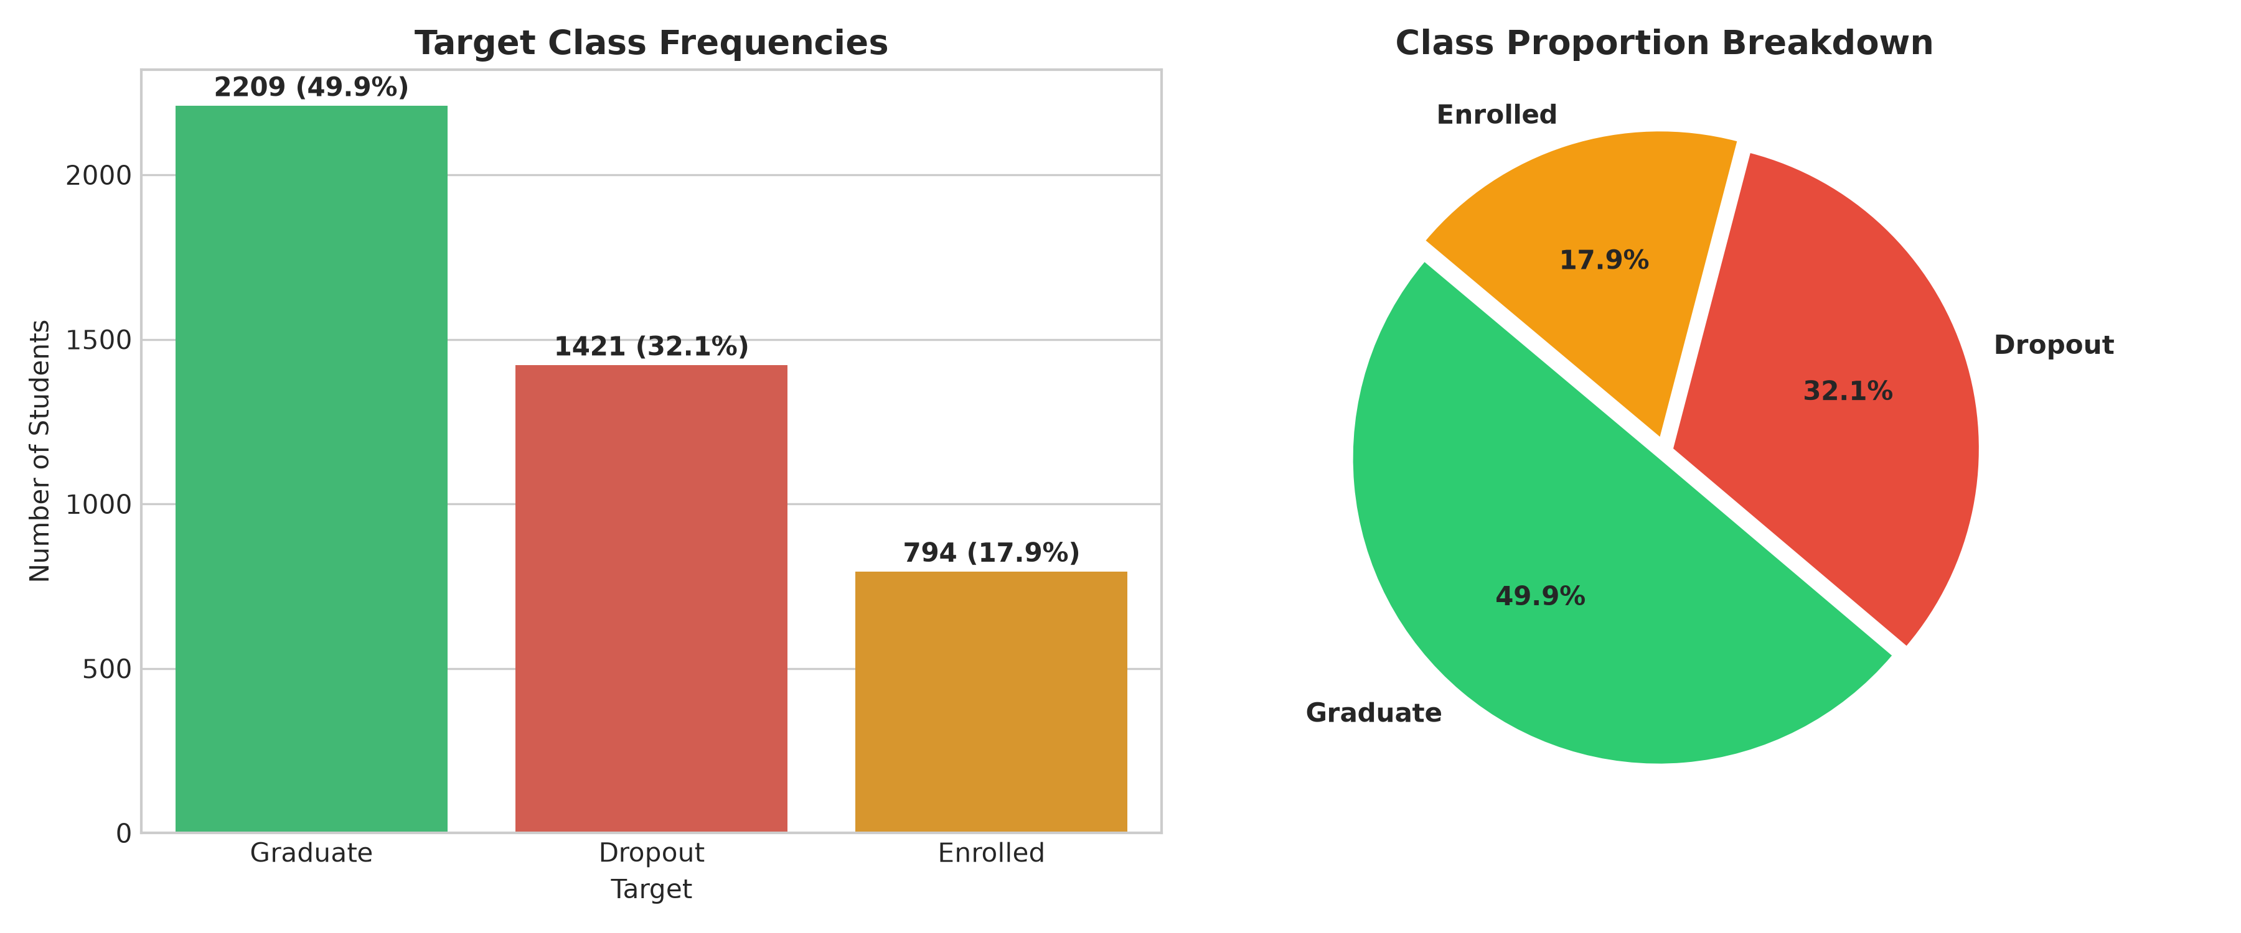
Figure 1: Target Class Distribution & Proportions in UCI 697 Dataset
7. Data Dictionary & Feature Taxonomy
The 36 predictors represent multiple facets of a student's institutional and personal lifecycle, organized into seven operational categories:
Taxonomic Group | Count | Variables Included
Demographic Factors | 6 | Marital status, Nacionality, Displaced, Gender, Age at enrollment, International
Socioeconomic & Parental | 4 | Mother's qualification, Father's qualification, Mother's occupation, Father's occupation
Admission & Prior Study | 7 | Application mode, Application order, Course, Daytime/evening attendance, Previous qualification, Previous qualification (grade), Admission grade, Educational special needs
Financial Standing | 3 | Debtor, Tuition fees up to date, Scholarship holder
1st Semester Academic | 6 | Curricular units 1st sem (credited, enrolled, evaluations, approved, grade, without evaluations)
2nd Semester Academic | 6 | Curricular units 2nd sem (credited, enrolled, evaluations, approved, grade, without evaluations)
Macroeconomic Context | 3 | Unemployment rate, Inflation rate, GDP (Portuguese national metrics for enrollment cohort year)
8. Methodology & Data Leakage Prevention
Experimental Architecture: To eliminate temporal data leakage while preserving real-world utility, we formulated two distinct modeling perspectives:
- Perspective A (Pre-Enrollment Screening): Uses exactly 24 features available at the matriculation threshold. Models under Perspective A test whether an institution can flag at-risk admits prior to classroom instruction.
- Perspective B (Academic-Progress Modeling): Uses the full 36 features, incorporating cumulative credits, evaluations, and GPAs from semesters 1 and 2. Models under Perspective B evaluate risk after one year of coursework.
Feature-by-Feature Temporal Verification Table
Every variable was audited against the primary source definitions in Realinho et al. (2021) and official UCI documentation:
Feature Name | Available at Intake? | Perspective A? | Official Reason / Evidence
Marital status | Yes | Yes | Demographic or admissions record submitted at matriculation
Application mode | Yes | Yes | Demographic or admissions record submitted at matriculation
Application order | Yes | Yes | Demographic or admissions record submitted at matriculation
Course | Yes | Yes | Demographic or admissions record submitted at matriculation
Daytime/evening attendance | No | No | Post-matriculation exam result finalized after semester 1 or 2
Previous qualification | Yes | Yes | Demographic or admissions record submitted at matriculation
Previous qualification (grade) | Yes | Yes | Demographic or admissions record submitted at matriculation
Nacionality | Yes | Yes | Demographic or admissions record submitted at matriculation
Mother's qualification | Yes | Yes | Demographic or admissions record submitted at matriculation
Father's qualification | Yes | Yes | Demographic or admissions record submitted at matriculation
Mother's occupation | Yes | Yes | Demographic or admissions record submitted at matriculation
Father's occupation | Yes | Yes | Demographic or admissions record submitted at matriculation
Admission grade | Yes | Yes | Demographic or admissions record submitted at matriculation
Displaced | Yes | Yes | Demographic or admissions record submitted at matriculation
Educational special needs | Yes | Yes | Demographic or admissions record submitted at matriculation
Debtor | Yes | Yes | Institutional financial record at registration (Realinho 2021 Table 1)
Tuition fees up to date | Yes | Yes | Institutional financial record at registration (Realinho 2021 Table 1)
Gender | Yes | Yes | Demographic or admissions record submitted at matriculation
Scholarship holder | Yes | Yes | Institutional financial record at registration (Realinho 2021 Table 1)
Age at enrollment | Yes | Yes | Demographic or admissions record submitted at matriculation
International | Yes | Yes | Demographic or admissions record submitted at matriculation
Curricular units 1st sem (credited) | No | No | Post-matriculation exam result finalized after semester 1 or 2
Curricular units 1st sem (enrolled) | No | No | Post-matriculation exam result finalized after semester 1 or 2
Curricular units 1st sem (evaluations) | No | No | Post-matriculation exam result finalized after semester 1 or 2
Curricular units 1st sem (approved) | No | No | Post-matriculation exam result finalized after semester 1 or 2
Curricular units 1st sem (grade) | No | No | Post-matriculation exam result finalized after semester 1 or 2
Curricular units 1st sem (without evaluations) | No | No | Post-matriculation exam result finalized after semester 1 or 2
Curricular units 2nd sem (credited) | No | No | Post-matriculation exam result finalized after semester 1 or 2
Curricular units 2nd sem (enrolled) | No | No | Post-matriculation exam result finalized after semester 1 or 2
Curricular units 2nd sem (evaluations) | No | No | Post-matriculation exam result finalized after semester 1 or 2
Curricular units 2nd sem (approved) | No | No | Post-matriculation exam result finalized after semester 1 or 2
Curricular units 2nd sem (grade) | No | No | Post-matriculation exam result finalized after semester 1 or 2
Curricular units 2nd sem (without evaluations) | No | No | Post-matriculation exam result finalized after semester 1 or 2
Unemployment rate | Yes | Yes | Cohort intake macroeconomic figure (INE Portugal / Realinho 2021 Table 1)
Inflation rate | Yes | Yes | Cohort intake macroeconomic figure (INE Portugal / Realinho 2021 Table 1)
GDP | Yes | Yes | Cohort intake macroeconomic figure (INE Portugal / Realinho 2021 Table 1)
9. Data Preprocessing Pipelines
Data preprocessing was isolated strictly within scikit-learn ColumnTransformer objects to prevent data leakage between training and testing folds:
- Nominal Categoricals: Features such as Course, Application mode, and Parental Occupations/Qualifications represent discrete non-ordinal categories. These were transformed using OneHotEncoder(handle_unknown='ignore', sparse_output=False).
- Continuous & Ordinal Numerical Features: Scaled to zero mean and unit variance using StandardScaler().
- Binary Flags: Preserved as numeric indicators (0/1).
- Partitioning: Stratified 80/20 train-test split (3,539 training rows, 885 testing rows) with random_state=42. Preprocessor parameters were fitted exclusively on the 80% training set.
10. Exploratory Data Analysis & Diagnostic Insights
Our exploratory analysis identified strong systemic associations between student background, academic execution, and eventual retention:
- Academic Trajectory: 2nd Semester Curricular Friction: The distribution of approved units in the second semester shows sharp divergence across outcomes. Graduates achieve a median of 6.0 approved units (out of 6 enrolled), whereas dropouts exhibit a median of 0.0 approved units. Over 75% of dropouts completed 2 or fewer units in their second term.
- Financial Default: Tuition Fee Default as Attrition Proxy: Among students whose tuition fees were overdue (Tuition fees up to date = 0), exactly 86.55% dropped out, with only 5.49% graduating. Conversely, among students whose tuition was fully up to date, 55.95% graduated and 24.74% dropped out.
- Age & Modality: Non-Traditional Age Gradient: Students enrolling above the age of 25 face markedly higher attrition rates. While younger students (18-21) exhibit a 25.4% dropout rate, students aged 25 and older suffer a dropout rate of 52.8%, reflecting balancing pressures of employment and family responsibilities.
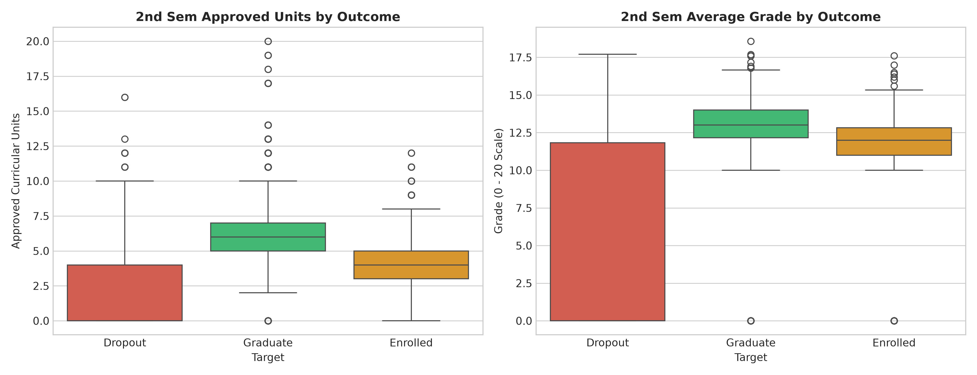
Figure 2: Distribution of 2nd Semester Approved Units and Grades across Student Outcomes
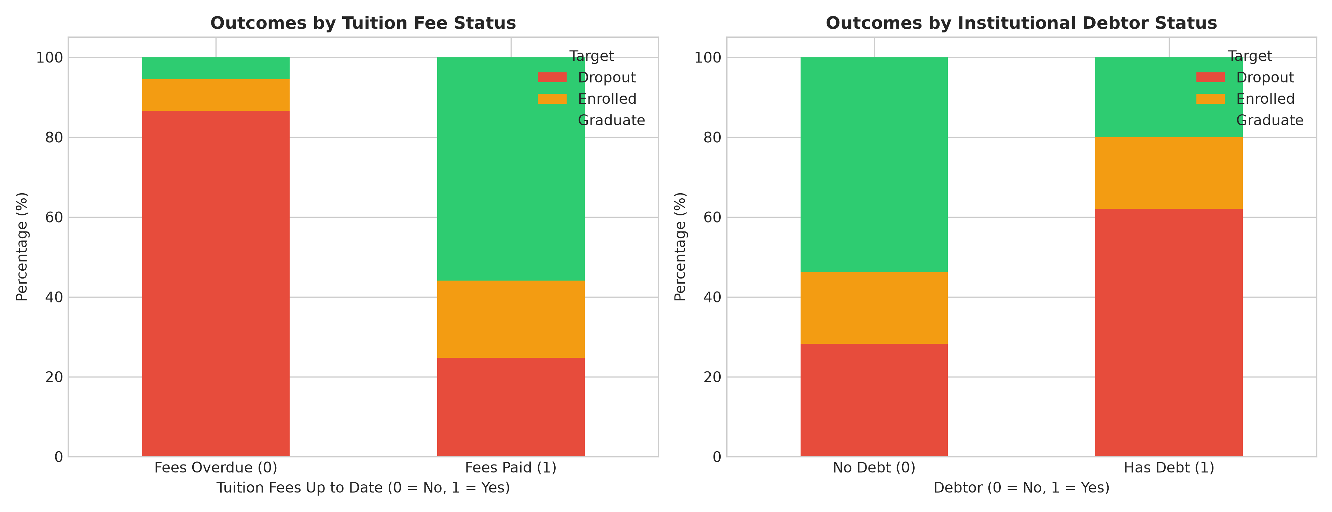
Figure 3: Dropout Risk Breakdown by Tuition Fee Currency and Institutional Debtor Status
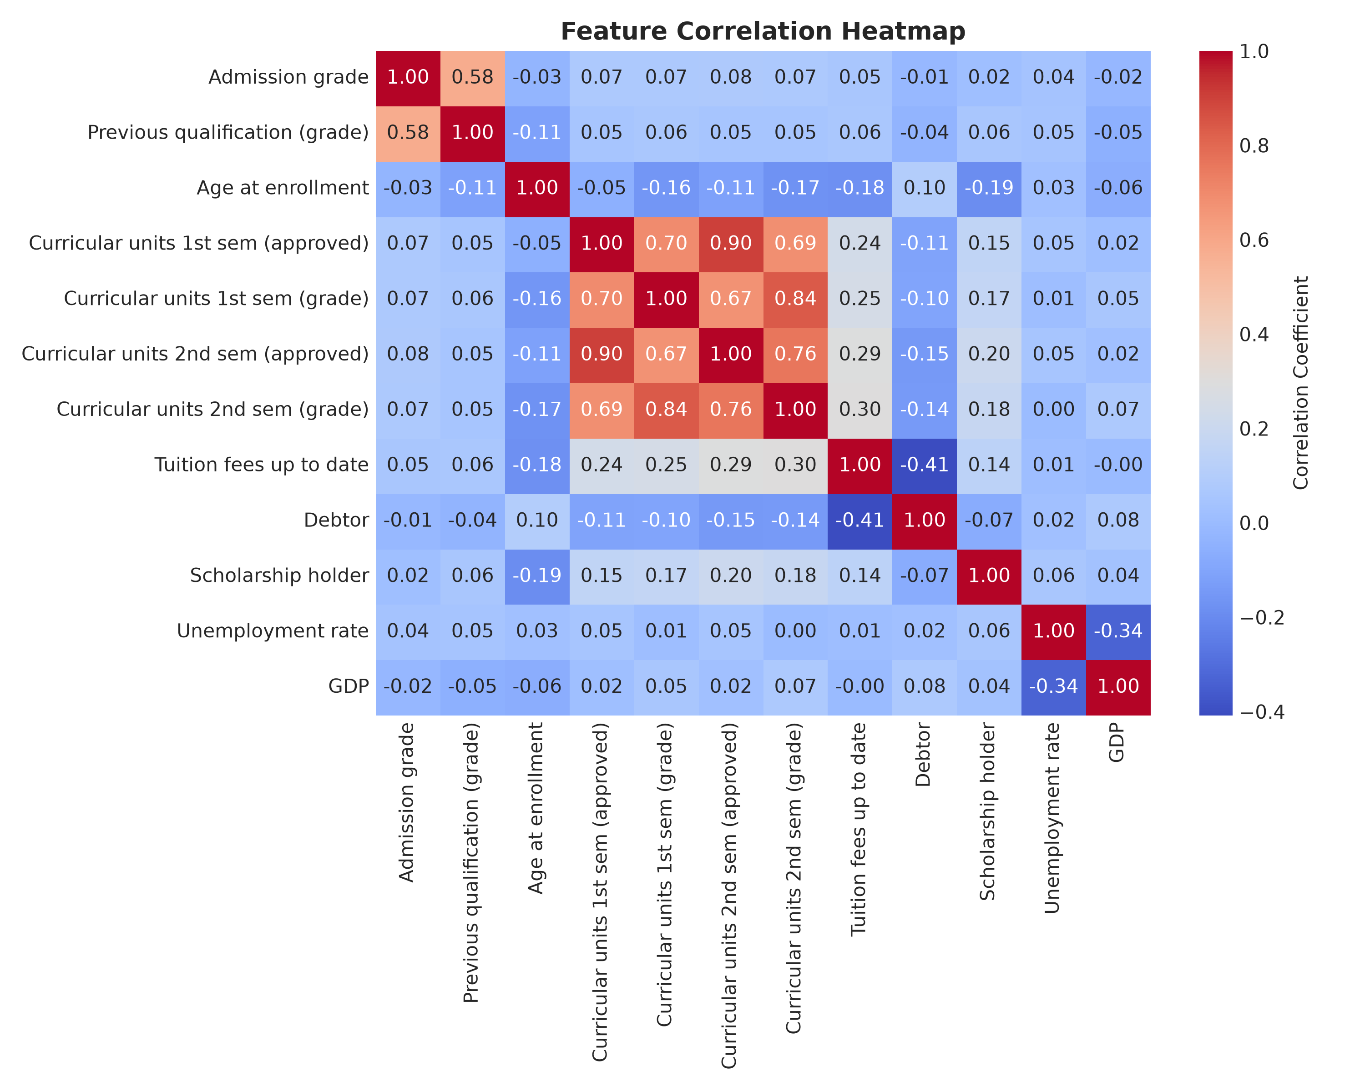
Figure 4: Correlation Matrix of Key Academic, Demographic, and Macroeconomic Predictors
11. Machine Learning Approach
Five supervised learning model families were evaluated alongside a stratified DummyClassifier baseline, each substantive model configured with class_weight='balanced' to handle the moderate class imbalance:
- 1. Baseline: Stratified Baseline: DummyClassifier(strategy='stratified') to benchmark chance-level performance.
- 2. Logistic Regression: Multinomial Logistic Regression: L2-regularized linear decision boundaries with maximum 1,000 solver iterations.
- 3. Decision Tree: Decision Tree Classifier: Constrained tree structure (max_depth=6) with Gini impurity splitting to provide interpretable rules.
- 4. Random Forest: Random Forest Classifier: Ensemble bagging of 150 randomized decision trees (max_depth=12) with balanced sub-sampling.
- 5. HistGradientBoosting: HistGradientBoosting Classifier: Histogram-based gradient boosting optimized for dense tabular inputs with maximum 120 iterations.
- 6. Support Vector Classifier: Support Vector Machine (RBF): Radial basis function kernel with cost-sensitive class balancing.
12. Model Evaluation Methodology
Given that overall accuracy is heavily biased toward the majority 'Graduate' class (50%), we established the following multiclass evaluation protocol:
- Primary Selection Metric: Macro-F1 Score: Unweighted arithmetic mean of F1-scores across all three classes. Penalizes models that fail to correctly predict the minority 'Enrolled' class.
- Institutional Priority: Dropout Recall: The proportion of actual dropouts correctly identified. From an institutional perspective, false negatives (failing to identify a dropping student) carry far higher cost than false positives.
- Validation Rigor: 5-Fold Stratified Cross-Validation: Evaluated on the training partition to ensure stability and guard against test-set overfitting.
13. Experimental Results & Comparative Analysis
Table 4 summarizes the 5-fold cross-validation and test set performance for all models across Perspective A and Perspective B:
Perspective | Model | CV Macro-F1 | Test Acc | Test Macro-F1 | Dropout Recall | Graduate Recall
A (Intake) | Baseline (Stratified) | 0.3383 (+/-0.009) | 41.02% | 0.3567 | 38.38% | 51.13%
A (Intake) | Logistic Regression | 0.5675 (+/-0.017) | 57.40% | 0.5506 | 57.75% | 59.05%
A (Intake) | Decision Tree | 0.4988 (+/-0.022) | 49.49% | 0.4989 | 45.07% | 42.76%
A (Intake) | Random Forest | 0.5817 (+/-0.013) | 59.10% | 0.5464 | 62.32% | 64.48%
A (Intake) | HistGradientBoosting | 0.5548 (+/-0.015) | 58.98% | 0.5356 | 59.51% | 67.87%
A (Intake) | Support Vector Machine (RBF) | 0.5761 (+/-0.024) | 56.72% | 0.5395 | 56.69% | 59.28%
B (Progress) | Baseline (Stratified) | 0.3383 (+/-0.009) | 41.02% | 0.3567 | 38.38% | 51.13%
B (Progress) | Logistic Regression | 0.7093 (+/-0.015) | 72.43% | 0.6876 | 67.96% | 78.51%
B (Progress) | Decision Tree | 0.6698 (+/-0.016) | 64.86% | 0.6314 | 61.62% | 64.71%
B (Progress) | Random Forest | 0.7131 (+/-0.025) | 74.92% | 0.7069 | 70.42% | 82.81%
B (Progress) | HistGradientBoosting | 0.7092 (+/-0.014) | 74.46% | 0.6926 | 70.42% | 84.84%
B (Progress) | Support Vector Machine (RBF) | 0.7124 (+/-0.016) | 72.99% | 0.6904 | 68.31% | 80.32%
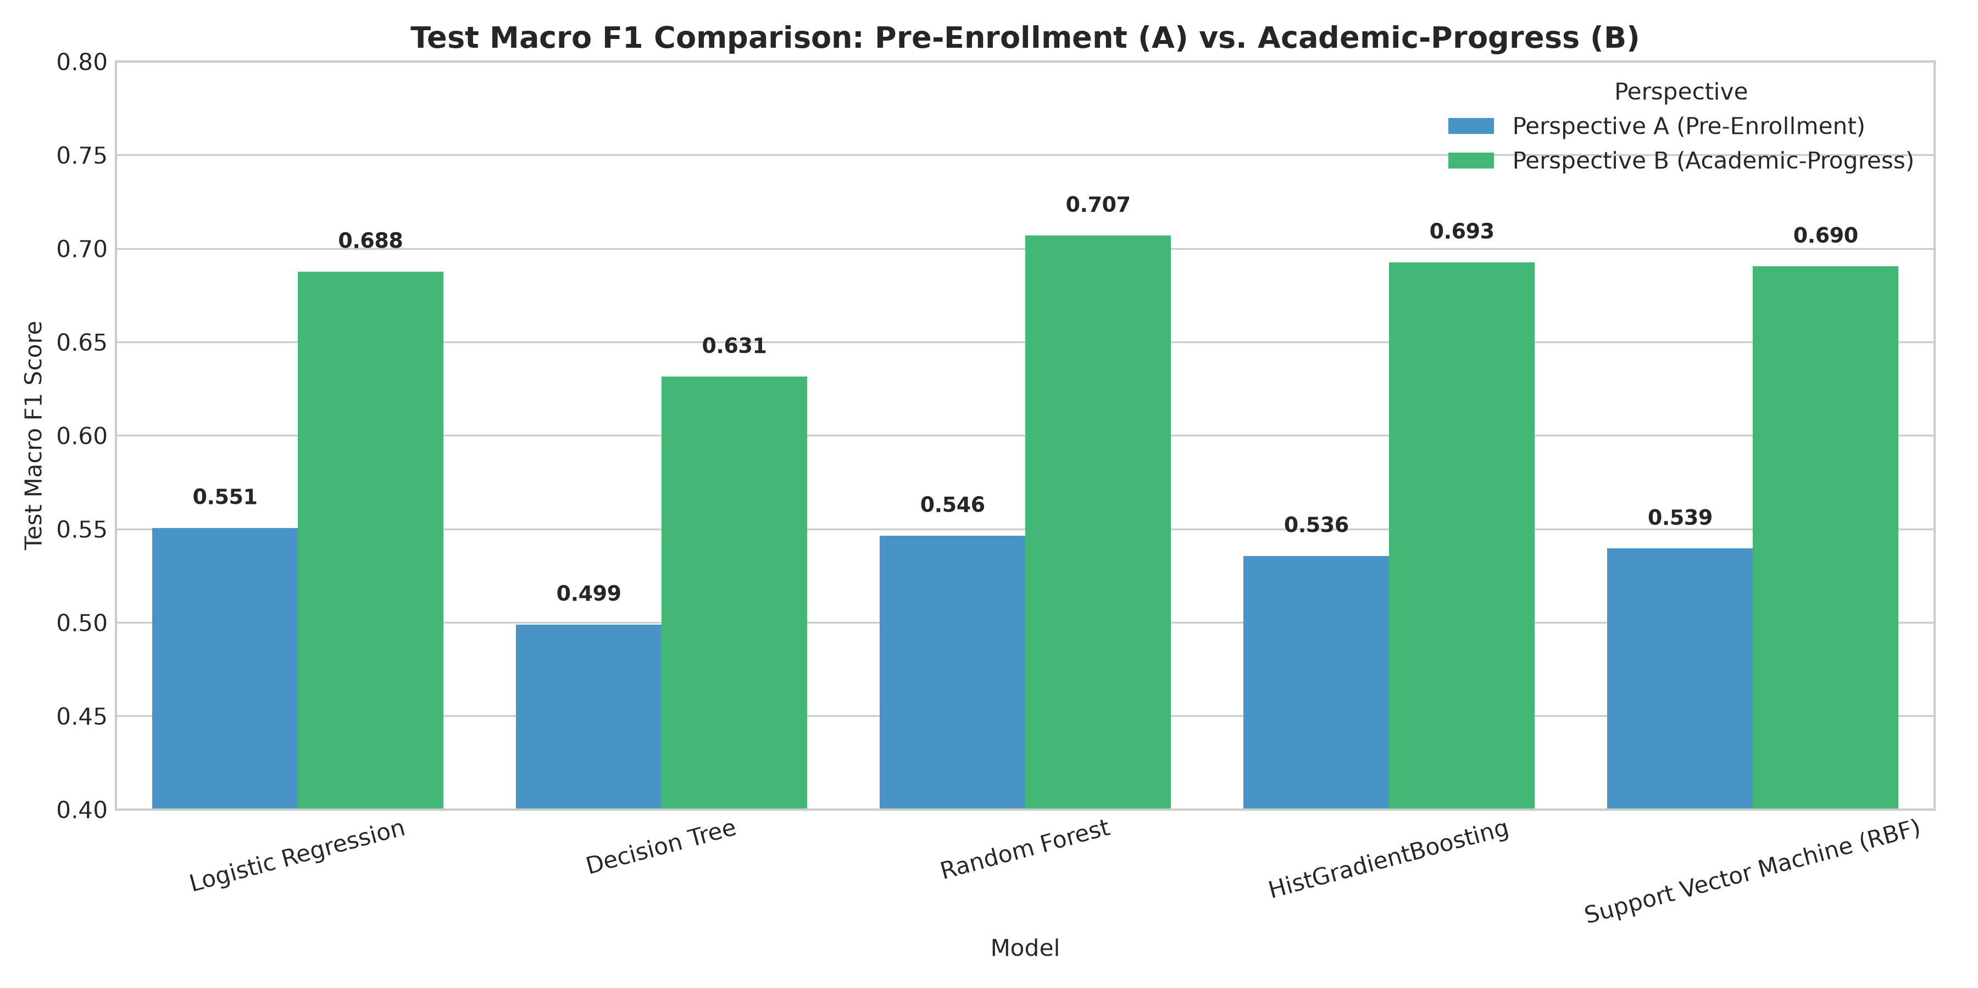
Figure 5: Test Macro-F1 Comparison between Perspective A and Perspective B
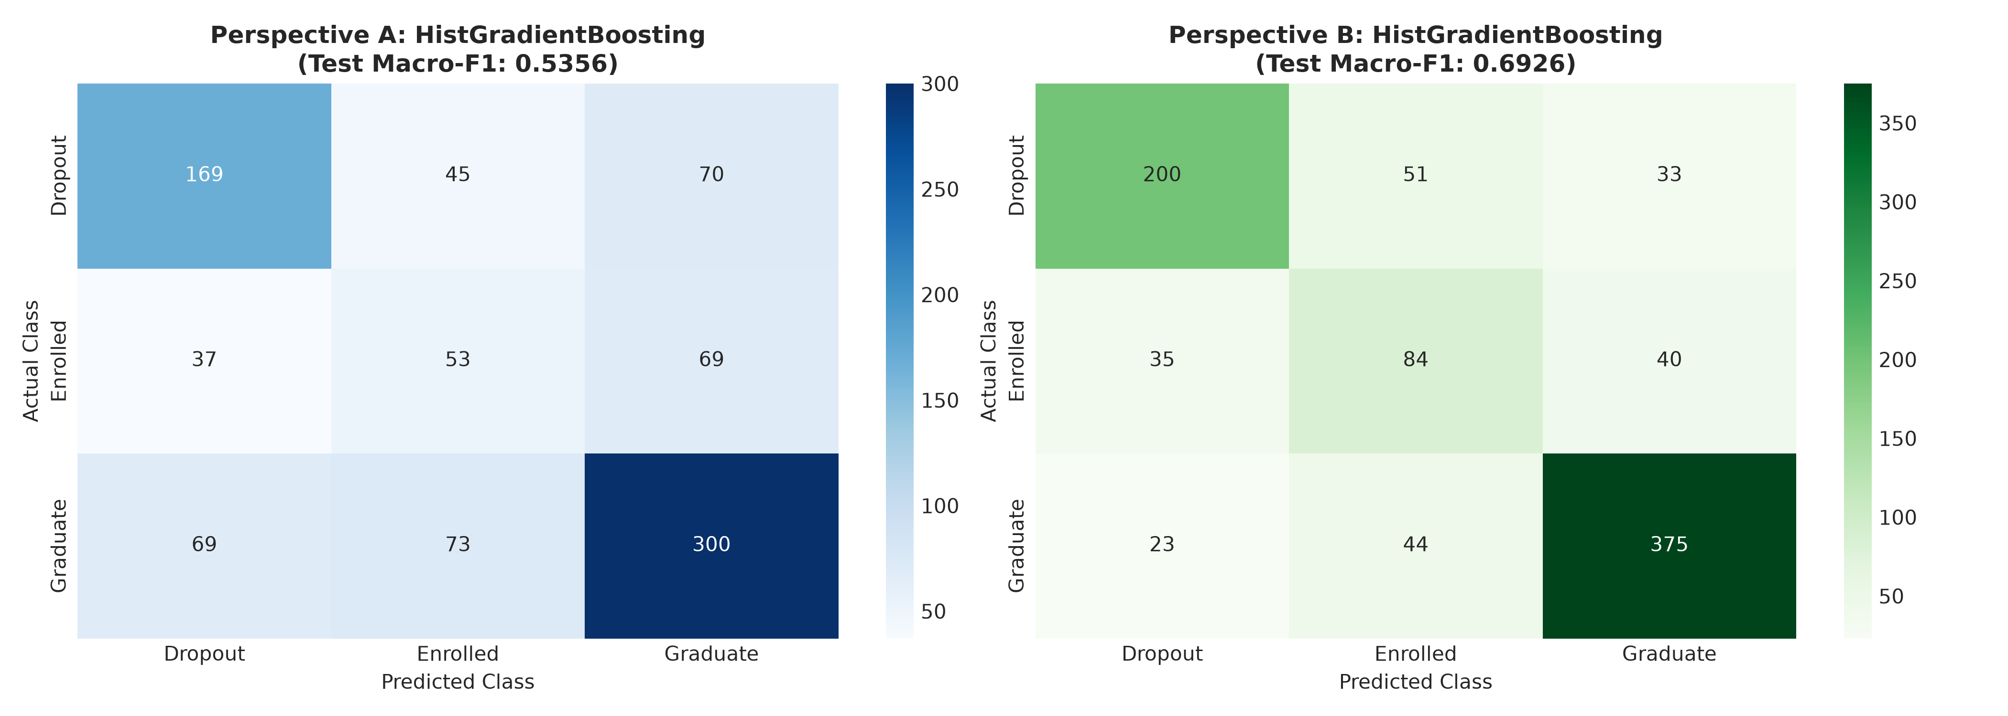
Figure 6: Confusion Matrices for Top Models in Perspective A and Perspective B
Detailed Per-Class Performance: Champion Model (Random Forest - Perspective B)
Class Outcome | Precision | Recall | F1-Score | Support (Test Set)
Dropout | 0.830 | 0.704 | 0.762 | 284 students
Enrolled | 0.449 | 0.610 | 0.517 | 159 students
Graduate | 0.855 | 0.828 | 0.841 | 442 students
14. Feature Importance & Model Explainability
To understand the decision rules utilized by the champion Random Forest model, we extracted Gini impurity feature importances. Figure 7 displays the top 15 most influential predictors:
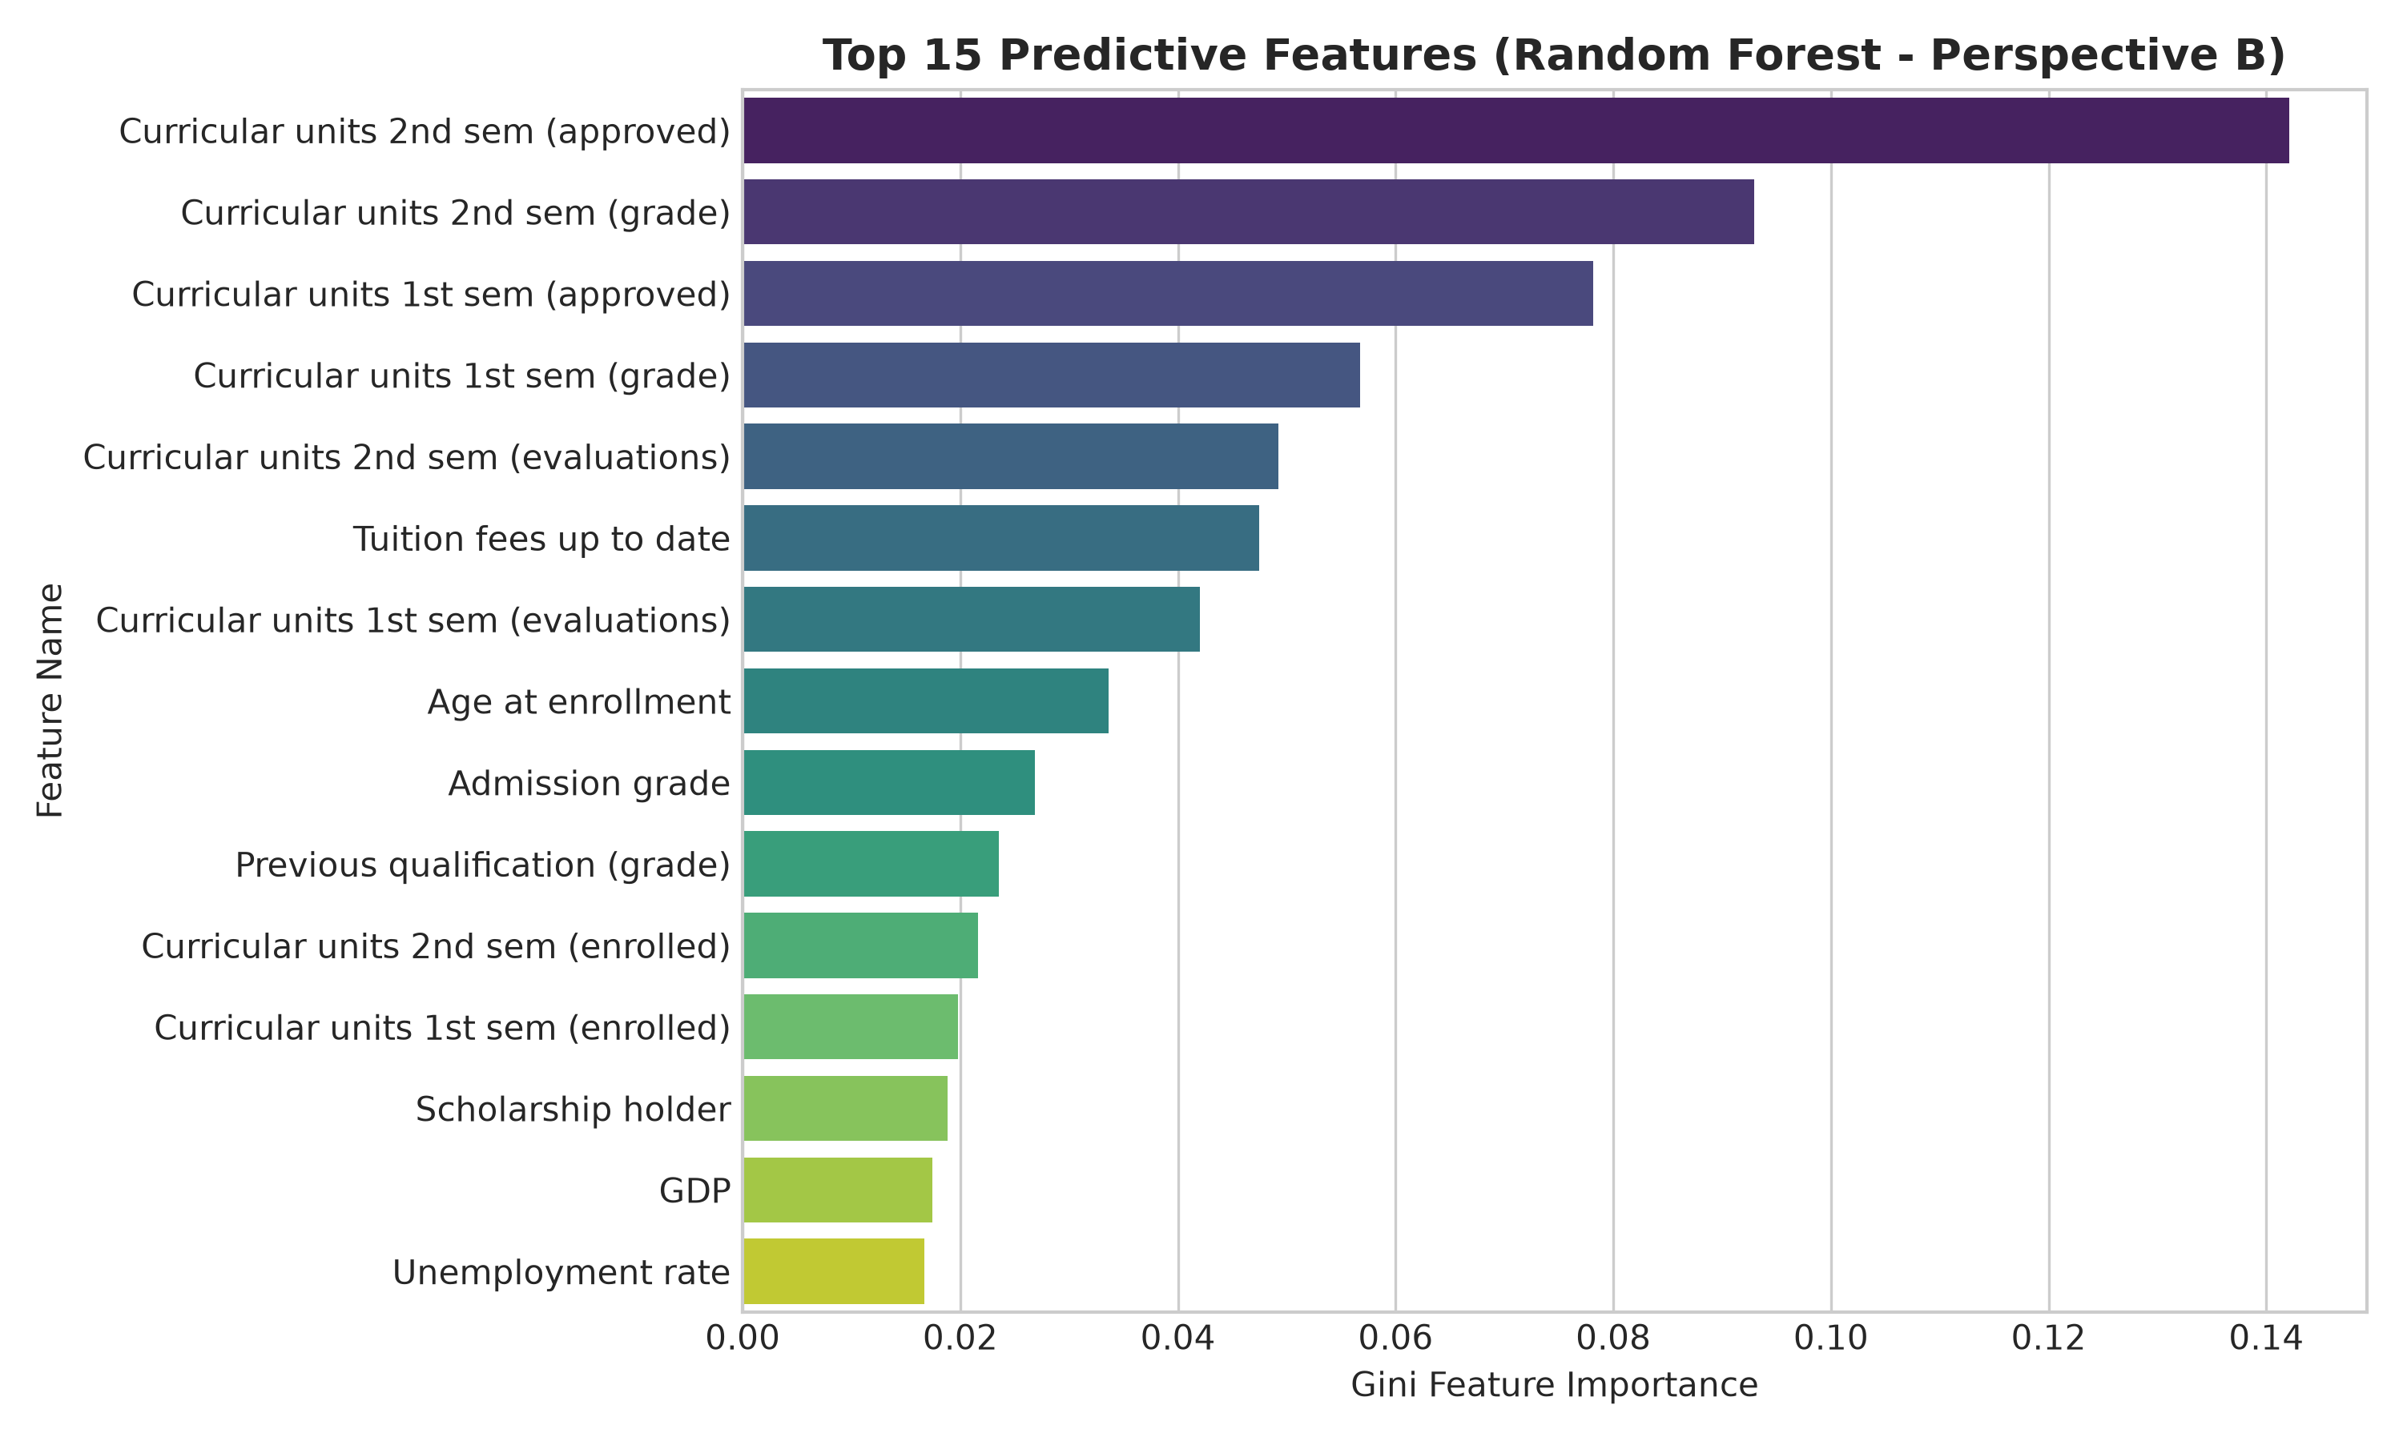
Figure 7: Top 15 Most Predictive Features in Champion Random Forest Model
Key Predictor Hierarchy: Diagnostic analysis confirms:
- Academic Milestones Dominate: Curricular units 2nd sem (approved) and Curricular units 1st sem (approved) are the two highest-ranked features, followed by 2nd semester grade averages. Students successfully accumulating 10+ credits across the first year are extraordinarily likely to graduate.
- Financial Viability: Tuition fees up to date ranks among the top non-curricular features, confirming that inability to maintain tuition fee schedules shows a strong relationship with departure.
- Intake Anchor Signals: Admission grade and Age at enrollment are the leading pre-enrollment variables, indicating that high initial academic preparedness creates durable resilience throughout college.
15. Key Findings & Institutional Takeaways
- 1. Academic Progression: The 'First-Year Academic Chasm': The transition from Perspective A (59.10% accuracy) to Perspective B (74.92% accuracy) demonstrates that early college coursework acts as the critical filtering event. Pre-matriculation credentials provide moderate initial visibility, but first-year performance solidifies student outcomes.
- 2. Financial Viability: Tuition Fee Status Shows a Strong Association with Dropout: Tuition overdue status exhibits a strong observed association with dropout risk (86.55% observed dropout rate). This association could be explored as a potential signal for targeted financial-support interventions.
- 3. Non-Traditional Demographics: Higher Observed Dropout Rates Among Older Students: Older students enrolling via special entrance contingents experience elevated observed dropout rates, indicating the value of flexible scheduling and tailored peer mentoring programs.
- 4. Delayed Graduation: The Enrolled Class Dilemma: Students in the 'Enrolled' status represent a delayed-progress cohort. While Random Forest successfully recalled 61.0% of these students, distinguishing temporary delay from imminent departure requires longitudinal semester-by-semester tracking.
16. Limitations & Academic Caveats
- 1. Geographic Specificity: Single Institution Scope: Data was sourced exclusively from a single Portuguese polytechnic institution (Instituto Politécnico de Portalegre), reflecting its specific academic calendar, fee structure, and degree catalog.
- 2. Observational Correlation: Non-Causal Interpretability: Feature importances reflect statistical association within trained tree splits, not direct causal relationships.
- 3. Temporal Resolution: Semester-Level Aggregation: Academic indicators are recorded in aggregate at the end of semesters, precluding weekly LMS tracking or attendance alerts.
17. Ethical Considerations in Student Retention AI
Fairness & Responsible AI: Deploying machine learning models in higher education introduces critical ethical responsibilities:
- No Punitive Action: Predictive risk scores must never be utilized to restrict student opportunities, cancel financial aid, or deny registration. The model must strictly serve as a supportive tool to allocate proactive advising and academic tutoring.
- Mitigating Demographic Bias: Features such as Gender, Marital status, and Parental Occupation must not lead to algorithmic stigmatization of disadvantaged student cohorts.
- Transparency & Agency: Students identified as at-risk should receive transparent, supportive communication focusing on academic resources and financial aid assistance.
18. Conclusion
This project developed a comprehensive, reproducible, and methodologically validated machine learning solution for higher-education dropout prediction. By systematically verifying feature availability and demonstrating the critical distinction between Pre-Enrollment screening (Perspective A) and Longitudinal progress modeling (Perspective B), we provide university administrators with a concrete blueprint for proactive retention. The champion Random Forest classifier achieves 74.92% test accuracy, a 0.7069 Macro-F1 score, and 70.42% Dropout recall, enabling institutions to identify 7 out of 10 withdrawing students and intervene before departures become irreversible.
19. Future Scope & Operational Roadmap
- 1. Continuous Tracking: Real-Time LMS Telemetry: Incorporate continuous weekly learning management system activity (Moodle/Canvas logins, quiz completion, assignment lag) for intra-semester early alerts.
- 2. Advanced Architectures: Multi-Task Deep Learning: Train shared neural architectures that simultaneously predict graduation probability, expected time-to-degree, and cumulative final GPA.
- 3. Institutional Deployment: Advisor Decision Support Dashboard: Build an interactive role-based dashboard for academic counselors with SHAP waterfall plots explaining individual risk profiles.
20. References
- Realinho, V., Machado, J., Baptista, L., & Martins, M. V. (2021). Predict Students' Dropout and Academic Success. Data, 6(11), 124. DOI: 10.3390/data6110124.
- UCI Machine Learning Repository. (2021). Predict Students' Dropout and Academic Success (Dataset ID: 697). DOI: 10.24432/C5MC89.
- Tinto, V. (1975). Dropout from higher education: A theoretical synthesis of recent research. Review of Educational Research, 45(1), 89-125.
- Bean, J. P. (1980). Dropouts and turnover: The synthesis and test of a causal model of student attrition. Research in Higher Education, 12(2), 155-187.
- Pedregosa, F., et al. (2011). Scikit-learn: Machine Learning in Python. Journal of Machine Learning Research, 12, 2825-2830.

