Syed Mahafuzul Hassan



20/09/2019

Dear Madam, C:\Users\abdou\Desktop\Resumes for Customer\Customer Project\Resume 5\mail.png

Dear Sir,



###### I am applying for **Ass. NetworC:\Users\abdou\Desktop\Resumes for Customer\Customer Project\Resume 5\location.pngk Engineer** position now available in **Circle network**, which has been recognized for its extraordinary service in the IT sector.

I have earned a bachelor’s degree in computer science and engineering and my studies centered on mathematics, web design, database management, coding and of the programming software used to create websites.

I have experience on problem solving, in many programming contests I attended during my university life. Furthermore, I have experience implementing links, tools and related features into web designs and I can prepare documents and keep accurate daily reports. I am self-motivated, I use good judgment and I have the ability to manage my time cleverly to meet deadlines. I have admirable verbal and written skills that make it easy to understand information and to articulate my thoughts clearly, so others can understand.

I am very flexible with the ability to work different shifts and weekends when necessary and I can adapt to different types of work environments without difficulty. I have a pleasurable and affable personality with the ability to work as a team or independently.

Although I’m a fresh graduate, I can assure you I’m a highly compatible applicant for this position and will be a fantastic member of **Circle Network** team.

My email id is [sdmahfuz@gmail.com](mailto:sdmahfuz@gmail.com) and I hope to meet with you soon to discuss the particulars of this position in more detail.

Sincerely,

Syed Mahafuzul Hassan

[sdmahfuz@gmail.com](mailto:sdmahfuz@gmail.com) +880 1770 472 939

https://www.linkedin.com/in/mahfuz-hasan/ Bhondon G-12, Khasdobir, Sylhet.



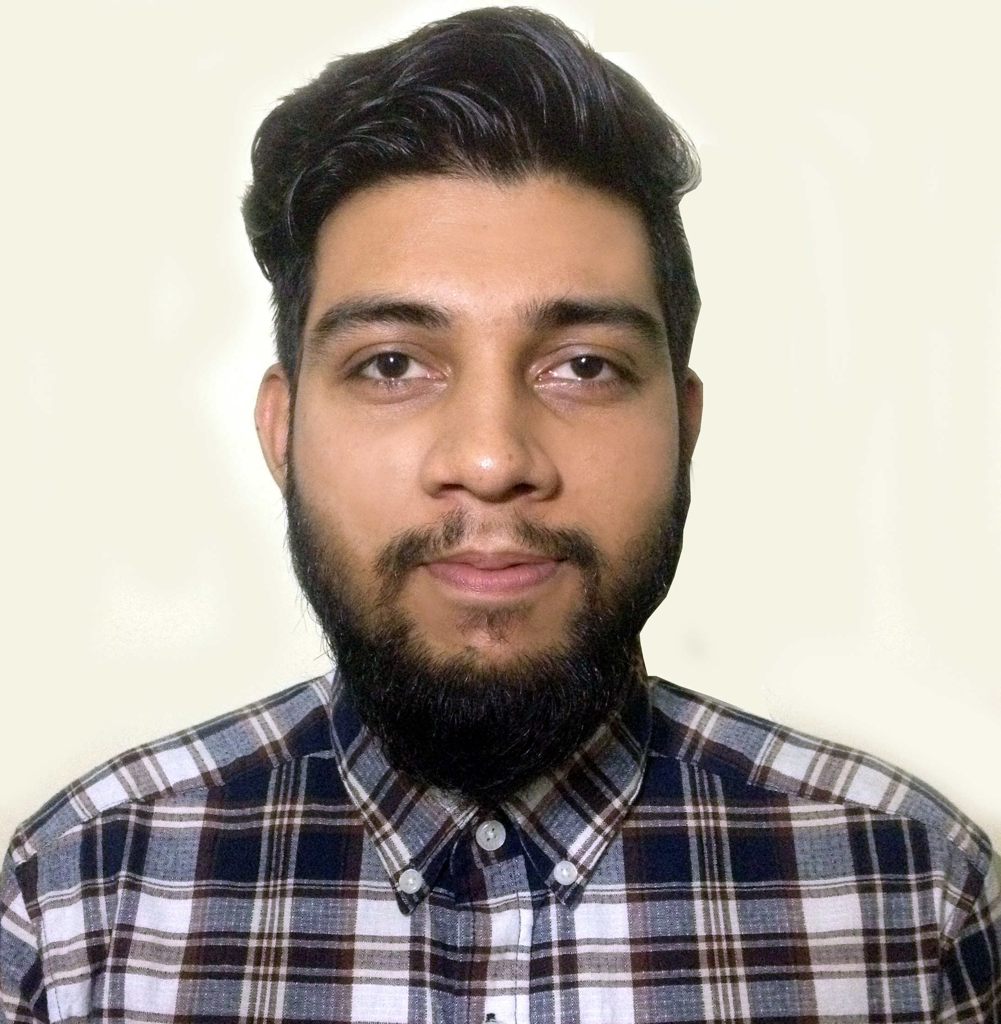

**Major:** Science

**College:** Modan Mohan College

**Board:** Sylhet

**GPA:** 3.9 out of 5.00

**Passing Time:** 06-2014

HSC

**Major:** Science

**School:** PK Adarsha High School

**Board:** Sylhet

**GPA:** 4.38 out of 5.00

**Passing Time:** 04-2012

SSC

**Dept:** Computer Science & Engineering (CSE)

B.Sc

**University:** Leading University, Sylhet

**CGPA:** 3.57 out of 4.00

**Passing Time**: 05-2019

EDUCATION

Object Oriented Programming

JavaScript

SKILLS

A platform where people who loves to travel can find their travel companion

Travelers can communicate with each other through one to one & group chat conversation systems.

Users can create travel plans & manage those plans.

There is also a GPS tracking feature through which one user can find the location of his/her friend.

**Technologies:** Java, XML, Android Studio, Firebase Database, Google Maps API.

**Academic Project & Thesis**

Predicting Bengali words from only video (own made dataset) without any use of audio signal.

**Technologies (Model):** Bi-directional GRU and convolutional neural network.

A Visual Speech Recognition System for Bangla Language

Travel Mate Finder Android App (2018)

Photoshop

Adobe Illustrator

Creativity

Team Work

HTML/CSS

Self-motivated, determinant and creative with both skills and passion.

ABOUT ME

Bhondon G-12

Khasdobir, Sylhet.

ADDRESS

[sdmahfuz@gmail.com](mailto:sdmahfuz@gmail.com)

https://www.linkedin.com/in/mahfuz-hasan/



Syed Mahafuzul Hassan