22/11/2019

Dear Sir/Madam,

# I am applying for Jr. Software Engineer position now available in SJ INNOVATION, which has been recognized for its astonishing service in the IT sector.

I’m currently working for a startup IT company named A26 Lab as a Laravel Developer, before starting my professional career I have earned a bachelor’s degree in computer science and engineering and my studies centered on mathematics, web design, database management, coding and of the programming software used to create websites.

I have experienced on problem solving; I attended in many programming contests during my university life. Furthermore, I have experience implementing links, tools and related features into web designs and I can prepare documents and keep accurate daily reports. I am self-motivated, I use good judgment and I have the ability to manage my time cleverly to meet deadlines. I have admirable verbal and written skills that make it easy to understand information and to articulate my thoughts clearly, so others can understand.

I am very flexible with the ability to work different shifts and weekends when necessary and I can adapt to different types of work environments without difficulty. I have a pleasurable and affable personality with the ability to work as a team or independently.

My email id is [sdmahfuz@gmail.com](mailto:sdmahfuz@gmail.com) and I hope to meet with you soon to discuss the particulars of this position in more detail.

Sincerely,

Syed Mahafuzul Hassan

**SYED MAHAFUZUL HASSAN**

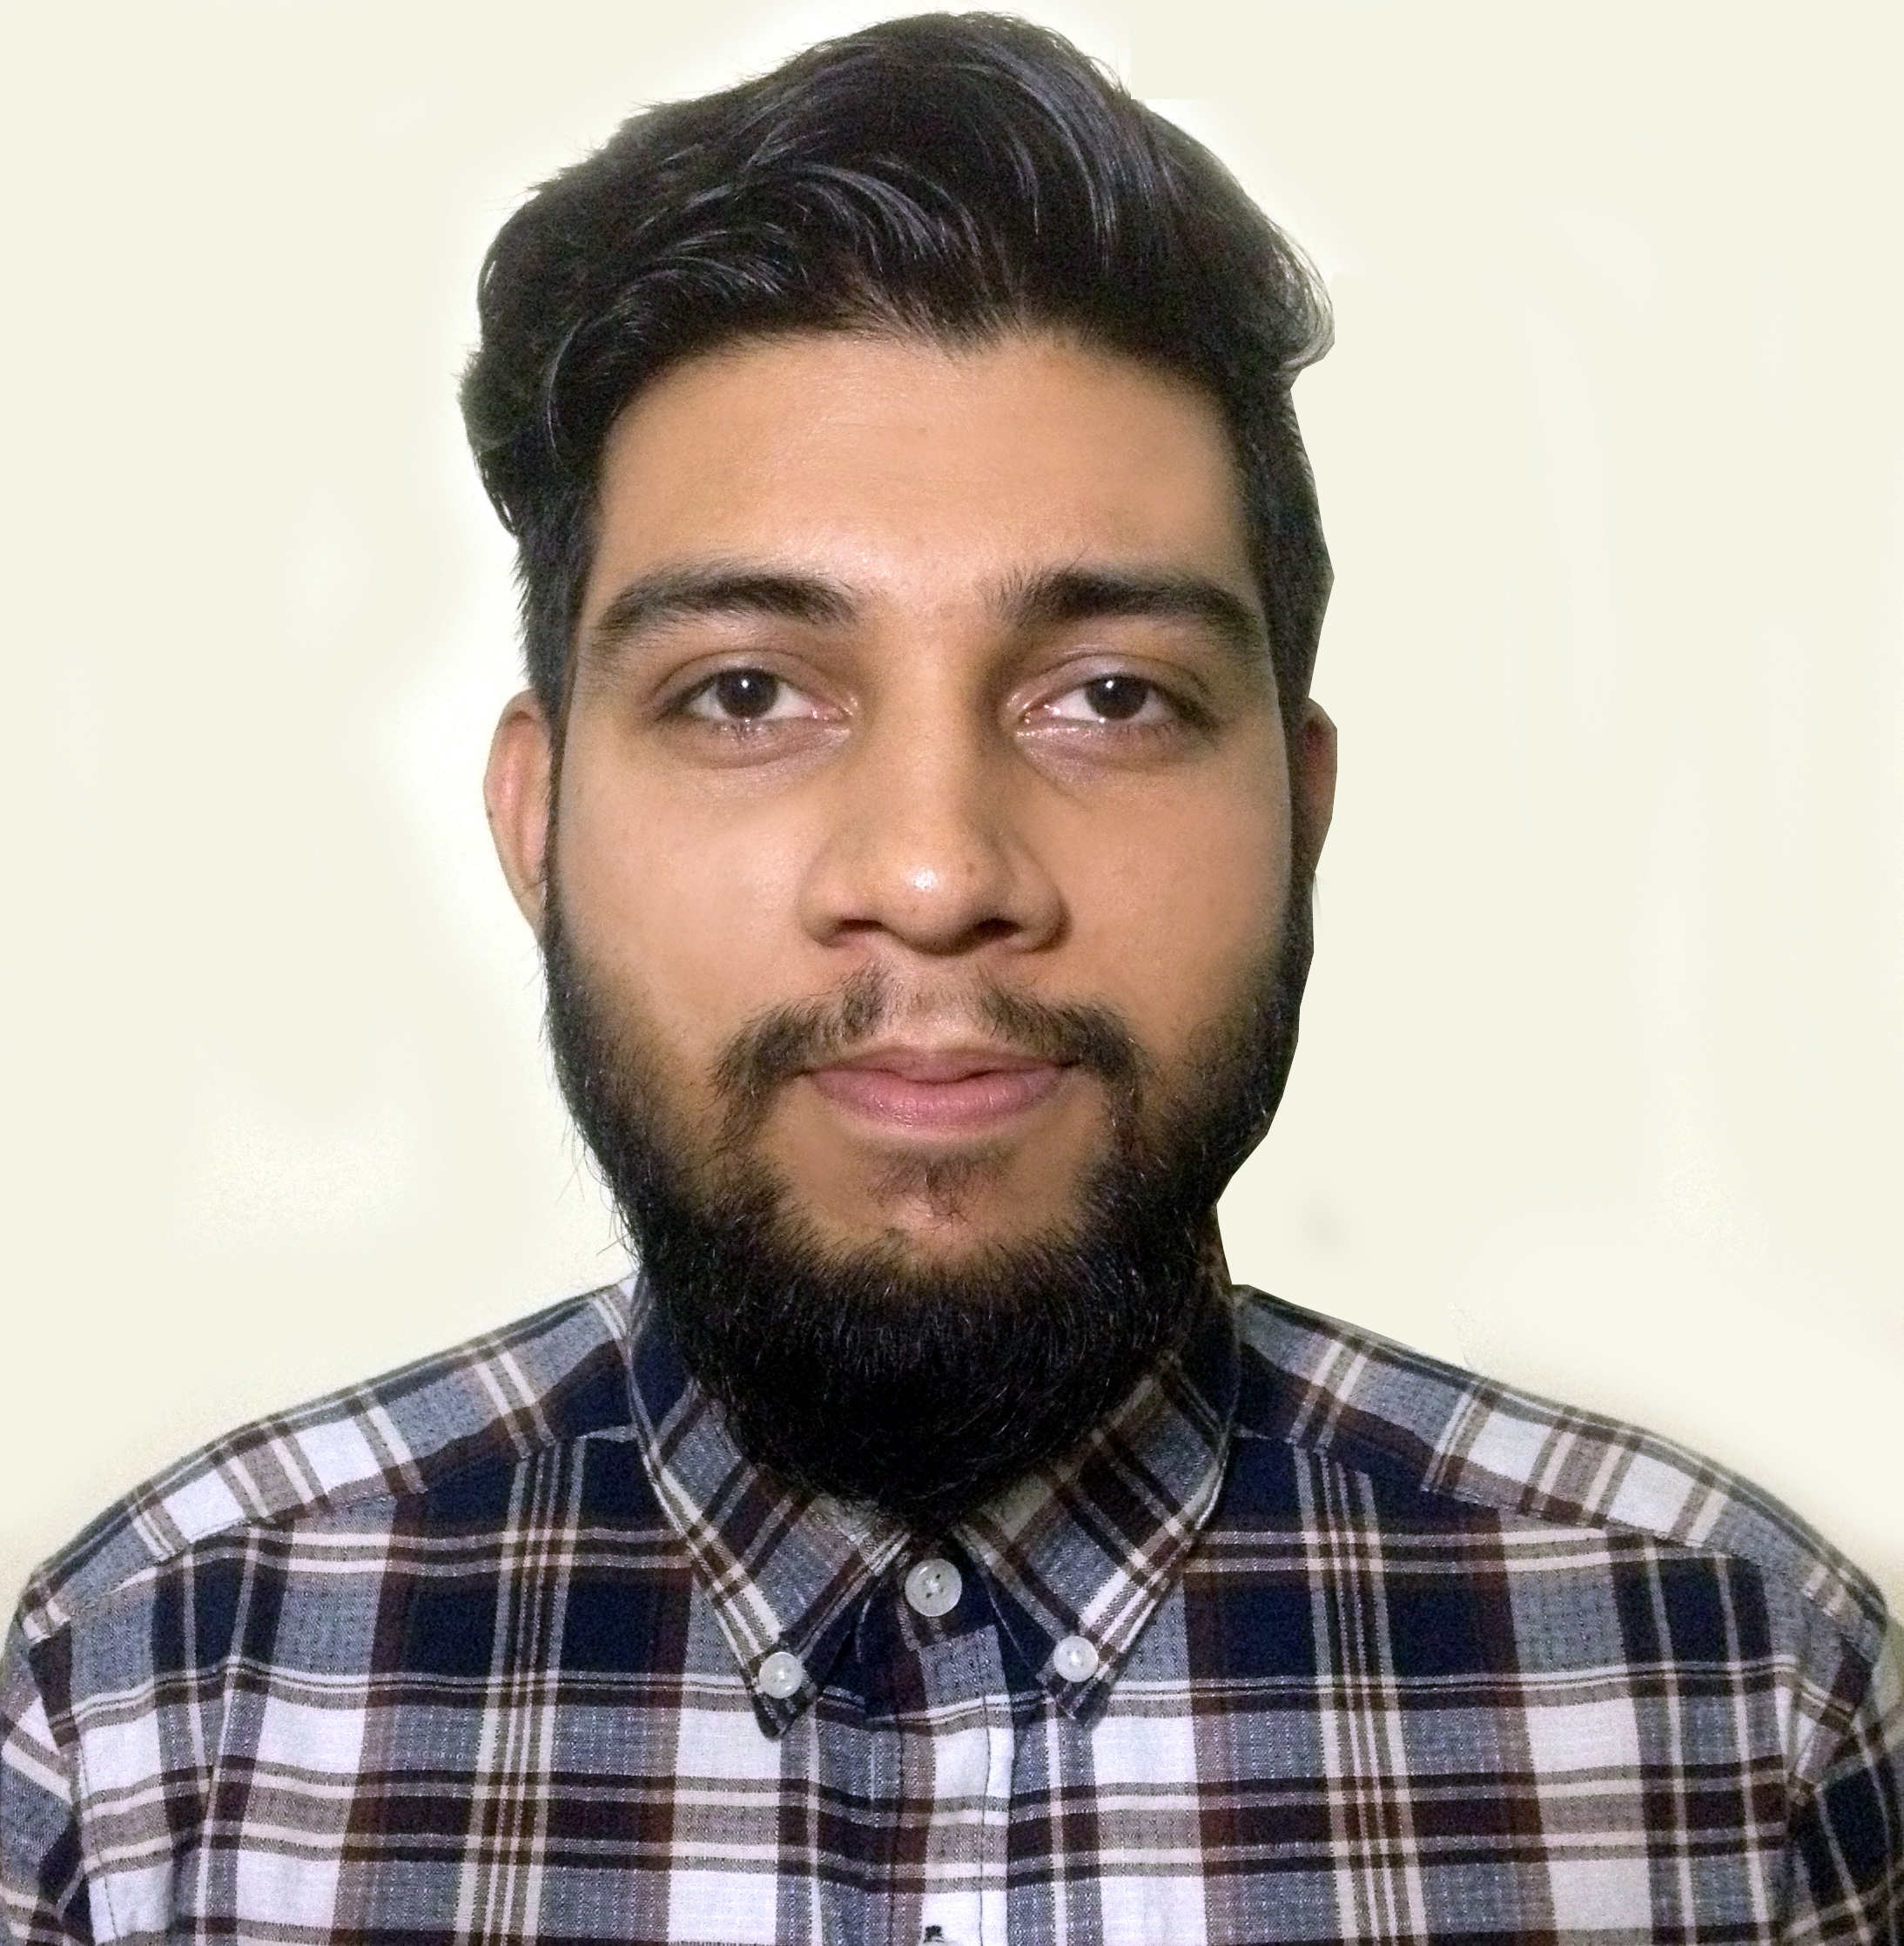

C:\Users\abdou\Desktop\Resumes for Customer\Customer Project\Resume 5\mail.png

[sdmahfuz@gmail.com](mailto:sdmahfuz@gmail.com)

+880 1770 472 939

https://github.com/r3dcoder

https://www.linkedin.com/in/mahfuz-hasan/

Bhondon G-12, Khasdobir, Sylhet.







C:\Users\abdou\Desktop\Resumes for Customer\Customer Project\Resume 5\location.png

**CAREER OB J E CT I V E**

I am a self-motivated person who is enthusiastic to go above and beyond on any mission, and to learn valuable skills on my own time. For instance, I have completed deep learning course on online (CourseEra), which is a part of artificial intelligence, simply out of a passion to gain knowledge of how think a machine/compute like human. I think you are looking for a person, who is self-motivated, determinant and creative with both skills and passion. I believe; I am that person. My prime goal is to be a corporate entrepreneur as my mind has some fascinating business ideas.

**Work Experience**

**Laravel developer** at A26 Lab, Sylhet (September, 2019 to present)

**EDUCATION**

|  |  |  |  |  |  |
| --- | --- | --- | --- | --- | --- |
| **Certification Name** | **Major** | **Institute Name** | **Current Status** | **Result in CGPA** | **Passing Time** |
| B.Sc | CSE | Leading University, Sylhet | Passed | 3.57/4.00 | 05-2019 |
| HSC | Science | Modan Mohan College | Passed | 3.90/5.00 | 06-2014 |
| SSC | Science | PK Adarsha High School | Passed | 4.38/5.00 | 05-2012 |

**SKILL**

|  |  |
| --- | --- |
| **Programming Language** | HTML/CSS, Bootstrap, C/C++, JavaScript, PHP, Java |
| **Operating System** | Linux, Windows |
| **Framework** | Laravel |
| **Database** | MySQL |

**Academic Major Project & Thesis**

|  |  |  |
| --- | --- | --- |
| **Topic** | **Year** | **Description** |
| Travel Mate Finder android app. | 2018 | * A platform where people who loves to travel can find their travel companion * Travelers can communicate with each other through one to one & group chat conversation systems. * Users can create travel plans & manage those plans. * There is also a GPS tracking feature through which one user can find the location of his/her friend. * **Technologies:** Java, XML, Android Studio, Firebase Database, Google Maps API. |
| A Visual Speech Recognition System For Bangla Language | 2019 | * Predicting Bengali words from only video (own made dataset) without any use of audio signal. * **Technologies (Model):** Bi-directional GRU and convolutional neural network. |

**Online Judge & Contest Judge ID(s):**

|  |  |  |
| --- | --- | --- |
| **Online Judge & Contest Judge Name** | **ID** | **Achievement** |
| http://codeforces.com/ | mahfuz.lu | Solved: 152 problems |
| https://vjudge.net/ | mahfuzthefailure | Solved: 117 problems |