CS008 Webpage Design

Lowell Deschenes and Rex Godbout

Assignment: Final- Cyber Stories

Cyber Stories

Version <1.0>

Table Of Contents

Time Log 3

Introduction 4

Purpose 4

Definitions, acronyms, and abbreviations 4

Overall Description 4

Story Board 5

Specific requirements 6

|  |  |  |  |
| --- | --- | --- | --- |
| Time Log | | | |
| Estimated time to complete assignment => | | | 30 Hours |
| Date | Time Spent  (in hours) | Description | Author |
| 11/4 | 2 | Came up with each of the animals we will be doing our project on. | Lowell Deschenes  Rex Godbout |
| 11/4 | 2 | Made the skeleton to the project with each site made but no content within. | Lowell Deschenes |
| 11/9 | 2 | Met up after class worked on layout of project setting up all the websites and top header nav and footer. | Rex Godbout  Lowell Deschenes |
| 11/11 | 3 | Kept working on building the skeleton of our project and looked into the work that needs to be done on the spec document. | Rex Godbout  Lowell Deschenes |
| 11/25 | 4 | Worked on the form creating the shell for me to put code in and also putting code into places allowing you to enter your full name and gender | Lowell Deschenes |
| 11/25 | 2 | Worked on the content and layout of each page | Rex Godbout |
| 11/26 | 2 | Worked on the content and layout of each page | Rex Godbout |
| 11/29 | 2 | Working on the form creating the new elements to the form and getting the registration csv to work and getting the email to say what we want. | Lowell Deschenes |
| 12/1 | 3 | Working on the css of the project making it look the way we want it to look | Rex Godbout |
| 12/3 | 4 | Trying to finish the form creating all the questions we need to ask with all the elements working and it sending and saving correctly. | Lowell Deschenes |
| 12/5 | 4 | Put together the form I had been working on with the pages rex had been working on. Took a while to get the form working on his computer. Also worked on entering the stories for each page form a csv file | Lowell Deschenes Rex Godbout |
| 12/6 | 3 | I wrote stories for the site which took way too long. | Lowell Deschenes |
| 12/6 | 3 | Messed around with css trying to make the site aesthetically pleasing | Rex Godbout |
| 12/7 | 3 | Drew the photos that will be contained in the site. | Lowell Deschenes |
| 12/7 | 3 | Kept working on the css of the site messing around seeing what works | Rex Godbout |
|  |  |  |  |
|  |  |  |  |
|  |  |  |  |
|  |  |  |  |
|  |  |  |  |
|  |  |  |  |
|  | 42 | <=Total Time Spent |  |

# Introduction

### Purpose

The purpose of this document is to describe the requirement specification for the web site “_Cyber Stories__”.

The intended audience for this document is children seeking stories to entertain them.

*First it is the contract between you and the client. Second it is for the developer of the site. Two primary goals are:*

1. *Client gets a very good understanding of what you will be delivering.*
2. *Developer has a very good understanding of what they are going to create.*

### Definitions, acronyms, and abbreviations

*Sample for the client:*

ER Diagram – a diagram to represent the data you want to save with your system

W3 Validation – refers to both Html and CSS validation tool provided by the W3c.org. the html validator is located at:

<http://validator.w3.org/>

with the CSS validator located at:

<http://jigsaw.w3.org/css-validator/>

# Overall Description

This site will be an area for kids to go who want to read for entertainment. The site will contain stories from the creators, Lowell and Rex, and also allow for other visitors of the site to give their input for new stories on the site. They will be able to input their ideas through a form which will be sent to the creators to look over and decide if they want that story to be entered into the site. The site is customized with out own fun art work and is meant to bring joy to any child that visits it.

# Story Board

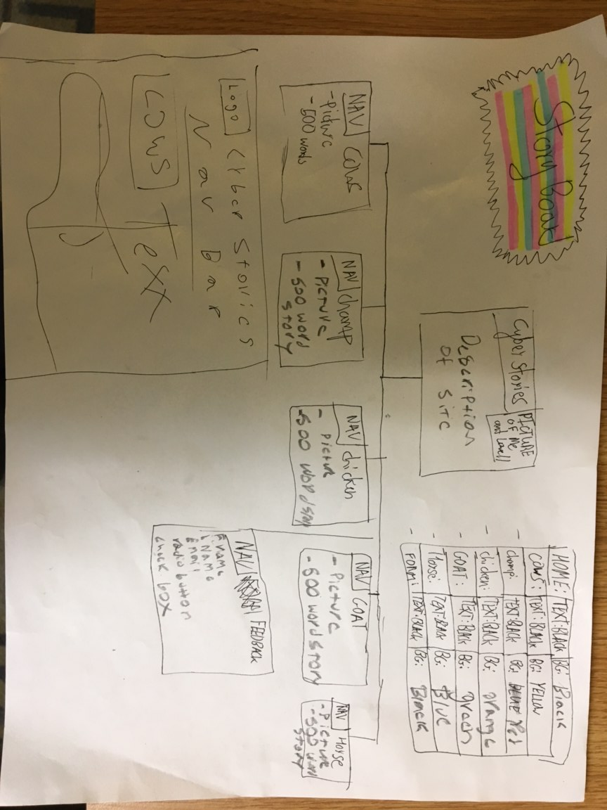

# Specific requirements

1. *Title for main page*: *Cyber Stories.*
2. *Meta Description*: Some cyber stories for some sick kids!
3. *Meta Character set*: UTF - 8
4. *Logo*: *.*
5. *Main page photo*: *.*
6. *Content can be found here*:

**Home page:**

**Story 1:**

Happy the Horse

There once was a horse named happy who lived on a farm in Texas. It was warm and sunny all year round down in Texas. Happy rode all day long everyday. He would run through the sand leaving a trail of dust as he went neighing pleasantly all the way. He would hurdle over 10 foot high cacti showing off to all the lady horses. He pranced and played and had a magnificent time on this farm. Then one day a new shiny car pulled into the farm. Inside of the new car was a man that happy had never seen before. He was very sweaty for some reason as if he wasn’t used to the Texas heat. Happy galloped over to the house where the man had entered and listened to what he was saying to his farmer. He heard his farmer say, “What can I do you for sir?” the other man said, “I’m looking to purchase a horse”. Happy wasn’t fazed by this statement. He knew his farmer would never sell him. He was the happiest fastest and cutest horse on the farm. Happy kept listening. Happy’s farmer said, “Have you eyed out any horse that you would like to purchase?” the man replied, “Why yes the one right outside the window looks magnificent”, Happy’s farmer returns, “Well yes and he is magnificent. That’s happy but he’s not for sale. He’s the happiest, fastest, and cutest horse on the farm and I can’t give him up.”. Happy let out a big neigh showing his approval. The man then made an offer Happy’s farmer could never refuse. He said, “What about for a million dollars?”. The next day Happy was on a trailer attached to the shiny car of the man from the day before. They pulled out of the farm away from Happy’s home. It was a sad long ride to his new home. They passed state after state and with each new state the temperature dropped. Finally they made it to Happy’s new farm in the state of Vermont. It was cold outside, very cold outside. Happy sadly neighed in disapproval. Happy no longer rode all day everyday. Happy no longer jumped 10 feet high to impress the ladies. Happy now just kept inside to keep warm. One day Happy saw two planks of wood laid out in the snow. In his extreme boredom he thought to himself, “what if I go jump on those two planks of wood”. He raced out of the barn at full speed towards those pieces of wood and leaped through the air landing sturdily on top the pieces. At impact the pieces started sliding across the snow and happy rode them until he was about to hit the fence and then jumped and neighed with excitement. Well it just so happens that Happy’s new owner was looking out the window just as happy decided to jump on the two planks of wood and saw the whole thing. It was the most amazing thing he had ever seen. He then bought two giant custom pairs of skis and Happy the horse became the first ever horse to ski. He lived his life shredding the hills during the winter and running happily in the grass during the summer. Happy was happy again.

**Story 2:**

The Chicken Without a Cluck

Back in the time before man there used to be a giant colony of chickens that lived on the land where the United States is now. In this colony of chickens, the members clucked all day long. They clucked about the food they ate. They clucked about other chickens, about the chickens they hate, about the chickens they love, about the chickens they’re friends with. They clucked and clucked. One day a new special chicken was born. This chicken acted like every other chicken. He ate like every other chicken. He moved like every other chicken. He looked like every other chicken. The one thing that separated him was his cluck. This chicken didn’t cluck at all. No other chicken knew what this chicken was thinking. No other chicken knew how he was feeling. No other chicken could connect with him at all. He was an outcast in the chicken colony and it made him very lonely and sad. This chicken stayed on the outskirts of the colony mopping around barely eating, barely staying alive. At the same time of this some other chickens were coming up with a great idea. They found out when they pecked at wood they made a sound and if they pecked at the right times the sound made the chickens want to move, jump and twist. Those these chickens did not know it they had just make what us humans call music. Also these chickens created dancing with the movements they wanted to do when they heard the music. Well it was getting around the whole colony that there was this amazing group of chickens that made noise by banging their beaks against wood and that it put a sensation in all the chickens that listened of wanting to move and dance. The news reached all the way out to the chicken who didn’t cluck. The sad lonely chicken thought to himself, “Maybe I’ll try to this wood pecking since I can’t make noise any other way”. Well the chicken started pecking and he was pecking good. He pecked the moviest grooviest song there ever was and all the chickens around him started moving and grooving to the music. Every chicken that heard his song came up to him and told him how wonderful his music was and this made the chicken so happy. News got around to the whole colony of how wonderful this chickens music was and it eventually got to the original group of chickens who created music. These chickens trekked to the outskirts of the chicken colony to hear this music in person. When they got there and listened to the music they knew this chicken needed to be apart of their group. They went up too the chicken with a cluck and asked, “will you join our music group”. Excitedly the chicken without a cluck answered with an enthusiastic nod. For the rest of his life the chicken without a cluck created music for all the other chickens to enjoy and he was happy without a cluck.

**Story 3:**

Gassy The Goat

There once was a farm in Vermont with animals of all sorts. They had cows, horses, sheep, goats, dogs, cats, chickens, and pigs. All the animals lived in harmony, Well all except one. Gassy the goat was the gassiest goat around. He would toot all day long giving off a smell that would make a dung beetle shy away. Every other animal on the farm hated him. They would always say things like, “That gassy the goat sure does stink it really makes me angry”, or “He’s so smelly why doesn’t he just leave the farm”. Gassy was saddened by all their hate. All gassy wanted was to be their friend and be able to live on the farm without any issues. Gassy wanted to come up with a plan to cure his gassiness. He knew where the source of his problem was. The source was coming straight from his butt. Gassy thought to himself, “Well how do I make it so this awful smell stops coming from my butt?”. Then it came to him, “I WILL COVER UP MY BUTT SO NO SMELL ESCAPES!” Gassy ran to the barn where he found some tape and then covered his butt with the tape. He strolled out of that barn feeling like a new goat. All the other barn animals were immensely surprised when gassy walked by they did not have the urge to hurl. They all started to talk to gassy and upon talking they found out he was the funniest goat they had ever met. He told jokes that would make the cows spit up milk. He told jokes that would make the chickens cluck with enjoyment. He told jokes that made the horses neigh uncontrollably. Everyone on the farm loved gassy. Then gassy started getting sick. Everyone was worried about gassy. Gassy had unbelievable stomach pains that made him not be able to move or tell jokes. Everyone on the farm wanted to find the source of the problem. Well gassy knew where the source was coming from. It was coming straight from his butt. All the gas was getting trapped inside of gassy making him feel awful. He told all the other animals what he had done and said he had to go back to being smelly. This saddened gassy so much he started to sob and said, “I just want to be friends with all of you these past few days have been so much fun telling jokes and laughing with all you”. All the other animals looked at each other and they all knew they had the same plan. All the animals ran into the barn leaving gassy alone crying. Gassy uncovered his butt letting all the smell and gassy the goat was smelly again. He was sad and alone sitting in the grass when something amazing happened. All the animals came out of the barn with clothes pins keeping their noses shut. The biggest horse came up to gassy and said, “It’s worth not being able to smell to be able to be your friend”. Gassy and all the animals farm lived in harmony for the rest of their days.

**Story 4:**

Speedy the Cow

Horse racing is an exciting sport where several horses are pitted against each other to see who is the fastest out of them. The Kentucky Derby is one of the largest horse races where the best and fastest horses are set against each other. Thoughts of the Kentucky derby jumble in Speedy the cows head as she runs around her farm. Speedy has wanted to race ever since she was a little calf. All the other cows never believed in her. They would always say things like, “speedy just make milk like the rest of us.” And, “you will never be as fast as the horses it’s just not in your blood.”. Speedy never believed them. Speedy wanted to win the Kentucky derby. She trained everyday gaining a reputation around all the farms around for being “the cow faster than a horse.” Even with this reputation no one was giving her a chance. No one wanted to actually enter a cow in a horse race. One day while speedy was training a car she had never seen before pulled into the farm and attached to the car was a horse trailer but with no horse in it. Speedy wondered what was up since there were no horses on her farm. One thought kept racing through her mind, “is that for me?”. When her farmer came out and started walking her towards the trailer she had her answer. She really was going to race. She couldn’t believe it. The first race she went too was a local one with very average horses. Stepping up to the starting line all the horses were laughing at her saying, “you’re not faster than us you’re just a cow”. This didn’t faze speedy; she was going to win. When the starting gun shot off she rocketed out of the gate. None of the average horses were even close to her: she won by a mile. The next day all the papers were talking about Speedy’s first win. No longer would she be taken as a joke. For the next few weeks Speedy kept racing and kept winning and until finally she found out she secured her place in that years Kentucky derby. She was super excited to finally get to live her dream. There was a problem though. All the other horse trainers were complaining about a cow being in the horse race saying that, “the Kentucky Derby is for horses only”. It was unclear if speedy would be allowed to participate in the race. This made speedy super sad and she cried all day and night. Her trainers took videos of her sadness and put it in on the internet. It immediately gained national attention and everyone wanted speedy to race. The race commissioner decided that speedy should be allowed to race. That year a cow was allowed in the Kentucky Derby. This made speedy ecstatic. When the day finally came for her to step up and race she was ready. When the gun went of she zoomed out of the gate at unheard of speeds. The other horses were fast too but no match for speedy. She crossed the finish line well in front of every other horse and won the Kentucky Derby.

**Story 5:**

Champ the Whale

There once was a whale who lived in Lake Champlain. His name was Champ. Champ was a lonely whale. He was obviously the only whale in the lake and had no friends. He didn’t know what to do he really wanted someone to be friends with. The other fish in the lake would not be friends with him because he was too big and scary for them. They all kept away from him and that made him lonely. One day looking to the surface of the water he saw something that was just as big as him cutting through the surface. He was so excited to see another thing as big as him he raced to the surface launching out of the water and then landing back in the water creating a huge splash. This big thing that champ saw was a tour boat and when champ jumped out of the water everyone on the tour boat was amazed. Who knew there was a whale in Lake Champlain. Right after that surprise everyone on the tour boat was hit by a giant wave. They all got soaked by the huge splash champ made and some even got knocked off the boat. It was a catastrophe. The wave created by champ was so powerful it had knocked people into walls causing injuries and some unconscious people even fell off the boat. Champ saw what he had done and tried to help. He gathered as many people as he could who had fallen off the boat into his mouth and brought them to the surface saving their lives. After this champ went back to being lonely on the bottom of the lake. There was outrage in Burlington at the event champ had made. Many people thought that they should get rid of Champ from the lake so an event like that never happens again. One of the people saved by champ knew the truth. He knew that champ was a nice whale and that they should be celebrating the fact that there’s a whale in Lake Champlain not trying to get rid of him. Later that day he went to the water front and called for Champ yelling, “Hey whale I want to talk to you!”. Champ on the bottom of the lake heard his cries and rocketed to the surface at the chance to make a friend. Coming to the surface the man and champ talked all night about life becoming very good friends. The man found that Champ was the nicest whale ever and he needed to show everybody that Champ should stay. The next day he told everyone he could to come down to the water front to see a spectacular show. When everyone in town was down at the water front the man screamed out, “INTRODUCING CHAMP THE WHALE!” and with that signal champ shot to the surface performing a double backflip in front of the whole crowd. Everyone went wild. It was the most amazing thing any of them had ever seen. They all unanimously agreed that Champ would stay and be friends with them all and champ lived a happy life with the people of Burlington.

1. Have the nav bar say “Home”, “Champ the whale”, “Chicken”, “Speedy the Cow”, “Gassy the Goat”, “Submit Yours!”
2. Create a form that allows users to submit story ideas
   1. Include one text box for a users email address.
   2. Include two text boxes for first name and last name.
   3. Include one list for gender.
   4. Include three check boxes for what you want show if your story is submitted: first name, last name, and email.
   5. Include three radio buttons for if your story will be for ages 3-7, 8-12, and 13-17.
   6. Include a Submit button.
   7. Include field sets and legends as needed.
   8. Data should be validated for not missing, valid format etc as needed with php, appropriate error messages will be displayed.
   9. Form should email the person who filled it out. The from address needs to be your email address so i can reply to the email.
   10. Form data should be saved to a csv file. Provide a link to this file on your main index.
   11. Forms always need to provide feedback to the user so they know what happened after filling out the form.

9. Use CSS to make the site look aesthetically pleasing.