**HW-1**

Instructions: The neural network code must be implemented in Pytorch. Other parts of the code may be either in Matlab or in Pytorch according to your convenience.

Q 1. In this question, you will implement a deep neural network for image classification. The program file **main.m** implements Matlab code to read the inputs and target labels, and a bare-bones deep network for image classification. Follow the instructions, rewrite (parts of ) the code in Pytorch, and make changes to improve the layered neural network architecture and the training algorithm for better performance.

Implement relevant portions of the code in Pytorch. Fine tune and train the network for optimal performance. During training, make sure that the loss (in Matlab it is the bottom plot of the Training Progress window) w.r.t. training and validation data are less than 1.

The performance along with your score is printed by the program. Include a copy-paste of this output in your answer.

Also include a screen shot of the training progress window in your answer. This should be in Pytorch.

.

(See page 2 for sample answer in Matlab version.)

Q 2. In this question, you will implement a deep neural network for sequence forecasting. The program file **main.m** implements Matlab code to read the inputs and outputs, and a bare-bones deep network for sequence prediction. Follow the instructions, rewrite (parts of ) the code in Pytorch, and make changes to improve the layered neural network architecture and the training algorithm for better performance.

Fine tune and train the network for optimal performance. The performance along with your score is printed by the program. Include a copy-paste of this output in your answer.

A plot of the real and predicted outputs is automatically created by the code. You may optionally rewrite the relevant commands in Pytorch. Include this plot in your answer.

Also include a screen shot of the training progress window in your answer. This should be in Pytorch.

(See page 3 for sample answer in Matlab version.)

**Example Answers**

Q 1.

**NEURAL NETWORK PERFORMANCE WITH TRAINING DATA**

**Correct: 864/ 956 (90.38%);**

**Wrong : 92/ 956 ( 9.62%)**

**-------------------------------------------------------**

**NEURAL NETWORK PERFORMANCE WITH VALIDATION DATA**

**Correct: 139/ 169 (82.25%);**

**Wrong : 30/ 169 (17.75%)**

**-------------------------------------------------------**

**YOU SCORE 7.0 POINTS OUT OF 10**

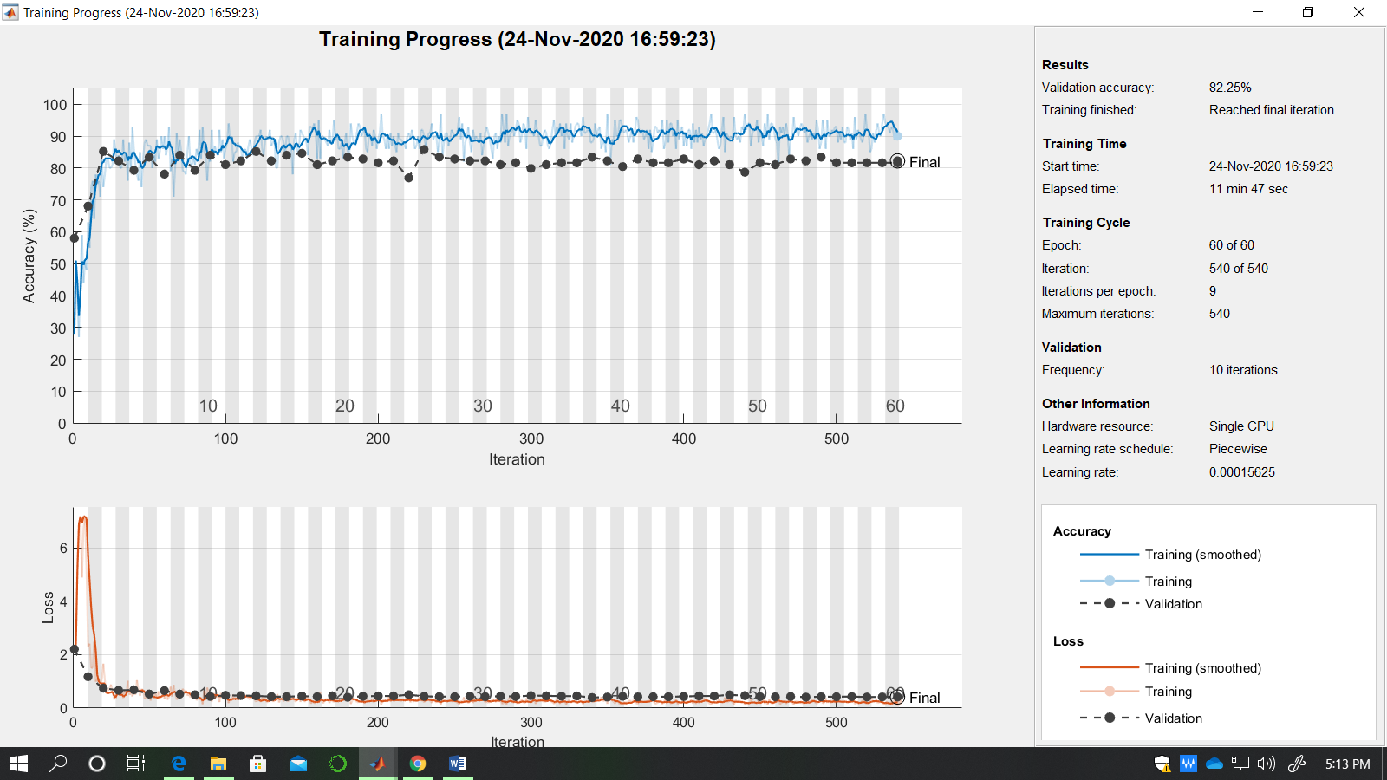

Q 2.

**Errors: [ 0.01259 0.00940 0.00998 ]; Total Error 0.018613.**

**YOU SCORE 10.0 POINTS OUT OF 10**

