AUSIGN - An AUSLAN Interpreter

The primary concept behind AUSIGN is to design a pair of smart gloves that interpret Auslan (Australian Sign Language) and convert the signs into spoken language via built-in speakers. This will empower individuals who are deaf or nonverbal to communicate more easily with the broader public, particularly in situations where an interpreter is not available.

One of our key design goals is to make the gloves lightweight, portable, and comfortable, but we also understand that usability involves more than just hardware specs. To ensure that AUSIGN addresses real user needs, we are conducting primary market research through a structured survey. This will help us:

* Validate the real-world usefulness of our concept
* Gather direct feedback on desirable features, comfort, pricing, and expectations
* Understand attitudes within the Deaf and non-verbal community toward current assistive technologies

In order to gather meaningful and relevant insights, we plan to distribute this survey to individuals who are deaf, hard of hearing, or non-verbal, as well as people who work closely with them (e.g. Auslan interpreters, educators, and disability support workers). Specifically, we will target local Deaf advocacy and community groups along with online forums and Reddit communities (e.g. r/auslan, r/deaf).

Keeping this in mind, we came up with around 10 questions that we feel would help us best understand the market. We distributed them to the above mentioned groups through online forms to the best of our ability. We also got our relatives and anyone they knew who had a hearing impairment to fill out our form in order to get more data. In total, we received about 21 responses. The questions and the results are as follows:

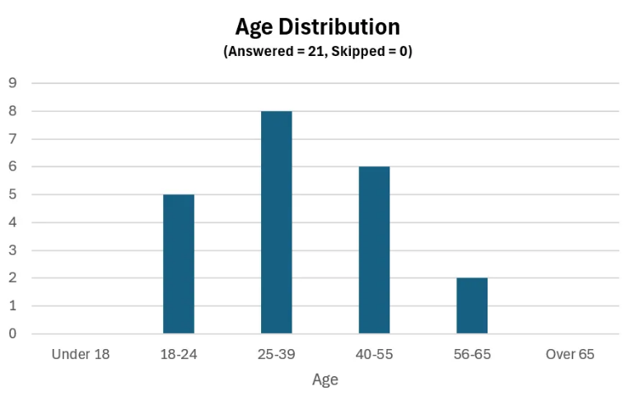**Section 1: Demographics**

1. Age:
   1. Under 18
   2. 18 - 24
   3. 25 - 39
   4. 40 - 55
   5. 56 – 65
   6. Over 65
2. What is your level of hearing loss?
   1. A graph of hearing loss

      AI-generated content may be incorrect.No hearing loss
   2. Mild (21 - 40dB)
   3. Moderate (41 - 70dB)
   4. Severe (71 - 90dB)
   5. Profound (91+ dB)
3. Are you also non-verbal or do you experience speech difficulties?
   1. A graph of a speech difficulty

      AI-generated content may be incorrect.Yes
   2. No
   3. Prefer not to say

**Section 2: Communication Tools and Tech Usage**

1. Do you currently use any assistive devices for communication?
   1. A graph with blue rectangular bars

      AI-generated content may be incorrect.Yes
   2. No
2. *(If answered Yes above)*

What communication device(s) do you currently use?

(Open-ended)

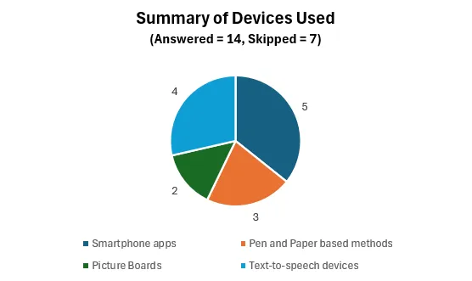

1. *(If answered Yes above)*

On a scale of 1 to 10, how useful is your current communication aid in daily life?

(1 = Not useful at all, 10 = Extremely useful)

1. *(If answered No to Q4)*

How open are you to using a new device that may improve daily communication?

(1 = Not open at all, 10 = Very open)

**Section 3: Product-Specific Feedback**

1. Would you be interested in using a device like AUSIGN that converts Auslan gestures to speech? If no, why?

**(Primary reasons for not interested deviate towards concerns about feasibility of complete interpretation of Auslan as it relies on facial expressions and context. There were also concerns about regional sign variation.)**

1. Aside from translating sign language into speech, are there any additional features you believe would make this product more useful or appealing for members of the Deaf or non-verbal community?

**(Most features fall under context awareness, ease of use, long battery file and comfortability)**

1. What price range would you consider reasonable for this product?
   1. 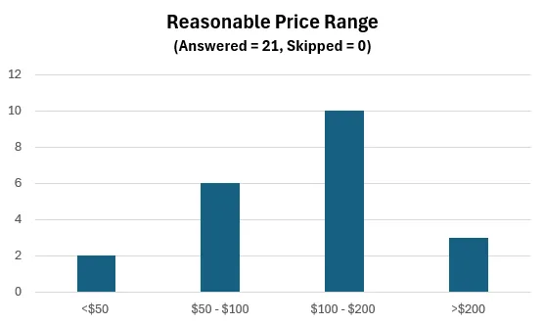Less than 50 AUD
   2. 50 to 100 AUD
   3. 100 to 200 AUD
   4. Over 200 AUD

**Survey Outcomes**

As mentioned before, our survey gathered input from 21 respondents within the Deaf and non-verbal community. Most were aged 25–55 with moderate to profound hearing loss, confirming a mature and tech-aware user base. Around 67% currently use communication aids—mostly smartphones or text-to-speech devices—with an average usefulness rating of 6.1/10, suggesting scope for improvement. Non-users reported a high openness to trying new tools (average 8.2/10), validating demand for improved solutions.

62% expressed interest in AUSIGN, but 38% raised concerns based on past devices that failed to capture Auslan’s full complexity (e.g. facial cues, grammar, regional signs). Using ML to achieve context awareness and having a larger data set could help with this issue as it seemed to be a major point of concern among many. Most respondents supported a $100–200 AUD price range. These findings will guide AUSIGN’s design focus on usability, adaptability, and affordability.