Please note that this syllabus should be regarded as only a general guide to the course. The instructor may change specific course content and requirements after posting this syllabus.
Sociology 2010
Introduction to Sociology
Spring 2024

Modality: In-person
Meeting Time: MWF, 1:25 - 2:15 pm
Location: Brackett Hall 113
Instructor: Miao Li, PhD
Email: miaol@clemson.edu
Office Hours: See the Canvas page
Office Phone: 864-656-3819
Office Address: Brackett 135A
Time to Wait: If I am late, please wait for at least 15 minutes before assuming that class is canceled.

COURSE DESCRIPTION:
The sociological imagination enables its possessors to understand the interplay of man and society, of biography and history, of self and world. -- C. Wright Mills
This a course introduces you to the discipline of sociology. In this class we will explore how different forms of social forces shape different aspects of our life. We will learn about different theoretical perspectives that sociologists have developed to explain society, as well as conceptual and methodological tools that sociologists use to study social phenomena. A range of topics will be covered, including but not limited to social structure, social interaction, social inequalities, and a selected number of areas of social life. The goals of this course are not only to acquaint you with basic concepts and theories of sociology, but more importantly, to train your analytical mind to make your own sensible judgments of the world around you. Topics will be examined through lectures, readings, and class discussions.
LEARNING OBJECTIVE:
After you have completed this course, you should be able to:
- Identify social forces that affect individuals.
- Develop a historic overview of the development of the discipline.
- Understand concepts that are commonly used in the field.
- Use your “Sociological Imagination” to ask meaningful sociological questions in your everyday life.
- Apply sociological concepts and/or theoretical perspectives in answering these questions.
REQUIRED TEXTBOOK:
To promote equal access and reduce educational barrier due to high textbook costs, this course will use Open Education Resources. The core readings are the lecture notes. Supplemental reading materials could be found here: http://freesociologybooks.com/.
GRADING:
Grades of this class are determined by following components.
Items | Percentage
Quizzes | 40%
Class Attendance | 15%
Midterm Exam | 15%
Research Project | 10%
Final Exam | 20%
Total | 100%
90%-100% =A; 80%-89.9%=B; 70%-79.9%=C; 60%-69.9%=D; Below 60%=F
Note: Grades are not negotiable. It is your responsibility to keep track of your grades via Canvas. Report to me within a week if you find there is any mistake regarding your grade after the grades are posted on Canvas. Do not wait until the end of the semester.
Quizzes (40%): There will be five quizzes throughout the semester. Quizzes compose 40 percent of your final grade. Grading will be based on the mean score for all quiz scores. The quizzes will be in the format of multiple-choice questions or true/false questions. Quizzes will NOT be cumulative; that is, each quiz will cover only the material presented in the segment of the course after the previous quiz. All quizzes must be completed and submitted online through Canvas. Plan to complete quizzes on time. Late submission is not accepted.
Class Attendance (15%): This course will involve a significant amount of in-class discussions. Therefore, students’ continual attendance is critical for successful learning. Students are required to attend all classes through the semester. Attendance will be taken throughout the semester.
Each unexcused absence will result in a 20% discount in your Class Attendance Score (which transfers to a 3% discount of your final grade). Excessive absences (defined as being >5) will lower your final grade by one letter grade (i.e. B to C), in addition to losing all Class Attendance Score (15% of the total score). Students who miss 10 or more class meetings will get an “F” for final grade. Attendance will be taken at the beginning of each class throughout the semester. Excusable absences include the following categories:
- A medical complication (pregnancy/childbirth-related, physical injury, illness, etc.) too severe or contagious for the student to attend class, when certified by an attending physician. Healthcare providers at Redfern Health Center do not provide written excuses; however, students should retain paperwork of medical visits affirming date and time. Whenever possible, students should visit Redfern as outpatients without missing class. An absence for a non-acute medical service does not constitute an excused absence. Course instructor may, at his discretion, require documentation of medical absences.
- Death of an immediate family member (spouse, parent or legal guardian, child, grandparent, grandchild, or sibling, including a corresponding in-law or step-relative). In this case, students could be excused for absences from classes for at least five (5) consecutive business days. Documentation (e.g., death certificate) could be provided afterward.
- Serious illness or emergency in a student's immediate family (course instructor may require documentation).
- Participation in authorized University-sponsored activities, not to include practice for the activities. Course instructor may require documentation from the course instructors or staff advisor of the sponsored University group.
- Religious observances and practices which prevent the student from being present during a class period (prior consultation with the instructor is necessary).
- Participation in court-imposed legal proceedings (e.g., jury duty or subpoena).
- Required participation in military obligations as certified by the student's commanding officer.
- Interviews for jobs, co-op assignments, internships, graduate school, or professional school. Students should make every effort to schedule appointments around their class obligations and will provide documentation beforehand to verify a class conflict.
Mid-term Exam (15%) and Final Exam (20%): Both exams will be about materials covered in the textbook, lectures, or other assigned readings. The Final Exam is cumulative, meaning that it will cover all course materials. The exams are close-book, so it is recommended that you study carefully for the tests. The exam dates are listed on the course schedule. Make-up exams may be given only for valid excused absences with written documentation. Unless there are major extenuating circumstances, exams must be made-up within one week. If you know that you will be absent on the day of an exam, you need to let me know ASAP so that I can schedule another time for you to take it.
Research Project (10%): There will be one research project related to the teaching content. Students who fail to submit on time will receive a zero score. Failing to complete required components of the project will incur score penalty. Detailed requirements of the project will be posted on Canvas.

INSTRUCTOR-STUDENT COMMUNICATION ETIQUETTE:
You must regularly check the Canvas page for the course and your university email account for announcements regarding this course. I am not responsible for emails you did not receive because you did not check your account or because your inbox was full and the email was denied. If an email is rejected from an account, I will not resend it. In sending emails to the Instructor, you should use your University Email Account and edit your email Subject following the following templates (depending on the reason of contact):
For emails related to absences:
SOC2010_Student Name_Absence
For emails related to inquiries on course content, homework, and exams/quizzes:
SOC2010_Student Name_Inquiry
For emails requesting for appointment:
SOC2010_Student Name_Appointment
For all other emails:
SOC2010_Student Name_[put a key word for your reason of contact here]
Following these templates in your email Subject line ensures your email is filtered directly into my course folder and does not get lost among other messages. As I receive a lot of emails each day, your email will be overlooked when “SOC2010” or your name are not in the subject line. I will make every attempt to answer your email within 48 hours. If you do not receive a response after 48 hours, please do not hesitate to email me again. If you email me on a Friday, I may not return the email until Monday.
When you are composing your email message, remember you are not writing to describe last Friday night to a friend. You are talking to someone in a professional setting! Please see below for some common mistakes.
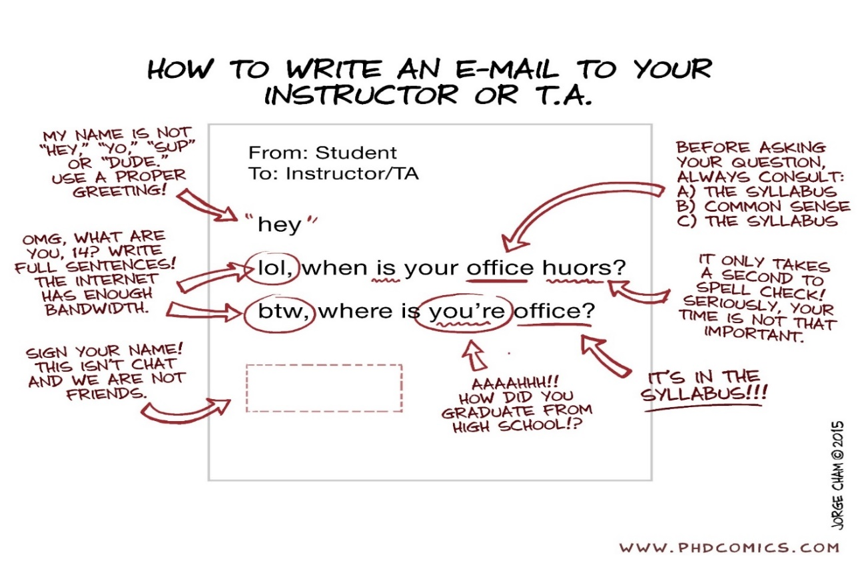

Electronic Devices:

No electronic devices of any kind are allowed in my classroom: no personal computers, PDAs, iPODs, iPADS, texting, cell phones or anything else. Do not send or read texts during lectures or group activities. I will only permit the use of computers during class exercises where I have specifically asked you to use them. Otherwise, they need to be closed or turned off.

Standard Academic Policies:

Accessibility
Clemson University values the diversity of our student body as a strength and a critical component of our dynamic community. Students with disabilities or temporary injuries/conditions may require accommodations due to barriers in the structure of facilities, course design, technology used for curricular purposes, or other campus resources. Students who experience a barrier to full access to this class should let the instructor know and are encouraged to request accommodation through SAS (Student Accessibility Services) as soon as possible. To request accommodations through SAS, please see this link: https://www.clemson.edu/academics/studentaccess/register.html. You can also reach out to SAS with questions by calling 864-656-6848, visiting SAS at the ASC Suite 239, or stopping by the office as a drop-in appointment.

Clemson University Title IX Statement
Clemson University is committed to a policy of equal opportunity for all persons and does not discriminate on the basis of race, color, religion, sex, sexual orientation, gender, pregnancy, national origin, age, disability, veteran’s status, genetic information or protected activity in employment, educational programs and activities, admissions and financial aid. This includes a prohibition against sexual harassment and sexual violence as mandated by Title IX of the Education Amendments of 1972. This Title IX policy is located on the Access and Equity website.
Ms. Alesia Smith is the Clemson University Title IX Coordinator, and the Assistant Vice President of Equity Compliance. Her office is located at 223 Brackett Hall, 864-656-3181 and her email address is alesias@clemson.edu. Remember, email is not a fully secured method of communication and should not be used to discuss Title IX issues.
Clemson University aspires to create a diverse community that welcomes people of different races, cultures, ages, genders, sexual orientation, religions, socioeconomic levels, political perspectives, abilities, opinions, values and experiences.

Emergency Preparation
Emergency procedures have been posted in all buildings and on all elevators. Students should be reminded to review these procedures for their own safety. All students and employees should be familiar with guidelines from Clemson University Public Safety.
Clemson University is committed to providing a safe campus environment for students, faculty, staff, and visitors. As members of the community, we encourage you to take the following actions to be better prepared in case of an emergency:
- Familiarize yourself with all possible exits, safer locations, and other key information on the emergency evacuation maps in this building, and those that you visit regularly.
- Make a plan for how you would Run, Hide, and Fight in case of an active threat in this building, and those that you visit regularly. For example:
  - Run – what are all the possible exits in this building, and the routes to them?
  - Hide – what are the potential hiding locations in this room and building that are out of sight of doors and windows, how do you lock the door(s), how would you barricade the door(s) and windows, where do you turn off the lights?
  - Fight – What tools are available in this room and building, should you have to fight?
- Ensure you are signed up for emergency alerts. Alerts are only sent when there is a potential threat to safety, a major disruption to campus services, and once-monthly tests.
- Download the Rave Guardian app to your phone. (https://www.clemson.edu/cusafety/cupd/rave-guardian/)
- Learn what you can do to prepare yourself for the hazards that affect our locations. (http://www.clemson.edu/cusafety/EmergencyManagement/)

DATES | Mon | T | Wed | Th | Fri | What’s Due
 |  |  |  |  |  | (All due dates fall on Saturday Midnight)
Week 1  (Jan. 8-12) |  |  | Course Introduction |  | Sociological Imagination
Week 2  (Jan. 15-19) | MLK Holiday |  | Sociological Perspectives |  | Sociological Perspectives
Week 3  (Jan. 22-26) | Macrosociology |  | Macrosociology |  | Macrosociology | Quiz 1 Due by Midnight
Week 4  (Jan. 29- Feb. 2) | Microsociology |  | Microsociology |  | Microsociology
Week 5  (Feb. 5-9) | Culture |  | Culture |  | Culture | Quiz 2 Due by Midnight
Week 6  (Feb. 12-16) | Social Stratification |  | Social Stratification |  | Social Stratification
Week 7  (Feb. 19-23) | Global Inequality |  | Global Inequality |  | Global Inequality | Quiz 3 Due by Midnight
Week 8  (Feb. 26-Mar.1) | Midterm Review |  | Midterm Exam
Week 9  (Mar. 4-8) | Race/Ethnicity |  | Race/Ethnicity |  | Race/Ethnicity
Week 10  (Mar.11-15) | Immigration |  | Immigration |  | Immigration | Quiz 4 Due by Midnight
Week 11  (Mar.18-22) | Spring Break
DATES | Mon | T | Wed | Th | Fri | What’s Due (All due dates fall on Saturday Midnight)
Week 12  (Mar.25-29) | Religion |  | Religion |  | Religion | Research Project Due by Midnight
Week 13  (Apr.1-5) | Media & Technology |  | Media & Technology |  | Media & Technology
Week 14  (Apr.8-12) | Health & Aging |  | Health & Aging |  | Health & Aging
Week 15  (Apr.15-19) | Urbanization & Environment |  | Urbanization & Environment |  | Urbanization & Environment | Quiz 5 Due by Midnight
Week 16  (Apr.22-26) | Review Week
Week 17  (Apr.29-May.3) | Final Exam |  |  |  |  | SEMESTER ENDS
*Each quiz will be posted at 4:00 PM of Friday in the week that has the quiz and will be due by Saturday midnight (11:59PM) of that week.
Research project will be posted on March 4th (Week 9) and due by the Midnight of April 1st. Final Grade Will be Posted No Later Than 9:00 A.M, May 6th.

