|  |  |  |
| --- | --- | --- |
| 1 928 404 916  **58 way**  **Female CONN.** | **S.Seal** 282080-1  **2way**  **Male CONN.** | **Description** |
| 211 | 1 | CAN L |
| 224 | 2 | CAN H |
|  | | |

|  |  |  |
| --- | --- | --- |
| 1 928 404 916  **58 way**  **Female CONN.** | **S.Seal** 282080-1  **2way**  **Male CONN.** | C:\Users\ricca\AppData\Local\Microsoft\Windows\INetCache\Content.Word\res.png**Description** |
| 209 | 1 | CAN L |
| 222 | 2 | CAN H |
| Conn.Programmer Cable | | |

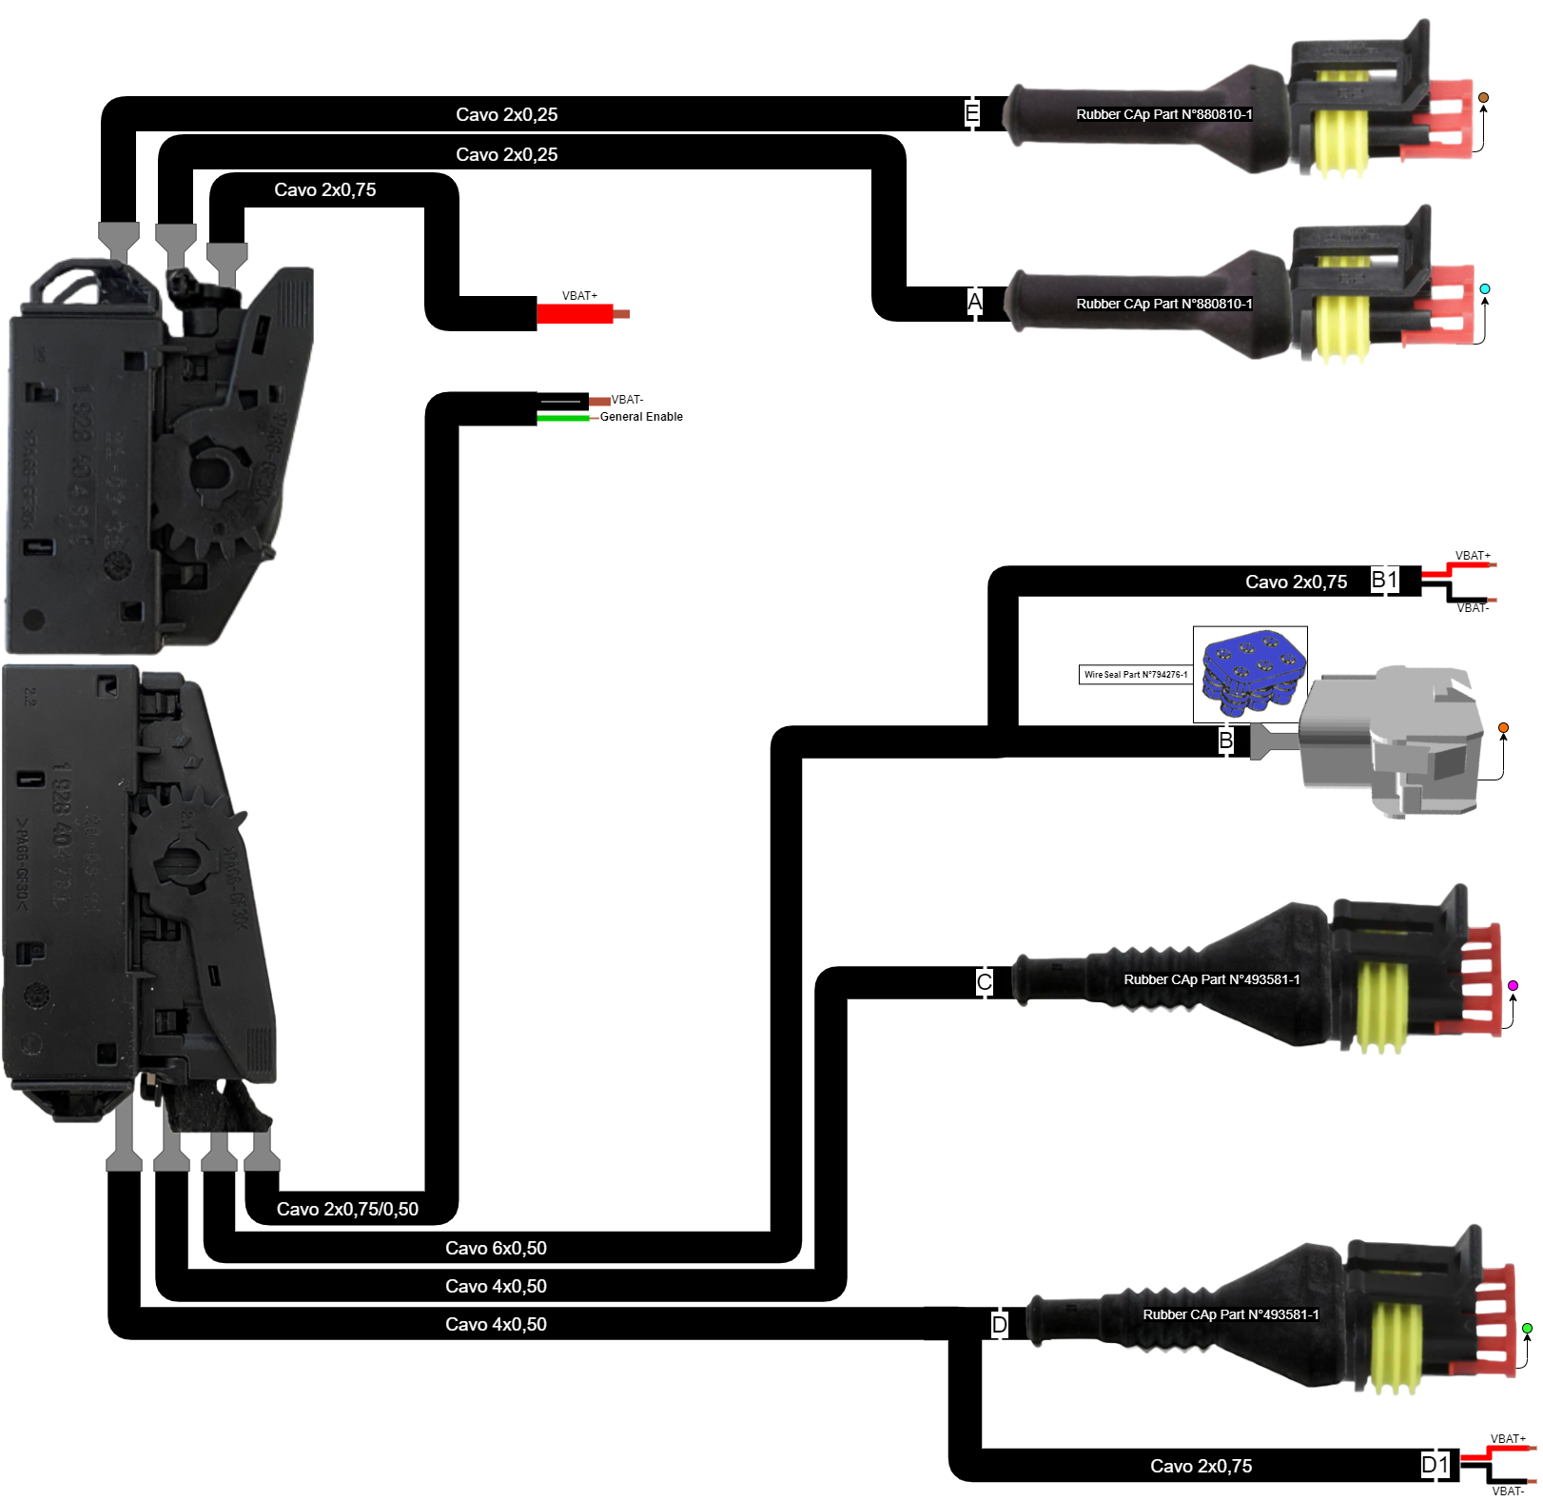

|  |  |  |
| --- | --- | --- |
| 1 928 404 781  **96 way**  **Female CONN.** | **Mini-Fit6way**  **Male CONN.** | **Description** |
| 143/VBAT-(Ref.B1) | 1 | GND |
| 140 | 2 | OSSD 2.2 |
| 116 | 3 | OSSD 1.2 |
| VBAT+(Ref.B1) | 4 | 24V |
| 139 | 5 | OSSD 2.1 |
| 115 | 6 | OSSD 1.1 |
| Conn.Ultrasuonic ECU | | |

|  |  |  |
| --- | --- | --- |
| 1 928 404 781  **96 way**  **Female CONN.** | **S.Seal** 282088-1  **4way**  **Male CONN.** | **Description** |
| 158 | 1 | Signal FWD |
| 142 | 2 | GND |
| 182 | 3 | Signal REV |
| 118 | 4 | GND |
| Conn.Output FWD/REV | | |

|  |  |  |
| --- | --- | --- |
| 1 928 404 781  **96 way**  **Female CONN.** | **S.Seal** 282088-1  **4way**  **Male CONN.** | **Description** |
| 141 | 1 | Signal REV |
| 117 | 2 | Signal FWD |
| 143/VBAT-(Ref.D1) | 3 | GND |
| VBAT+(Ref.D1) | 4 | 24V |
| Conn.Output FWD/REV | | |

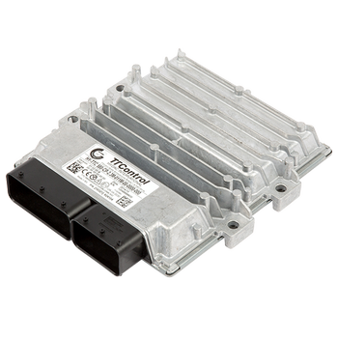

|  |  |  |  |  |  |  |
| --- | --- | --- | --- | --- | --- | --- |
| Data | Descrizione | | | |  | |
| 10/06/2022 | Pinout lato centralina SIMAI | | | |  | |
| Diseganto/Designed by  R.Mucci | Verificato da/Verified By Approvato da/Approved by  N/D N/D | |  | N°Foglo/N°Sheet  1/4 |
|  | Note/Notes  Schema elettrico centralina HTTC 540 con sensore ultrasuoni e radiocomando | | | | Rev/Rev  0 | Codice/PartNumber  Da Richiedere |
|  |  |  |  | |

|  |  |  |  |  |  |  |
| --- | --- | --- | --- | --- | --- | --- |
| Data | nuovo-logo-kiwitronDescrizione | | | |  | |
|  |  | | | |  | |
| Diseganto/Designed by | Verificato da/Verified By Approvato da/Approved by | |  | N°Foglo/N°Sheet |
|  | Note/Notes | | | | Rev/Rev | Codice/PartNumber |
|  |  |  |  | |