Remix Rally

Audience Remix Queue

STATUS  Proposed |  | OWNER  Channel creator |  | LAST UPDATED  August 3, 2026

Authors | Channel creator with Codex synthesis
Reviewers | Product, platform, agent-workflow, and catalog reviewers
Related docs | Platform research note in docs/research
Scope | Public queue, engagement loop, creator studio, track catalog, and external agent-sync seam

1. Abstract
Remix Rally turns song requests scattered across YouTube comments into a public, deduplicated, community-informed remix queue. A FoldKit and Tailwind CSS single-page application shows ranked requests, each song's journey, participation recognition, and releases. A small Cloudflare Worker owns the public and protected write interfaces, while D1 owns the track catalog and application state.
A scheduled Codex automation invokes a song-sync skill that reads comments through MCP, researches each requested recording on the internet, resolves it against YouTube and central music catalogs, and submits one structured record. Alchemy Run remains the sole definition for the smaller deployed application.

2. Goals and Non-Goals
Goals | Non-goals
One canonical public request per song with transparent stage and support. | No guarantee that the highest-voted song is produced next.
Reward useful participation and close the loop from request to release. | No pay-to-win rewards, transferable voting power, or cash prizes.
Resolve comment requests through an external agent skill with traceable catalog evidence. | No in-app classifiers, provider adapters, agent runtime, or direct MCP writes to D1.
Deploy reversible, isolated environments through Alchemy Run. | No multi-creator marketplace or generic campaign platform in v1.

3. Background and Problem Statement
Song requests currently arrive across many videos and threads. Titles and spellings vary, duplicates fragment support, and viewers cannot see what is popular, selected, in production, or released. The creator must repeatedly review comments and answer the same status questions, while engagement ends after a comment is posted.
The system creates one canonical song request, preserves every source and supporter, and exposes a fan-safe projection. The home experience is queue-first; the request detail is journey-first; a light seasonal Remix Rally layer adds milestones, points, and badges. The invariant is simple: community signals are explainable, creator decisions are explicit, and agent research reaches D1 only through a validated, idempotent interface.

4. Proposed Architecture

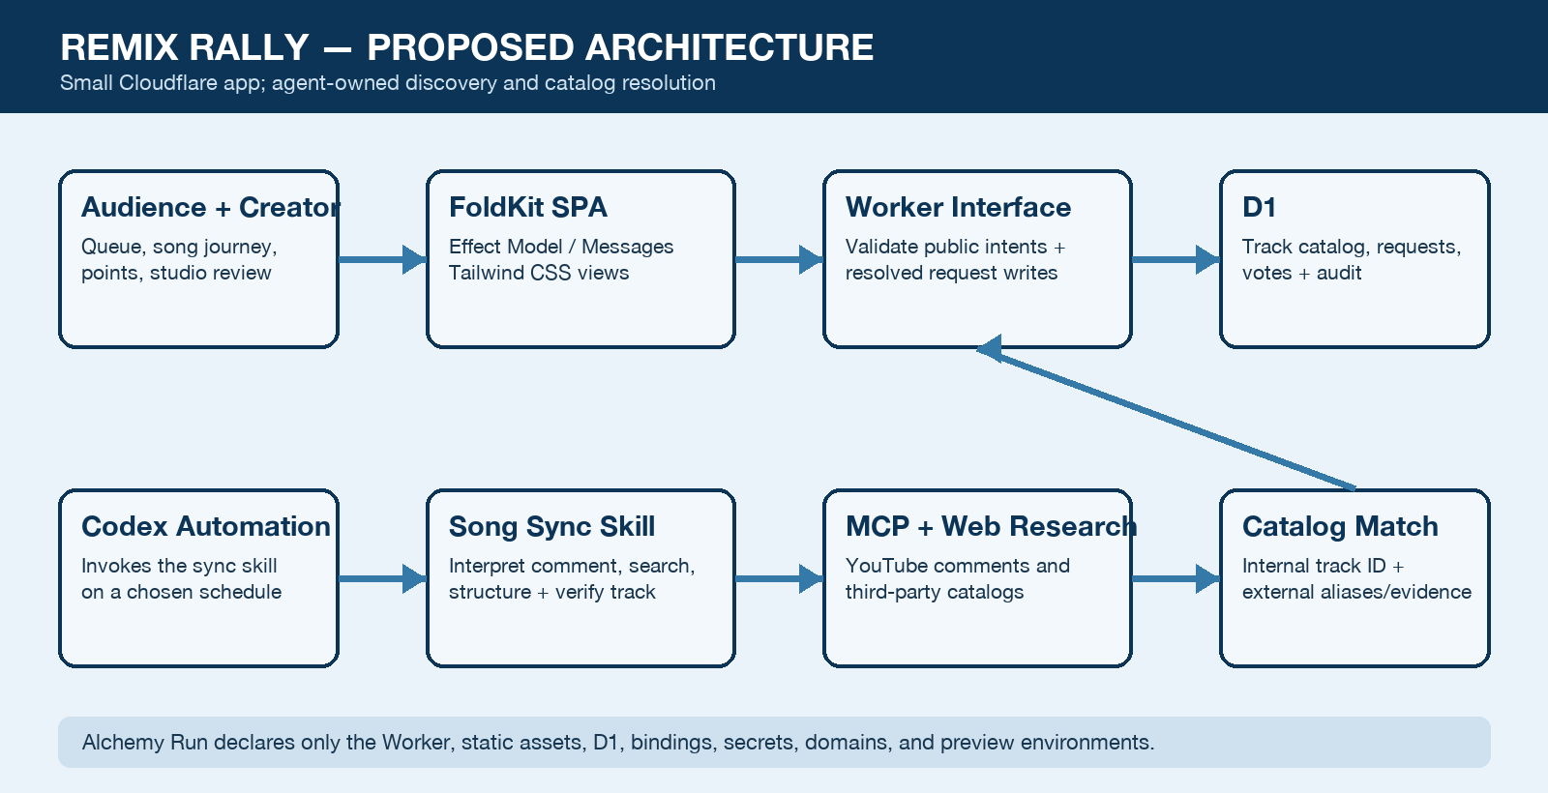
Figure 1. Remix Rally system boundaries and durable data flow.

Core components

Component | Responsibility | Primary storage | Failure behavior
FoldKit web | Queue-first home, song journey, profile, releases, and creator studio using Tailwind CSS. | Worker Static Assets | Show cached/safe error state; never guess a mutation result.
Worker domain interface | Decode public intents and resolved-request writes; apply catalog, ranking, and stage invariants. | D1 + bindings | Fail closed on invalid input, auth, aliases, or required writes.
Agent sync module | Read comments by MCP, research exact recordings, match the catalog, and submit evidence. | Codex automation + MCP + web | Do not write on ambiguity; report needs review and preserve checkpoint.
D1 catalog state | Own tracks, external aliases, request sources, votes, progress, points, and audit events. | D1 | Reject incomplete catalog mutations and return an explicit receipt.
Alchemy and telemetry | Declare the small app resources and expose health, sync freshness, logs, and drift checks. | Alchemy state + Worker observability | Block promotion on drift; preserve last good deployment.

5. Request Lifecycle
- A scheduled Codex task invokes the song-sync skill, which lists new YouTube comments through the configured MCP adapter.
- The agent interprets each comment directly; there is no separate classifier, confidence engine, or application-side enrichment path.
- For a request, the agent searches the web and music catalogs to identify the exact recording, official video, and stable aliases.
- The skill searches Remix Rally's internal track catalog and either selects an existing track or proposes a new resolved track.
- The agent submits the source, resolved track, external identifiers, and evidence through upsertResolvedRequest(resolvedRequest) → receipt.
- The Worker validates identity, schema, source-event uniqueness, and catalog aliases before atomically updating D1 and its audit log.
- The receipt reports created, matched, already processed, or needs review; the skill advances its checkpoint only after a durable receipt.

6. API and Data Contracts

Primary data contract

Field | Type | Required | Description
sourceEventId | string | Yes | Stable YouTube comment ID used for ingestion idempotency.
source | RequestSource | Yes | Video URL, comment URL, observed time, and original request text.
track | ResolvedTrack | Yes | Exact recording title, artists, film/album, language, year, and internal match when found.
youtubeVideoId | string | Yes | Canonical source video selected and evidenced by the agent.
externalIds | Identifier map | No | Provider aliases such as ISRC, MusicBrainz, Apple Music, Spotify, or Shazam.
evidenceUrls | URL list | Yes | Pages used to support the identity; no opaque confidence score is accepted.
requestedStyle | string | No | Remix style explicitly requested in the source comment, when present.

Contract guarantees

- Every public projection is decoded from a versioned Effect Schema; invalid or unauthorized shapes fail closed.
- The source comment ID is the ingestion idempotency key; D1 uniqueness protects repeated scans, votes, aliases, and request-source attachment.
- A resolved request carries the source URL, original request text, normalized recording, external identifiers, and research evidence.
- D1 is authoritative for Remix Rally state; external catalogs remain evidence and aliases; remix workspaces remain authoritative for production.
Public routes: /, /r/:requestId, /me, and /releases. Creator routes: /studio and /studio/replies/:draftId. Request creation opens as a duplicate-aware sheet from the active queue or season.
FoldKit uses one immutable Model with route-specific fan-safe projections, typed Messages for user intent, and Commands for Worker calls. Shared Effect Schemas version browser/API contracts with each release.

7. Consistency, Idempotency, and Replay

Public writes use optimistic feedback but reconcile against D1 receipts. Agent scans may repeat, arrive late, or submit the same source again; the protected interface converges on one request-source attachment. Canonical merges preserve attribution and redirect old links. A failed or ambiguous song resolution produces no canonical catalog mutation.
Scenario | Expected behavior | Reasoning
Repeated comment submission | Return the existing receipt or attach no duplicate source. | The YouTube comment ID is unique at the write interface.
D1 write or required binding fails | Return a retryable error and do not advance the sync checkpoint. | The agent can safely resubmit after recovery.
Ambiguous or conflicting track | Return needs review; create no canonical track or alias. | Agent judgment is useful, but unsupported identity must not become catalog truth.
Catalog alias already belongs elsewhere | Reject the write and surface the conflicting tracks. | Provider aliases cannot silently merge different recordings.

8. Security and Privacy Considerations

- Audience members use a signed pseudonymous session; the Worker enforces one current vote per session and request. Creator routes require Cloudflare Access.
- Public views expose aggregated request data, not raw YouTube author profiles or moderation details. Logs redact comment text and tokens by default.
- The protected agent-write credential and Turnstile/session secrets use Worker secrets. YouTube and catalog credentials remain with their MCP adapters, outside the app.
- The agent never receives direct D1 access. Ambiguous identity, conflicting provider evidence, or invalid aliases fail closed into needs review.
- Persist only request text and source identifiers needed for attribution and audit. Provider evidence is refreshable; external author profiles are not public catalog data.

9. Operational Readiness
Signal | SLO or alert | Owner | Launch gate
Public mutation success | Proposed ≥99.9% valid requests over 30 days | Creator/operator | Required
Interactive API latency | Proposed p95 <500 ms excluding external-provider work | Creator/operator | Recommended
Agent sync freshness | Alert when last successful sync exceeds the configured threshold | Creator/operator | Required
Deployment/binding drift | Block promotion when declared and observed targets differ | Creator/operator | Required
Catalog-write integrity | Zero duplicate source IDs or conflicting external aliases | Creator/operator | Required

10. Alternatives Considered

Alternative | Why it was considered | Why it was not selected
In-app classifier/enrichment | Could run without Codex availability. | Duplicates agent reasoning and expands the app with prompts, models, jobs, and provider logic.
Direct MCP writes to D1 | Fewest apparent moving parts. | Bypasses catalog invariants, auditing, authorization, and schema locality.
Provider ID as primary key | Easy matching to one catalog. | Locks the catalog to a vendor and mishandles regional, live, cover, and remastered recordings.
Cloudflare Cron/Queues/AI | Cloud-native scheduling and execution. | Unnecessary for low-volume agent-led resolution and materially enlarges v1.

11. Open Questions
- What sync cadence and stale-sync threshold should the scheduled Codex automation use?
- Which catalog evidence is preferred for text resolution, and when should optional audio identification be attempted?
- Should audience identity remain pseudonymous for v1, or require Google sign-in for durable cross-device recognition?
- Which public domain, creator brand, Cloudflare account, and MCP credential owner will operate production?

12. Decision and Next Steps
Adopt the queue-first plus song-journey interface with a deliberately light seasonal game layer. First prove FoldKit Static Assets and the protected resolved-request write interface, then launch a manual queue and run the agent skill against fixtures before enabling scheduled YouTube scanning. Production scheduling remains gated on isolated previews, a stale-sync alert, and exact catalog/request readback. Keep engagement replies in a separate approval-gated skill.
Milestone | Deliverable | Exit criteria
M1 | FoldKit/Tailwind SPA, Worker interface, D1 catalog schema, and Alchemy preview spike | Build serves SPA routes plus protected resolved-request writes with isolated bindings.
M2 | Manual public queue, voting, song journeys, creator studio, and audit | Browser tests prove request, vote, merge, stage, and ranking behavior end to end.
M3 | Codex song-sync skill with YouTube/catalog MCP and web research | Fixture and live dry runs resolve exact tracks, preserve evidence, and repeat safely.
M4 | Scheduled comment sync and limited Remix Rally season | Freshness and catalog-integrity gates hold; ambiguous records remain review-only.

Use footnotes for definitions, assumptions, or terms that need precision without interrupting the main narrative.

