

Caelus Management System
Release: R7.00.00
Date: 08/06/97

CMS/AutoCAD Set Up & Use
This document describes the set up steps to perform before using CMS with AutoCAD and the functions you can perform while in AutoCAD that are CMS specific. The CMS programs that support this CMS/AutoCAD interface are documented within the Bill of Materials Reference Manual.

Table of Contents
Table of Contents
Overview
Functions
Export BOM from AutoCAD to CMS
Import BOM from CMS to AutoCAD
Programs
Files
bomcadat.dat
bomcadxr.dat
bomcadup.dat
Data Transfer
Block Drawing Templates
bomcad_1.dwg - BOM Assembly Block
bomcad_2.dwg - BOM Component Header Block
bomcad_3.dwg - BOM Component Block
Set Up Procedures
Edit Configuration File
Modifiable Data Fields
Edit acadunx.lsp or acadpc.lsp
BOM/AutoCAD Functions using bomcad
Run bomcad
Import BOM from CMS
Export BOM to CMS
Build BOM
Append a BOM
Delete a BOM
Manually Transfer Files
Manually Import a BOM from CMS into AutoCAD
Manually Export a BOM from AutoCAD to CMS
Possible Update Errors

Overview
The CMS/AutoCAD functions provide an interface between CMS Bill of Materials and part master data stored in CMS and similar data contained within AutoCAD drawings. BOM data can flow from CMS to an AutoCAD drawing, or from an AutoCAD drawing to CMS. However, caution should be used when exporting BOM material from AutoCAD to CMS as there are no “checks” in place to ensure CMS BOM accuracy on the AutoCAD side.

Functions
With CMS/AutoCAD, you can:
- Export BOM information from AutoCAD to CMS.
- Edit BOMs in AutoCAD; that is, adding, deleting, and modifying line items as needed.
- Import BOM information from CMS to AutoCAD.
- The Export and Import process is illustrated in figure AC-1 and AC-2.

Export BOM from AutoCAD to CMS
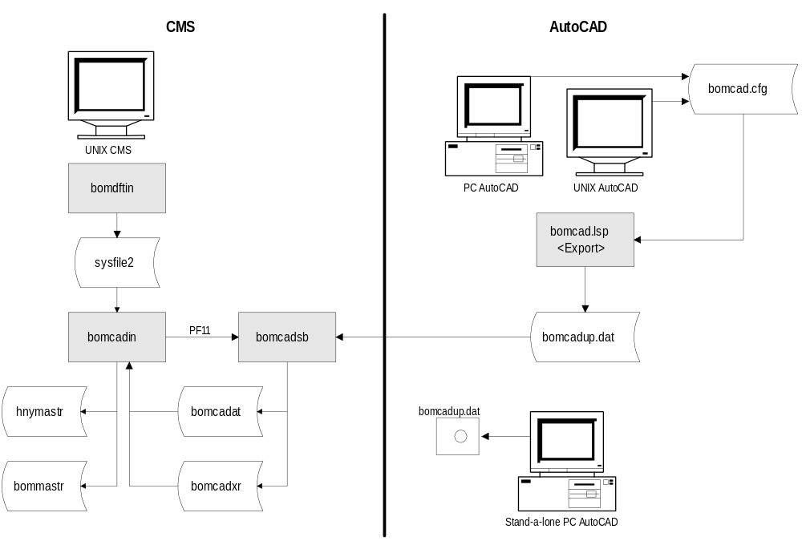

Export BOM from AutoCAD to CMS Figure AC-1

Import BOM from CMS to AutoCAD
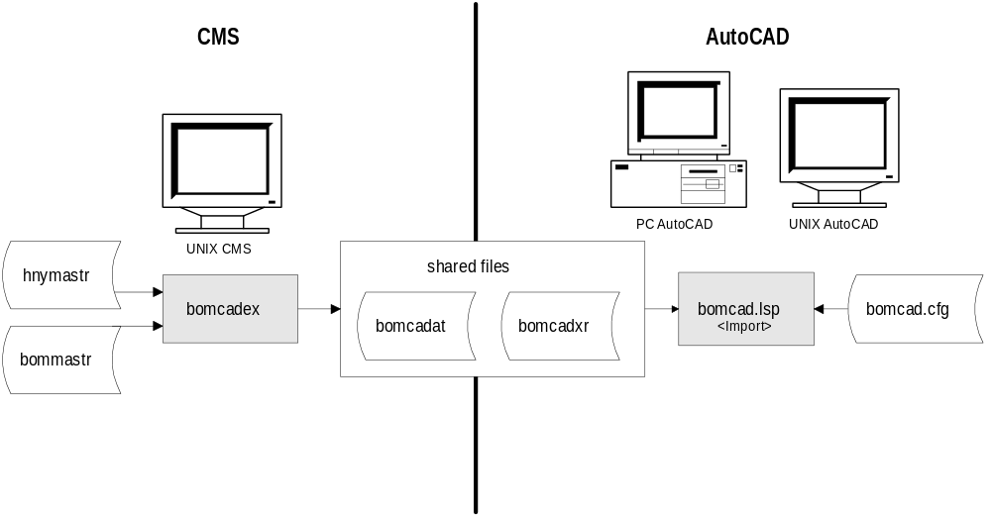
Import BOM to AutoCAD from CMS Figure AC-2

Programs
The CMS/AutoCAD programs are listed and briefly described below:
Program Description
bomcadex CMS Program. Use this program to export BOM/Part ID data to AutoCAD.
bomcadsb CMS Subroutine. Works with bomcadex and is not directly run by users. Loops through CMS BOM and extracts and writes data for importing BOM information to AutoCAD.
bomcadin CMS Program. Interacts with CMS. Use this program to import BOM/Part ID data from AutoCAD.
bomdftin CMS Program. Interacts with CMS. Use this program to set up defaults for BOMs imported into CMS from AutoCAD that are missing information or for which invalid information exists. This default information is used as a last resort and is not BOM ID specific.
bomcad.lsp AutoCAD Program. Use this program to import, export, append, delete, build BOMs.

Files
The CMS/AutoCAD interface extracts and adds Part and BOM data to and from the CMS master files. This transfer of data is not done directly, but through intermediary files. This methodology protects the CMS information from corruption due to PC or UNIX problems. An understanding of how the intermediary files interact is necessary to avoid potential problems when transferring BOM information to/from CMS.
Three intermediary files are used when transferring information:

bomcadat.dat
This file contains the CMS BOM information that will be transferred to an AutoCAD drawing or is coming from an AutoCAD drawing. This file is created via the CMS program bomcadex or during the update process (with bomcadin, press PF11) of the bomcadup.dat file. The working copy resides in the CMS database. A current copy of this file must be visible to an AutoCAD drawing session to import BOMs into the drawing. After a BOM transfer occurs and all updates have been successfully processed, the BOM data is no longer in the file.

bomcadxr.dat
This file contains a permanent record of which BOMs have been transferred to and from AutoCAD drawings. When a BOM has been extracted from CMS its status is kept track of. That is, whether the BOM is available to import into a AutoCAD drawing or if it has been imported into a drawing. Like wise the status of BOMs being transferred from an AutoCAD drawing are also kept track of. This file is created via the CMS program bomcadex or during the update process of the bomcadup.dat file (PF11 of bomcadin). The working copy resides in the CMS database. A current copy of this file must be visible to an AutoCAD drawing session.

bomcadup.dat
This file contains the results of the AutoCAD drawing session. This might indicate what BOM has been imported or might contain the complete BOM that is being exported from the drawing session to be imported into the CMS system. This update file is created via the lisp program bomcad.lsp in the library designated in the configure file bomcad.cfg.
Multiple transactions can occur within the drawing session and each one will be recorded in the update file bomcadup.dat. The information in this file must be updated to the other interim files. This update process, which is done by pressing PF11 in the CMS program bomcadin, transfers the data stored in the flat file format of the bomcadup.dat file into the indexed format required by the CMS data file system.

Data Transfer
CMS/AutoCAD functions work with AutoCAD running on UNIX or AutoCAD running on a PC. They run the same on these two platforms except in data transfer. AutoCAD on UNIX transfers and receives data directly from CMS on UNIX. AutoCAD running on a PC can transfer and receive data in one of three ways:
Network File Server (NFS) link. Data files are transferred directly to and from the UNIX box and the PC.
File Transfer Protocol (FTP) link. Data files can be transferred manually to and from the UNIX box and the PC. Procedures for this are covered later in this document.
Floppy Disk. Data files are copied to floppy disk to and from AutoCAD and to and from CMS on UNIX.
The most seamless method of handling the file transfer and maintenance between the UNIX and PC file systems is by using a PC NFS link which allows the UNIX files to be directly connected to the PC as an additional drive on the PC. The advantage with this method is that all files can stay on the UNIX file system and are accessible at all times to both the PC and the CMS programs. All necessary file data transfers and updates can occur without special user maintenance to manually transfer, delete, or copy files. By designating the paths to the interim data files in the lisp configure file, bomcad.cfg, the user has complete control.

Block Drawing Templates
Three BOM blocks are provided as templates for users. They define the attribute structure required by CMS to ensure proper part and BOM information. The provided BOM blocks have their attributes is the proper order. You may modify the provided blocks or create new blocks to meet your drawing standard; but you must not alter the current attribute sequence.
If your company drawing standards require more BOM information than the CMS system provides, you may add additional attributes to the end of the BOM blocks. If you add additional assembly attributes, you must change the bomcad.cfg variable BOM#XAA to reflect the number of additional assembly block attributes. If you add additional component attributes, you must change the BOM#XCA variable. Additional attributes must follow the CMS attributes in the BOM blocks.

bomcad_1.dwg - BOM Assembly Block
The BOM assembly block contains the following CMS attributes:
- Assembly part number
- Assembly part description
- Batch size
- BOM Id
- BOM description
- Attached Route
- Number of components
- Assembly Text Id
- Phantom flag
- Assembly part category
- Assembly part type
- Drawing Name (title block info)
- Drawing File (DOS file name)
- Component Handle list

bomcad_2.dwg - BOM Component Header Block
The BOM component header block contains the following AutoCAD attribute:
- Assembly BOM block Handle

bomcad_3.dwg - BOM Component Block
The BOM component block contains the following CMS attributes:
- Unit of measure (required qty)
- Component part name
- Component part description
- Fixed quantity
- Overage quantity
- BOM Marker
- Component option BOM flag
- Peg BOM
- Pick before route step
- Auto replace flag
- Component part category
- Component part type
- Component BOM sequence number
- Assembly BOM block Handle
- Per unit quantity
- Times used multiplier
- Unit of measure

Set Up Procedures
Follow these procedures before attempting to use CMS/AutoCAD functions.

Edit Configuration File
Before using CMS/AutoCAD, you need to edit the bomcad.cfg configuration file using either a PC or UNIX text editor that saves in ASCII mode. This file is required by the AutoCAD program bomcad.lsp. It contains a variable table of the BOM block drawings, BOM data files, paths, drawing scale, etc. The contents and fields of the configuration file are illustrated and described in figure AC-3.

Variable |  | Mod | Value |  | Description
BOM#SCL |  | YES | 12.0 |  | Drawing scale factor
BOM#XAA |  | YES | 0 |  | Additional user Header BOM Attributes
BOM#XCA |  | YES | 0 |  | Additional user Component BOM Attributes
BOM#SFG |  | NO | 0 |  | Update BOM Attribute file Script flag (0=N,1=Y)
BOM#ATF |  | NO | “bomcadat.dat” |  | CMS BOM Attribute File Name
BOM#XRF |  | NO | “bomcadxr.dat” |  | CMS BOM Cross reference File
BOM#UPF |  | NO | “bomcadup.dat” |  | CAD BOM Update File
BOM#SCF |  | NO | “bomcdscr.scr” |  | CAD Auto Update CMS Files Script
BOM#BKP |  | YES | “/directory/directory” |  | Path to BOM block drawings
BOM#DTP |  | YES | “/directory/directory” |  | CMS Data files path
BOM#UPP |  | YES | “/directory/directory” |  | Path to Update files
BOM#SCP |  | NO | “/directory/directory” |  | Script file path
BOM#BK1 |  | YES | “BOMCAD_1” |  | Assembly BOM block drawing
BOM#BK2 |  | YES | “BOMCAD_2” |  | Components Header block drawing
BOM#BK3 | YES |  | “BOMCAD_3” | Components BOM block drawing
bomcad.cfg File Contents Figure AC-3

Modifiable Data Fields
Note that the “Mod” field shown in figure AC-3 indicates whether or not the variable field value can be changed. While a short description of each variable is included this figure, each modifiable data field is further described below:
BOM#SCL This drawing scale factor is an AutoCAD function that is described in the AutoCAD documentation.
BOM#XAA This field allows you to indicate to AutoCAD that there are more BOM header attributes than are passed from CMS. A BOM Header Attribute is a header field that appears for each BOM, such as “BOM ID.” Note that any header fields that are added in AutoCAD are considered custom and are not read by CMS.
BOM#XCA This is the same as the BOM#XAA field except it relates to component attributes of a BOM instead of the header attributes of a BOM.
BOM#BKP Enter the path to the BOM block drawings, bomcad_1, bomcad_2, and bomcad_3. A BOM block drawing is the format and expected fields for a block of BOM attributes.
BOM#DTP Enter the path to the CMS data files bomcadat.dat and bomcadxr.dat.
BOM#BK1 Name assigned to the assembly BOM block drawing. Only change this if you rename the Assembly BOM block drawing.
BOM#BK2 Name assigned to the components header block drawing. Only change this if you rename the components header block drawing.
BOM#BK3 Name assigned to the components BOM block drawing. Only change this if you rename the components header block drawing.

Edit acadunx.lsp or acadpc.lsp
Before using CMS/AutoCAD, you need to define the path to the bomcad.cfg and bomcad.lsp files in either the acadpc.lsp (for AutoCAD running on a PC) or acadunx.lsp (for AutoCAD running on UNIX) file and then append the file to AutoCAD’s acad.lsp file. An example of the file and the fields to edit are shown in figure AC-4.
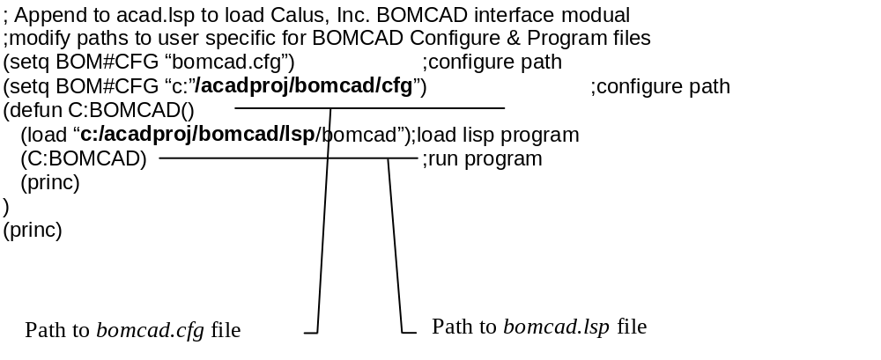
Contents of acadpc.lsp or acadunx.lsp file Figure AC-4

BOM/AutoCAD Functions using bomcad
The BOM/AutoCAD functions are available by running the bomcad program. Bomcad allows you to perform the following functions:
- Import BOMs from CMS
- Export BOMs to CMS
- Build (Create) a new BOM
- Append (Add to) an Existing BOM
- Delete Components of a BOM
Note that the “handles” function must be “ON” in the AutoCAD drawing session.

Run bomcad
To access the BOM/AutoCAD functions:
- Run AutoCAD.
- Enter bomcad at the command: prompt.
The list of options you can perform appears:
Import/Export/Build/Append/Delete/eXit<Import>
Enter the capitalized letter that corresponds to the function you want to perform. Or press RETURN to accept the default of the Import function.

Import BOM from CMS
BOMs are imported from the bomcadat.dat file, which must be visible to AutoCAD. This file is created when the CMS program BOMCADEX is run and specific BOMs are selected and exported.
To import one or more BOM from CMS:
- While in bomcad, at the Import/Export/Build/Append/Delete/eXit <Import> prompt, either enter I or press Enter. A list of BOMs that have been exported from CMS appears on the screen.
- At the Select Line number for Part-BOM/Quit: prompt, enter the number that corresponds to the BOM you wish to import.
- Place the selected BOM onto the screen by positioning arrow and clicking the mouse.

Export BOM to CMS
To export a BOM from AutoCAD to CMS:
- While in bomcad, at the Import/Export/Build/Append/Delete/eXit <Import> prompt, enter E. A series of prompts appear, one at a time, requesting information regarding the BOM to be exported.
- Pick BOM to Export . Select the BOM to export. To do this, place the cursor anywhere within the BOM text and click the mouse button.
- Associate Drawing File. Enter the name of the file to which you want the CMS BOM drawing to be saved or press ENTER to accept the default. The default is the current drawing file name.
- Drawing Path (Location). Enter the directory in which you want to save the drawing file and the path to that directory or accept the default. The default is the current directory.
- Drawing Name. Enter the name of this particular drawing. The drawing name and the drawing file can be the same or they can be different. You may have more than one drawing within a drawing file. Or you may have different revisions of one drawing in different files. The default is the selected drawing name.
- Drawing Name Revision Number. Enter the revision number you want assigned to the selected drawing or accept the default. After you enter this information, BOMCAD exports the selected drawing to the bomcadat.dat file.

Build BOM
Building a BOM is actually creating a BOM within AutoCAD.
- While in bomcad, at the Import/Export/Build/Append/Delete/eXit <Import> prompt, enter B. A series of prompts appear, one at a time, requesting information regarding the BOM to be built.
- BOM Start Point . Place the cursor anywhere within the screen and click the mouse button. This indicates to bomcad where the upper left corner of the BOM is to be.
- Assembly Part Number. Enter the parent part of the BOM you are creating.
- Assembly Part BOM ID. Enter the ID to be associated with the BOM you are creating.
- Assembly Part Number Description. Enter the description for this part.
- Assembly Batch Quantity. Enter the batch quantity for this part.
- BOM Description. Enter the text description to be associated with this BOM.
- Route Attached to this BOM. Enter the route number associated with this BOM.
- Phantom Part Flag? Enter “Y” if there is a phantom part in this BOM.
- Assembly Part Category. Enter the category for this part.
- Assembly Part Type. Enter the type for this part.
- Associate drawing name. Enter the drawing to be associated with this BOM.
- Associate drawing file. Enter the name of the file that contains the drawing to be associated with this BOM.
- Component Part Number. Enter the part number for this component part of the BOM.
- Component Part Number Description. Enter the description of this component part.
- Quantity per unit. Enter the quantity of component parts for one assembly part.
- Size (times used). Enter the size factor or number of times the quantity is used for this component.
- Added Overage per Run. Enter the quantity of this component that is fixed to the number of parents being built.
- Fixed Quantity per Run. Enter the fixed quantity of this component that is used in each job to build the parent part.
- BOM Marker (AS, PA, PH, RE, SP, ST, TL, UU). Enter the marker for this BOM. See the BOMINPUT documentation in the Bill of Materials Reference Manual for specific information about BOM Markers.
- Pick Before Route Step. Enter the route step that this component part is to be picked before.
- Specific BOM ID. This field allows you to override the effectivity calendar when determining the BOM version used to build this component. If you wish to use a specific BOM version to build the component for building this version for the parents BOM, enter the components BOM version here. When using this feature, you should be aware that it requires more maintenance than using the effective BOM of the component. You may only enter BOM versions on file.
- Component Part Category. Enter the category for this component.
- Component Part Type. Enter the part type for this component.
- Component Part Unit of Measure. Enter the unit of measure for this part.
- You will be prompted again to enter another component for this BOM and the associated information. Do this for as many components as are in this assembly. When you have finished entering all components, press ENTER at a blank component part prompt to quit.

Append a BOM
Appending a BOM is adding to a BOM within AutoCAD.
- While in bomcad, at the Import/Export/Build/Append/Delete/eXit <Import> prompt, enter A. A series of prompts appear, one at a time, requesting information regarding the BOM to be appended.
- Pick BOM to Append. Place the cursor anywhere within the screen and click the mouse button.
- Component Part Number. Enter the part number for this component part of the BOM.
- Component Part Number Description. Enter the description of this component part.
- Quantity per unit. Enter the quantity of component parts for one assembly part.
- Size (times used). Enter the size factor or number of times the quantity is used for this component.
- Added Overage per Run. Enter the quantity of this component that is fixed to the number of parents being built.
- Fixed Quantity per Run. Enter the fixed quantity of this component that is used in each job to build the parent part.
- BOM Marker (AS, PA, PH, RE, SP, ST, TL, UU). Enter the marker for this BOM. See the documentation for BOMINPUT in the Bill of Materials Reference Manual for specific information about BOM Markers.
- Pick Before Route Step. Enter the route step that this component part is to be picked before.
- Specific BOM ID. Enter the BOM ID if you are renaming this BOM or accept the default of the previous BOM ID if you are only changing the existing BOM.
- Component Part Category. Enter the category for this component.
- Component Part Type. Enter the part type for this component.
- Component Part Unit of Measure. Enter the unit of measure for this part.
- You will be prompted again to enter another component for this BOM and the associated information. Do this for as many components for this assembly as desired. When you have finished entering all components, press ENTER without entering data to quit.
- You will be prompted with New Assembly Part BOM ID. Enter the new assembly BOM ID if renaming this changed BOM. Otherwise, accept the default of the existing BOM.

Delete a BOM
This function deletes line items of a BOM and then requests that you rename the BOM. To delete line items of a BOM.
- While in bomcad, at the Import/Export/Build/Append/Delete/eXit <Import> prompt, enter D.
- Pick BOM to delete. Place the cursor on the line item to delete and click the mouse button.
- New Assembly BOM ID. Enter the new name for this changed BOM or accept the default of the current BOM.

Manually Transfer Files
You can manually transfer, delete, or copy files. The most common method is through an FTP (File Transfer Protocol) program. The procedure would vary slightly depending what type of function you are performing.

Manually Import a BOM from CMS into AutoCAD
To export a BOM from the CMS system:
- Add the BOM to the bomcadat.dat and bomcadxr.dat files via bomcadex.
- Delete any bomcadat.dat , bomcadxr.dat , and bomcadup.dat files on the PC's designated directory.
- Transfer or copy via FTP the bomcadat.dat and bomcadxr.dat files to the PC's designated directory.
- Import the BOM data into the AutoCAD drawing using the bomcad.lsp program.
- Transfer or copy via FTP the bomcadup.dat file back to the designated UNIX directory.
- Process the update file information in bomcadup.dat via PF11(Update ) using the CMS bomcadin program.
- Delete the bomcadat.dat , bomcadxr.dat , and bomcadup.dat files on the PC's designated drive.

Manually Export a BOM from AutoCAD to CMS
To import BOMs into the CMS system:
- Add the BOM data to the bomcadup.dat file via the lisp program bomcad.lsp.
- Delete the bomcadup.dat file on the UNIX designated directory.
- Set UNIX permissions for file receipt.
- Transfer or copy using FTP the bomcadup.dat file to the UNIX box's designated directory.
- Process the update file information using bomcadup.dat via PF11(Update ) in the bomcadin program.
- Delete the bomcadup.dat file on the PC's designated drive.
Be aware that your procedures must be very disciplined to avoid errors when using the FTP method of sharing data between the PC and UNIX box.

Possible Update Errors
You may be prevented from completing an update on the update file bomcadup.dat due to some file problem. Listed below are possible error messages you could encounter and possible solutions. These errors will appear in the bomcader file in your print directory:
- "Unable to open input file [filename]: error = [err type]" - update file bomcadup.dat does not exist at designated location or permission not correct.
- "Unable to open error file: error = [err type]" - error file already exist, you must resolve previous errors and remove error file.
- "Unable to open or create disam file [filename]: disam error = [err type]" - permissions not correct for bomcadat.dat or bomcadxr.dat file.
- "Export Error [ERROR] writing BOMCADXR record: [record]" - error writing the record. Most likely a duplicate key error due to attempting to process the bomcadup.dat file for a second time. If new records had been appended to the bomcadup.dat file after it was processed once (i.e., it has not been deleted from the PC directory processing), the good records were most likely processed correctly. Check to see what records have been processed. You may only have to delete bomcadup.dat from the PC files and UNIX files if everything is correct.
- "Import Error[ERROR] rewriting BOMCADXR record: [record] - error writing the record. Most likely a duplicate key error due to attempting to process the 'bomcadup.dat' file for a second time. If new records had been appended to the bomcadup.dat file after it was processed once (i.e., it has not been deleted from the PC directory processing), the good records were most likely processed correctly. Check to see what records have been processed. You may only have to delete bomcadup.dat from the PC files and UNIX files if everything is correct.
- "Unrecognized Instruction Mode [record]" - Most likely a previous error has allowed processing to get out of step and this error will be repeated until a valid processing step is encountered. Processing will continue from that point.
- "Error reading BOMCADXR record: [record]" - Record problem. Possible corrupted file.
- "Error reading Date Stamp: [record]" - Record problem. Possible corrupted file.
- "Import Error: [ERROR] Deleting BOMCADAT Record: [record] " - disam error removing record from data file. Possible corrupted file.

