CALENDAR DATE CONVERSION FUNCTIONS

PURPOSE

Calculate the calendar date, (given a number of days into the future or into the past), convert from one date format to another, show today's date in Gregorian and Julian formats, and show today's date in CMS Planning Calendar date format (1 to 490).

GENERAL DISCUSSION

This program provides a number of date conversion capabilities and prints a fifty-two week Planning Calendar which incorporates all three date formats. The date conversion is based on three different calendar types:

- Gregorian Calendar The Year/Month/Day calendar used throughout CMS.

- Planning Calendar The CMS planning calendar. Each day is represented as an integer number of days from the beginning of the planning calendar and is limited to 490 days.

- Julian Calendar Each date within a year is the number of days since the beginning of the year. Thus, 89001 is January 1, 1989, and 89100 is April 10, 1989 (100 days from the beginning of the year).

SCREEN EXAMPLE

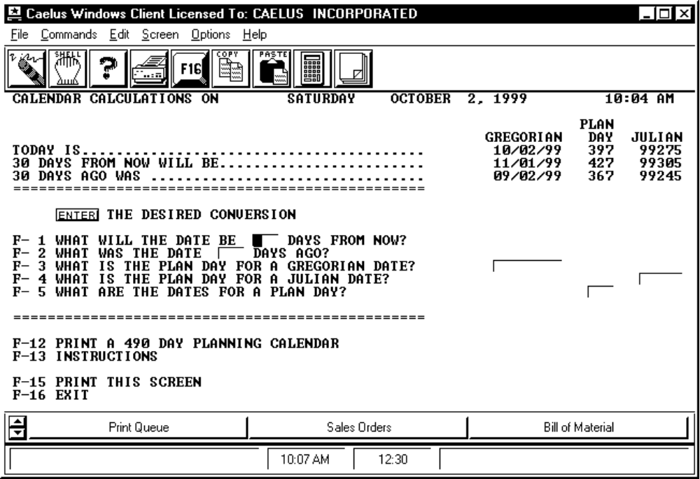

PROCEDURE DISCUSSION

Upon entry to the program, today's date, the date 30 days from now, and the date 30 days ago, are displayed in all three formats: Gregorian, Planning, and Julian. To perform conversions or calculations, choose one of the first five PF keys depending on the information you desire. For example, to start with a Gregorian date (MM/DD/YY) and determine the other two date forms, enter the date in the blanks on the line for F3. Then press F3 to view the results of the conversion. The converted dates appear in their respective columns.

Press F12 to print a 490 day planning calendar.

Active Function Keys

F1 WHAT WILL THE DATE BE *** DAYS FROM NOW? Enter the number of days from today and press F1 to see the dates on each calendar that many days from today.

F2 WHAT WAS THE DATE *** DAYS AGO? Enter the number of days before today and press F2 to see the dates on each calendar that many days before today.

F3 WHAT IS THE PLAN DAY FOR A GREGORIAN DATE? Enter a Gregorian date and press F3 to see the planning calendar date and the Julian calendar date for that day.

F4 WHAT IS THE PLAN DAY FOR A JULIAN DATE? Enter a Julian calendar date and press F4 to see the planning calendar and the Gregorian calendar dates for that day.

F5 WHAT ARE THE DATES FOR A PLAN DAY? Enter a planning calendar date and press F5 to see the Gregorian calendar and the Julian calendar dates for that day.

F12 PRINT A 490 DAY PLANNING CALENDAR To print a calendar showing the dates for each day of the current planning calendar.

REPORT CONTENTS

The report generated from this program shows the entire planning calendar and the Gregorian dates for each day on the calendar. Specifically, the report includes the following information:

PERIOD (Planning Calendar Day)
DATE (Gregorian Date)
DAY-OF-WEEK
YEAR (including century)
MONTH
DAY (Day of Month)
WK-OF-YR 1ST-MON (The week of the year starting of the first Monday of the year)
WK-OF-YR 1ST-DAY (The week of the year calculated from the first day of the year)
QRT-OF-YEAR CALENDAR (The quarter of the calendar year in which the date occurs)
QRT-OF-YEAR FISCAL (The quarter of the fiscal year in which the date occurs)
Report Sample: Production Calendar Printout (CALMENUM)

PRODUCTION CALENDAR FOR FRIDAY SEPTEMBER 17, 1999 1:30 PM

PERIOD DATE DAY-OF-WEEK YEAR MONTH DAY WK-OF-YR WK-OF-YR QRT-OF-YEAR QTR-OF-YR
1ST-MON 1ST-DAY CALENDAR FISCAL

1 10/01/98 THU 1998 10 1 39 40 4 3
2 10/02/98 FRI 1998 10 2 39 40 4 3
3 10/03/98 SAT 1998 10 3 39 40 4 3
4 10/04/98 SUN 1998 10 4 39 40 4 3
5 10/05/98 MON 1998 10 5 40 40 4 3
6 10/06/98 TUE 1998 10 6 40 40 4 3
7 10/07/98 WED 1998 10 7 40 40 4 3
8 10/08/98 THU 1998 10 8 40 41 4 3
9 10/09/98 FRI 1998 10 9 40 41 4 3
10 10/10/98 SAT 1998 10 10 40 41 4 3
11 10/11/98 SUN 1998 10 11 40 41 4 3
12 10/12/98 MON 1998 10 12 41 41 4 3
13 10/13/98 TUE 1998 10 13 41 41 4 3
14 10/14/98 WED 1998 10 14 41 41 4 3
15 10/15/98 THU 1998 10 15 41 42 4 3
16 10/16/98 FRI 1998 10 16 41 42 4 3
17 10/17/98 SAT 1998 10 17 41 42 4 3
18 10/18/98 SUN 1998 10 18 41 42 4 3
19 10/19/98 MON 1998 10 19 42 42 4 3
20 10/20/98 TUE 1998 10 20 42 42 4 3
21 10/21/98 WED 1998 10 21 42 42 4 3
22 10/22/98 THU 1998 10 22 42 43 4 3
23 10/23/98 FRI 1998 10 23 42 43 4 3
24 10/24/98 SAT 1998 10 24 42 43 4 3
25 10/25/98 SUN 1998 10 25 42 43 4 3
26 10/26/98 MON 1998 10 26 43 43 4 3
27 10/27/98 TUE 1998 10 27 43 43 4 3
28 10/28/98 WED 1998 10 28 43 43 4 3
29 10/29/98 THU 1998 10 29 43 44 4 3
30 10/30/98 FRI 1998 10 30 43 44 4 3
31 10/31/98 SAT 1998 10 31 43 44 4 3
32 11/01/98 SUN 1998 11 1 43 44 4 4
33 11/02/98 MON 1998 11 2 44 44 4 4
34 11/03/98 TUE 1998 11 3 44 44 4 4
35 11/04/98 WED 1998 11 4 44 44 4 4
36 11/05/98 THU 1998 11 5 44 45 4 4
37 11/06/98 FRI 1998 11 6 44 45 4 4
38 11/07/98 SAT 1998 11 7 44 45 4 4
39 11/08/98 SUN 1998 11 8 44 45 4 4
40 11/09/98 MON 1998 11 9 45 45 4 4

