ENTER/MANAGE CORE CROSS REFERENCE FILE

PURPOSE

To define relationships between remanufactured items and the cores used to remanufacture them. This function also allows you to define the G/L accounts to post, price code, and drop-off days, as a function of either the core item alone, or as a function of the core item in combination with a particular remanufactured part.

GENERAL DISCUSSION

This routine is used to write records to a cross reference file that links cores with remanufactured items built from those cores. However, records can also be placed in this file for the core item alone. Such records are handy if you wish to control the G/L accounts and other defaults at the part level rather than at the system level when the core is involved in a transaction not related to a particular remanufactured part. Such a case would be the receipt/acceptance of an unapplied core. To create such a core-item-specific record, just leave the remanufactured part number field blank.

A third part number is used by in the Core Management Module. It is called the Core Credit Non Stocked Part ("NSP"). This is the part number that is shown on drop-off invoices and it is a non-stocked part to avoid triggering an inventory withdrawal when the drop-off invoice is processed by the normal CMS invoice processing functions.

The structure of the cross reference file imposes the following restrictions and rules:

- a given remanufactured item will be associated with one and only one core item

- a given core item may be associated with multiple remanufactured items

- a given Core Credit non-stock part number is associated with each unique combination of remanufactured item/core item.

G/L Account and Other Defaults

It is important to note that the records in this cross reference file are the first places that the system looks to obtain defaults for G/L accounts, price codes, and the drop-off days used to calculate expiration of a core bank debit. If you wish any of these data to be specific to a particular remanufactured part/core combination or to a particular core item, you should set the defaults here. If you leave the fields blank here, the system will use the defaults set at the system level (see CORFLAGS), unless they are overridden by a customer-specific default (see CORPARIN).
SCREEN EXAMPLE:

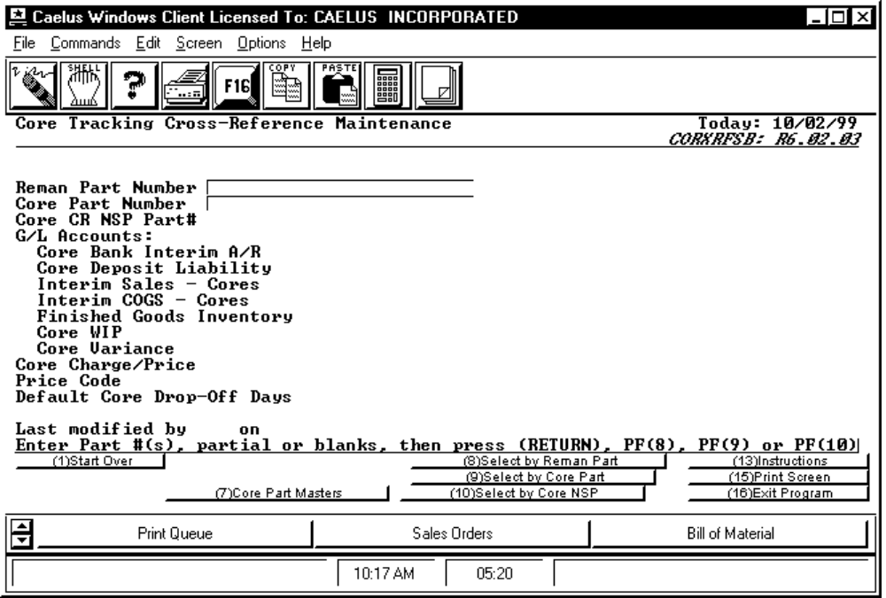

PROCEDURE DISCUSSION

This screen appears when you first enter the program. Enter valid part numbers in the two part number fields to create a new cross reference file record for that combination. If one already exists for the combination you enter, it will be recalled from the file and displayed for you to examine or edit. Entering partial or invalid values will cause lists to be displayed from which you can choose. You can search for cross reference records already in the file by using F8, F9, or F10 to search by remanufactured part number, core part number, or Core NSP, respectively. F7 is provided to search for records where the remanufactured part field is blank. These are referred to as "Core Master Records" because the data (default accounts, etc.) stored in those records applies to that core item, specifically.

Data Field Definitions

Reman Part Number Enter the valid part number of the remanufactured item ore leave blank to cause this record to be specific to the core item alone.

Core Part Number Enter the valid part number of the core item. If a Reman Part Number was entered in the previous field, this would be the part number of the core item used in that remanufactured item.

Core CR NSP Part# Enter the non-stocked part number that is to show on drop-off invoices for this core item.

NOTE: Leaving any of the following fields blank will cause the system to look for a default for that item at the next level of the search hierarchy.

G/L Accounts

Core Bank Interim A/R Leave blank or enter a valid G/L account code. This account is posted if "Post Unapplied Cores?" = "N". This account will be debited with the selling price of the core.

Core Deposit Liability Leave blank or enter a valid G/L account code. This account is posted only if "Post Unapplied Cores?" = "N" and "Post Core Deposit Liability?" = "Y". This account is posted with a credit in the amount of the gross profit (arithmatic sum of selling price and COGS) when the remanufactured item is sold.

Interim Sales - Cores Leave blank or enter a valid G/L account code. This account is posted if "Post Unapplied Cores?" = "N". This account will be credited with the selling price of the core. Note that if the behavior switch to "Post Core Deposit Liability?" = "Y" then this posting and the posting to Core Bank Interim COGS (below) is replaced by a single posting to the Core Deposit Liability Account.

Interim COGS - Cores Leave blank or enter a valid G/L account code. This account is posted if "Post Unapplied Cores?" = "N". This account will be debited with the value (cost) of the core. Note that if the behavior switch to "Post Core Deposit Liability?" = "Y" then this posting and the posting to Core Bank Interim Sales (above) is replaced by a single posting to the Core Deposit Liability Account.

Finished Goods Inventory Leave blank or enter a valid G/L account code. This is the account that is to be credited with the value (cost) of the core when the remanufactured item is sold.

Core WIP Account Leave blank or enter a valid G/L account code. This account is debited with the value (cost) of cores that are issued to production jobs to produce remanufactured items. This account is then credited with the value (cost) of the core when the remanufactured item is reported completed from the job.

Core Variance Leave blank or enter a valid G/L account code. This is the account that will be posted with the difference when the value (cost) of a core changes between the time of the sale of the remanufactured item and the time of the receipt of the core (or visa versa). This account captures the variance in cost occuring between those two transactions. This account also captures the change in cost due to revaluation of core bank if a new standard cost set is implemented and if the behavior switch titled "Revalue Cores on Cost Set Implementation?" = "Y".

Core Charge/Price Leave blank or enter a the flat amount that is to be the price of the core charged to the customer if the price is not to be automatically determined by the normal CMS customer pricing mechanism.

Price Code Leave blank or enter the price code to be used for determination of the price of the core item. For more information on automatic pricing using price codes, see the CMS Customer and Pricing User Reference Manual. Note that if a flat amount is entered above, the flat amount takes precedence.

Default Core Drop-Off Days Leave blank or enter the number of days that can pass before the core debit can be converted to a drop-off invoice.

Active Function Keys

F7 Core Part Masters Press this key to see a list of all cross reference file records where the remanufactured part field is blank. These are records containing core-item-specific default accounts and parameters.

F8 Select by Reman Part Press this key to see a list of all cross reference file records by remanufactured part number. These are records containing default accounts and parameters for use in situations involving the particular combination remanufactured item and core item.

F9 Select by Core Part Press this key to see a list of all cross reference file records by core item part number. These are records containing default accounts and parameters for use in situations involving the particular combination remanufactured item and core item. Note that a given core item can be associated with more than one remanufactured item.

F10 Select by Core NSP Press this key to see a list of all cross reference file records by Core NSP part number.

SCREEN EXAMPLE:

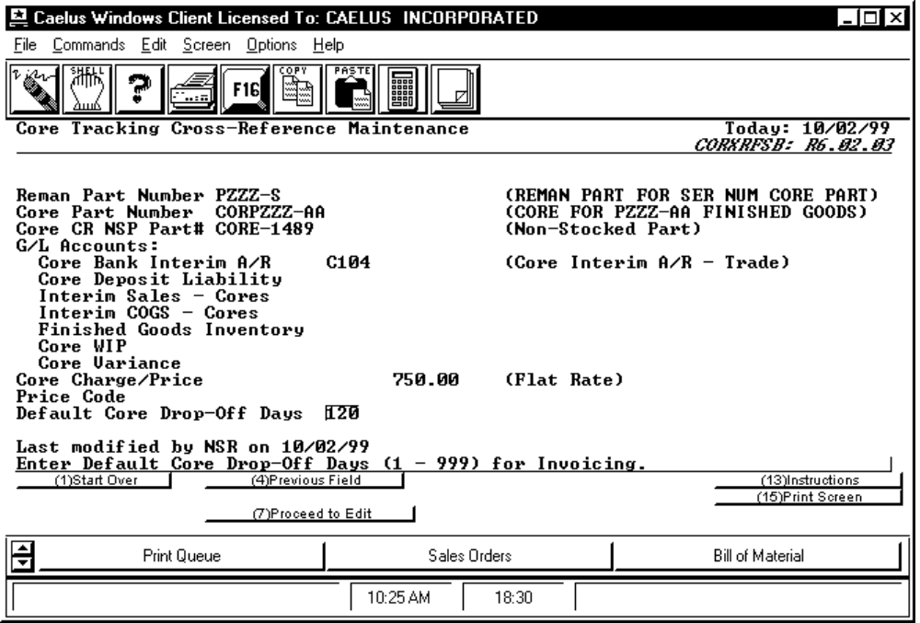

PROCEDURE DISCUSSION

The screen example above shows a cross reference record in edit mode. You can change any of the information on the record by positioning the cursor to the particular field and pressing RETURN. To save the data to the file, press F16.

