BALANCE FORWARD PAYMENT UPDATE

PURPOSE

To distribute payments entered as Balance Forward Payments.

GENERAL DISCUSSION

This program distributes payment amounts entered as Balance Forward Payments (posting type 'B'), and any unapplied payments in the Customer AR file to open AR items. The process is the same as manually distributing the items except it is more rapid.

Run Procedures

Run UPDCRCIN, to open a Cash Entry Session where the 'balance forward' distributions are placed. This session should be a separate session to keep the balance forward update distributions apart from other entries.

After you have opened the unique session, process the balance forward cash receipts via CRCBFPD. When the program is run, the first and only screen prompts you to select an open session. Once you select the session and choose to continue, the program updates all cash receipts processed as Balance Forward Payments (posting type 'B'). If you have any unapplied amounts in the Customer AR file with a balance forward, the process looks at the unapplieds as a balance forward amount and also updates the unapplieds. The screen displays each Bill-to customer being updated.

As a Bill-to is processed, it is locked out from cash receipts processing by others on the system. If a Bill-to is encountered that is already being processed, a message is displayed showing the Bill-to and the user ID of the person who is posting cash to that Bill-to. The program continues when the Bill-to is released. No adverse effects result from the conflict, but you should probably review the postings made to that Bill-to.

Once the update is completed, close the session and process as a regular cash receipts session via PROCCRCU.

A cash receipts journal prints showing a debit to the balance forward payment, and a credit to the settlement number applied to. Both debits and credits should be against the same AR trade account.

A cash receipts register prints that shows a zero (0) check amount with the distribution. The balance should be zero (0).

Update Details

Distributions are done by Bill-to and placed into the cash receipts holding as adjustment vouchers. The document numbers are set to 'BFYYMMDD' where 'YYMMDD' is the system date when the update occurred. Note however, the system drops the first digit of the year when displaying or printing the year. So, if the process occurred on 08/10/93, what you see is BF308100. If such a document number already exists for a bill-to, that bill-to is skipped.

Distributions are made by totaling all balance forward payments for a bill-to and applying those payments first to credit balance items (thus resolving those items and increasing the amount to distribute to debit balance items) and then to debit balance items on a oldest first basis per discount due date. Any amount remaining is left on the most recently entered balance forward payment transaction.

SCREEN EXAMPLE: Select Cash Entry Session

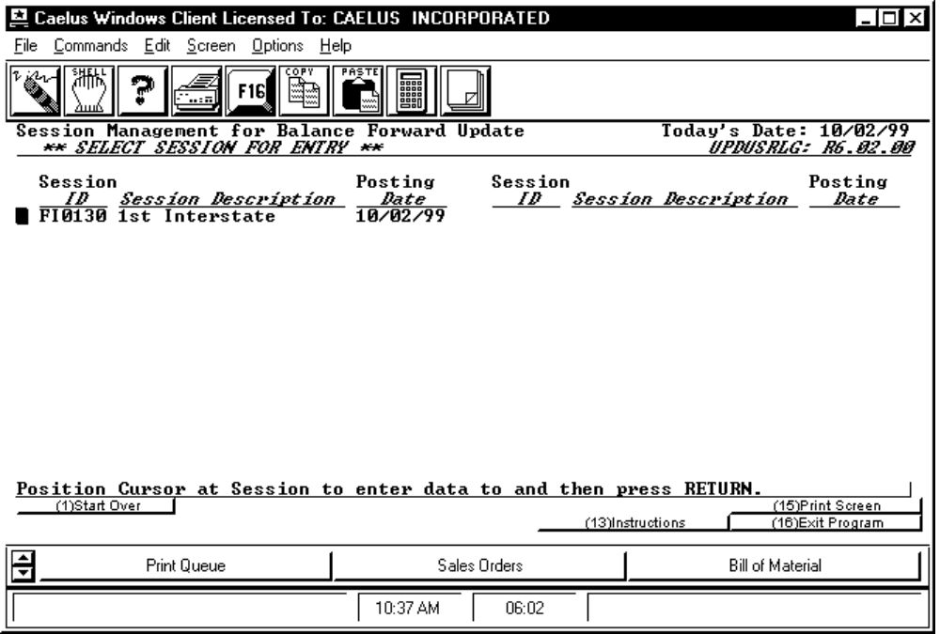

PROCEDURE DISCUSSION

The first (and only) screen displayed when you run this program requests the Cash Entry Session to place the checks into. Select the session you want by positioning the cursor and pressing RETURN. Press F16 to abort the process.

