ENTER/MANAGE CUSTOMER MASTER FILES

PURPOSE

Enter or modify Customer Master File records for each customer you do business with.

GENERAL DISCUSSION

You must establish a master record for each customer before that customer can be referenced in the Sales Order or Accounts Receivable Modules. The master record is created by entering basic information about the customer in this program.

Each customer must have a unique "customer code" that distinguishes that customer from all others. If you enter a customer code for a customer that is already on file, this program retrieves the existing information and displays it in edit mode for review and/or edit. If a customer code is not on file, the program assumes that you wish to enter information about a new customer and it proceeds to prompt for entry of data for each field, as described below. It requires four screens to display all of the data fields, plus a fifth screen of custom data that you can control.

Defaults for Data Fields

You can, at any time, establish defaults for most of the customer master fields. Press F17 from the first screen to set or change the defaults. position the cursor to a field and enter the data to default to that field when recording new customer records. Any default values can be accepted or changed as required as you enter the master records for each new customer (subject to the use of the Soft Enable feature). The defaults can be changed at any time as needed to speed the data entry process. Remember, much of the master file information entered for each customer is, in turn, used as defaults for the entry of sales orders and invoices.

If you are a CMS database administrator or a module administrator for the A/R module, you will be prompted for whether the defaults you set/change are to be retained only for the entry session or saved for use in later sessions. If you are not a database administrator or an A/R module administrator your defaults will disappear at the end of the entry session.

General Ledger Accounts as Defaults

You can enter certain customer or region-specific general ledger accounts in the Customer Master File records for each customer. Any general ledger accounts listed in the Customer Master File record become defaults when sales orders and invoices are created. The accounts actually recorded on those documents are then posted when the transactions are processed. If specific accounts are not listed here for the customer, the system uses a hierarchy to determine the account to use as the default when a transaction is recorded. Enter accounts here only if transactions for this customer are to post special accounts. See the Accounts Receivable Reference Manual for more information.

Remember, as a sales order, invoice, or payment is entered into the system, regardless of how the default is derived, the defaults can be accepted or overridden at that time (subject to control by soft enables).

Use of Invalid G/L accounts

Invalid General ledger accounts can be entered here in the Customer Master File record. This feature is helpful when all that is desired is to default an account 'prefix' to the sales order or invoice document. At that time you would input the remaining portion of the account code.

Free Text

The system Text Management feature is provided for entry of comments and memo information about each customer. For more information, refer to the discussions of the TXTINSUB program in the System Module Reference Manual.

Soft Enables

This program is equipped with the "soft enable" feature allowing authorized users to control which fields are available for input or edit. To control the enable setting you must be a database administrator or a module administrator for the A/R module. For more information on the soft enable feature and its use, please refer to the documentation for the ENABLSUB program in the System Module Reference Manual.

Deleting Customer Master Records

A separate program is provided to delete Customer Master File records from the CMS files. For more information on this task, refer to the documentation for the program CUSDLETE.

Copy Customer Master Record When Creating New Record

You can speed up the process of entering new customer records by copying an existing customer master record and altering it. The first screen displays a function key allowing you to do this after you have entered the new customer code and sort name.

User Defined Fields

The fifth screen of customer master information is composed of up to ten user-defined fields. Through the user-defined fields feature explained in the documentation for the VFDEFINE program in the System Module Reference Manual, you can describe the screen prompts for each of up to ten custom fields to record information not included in the CMS Customer Master File. You can also define the length of each data element, the editing, and the enable setting. You also can control the wording of the prompt message to appear on the screen to explain the purpose of the field to the data entry operator. If any of these custom fields are required, they will be enabled for input and this fifth screen will appear as you enter each new customer. If none of the fields are required, the screen is only available in edit mode, after the data for a customer has been entered.

SCREEN EXAMPLES: First Screen - Input Mode

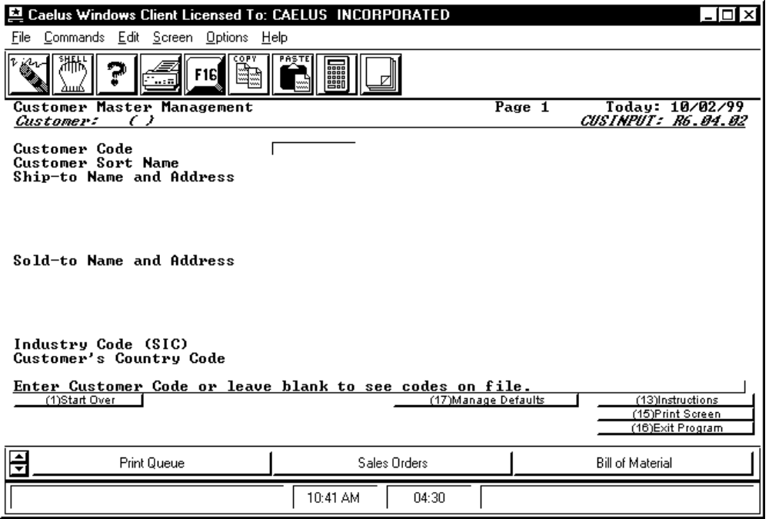

PROCEDURE DISCUSSION

From this screen you can:

1. Recall an existing customer record by entering the customer code and pressing RETURN. If you do not remember the proper code, enter a "?" to see a list of all customers on file. You can choose from the list.

2. Enter a new customer master record by entering data for each of the fields on each of five screens. See the screen examples and data field definitions below. As you enter the data, F4 is provided to allow you to back up to change the data for fields entered previously. When all data is input, you will be placed in edit mode to review and/or change data entered for any field. From edit mode press F16 to save the record to the Customer Master File.

3. Enter a new customer master record by copying an existing master record and editing it. To do this, enter the new customer code and customer sort name. F3 Copy Customer will display on the screen. Press it to display a list of existing customer master records. Press RETURN to select the one you want. The information from the copied customer master record will be entered into the new customer master record you are creating. From edit mode you can change any of this copied information to accurately reflect the new customer.

4. Set the defaults for any or all fields by pressing F17. The screens will appear to be the same as input mode or edit mode but the header will change to confirm that you are entering ** DEFAULTS **" rather than data for a particular customer. Use the Function Keys to move forward or backward from screen to screen. Record the default for any field by positioning the cursor to that field and pressing RETURN; setting the defaults is much like changing a field in edit mode.

SCREEN EXAMPLE: Customer Data Screen 1

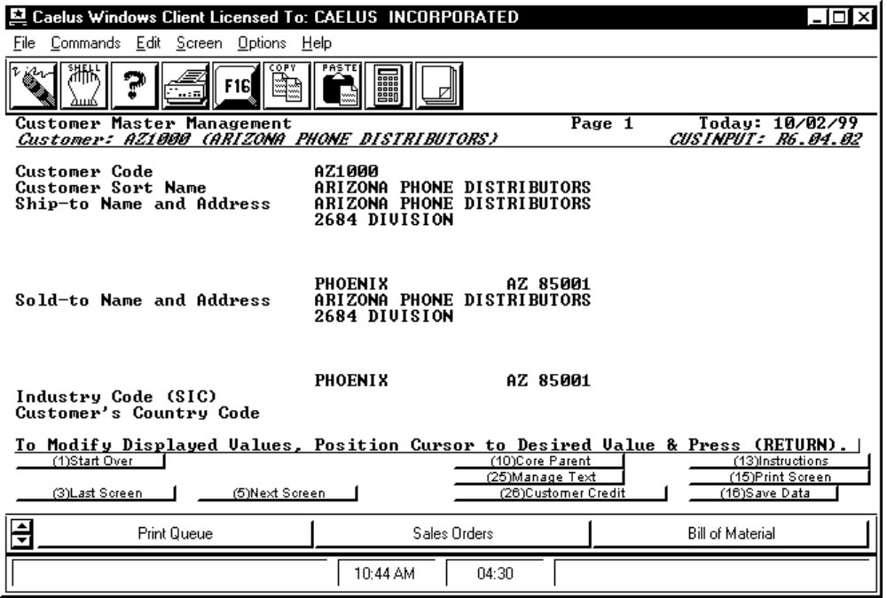

PROCEDURE DISCUSSION

When entering the master record for a new customer, input data for each of the data fields as described below. As you enter data for the last field on this screen, the next screen appears prompting for entry of additional data. F4 can be used to go back up to a field entered previously to change the data. Remember, the exact combination of fields for which you are prompted is controlled by the soft enable feature.

Press F25 to enter free text about this customer. For information on how to use this screen, refer to the documentation for the TXTINSUB program in the System Reference Manual.

Data Field Definitions

Customer Code Enter the unique identification code or number for the customer. The maximum length is nine characters, alphanumeric. To recall an existing customer record, enter that customer's unique code and press RETURN or leave the field blank and press RETURN to see a list of all customers on file. You can search the list and select the proper customer code.

Customer Sort Name Enter the name used to report data for this customer. This is a required field and allows you to use a name different from the name appearing on the first line of the addresses below. For example, you might wish to arrange the name as it would appear in a phone directory with last name first.

Ship-to Name and Address Enter the address where goods are to be sent. You can use up to six lines of 30 characters each. As you enter the address, fill the lines from the top down (if lines are to be left blank, place the blank lines near the bottom). All unused address lines will be collapsed out when the address is printed on documents. You must enter something here. BE SURE THE CITY, STATE AND ZIP ARE ON THE LAST LINE.

Sold-to Name and Address Six more lines are provided for entry of the address to which invoices for orders are to be sent. If this address is left blank, the system will assume that the shipping address as entered above is to be used. If you enter an address, BE SURE THE CITY, STATE AND ZIP ARE ON THE LAST LINE.

If you are entering a ship-to customer, indicate this by entering the bill-to customer code for this customer in the "Bill-to Cross Reference" field on the following screen. In such cases, you can control where the invoice is to be sent (to the ship-to or to the bill-to customer). If you enter a sold-to address for the customer, that address will default to the sales order. Then, at invoice creation time, the sales order sold-to address is defaulted to the invoice.

To have the invoice sent to the bill-to customer, enter the words "BILL-TO" here in the sold-to address field (instead of an actual address). If you do this, at invoice processing time the system will look to the master record for the bill-to customer and use that customer's sold-to address for the invoice. However, if the sold-to address for the bill-to customer is blank, the bill-to customer's ship-to address appears on the invoice.

If you enter "BILL-TO" instead of the address, you can override the default address on the invoice and send the invoice to any other address by indicating an actual address on the sales order or invoice.

Industry Code (SIC) Enter the standard industry code for this customer. This is a memo only field. If you wish to maintain a table to validate this field, you use GENCODES procedure PROCGC23.

Customer's Country Code Enter the country code for this customer.
This is a memo only field. If you wish to maintain a table to validate this field, you use GENCODES procedure PROCGC24.

Intercompany Corp. Code If management values are not active (see GLFLAGS) this field is not seen. Enter the ICC code for this customer if it is a sister corporation. A sister corporation is one that is owned by the same corporation as your company. A valid table of ICC code is suggested and can be maintained using PROCGC33.

Active Function Keys

F10 Core Parent Press this key to input/edit information about core customer/parents. See CORPARSB for detailed information.

F26 Customer Credit Press this key to view customer credit information. See ARQCUSCR for detailed information.

SCREEN EXAMPLE: Customer Data Screen 2

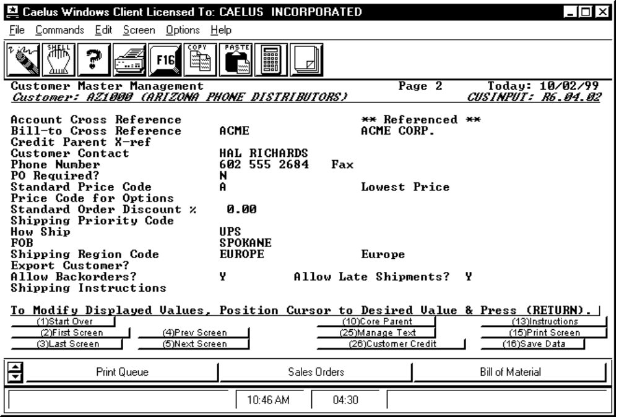

PROCEDURE DISCUSSION

This screen appears after you have entered the last field on the first screen and pressed RETURN or when you press F5. Enter data for each of the data fields as described below. As you enter data for the last field on this screen, the third screen appears, prompting for entry of additional data. Press F4 to go back up to a previous field to change the data. Remember, the exact combination of fields for which you are prompted is controlled by the soft enable feature.

Data Field Definitions

Account Cross Reference Leave this field blank if sales analysis reporting is to occur for this customer rather than another ACCOUNT customer. If another customer is the ACCOUNT for this customer, enter that other customers code here. When you are reviewing an existing customer record, the message "** Referenced ** will appear on the right side of the screen on this line if this customer is referenced on at least one other Customer Master File record as the ACCOUNT customer.

Bill-to Cross Reference Enter the bill-to customer (if any) for this customer. The bill-to customer is used to maintain the A/R balance and open sales order balance for all orders from this customer. Automatic credit checking is also performed at the bill-to level (unless the bill-to customer refers to a credit parent). See the Manage Customer File submodule overview for more information on automatic credit checking. If this customer has no bill-to reference, leave this field blank. The system then treats this customer as its own bill-to. If this customer is a bill-to for another customer then the message "** Referenced **" appears on the right side of the screen on this line. A bill-to customer cannot have another bill-to reference.

Credit Parent X-ref Enter the customer code of the credit parent of this customer. The credit parent serves as a base for credit limit checking for customers linked to it. If this customer is referred to as a credit parent by another customer, the message "** Referenced **" appears on the right side of the screen on this line. A credit parent customer cannot have another credit parent reference. See the Manage Customer File submodule overview for more information on automatic credit checking.

Customer Contact Memo field to record the name of the individual to contact or the buyer's name within the customer's organization.

Phone Number, Fax Memo field to record the phone number and FAX of the customer contact or buyer.

PO Required? Enter "Y" or "N" to indicate if a Purchase Order is required from this customer to authorize any purchases. If this field is set to "Y", the purchase order number will be required during the order entry routine.

Standard Price Code Enter the pricing code to default to sales orders and direct invoices to this customer. As such, it will be used to determine the default sales price for items sold to this customer. Valid codes are the letters A thru Q and the numbers 0 thru 8. Price code "Q" will force the order taker to manual enter the a price, and price code "0" (zero) will cause the price to be the standard cost on file. For more information on the valid price codes and their use, refer to the discussions in Submodule 40 of this manual.

Price Code for Options Enter the price code to be used to determine the selling price for generic (type 000) parts sold to this customer. If no price code is entered here, the standard price code will be used for generic parts. If the price code is a letter between A-Q, selling price will be calculated by adding the price of selected top-level replacements to the "base" price of the generic part. If the price code is a number 0-8, the selling price will be calculated by adjusting the cost of the generic assembly by the cost(s) of the replacements selected and then applying a profit margin percent associated with the price code. For more information, refer to discussions of pricing of options in the Bill of Materials Reference Manual in section 20.

Standard Order Discount Enter the discount percent that is to be applied to all line items on invoices, prior to calculation of the total invoice amount. This discount will default to the header of the sales order where it can be edited if necessary. The discount percent listed on the header of the sales order is then is applied to the total of the selling prices determined by the pricing structure in force for each line item.

Shipping Priority Code Enter the shipping priority code for this customer, which defaults to all Sales Order Entry programs. The range is one (1) to five (5) where one (1) is the highest priority. If you do not set a code, the field defaults to three (3). You can override this default in Sales Order Entry programs if needed with a range of zero to five (0 - 5) where zero (0) is the highest priority and overrides all 1s.

How Ship Enter the method of shipment or any comments about the carrier to use. The field length is 20 characters.

FOB Enter the location, beyond which the customer pays the freight costs. This is a comment field. The field length is 20 characters.

Shipping Region Code Enter the valid identification code for the region to which the items sold to this customer are to be shipped or leave the field blank. Enter a "?" to see a list of valid codes on file..

Export Customer? Enter "Y" if the customer is an export customer.

Allow Backorders? This is a memo field to indicate whether orders from this customer are to be backordered, if not found in stock. Enter a "Y" or an "N".

Allow Late Shipments? This is a memo field to indicate whether shipments beyond the due date requested by this customer are to be scheduled. Enter a "Y" or an "N"

Shipping Instructions Enter up to two lines of up to 50 characters each for instructions that are to appear on the Bill of Lading shipping documents.

SCREEN EXAMPLE: Customer Data Screen 3

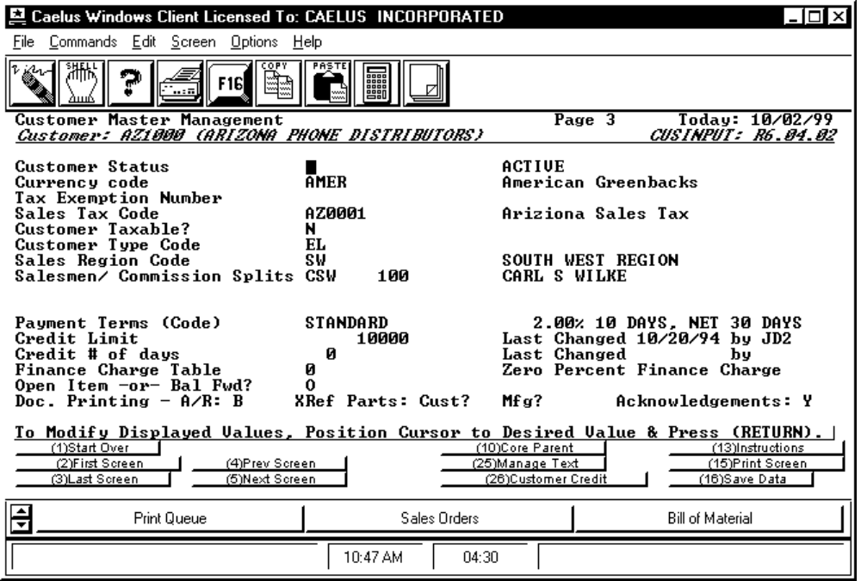

PROCEDURE DISCUSSION

This screen appears when you enter data on the last field of the previous screen and press RETURN or when you press F5 from the previous screen. Enter data for each of the data fields as described below. As you enter data for the last field on this screen, the fourth screen will be displayed, prompting for entry of additional data. F4 can be used to go back up to a field entered previously to change the data. Remember, the exact combination of fields for which you are prompted is controlled by the Soft Enable feature.

Data Field Definitions

Customer Status Enter the status code for this customer. The valid codes are A = Active, I = Inactive, H = Hold, D = Delete. At order entry and invoicing time, if the status is other than "A" a message is displayed informing the user of the status and asking if they wish to continue. Continuation is allowed regardless of the status.

Currency Code This field only appears if you are running the multi-currency extension to CMS. Enter the default currency code for this customer. The currency code appears automatically on sales orders and A/R invoices you create for this customer. You can then change the code if it is different for a specific sales order or invoice.

Tax Exemption Number This is a 25 character memo field for recording the customers identification number for tax exemption reporting.

Sales Tax Code Enter the valid sales tax code indicating the tax jurisdiction (and indirectly the rate) for this customer or leave the field blank. Enter a "?" to see a list of valid codes on file. Any code entered must have been previously defined through the Accounts Receivable Module - Enter/Manage Sales Tax Codes function (STXINPUT). If this field is left blank, the sales tax code will default to the code on file in the store/warehouse master record when sales are processed.

Customer Taxable? Enter a "Y" or an "N" to indicate whether this customer is to be charged sales taxes. This default will then be used, together with the default for the inventory part that is sold, to determine if a particular sales order line is to be subject to tax. Non-stock parts have a blank 'item taxable' flag. The determination of whether a particular sale is taxable is based on the following table: ("b" = blank)

Is Customer Taxable? Y N Y N Y N
Is Part Taxable? Y N b Y N b
Is Sale Taxable? Y N Y Y N N

Customer Type Code Enter the valid customer type code or leave the field blank. Enter a "?" to see the list of all valid codes from which you can choose the proper code. See the discussions in CPM-10 for information on setting up these codes.

Sales Region Code The code identifying the sales region to be used to accumulate sales totals for sales analysis reporting or leave the field blank. Enter a "?" to see a list of the valid codes on file. See the Sales Analysis Module Reference Manual for information on setting up these codes.

Salesmen/Commission Splits Enter the names of up to three salespersons who are to receive credit for sales to this customer. You can also enter the percent of the sale credit that each salesperson is to receive. The total of the percents cannot exceed 100%. This commission split will then default to each sales order to this customer. No automatic posting of sales commissions is performed as a result of this data when sales are recorded or processed.

The salesperson split information on the sales order becomes the default when the invoice is created. When the invoice is processed, the sales credit for each salesperson is saved along with the invoice data. The calculation of sales commission amounts occurs at sales commission reporting time. Enter a "?" in any of the three salesperson code fields to see a list of salespersons on file. NOTE: the first of the three salespersons is given full credit for the sale from the sales analysis standpoint.

Payment Terms (Code) Enter the code to identify the payment terms offered to this customer. Enter a "?" to see a list of of all valid codes on file. You can enter anything in this field to describe terms or make use of pre-defined terms codes. If you enter something in this field that is not a valid code, the message will appear as "0% 0 DAYS NET )" and the terms will be treated as comments or memos by the system.

Credit Limit Enter the amount of the credit limit that will be extended to this customer. If you are using multi-currency, enter the amount in your statutory currency. A behavior switch governing the sales order entry functions can be set to cause the order entry functions to respect this limit. Whenever this field is changed, the user ID of the person who changed it and the date are retained and displayed for audit purposes.

NOTE: This field is ignored if this customer is not a bill-to customer or a credit parent. All credit checking for ship-to customers is carried out at the bill-to or credit parent customer level.

Credit # of days Enter the number of days the customer can be late on a payment before further orders from that customer are automatically placed on credit hold. Enter "0" if the credit number of days check does not apply to this customer. Note that automatic credit hold is activated or deactivated depending on a flag setting in the program BCKFLAGS. Credit number of days checking occurs at the bill-to customer level if the Automatic Credit Hold flag is set to "Y" (yes).

Finance Charge Table Enter the identification code for the finance charge table to be used to calculate the finance charges for this customer or leave this field blank. Enter a "?" to see a list of the valid table codes on file. This table must have been previously defined through the Accounts Receivable Module, Create Finance Charge Table program ARMFCINP.

Open Item -orBal Fwd? Enter an "O" or a "B" to indicate whether this customer is to receive open item or balance forward type statements.

Doc. Printing - A/R This field controls whether this customer is to receive statements, late notices, both, or neither. Enter an "S", an "L", a "B", or an "N" respectively.

XRef Parts: Cust? Mfg? Enter "Y" to print the cross reference part number on sales acknowledgments and invoices if there is customer/manufactured part number associated with the CMS part. Enter "B" to print both theCMS part and the associated cross referenced part. Enter "N" to only print the CMS part.

Ackowledgments Enter "Y" to print sales order acknowledgments for this customer. This value defaults in at sales order entry and may be changed on any individual order.

ICOC Prompt and Code Appears on this line if the appropriate flags are set.

SCREEN EXAMPLE: Customer Data Screen 4

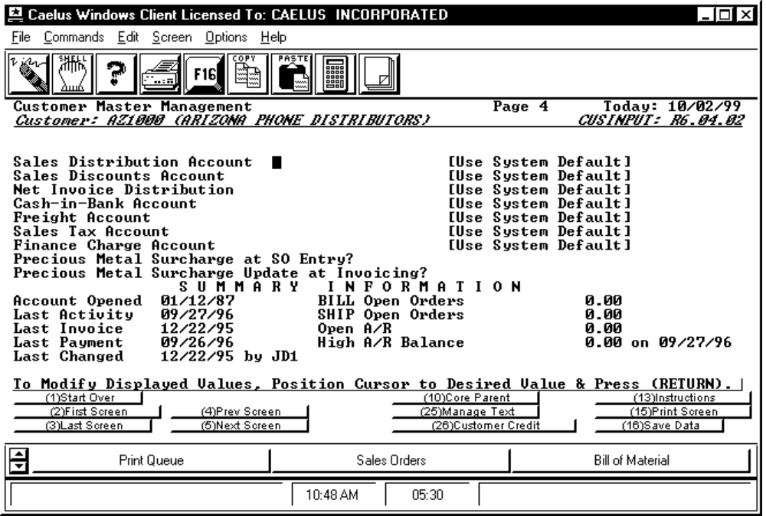

PROCEDURE DISCUSSION

This screen appears when you enter data into the last field of the previous screen and press RETURN or when you press F5. The upper half of the screen prompts for general ledger accounts for this customer. The lower half of the screen displays master data that is maintained automatically by the system. Enter Data for each of the data fields as described below. As you enter data for the last field on this screen the fifth screen will be displayed, prompting for entry of data in user defined fields. F4 can be used to go back up to a field entered previously to change the data. Remember, the exact combination of fields for which you are prompted is controlled by the Soft Enable feature.

F5 Next Screen calls the program VFINDSUB, the next screen example.

Data Field Definitions

NOTE: All accounts can be left blank or an invalid entry is OK. If the account entered is valid, the account title is displayed. If the account field is left blank, the message reads "USE SYSTEM DEFAULT" to remind you that the system will look elsewhere to determine the G/L account to default. If the entry is invalid, the message reads "NOT ON FILE".

Sales Distribution Account This is the account to be the default revenue account for sales of non-stocked parts. If the part sold is an inventory part, the default will be the sales account from the inventory store/lot record.

Sales Discounts Account The account to default to the sales order or direct invoice to this customer. As such it would be the account to be posted with document/header level discounts for sales orders and invoices.

Net Invoice Distribution The account to default to the sales order or direct invoice to this customer. As such it would be the account to be posted with the net invoice amount. This is typically the A/R account or cash account on cash invoices.

Cash-in-Bank Account The account to default to the cash invoices to this customer.

Freight Account The account to default to the sales order or direct invoice to this customer. As such it would be the account to be posted with the freight amount when invoices to this customer are processed.

Sales Tax Account The account to default to the sales order or direct invoice to this customer. As such it would be the account to be posted with the sales tax amount when invoices to this customer are processed.

Finance Charge Account The account to default to finance charge invoices to this customer. As such it would be the account to be posted with the finance charge amount when finance charges to this customer are processed.

The lower half of the screen displays information for existing customers. No entry or edit of data in these fields is allowed. The fields are:
Precious Metal Surcharge at SO Entry? Enter "Y" to include any precious metal surcharges in the price of the line item, if applicable, at order entry. MLQ price will also include the current surcharge amount. The default value is first taken from the Customer file; if the value is "blank," than the default is taken from the system defaults as set using the BCKFLAGS program.

Precious Metal Surcharge Update at Invoicing? Enter "Y" to adjust the line item price for precious metal surcharges, if applicable, at invoicing. If "Y" is entered in the previous field, then an adjustment is made to the precious metal charges according to the difference in price from sales order entry and invoicing. If "N" is entered in the previous field, then the precious metal surcharges will be charged for the first time at invoicing.

Account Opened Defaults to today's date as you first create a Customer Master File record for a customer.

Last Activity Automatically updated with the current date whenever a sales order, invoice, credit memo, or check is processed for this customer.

Last Invoice The date of the last invoice processed for this customer.

Last Payment The date of the last payment received from this customer.

Last Changed The date that this customers master record was last modified.

By The user who last modified this customers master record.

BILL Open Orders The value of open orders for BILL-TO customers. If this customer is a BILL-TO customer, this field will display the total open orders for the BILL-TO customer and all SHIP-TO customers under that BILL-TO. If this customer is a SHIP-TO only, this field will normally be 0.00. For customers that are only SHIP-TOs, this field could show a non-zero amount if the customer used to be a BILL-TO.

Ship Open Orders This field will display the total value of the open orders to this customer. If this customer is a BILL-TO customer for other customers, this field will only display the sub-set of the BILL OPEN ORDERS field that are for this customer as a SHIP-TO.

Open A/R This is the total open A/R amount for this customer. This field will be 0.00 for ship-to customers that are not also a 'bill-to' customer. However, if the customer was at one time a 'bill-to' customer this field will display the unpaid A/R amount for the activity remaining from the time the customer was a 'bill-to'.

High A/R Balance This is the high A/R amount for this customer and is only applicable to 'bill-to' customers. Again, if the customer was a 'bill-to' customer at one time, this yield will show the high for that old activity.

SCREEN EXAMPLE: User Defined Fields Screen

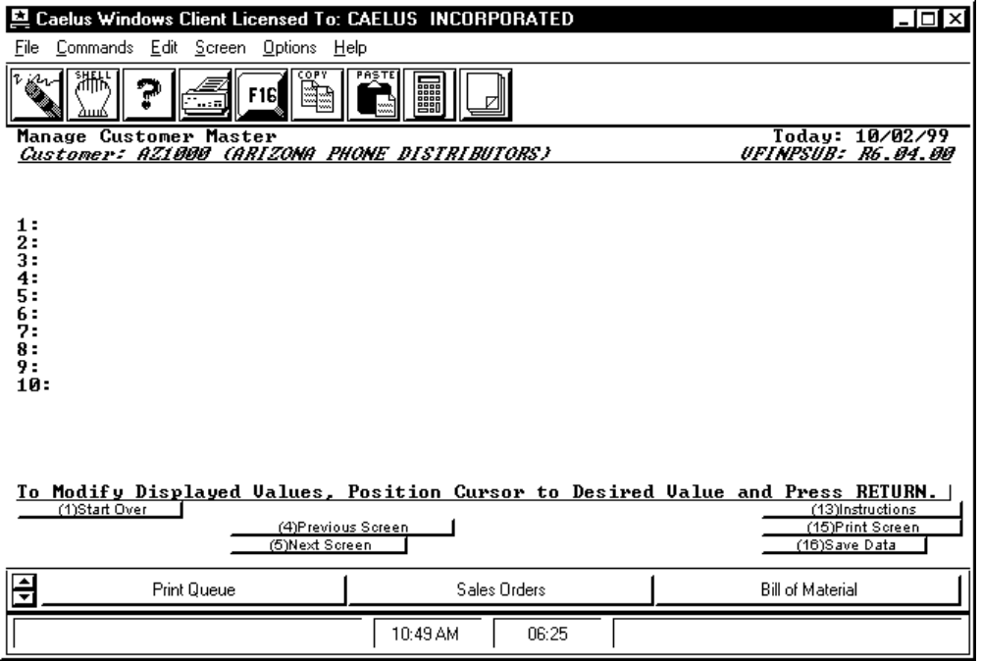

PROCEDURE DISCUSSION

This screen appears when you enter data into the last data of the previous screen or press F5. This fifth and last screen of customer data is controlled through the User Defined Fields feature. Each of up to ten fields that appear on the screen are controlled by you and can be customized to prompt for any additional data not included in the standard CMS Customer Master File fields described above. For more information on setting up this screen, refer to the documentation for the VFDEFINE program in the System Module Reference Manual.

NOTE: The enable for each of the fields on this screen is controlled through the Variable Fields function, rather than the soft enable function.

Enter data for each of the fields. As soon as you press RETURN for the last field, data entry for this customer will be complete and the first screen of customer data will be displayed in edit mode as in the example below.

SCREEN EXAMPLE: First Screen - Edit Mode

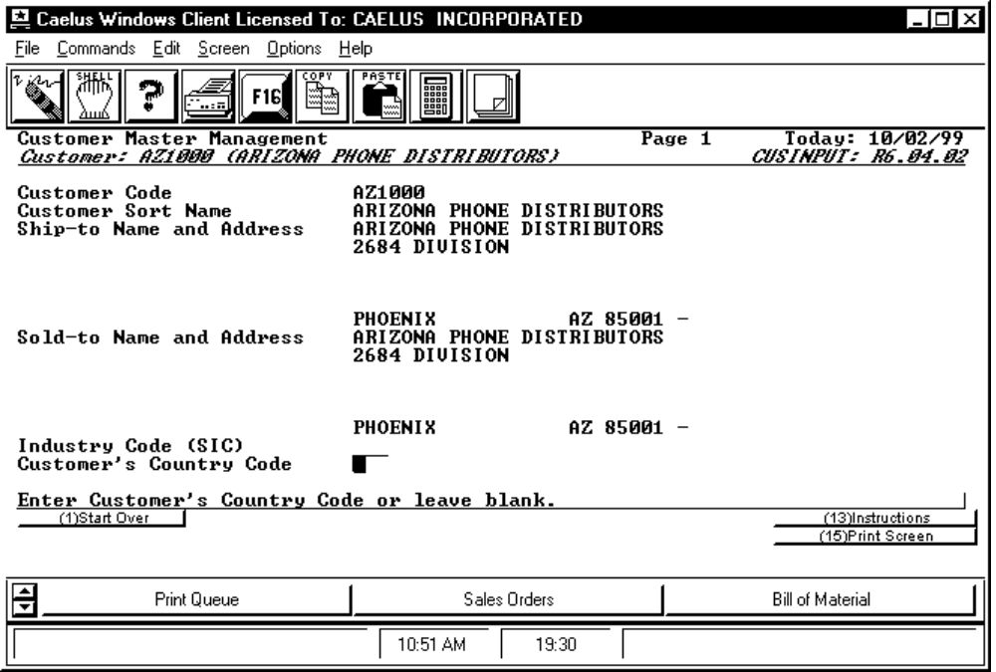

PROCEDURE DISCUSSION

From here you can scroll through the pages of data just entered, select and edit any field (that is enabled for edit through the Soft Enable feature) and/or save this Customer Master File record to the file. Use the Function Keys 3, and 5 to move to subsequent screens of data. From those screens, prompts for F2 and 4 will appear to allow you to move back to this first screen or to the 'previous' screen, respectively. F25 is provided on all of the screens in EDITMODE to access the System Text Management functions for entry or edit of free text associated with this customer.

