UPDATE AN SES DATABASE FROM AN EXTRACT FILE

PURPOSE

You can use this program to:
o Update your SES database with release specific information from a central SES database to accompany a software release
o Build a new SES database
o Restore previously archived information.

GENERAL DISCUSSION

This function creates/updates information in the current SES database from an extract file created for that purpose by the DCXTRACT utility. Please note that any element dictionary code definitions contained in the extract file will replace the current definitions for the same elements in your SES database.

Technical Description: DCUPDATE is a utility program which uses a GETPARM screen to obtain the update parameters and options. The GETPARM screen enables this function to be proceduralized if desired. Information updated is obtained from a SES Extract file which must already exist in your SES system library (usually SESDBASE). Both element structure and element dictionary definitions for each parent and component of a element structure are created/replaced from the contents of the extract file. The extract file will still exist after updating the SES database and should be archived (backup then scratch) to avoid confusion with future update releases.

Note that the files INTDOC01 and INTDOC02 are opened in exclusive mode. The system library used to find these files is specified in your OUTLIB usage constant when you start the program. If the files don't exist in your OUTLIB, then this program creates them.

SCREEN EXAMPLE: Input Screen

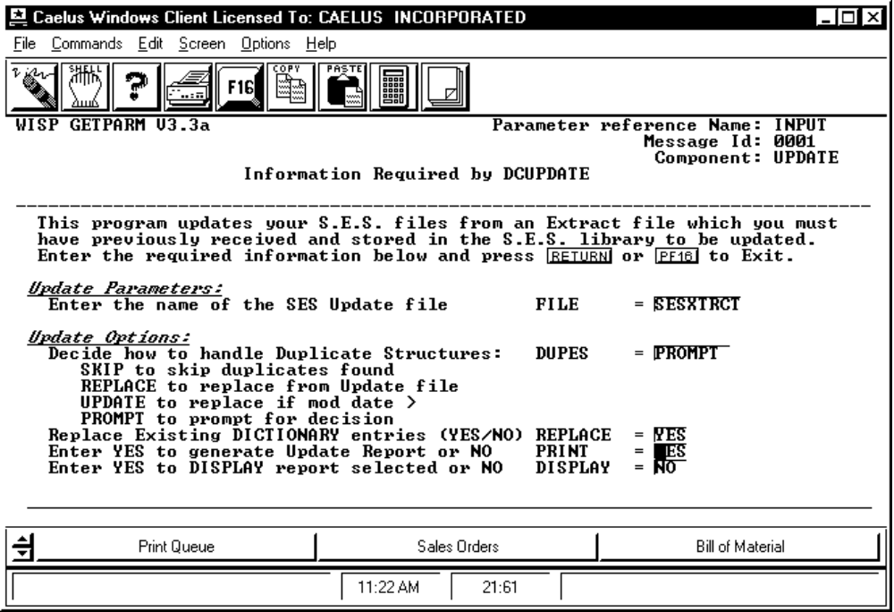

PROCEDURE DISCUSSION

Use this screen to enter update parameters and options. Press RETURN after entering the information on this screen. If you enter "YES" in the REPLACE field, the options screen appears. Otherwise the extract begins automatically.

Data Field Definitions

FILE This parameter asks for the name of the extract file containing the information to be updated into your SES database. You must know the name of the correct file containing the update information before running this utility. Also this file must reside in the SES database library.

DUPES The possibility exists that the element structures contained in the update (extract) file already exist in your SES with the same parent code, SES library, and version ID combination. To prepare for this eventuality you must decide ahead of time how you want to handle the updating of these duplicate element structures. The options you have are to:

SKIP to skip (not update and/or replace) pre-existing element structures.
REPLACE to replace any existing element structures with the information in the update (extract) file.
UPDATE to replace existing structures only if the modification date in the extract file is more recent than the last modification date of the pre-existing element structure.
PROMPT to prompt you for the decision to skip or replace each duplicate structure found as they occur.

REPLACE Enter "YES" to replace any existing dictionary information with the contents of the extract file. Enter "NO" to only allow blank entries for an element to be replaced.

PRINT This option controls whether or not a printed audit trail of what was updated will be generated. Enter "YES" to generate a printed report with a one-line entry for each element structure updated with all the information needed to identify that element structure. Enter "NO" to omit the report generation. The default value is "YES".

DISPLAY This option allows you to view on-line the update report created by the PRINT option above. If the PRINT option was "NO" then this option has no meaning. Otherwise enter "YES" for this option then following completion of the update process you will immediately see the update report displayed on-line. Enter "NO" if you do not wish to view the report automatically at the completion of the update. The default value is "NO".

SCREEN EXAMPLE: Option Screen

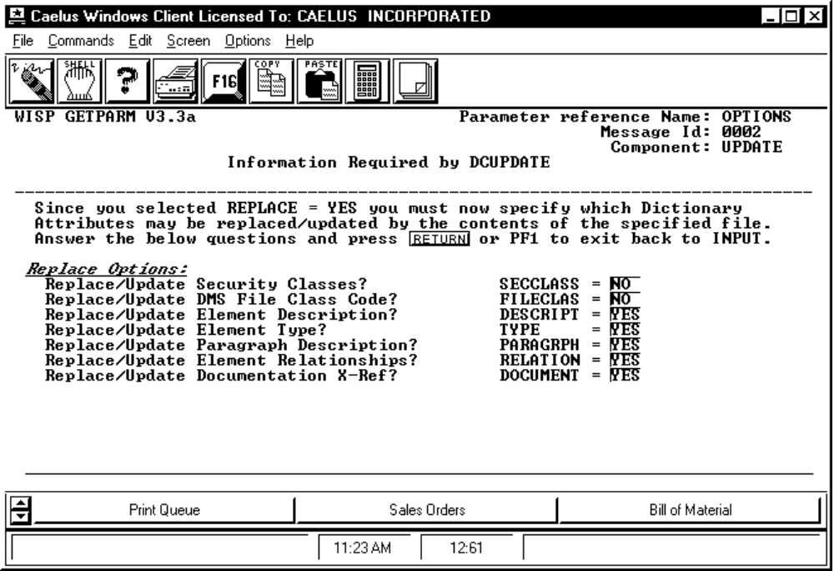

PROCEDURE DISCUSSION

If you entered "YES" in the REPLACE field on the Input screen, then this screen appears to allow you to specify more detail about what information should be replaced in the dictionary. Enter the information on this screen and press RETURN to begin the extract or press F1 to return to the Input screen. Note: for a complete definition of each of the fields on this screen, refer to the documentation for the program DDINPUT.

Data Field Definitions

SECCLASS Enter "YES" to update the security class of each applicable dictionary element with the contents of the extract. Enter "NO" to leave the security class the same for each replaced or updated element. The default is "NO".

FILECLAS Enter "YES" to update the file class of each applicable dictionary element with the contents of the extract. Enter "NO" to leave the file class the same for each replaced or updated element. The default is "NO".

DESCRIPT Enter "YES" to update the element description of each applicable dictionary element with the contents of the extract. Enter "NO" to leave the element description the same for each replaced or updated element. The default is "YES".

TYPE Enter "YES" to update the element type of each applicable dictionary element with the contents of the extract. Enter "NO" to leave the type the same for each replaced or updated element. The default is "YES".

PARAGRPH Enter "YES" to update the long description of each applicable dictionary element with the contents of the extract. Enter "NO" to leave the long description the same for each replaced or updated element. The default is "YES".

RELATION Enter "YES" to update the element relationship field of each applicable dictionary element with the contents of the extract. Enter "NO" to leave the element relationship the same for each replaced or updated element. The default is "YES".

DOCUMENT Enter "YES" to update the document cross-reference of each applicable dictionary element with the contents of the extract. Enter "NO" to leave the document cross-reference the same for each replaced or updated element. The default is "YES".

