DIRECTLY MANAGE RECORDS IN AN INDEXED FILE

PURPOSE

Alter data fields within file records according to specified selection criteria.

GENERAL DISCUSSION

This program is intended for use by programmers and Customer Support Representatives to correct problems in data base files. IT CAN BE VERY DANGEROUS IN THE HANDS OF USERS WHO ARE NOT TOTALLY FAMILIAR WITH THE SUBJECT FILES AND PROGRAMMING TECHNIQUES.

This program acts on data files 'in place', that is, no copy is made of the subject file. BE SURE TO MAKE A BACKUP COPY OF THE FILE(S) TO BE ALTERED PRIOR TO RUNNING THIS PROGRAM.

FILEFIX1 complements the USERAID named 'CREATE'. While CREATE can alter key structures and record lengths, and create new files based on data contained in existing files, FILEFIX1 can alter data contained in the records based on criteria you specify. It can also be used to delete records meeting specified criteria or count the number of records containing certain data without altering the data. Together, these two utilities provide the tools to deal with most data file problems.

To use FILEFIX1, a file is chosen and the starting position, format and length is entered for the portion of the record to be altered. A new value or character string is then entered. This value will replace the old field value if the criteria are met. Up to 6 different selection criteria can be specified. They are linked by 'logical and' (if 2 criteria are defined, both must be met before the subject field will be altered). The selection criteria are values or strings contained in other fields in the record that you specify. This is done by describing a field and a value to compare to the current value contained in the field.

To alter records in the file, the program examines each record in primary key sequence. Each time a record is found that satisfies the selection criteria the subject field value is changed to the new value. The program also allows 1) deletion of records when the criteria are met, 2) shifting of values to a different position in the record, and 3) counting of all records meeting the specified criteria. At the conclusion of any processing, the number of file records found and the number of records updated, deleted or counted is displayed at the top of the screen.

It may be necessary to break some data file alteration tasks down into steps and re-run FILEFIX1 several times to accomplish the goal.

You cannot use this program to modify a field that is an alternate key that does not allow duplicate key values. Also, you cannot modify any portion of a primary key field. You cannot use this program to alter data in consecutive files - only indexed and alternate indexed files.

SCREEN EXAMPLES: FILE FIXUP UTILITY

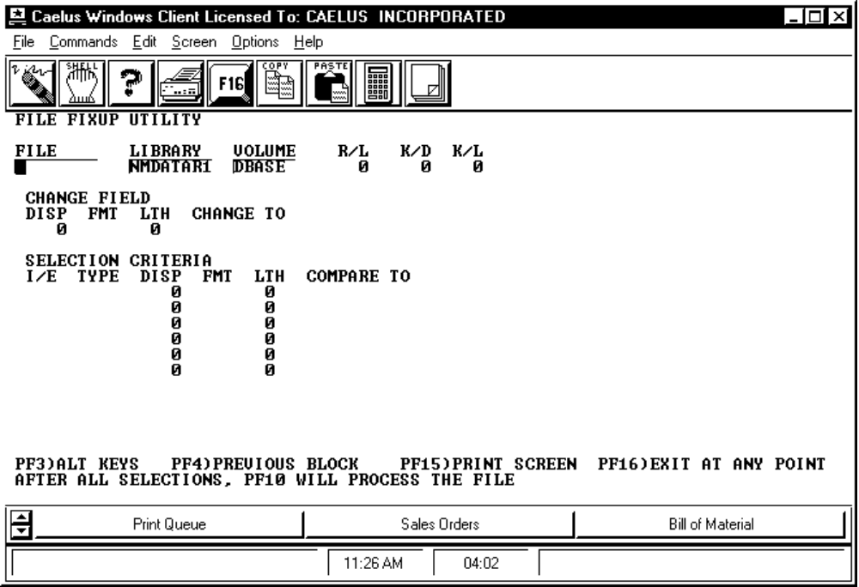

PROCEDURE DISCUSSION

A file is identified by entering the file name, library and volume. Once this information is input, press RETURN. The record length, primary key position and primary key length are then extracted from the S.E.S. library and displayed on the same line. The subject portion of the record and the selection criteria can then be input as described below. Each is treated as a 'block' of input data so you must use the TAB key to move from field to field. Press RETURN after entering the CHANGE FIELD information to allow input of the SELECTION CRITERIA data.

Data Field Definitions

FILE Enter the name of the file you wish to select.

LIBRARY Enter the name of the library where the file resides. Default for library is taken from usage constants.

VOLUME Enter the name of the volume where the file resides. Default for volume is taken from usage constants.

R/L The record length of the selected file. This, and the next two fields, are extracted from the S.E.S. library.

K/D The displacement (starting position relative to the beginning of the record) of the primary key.

K/L The length of the primary key.

CHANGE FIELD This information describes the portion of the record to be altered if the selection criteria is met (or counted if no modification of data is to take place). In descriptions of processing below, this is referred to as the 'subject field'.

DISP Enter the 'Displacement' or starting position relative to the beginning of the record for the subject field.

FMT Enter the format in which the system is to read the subject field. The valid format codes are: 'P' = Packed Decimal (14,4), 'B' = Binary, 'H' = Hex, 'C' = Character.

In addition, three other codes can be input to dictate special processing. When any of these codes are entered, the CHANGE TO data is no longer applicable. Enter 'D' to delete the record if subject field meets criteria. If this code is input, the CHANGE TO field displays "*** DELETE ***" to confirm that the processing will involve deletion of records. Enter 'R' to extract the value in the subject field and write it to a different position in the record. If this code is input, the CHANGE TO field displays "*** RECORD ***" to confirm that the processing will involve movement within the record. A field will appear to the right to allow entry of the new starting position. Enter 'N' to cause the system to count the number of records that meet all the selection criteria. No data will be altered. If this code is input, the CHANGE TO field displays "*** NUMBER ***" to confirm that the processing will involve counting of records.

LTH Enter the length of the subject field. The maximum length allowed varies, depending on the format: Hex = max length of 30, Character = max length of 60, Binary = max length of 4, Packed Decimal = always length of 8.

CHANGE TO Enter the value to be used to replace the current subject field value if all the selection criteria are met. The length of this input field depends on the format type and subject field length. The maximum input lengths are: Hex - 2 X LTH with max. of 60 positions, Binary - max. of 8 positions (numeric), Packed Dec. - max. of 16 positions (numeric), Character - max. of 60 positions.

SELECTION CRITERIA The subject field described above must meet selection criteria to be processed. Up to six selection parameters can be defined. Each is identified by a separate line of data describing a comparison between the current value of a field in the record and a 'compare to' value or character string. All comparisons must be met for the subject field to be processed.

I/E (I)nclude or (E)xclude. Enter 'I' to cause the system to include processing of the subject field when the logical relationship described in the remainder of the selection criteria line is met. Enter 'E' to exclude processing of the subject field.

TYPE Enter one of the following codes to describe the logical relationship between the current value of the 'compare to' field and the selection 'compare to' value or field. The valid codes are: 'EQ' = Equal to, 'NE' = Not Equal to, 'GT' = Greater Than, 'LT' = Less Than, 'LE' = Less Than or Equal to, 'GE' = Greater Than or Equal to.

DISP Enter the starting position (displacement) of the field to be compared.

FMT Enter the format code describing the 'compare to' field. See the list of valid format codes for CHANGE FIELD above.

LTH Enter the field length of the 'compare to' field. See maximum length information described above for CHANGE FIELD.

COMPARE TO The value to be compared to the current value of the 'compare to' field. See maximum length information described above for CHANGE FIELD.

Active Function Keys

F3 ALT KEYS Displays the alternate key information screen shown below.

F4 PREVIOUS BLOCK Allows you to return to a previous portion of the input screen to edit any data entered. Together, this key and the TAB key allow you to move forward and backward to any input field.

F10 WILL PROCESS THE FILE Causes processing of the file to begin. At conclusion of processing, the data file will have been altered according to the selection parameters input. BE SURE TO HAVE MADE A BACKUP COPY OF THE FILE BEFORE PROCESSING.
At the conclusion of processing, the number of records found and the number of records altered, counted, or deleted will be displayed at the top of the screen.
SCREEN EXAMPLE: Alternate Key Information Screen

This screen appears when you press F3 from the initial input screen.

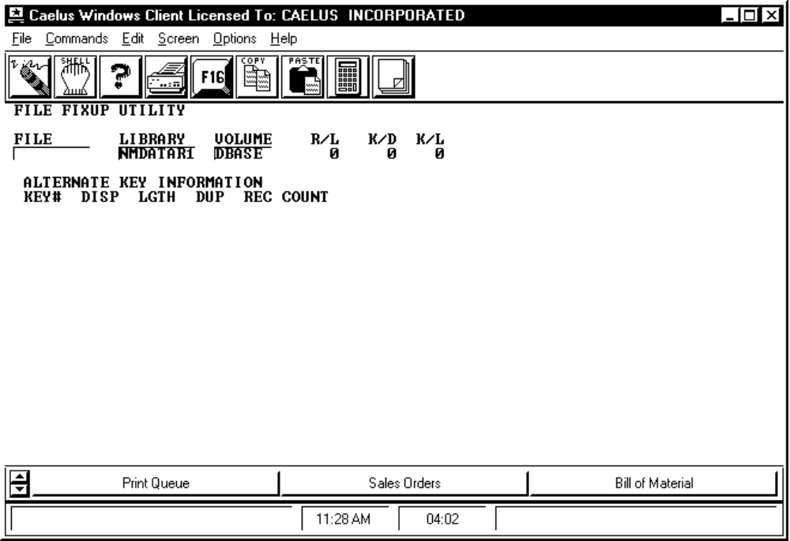

PROCEDURE DISCUSSION

This screen displays information about the primary key and any alternate keys which may exist for the file you selected. This information is extracted from the S.E.S. library. To return to the initial entry screen, press the return key.

Data Field Definitions

FILE The name of the file you have selected for change.

LIBRARY The library where the selected file resides.

VOLUME The volume where the selected file resides.

R/L The record length of the selected file.

K/D The displacement of the primary key of the selected file.

K/L The length of the primary key of the selected file.

KEY# Key number. The primary key is shown as "0".

DISP Starting position (displacement) of the key.

LGTH Length of the key.

DUP Displays "D" to indicate that duplicate key values are allowed. Blank if duplicates are not allowed. No duplicate values are allowed for primary keys.

REC COUNT The number of records that can be read through this alternate key. This should be an identical number for all keys.

