MANAGE FISCAL PERIODS, OPEN MONTHS

PURPOSE

To create the fiscal calendar, and declare which period is currently open. A secondary purpose is to declare the system suspense account.

GENERAL DISCUSSION

The fiscal calendar can be either 12 or 13 periods in length. The first step in creating the calendar is to declare the number of periods. Next, you enter the beginning date for each of the calendar periods. Each period runs from this start date until the day before the start date for the next period. Finally, you set the GL suspense account and declare the fiscal period that is currently open.

Data entered in this process is used not only by the General Ledger Module, but by any module which posts to the General Ledger. Once the dating structure has been defined it should only be changed with the greatest care.

You can return to this function later, if necessary, to change the current open period or change the suspense account. However, all changes to data here should be carefully considered for their posting ramifications.

The Open Period

As soon as you have defined the fiscal periods you indicate which period is currently open to the rest of the CMS modules and for normal journal posting. The period that you indicate is actually the middle period of the three periods that are open to posting at one time. These three periods are commonly referred to as "last period", "this period", and "next period". Together these periods constitute the posting window.

The current period open must be defined when initially setting up the dates structure, but thereafter should be allowed to be maintained as part of the month-end ledger closing routine. The closing routine automatically advances the open period; "last period" becomes closed, "this period" becomes "last period", "next period" becomes "this period" and a new "next period" is opened. Remember that the open periods limit the dates that the other CMS modules are allowed to post to. If module posting dates are outside of the GL open periods, the module journal transactions are not be posted.

Suspense Account

You also record the General Ledger Suspense Account. The setting of this account is a secondary function, not related to the creation or management of the fiscal calendar structure.

The general ledger suspense account is posted any time the system cannot find a valid GL account to post for a transaction. When you enter a new suspense account or changing to a new suspense account, this program automatically creates the suspense account in the Chart of Accounts if it does not it already exist and defines the suspense account as an expense account.

SCREEN EXAMPLE: Select the Number of Periods

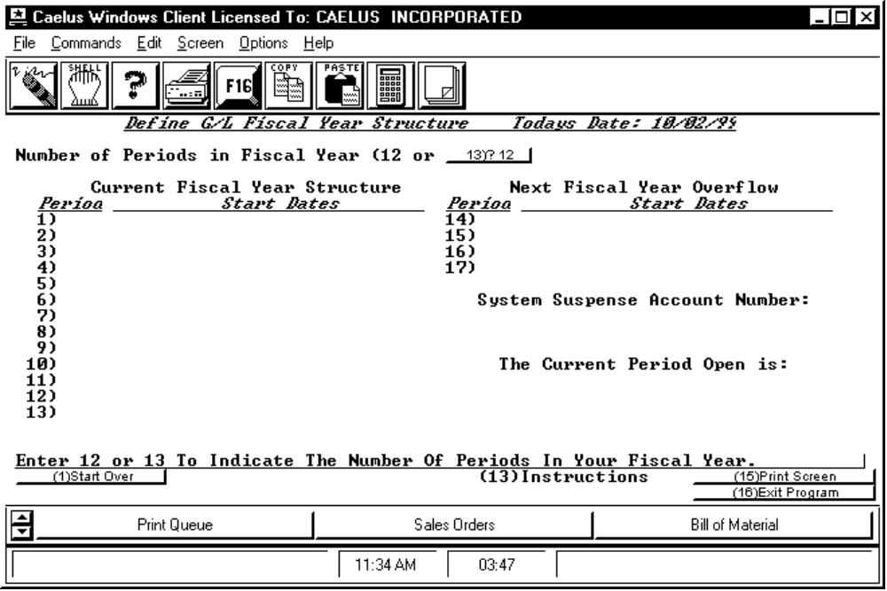

PROCEDURE DISCUSSION

The first time this function is executed against the database, before the fiscal calendar is established, the first screen you see is as shown in the example above. Enter the number of periods to be included in the fiscal calendar (12 or 13) and then press RETURN. Enter the starting date for each period.

If the fiscal calendar already exists, the first screen to appear is the Edit mode screen.

SCREEN EXAMPLE

PROCEDURE DISCUSSION

This screen prompts for the start date for each of the fiscal calendar periods. As you enter the start date for each and press RETURN, you are immediately prompted for the next. After the 12 or 13 periods have been defined, enter the account number of the GL account to be used for suspense postings. Finally, enter the number of the current open period. Do so by entering the number (1 thru 12 or 13) corresponding to the fiscal period that is currently open.

SCREEN EXAMPLE: Edit Mode Screen

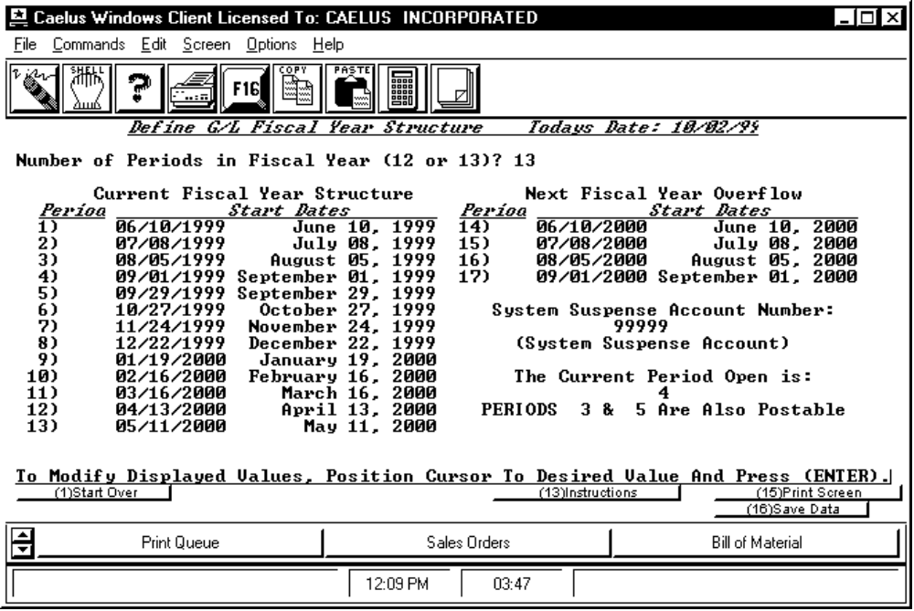

PROCEDURE DISCUSSION

After all periods are defined and the suspense account and open period are indicated, the screen appears as in the example above. This is also the first screen to appear if you rerun this program after saving the new structure.

Notice that four periods beyond the end of the fiscal calendar are also shown. These periods are automatically determined by the system using the date information you entered for the first four periods of the current year. They become active after the end of the current year and remain active until you actually close the books on the year. They then become the first four periods of the new year.

You can change any data by positioning the cursor to the field and press RETURN to highlight the data field for edit. Consider all changes carefully. Caelus recommends that you not change the start dates for any fiscal period that you have already posted to. Changing these dates can cause serious problems with month and year-end closing activities.

Data Field Definitions

Number of Periods in Fiscal Year Enter 12 or 13.

Current Fiscal Year Structure - Year/Period Enter the start dates of each fiscal period.

Next Fiscal Year Overflow - Year/Period Enter valid dates in ascending order. These dates will be used for the first four periods of the next fiscal year.

System Suspense Account Number Enter the GL account code for the system suspense account. If the account code you enter is not currently on file, the account will be automatically created. Be Careful. The account will be automatically added to the chart of accounts.

Current Period Open Enter the number between 1 and 12 or 13 to indicate the period that is currently open in the fiscal calendar. The other open periods in the posting window appear below the current open period.

