GENERATE SOURCE CODE PROGRAM HEADER

PURPOSE

This program generates the standard Caelus, Incorporated program header complete with dimensioning of critical variables and the standard line 65000 closing of files and exit.

SCREEN EXAMPLE: GENERATE PROGRAM HEADERS

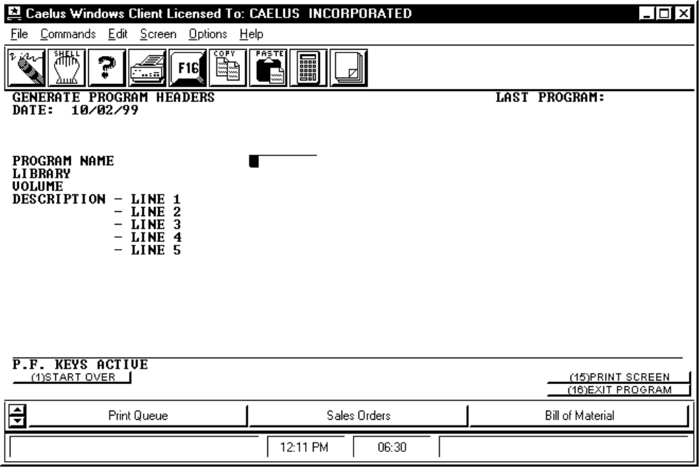

PROCEDURE DISCUSSION

This screen allows you to enter a program name and up to five lines of text to describe an application you want to produce. GENHEAD then generates the header for the application utilizing the program name and description you have supplied.

Data Field Definitions

LAST PROGRAM Not used.

PROGRAM NAME Enter the name of the program for which you wish to generate a header.

LIBRARY Enter the name of the library in which you want the program header to be placed.

VOLUME Enter the name of the volume on which you want the program header to be placed. Default for volume is taken from usage constants.

DESCRIPTION - LINE 1 etc. Enter up to five lines of text to describe the function of the program.

Active Function Keys

Edit Mode:

F16 CREATE HEADER Generates the program header and places it into the library you specified.

