GENERATE PROGRAM SOURCE CODE

PURPOSE

Generate BASIC source code. Creates a skeleton program which handles dimensioning of critical variables, opening of selected files, input of data from terminal, and exiting from program.

GENERAL DISCUSSION

GENPGM generates a skeleton program to your specifications. It prompts you to enter a name and a description of the program which it uses to create the header. The skeleton includes screen handling logic for input and edit modes and field by field entry. You can enter up to 15 variables for each input screen for a maximum of five input screens. GENPGM also prompts you to enter the names of files which you want your program to have access to. If the file(s) are defined in SES, GENPGM will optionally place a format in the program.

GENPGM then generates a skeleton program which accomplishs the menial tasks of dimensioning critical variables (including variables you specify), opening of selected files, setting up input screens which get input from the user, and a clean exit from the program. Once the skeleton is created you can use the editor to supply the necessary logic to interact with the database and manipulate the data.

GENPGM implements Caelus program structure standards and line numbering convention standards. The layout of the standard structure is as follows:

CAELUS STANDARD PROGRAM LAYOUT

00010 Banner

01000 Dimension Variables

02000 Select Files

Open Files

09000 Initialization

10000 Screen 1 Input Control Loop
GOSUB'051
GOSUB'101
GOSUB'151

Screen 2 Input Control Loop

Screen 3 Input Control Loop

Screen 4 Input Control Loop

Screen 5 Input Control Loop

11000 Screen 1 Edit Control Loop

Screen 2 Edit Control Loop

Screen 3 Edit Control Loop

Screen 4 Edit Control Loop

Screen 5 Edit Control Loop

Miscellaneous Processing

20000 Default/Enable DFFN'051

29900 Start Over

30000 Data Load

Data Put

Data Save

Miscellaneous processing

35000 File Format Statements

40000 Screen 1 Accept Statement DFFN'101

Screen 2 Accept Statement

Screen 3 Accept Statement

Screen 4 Accept Statement

Screen 5 Accept Statement

50000 Screen 1 Test/Validation DFFN'151

Screen 2 Test/Validation

Screen 3 Test/Validation

Screen 4 Test/Validation

Screen 5 Test/Validation

65000 Exit Program

SCREEN EXAMPLE: BASIC Source Code Generator

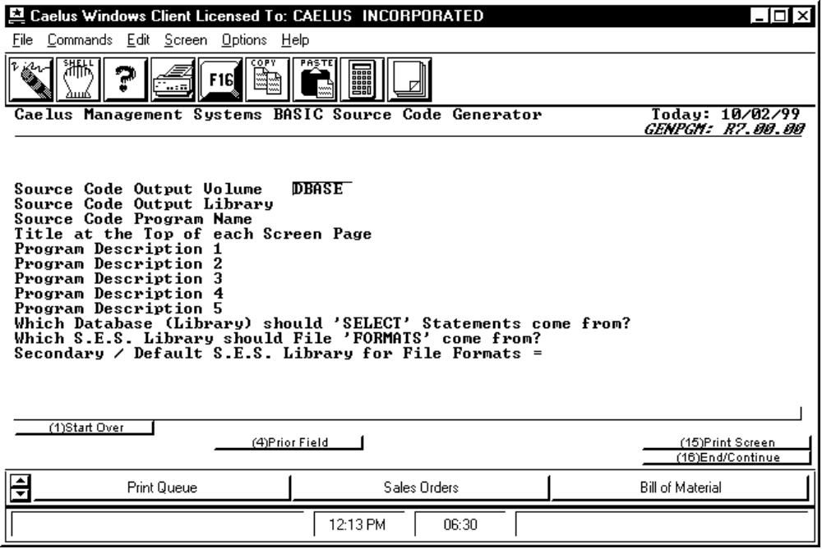

PROCEDURE DISCUSSION

This is the initial input screen for GENPGM. It allows you to enter information describing the program you wish to create. You are prompted to enter a program name and a short description of the program function which are used to produce the program header. You are prompted to enter information regarding the database and the S.E.S. (System Element Structure) libraries you want to use.

Data Field Definitions

Source Code Output Volume? Enter the volume in which you wish to place the source code which will be generated. Default for volume is taken from usage constants.

Source Code Output Library Enter the name of the library in which you wish to place the source code which will be generated. Default is taken from usage constants.

Source Code Program Name Enter the name of the program you wish to create.

Title at the Top of each Screen Page Enter a title to appear at the top of each input screen.

Program Description 1 etc. Enter up to five lines of text to describe the function of the program. This will appear in the program header just under the program banner.

Which Database (Library) should 'SELECT' Statements come from? Enter the name of the database library from which the SELECT statement will extract information such as file type, record size, and key(s) specifications. Default is taken from usage constants.

Which S.E.S. Library should File 'FORMATS' come from? Enter 'CAELUS' to specify that the file layouts (file formats) to be generated by the program are to be generic. If the file formats are to come from a custom, user defined library; enter the name of the custom library. Default is 'CAELUS'.

Secondary / Default S.E.S. Library for File Formats Enter the name of a secondary / default S.E.S. library for custom file formats. Default is blank.

Active Function Keys

Input Mode:

F4 Prior Field Scrolls the cursor up through the line items one at a time, enabling them to be modified.

Edit Mode:

F2 Edit Line Items Displays the first Data Entry Screen for edit.

F8 Edit File Selections Displays the file selection screen for edit.

F16 Generate Code Causes a source code file to be generated using the parameters you have specified.
SCREEN EXAMPLE: Data Entry Screens

This screen appears after you have entered a response for the last item on the initial entry screen.

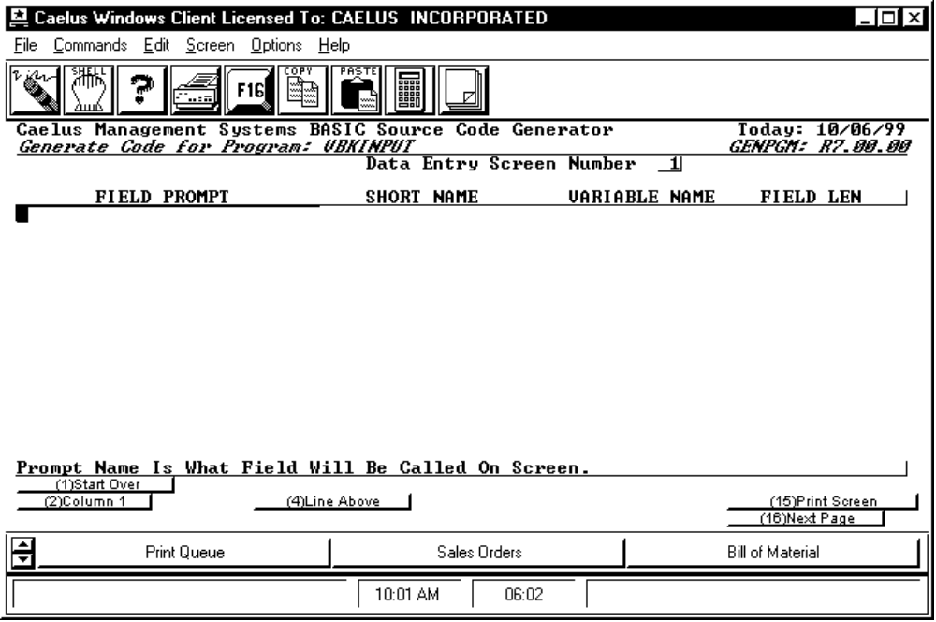

PROCEDURE DISCUSSION

This is the first of up to five identical data entry screens. It allows you to enter attributes for up to 15 variables to be included in an input screen within the generated program.

Data Field Definitions

FIELD PROMPT Enter a 28 character constant which will appear next to each field on the generated screen. Field Prompt will also be used as internal program documentation describing the field.

SHORT NAME Enter a 16 character short field description used for internal program documentation. Default is the first 16 characters of the Field Prompt.

VARIABLE NAME Enter the program variable name to be assigned to this field. No default, string variables are assumed.
FIELD TYPE Enter '1' to enable entry of either upper or lower case characters for this variable. Enter '2' to specify entry of uppercase characters only for this variable. Enter '3' to specify the entry of numeric characters only for this variable. Enter '4' to allow entry of uppercase characters with description fields. No default.

LEN Enter the length (number of characters) you desire for the variable.

Active Function Keys

Input Mode:

F2 Column 1 Causes the cursor to return to column 1 (the left end) of the present line so it can be retyped.

F4 Line Above Copies the value for the column where the cursor is located from the previous line to the current line.

F16 Next Page If pressed from a full or partially completed screen it causes the next Data Entry Screen to appear for input. If pressed from an empty screen, it causes the file selection screen to appear for input.

Edit Mode:

F2 First Displays the first Data Entry Screen for edit.

F3 Last Displays the last Data Entry Screen for edit.

F4 Previous Displays the immediately previous Data Entry Screen for edit.

F5 Next Displays the next Data Entry Screen for edit.

F8 Select Files Displays the file selection screen for edit.

F9 Header Displays the initial input screen for edit.

F11 Insert Causes a blank line to be inserted for input directly after the line on which the cursor is currently located.

F12 Delete Causes the line on which the cursor is currently located to begin blinking. You will be prompted to press the return key if you wish to continue the deletion of the line or F1 to abort the deletion.

F16 Generate Pgm Causes a source code file to be generated using the parameters you have specified.
SCREEN EXAMPLE: File Selection Screen

This screen appears when you press F16 from an empty Data Entry Screen.

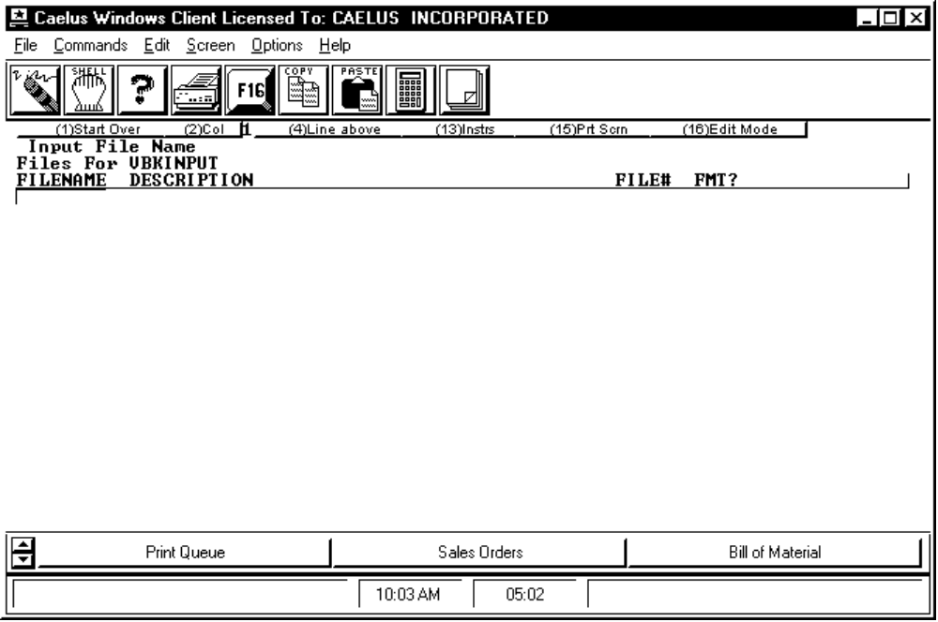

PROCEDURE DISCUSSION

At this screen you are asked to enter information about the files you want your program to use. You are prompted to enter the name of a file, at which time GENPGM calls PLOWCODE to validate the name and return a description of the file. If you have entered the name of a file which does not exist, PLOWCODE will show you the names of some files which are spelled similarly and allow you to choose from them. However, if you have intentionally entered the name of a file you intend to create, you can exit PLOWCODE without choosing an existing file and return to the file selection screen to enter the description manually. Next, you will need to enter a file channel for the file. Finally, you will be asked whether or not you want GENPGM to generate a file format for this file from the selected S.E.S. library.

Data Field Definitions

FILENAME Enter a file name or enter a blank or partial file name to choose from files listed in the S.E.S. Element Dictionary.

DESCRIPTION If the file name was found in the S.E.S. Element Dictionary the description will be automatically supplied. Otherwise you must supply a description of the file.

FILE# Enter the file channel number (1 thru 64) by which this file will be addressed in the generated program.

FMT? Enter 'Y' to have a file format automatically generated from the file layout in the S.E.S. library selected on the initial input screen, or 'N' for no file format.

Active Function Keys

Input Mode:

F2 Col 1 Causes the cursor to return to column 1 (the left end) of the present line so it can be retyped.

F4 Line above Copies the value for the column where the cursor is located from the previous line to the current line.

F16 Edit Mode Causes the initial input screen to appear for full screen edit.

Edit Mode:

F2 First Displays the first file selection screen for edit.

F3 Last Displays the last file selection screen for edit.

F4 Prev Displays the immediately previous file selection screen for edit.

F5 Next Displays the next file selection screen for edit.

F6 Down Scrolls the cursor down through the line items one at a time, enabling them to be modified.

F7 Up Scrolls the cursor up through the line items one at a time, enabling them to be modified.

F9 Header Displays the initial input screen for edit.

F11 Insert Causes a blank line to be inserted for input directly after the line on which the cursor is currently located.

F12 Delete Causes the line on which the cursor is currently located to begin blinking. You will be prompted to press the return key if you wish to continue the deletion of the line or F1 to abort the deletion.

F16 Gen Prgm Causes a source code file to be generated using the parameters you have specified.

