GENERATE REPORT PROGRAM

PURPOSE

Generate BASIC source code for a report program. Creates a skeleton report program which handles dimensioning of critical variables, opening of selected files, input of ranges from terminal, and exiting from program.

GENERAL DISCUSSION

GENRPPGM generates a skeleton report program to your specifications. It prompts you to enter a name and a description of the program which it uses to create the header. You are then prompted to enter the names of variables which will be used to select data for your report. You can enter up to 12 variables for which you will be able to specify a range of values for your report. GENRPPGM also prompts you to enter the names of files which you want your program to have access to. If the file(s) are defined in SES, GENRPPGM will optionally generate a format statement and place it in the program.

GENRPPGM generates a skeleton report program which accomplishs the tasks of dimensioning critical variables (including variables you specify), opening of selected files, setting up screen handling logic for input and edit modes and field by field entry, and a clean exit from the program. The skeleton program utilizes a call to COMPNAME to get the company name to insert into the printed report. It prints page zero of the report, which displays the input selection parameters. The skeleton program also contains the logic for pagination control for the report. Once the skeleton is created, use the editor to supply the necessary logic to extract data, create workfiles, and generate the report.

GENRPPGM differs from GENPGM in the fact that it sets up space for logic to extract data and generate the report, calls SETPRINT to select the printer, creates a section of code to print the report, and creates image statements for the report heading.

SCREEN EXAMPLE: BASIC Report Program Generator

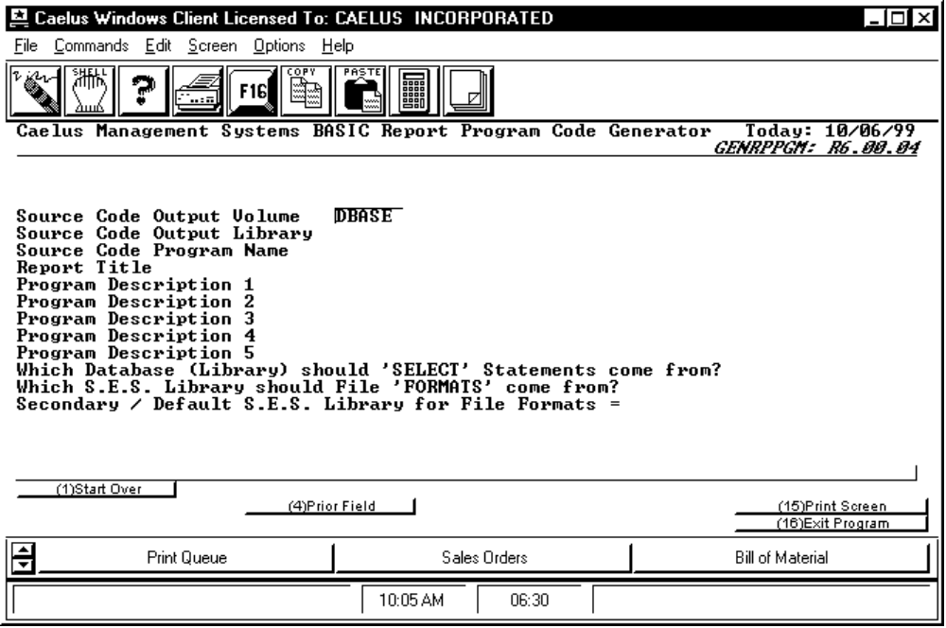

PROCEDURE DISCUSSION

This is the initial input screen for GENRPPGM. It allows you to enter information describing the report program you wish to create. You are prompted to enter a program name and a short description of the program function which are used to produce the program header. You are prompted to enter information regarding the database and the S.E.S. (System Element Structure) libraries you want to use.

Data Field Definitions

Source Code Output Volume? Enter the volume in which you wish to place the source code which will be generated. Default for volume is taken from usage constants.

Source Code Output Library Enter the name of the library in which you wish to place the source code which will be generated. Default is taken from usage constants.

Source Code Program Name Enter the name of the program you wish to create.
Report Title Enter a title to appear at the top of each page of the report.

Program Description 1 etc. Enter up to five lines of text to describe the function of the program. This will appear in the program header just under the program banner.

Which Database (Library) should 'SELECT' Statements come from? Enter the name of the database library from which the SELECT statement will extract information such as file type, record size, and key(s) specifications. Default is taken from usage constants.

Which S.E.S. Library should File 'FORMATS' come from? Enter 'CAELUS' to specify that the file layouts (file formats) to be generated by the program are to be generic. If the file formats are to come from a custom, user defined library; enter the name of the custom library. Default is 'CAELUS'.

Secondary / Default S.E.S. Library for File Formats Enter the name of a secondary / default S.E.S. library for custom file formats. Default is blank.

Active Function Keys

Input Mode:

F4 Prior Field Scrolls the cursor up through the line items one at a time, enabling them to be modified.

Edit Mode:

F2 Edit Range Select Items Displays the Data Entry Screen for Ranges for edit.

F8 Edit File Selections Displays the file selection screen for edit.

F16 Generate Code Causes a source code file to be generated using the parameters you have specified.

SCREEN EXAMPLE: Data Entry Screen for Ranges

This screen appears after you have entered a response for the last item on the initial entry screen.

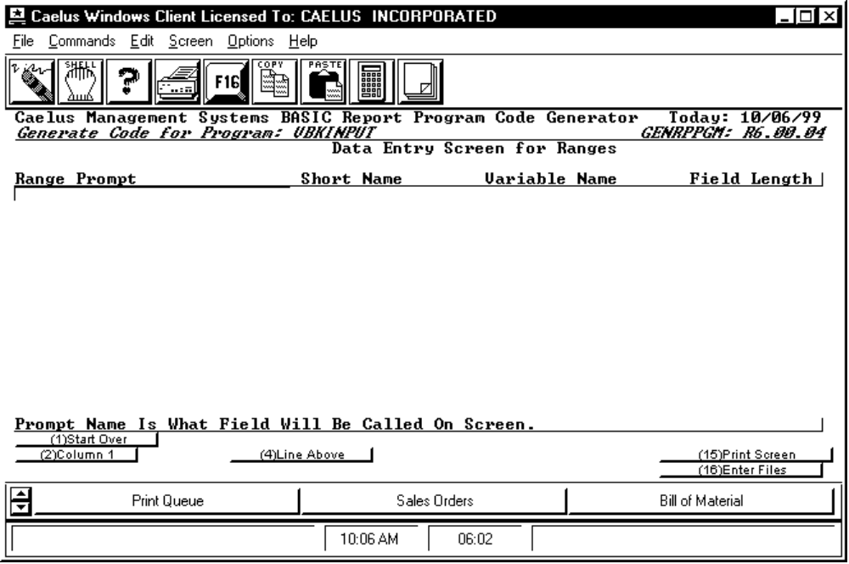

PROCEDURE DISCUSSION

This screen allows you to enter the names of up to 12 variables which you want to include in your report. GENRPPGM will generate a screen for your report program with which you will be asked to supply a range of values for each variable you specify here.

Data Field Definitions

RANGE PROMPT Enter a 27 character constant which will appear next to each field on the generated screen. Range Prompt will also be used as internal program documentation describing the range.

SHORT NAME Enter a 16 character short field description used for internal program documentation. Default is the first 16 characters of the Range Prompt.

VARIABLE NAME Enter the program variable name to be assigned to this range. No default, string variables are assumed.

FIELD TYPE Enter '1' to enable entry of either upper or lower case characters for this variable. Enter '2' to specify entry of uppercase characters only for this variable. Enter '3' to specify the entry of numeric characters only for this variable. No default.

LEN Enter the length (number of characters) you desire for the variable.

Active Function Keys

Input Mode:

F2 Column 1 Causes the cursor to return to column 1 (the left end) of the present line so it can be retyped.

F4 Line Above Copies the value for the column where the cursor is located from the previous line to the current line.

F16 Enter Files Displays the file selection screen for input.

Edit Mode:

F2 First Not used.

F3 Last Not used.

F4 Previous Not used.

F5 Next Not used.

F8 Select Files Displays the file selection screen for edit.

F9 Header Displays the initial input screen for edit.

F11 Insert Causes a blank line to be inserted for input directly after the line on which the cursor is currently located.

F12 Delete Causes the line on which the cursor is currently located to begin blinking. You will be prompted to press the return key if you wish to continue the deletion of the line or F1 to abort the deletion.

F16 Gen Program Causes a source code file to be generated using the parameters you have specified.
SCREEN EXAMPLE: File Selection Screen

This screen appears when you press F16 from the Data Entry Screen for Ranges.

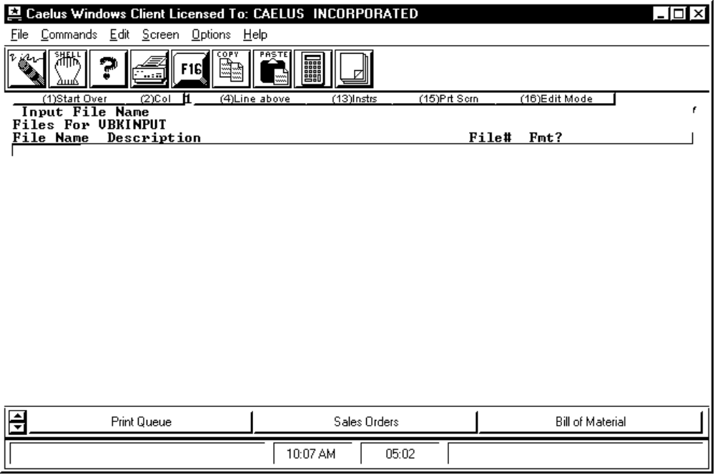

PROCEDURE DISCUSSION

At this screen you are asked to enter information about the files you want your program to use. You are prompted to enter the name of a file, at which time GENRPPGM calls PLOWCODE to validate the name and return a description of the file. If you have entered the name of a file which does not exist, PLOWCODE will show you the names of some files which are spelled similarly and allow you to choose from them. However, if you have intentionally entered the name of a file you intend to create, you can exit PLOWCODE without choosing an existing file and return to the file selection screen to enter the description manually. Next, you will need to enter a file channel for the file. Finally, you will be asked whether or not you want GENRPPGM to generate a file format for this file from the selected S.E.S. library.

Data Field Definitions

File Name Enter a file name or enter a blank or partial file name to choose from files listed in the S.E.S. Element Dictionary.

Description If the file name was found in the S.E.S. Element Dictionary the description will be automatically supplied. Otherwise you must supply a description of the file.

File# Enter the file channel number (1 thru 64) by which this file will be addressed in the generated program.

Fmt? Enter 'Y' to have a file format automatically generated from the file layout in the S.E.S. library selected on the initial input screen, or 'N' for no file format.

Active Function Keys

Input Mode:

F2 Col 1 Causes the cursor to return to column 1 (the left end) of the present line so it can be retyped.

F4 Line above Copies the value for the column where the cursor is located from the previous line to the current line.

F16 Edit Mode Causes the initial input screen to appear for full screen edit.

Edit Mode:

F2 First Displays the first file selection screen for edit.

F3 Last Displays the last file selection screen for edit.

F4 Prev Displays the immediately previous file selection screen for edit.

F5 Next Displays the next file selection screen for edit.

F6 Down Scrolls the cursor down through the line items one at a time, enabling them to be modified.

F7 Up Scrolls the cursor up through the line items one at a time, enabling them to be modified.

F9 Header Displays the initial input screen for edit.

F11 Insert Causes a blank line to be inserted for input directly after the line on which the cursor is currently located.

F12 Delete Causes the line on which the cursor is currently located to begin blinking. You will be prompted to press the return key if you wish to continue the deletion of the line or F1 to abort the deletion.

F16 Gen Prgm Causes a source code file to be generated using the parameters you have specified.

