ENTER/MANAGE INVENTORY PART MASTER FILE

PURPOSE

Enter Inventory Master File records and review, or edit, the data contained in the records. Create and manage the list of alternate parts for any given inventory part.

GENERAL DISCUSSION

Through this function, you may enter or modify master file information for each inventory part. You must enter all part numbers into CMS here before you can reference them elsewhere in the system. You can also define the list of alternates to the primary part you are entering. Several other features are also available. You can press a Function Key to see the procurement history for the part and from there you can move on to see the current prices. Another key is provided to allow you to display the higher level parts in which this part is used. Another key allows you to examine the standard costs associated with the part.

Defaults

To speed the data entry process, you can establish defaults for field values that are common to a large number of parts using the key F17 Manage Defaults. If a default value for a field exists, the system displays the value when you enter data for a new part. You can accept the default or enter any other data or blank spaces over the default.

Use of G/L Accounts Specified in the Part Master File

The General Ledger Account codes entered here are not the accounts posted for transactions of the particular part. Rather, the accounts you enter here become the default accounts for the lot quantity file records when they are created at the first activity for each lot number for the part (file = HNYQUAN). When you initiate inventory transactions, the system looks to the G/L accounts on file in lot quantity record and posts to the accounts indicated there. This is also true for the inventory valuation method entered here. It becomes the default valuation method when creating lot quantity records for the part.

Free Text

The System Text Management functions are provided to record memos or specifications text for each inventory part. For more information, refer to the description of System Text Management in the System Module Reference Manual.

Alternate Parts

You can define a list of alternate parts for any inventory part. The planning system considers these alternates when procurement of the primary part is not feasible.

Balance PIP Records

This function provides two methods of saving the entered data. The normal method (F16) causes updating the part master file only. The alternative method (F32) saves the data to the master file and also causes the system to recalculate the PIP quantity for the part for each day of the calendar. This is exactly the same processing performed by PIPRESTR and is provided here to allow you to rebalance the PIP on a part-by-part basis as an alternative to the global rebalancing provided by PIPRESTR.

SCREEN EXAMPLE: First Screen in Input Mode

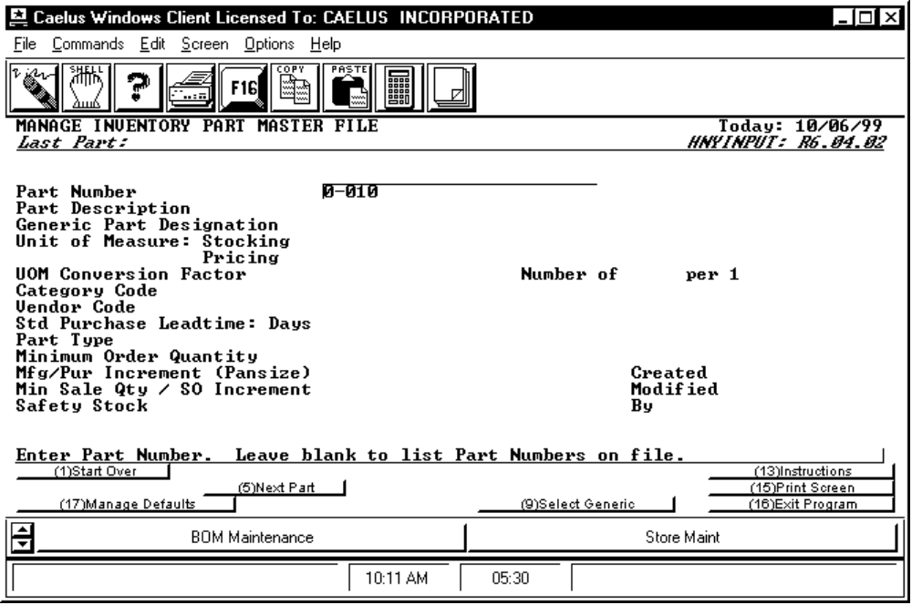

PROCEDURE DISCUSSION

This is the first screen that you see when you enter this program. You can enter a new part into the master file or you can view information on a part already stored in the file. You can press F9 to display a list of generic codes and then parts within each code category so that you can select one to be loaded onto the screen.

To Enter Data for a New Part

To enter master data for a new part, type in the new part number, then you can proceed in either of two ways:

1. Enter data field by field, pressing return after each entry.

2. Enter a part number and description and press F7 Proceed To Edit. The system loads all the defaults entered via F17 places the screen in EDITMODE. You can position the cursor to select any field for edit. If you have no defaults for fields that are 'required', the system prompts you to enter data for those fields before you can proceed.
To Review Data on an Existing Part

If you enter an existing part number, the system displays the master information for that part on several screens. If you enter a part number that is not on file, the system proceeds as described above to allow you to define a new part. Leave the part number field blank and press RETURN to see a list of all part numbers on file from which you can choose the one you want to display.

Active Function Keys

F3 COPY After you enter the Part Description and press RETURN, this key becomes active. Use this key to copy the part information from a part already on file to the screen. The screen is then in Edit Mode. This feature can dramatically speed up the entry of new parts if the parts have similar parameters associated with them.

F5 Next Part Press this key to cause the next part number in the part master file to appear in the PART NUMBER field.

F7 Proceed To Edit This key appears after you enter the part description and press RETURN. Press this key to bypass all the fields which have system defaults and which do not require data entry. If all of the required fields have been entered, press this key to proceed to Edit Mode.

F9 Select Generic This key appears upon entry into the program. Press it to display a list of all generic codes for parts on file. You can then select a generic code and the system displays all parts that are categorized by that generic code. Select one of the parts for the system to load.

F17 Manage Defaults Press this key (Shifted F 1) to enter the inventory defaults that you wish to appear automatically as you enter information for a new part. See the screen at the end of this section for more information.

Data Field Definitions

Part Number Enter a unique part identifier up to 25 characters long. Note: (1) Do not use ALL as a part number, (2) leading blanks count as characters, hence ABC is different than ABC.

If you wish to view or modify data for a part already on file, enter the part number and press RETURN. The system automatically retrieves all of the data for the part and displays the data in edit mode.

If you do not know the correct part number of an existing part, leave the field blank and press RETURN. The system displays a list of all valid part numbers from which you can choose. You can narrow the list by searching for all part numbers beginning with certain characters. When you find the part number you want, move the cursor to it and press RETURN to retrieve it and proceed.

Description Enter a description of up to 30 characters for the part. Several parts can share the same description.

Generic Part Designation Enter the generic family to which this part belongs. In certain areas of CMS, the generic "designator" is helpful if you do not remember the exact part number. For example, when entering a purchase or sales order line item, you can enter the generic name in place of a valid part number. The system displays all parts that share this same generic designator. You can then select the single part that you intend to buy or sell from the list. The system automatically enters it on the purchase or sales order line.

Unit of Measure: Stocking Enter the code to indicate the unit of measure in which this part is stocked. You must enter a code that was previously defined through INV-10-PROCGC05. If you leave the field blank or enter a code that is not defined, the system displays a list of valid codes from which you can choose. The system expresses the on-hand, on-order, open sales quantities, etc. for this part in this unit of measure. This is your primary unit of internal usage.

Unit of Measure: Pricing Enter the code to indicate the unit of measure by which this part is priced. For example, if this part is priced according to the case, then enter a code to express the case size. You must enter a code that was previously defined through INV-10-PROCGC05. If you leave the field blank or enter a code that is not defined, the system displays a list of valid codes from which you can choose. For more information on pricing please refer to the discussions in the Customer and Pricing User Reference Manual.

Conversion (Stk===Pricing) Enter the number of stocking units represented by one selling unit. If you stock by the each and sell by the case of 48, the conversion factor is 48. The system multiplies the stocking unit by the factor to calculate the quantity consistent with the pricing unit of measure. If you enter blank spaces or do not enter a default conversion, the system assumes a conversion of one (1). If you defined the relationship between the two unit of measure codes entered above via INV-10-PROCGC12, the system automatically enters the predefined factor.

Category Code Enter the four-character code that identifies the inventory category to which this part belongs. You must have previously defined any code entered here through the Enter/Manage Inventory Category function INV-10 CATINPUT. In CMS, categories are used as criteria for sales analysis reporting, for customer special pricing and for entry of quality control rejection reasons.

Vendor Code Enter the valid vendor code for the main supplier for this part. Any code entered here must have been previously input through the Enter/Manage Vendor Master File function. This vendor is the default vendor from which to purchase this part, unless one or more vendors have been entered as sources for the product through the Enter/Manage Vendor Prices Function. This "primary" vendor is highlighted on lists of vendors who sell this part to you. The part does not have to be a purchased part for you to record a vendor in this field.

Std Purchase Leadtime: Days Enter the number of days it takes for this part to reach you from the vendor, including the time it takes you to place the order,the vendor to process it and ship the goods to you. NOTE: If this part has a variable leadtime, and the various leadtimes that are effective at different times of the year have been expressed in the Set Leadtime function (INV-20-SETLT), then the leadtime that is effective today displays in this field. This field is used to record the leadtime for manufactured parts if using CMS Production Planning with capacity planning turned off. See the Planning System Behavior Switches for more information (PLNFLSUB).

Part Type Enter a number between 000 and 999 as a code to identify the nature of the part for the planning system and the option bill processing system. Certain subsets of the range 000-999 mean different things to the CMS planning system.

000 = Generic part for the purposes of "option BOMs" (See the Bill of Materials Reference Manual)
001 - 199 = Nonplanned Parts ignored by planning system.
200 - 489 = Purchased Parts, planning system creates "Purchase Order Advices" to procure.
490 - 499 = Purchased Tools, planning system schedules use or creates "Purchase Order Advices" to procure.
500 - 789 = Manufactured Parts, planning system creates "Work Order Advices" to procure.
790 - 799 = Manufactured Tools, planning system schedules use or creates "Work Order Advices" to procure.
800 - 999 = Manufactured Parts, planning system creates "Work Order Advices" to procure.

The part type code is used to control planning system performance when planning the part. See the discussion of the Planning System Behavior Switches in the Production Planning Reference Manual for more information.

Minimum Order Quantity Enter the minimum number of part units that you can procure by purchase or manufacture. This quantity is in the stocking unit of measure as defined above. For example, if you must procure any units to fill a demand, you procure at least this many units.

Note: If you have a list of valid part types on file, a '?' or partial entry presents a GETCODE screen to select from. The program PROCGC44 is used to input valid part code types.

Mfg/Pur Increment (Pansize) Enter the incremental quantity above the MOQ to be used to determine the quantity to procure. This is sometimes referred to as the 'Pansize.' For example, if you always build or buy 500 at a time, and if a demand requires that you procure 501, you procure 1000 (500 + 500). If the demand requires 1025, you procure 1500.

Min Sale Qty / SO Increment This is actually two fields on the same line. In the first field, enter the minimum amount that should appear on any sales order for this item. In the second field, enter the increments in which this part may be ordered by a customer. These quantities are referenced when someone enters a sales order for this part. If the order quantity on the sales order does not correspond to these fields, a warning message appears in the sales order entry program. If you do not have standards for order size or order increment for this part, you can leave this field blank.

Safety Stock Enter the quantity that the CMS planning system should protect. You can control which demands may intrude on this quantity via the Planning System Behavior Switches. Several reporting functions allow you to search for shortage situations where inventory levels have dropped below this quantity.

Dates No modifiable fields.

Created When the record was first entered. Preexisting records will have no dates.

By User Id of who last changed record.

SCREEN EXAMPLE: First Screen in Edit Mode

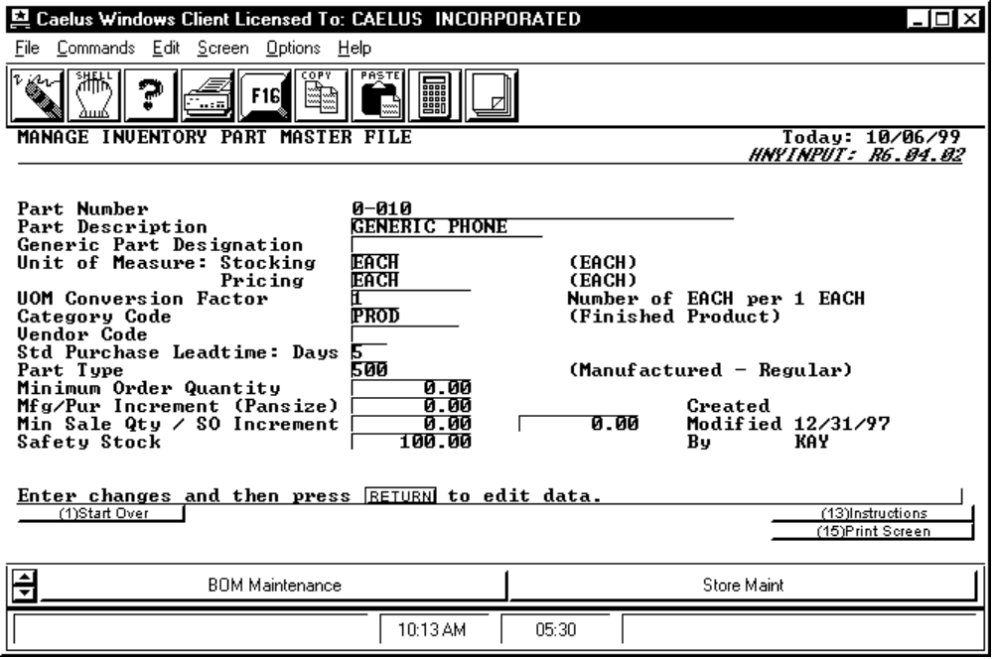

PROCEDURE DISCUSSION

The screen example above shows data entered for each of the fields on the first screen. The screen is in EDITMODE, allowing you to change any of the field entries. For existing part records, you can modify all fields except the part number. The content and purpose of each of the data fields is described below.

To make changes, move the cursor to the desired line and press RETURN. The field is highlighted for edit. Type in the change and then press RETURN to set the change.

Active Function Keys

Edit Mode

F2 Alternate Parts Press this key to display the Alternate Parts Screen and modify the list of alternate parts. See the example and discussion of this screen at the end of this section.

F3 Core Tracking Press this key to display core tracking cross reference information for the part entered, if it exists. This accesses the CORXRFSB function. Refer to the documentation for CORXRFIN in the Core Reference manual for information on this subroutine.

F6 Edit All Press this key to open all the fields on the screen For editing. This feature is very useful if you need to change a number of fields on a screen that is already in Edit Mode. Change the data in each field as necessary, using the tab key to move through the fields.

F8 Procurement History Press this key to activate the procurement history display routine. Refer to the INV-50-HNYPRCSB for more information on this display routine.

F9 PM Items Press this key to activate the precious metal surcharge display/input routine. This allows you to associate precious metal items with the displayed part.

F10 See Std Costs Press this key to activate a function that displays the standard costs associated with the part. For more information on this display routine, see the Standard Costing Module User Reference Manual, SC-20 STCHNYSB.

F11 ECR Info This key only appears if Engineering Change Tracking information has been entered for the displayed part. This function key accesses the ECRINQSB subroutine that displays the ECR information.

F14 Where Used If the part is currently contained in a bill of materials for a higher level product, press this key to display those first level parent parts and the bill of materials version IDs. If the part is not found in a bill, the system displays a message informing you of this.

F16 Save Data Press this key to save the data to the part master file.

F25 Part Text Press this key to activate the System Text Management function for entry or edit of free text about this part. You can include this text on certain printed reports.

F32 Balance PIP Press this key to save the data to the master file and to perform the 'PIP restore' function for the part. This corrects any imbalance between the PIP master record and the details (PIPINs and PIPOUTs). This is also helpful if 'late' actions in the system have caused the PIP status indicator to become incorrect.
SCREEN EXAMPLE: Second Screen in Edit Mode

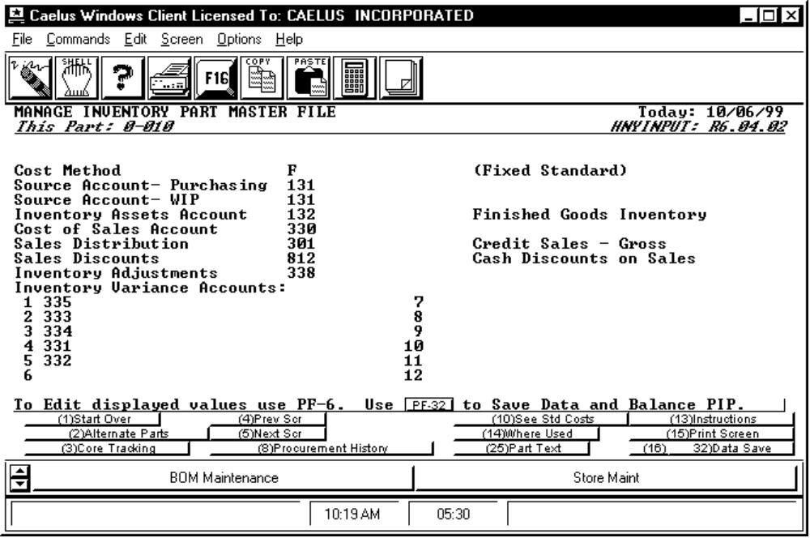

PROCEDURE DISCUSSION

This screen appears when you press F5 from the first screen. As with the first screen, enter or edit data for each of the fields. Remember, the G/L accounts entered on this screen are merely defaults for the creation of the inventory lot quantity records. Regardless of what you enter here, the system always posts according to the data contained in the lot quantity record for the particular lot involved in the transaction.

Data Field Definitions

Cost Method Enter the character that identifies the inventory valuation method to use when the system creates lot quantity records for this part. The valid choices are listed below. See the definitions and discussion of each of these choices in the INV-30 Submodule Overview.

R Actual LIFO W/ Auto Error Correction
X Actual LIFO W/ Adjustment Posting
P Actual FIFO W/ Auto Error Correction
Y Actual FIFO W/ Adjustment Posting
S Standard Cost W/ LIFO Treatment
T Standard Cost W/ FIFO Treatment
F Fixed Standard Cost
A True Average Cost
B Modified Average Cost
L Last Cost
M Manual Cost

Source Account - Purchasing The default G/L account that acts as the source account for purchases when lot quantity records for this part are created. As a source account, when the system debits the inventory asset account to reflect receipt of goods to "on-hand," this account receives the offsetting credit. The system only posts this account if the part is purchased (Part Type 200-499). If this is a manufactured part, the WIP account becomes the source account. You can specify both Purchase and WIP accounts for each part so that you can choose later whether to buy or build the part. For more information on the posting actions during inventory transactions, refer to the discussions in the INV-20 Submodule Overview.

Source Account - WIP The default G/L account that acts as the source account when the lot quantity record is created for this part. The system credits this account when the work on a part is completed and the part is moved to on-hand inventory. The posting of this account only occurs if this is a manufactured part (part type 500-999). If it is a purchased part, the purchase account entered above is the source account.

Inventory Assets Account The default G/L account used as the asset account when lot quantity records for this part are created. The system debits the inventory asset account when you receive goods into on-hand inventory, and credits this account when you issue goods to a job or ship goods to a customer.

Cost of Sales Account The default G/L account used as the COGS account when lot quantity records for this part are created. The system debits the Cost of Goods account with the cost of inventory items sold when sales invoices are processed to receivables. The system performs an offsetting credit to either the Interim Asset account if pre-invoicing is used or the Inventory Asset account if pre-invoicing is not used. See the Order Processing Reference Manual for more information.

Sales Distribution The default G/L account used as the sales account when lot quantity records for this part are created. The system credits the sales account when you process sales invoices into receivables.

Sales Discounts The default G/L account debited with the discount amount when sales invoices are processed into receivables.

Inventory Adjustments The default G/L account used as the adjustment account when lot quantity records for this part are created. The adjustment account is posted with an adjustment amount when insufficient inventory exists to which the adjustment value is applied.

Inventory Variance Accounts: The default G/L accounts are posted with variances to standard costs when you procure this part. The account numbers to enter here are determined by the cost model that you use when procuring this part. You should define as many Variance accounts as the number of buckets in the standard cost set you use. If variances occur in a cost bucket that has no corresponding variance account, the system posts the variance to the G/L Suspense account. This could make variances very difficult to track. Press Function Key 10 when the screen is in Edit Mode to display the standard costs and the cost buckets associated with the part. For more information on cost models and cost buckets, see the Standard Costing Module.
SCREEN EXAMPLE: Third Screen in Edit Mode

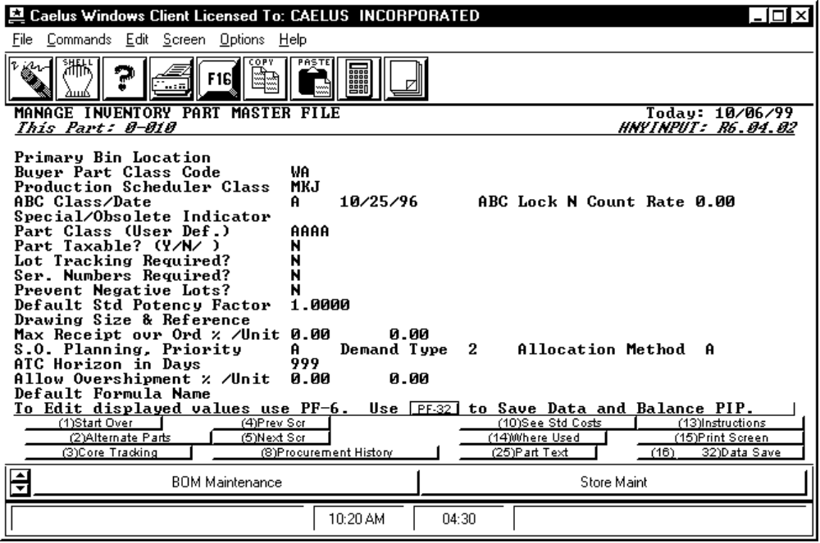

PROCEDURE DISCUSSION

Use this screen to enter miscellaneous information about the part into the part master record. The fields presented on this screen are outlined below.

Data Field Definitions

Primary Bin Location Enter the default location code for this part. This Code defaults in to lot quantity records when the system automatically creates those records.

Buyer Part Class Code Through the functions described in the Purchasing and Receiving Reference Manual (PROCGC01) you can establish buyer class codes to restrict authorization creating purchase directives for certain parts. You can then enter the buyer class code here. You can assign one or more buyer codes to individual users (through the purchasing function (PORELXRF) authorizing them to respond to purchase order advices and to create purchase directives for the parts to which those codes are assigned. For more information, see the Purchasing and Receiving Reference Manual.

Production Scheduler Class This field operates just like the buyer class code field above. The code assigned here is used to restrict the release of work order advices created by the CMS planning system. You must first establish the codes through the function PROCGC02, described in the Shop Floor Control Reference Manual.

ABC Class/Date Enter the letter "A", "B", "C" "D", or "X" (eXclude) to classify this part for ABC analysis. You can also enter or change the date this part was last counted. You can have the system automatically calculate and set the ABC code for all parts using the function HNYABC. The system, updates the 'last counted date' each time you process a count for this part through the Physical Inventory functions.

ABC Lock Enter "Y" to prevent the ABC code from being Auto updated by HNYABC. The lock does not apply if the ABC code is 'blank'. Enter "N" for the lock to be off.

Count Rate Enter the rate this part can be counted in pieces per hour. This field is used in cycle counting resource analysis. It is the second in a four part hierarchy; therefore, zero is considered as no count rate.

Special/Obsolete Indicator This field is used to record that the part is currently in a special status or is obsolete. Enter SPEC for special status, or OBSO for obsolete. (Maximum length is 4 characters).

Part Class (User Def.) This field is user-defined. (Maximum length is 4 characters.) You can use it to classify the part in any way and for any purpose.

Part Taxable? (Y/N/) Enter a "Y" to indicate that sales of this part are subject to sales tax or enter an "N" to indicate that they are not. This flag is considered in combination with a similar flag set in each customer master record to determine if a particular sale to a particular customer is taxable. For more information, see the discussions of sales order entry in the Order Processing Reference Manual or the discussions of customer invoicing in the Accounts Receivable Reference Manual.

Lot Tracking Required? Enter a "Y" to indicate that lot tracking or the lot field is required for this part, or enter an "N" to indicate that this part is not subject to lot tracking and control. This flag works in combination with the lot tracking behavior switch activated for the database through the Inventory Control Module Behavior Switches (HNYFLAGS). If the behavior switch is set to "Y" and this flag is set to "Y", the system then performs detail lot tracking for all movement of the part. If the system switch is "N" and this flag is "N" the lot field is skipped entirely. If the behavior switch is set to "N" and this flag is set to "Y", then the system prompts for lot numbers but uses summary tracking to track the lots and saves no movement data. For more information, refer to HNYFLAGS documentation and the discussions of lot tracking in the Inventory Control Reference Manual.

Ser. Numbers Required? Enter a "Y" to activate serial number tracking for this part. Enter an "N" to specify no serial number tracking for the part. For more information, refer to the discussions of serial number tracking, the discussions of serial number format control and number assignment in HNYFLAGS documentation in the Inventory Control Reference Manual.

Prevent Negative Lots? Enter a "Y" in this field to prevent the system from allowing any overdraws of inventory for any part/store/lot of this part. Enter an "N" to allow the system to accept transactions to withdraw a quantity greater than the system understands to be on-hand. When this flag is set to "Y", the system keeps track of all 'pending' inventory withdrawals and shows you that insufficient inventory exists to make a withdrawal. This feature is independent of the lot tracking feature described above. However, it is usually mandatory to prevent a lot-tracked part from being overdrawn, so this switch is usually "Y" when lot tracking is desired.

Default Standard Potency Factor Enter the potency factor on which to base the bill of material (or 'formula') for this part. If potency does not apply to this part, accept the default of "1.00". CMS provides a special job 'picklist' program to adjust the quantities of each component issued to a job based on the difference between this standard potency and the actual potency on file for the lot of the part to issue. See the discussions of HNYQIPUT for recording actual potency and the discussions of JBPOTPRT in the Shop Floor Control Reference Manual.

Drawing Size and References Enter a Drawing Size code of up to two characters and up to 16 characters of reference indicators. These are free text fields and you may enter any information that is meaningful or useful to your plant. The information appears on a number of reports in the CMS system.

Max Receipt ovr Ord % / Unit This is actually two fields. These two fields define the maximum allowed amount that a receipt can exceed the quantity specified on a purchase order line item. The data you enter are a percentage of the order and a flat quantity. If for example, you ordered 100 units of this part on a purchase order line item, and you entered 10 percent and 50 parts in this field, then you could receive up to 10 extra parts on the receiver for this line item. This is because the receiving programs check these quantities on the part master file and determine which is the minimum limit for the given order. Since 10 percent of 100 is less than 50, the percent figure determines the maximum in the example. If the purchase order specified 1000 parts, then the maximum overreceipt would be 50, since 50 is less than 10 percent of 1000. Note that the over-receipt information you enter here is part-specific. If you do not enter anything here, then the system over-receipt percent defined in the program VBKFLAGS is used to determine the allowed overreceipt amount.

S.O. Planning, Priority Enter the letter from A-Z representing the default priority code assigned to demands for this part. See the discussions regarding the Planning System Behavior Switches for more information on the use of planning priority codes.

Demand Type Enter a "1" to indicate that this is a sale to be netted against the forecast or a "2" to indicate that this sale is outside of the forecast and therefore does not net against the forecast.

NOTE: The default for this switch is set in the Manage SO Module Behavior Switch functions (BCKFLAGS).

Allocation Method Enter one of the allocation flags "A", "C", "N", "P" or "Z". Allocation flags are described in the submodule overview for the Order Entry Programs in the Order Processing Reference Manual. The default allocation flag is determined by the program BCKFLAGS.

ATC Horizon in Days Enter the number of days the system should look into the future to determine the 'Available To Commit' quantity for this part. The system uses this value to determine the ATC for the CMS planning process and all displays showing the ATC. The ATC is the lesser of the PIP quantities from the day in question out this number of days. For demands beyond the ATC horizon, the system uses the full PIP quantity for the day in question instead of the ATC. This length of time should be at least as long as the total leadtime needed to procure this part and any components under this part. This horizon is helpful in that it allows you to over-commit inventory because you can project the length of time it will take to procure the parts needed to fill demands within the horizon.

Allow Overshipment % / Unit These fields are analogous to the maximum over-receipt percent and amount specified above. Enter a percent and a flat amount that defines the maximum overshipment amount you can specify in shipment scheduling (SHPSCHIN) or shipment recording (SHPACTIN). For a given shipment, the minimum of the percentage or the flat amount is used to determine the allowed overshipment amount.

Default Formula Name Enter the formula name to be used as the default when this part is used in a Bill of Materials. If a default name is not entered here, and the formula calculations feature is activated using BOMFLAGS, then the user can select the formula to use. The default entered here can only be changed when used if the switches in BOMFLAGS allows it to be.

SCREEN EXAMPLE: Alternate Parts Screen

The screen below is displayed when you press F2 from any EDITMODE screen.

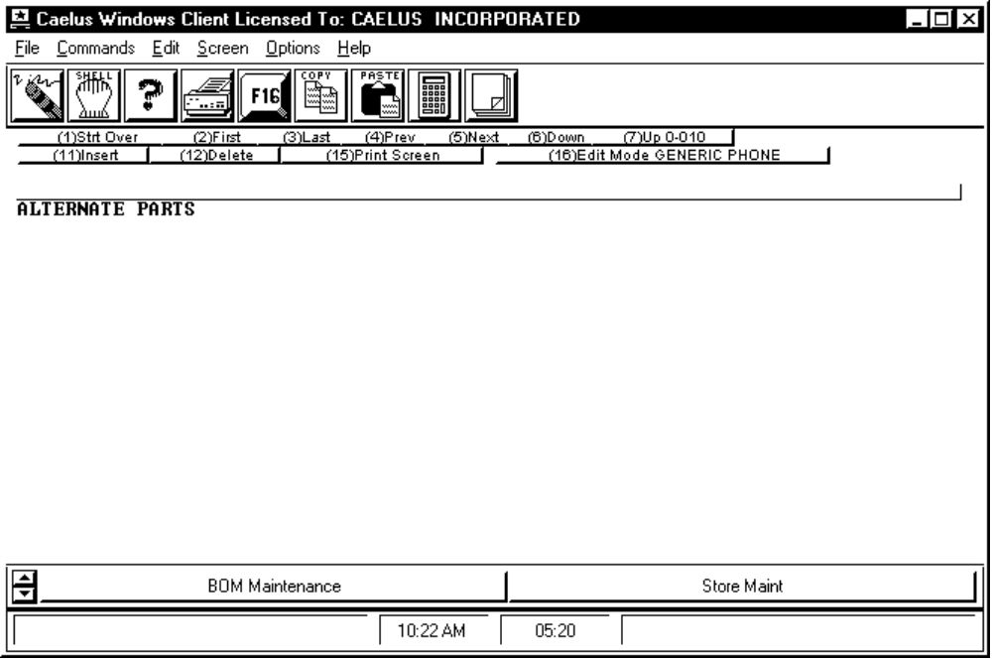

PROCEDURE DISCUSSION

You can identify any other parts as alternates to a part for which you are entering master file information by listing them on this screen. To add alternate parts to the list, press F11. Enter the part number of each alternate and press RETURN after each part number.

After you enter an alternate part number, the screen steps down a line, allowing you to enter the next alternate part. When you have entered twenty alternate parts, a clear screen appears, so that you may continue entering alternate parts. You can enter as many alternates for the original part as you wish. When you complete the list, press RETURN to display the first entry screen of master information for the original part. All part numbers for alternates must have been previously entered in the inventory master file.

In the CMS planning process, if the original part cannot be procured in time to meet the date needed, the system attempts to procure the first alternate before planning the demand for completion later in time than the date requested. If more than one alternate exists, and if the first alternate cannot be procured in time, the planning system tries to procure the next alternate on the list in order of entry. The system continues down the list until it procures an alternate part or it fails to procure any of them.

To delete alternate parts, position the cursor on the line you wish deleted and press F12. The system prompts for confirmation that this is alternate you wish to delete.

Remember that a part can be an alternate of the original part but the reverse may not necessarily be true. An alternate relationship between two parts can be either one or two way. For example, if Part A has an alternate part B, but part A is not on the list of alternates for part B, part A is not an alternate of B. In this case the relationship is one-way. If you use this function to add part A to part B's alternate parts list, then part A becomes an alternate of part B and the relationship is two-way.

SCREEN EXAMPLE

The following screen appears when you press F17 from the first screen.

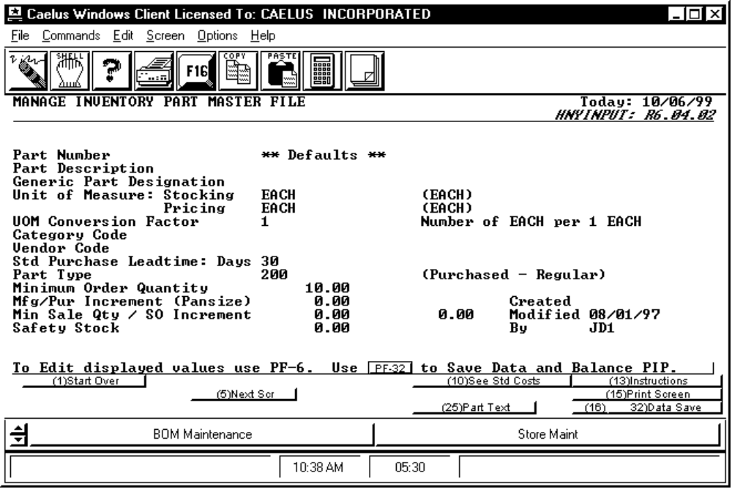

PROCEDURE DISCUSSION

Use this screen to begin entering default part information. This screen is exactly the same as the first screen in input mode, except the part number field displays "Defaults". Enter default information just as you would enter information for any other part. When you have entered all the default information that you need, press F7 Proceed to Edit and complete all of the required entry fields before pressing F16 to save the default information.

SCREEN EXAMPLE

This screen appears when you press F5 from the last screen in this program. It displays variable fields that you have defined using the VFDEFINE program.

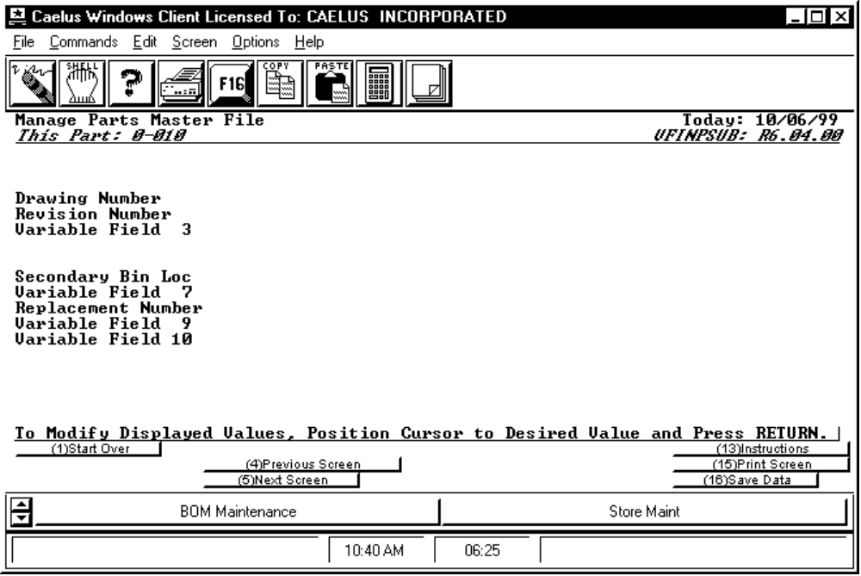

PROCEDURE DISCUSSION

The information that appears on this screen depends on what you have defined for the variable fields using the VFDEFINE program. If you have not defined variable fields, the screen appears as shown above. To define variable fields for this program, run VFDEFINE, select the Parts Master File, and then define the prompts to display on this screen and the valid entries. See the documentation for the VFDEFINE program in the CMS System Module Reference Manual for information on how to define variable data fields.

SCREEN EXAMPLE: Part Formula Calculation Variables

The following screen appears after the variable fields screen only if formula calculations is activated in BOMFLAGS.

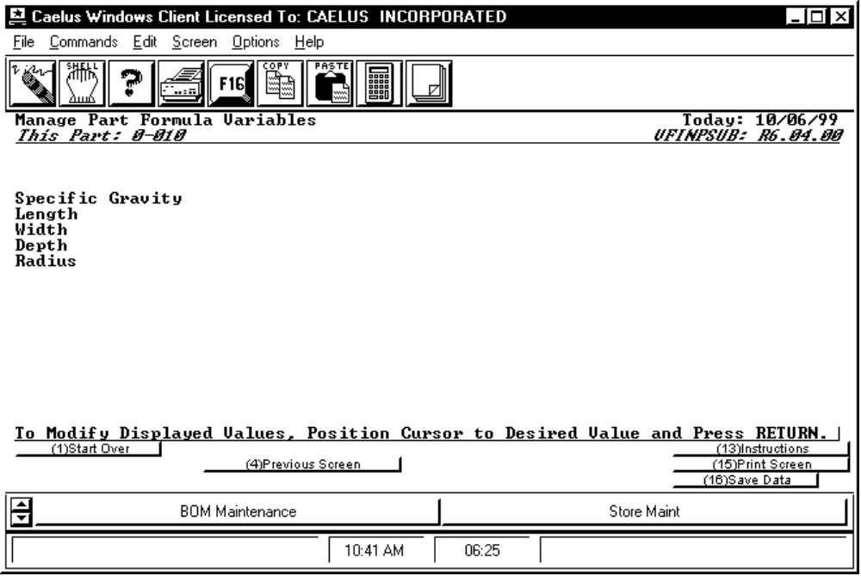

PROCEDURE DISCUSSION

This screen allows you to define the values that are to be used for formula calculations for this part. Enter the appropriate data into the fields and then press F16 Save Data.

