DIRECTLY MANAGE LOT QUANTITY RECORDS

PURPOSE

Create, manage, or display lot quantity records and costs. You should not use this function casually.

GENERAL DISCUSSION

This function has two modes: display and security. If you do not have either a database or an inventory module administrator security clearance, run this function in display mode. In this mode, you can edit various non-quantity data in the part/store/lot record; you cannot edit any quantity or pool information and you cannot create new store/lots. These functions are active in security mode. Security mode is only active for users with database or inventory module security clearances.

In CMS, the total quantity of a particular part is the sum of those parts in each store/lot combination in which that part exists. For example, if 700 count of part "A" is located in store/warehouse 100 in lot 4587A and 550 count of part "A" is also found in store 200, lot 47G10, the system calculates the total quantity of part "A" as 1250 units. The CMS system never stores the total quantity of any part. Rather, it stores the individual quantities of the part in each store/lot combination and then calculates the total when necessary. All inventory transactions in CMS are 'lot specific', meaning that you specify a lot number and the system posts the transaction quantity in or out of that lot.

A blank lot number is as valid as any other lot number for a part. A separate lot quantity record is created and maintained for each lot number. If you do not use lot tracking to trace movement of lots through the course of production, you can simplify the system by leaving the lot number field blank. This causes the system to record all transactions for all parts in the lot quantity record for lot = " ". You have only the single record and it contains the totals for the part in the specified store.

Lot Quantity Record Data

The data contained in the lot quantity record controls inventory processing and costing for that lot. The lot-specific data includes the quantity, the costing method, the unit cost, and miscellaneous information such as potency and expiration date.

GL Accounts

The lot record also stores the GL accounts posted for transactions of that particular lot. The defaults for this data are from the part master file record for the part.

The volume of data contained in the lot quantity record requires several screens.

Creation of Lot Quantity Records

CMS offers two methods for creating part/store/lot records: automatic and manual. The system automatically creates a part/store/lot record if you enter a transaction and specify a nonexistent part/store/lot. Alternately, you can use this function to manually create an empty part/store/lot and then enter a transaction to "fill" the part/store/lot. If the system creates the records automatically at the first transaction, the data defaults from the master record for the part (see the documentation for the HNYINPUT program in this manual). This defaulting action is the reason for creating the records manually. If you do not wish to use the part-specific data such as general ledger accounts, costing method, etc. then create the lot quantity records manually with the proper data. When creating lot quantity records manually, enter an on-hand quantity of zero. When inventory arrives, the system posts it according to the valuation method and GL accounts you have manually set for the lot.

WARNING: Edit Lot Quantity Record Data

You can modify any of the lot data using this function if you have database administrator or inventory module administrator security clearance. The details of each field are described below; however, you should fully understand that the system does not provides an audit trail or GL posting and that you can throw the system out of balance.

One of the ways the system is commonly thrown out of balance using this program is when the on-hand quantity for a part is edited. The new quantity is only updated in the HNYQUAN file, not the PIPMASTR file. This presents an out of balance condition because the CMS planning system uses the PIPMASTR file to determine the quantity on hand. Therefore, whenever the quantity on hand field is changed using this program, PIPRESTR needs to be run or HNYINPUT for that part using F32 to save and balance the PIP for the part.

No Audit Trail or General Ledger Posting

Any cost or quantity adjustments made to an existing part/store/lot record do not result in an automatic posting to the General Ledger. To add or withdraw inventory to/from a part store/lot and post audit trail and GL, use the direct inventory adjustment functions.

Lifo/Fifo Pool Records

The lot quantity is supported by lifo/fifo pool records. When you first add inventory to a part/store/lot record, the system notes the addition by creating a pool record containing the cost and the quantity of the addition. From this point on, the system maintains a record of additions and the costs associated with them by adding to the pool records. Withdrawals are recorded by subtracting the quantities from the appropriate pool record.

Single or Multiple Pool Records

CMS maintains pool records in two different ways depending on the valuation method for the part/store/lot. If you use one of the Fifo or Lifo valuation methods, then the system creates a new pool record every time you post additions to the part/store/lot. Withdrawals are removed from the pool records in Fifo or Lifo order depending on the valuation method. Cost changes are limited to pool records created after the change. Old pool records maintain the old costs of the inventory.

If you use any of the other valuation methods, then the system maintains a single pool record for the part/store/lot and adds or subtracts quantities from the record as necessary. Changes in cost cause the value of the inventory in the pool record to be revalued.

The total quantity maintained in the pool record is the On Hand quantity associated with the part/store/lot. Each pool record also contains the original quantity put in to the part/store/lot when the pool was created. As parts are issued out of the part/store/lot, pool records are emptied and subsequently deleted. A Function key is provided allowing you to inspect the pool records for a part/store/lot. You can even make changes in the quantity and cost. Remember, no audit trail is provided so be certain you know what you are doing when adjusting the pools.

A special Function key allows you to combine multiple pool records into a single pool record. The resulting single record contains the combined quantity and the per-unit cost for the new single record. The system calculates the per unit cost as the weighted average of the old individual records. This feature is helpful if you are changing inventory valuation to a single pool valuation method for the lot.

Balancing Pool Records to Lot Quantity Records

The on-hand quantity the system for the lot should equal the sum of the quantities for each of the pool records. Likewise, the average per-unit cost for that quantity should balance to the sum of the unit costs and quantities for the individual pool records. You can think of the lot quantity records (HNYQUAN) as summary records and the pool records (HNYPOOL) as detail records.

This program includes a special screen to display the state of this balance between the lot quantity record data and the pool record data. Additionally, if you make adjustments to either side which throws the system out of balance, when you attempt to save the data, the system displays the balance screen and prompts you to correct the situation. You can either make other adjustments to put the system in balance or exit and leave the system out of balance.

If you make changes that throw the system out of balance, the system sends a notice to the printer. The notice includes the data on the 'out of balance' screen showing the net difference in cost and units.

Free Text

This program supports the System Text Management function allowing you to enter free text about each lot quantity. This text can be memos or specifications about the particular lot. Its use is up to you. Once entered, it is available for inclusion on custom reports. For more information on the features and functions of System Text Management, refer to the System Module Reference Manual.

User Defined Fields

This program provides an additional screen/page allowing you to enter up to 10 fields of data about each part/store/lot. You can define the length and title for each field and certain restrictions on the type of data allowed. For more information on this feature, refer to the documentation for the VFDEFINE program in the System Module Reference Manual.

SCREEN EXAMPLE

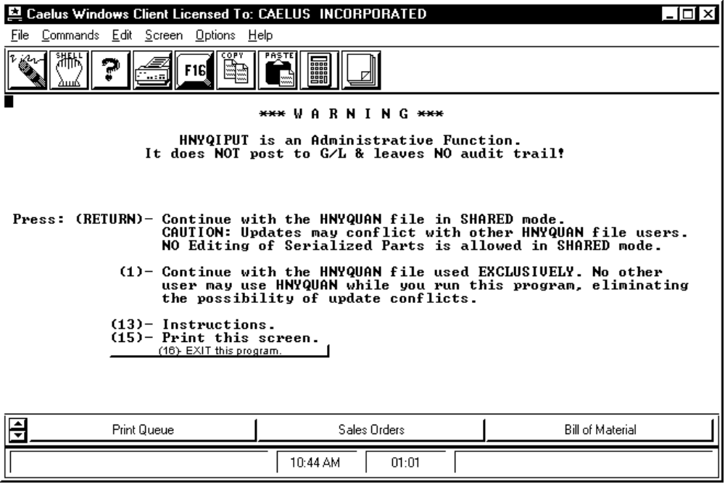

PROCEDURE DISCUSSION

This screen is only displayed for security mode users. The screen displays a warning message saying that the purpose of this function is administrative adjustment. Be sure you know what you are doing if you intend to modify data.

You can choose to run this program, accessing the HNYQUAN file, in shared mode or exclusive mode. Shared mode means that any updates you make can conflict with other HNYQUAN users; editing of serialized parts quantities is not allowed in this mode. Exclusive mode allows you alone to access the HNYQUAN file, thereby eliminating update conflicts.

Press RETURN to work in shared mode. Press F1 to work in exclusive mode; the system checks that no other users are accessing the HNYQUAN file. If they are, a message from the operating system is displayed. If you see that message, you must exit and wait until the other users exit the file.

SCREEN EXAMPLE

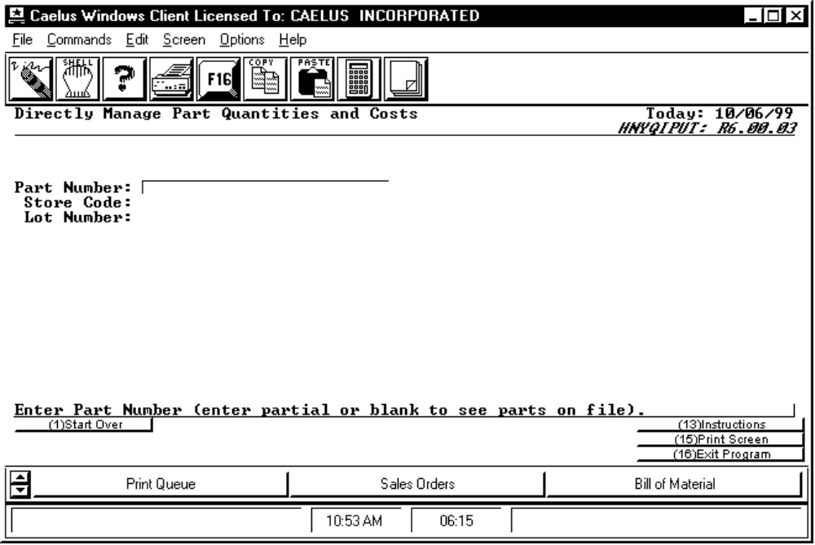

PROCEDURE DISCUSSION

To create a new quantity record, enter a part, store and lot combination that does not yet exist (creation of new part/store/lot combinations is not available in display mode).

To review or edit data for an existing quantity record, enter the proper part, the store number, and the lot number. You can see a list of the valid selections by leaving each field blank and pressing RETURN. The part/store/lot collectively make each record in the inventory quantity master file unique. After you enter these three fields, the system checks to see if a record for this combination already exists in the inventory quantity master file (HNYQUAN). If it does, the system assumes that you want to modify data. The system retrieves all of the previously stored data and places the screen in EDITMODE. If the combination of part/store/lot numbers does not yet exist, the system prompts you for entry of each of the data fields described below.

Because a 'blank' lot number is a valid lot identification, you must enter a question mark ("?") to access the list of lot numbers on file for the part/store combination you select.

SCREEN EXAMPLE: Quantity Display Screen in Edit Mode

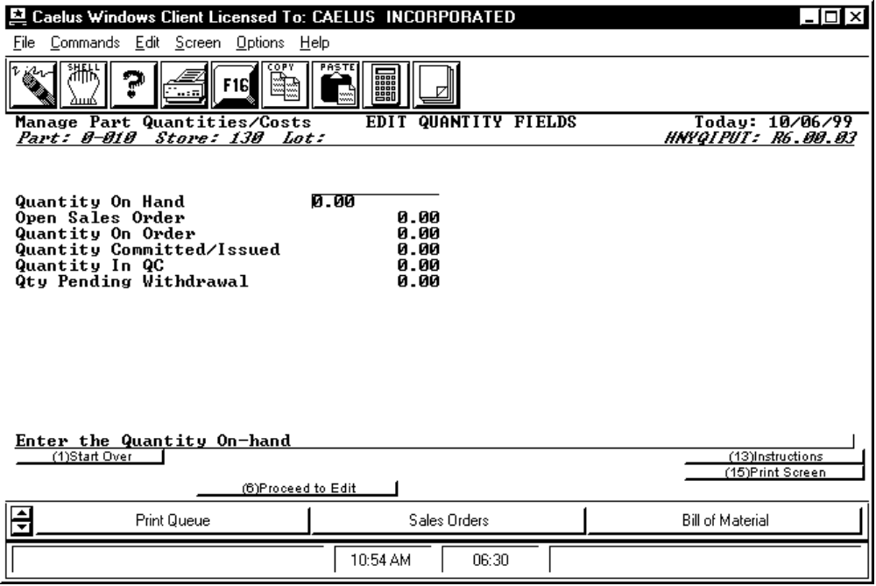

PROCEDURE DISCUSSION

You can edit the information on this screen only if you run this program in Security mode. The quantity fields displayed on this screen are each a maximum of 10 digits. When creating a new lot quantity record, the default quantity for each field is zero (0.00).

Data Field Definitions

Quantity On Hand The quantity currently in stock for this part/store/lot combination.

Open Sales Order The quantity of this lot currently sold to customers but has not yet been reported as shipped. This is equivalent to the backordered quantity. This is a subset of the on-hand quantity shown above.

Quantity On Order The quantity currently shown on open purchase orders for this part/store/lot, or if the part is a manufactured part, this is the quantity currently being built in production jobs. If the part is both purchased and manufactured in-house, this quantity can be the result of both open purchase orders and open jobs.

Quantity Committed/Issued The quantity of this part/store/lot that was issued to currently open production jobs. These units may or may not still be available for use in emergencies. The value of these units was posted to WIP and may, in fact, already be re-posted into inventory with any finished products reported complete by the job.

Quantity In QC This is the quantity received from a vendor into quality control and is yet accepted into on-hand inventory.

Quantity Pending Withdrawal The quantity of the part/store/lot currently involved in an inventory withdrawal transaction is not completely posted.

Active Function Keys

The Function keys available on most screens when in Edit Mode are listed below. Refer to the screen examples and discussions later in this document.

F 2, 3, 4, and 5 allow you to move forward and backward through the various screen/pages of lot quantity record data.

F8 Check Status Press this key to view the Balance Display Screen. This screen displays the on-hand quantity on file and the total quantity of the pool records, and compares them to see if they are in balance. See the discussion below.

F16 Save Data Press this key to display the lot quantity data to save to the HNYQUAN file. However, if the lot quantity data is not balanced with the Lifo/Fifo Pool record data, the Out of Balance screen appears, prompting you to correct the situation.

F20 Edit Pool Items (Not available in display mode) Press this key to display the Pool Record Display screen as described later in this document. From there you can review or edit data for any lifo/fifo pool record.

F25 Edit Text Activates the System Text Management function for entry or edit of free text. See the System Module Reference Manual for more information.

F28 Combine Pool Records (Not available in display mode) Combines all the individual pool records for this part/store/lot into a single record having a quantity equal to the total of the old individual records and a per unit cost equal to the weighted average of the old records.

SCREEN EXAMPLE: Unit Cost Screen

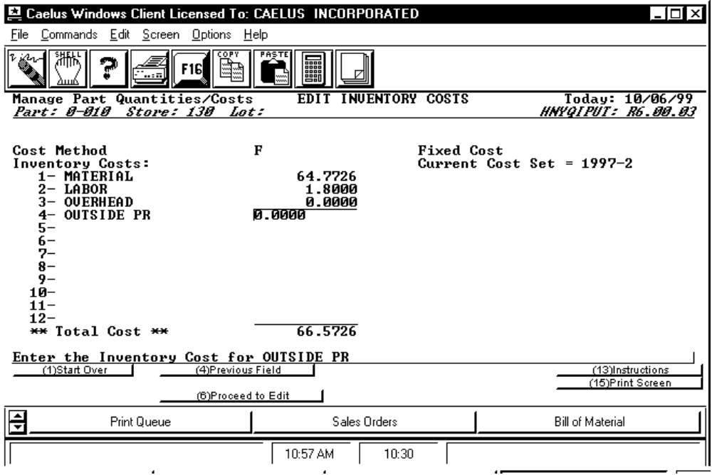

PROCEDURE DISCUSSION

You can edit the information on this screen only if you run this program in Security mode. This screen displays the cost method for this part/store/ lot and the average unit cost of the current Lifo/Fifo Pool Records.

Cost Method Enter the alpha character identifying the inventory valuation method to use when calculating the value of this part/store/lot. The valid choices are listed below. See the definitions and discussion of each of these choices in the Submodule 20 Overview.

R Actual LIFO W/ Auto Error Correction
X Actual LIFO W/ Adjustment Posting
P Actual FIFO W/ Auto Error Correction
Y Actual FIFO W/ Adjustment Posting
S Standard Cost W/ LIFO Treatment
T Standard Cost W/ FIFO Treatment
F Fixed Standard Cost
A True Average Cost
B Modified Average Cost
M Last Cost
L Manual Cost
The valuation method you choose for a part/store/lot determines the method the system uses to calculate the per unit cost of the inventory in the part/store/lot. The valuation method also determines how the system handles cost adjustments. For more information on each of the valuation methods listed on the previous page, see the discussion of Valuation Methods in the Submodule 30 Overview.

Current Cost Set Displays the current cost set implemented for your inventory.

Inventory Costs Displays the cost buckets in the current cost set and the weighted average of the costs associated with each bucket for one unit of the part. You can change the standard cost sets through the functions available in the Standard Costing module. See the Standard Costing Module Reference manual for more information.

Total Cost The costs shown on this screen are the weighted average cost of the lifo/fifo pool record broken down according to the active cost set. This set of costs is retained in the quantity record for use when the quantity of this lot is drawn negative. In such cases, this unit cost is used to value the overdraft. When the quantity is replenished, adjustments are posted. Therefore, when the lot on-hand quantity is negative, these fields show the average of the last pool records before the lot was overdrawn.

SCREEN EXAMPLE: Default GL Accounts Screen

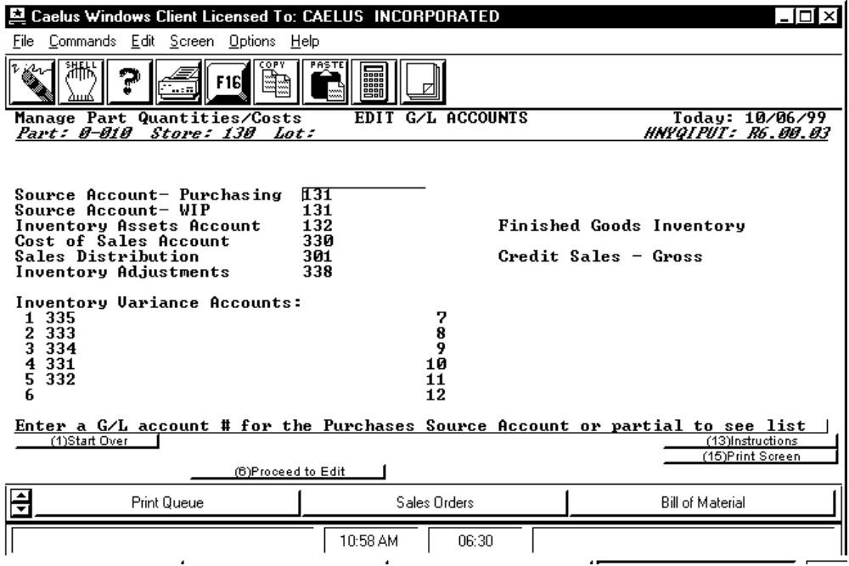
PROCEDURE DISCUSSION

The GL accounts on this screen are accounts that the system posts when you process transactions for this part/store/lot. The default is from the part master file record. You can edit the information on this screen as necessary.

Data Field Definitions

Source Account The valid GL accounts credited with goods are received into on-hand inventory. You can specify both a Purchase and a WIP account for the part/store/ lot. If the part enters the part/store/lot from WIP, then the system posts the WIP source account. If the part enters the part/store/lot from a purchase, the system posts the Purchases source account. For more information on the posting actions during inventory transactions, refer to the discussions in the INV-30 Submodule Overview.

Inventory Assets Account The valid GL account debited with goods received into on-hand inventory and credited when goods are issued to a job or shipped.

Cost of Sales Account The valid GL account to debit the cost of inventory items sold when sales invoices are processed to receivables. The offsetting entry is a credit to either the interim asset account, if pre-invoicing is used, or the inventory asset account, if pre-invoicing is not used. See the Order Processing Reference Manual for more information.

Sales Distribution The valid GL account credited with sales invoices are processed into receivables.

Inventory Adjustment Account This account is used in special cases where adjustment postings are required. Specifically such adjustments occur: a) when an cost adjustment is determined and insufficient inventory exists over which to spread the adjustment; b) if inventory is drawn negative, then replaced, and if the replacement exactly equals the negative quantity and the cost is different, this account is posted with the difference.

Inventory Variance Accounts The accounts shown here are used to post variances to standard cost when entering parts into this part/store/lot. You can set up as many as 12 variance accounts. This posting occurs on additions to inventory if the inventory valuation method for the part is one of the three methods involving standard costing. These accounts should parallel the cost buckets specified for the active cost set for this part/store/lot shown on the previous screen.

SCREEN EXAMPLE

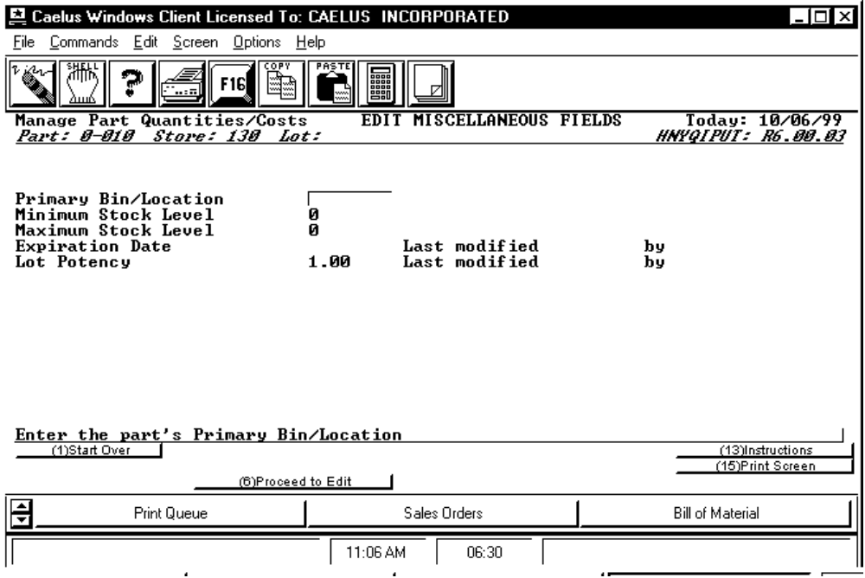

PROCEDURE DISCUSSION

The data fields on this screen control miscellaneous features in CMS processing.

Data Field Definitions

Primary Bin Location The primary bin location for this part/store/lot. The default is the bin location on file in the part master record. This field allows you to record the normal or standard location for this part/store/lot. The contents of this field prints on job picklists showing where this part may be found. This location is not updated by actions in other areas of the system such as physical inventory counting or warehouse location management functions.

Minimum Stock Level This field is not the same as the safety stock quantity on file in the part master record. This field, together with the one below, is provided to allow MIN-MAX reporting functions.

Maximum Stock Level This field is not the same as the surplus quantity determined by the CMS planning system (as Safety Stock plus 1 X MOQ). This field, together with the one above, is provided to allow MIN-MAX reporting functions.

Expiration Date Enter the date on which this lot expires and is to be removed from inventory. If the date you enter is within the current CMS planning calendar, the system writes a special PIPOUT for the lot quantity to record the fact that the lot will expire. The PIPOUT tag number will contain a “EX” prefix, followed by a lot # and expiration date. The PIPOUT date is this date plus the 'ATC horizon' on file in the part master record. In this way, as time passes and the ATC horizon falls on or after the PIPOUT date, the ATC is reduced by the quantity of the PIPOUT. Any time you make a change to this field, the system saves your USERID and the date of the change. The position of the PIPOUT is changed to reflect the new expiration date. PIPOUTs are created during the planning calendar rolling process for expiration dates beyond the end of the old calendar. The fields to the right display the USERID and the last date the expiration date was modified. expiration date.

Lot Potency Enter the actual potency of this lot of material. This data is used in the Shop Floor Control Module to generate job picklists showing the adjusted quantity of the necessary components, based on the actual potency of the component lots selected to use in the job. See SFC-30-JBPOTPRT for more information. Any time you make a change to this field, the system dates it and saves your USERID. The fields to the right display the USERID and the last date the expiration date was modified.

SCREEN EXAMPLE

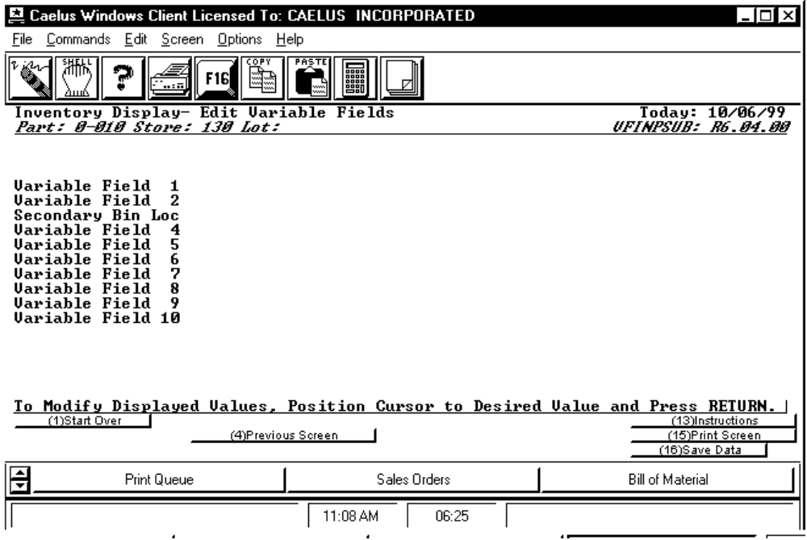

PROCEDURE DISCUSSION

This fifth and last screen is controlled through the User Defined Fields feature. Each of up to 10 fields that appear on the screen are controlled by you and can be customized to prompt for any additional data not included in the standard CMS quantity master file fields described above. For more information on setting up this screen, refer to the documentation for the VFDEFINE program in the System Module Reference Manual.

SCREEN EXAMPLE

The following screen appears when you press F8 from any of the preceding screens.

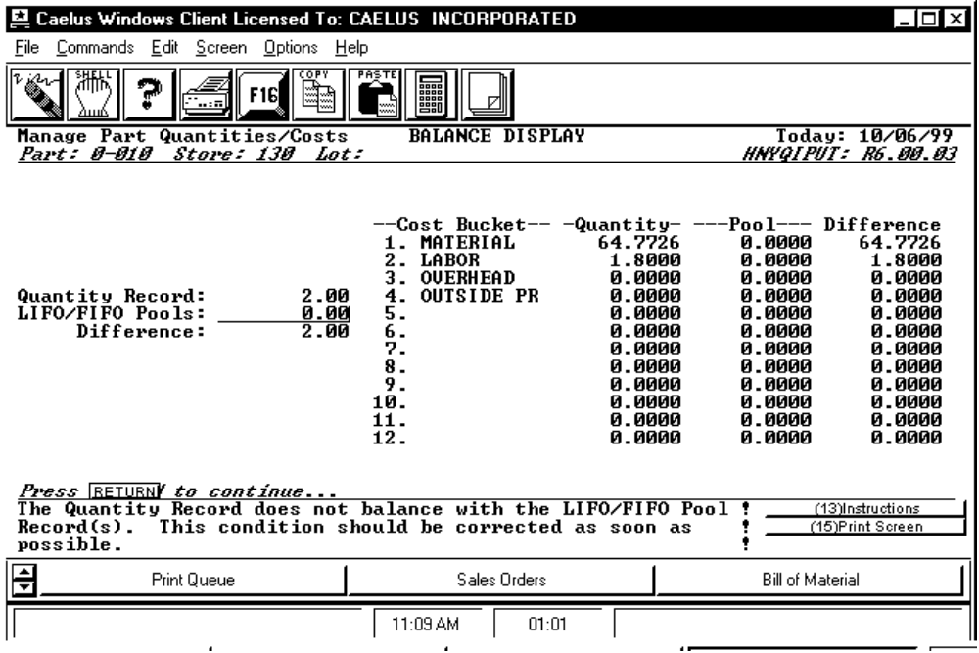

PROCEDURE DISCUSSION

This screen allows you to 'check the status' of the balance between the data in the lot quantity record and the data in the lifo/fifo pool records. Press RETURN to return to the screen from which you came.

SCREEN EXAMPLE

This screen is displayed any time you press F20 to 'edit pool items' from any of the lot quantity data display screens (not available in display mode).

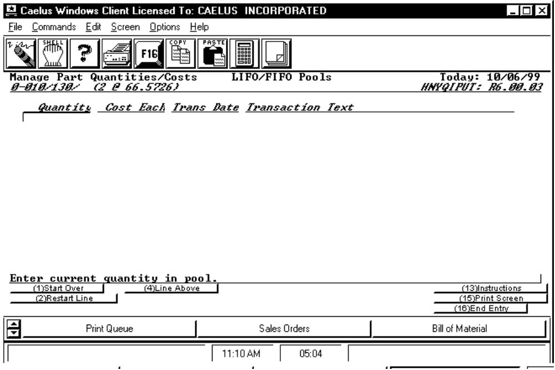

PROCEDURE DISCUSSION

The example shows a multiple pool record which is consistent with the valuation method used in the example. However, for lots valued according to a single pool method, the screen would show only a single pool record. Each record contains the quantity currently in that unique pool, the per-unit costs, the date the pool was created, and posting text explaining the source of the pool quantity.

You can edit any data by positioning the cursor and pressing RETURN. When you edit the Cost Each field, you see the screen change. This function allows you to manipulate costs within each pool (see INV-30 HNYCDIST for more information). Type in your changes and then press RETURN again to set the changes. Press F1 to start over if you make a major mistake. F 2, 3, 4, and 5 allow you to scroll the list of pool records one screen/page at a time. F6 and F7 allow you to scroll the list up and down, one line at a time.

Active Function Keys

F9 Header Causes you to return to the lot quantity display screen from which you accessed the pool records screen.

F11 Insert Move the cursor to the position you wish to insert a new pool record and press this key. The system prompts you for each data field, one at a time.

F12 Delete Position the cursor to select a pool record and press this key to delete the record. The system prompts you to confirm your intention before the deletion actually takes place.

F16 Write Data Press this key to save the displayed pool record data to the appropriate file (HNYPOOL). If you have made any changes causing an imbalance between the pools and the lot quantity record, the 'Out of Balance Screen' is displayed. See the example and discussion below.

SCREEN EXAMPLE: Out of Balance Screen

The following screen displays if you attempt to SAVE DATA (F16) after causing an imbalance between the pool record quantities and the Inventory Quantity record for the part/store/lot.

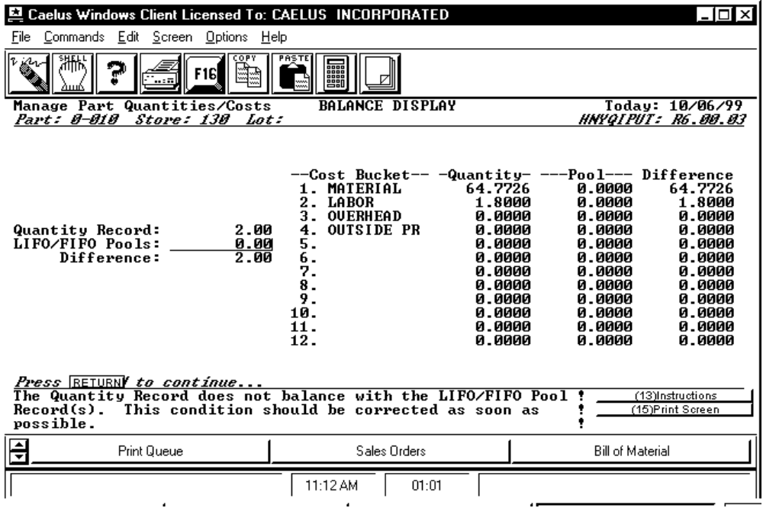
PROCEDURE DISCUSSION

The Function key selections present your alternatives. You must execute one of the Function keys to exit this program if the quantity records are out of balance.

Active Function Keys

F4 Modify the Quantity Record Press this key to return to the quantity screen, for modification of the lot quantity record and balance within the pools. The system can be out of balance for cost, quantity or both so you must make adjustments accordingly. F16 provides an automatic method of making changes to the lot quantity data. See below.

F8 Modify the LIFO/FIFO Pools This key returns you to the pool record display. From there you can bring the system into balance by editing any displayed pool data.

F14 Exit without balancing Press this key to exit this administrative function, leaving the system out of balance. The system prints an out of balance report for the part/store/lot when you exit this function. (See the report contents and sample report at the end of this document.) You can return later to set things straight, but, as long as the system is out of balance for this lot, this screen will display when you save data from this function in the future.

F16 Set Quantity Records = Pools Press this key causing the system to reset the lot quantity data which balances the pool record data. When you press this key, the system automatically calculates and implements the adjustments and returns to the first screen for selection of the next part/store/lot. From there you can press F16 again to exit this administrative function entirely.

REPORT CONTENTS

PART CODE
PART DESCRIPTION
STORE
LOT
ORIGINAL
QUANTITY
COST EACH
CURRENT
QUANTITY
COST EACH
CHANGE
QUANTITY
COST EACH

Report Example: Quantity/Pool Record Out-Of Balance Report (HNYQIPUT)

RUN DATE: 06/19/87 10:53 AM C A E L U S A S S O C I A T E S , I N C . HNYQIPUT-HNY003
USER: JWD DIRECT INVENTORY QUANTITY/COST ADJUSTMENT AUDIT LISTING PAGE: 1

** O R I G I N A L ** *** C U R R E N T *** **** C H A N G E ****
PART CODE PART DESCRIPTION STORE LOT QUANTITY COST EACH QUANTITY COST EACH QUANTITY COST EACH
------------------------- ------------------------ ----- ------ ---------- ---------- ---------- ---------- ---------- ----------
5-010S SERIAL NUMBERED PHONE 100 5-010S 4.00 8.0000 3.00 8.0000 -1.00 0.0

