PRINT PART NUMBER LISTS

PURPOSE

Print a variety of part number lists.

GENERAL DISCUSSION

Use this program to generate any or all of 19 different inventory reports. You select the report to generate by moving the cursor to the report description and pressing RETURN. Many of the reports require no other input. However, certain reports require you to enter selection criteria. For a description of the selection criteria and a description of the content of each report, please refer to the REPORT SUMMARY DISCUSSIONS section, below.

A screen message appears if a file necessary for a particular report does not exist or contains no records.

Inventory quantities are shown to four decimal places. Costs and such items as MOQs and Safety Stock levels are shown to two decimal places.

This program now supports the Management Values Enhancement (see Release Notes for R6.01.00).

SCREEN EXAMPLE

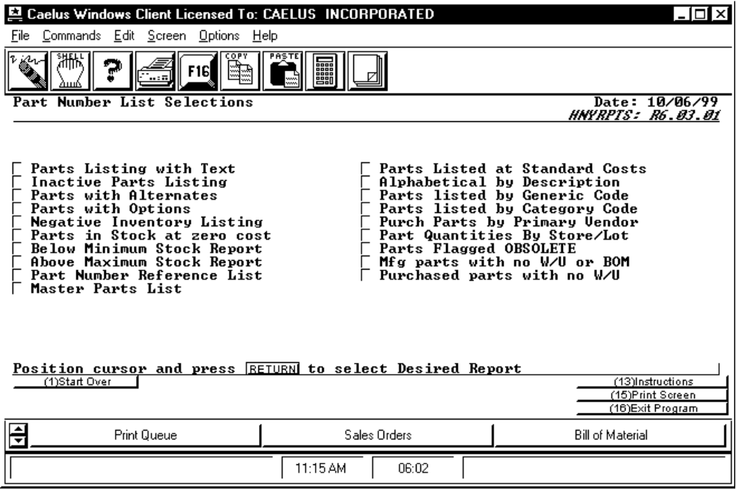

PROCEDURE DISCUSSION

Position the cursor next to the report you wish to print and press RETURN. Most reports allow input of various selection criteria. If any of these reports are chosen, a screen appears to provide the entry fields for the selections (see the screen example following the report descriptions).

REPORT SUMMARY DISCUSSIONS

Parts Listing With Text Select a range of part numbers, part categories, and part type to include on this report. The report shows each part for which text is defined and the text associated with each part.

Inactive Parts Listing You can select a range of part numbers, a range of part types, and the number of inactive days that qualify a part to appear on this report. For this report, the system inspects the inventory transaction detail file (HNYDETAL) and prints a record of every part that has not had a transaction recorded for it within the specified period of time. Records are printed in part number sequence. This report is part-specific rather than lot-specific. For each part record, this report displays the part description, last transaction date, the ID of the user who entered the last transaction, and last transaction description. This report prints up to 51 records per page.

Parts With Alternates You can include a range of part numbers and types on this report. This report lists all parts within the selection criteria that have alternate parts assigned to them. For each part, the alternates are listed. Descriptions are shown for each primary part and each alternate. The report is printed in part number sequence by the primary parts. This report prints up to 51 alternate parts per page.

Parts With Options You can include a range of part numbers and types on this report. This report lists all parts within the selection criteria that have option parts assigned to them. For each part, the options are listed. Descriptions are shown for each primary part and each option part. The report is printed in part number sequence by the primary parts. This report prints up to 51 option parts per page.

Negative Inventory Listing You can include a range of part numbers, part types, and store numbers on this report. This report is printed in part/store/lot sequence and shows only those part/store/lot combinations that have a negative inventory quantity. For each record the part number description, store, lot and quantity (negative) is shown. This report prints up to 51 part/store/lot combinations per page.

Parts in Stock at Zero Cost You can include a range of part numbers, part types, and store numbers on this report. This report shows part/store/lot records having no costs on file. The report is printed in part/store/lot sequence and the description, part type, and current lot quantity are shown for each record. Zeros are shown for the total of the inventory in the part/store/lot. Negative and zero quantities are shown. This report prints up to 51 part/store/lot records per page.

Below Minimum Stock Report You can include a range of part numbers, part types, and store numbers on this report. To generate the report, the system inspects all lot records for all parts in the specified warehouse(s). It evaluates each lot record for the smallest minimum stock level assigned to the record that it finds for the part in each warehouse. It accumulates the quantities in each lot record, and if the total quantity for all lots of a part in a warehouse falls below the smallest minimum stock level, it is reported on. BEWARE, this report may not be appropriate for users who have assigned a different minimum level for individual lots of a given part in the given store. The report is printed in sequence by store code and part sequence within each store. For each part reported, the description is shown along with open sales order quantity, the on order quantity, the total quantity on-hand (combined quantity in all lots of that part within the warehouse), the minimum (as determined by the first lot record), and the total quantity under the minimum. A blank line is used to indicate the start of the records for the next store. This report prints up to 51 records per page.

Above Maximum Stock Report You can include a range of part numbers, part types, and store numbers on this report. To produce the report, the system inspects all lot records for all parts in the specified warehouse(s). It evaluates each lot record for the largest maximum stock level assigned to the record that it finds for the part in each warehouse. It accumulates the quantities in each lot record, and if the total quantity for all lots of a part in a warehouse grows above the largest maximum stock level, it is reported on. If a maximum value of zero or a blank is encountered in the record, it is assumed the record has not been maintained and the maximum is large, i.e., 900,000,000. BEWARE, this report may not be appropriate if you have assigned a different maximum level for individual lots of a given part in the given store. The report is printed in sequence by store code and part sequence within each store. For each part reported, the description is shown along with the total quantity on-hand (combined quantity in all lots of that part within the warehouse), the maximum (as determined by the first lot record), and the total quantity above the maximum. A blank line is used to indicate the start of the records for the next store. This report prints up to 51 records per page.

Part Number Reference List You can include a range of part numbers, types, and categories to include on this report. This report is a simple list of all parts on file printed in part number sequence. The description is shown next to each part. The report is arranged in two columns with the last half of the parts appearing in the right hand column. This report prints up to 100 parts per page.

Master Parts List You can include a range of part numbers, types, and categories on this report. In this report, all parts within the selection criteria are printed in part number sequence. The basic information is shown for each part including description, units of measure, category and ABC codes assigned, part type, leadtime, MOQ, safety stock, and procurement increment ('pansize'). This report prints up to 51 parts per page.

Parts Listed at Standard Cost You can include a range of part numbers, types, and categories on this report. All parts within the selection criteria that have standard costs associated with them appear on this report. The report also includes the description of the part, the part type, category, and the total per unit standard cost of each part. The report prints up to 51 parts per page.

Alphabetical by Description You can include a range of part numbers, types, and categories on this report. This report lists all parts within the selection criteria in part description sequence. The part number is shown next to each part description. The report is arranged in two columns with the last half of the parts appearing in the right hand column. The report prints up to 100 parts per page.

Parts Listed by Generic Code You can include a range of part numbers, types, and generic codes to on this report. CMS Generic Part Codes, often called 'industry standard part numbers', and can be assigned to inventory parts to indicate that one or more of your part numbers are equivalent to the industry standard number or generic. The report shows all parts that have been assigned each generic code. The report is preceded by a list of all parts that do not have a generic code assigned. The rest of the report is printed in generic code sequence and part number sequence within each generic code. The full description is shown for each generic code. For each part, the part description, category, primary vendor and part type are shown. The report prints up to 52 records per page. A plank line is used to indicate the start of the next generic code.

Parts Listed by Category Code You can include a range of part numbers, types, and categories on this report. The report shows all parts that have been assigned each category code. The report is preceded by a list of all parts that do not have a category code assigned. The rest of the report is printed in category code sequence and part number sequence within each category code. The category description is shown for each category code. For each part, the part description, generic part number, primary vendor (if one is assigned) and the part type are shown. The report prints up to 52 parts per page. A plank line is used to indicate the start of the next category code.

Purchased Parts by Primary Vendor You can include a range of part numbers, part types, and vendor codes on this report. The report shows all purchased parts that have been assigned each vendor code. The report is preceded by a list of all parts that do not have a primary vendor code assigned. The rest of the report is printed in vendor code sequence and part number sequence within each vendor code. The vendor description is shown for each vendor code. For each part, the part description, lead time, buyers (both buyer and scheduler codes) MOQ, Safety Stock, procurement increment ('pansize'). The report prints up to 52 records per page. A plank line is used to indicate the start of the next vendor code.

Part Quantities by Store/Lot You can include a range of store numbers, part numbers, and category types on this report. The report lists each store/lot within the selection criteria and each part number associated with each store/lot. The report also prints the part description, on-hand quantity, backordered quantity, on order quantity, committed quantity, and in QC quantity for each part printed. If more than one of the same part is printed consecutively, a part total is printed before the next different part. The report prints up to 51 parts per page.

Parts Flagged as Obsolete This report prints a list of all parts on file that have been marked as obsolete (by setting the obsolete flag in the part master record). The report is printed in part number sequence. The description is shown next to each part. The report is arranged in two columns with the last half of the parts appearing in the right hand column. The report prints up to 100 parts per page.

Mfg Parts with no W/U or BOM This report shows all parts on file that cannot be found as components (no "Where Used") in any higher level assembly and/or have no bill of materials of their own. All bills of materials on file are searched, not just the effective bills. The report is printed in part number sequence. For each part found, the description is shown along with a message that if the part is NOT USED in any higher parts and another message if the part has no bill of materials of its own. If the part is generic (part type 000) this is indicated in a message under the column heading 'GENERIC?'. The report prints up to 51 parts per page.

Purchased Parts With no W/U This report prints a list of all purchased parts that cannot be found as components (no "Where Used") in any higher level assemblies. All bills of materials on file are searched, not just the effective bills. The report is printed in part number sequence. The description is shown along with a message that the part is NOT USED IN ANY BILL OF MATERIALS. The report prints up to 51 parts per page.

SCREEN EXAMPLE

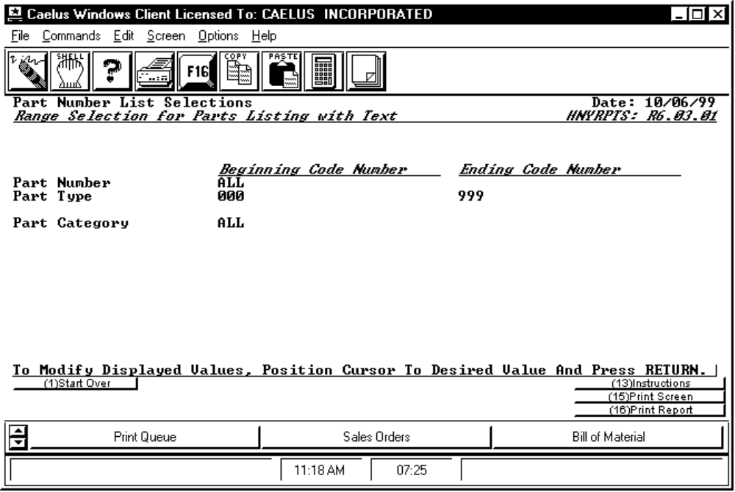

PROCEDURE DISCUSSION

Use this screen to enter the selection criteria for the reports that require it. The screen appears with differing selection criteria depending on the information required for the report you chose. The example screen above lists all of the possible selection criteria that can appear. However, these criteria never all appear on the screen for a single report.

