PRINT PICKLISTS AND TRAVELERS

PURPOSE

To print a group of shop floor and inventory documents for a job.

GENERAL DISCUSSION

You Cannot Run this Function Directly

This function is a "subroutine"; it is accessed only when you run a program that is defined to use it. You can not place a subroutine on normal CMS menus nor can you run it using the "Direct Run" option on the menu screen. For a complete list of the programs that use this subroutine, run the program DCWHEREU and enter the subroutine name. Press F14 to display a list of the programs that call this subroutine. For more information, see the discussion of DCWHEREU in the System Element Structures Reference Manual.

You can use this function to print any combination of the following documents:

o Picklist
o Traveller
o Single-Level Parts List
o Byproducts List
o Vendor Service Sheet

Picklist

The job picklist (also known as a "kit list") is a list of the parts required for a job. Blank spaces are provided to allow the entry of the actual quantities kitted and the dates that they were kitted to the job. Spaces are also provided for specifying serial numbers of components if the components are flagged for serial number tracking. You can also print bin numbers for components on the picklist if the bin numbers are on file and if the "Should Bin Locations Be Printed On Pick Lists ?" flag is set to "Y" in the program JBFLAGS.

Picklists can also be generated with a specified number of extra lines for each component on the list. These lines can be used by inventory personnel to show locations or other information for the component parts kitted to the job.

Picklists can be printed for a range of production jobs through this function. After selecting the range of jobs and entering other information discussed below, a picklist for each job is printed.

You cannot use this function to print picklists for projects. To print a project pick list, run the program PRJPICKL.

Traveller - Summary or Detail or Both

These documents show the capacity reserved for the job as defined through either the planning system or the function JBINPKIT. Blank spaces are provided on the detail traveller to allow the entry of actual movement information between work centers and activities on the shop floor. CMS provides a flag in the function JBFLAGS that you can use to indicate which traveller should be printed. You can also choose to print both travellers. If you have not created capacity reservations for the job through planning or JBINPKIT, then the detail traveller cannot be printed. In this case, the summary traveller is printed from the 'route to use' specified when you opened the job. This route is set up in the function RTEINPUT (see the Workcenters and Routes Reference manual for more information).

Single-Level Parts List

This report contains information from the Bill of Materials of the assembly. The report shows a list of components and the batch quantity, marker, and fixed quantity per run for each component. This list is printed in bill of materials order.

Byproducts List

If you have set the planning flags to allow for byproducts from manufacturing (through the function PLNFLAGS), and if you have specified a negative quantity to kit for a component in the assembly's bill of materials, then this report contains the part number and the planned quantity of the byproduct that will be added to inventory. Blank spaces are also provided for entry of actual quantities and the destination store/lot for the byproduct.

Vendor Service Sheets

If a route step is for outside processing by a venodr (vendor service), a sheet that lists the known information about this step will be printed.
SCREEN EXAMPLE: Print Selected Job-Related Documents

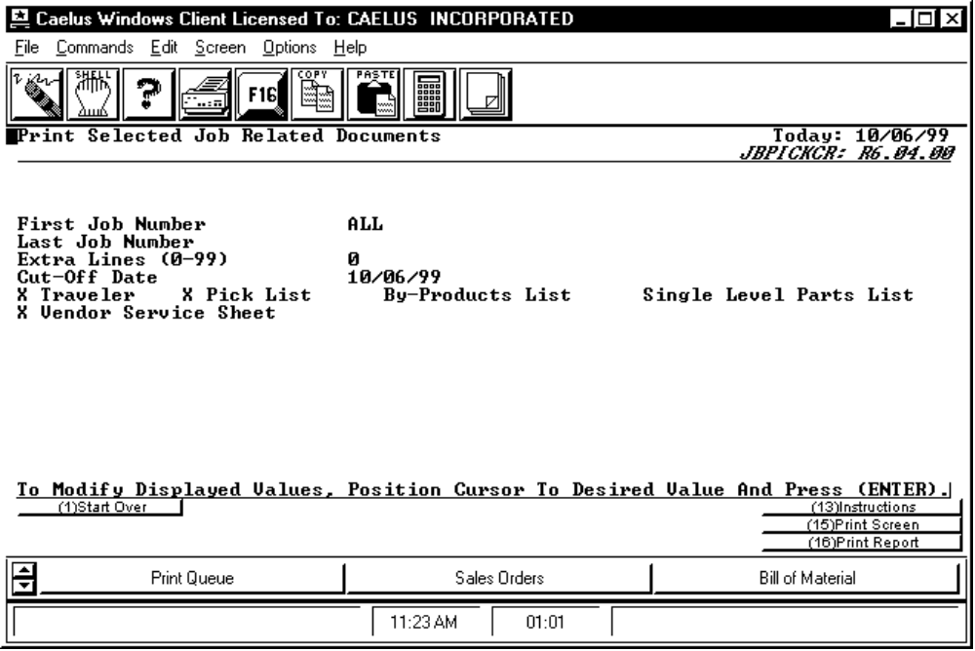

PROCEDURE DISCUSSION

Enter the first and last job number of the range for which picklists are to be printed or "ALL". Remember that the first job must precede the last job in sort sequence. (Spaces and special characters like dashes precede numbers which precede letters.) F14 is available when the screen is in input mode; it allows you to view the list of jobs in the job master file and select one.

Data Field Definitions

Extra Lines (0-99) Specify the number of extra blank lines for recording store/lots from which each part is picked. The standard picklist contains two blanks for each part allowing for the picklist to clearly show the part picked from two separate store/lots. The default for extra lines is 0 indicating no extra lines.

Cut-Off Date The bill of materials to be used for the job contains "pick before step" information for each component part. The system translates this information into actual "pick before" dates to provide the ability to "split pick", that is, pick components proximate to the time they are actually needed in the process. This print picklist function can be run again and again to print picklists for the various components that are due to be kitted to the job at different times over the course of the process.

DOCUMENT CONTENT AND FORMAT

Material Requirements List (Picklist)

One picklist is printed for each job of the range. Only those parts remaining to be issued to the job, allowing for the cut-off date constraint imposed above, are printed. Each picklist contains a header showing the job number, quantity to build, part number to build, start date, and first workcenter of the routing process.

For each component part to be picked, the part number and description, the unit of measure, pick-by date, and quantity required are shown. An asterisk located to the right of a part number, indicates that an alternative part number exists for that line item. Beside this information, blank spaces are included in which you can enter the quantity actually issued to the job and the store/lots from which it was issued. If components are tracked by serial numbers, then a space is provided for one serial number from each known store/lot of the component part. If the job's part to build is also serialized, then a space is provided to the left of the component serial number for the parent serial number that is to contain that component part.

Summary Traveller

The summary traveller includes a header showing the job number, part to build, the route used, and the run quantity. Next, the report shows a list of the steps in the route. For each route step, the report shows the workcenter, the range of time (in days) that the job is expected to be in that work center, and the activity performed in that workcenter. If no workcenter capacity has been reserved for the job, the date ranges appear as blanks.

Detail Traveller

The detail traveller contains the same header information as the summary traveller, but has more information on the planned route steps. The report shows four time fields associated with each route step: Move/Queue, Set Up, Run Time, and Other. For each of these categories, the report shows the planned time (in hours) and provides a blank space for the entry of the actual time in each category. The report also shows four material fields for each route step: Material In, Material Out, Material To Scrap, and Material To Rework. For the Material In and Material Out categories, the report shows the planned quantity of the assembly to pass through the workcenter. for each of the four quantity fields, blank space is provided for the entry of actual quantities. Note: If you have not allocated workcenter capacity for this job, the detail traveller is not printed.

Single Level Parts List

The single-level parts list provides some basic information on the structure of the assembly. The header contains the part number, BOM ID, and the batch quantity to produce. The rest of the report is a list of components for the assembly. For each component, the report contains the component name, the batch total quantity, the component marker, and the component fixed quantity per run.

Byproducts List

The job byproducts list shows all the byproducts expected from the production of the assembly. This report contains the job number, the assembly part number, the job quantity to build and the job start date. For each byproduct expected from the job, the report shows the byproduct's part number, the expected date, the planned quantity of the byproduct, and the unit of measure of the byproduct. The report provides blank spaces for the entry of the actual byproduct quantity produced, the bin it was moved to in inventory, and the inventory store/lot associated with that quantity.

Vendor Service Sheet

The Vendor Service Sheet lists the vendor and address, purchase order, purchase order line number, vendor contract, vendor contract line number, job number, workcenter, shipper, ship date, ship quantity and service activity.

