VERIFY/VALIDATE PIP DETAILS

PURPOSE

To verify and validate PIP data (withdrawals and procurements) and workcenter data against corresponding transaction files. To adjust the records in the PIPIN and PIPOUT files to match the original transaction files when discrepancies are found and to delete records in the WCOUT file when a corresponding transaction does not exist. To optionally report on the action taken.

GENERAL DISCUSSION

Use this program to change records in the PIPIN, PIPOUT, SFCUM2, SFMASTR2 and WCOUT files to reflect the information of the "source" transaction. USE THIS PROGRAM WITH CAUTION...BE AWARE OF THE IMPLICATIONS IN YOUR DATABASE BEFORE RUNNING IT!!!

A difference between the original transaction and the corresponding record in the PIP files could be the result of a system crash that corrupted files during update processing; for example, the transaction may have only been partially recorded in the PIP files or not recorded at all.

The Role of PIPVRFY

This program allows you to align the PIP detail files (PIPIN and PIPOUT) and the workcenter detail file (WCOUT) with the other files in CMS that record the results of planned or actual material transactions. You can select the type of transaction that the system checks. The program checks the contents of transaction records throughout CMS and adjusts the PIP detail files and the WCOUT file with the results of the check. The check is performed in two possible ways:

Validate Check the PIP additions and withdrawals and the WCOUTs to determine if each PIP and WCOUT record has a corresponding transaction record. If the PIP record shows a different quantity for the transaction than the transaction record, then the program adjusts the PIP record to the quantity shown on the transaction record. If the WCOUT record does not have a corresponding record in the Production Job Master file, then the program deletes the WCOUT record.

Verify Check CMS transaction files and determine if a PIP record exists for a given transaction and create missing PIPIN or PIPOUT records and adjust the PIPMASTR accordingly. Again, if the PIP record shows a different quantity for the transaction than the transaction record, then the program adjusts the PIP record to the quantity shown on the transaction record.

In normal CMS processing, the PIP should reflect exactly the information contained in the transaction records throughout CMS.

Other Programs to Use with PIPVRFY

PIPVRFY provides visibility to the imbalances it finds or the changes it makes, via a Function Key after all records are processed. If you need to know what is out of balance before running PIPVRFY, you should run PIPCHECK first. PIPCHECK will list the out of balance conditions. You can then run PIPVRFY to correct differences between the original transaction and the PIP files. It is a good idea to then run PIPCHECK again to see if there are still out of balance conditions that PIPVRFY does not correct. If there are other problems, you can make corrections on a part-by-part basis by running HNYINPUT and restoring the PIP for a specific part or by running PIPRESTR, which restores the PIP for all parts.

Review of the Planned Inventory Position (PIP)

PIP data is stored in three files:

PIPOUT Each planned withdrawal indicated for each part for each day of the planning calendar.

PIPIN Each planned addition indicated for each part for each day of the planning calendar.

PIPMASTR The PIP master file containing the sum of planned additions and withdrawals for each day and the present on-hand inventory.

The planned additions and planned withdrawals files provide the details of planned transactions recorded on the PIP. The PIP master file records the results of additions and withdrawals and allows comparison with current on-hand inventory.

Each released planned addition and planned withdrawal has a corresponding detail record elsewhere in CMS. When you record a released planned addition or withdrawal, CMS creates a complete record of the planned transaction and, at the same time, updates the PIP with the planned results of the transaction. We'll discuss this in more detail shortly, first let's look at an example.

Suppose you enter a purchase order for 10 part Zs. Among other information, the purchase order states the date that the order is due and the vendor. When you save the order, each line item is stored in a record in the Purchase Order Line Item file. At the same time, the program that saves the purchase order line item also updates the PIP with the information from the purchase order. In this case, the PIP is updated by:

- Adding a record to the planned additions (PIPINT) file. The new record shows the addition of ten Zs on the appropriate date and indicates the purchase order number of the order on which the addition was recorded.

- Updating the PIP master record for part Z to show the addition of ten Zs on the due date for the line item.

- Checking for and recording any problems created by the addition. For example, "Does this future addition throw the part into a surplus condition?"

Add and Withdrawal Transactions

The transaction recorded in the example above was a purchase order, which is by nature a planned addition to inventory. When you record a transaction that has an immediate impact on inventory, you affect the PIP records in much the same way as planned transactions do, with an extra processing step.

Since the PIP master file maintains the on-hand inventory, any transaction that adds or subtracts inventory must change the on-hand quantity stored in the PIP master file.

For example, when you record a receipt of goods on the purchase order entered in the example above, the update program records the quantity received in the purchase order files. The update program also records the new on-hand quantity in the inventory quantity file and in the PIP master file as well as decrementing or extinguishing the PIPIN.

SCREEN EXAMPLE: Check Contents of PIP Files Against Transactions

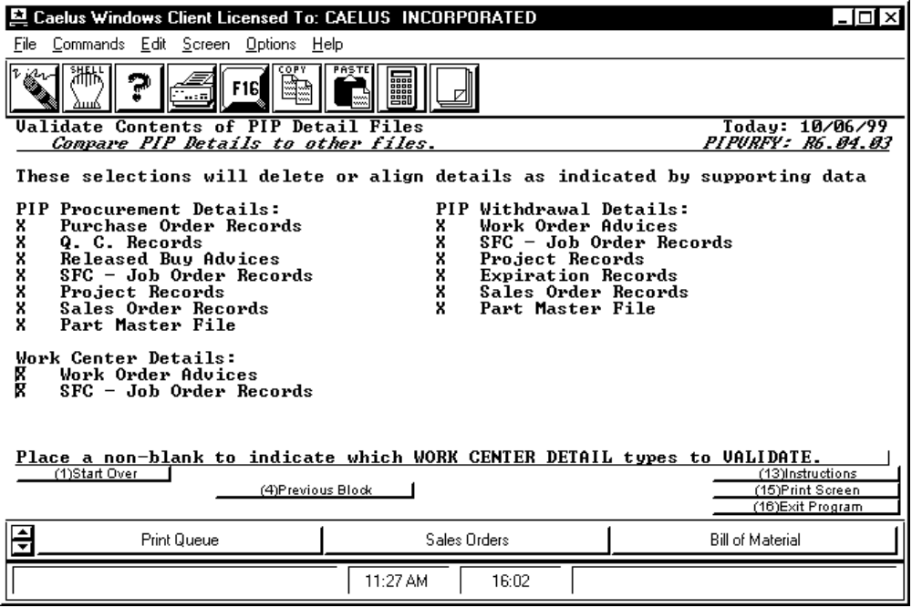

PROCEDURE EXAMPLE

This is the first screen of this program. It lists the kinds of transactions that you can have the program check in the PIP and WCOUT files. Mark the kinds of transactions you want validated. Those that are marked will be checked against the originating transaction. Differences found between the originating transaction and the PIP or WCOUT files will be changed; that is, the records in the PIPIN, PIPOUT, and/or WCOUT files will be changed to reflect the originating transaction. Each grouping must be marked separately. Press RETURN after marking each to continue. After pressing return on the last grouping, a second screen appears.

SCREEN EXAMPLE: Check Transactions and Verify in PIP Files

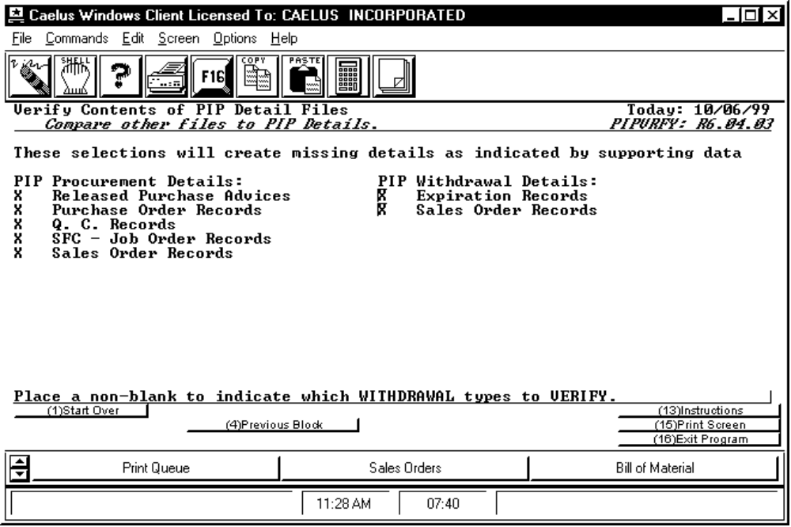

PROCEDURE DISCUSSION

This is the second screen of this program. It lists the transactions that can produce a PIPIN and a PIPOUT and allows you to mark those you want verified against the PIP files. Differences found between the originating transaction and the PIP files will be changed; that is, the records in the PIPIN or PIPOUT files will be changed to reflect the originating transaction. Make your selection and press F16 Verify Data.

