MANAGE BUYER/PART CROSS REFERENCE

PURPOSE

Assign purchase responsibility or authority to individual users by assigning buyer part class codes to each individual user. And, you can also designate the buyer as a Primary or Alternate.

GENERAL DISCUSSION

Use of this function assumes that 1) buyer part class codes have already been defined through the Enter/Manage Buyer part class codes procedure (PROCGC01), and 2) that buyer part class codes have already been associated with inventory parts through the Enter/Manage Part Master File program (HNYINPUT).

Here the assignment of responsibility for purchase of particular products is accomplished by listing for each individual, the buyer part class codes he/she is responsible for. A particular buyer part class code can be assigned to more than one individual. This would indicate that any of those persons is authorized to purchase the items marked in the master file with that buyer part class code. And, you can also designate the buyer as a Primary or Alternate for any buyer part class code. Purchase directives for the items/parts in question can hereafter only be generated by the persons responsible.

This system of restriction is activated as soon as any code is assigned to any individual user through this function.

A printed report is available showing which buyer part class codes are currently assigned to each individual user. You can generate the list for a range of users or all users.

A copy capability is provided to allow you to quickly set up a new user to have the same codes as another user. This function can also be used to add the codes assigned to one user to another user in which case the system will actually append the codes as currently assigned to the other user.

Note: A buyer part class code that is no longer a valid CMS user can be deleted from the scheduler file (PORELUSB) by entering the code in the first input screen and pressing RETURN. A selection screen is displayed. Press F16 without making any selection.

You are returned to the first screen where you see the message 'Scheduler number xxx is not a valid CMS user. Now deleted from the scheduler file'.
SCREEN EXAMPLE: USERID Input Screen

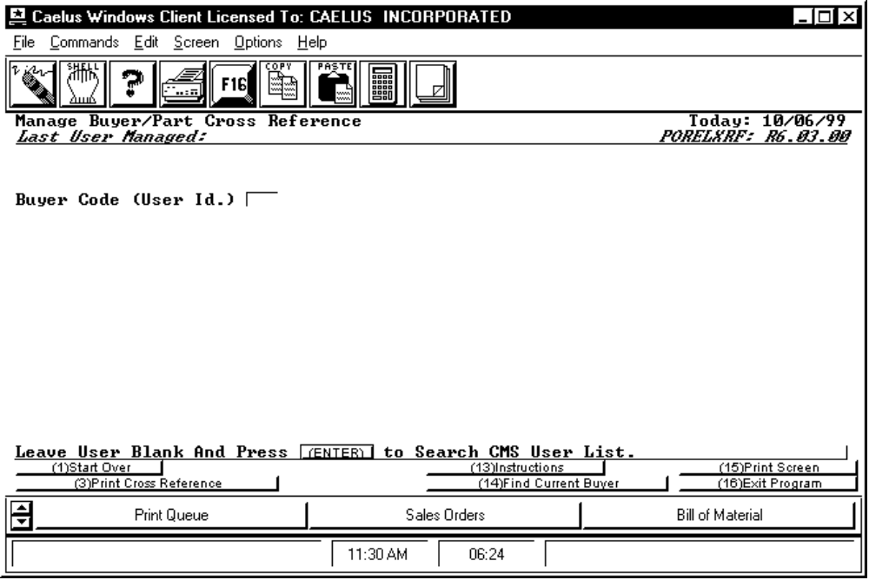

PROCEDURE DISCUSSION

Enter the user ID identifying the individual with whom you wish to associate buyer part class codes. If you do not remember the proper user ID, leave the field blank and press RETURN to see a list of all users for the CMS system. When you enter a valid user ID and press RETURN, the screen displays the buyer part class codes already assigned to that person. From there you can add more, delete any or all, or change the list in any way.

Active Function Keys

F3 Print Cross Reference To display the Print Selection Screen for selection of the range of user IDs to include on the report.

F14 Find Current Buyer To display a list of those persons currently assigned purchase responsibility.

SCREEN EXAMPLE: Buyer part class code Input/Display Screen

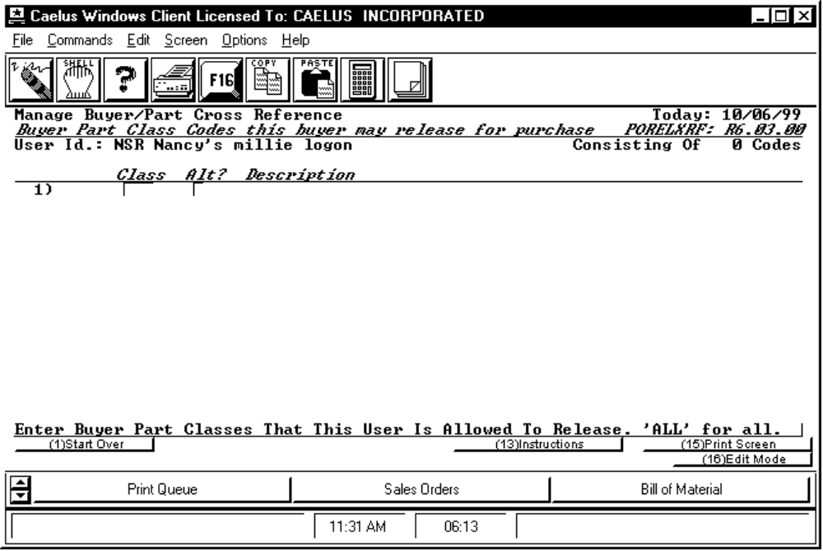

PROCEDURE DISCUSSION

The example above shows how the screen appears if no buyer part class codes have been recorded for the user. The input field prompts for entry of the buyer part class code you wish to assign to the user, and whether the buyer is a primary or alternate for the code.. If you do not remember what the exact code is, leave the field blank and press RETURN to see a list of all buyer part class codes. You can select from the list. A 'blank' in the Alt field indicates the buyer a a primary; a 'Y' indicates an alterante.

If you wish the user to have access to all buy orders and to generate directives for any part, enter the buyer class code = "ALL". When all the codes are entered, press F16 to display the list of codes. You can then edit the list or you can append to the list from codes assigned to a different user. The system will automatically sort out duplications.

SCREEN EXAMPLE: Display Assigned Buyer part class codes

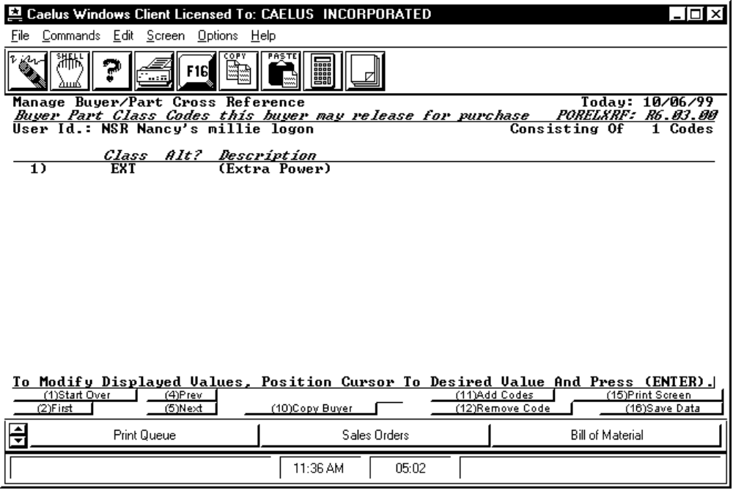

PROCEDURE DISCUSSION

A screen like the example above is displayed if buyer part class codes have already been assigned to the user. From this screen you can add more codes, delete codes from the list or add/append the codes currently assigned to another user.

Active Function Keys

F2 First If you have used F5 to scroll the list of codes up, pressing this key will return you to the top of the list.

F4 Prev Pressing this key will scroll the list down, showing the previous screen-full of codes.

F5 Next Pressing this key will scroll the list up, showing the next screen-full of codes.

F10 Copy Buyer *** Enter another user ID to copy that user's buyer class codes to the user ID you are currently editing. The other user's list is unchanged by this action. If duplicates exist (both users already are assigned the same code) they are ignored. The new codes are immediately copied and a summary is displayed showing the number of new codes added as a result of the copy and the number of duplications that were ignored.

F11 Add Codes Allows addition of another buyer class code to the list. The screen will change to allow input of a new class code.

F12 Remove Codes Position the cursor to a class code on the list and press this key to remove the class code from the list. The screen changes to allow you to confirm your intention to remove the code. Press F1 to abort the removal and return to edit mode. Press RETURN to remove the code from the list.

SCREEN EXAMPLE: Add Buyer Class Code to the List

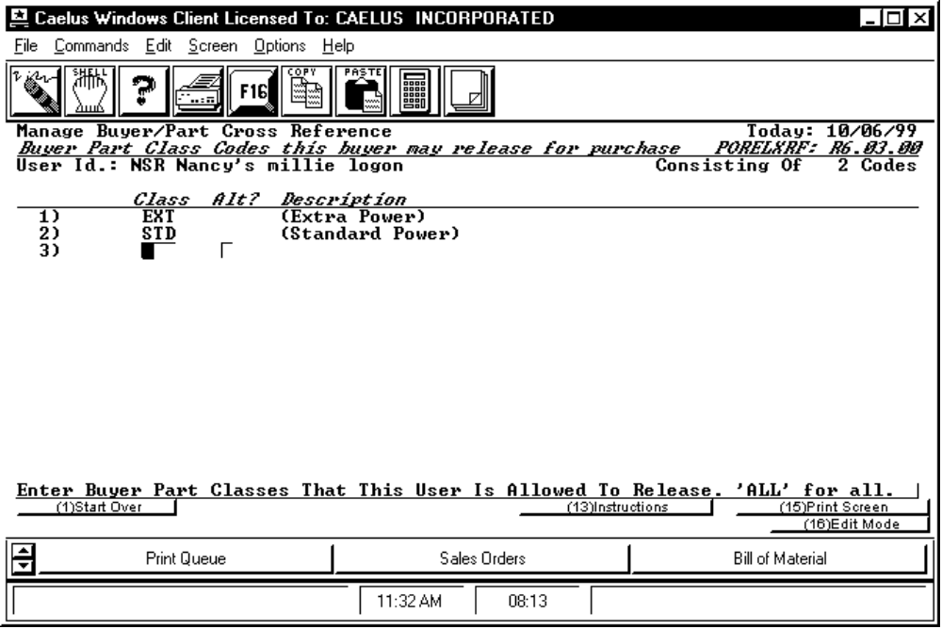

PROCEDURE DISCUSSION

This screen allows entry of additional buyer class codes for the user. Continue entering codes until finished, then press F16 to review the list and edit if necessary. To allow the user to release any buy order, enter "ALL" in the code field.

SCREEN EXAMPLE: Report Range Selection Screen

The screen shown in the example below appears when you select to print a report of the buyer/part cross reference by pressing F3 from the first screen.

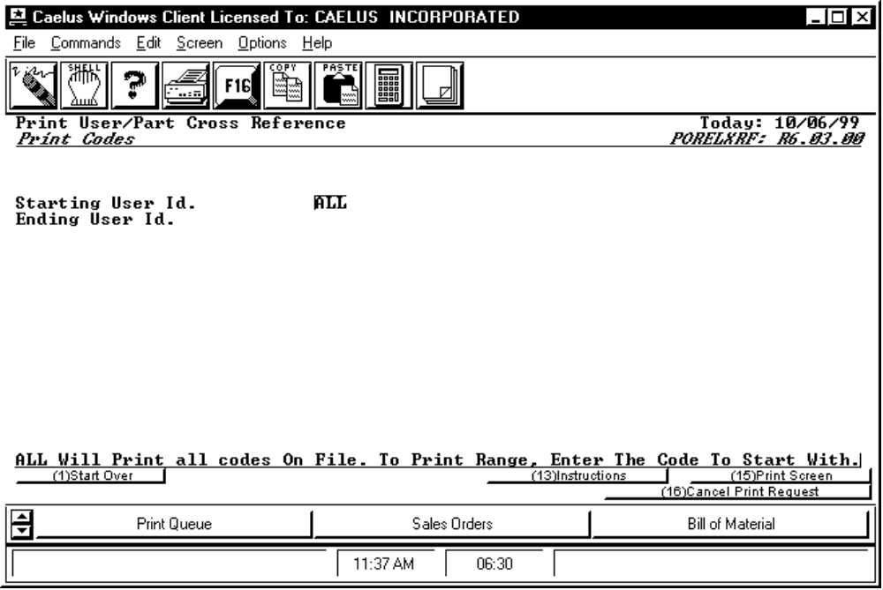

PROCEDURE DISCUSSION
Enter the range of users to include on the report by entering the range of user IDs or, to print a report of all users having buyer class codes enter "ALL". If you choose to not print a report, press F16 to return to the user ID Input Screen.

REPORT CONTENT
In columns, left to right across the page, the report shows:
BUYER (USERID)
NAME (Full Name of user)
PART CLASS (the list of BUYER PART CLASS CODEs assigned)
DESCRIPTION (description of each BUYER PART CLASS CODE is shown beside it)
TYPE (Designates the buyer as Primary or Alternate)

