EXAMINE FILES IN A LIBRARY

PURPOSE

This program provides an alternative for end users to the UniQue Print Queue Manager function. By setting a users default PRINT MODE setting to Keep, and using PrintQ for individual user’s print file management (which may be overridden only by a shell script using the CHANGE Getparm), several problems may be avoided that are associated with using UniQue solely. Through use of this utility users can see the list of the files in a directory (default is user’s print directory) for the purposes of displaying or printing their file(s).

GENERAL DISCUSSION

When you first run PRINTQ, the program displays a list of files in your default print library and volume. You can then choose from a number of options.

- Enter a new library and volume to display the contents of that library.

- Sort the list of files by file name, by size, or by date/time.

- Position the cursor on one of the files in the list and press the appropriate key to display, print, or delete the file. PRINTQ can display print files, data files, and text files.

- Search a long list of files for a specific file.

OPTIONS AND SECURITY FEATURES

PRINTQ accepts information from two hidden screens (called GETPARM screens). You can write shell scripts to drive PRINTQ that allow you to control certain aspects of the program (such as whether the user is allowed to change his directory or scratch files). The two hidden screens are described in detail at the end of this document.

SCREEN EXAMPLE: File List Screen

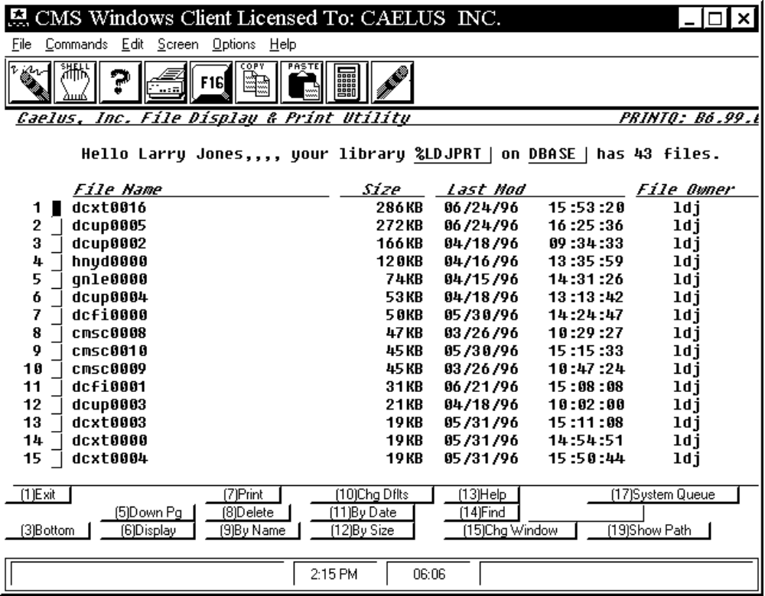

PROCEDURE DISCUSSION

When you enter this program, the screen appears as in the example above. The library displayed is, by default, your print library.

The top half of the screen may display some summary information about the program. The bottom half of the screen shows the first ten or 15 files in the library or directory. You can use Function keys 2 through 5 to scroll up and down the list of files. The total number of files in the library is displayed at the top of the screen.

To Change the Library

Note that the library and volume currently displayed appear at the top of the screen. If you are not restricted from changing libraries (see the CHANGE Getparm screen for more information), you can press the HOME key, enter a new library and volume, and press RETURN to change to displaying a different library.

Active PF Keys

F1 Exit:

F2 Top: To list the first few files in the library. This key only appears if you have previously moved down the list.

F3 Bottom: To list the last files in the library.

F4 Up Pg: To list the previous screen of files in the library.

F5 Down Pg: To list the next screen of files in the library.

F6 Display: Position the cursor to the file to display and either press ENTER or F6 to display it’s contents.

F7 Print: Position the cursor to a file and press this key to send the file to the system print queue for immediate printing. The destination printer and print options are controlled by your printer defaults (see F10 below).

F8 Scratch: Position the cursor to a file name and press this key to delete the file. A message appears to confirm your intention to delete the file. Press RETURN to delete the file from the library or press F1 to cancel the delete operation.

F9 By Name: Sorts the list of files in ascending order by File Name.

F10 Chg Dflts: To examine the print settings for the current PRINTQ
session. See below.

F11 By Date: Sorts the list of files in ascending order by date/time created (or last modified).

F12 By Size: Sorts the list of files in descending order by file size.

F13 Help: Displays Online Help.

F14 Find File: Enter a full or partial file name in the space following this prompt and then press F14 to position the list to that file.

F15 Chg Window: Switch from a verbose screen to one that shows more files and back.

F17 System Queue: Run the System Print Queue Manager (ILPMAN or ULPMAN).

F19 Show Path: Show the directory path name for the library and volume.

CHANGING DEFAULTS

After pressing F10 from the file list screen the below screen is displayed. One or more options may be disabled depending on Options and Change settings (see below). The print settings on this screen apply to all print requests made on the File List screen. Default values come from either the user’s default settings (see program CMSUSRIN) or from a shell script file such as procprtq.

SCREEN EXAMPLE: Change Defaults

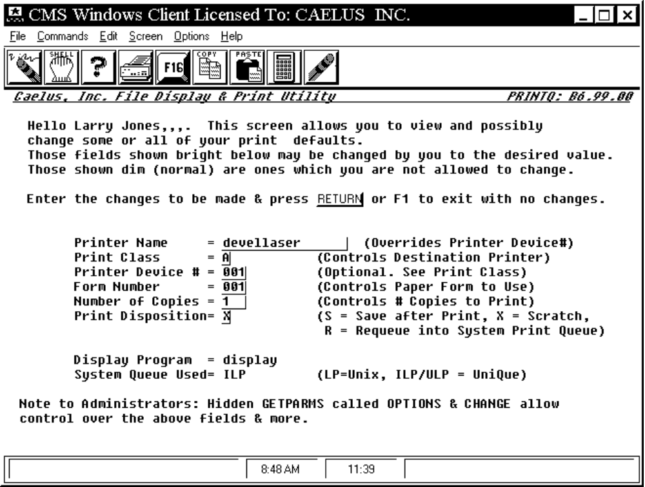

Field Settings:

Printer Name: Defines the name of the destination printer to use. If using ULP or ILP then this name if present must correspond to a printer name as defined in the ILP or ULP prtdef file. If using the UNIX print queue (LP) then this must be the name (as defined by your UNIX administrator) of a printer or class of printers.

Print Class: Mechanism used with ULP or ILP to route print files to a class of printers. Also may be used to determine whether or not a banner page is printed. Ignored if Printer Name is present or Printer Device # is greater than 000. Only applies to ILP or ULP print queues.

Printer Device #: Assigns printer destination by printer number using the ILP/ULP file prtdef. Only applies if using ILP or ULP and the Printer Name field is blank.

Form Number: With ILP or ULP is used to identify special print characteristics or paper formats. Causes ILP/ULP Queue Manager to prompt operator for form change before printing if necessary. Maps to ILP/ULP formdef file.

Number of Copies: Number of copies to print. Default value is 1.

Print Disposition: Defines what to do with a file after printing. If using LP (UNIX Print Queue) then only option S may be used at present. S means the file is saved after printing. R means the file is requed on hold in the system print queue after printing. X means the delete the file after printing. X is the default value unless overridden by shell script using the OPTIONS Getparm.

LP ‘-o’ options: Only appears if using the LP system print queue. Provides means of entering / defining printer specific options to the LP command.

Display Program: Non modifiable field. Shows the name of the program used to display files with. Default value is ‘display’ which may be overridden only by a shell script using the OPTIONS Getparm.

System Queue Used: Non modifiable field. Shows the name of the system print queue manager that print requests will be submitted to. Current valid values include two versions of the UniQue print queue manager - ILP and ULP, as well as the native UNIX LP print command. Default value is ‘ILP’ which may be overridden only by a shell script using the OPTIONS Getparm.

GETPARM Screens

There are two hidden Get Parameters or GETPARM screens in this application. These screens allow overrides of the normal defaults as well as inhibiting functionality (applying security features) via the use of a shell script. An example shell script is included with the distribution of PrintQ. It’s name is procprtq.

Options GETPARM

The following settings may be made/overridden using this getparm:

HELPTEXT If set to YES then a more verbose file list screen is displayed but with fewer files displayed at a time. Set to NO (default setting) to list more files.

LIBRARY Optionally override the user’s default print library/directory.

VOLUME Optionally override the user’s default print volume.

SYSQUEUE Optionally override the default system print queue setting of ILP with either ULP or LP.

DESTINAT * Defines the printer or destination name for print requests. Name must be 16 or less characters in length.

PRTCLASS Optionally overrides the user’s default print class.

PRINTER Optionally overrides the user’s default printer device number.

FORM# Optionally overrides the user’s default form number.

DISPLAY * Optionally overrides the default file display program name. Name must be 8 or less characters in length.

* = currently all characters in these fields are translated to lower case characters.

Change GETPARM

The following features and/or settings may be disabled using this getparm. All settings have YES or NO as their only values.

CHGLIB If NO then user is not allowed to change their Library/Volume.

CHGCLASS If NO then user is not allowed to change the Print Class.

CHGPTR If NO then user is not allowed to change the Printer Device Number.

CHGFORM If NO then user is not allowed to change the Form Number.

CHGDISP If NO then user is not allowed to change the Print Disposition.

CHGDEST If NO then user is not allowed to change the Printer Name.

SCRATCH If NO then user is not allowed to delete any files. Print Disposition will be changed to S.

