CREATE/MANAGE PLANNING CALENDAR

PURPOSE

o To establish the first planning calendar.

o To roll the calendar ahead as necessary thereafter.

o To print a planning calendar showing the 490 days of the calendar in all formats.

GENERAL DISCUSSION

The primary purpose of this program is to create and subsequently roll the production calendar. This operation has a significant impact on the data files that record planned inventory status.

Take These Precautions

Replacing the old calendar requires that fundamental files be considerably altered. Because of this, it is necessary to backup your entire database before and after a new calendar is implemented. In addition, follow these guidelines:

o Only run this function when the system is not in use by other people. It is necessary that none of the planning files be in use during any portion of the process.

o The process can take considerable time; it is best to perform this task overnight or over a weekend.

Creating the First Planning Calendar

The planning calendar must be created near the beginning of the CMS implementation process. The calendar establishes the time framework on which the planning system locates the various activities necessary to fill demands. Internally, these planned activity dates are numbers between 1 and 490, referencing this calendar.

Rolling the Planning Calendar

Periodically, you must roll the calendar ahead to expand or "refresh" the planning horizon. A good rule of thumb is every 90 days. This gives you an opportunity to resolve any late PIPs.

The rolling action rewrites all the detail records that rely on the planning calendar date. The records are written to a new copy of the file with the dates aligned with the new calendar. This occurs for the files PIPIN, PIPOUT, and WCOUT. In addition, the calendar information in all files that contain supporting PIP data is rewritten to conform with the new calendar. Depending on the size of the files, the task can take a significant amount of time.

The new calendar always begins on the first day of the month you indicate for the new start. The planning calendar cannot be rolled so far forward that the new start date is beyond the start date for any planned activities on file that are late (have not taken place yet). To successfully roll the calendar to the maximum amount, it is necessary to first resolve all planned activities that have not been performed on time and all uncleared workcenter capacity reservations. You will not be able to roll the calendar until these late activities and reservations are resolved.

Resolving Late Activities

Late activities can exist in the data files for either of two reasons:

o An action was expected but it never occurred; for example, a purchase order was cut for an item and delivery has not yet taken place.

o The action took place but it wasn't recorded on the computer.

The resolution of the first type of problem is as easy as setting the computer straight. (For example, call up the purchase order and change the due date to be the date the goods can now be expected to arrive; when the purchase order is saved, it is no longer "late".) Omissions in reporting data are procedural and involve changing habits and company policy and procedures.

A report of late PIPs can be printed using the function PIPLATE. A report of all uncleared reserved workcenter capacity can be printed using WCDSPLY. It is best to run these reports before running PROCCAL - to see how many late or unresolved items exist.

Late items can be capacity reservations (WCOUTs) that have never been cleared by closing production jobs, sales order shipments that have never taken place, withdrawals of items to be kitted to jobs (PIPOUTs), or purchase order receipts that have never taken place (PIPINs). An abundance of late actions can indicate improper setting of the planning system behavior switches. For example, it is possible to create late "BO" advices if CMS production planning is used but the purchasing department is not using the advices to trigger procurement. In this case, the buy order advices accumulate but nothing is done through purchasing to clear them. To resolve the problem, cancel the advices and change the planning system behavior switches to force inventory withdrawal of purchased items. This eliminates the creation of "BO" advices if they are not being used.

Late activities will prevent you from rolling your calendar. You can resolve the majority of late activity issues by running the program PIPLATE and acting on the late activities that appear earlier than the start date for your new calendar; however, PIPLATE does not resolve the late WCOUTs. You need to manually resolve late WCOUTs. Run WCDSPLY to identify the jobs with the late WCOUTs. If the job is released, then change the WCOUT date (when the capacity is reserved) using JBINPKIT; if the job is only advised, then either unplan the demand, run PIPSCAN to cancel the work order advise, or change the WCOUT (capacity reservation) date using JBINPKIT.

The Process of Rolling the Calendar

PROCCAL is composed of a number of programs. The complex appearance of this procedure is misleading. The process of creating/rolling the calendar is broken into a number of programs to accomplish the action using a minimum amount of disk space.

The following programs are used by PROCCAL:

CALINPUT Show the screen and prompt for dates
PIPOUTOP Rename the old PIPOUT file
CALCHNG1 Create a new PIPOUT file and convert the records from the old to the new file with re-aligned dates.
PIPOUTSR Scratch the old PIPOUT file.
PIPINOP Repeat the process for PIPIN file.
CALCHNG2
PIPINSR
WCOUTOP Repeat the process for the WCOUT file.
CALCHNG3
WCOUTSR

Each of the three major planning files (PIPIN, PIPOUT, and WCOUT) are recreated with all the planned activity records aligned to new dates in the calendar (1-490). To accomplish this task, a new file is opened to receive the adjusted records and are processed from the old to the new files. This action is performed for each of the three files. If the process was performed by one program, the duplicate copies of all three files would exist on the disk drives simultaneously. Instead, the procedure PROCCAL breaks the process up into three separate processing tasks, run one after the other. Essentially, the same process is performed on each of the major files, one file at a time. Other parts of the procedure judge the size of the current files to declare the proper size of the receiver files, again to minimize disk space.

Warning Messages

The system displays warning or error messages if problems are encountered. At any of these points you may exit without disturbing your current calendar.

Abort Message

With all the safeguards built into this process, it is still possible to come across a problem that causes a complete abort. When the abort message is displayed, you must exit the function. Certain errors causing an abort of the function will damage the database. You must then restore your database from a backup copy (the abort message will tell you what to do). If you encounter the abort message during the calendar rolling process, you should rename or delete your database before restoring the backup. This prevents the calendar rolling from attempting to reuse files created by the aborted roll attempt.

Printing the Planning Calendar

You can choose to print a copy of the current planning calendar or a future calendar. The resulting printout shows the days of the calendar in several formats: Internal (1 to 490), Gregorian, day of week, week of quarter, and quarter of year. The calendar also shows the position of each day relative to the fiscal year.

SCREEN EXAMPLE: Initial Warning

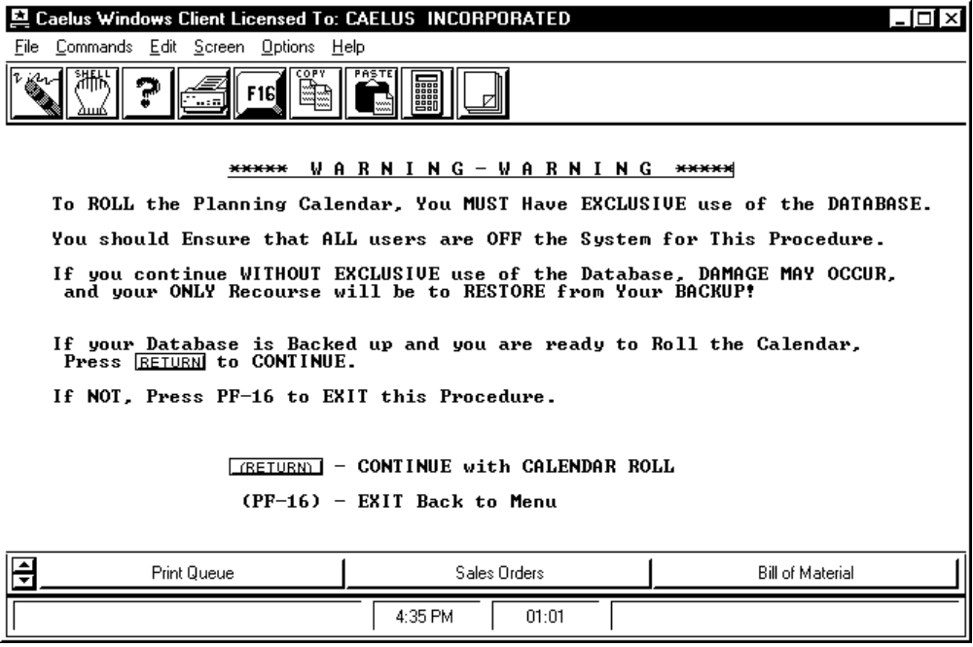

PROCEDURE DISCUSSION

This screen always appears before you can access the PROCCAL functions. It is very important that you pay attention to the information on the screen. If you have not backed up your database, press F-16 to exit. If you do not have exclusive use the your database, press F-16 to exit. ONLY PRESS RETURN TO CONTINUE IF YOU HAVE BACKED UP YOUR DATABASE AND YOU ARE SURE NO OTHER USERS ARE ON THE SYSTEM.

SCREEN EXAMPLE: Define Calendar Dates

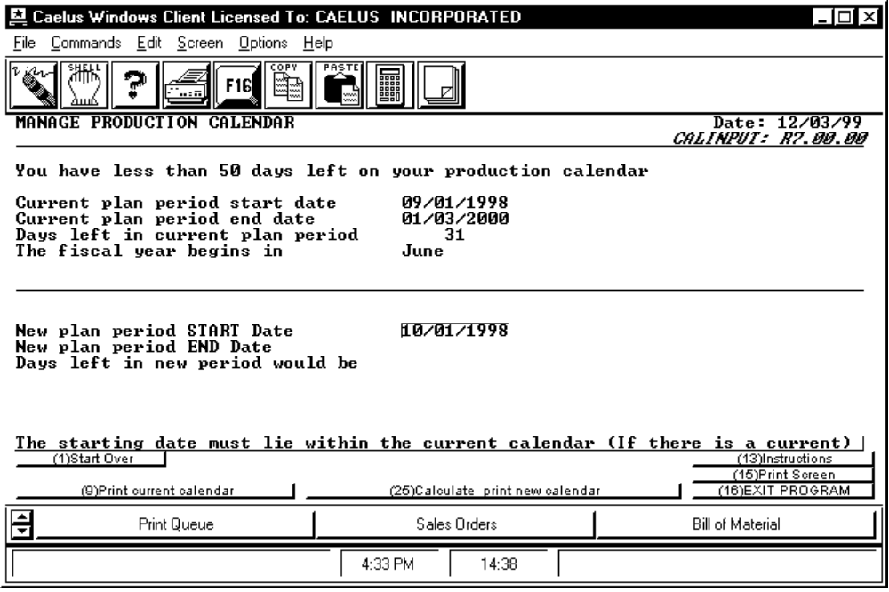

PROCEDURE DISCUSSION

This screen appears after you press RETURN while the initial warning message screen is displayed. It allows you to define the starting date of your new planning calendar. Enter the date you want the new planning calendar to begin. A new calendar will be calculated and then this message appears:

"Before the new calendar can be implemented, it must be checked against your current planned inventory. This will take a few minutes.

Do you want to do it now? "

You cannot roll your calendar until the system checks the planning inventory for any late PIPs or reserved workcenter capacity. (You should not have any since you already ran PIPLATE and WCDSPLY then you cleared any late or unresolved items up.....). Enter YES to proceed with the calendar roll. The system will check your current planned inventory. If you can begin your calendar on the date you entered, the system accepts your starting date and calculates the ending date using the 490-day calendar. If you have late PIPs or unresolved reserved workcenter capacity that prevent you from using the entered date, a screen appears with information about the files that are preventing the current roll using the selected date. From this screen, you have the ability to print a list of items which are preventing the roll. Also, a message appears after returning from the above info screen letting you know when you can begin your new calendar and resets your starting date to that suggested date. STOP! When the system does not let you begin your new calendar on the first day of the selected month, you still have late PIPs or reserved workcenter capacity that has not been cleared. You should not be lax about these. Unresolved late PIPs and reserved workcenter capacity foul up your planning data. Exit and resolve these now!

After the planning system has checked late PIPs and calculated an ending date to your planning calendar, you can press F12 IMPLEMENT the new calendar to proceed implementing that calendar.

After you have set up your calendar, you can print the current calendar by pressing F9 or press F25 to calculate and print the new calendar at the same time.

Data Field Definitions

New Plan Period START Date Enter any valid date prior to or including today and within the current planning calendar. Although you may enter any date, the new calendar will begin with the first day of the month that you enter.

NOTE: If you have planned transactions in the system that have not been acted upon, the new calendar will begin with the earliest of these dates.

New plan period END Date The system fills in the end date based on the calendar start date.

Days left in new period would be The system subtracts the number of days already used in the new calendar from 490 to come up with the number of days remaining in the new calendar.

Warning Messages

When reviewing an old calendar or trying to generate a new planning calendar, you may receive any of the following messages:

"YOU HAVE LESS THEN 50 DAYS LEFT ON YOUR PRODUCTION CALENDAR"
- This is simply to let you know that it is about time to generate a new production planning calendar.

"DATE CANNOT BE GREATER THEN TODAYS DATE"
- The date entered is in the future. The old and new production planning calendars must contain today's date. Enter a new date that is earlier or equal to today.

"DATE MUST BE WITHIN THE CURRENT CALENDAR"
- You have entered a date that is not included in the current production planning calendar. Enter a new date that falls between the starting and ending dates of the current plan period.

"BECAUSE OF CURRENT ACTIVITY, DATE MUST BE LESS THAN ../../.."
- Actions prior to the date entered have been planned but not taken. Either you must perform the planned transactions, unplan them, cancel them, or enter a date earlier than the one listed in the error message.

"CALENDAR WON'T CONFORM WITH YOUR DATA BASE. CALENDAR MUST START BEFORE ../../.."
- Again, a planned transaction is late and the new calendar cannot start after it. Resolve your planned transactions or re-enter the start date of the new planning calendar.

SCREEN EXAMPLE: Warning Before System Rolls the Calendar

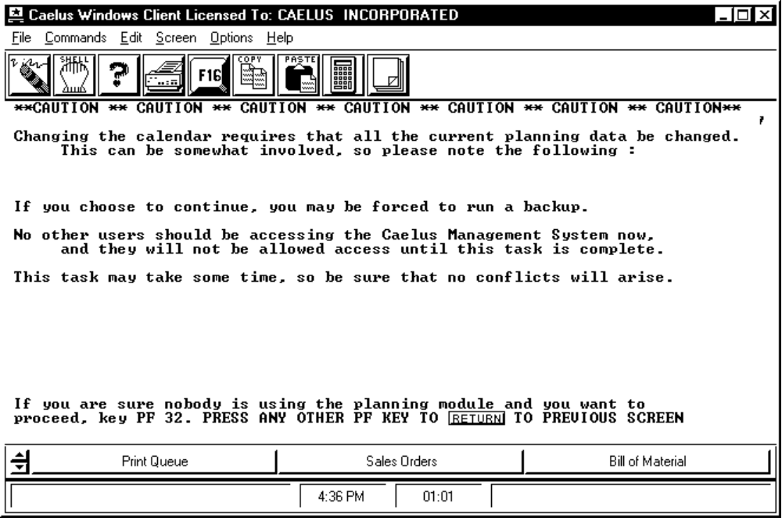

PROCEDURE DISCUSSION

This screen appears after the system has set your new planning calendar range and you have pressed F12 IMPLEMENT the new calendar. Press F32 to continue rolling the calendar. If you do not want to proceed, press any other key to quit.
Screen Example: The Abort Message

This screen only appears if the system aborts while the calendar was being rolled.

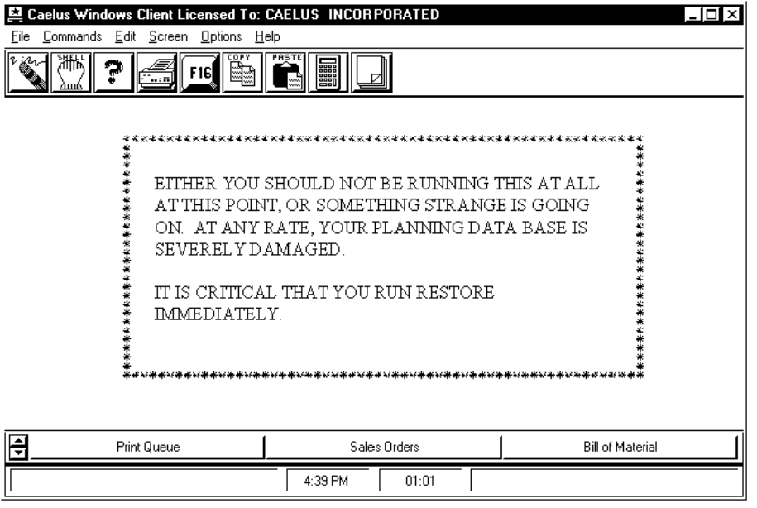

PROCEDURE DISCUSSION

If you see this message, your planning data is no longer synchronized with your database, making the database useless. At this point, all keys except RETURN have been disabled. You will only be able to exit the function. It is extremely important that you immediately:

1. Rename or delete your database.

2. Restore from backup the database existing before you attempted to generate the new planning calendar.

This should never happen, but if you ever see this screen, record the actions you took prior to the screen and notify CAELUS.

