ENTER/MANAGE BUYER PART CLASS CODES

PURPOSE

Define a list of Buyer part class codes to use to assign purchase responsibility or purchase authority to individual users.

GENERAL DISCUSSION

How Buyer part class codes are Used

Buyer part class codes are classification codes that, once defined here, can then be 1) indicated on the part master file records for inventory parts, and 2) be associated with individual users. Buyer part class codes thus provide a link between a specific user and specific inventory parts. This linkage can used to assign purchase responsibility to an individual person or restrict purchase decisions or commitments for a given product to one or more authorized persons.

The buyer part class code system limits access to the function for releasing buy order advices generated by the CMS planning system (PORELSUB). In doing so, it limits creation of purchase directives in response to buy orders. It also limits purchase directives created manually. Buyer part class codes do not limit access to the Create Manual Purchase Orders program (VBKINPUT).

Buyer part class codes vs User IDs

Do not confuse buyer part class codes with the user identification code (user ID) assigned to each user. Sometimes it is confusing because buyer part class codes and user IDs both happen to be three characters long. The user ID code is usually the individual's initials and is used by that person (along with their password) to log onto the computer. The user ID uniquely identifies that user from other users of the computer. Keeping buyer part class codes separate and different from user IDs allows you to assign purchase responsibility for a given product to more than one user. Buyer part class codes can also be reassigned to different individuals from time to time as job responsibilities change.

As many buyer part class codes as necessary can be created here. Once created, the codes can be referenced in the part master file records using the Enter/Manage Part Master File program (HNYINPUT). Buyer part class codes are linked to individual users through the Manage Buyer/Part Cross Reference program (PORELXRF).

Activating The System

As soon as one or more codes are assigned to any individual this system of restriction becomes active for all users of the CMS purchasing functions. Until that time, any person can purchase any item with no restriction. Once this system is activated, persons having no purchase responsibility assigned (in other words, those persons who have not been assigned any buyer part class codes), will not even see, or have access to, the Manage Buy Orders and Purchase Directives function.

If this system is activated, parts having no buyer part class code can be purchased by any person who has been assigned purchase responsibility via any buyer part class code.

Database & Module Administrator Status

A person who is a CMS database administrator or a purchasing module administrator (through VBKFLAGS) will automatically, by nature of their administrator status, have authorization to purchase all parts. This ability to purchase any part can also be granted to a non-administrator by stating that they are authorized to purchase "ALL" buyer part class codes. (See the documentation on the program PORELXRF for more information.)

TECHNICAL NOTE: The procedure PROCGC01 uses the CMS general codes entry routine, GENCDSIN, and the codes are stored in the data file named GENCODES under the table name BYCLASSES (a "table" refers to a group of related codes). You can access these codes either here through PROCGC01 or directly by running the program GENCDSIN and specifying the table name. GENCDSIN is used throughout CMS to record codes such as units of measure, and various classifications. All the different codes are stored in the one file GENCODES. The are organized and accessed by the table to which they belong.

SCREEN EXAMPLE: Input Screen

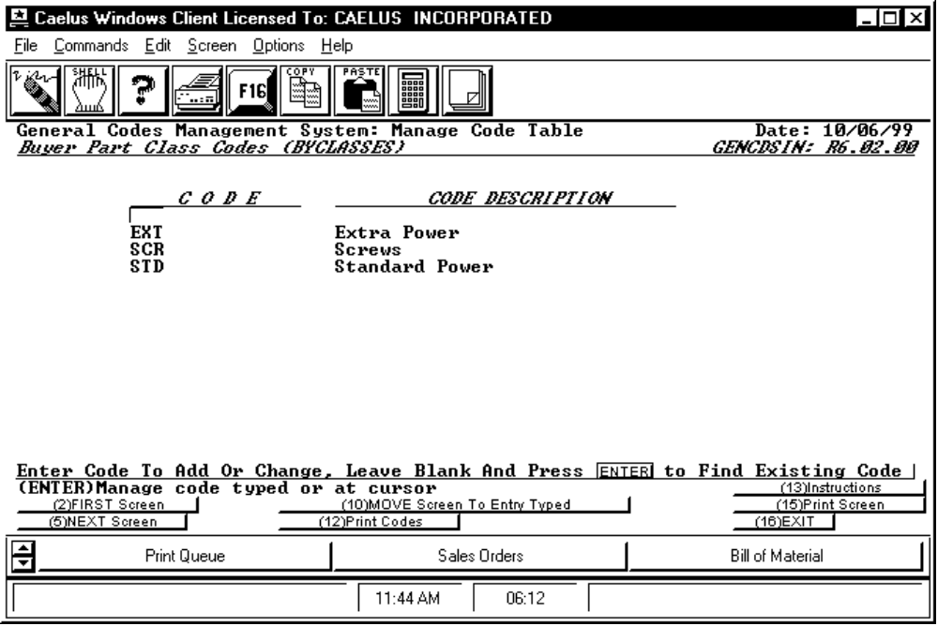

PROCEDURE DISCUSSION

When this function is used for the first time, no codes yet exist so the Input Screen will display no codes and it will prompt for entry of the first code. Thereafter, the Input Screen will display the first few codes on file in code sequence (ASCII order) as in the example above.

To enter a new code, type in the code and press RETURN. You will then be prompted to enter the description for this new code.

To modify an existing code, you can either 1) input the code, if you know it, and then press RETURN, or 2) position the cursor to the code if it appears on the screen. If you leave the input field blank and press RETURN, you will access the GETCODE routine allowing you to search for the code you want. A similar search/find capability is provided directly through F10.

To delete a given code, select it just as if you were going to edit it. F8 will become active to allow you to initiate the delete action. Refer to the example of the Edit Screen below.
Data Field Definition

CODE The three character buyer part class code.

CODE DESCRIPTION The 30 character description assigned to the code.

Active Function Keys

F2 FIRST Screen If you have used F5 to scroll to display later codes or if you have used F10 to display later codes on the list, pressing F2 will return you to the display of the first few codes on file.

F5 NEXT Screen Causes the next screen of codes to be displayed.

F10 MOVE Screen To Entry Typed To use this key, input a code, or the first character or two of a code and press F10, the list of codes will be displayed starting with the first code that matches the characters that you entered.

F12 Print Codes Pressing this key causes a report of all codes on file to be sent to the printer. The report shows the codes in ASCII sequence and the description for each. See the example of the report format at the end of this document.

SCREEN EXAMPLE: Edit Screen

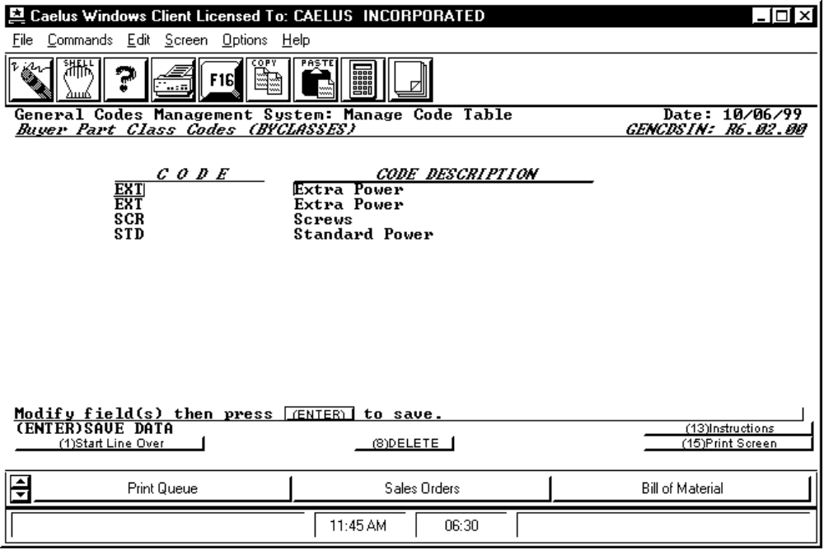

PROCEDURE DISCUSSION

The example above shows a code selected for edit. In this mode, you can modify the description field for the selected code. However, you cannot modify the code itself as that would change its identity. If you wish to change the actual code, delete it and re-enter the new one.

Note that F8 is now available to delete the selected code. If you press F8, you will be prompted to confirm your intention to delete. Press F24 to complete the deletion process or press RETURN to abort it.

Active Function Keys

F1 Start Line Over If you begin to change the description and then change your mind, press F1 to restart the edit of the selected code. Your changes will be lost.

F8 DELETE Initiates the deletion process for the selected code. You are then prompted to abort the process by pressing RETURN or complete the deletion by pressing F24.

REPORT CONTENT

Below is an example of the content and format of the printed report generated when you press F12.

10/06/99 SYS003 GENERAL CODES FILE LISTING 1

TABLE: BYCLASSES Buyer Part Class Codes

CODE CODE DESCRIPTION
--------------- ------------------------------
EXT Extra Power
SCR Screws
STD Standard Power

