ENTER/MANAGE PURCHASE ORDER RECEIPTS

PURPOSE

Report receipt of goods against purchase orders by creating a "receiver" document and record the distribution of received goods.

GENERAL DISCUSSION

Two different procedures run the programs that allow you to enter and manage the purchase order receipts:

o PROCRCVI performs all processing in foreground. Thus, your computer is busy and cannot be used until it has completed the processing of PO receipts.

o PROCRCVA performs processing in background. Thus, your computer is available for you to perform other functions during processing.

Other than the processing differences, these two procedures perform the exact same functions.

Goods are reported as received by recording the quantity received for a given purchase order line on a document called a "receiver". A receiver reflects the items received in a specific freight carrier delivery. A receiver can record received quantities for a variety of purchase order lines, or receipts from multiple purchase orders, or even shipments from multiple vendors. The common element relating all of these receipts is the single freight carrier delivery. A receiver can be as specific or general as you wish to make it. The only restriction is that one receiver cannot reflect more than one freight carrier/bill of lading.

Flow of Processing

Fill out the receiver header screen indicating the carrier and freight information. The next screen prompts for entry of the purchase orders received against the receiver. For each order, the line items are shown and the actual received quantity can be indicated. You can manually enter the received quantity or use an automatic feature to set the received quantity equal to the open quantity. If the automatic feature is used, any line can be edited to reflect exceptions. When the receiver is complete, it is saved to the data files. All receivers created or changed during the session are processed and posted when you exit the function.

A receiver can be recalled and edited at any time. All inventory, PIP, AP, and GL postings are reversed and reposted to reflect the changes made.

Distribution

You have several choices as to the distribution of the received goods. The choice is indicated by the receiver "mode" identified for each line item. The modes are:

"I" Receive the entire quantity directly to on-hand inventory for the store/lot indicated on the purchase order line. The GL and AP are posted. The on-order quantity for the store/lot indicated on the purchase order line is reduced by the received amount and the on-hand quantity for that same store/lot is increased. The Planned Inventory Position is updated to reflect the arrival of the goods. (The PIPIN is decremented or extinguished.)

"Q" Receive the entire quantity to QC In Process. The GL and AP are posted, and the on-order quantity for the store/lot indicated on the purchase order line is reduced by the received amount. The "QC In Process" quantity for that store/lot is increased. The Planned Inventory Position is not changed. The planned addition to inventory (the PIPIN) is altered slightly to reflect that the goods are now expected from QC rather than an open purchase order.

"R" The entire received quantity can be placed on Receiver Hold which allows acknowledgement of the liability but defers the decision about distribution. The interim payables GL account is posted with the liability and the value is recorded in a user-specified clearing account (as defined in the store master record for the user reporting the receipt). From the inventory standpoint, the goods have not been fully received. The on-order quantity is reduced but no on-hand quantity is increased. Also, no change is made to the Planned Inventory Position to reflect that the receipt has occurred. This is understood to be a very temporary condition until a decision can be made.

"D" Manually distribute the received quantity. This mode invokes a special distribution detail screen allowing the any portions of the received quantity to be spread to any of the following locations/statuses:

o QC In Process as described above.

o Conditional Acceptance Any quantity can be recorded as conditionally accepted to a special store/lot combination for the purposes of rework or other processing. (See the discussion of scrap and rework below.)

o Rejected Any quantity can be recorded as unacceptable, in which case GL postings are reversed, reflecting the return to vendor (elimination from the system). The on-order quantity and Planned Inventory Position are decremented indicating that the receipt is no longer in the system or expected. Inventory and the PIP are not restored to the pre-receipt condition, which may create a shortage reflecting a need for, and the unavailability of, the goods. A rejection reason code as entered through the program QCRCODES can be specified to reflect the reason for rejection. See the discussions of "Return to Vendor".

o On-hand Inventory for any combination of Store/lots Any subset of the received quantity can be accepted to inventory to any user specified store/lot(s). The asset account for the selected store/lots is debited with the value. The interim payables liability account is credited. The on-order position for the store/lot indicated on the purchase order is decreased. The on-hand quantity for the specified store lot is increased and the PIP is updated to reflect the receipt.

NOTE: Lot tracked parts are forced as a receive mode "D".

Recording Vendor's Lot Number

If the "D" mode is chosen for manual distribution, you can record the vendor's lot number for the received goods. In fact, a separate vendor's lot number can be recorded for each of the multiple store lots to which the goods are distributed. If the shipment is to be received into a single store/lot, but multiple vendor lot numbers are represented in the received quantity, you can record multiple store/lot records showing the same store/lot for each. In this way the multiple vendor lot numbers can be input with the appropriate quantity for each. If you receive goods that are tracked using CMS Lot Tracking, the lot tracking system can identify the vendor lot for these goods if you enter it.

Scrap and Rework

The concepts of "scrap" and "rework" are treated as conditional acceptance. In either case, if you choose to receive the goods, they are posted to a special, user specified, store/lot combination (the store number must be alphanumeric to hide the receipt from use by the planning system). Goods to be reworked can be posted from that special store/lot to a rework job using the features of the CMS Shop Floor Control Module. There, the costs of rework or corrective actions can be recorded and the goods eventually reported to normal inventory (or scrapped or reworked further).

Goods that are totally unusable can be moved out of the special scrap store/lot and posted to any expense account through the Direct Inventory Adjustments procedure PROCHNYW. Just like all other store/lot combinations in CMS, the special store/lot(s) used for these purposes can indicate special General Ledger accounts to be posted for inventory transacted to and from that store.

Remember, anytime goods are moved into a store with an alphabetic character for the first digit of the store ID code, that inventory is hidden from the PIP and the CMS planning system. The PIP is decremented by that amount as these goods are hidden from the planning system. A shortage may result from this action and, if so, will be visible in the PIP management functions. This accurately reflects that the goods are not available for use which is consistent with the fact that they are issued to the alpha store because work must be done to correct a problem or they are completely unusable. They can be issued from that alpha store/lot to a special job created for the purpose of correcting any problem. The PIP will recognize the expected completion date for any job created to rework them as the date they will finally be available (which may solve the shortage as of that date).
Return to Vendor

You can refuse receipt and thus imply return of the goods to the vendor. Notes can be maintained through the System Text Management functions about unacceptable deliveries for the purchase order line. You may also choose to accept the goods into receiver hold or QC and later indicate that they are to return to the vendor. If any receipt is acknowledged on the receiver, the GL is posted with the liability. These postings are reversed automatically if the goods are eventually returned. As an example, if 100 units are reported received in mode = "D", the distribution screen appears to allow you to spread the 100 units to the various distribution paths. If 90 are accepted and 10 are rejected, the entire 100 are posted to the interim payables liability and a reversal is posted for the 10 rejected. This places the necessary audit record in the GL to reflect the rejection. (Also, if the quantity indicated as received on the receiver is later reduced to reflect a decision to not receive the goods after all, all postings for the difference in quantity are reversed.)

The System Text Management feature is constantly available to record historical notes about or full descriptions of the receipt and decision process.

Respect of Receiving Date Window

The receiving window (the range of acceptable receipt dates) set when the purchase order line was created is honored here as the goods are received. An attempt to receive the goods outside the window results in message and denial of the receipt.

Respect of Purchase Order Line Status

The status flag set for any purchase order line is also respected. When the order is created a status flag can be set on any or all of the lines to indicate special conditions or attention. The flags are: "A" = active, "C" = closed, "H" = held, "W" = waiting for price, and "N" = not within window.

You can only receive Purchase order line items having a status of "A" for active. Receipt against all others is denied. The "N" status is set here in the Enter/Manage Receivers function. For more information on setting and thereafter, changing these flags, refer to the documentation for the program VBKINPUT.

Over-Receipt Limit

You can set system-wide over-reciept limits or part-specific limit information:

o Purchasing system over-receipt limit is set via a behavior switch set in the program VBKFLAGS. This limit is honored in this program as the goods are reported received. An attempt to receive a quantity above the order quantity is permitted but a message appears to remind you that the received amount exceeds the expected receipt amount. Any attempt to over-receive beyond the limit set through the behavior switches results in a message indicating that the receipt is not allowed.

o Part-specific over-receipt limit is set using HNYINPUT. HNYINPUT allows you to specify a maximum over-receipt for a part as a percentage of order quantity and a flat quantity. For a given receipt, the maximum allowed over-receipt is determined by taking the lesser of the percentage allowed for the part or the flat amount. See the documentation for HNYINPUT in the Inventory Reference Manual for more information on this feature.

Serial Number Considerations

If you are receiving goods that you track by serial number, then when you enter a quantity to distribute to inventory, the program invokes the Serial Number Entry subroutine SERINSUB to allow you to enter serial numbers for the received goods. You must enter a serial number for each item received. You can enter the serial number manually or, subject to inventory behavior switch settings, you can let the system automatically assign the serial numbers. Serial number tracking in CMS is described in the Inventory Control Reference manual.

Lot Tracking Considerations

If you receive goods that you track by inventory store/lot, you must enter a lot number or lot numbers when you distribute the goods to an inventory store/lot other than the store lot indicated on the purchase order. In addition, lot tracked parts must be a "D" receive mode. You can find out more about CMS lot tracking features from the Inventory Control Reference manual.

Receiver Ticket Printing

A flag in the program VBKFLAGS allows you to indicate either that receiver tickets can be printed manually or that receiver tickets are automatically generated each time you save a receiver. The tickets identify the destination of the received goods or a change in status for goods moved from one receiver status to another status or to inventory. If you choose to print tickets manually, you must access the Receiver Header screen in edit mode immediately before you save the receiver and press F12 to generate the tickets. Then you can press F16 to save data.

Soft Enables

The Receiver Header screen fields are controlled through the soft enables feature. You can restrict certain fields from being modified in input mode or edit mode using this feature. To set soft enables, display the Receiver Header screen in edit mode and position the cursor to a field. Press F29. A message appears at the bottom of the screen identifying the current state of the field (Whether the field can be modified input and edit mode, edit mode only, or neither input nor edit mode). Press RETURN to return to the normal edit mode screen.
SCREEN EXAMPLE: Receiver Header Screen

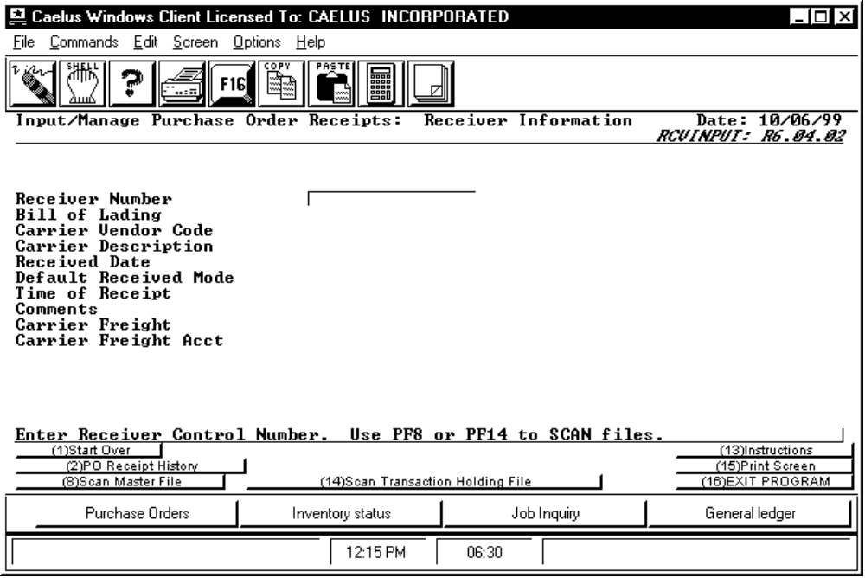

PROCEDURE DISCUSSION

This screen appears when you first enter this procedure. From this screen you can enter a receiver number to call up an existing receiver or you can enter a new receiver number to record a new receipt.

To call up an existing receiver, enter the receiver identification number and press RETURN. The receiver information appears on the screen and you can then proceed to the list of purchase orders for that receiver and from there to the actual line items received.

If you do not know the exact receiver number, press F8 or F14 to display lists of all receivers. F8 shows all receivers that have been processed to the master file. F14 shows all receivers pending processing. If an existing receiver has been processed and is currently pending processing for some recent changes, it is visible on both lists. If this is the case, and you choose if from either list, the one in the holding files is the one that is recalled for review or edit.

To record a new receiver, enter the new receiver number or leave the field blank to have the system assign the number (from the sequence on file in the store master record associated with your user ID). Then complete the data fields as described below. The receiver number assigned is displayed as soon as you save the receipts against the first purchase order for the receiver. When receiver numbers are automatically assigned, the store ID is used as a prefix.
Data Field Definitions

Receiver Number Enter the receiver number for this receiver document. If you enter a number that is already on file, the information about that receiver appears for review or edit. Leave the field blank to let the system automatically assign the receiver number. The next number to use is the number stored on file in the store record identified for your user ID. Your "Default Store ID" is defined through the program SYSDATES (See the System Module Reference manual for more information on SYSDATES).

Bill of Lading Enter the freight carrier's bill of lading number if known.

Carrier Vendor Code If the freight carrier is a valid vendor (has a vendor master record) enter the vendor code here. Otherwise leave the field blank and enter the carrier name in the next field. Setting vendors up in the vendor master file allows them to be referenced here and allows the Accounts Payable system to access the receiver as detail when the freight carrier's invoice arrives. The receiver can then be linked to the carrier's invoice with the bill of lading number just like the receipt of goods can be linked to the vendor's invoice with the purchase order number.

Carrier Description The name of the carrier appears here as a default if the carrier is on file in the vendor master records and you entered the carrier's vendor code above. Otherwise, use this field to indicate a carrier not on file.

Received Date Enter the date which is to default to each receiver line as the date that line was received.

Default Received Mode Enter the receipt/distribution mode to default to each receipt line. The choices are:

o "I" to receive the entire quantity directly to on-hand for the store/lot indicated on the purchase order line.
o "D" to manually distribute portions of the received quantity to other store lots or combinations of rejected or hold. If this part is lot tracked, you are forced to enter a "D".
o "Q" to move the entire received quantity to QC In Process.
o "R" to place the entire received quantity in receiver hold pending a distribution decision.

If most of the lines will be received one particular way enter it here to save yourself the task of keying it in for each line separately. Your entry in this field becomes the default for each received quantity. You can edit the received mode as needed for any line. Note that if you are receiving lot tracked or serial numbered goods, you are forced to use the "D" receiving mode.

Time of Receipt Enter the time of day that the carrier delivery occurred. If the same carrier made several deliveries, this field can be used to identify the different events. The default is the current time of day.

Comments Use this field to record any memo information about the receipt.

Carrier Freight Enter the freight amount if known.
Carrier Freight Acct This field is only enabled if the freight carrier declared above is on file as a valid vendor. This is the account to debit with the freight expense. The offsetting account is the interim payables liability account specified for the purchase order. The default is the freight account on file for the carrier in the vendor master file. If no freight account is specified in the vendor master record, the freight account identified in the store record for the user recording the receipt is defaulted to this field. Enter a "?" to see a list of GL accounts from which to choose or leave the field blank.

Active Function Keys - Input Mode

F2 PO Receipt History To examine information for a selected purchase order. This key activates the display subroutine POSTATUS to display information about the status of currently open purchase orders. You can examine the purchase orders, receipts, and invoice information.

F8 Scan Master File To see a list of receivers currently in the receiving master file. These receivers have already been processed. Position the cursor at a receiver and press RETURN to call that receiver up on the screen.

F14 Scan Transaction Holding File To see a list of receivers that have been completed but not yet processed. No inventory movement or GL postings have yet been generated for the receivers you see when you press this key. Position the cursor at a receiver and press RETURN to call that receiver to the screen.

Active Function Keys - Edit Mode

F2 P.O. Summary To view the PO Summary Screen.

F12 Print Receiver Tickets To print receiver tickets for the receiver.
SCREEN EXAMPLE: PO Summary Screen

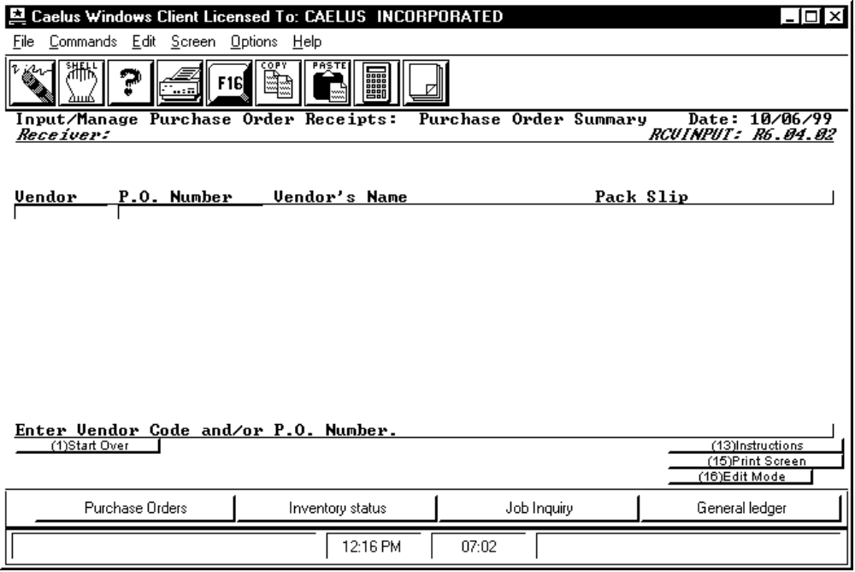

PROCEDURE DISCUSSION

This screen prompts for input of the purchase orders to record on this receiver. Enter a vendor code and purchase order number and optionally the vendor's packing list number. The system then displays the lines of the purchase order allowing you to indicate which goods were received. If you do not know the exact vendor code and purchase order number, leave the vendor field blank, place a "?" in the purchase order field and press RETURN to see a list of all purchase orders for each vendor. If you fill in the vendor code field and leave the purchase order number field blank you will see a list of purchase orders starting with those for that vendor.

NOTE: If you chose to have the system automatically assign the receiver number, the new number is not actually assigned until the receipts against the first purchase order are recorded and saved. Therefore, no receiver number appears at the top of the screen because it is not yet assigned.

After you select a vendor and/or a purchase order, F2 (Column 1) is provided to allow you to restart the line.

Data Field Definitions

Vendor Enter the vendor for the shipment. If you know the purchase order number, enter it in the following field.

P.O. Number Enter the purchase order number to receive. If you leave this field blank after having entered a vendor, you will see a list of all open orders for that vendor from which you can choose. Place a "?" in this field to see a list of all open purchase orders for each vendor, starting with the first vendor with open purchase orders on file and you can scroll the list.

Pack Slip Enter the vendor's packing list number for the shipment. This field is optional.

SCREEN EXAMPLE: PO Line Item Screen

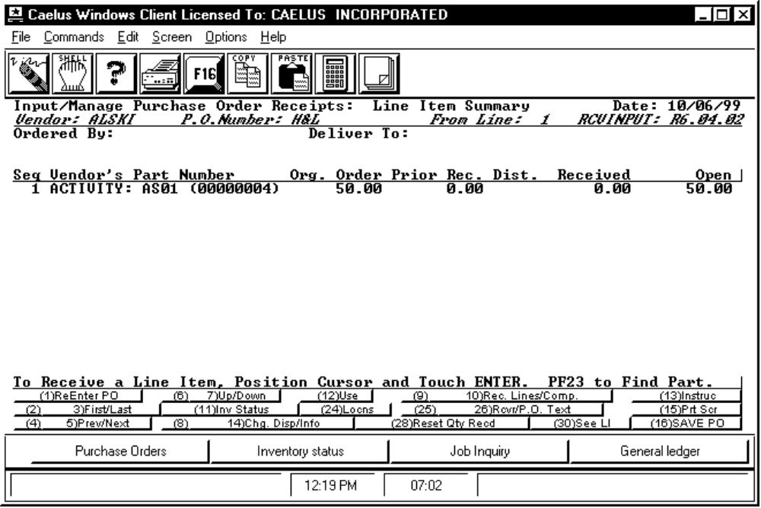

PROCEDURE DISCUSSION

As soon as you select a purchase order on the previous screen, the line items from that order appear on the screen as in the example above. The quantities that remain open to receive are shown along with the original quantity and the received-to-date quantity. (Note: The received-to-date quantity includes those items on this or other receivers, even if they have not yet have been processed.) To record receipt of any line, select the line by positioning the cursor and pressing RETURN. Then simply input the mode and received quantity for that line. The distribution mode default is the mode you entered on the first screen of the receiver. Notice, F10 is provided to automatically mark each line as received in full; the received quantity for each line is automatically set equal to the open quantity. You can manually adjust any lines that have not been completely received (in other words, edit the exceptions).

NOTE: For each line that you mark with a "D" to manually distribute, you will see the Detail Distribution Screen for that line item as explained later. This allows you to manually distribute any portions of the received quantity to various destinations within the system.

Notes on Use of This Screen

1) There are three basic methods to record the quantities received against each line:

o Position the cursor and press RETURN to record receipts for just that line.

o Press F9 to have the system walk you through each line.

o Press F10 to automatically set the received quantity equal to the open quantity and zero out the open quantity.

Both F9 and F10 respect any lines previously recorded received in this session.

2) If you choose the "D" mode to manually distribute the received quantity and then do not specify any distribution for some or all, those units are automatically placed in receiver hold status.

3) If you choose the "D" mode to manually distribute the received quantity and then distribute all of the quantity to one distribution path, the mode indicator is changed automatically to reflect the single distribution, ie. "R" or "Q" or "I".

4) If you leave the mode field blank when prompted for a distribution mode for a particular line, the line is skipped. The system will not prompt for the received quantity.

5) Beware, when displaying the line items in the vendor's part number and unit of measure, if you use the "D" mode, when you drop into the Distribution Details Screen for a particular line, the quantities there are always displayed in your internal unit of measure. This can be confusing at first.
Data Field Definitions

Org. Order The original quantity that the purchase order was opened to procure. F14 toggles to unit of measure.

Prior Rec. The quantity of this line item that has been received earlier, on this receiver or other receivers.

Dist. The flag to indicate the distribution mode for this received quantity. The choices are: "I" to receive the entire quantity to on-hand inventory. "D" to manually distribute portions of the received quantity. "Q" to receive the entire quantity to quality control/quarantine. "R" to place the entire received quantity on "receiver hold". This flag defaults to the mode set on the first screen of receiver information.

Received Enter the quantity you are reporting as received. Negative values are OK to correct previous mistakes. All posting is reversed for negatives when the receiver is processed. If you chose to distribute this quantity by entering a "D" as the distribution mode in the previous field, the Distribution Detail Screen appears to allow you to distribute the indicated quantity.

Open The original quantity for the line less any received against previous receivers, and any quantities indicated as received on this receiver. Although this field is editable, most of the time you should just accept the default. The field is editable to allow you to update the system with new information on expected future shipments against this line. Edit of this field might occur if: 1) you receive 50 of 55 and the vendor indicates that that is all you are ever going to receive, or 2) you indicate an over-receipt and then change the quantity received back to be the open quantity (reverse the over-receipt) this field should then be edited to express the quantity now expected.

Active Function Keys

F2/3 First/Last To scroll to the top or bottom of the list of line items to pick the ones for which you want to record receipts. If all the lines fit on one screen, these keys are inactive. Also, if you are currently viewing the first screen, pressing F2 has no effect.

F4/5 Prev/Next To scroll up or down the list of line items one screen at a time. If all the lines fit on one screen, these keys are inactive. Also, if you are currently viewing the first screen, pressing F4 has no effect.

F6/7 Up/Down To scroll up or down the list of line items one line at a time. If all the lines fit on one screen, these keys are inactive. Also, if you are currently viewing the first line, pressing F6 has no effect.

F8 Chg. Disp To change the display from showing vendor part numbers and quantity information in vendor units of measure to showing your internal part numbers and showing quantities in internal units of measure. This key works differently in conjunction with F14. If you first press F14, the screen changes to show the internal part number, part description, line item status, and expected destination store/lot. If you then press F8, the part description is replaced by the line due date and a display of the receiving window for each line item. The "Receiving Window" field shows the dates (if any) entered on the purchase order line item in the "Not Before" and "Not After" delivery date fields.

F9 Rec. Lines This key selection is provided as an alternative to both positioning the cursor to each line and pressing RETURN to record the quantity for that line or the F10 "receive all" option. When you press F9, the system automatically prompts you for the received quantity for each line, one at a time. This action begins with the first line not yet reported received and continues from there. First enter the distribution mode for the line then the quantity. You will continue in this mode until you press F16 to return to edit mode.

F10 Comp. To set all the received quantities equal to the open quantities and change the open quantities to zero. The result appears for your review or edit. Any lines previously received manually, are skipped by this action. However, if the default distribution mode for the receiver is "D", the Distribution Detail Screen appears for each line, prompting for the actual distribution of each line. If the default mode is other than "D", the lines are displayed in edit mode for your review and acceptance. You can then edit any exceptions on a line by line basis, either before you press this key, or afterward.

F11 Inventory Status Position the cursor to a line item and press this key to display information on the current stock of the part associated with that line item. The display is generated by the subroutine HNYQDISP. This subroutine is documented in the Inventory Control Reference manual.

F12 Use Position the cursor to a line item and press this key to show the uses of the part ordered on the line item. A screen appears showing all the planned usages for the part including all jobs and all open orders. The display appears from the subroutine PIPOASUB. See the Production Planning Reference manual for more information on PIPOASUB.

F14 Info To display internal information for each line item. The screen changes to show the internal part number, the part description, the line item status, and the expected destination store/lot for each line item. After you press this key, you can press F8 to display the line item due date and the receiving window dates for each line item.

F16 Save this PO To save the received quantities and return you to the display of the purchase orders on record for this receiver. From there you can indicate additional purchase orders to receive or process the receiver.

F23 To Find Press this key to find a part from the Line Item Summary screen. You are prompted to enter a part number. A partial part number is allowed. The find function will then find the first occurrance that matches this number. If you are viewing by vendor number, the search tries to match the vendor's number. If you are viewing by internal part number, then the search tries to match the part number.

F24 Locns Press this key to access the HNYLCSUB function, which allows you to transfer, add, or withdraw inventory. Note that this is only available if the lot exists in the Locations file.

F25 Rcvr Position the cursor and press this key to access the System Text Management function for the specific receipt against the selected line. From there you can create, edit, or display free text about that receipt. For more information, see the System Module Reference Manual.

F26 P.O. Text Position the cursor and press this key to access the System Text Management function for display of the free text associated with the selected purchase order line item. For more information, see the System Module Reference Manual.

F28 Reset Qty Received Use this key to undo all the received quantities you have just input. This is a helful "start over" feature when experimenting with functions of F9 and F10.

SCREEN EXAMPLE: Distribution Detail Screen

This screen and the following screen appear from the subroutine RCVDIST. This screen appears automatically if you enter a "D" distribution mode for a received item on the PO Line Item screen.

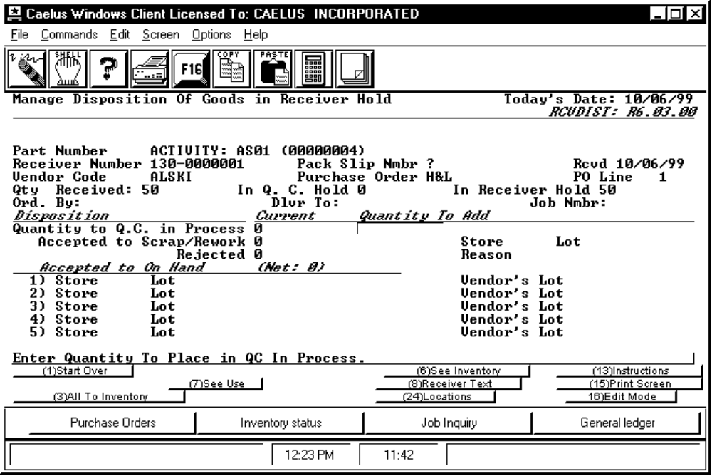

PROCEDURE DISCUSSION

IMPORTANT NOTE: All quantities displayed and entered on this screen are in your internal unit of stock only. If you were viewing the line items in the vendor's unit of measure, the quantities shown on this screen are different if the conversion factor is other than 1. If the conversion factor between the vendor's units and your units is other than "1", a message displays at the top of the screen to remind you of the different units of measure and to inform you of the conversion factor.

The screen shown in the example above is displayed for each line you marked with a "D" for manual distribution. The upper portion of the screen shows the total quantity you recorded as received and the quantity in "Receiver Hold". When you first see this screen, the default distribution for the entire received quantity is "Receiver Hold". This receiver hold figure constantly shows you the quantity remaining to explicitly distribute. The lower half of the screen presents the various distribution paths.

For each of the possible distribution paths, indicate the quantity to distribute to that path in the "Quantity to Add" field, or leave the field blank and press RETURN to move on to the next path. You can come back later and edit any mistakes. As you distribute various quantities, the total of the quantity remaining in Receiver Hold is adjusted downward to show the number of units remaining to distribute. If you do not explicitly distribute a quantity, the quantity is recorded as in Receiver Hold by default. You can return to this screen later and distribute them.

Data Field Definitions

Quantity to Q.C. in Process Enter the quantity to be received into the QC In Process status. From there the goods can be later reported to any of the other distribution paths or to QC Hold.

Accepted to Scrap/Rework Enter the quantity to be received to a special store/lot combination for the purposes of scrap or rework. This implies conditional acceptance. If some units are to be accepted to scrap and others to rework, use the "Accepted to On-Hand" fields below but specify a store ID beginning with an alpha character. If you must record a vendor's lot number for these goods, use the "accepted to on-hand" fields below but specify an alpha store number.

Rejected Enter the quantity to be rejected or returned to the vendor. An audit trail will be created in the General Ledger. Optionally you can specify a code to indicate the reason for rejection. The first four characters of the rejection reason default to the category of the part. The last two are the reason code for that category. If you enter a rejection code, the rejection description is displayed in the space below it. To see a list of all rejection codes, leave the two digit code field blank and press RETURN. For more information on this feature, see PO-40-QCRCODES.

Accepted to On Hand Enter the quantity to distribute to any one or more store/lot combinations you specify. For each store/lot you can optionally record the vendor's lot number for those goods. If all of the received quantity is to go to a single store/lot but you wish to record several vendor's lot numbers, enter the appropriate quantity for each of the vendor's lot numbers but indicate the same store/lot for each.

NOTE: Space on the screen allows display of only five store/lot combinations at one time. If you use all five, the list will scroll allowing you to enter quantities for up to 99 store/lots for that receiver line.

The total quantity distributed to the various on-hand store/lots is show as the "Net" quantity beside the words "Accepted to On-Hand".

Active Function Keys

F3 Move Remaining in Process to Inventory To move all received goods still in receiver hold to the inventory store lot indicated on the purchase order line item. The quantity is shown in one of the "Accepted to On Hand" fields at the bottom of the screen.

F4 Previous Field After you enter the first field on this screen, this key appears to allow you to back up one field.

F6 See Inventory To examine the inventory quantity information for the part specified on this line item. The display is generated by the subroutine HNYQDISP. This subroutine is documented in the Inventory Control Reference manual.

F7 See Use To show the uses of the part ordered on the line item. A screen appears showing all the planned usages for the part including all jobs and all open orders. The display appears from the subroutine PIPOASUB. See the Production Planning Reference manual for more information on PIPOASUB.

F8 Receiver Text To enter free text for this receiver line.

SCREEN EXAMPLE: Distribution Detail Screen in Edit Mode

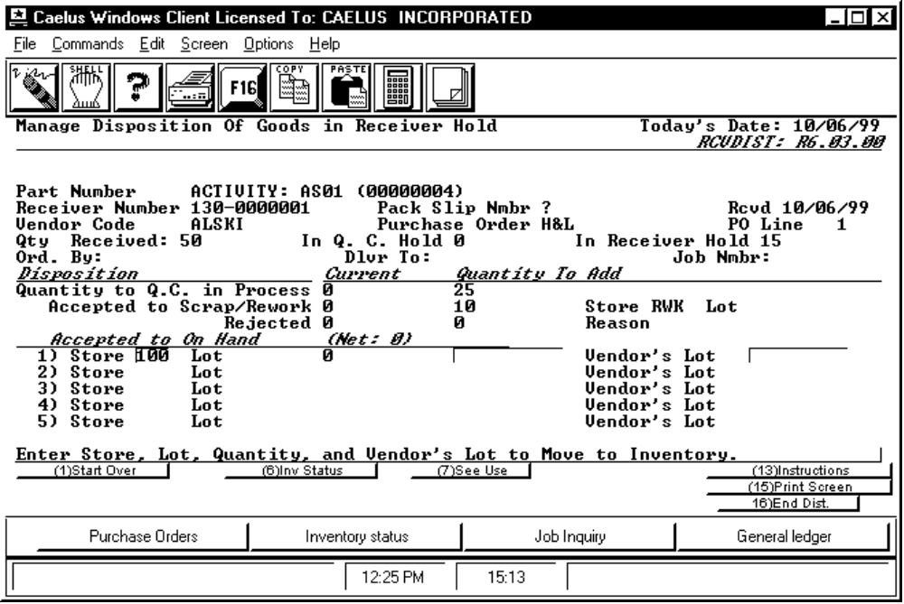

PROCEDURE DISCUSSION

The screen above shows an example of distribution data. You can edit any quantity field on the screen or press F16 to return to the PO Line Item screen.

To change any data Position the cursor to a field and press RETURN to edit the quantity or the store/lot information. The quantity in Receiver Hold displayed at the top of the screen changes immediately as a result of the changes you make. It constantly shows the quantity remaining to be distributed. You cannot exit this screen when that quantity is negative (that is, if you distribute more than you indicated was received on the PO Line Item screen).

To change your mind and move some units from one distribution path to another, enter the adjustment quantity in the "Quantity to Add" field as a negative number. Then enter the adjustment as a positive value in the "Quantity to Add" field beside the new path.

Active Function Keys

The Function Keys active in input mode on this screen are also active in edit mode. In addition, the following Function Keys are active in edit mode.

F5 Next Details The prompt for F5 appears if more than five store/lot combinations were specified. Press this key to scroll the list to show the other store/lots. If you do this, a prompt for F4 appears to allow you to scroll back up. F2 also appears to allow you to return to the top of the list.

F8 Receiver Text To enter or edit free text for memos about the receipt of this line.

F11 Insert Details Causes the system to begin to prompt for distribution quantities for additional store/lot combinations.

F16 End Dist. Returns you to the display of the purchase order lines for recording receipt against the next line(s).
SCREEN EXAMPLE: PO Line Item Screen - Edit Mode

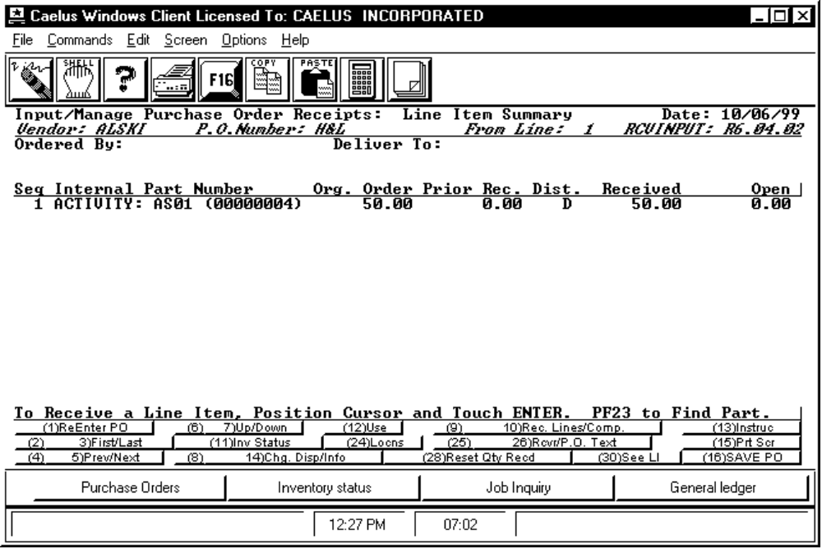

PROCEDURE DISCUSSION

Editing the Data Position the cursor to make a change in any line. To see the distribution of a line marked as "D", position the cursor under the "D" and press RETURN. If you reduce the received quantity for a line that is marked as a "D", the Detail Distribution Screen appears prompting for details of the reduction adjustment. The quantity of the adjustment is shown at the top of that screen as a negative quantity in the "Receiver Hold" field. You must reduce the distribution quantity to one or more distribution paths by a total of that adjustment amount.

BEWARE, the edit capability is very powerful. For example, if you change a line marked as a "D" to now be "I", all manual distribution is immediately and automatically reversed when you press RETURN. Notice that F28 is available to start the receipt session over for this purchase order if you get confused.

If the screen is correct, press F16 to proceed to the PO Summary Screen to indicate the next purchase order that appears on this receiver. From there you can also modify the basic receiver information or process the receiver and exit or start over.

SCREEN EXAMPLE: PO Summary Screen - Edit Mode

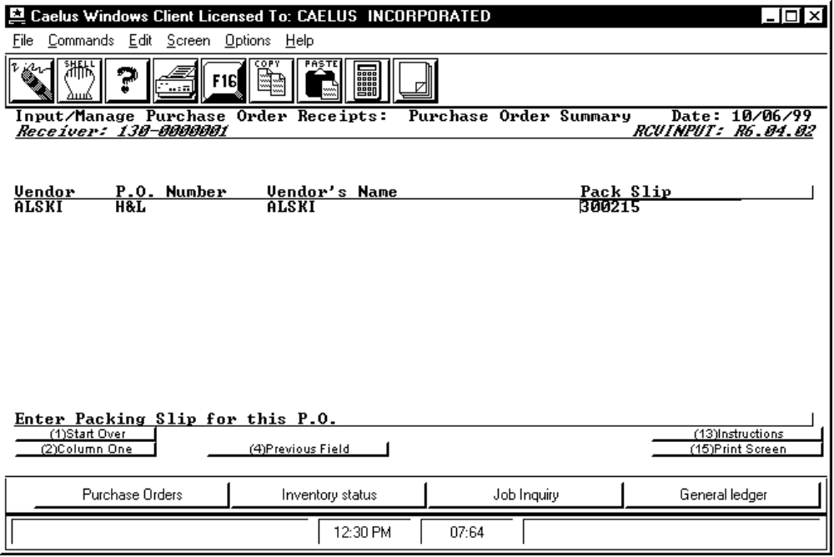

PROCEDURE DISCUSSION

You can select any purchase order and display its line items for review or edit. You can change any quantity to reflect previous mistakes. To delete a purchase order from the receiver, you must "un-receive" all the line items by adjusting the quantity received to zero for each and process the receiver.

Active Function Keys

Note that Function Keys 2 through 7 are provided for examining a list of purchase orders that is too long to display on a single screen.

F9 Receiver Go to the Receiver Input page to see or change information about the receiver or the freight carrier.

F11 Add P.O.s Add new purchase orders to the list of those received on this receiver.

F16 End Receiver To save this receiver to the "holding file". All receivers saved to this file will be posted/processed when you exit the program. See the discussions of posting on the following pages.
Reversals and Adjustments

The received quantity can be adjusted by recalling the receiver and editing the received quantity. The distribution can be totally changed. When the receiver is re-processed, the system automatically reverses postings to inventory and the GL in response to any changes, thus providing an audit trail of the changes. If the goods are no longer available in inventory, inventory values are adjusted though the normal CMS valuation and adjustment posting techniques. Differences in inventory cost and purchase price are handled in two distinct ways.

o If you value inventory according to a standard cost, the difference between the inventory cost stated on the purchase order and the standard cost of the item is posted to the standard cost variance accounts for that part (See the Inventory Control Reference manual for a complete discussion of inventory valuation methods).

o If the purchase price differs from the inventory cost on the purchase order line item, then the difference is posted to the Price Cost variance account on the purchase order.

Posting the Receiver

General Ledger

Received goods result in a credit posting to the interim payables account for the value of the goods received (at the cost indicated on the purchase order line item). Depending on the distribution within the system, the debit is one of the following:

o The asset account for the store/lot to which the goods are moved
o The purchases account indicated on the purchase order for nonstocked parts
o The QC clearing account or a Receiver Hold clearing account indicated in the store master record for the user recording the receipt.

The value is posted from the clearing accounts whenever the goods are accepted to inventory or rejected.

The receiver processing supports all three levels of GL posting: full detail, document (purchase order), or journal summary. The detail level at which the GL is posted is dictated through the journal posting options chosen in the General Ledger Module. The journal posted is JNLID = PRC. See the General Ledger Reference Manual documentation on the program GLJNLINP for more information.

Freight charges are posted as debits to the freight account specified on the header of the receiver and credited to the interim payables liability account.

Any goods indicated as rejected on the distribution screen are posted to the interim payables liability account and then the posting is immediately reversed to provide the record in the General Ledger of the rejection.

Inventory

Depending on the distribution, the On-Order quantity is reduced and the On-Hand quantity is increased. If goods are received to QC, the On-Order quantity is reduced and the QC In Process quantity is increased. Later acceptance from QC to inventory results in a decrease in QC In Process and an increase in On-Hand. Rejection of goods results in simply a reduction in the On-Order quantity. The on-order quantity is also reduced by the quantity reported into Receiver Hold status. In all cases, the inventory quantity (HNYQUAN) records impacted are those for the store/lots shown on the purchase order unless the goods are reported received to a different store/lot through the distribution feature.

Planned Inventory Position

The Planned Inventory Position is adjusted to reflect the receipt. The planned addition is decremented for partial receipts or extinguished entirely if received in full or over received. Early receipt results in a decrement of the future addition. Under receipt partially decrements the planned addition. The remaining quantity continues to be shown as a PIPIN which remains on the planned due date until the due date is changed on the purchase order. Rejection reduces the planned addition (the PIPIN).

Movements to QC do not impact the PIPIN quantity. They simply change the planned addition source from the purchase order to QC to reflect that the goods are in QC but not yet in inventory.

The Planned Inventory Position is not impacted by the quantity reported into Receiver Hold status.

Journals and Reports Printed

Processing begins as soon as you exit the function. Processing results in the printing of a standard CMS General Ledger Journal Summary and also a Posting Recap. A Materials Received/Distributed report is printed to list all changes to inventory as a result of creating or editing the receivers. This report is printed in order by receiver/vendor/purchase order. The same data is then also printed by part with subtotalling. You may also generate receiver tickets to accompany the received goods to their respective status locations (i.e., receiver hold, QC hold, scrap, inventory, etc.). A separate ticket is printed for each status type.

