PRINT SHIPPING DOCUMENTS

PURPOSE

To print shipping documents after you have specified the documents are available for printing.

GENERAL DISCUSSION

Shipping Documents consists of Pick Lists (Pull Sheets) and Bills of Lading (Packing Lists).

Documents can be requested at the time the sales order is processed, at the time the shipment is scheduled, or at the pre-invoice shipping time.

Pick Lists

Pick lists are intended to guide inventory personnel in assembling the order for shipping. The part number and quantity are shown and space is provided for recording the actual quantities picked and the lots from which the goods were removed. The items on the picklist are printed in sales order item sequence with valid bin location for each line item (as recorded in the part master file record for each part). The information on the picklist (part numbers and quantities) is the result of the data known to the system at the time the picklist is created.

Bills of Lading

Bills of lading (BOLs) are documents that uniquely identify each shipment against each sales order. You can use these documents as packing slips to accompany the shipment. Bills of lading show the parts and quantities included in the order. Bills of lading are uniquely identified by a BOL number composed of the sales order and a one to three digit suffix automatically assigned by the system. Just as for picklists, the accuracy of the shipment information is subject to the scope of the shipment at the time the document is requested.

Cross-Reference Parts
If a part was entered on the sales order via a customer or manufacturer cross-reference part, this part number and description is printed on the BOL according to the print document flag setting in BCKFLAGS.

Requesting Documents

You can request that the documents become available for printing at several steps in the order processing flow. The defaults for whether the documents should be printed at sales order processing time are controlled by the behavior switches described in the documentation for the program BCKFLAGS. Possible times to request document printing are:

Document SO Entry Scheduling Pre-Invoice Shipping
Pick List Yes Yes No
BOL Yes Yes Yes

When you want to print documents at sales order entry, shipment scheduling, or pre-invoice shipping, the documents are not immediately generated. Rather, the system places requests for the documents in a request file. This document printing function generates documents according to the records in that file.

Since the scope and timing of a particular shipment can change through the course of order processing, it is often best to delay printing the documents until the shipment is firm. If you print the documents prematurely, you can always reprint them. Each time you send a request to the print request file, any old request for documents for that shipment already in the file is deleted. If the same sales order is reprocessed multiple times and documents are requested each time, only the record for the most recent print request is retained.

Selecting Documents to Print

You can select to print only the picklists or only bills of lading or both. You can select to print only documents for a particular store, a range of stores, or all stores. You can select to print for a specific date, a range of dates, or all dates. Finally, you can print for a single sales order, a range of sales orders, or all sales orders. Print request file records are retained until the given document is printed.

Immediate Printing

When using this function to print shipping documents, you can respond to print request records that are on file for "immediate" printing. When scheduling shipments using the Shipment Scheduling program SHPSCHIN, you can request that not only are picklist and/or BOL print request records to be created but they are to indicate that the documents should be printed immediately. The records for these requests are created with the document due date blank. To print only the "immediate" documents, just leave the date range blank. To include the "immediate" documents with other documents, leave the first field of the range blank and enter the ending date of your range in the second date field.
SCREEN EXAMPLE

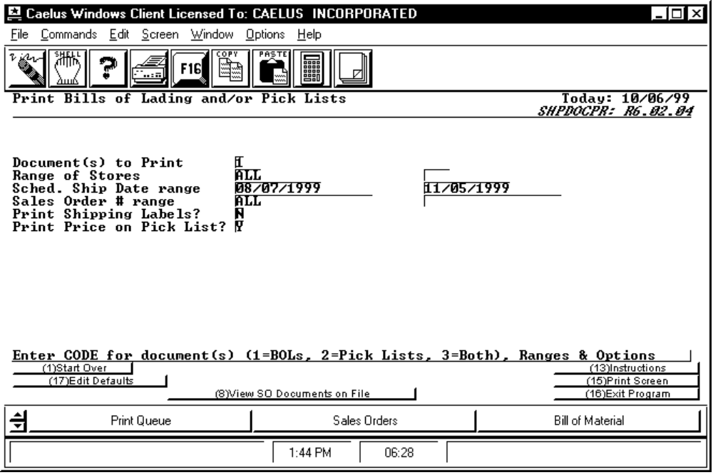

PROCEDURE DISCUSSION

Indicate whether you want only the bills of lading, only the pick lists, or both by entering a "1", "2" or "3" respectively. Then enter the range of store codes, the range of ship dates, and the range of sales order numbers or accept the defaults of "ALL". Leave the date range fields blank to generate the documents that have been requested for immediate printing. Print Shipping Labels? and Print Price on Pick List? gives you the options of yes or no (the price is the Sales Order price).

You can press F8 to view a list of all picklists and BOLs available for printing. The list shows each document on a single line. Picklists available for printing show a "P" in the first column and BOLs show a "B" in the first column. The document type is followed by the sales order number of the document and the BOL number (if appropriate).

The date range field properly handles "FIRST" and "LAST" to allow you to print all documents from the beginning of the file to a known ending point or from a known starting point to the end of the file. To select a single date, enter the date in the first field and leave the second field blank. As soon as you enter data for all fields, the screen changes to edit mode as in the example above. When the range data is correct, press F16 to generate the requested documents.

Any time you leave the first field of the date range blank, you will receive the immediate documents.

If you wish to edit the defaults, press F17. You enter an Edit screen shown below:

SCREEN EXAMPLE

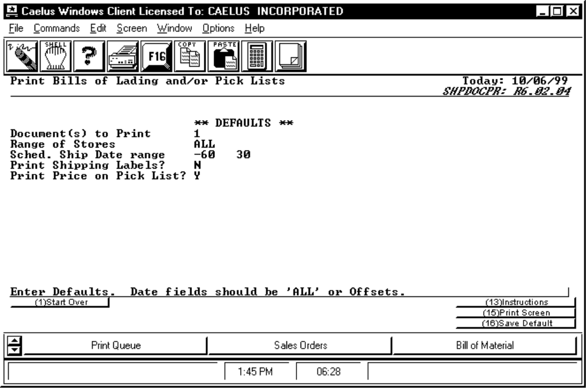

The Date range can be blank, All, or a numeric offset from today's date. The offset can be + or - (plus or minus) x number of days from today's date.

In the example above, the offsets will be (plus) five to twenty days from today's date. After F16 Save Data is pressed, you are returned to the first screen and the dates display as:

!Sched. Ship Date range 04/04/93 04/19/93 !

Based on today's date of 03/30/93.

