ENTER/MANAGE STORE/WAREHOUSE CODES

PURPOSE

Create and maintain the master records for each warehouse or 'store' to be recognized by the system. This function also prints a list of warehouses on file, and setting of the starting/next numbers used for automatic document numbering of sales orders, purchase orders, and invoices.

GENERAL DISCUSSION

You must record each warehouse in the warehouse master file before the system can reference it for inventory storage. (In CMS, a warehouse is referred to as a 'store' for screen display purposes.) You enter three types of information for each store:

1. Master information about the warehouse.
2. Starting numbers for system-generated, automatic document numbering.
3. GL account defaults for accounts that are to be determined by the store involved in a particular transaction.

You can also print a report listing all or part of the stores entered in the master file.

Store Master Information

The store (warehouse) master information you enter in this function consists of the store ID and the basic store data (e.g., store address, store descriptive name, default tax code). The store ID is the key information that uniquely defines a given store. Therefore, no two stores can have the same ID. A store's ID usually begins with a number. If you begin the name of a store with an alphabetic character, the store is invisible to the planning system and will not be called on for planned jobs. This can be useful for creating "rework" stores where faulty products or purchased goods are reworked.

The rest of the store master information consists of data uniquely associated with the store. This information is entered into a program automatically when you specify a store ID.

Starting Numbers For Automatic Document Numbering

CMS provides automatic numbering of many inventory movement related documents. You can enter default starting numbers for the automatic numbering feature in some of the major inventory movement documents. These features are described later in this document and in the individual modules where they are used.

Default GL Accounts

This function allows you to enter the default GL accounts for posting to any inventory movement out of or into each store you define. In most cases, the GL account numbers you enter becomes the lowest level default accounts for GL postings of inventory movement. One advantage of using this function to specify these defaults is that you can allow the default to appear automatically when you specify the inventory movement. You do not have to memorize the proper GL accounts to post for each store. Another advantage is that you can change the default accounts using this function and they are automatically changed for all functions that use these defaults.

Some of these accounts can be specified as defaults elsewhere in the system (usually in the respective module of the function being performed). Also, most of the functions that record inventory movement allow you to change the default account to a specific account required for a given transaction. As you can see, tracing the sequence of default accounts is sometimes a confusing process. For detailed information on the sequence the system uses to decide which default accounts to use, refer to the detail information on field entry later in this section or to the specific function or module in which the default is used.

You can specify default GL accounts for two types of inventory movement in this function: Into inventory (AP Defaults), and out of inventory (AR Defaults).

AP Defaults
The GL accounts you specify here become one level of default accounts for all Purchasing and Receiving and Accounts Payable functions that post amounts into inventory.

AR Defaults

The GL accounts you specify here become one level of default accounts for all Order Processing and Accounts Receivable functions that post amounts removed from inventory.

Default Store 001

CMS generates one store automatically whenever you enter an inventory transaction without specifying a store. For instance, you can generate purchase orders without specifying the store that the goods will be stocked in. In these cases, the system automatically creates a quantity record for the goods in the store 001. Since the system generates these store records automatically, store 001 quantity records are not necessarily associated with a store you defined in the store master file. This can cause problems when you try to examine quantity records for items in store 001. To prevent these problems, you should define a store 001 and assign its attributes through this function. Defining store 001 here prevents problems you might otherwise have later in the manipulation of quantity records.
SCREEN EXAMPLE

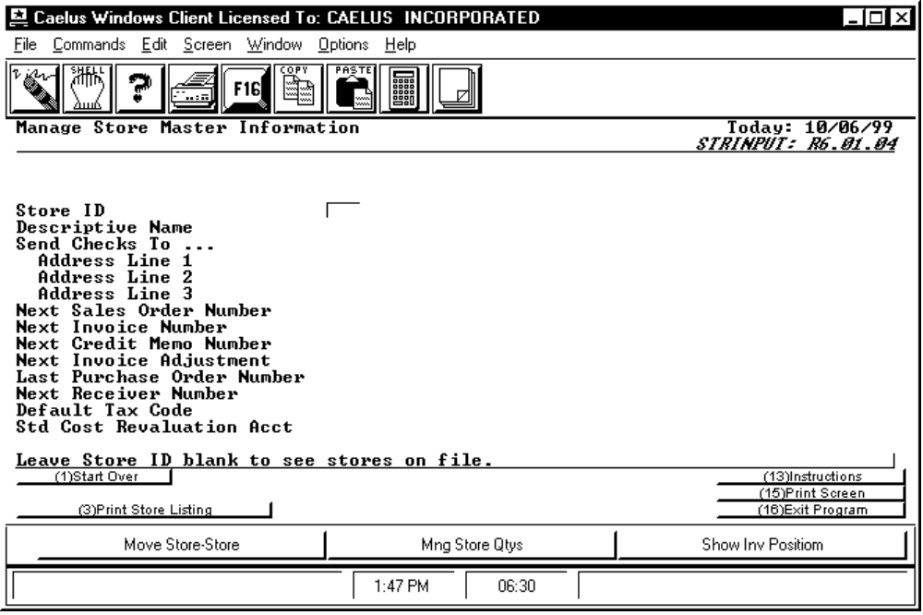

PROCEDURE DISCUSSION

This is the first screen that appears when you access this program. It allows you to recall a store record already on file or to enter a new store. To recall a store record on file, enter the store I.D. code and press RETURN. To see a list of all stores on file, leave the field blank and press RETURN. F3 allows you to print a list of all store records and the data contained in each record. See the description of the report content at the end of this document.

To record a new store record, enter the new identification code and then supply data for each of the fields as described below.

Data Field Definitions

Store ID Enter the unique three character code that identifies a store (warehouse). If you enter a code that already exists in the file, the system displays the information on record for this store in edit mode. The CMS planning system does not recognize warehouse codes that begin with an alpha character. If inventory is stored in such a warehouse, it is not available to the planning system.

Note: Leading blanks count as characters, hence 1 is different than 1 and 001. Do not use "ALL" as a code.

Descriptive Name Enter the descriptive title of the store (warehouse), such as a location or familiar name. The description may contain up to thirty characters including blanks, and may also be part of the address. This familiar name is displayed on the screen when this warehouse is referenced elsewhere in the system.

Send Checks To Enter the name of the person or department, etc. to which customers mail payments for goods shipped from this store. This field may contain up to thirty characters (including blanks). This field is used when invoices are printed.

Address Lines Enter the address of the person, department, etc. to which customers are to mail payments for goods shipped from this store. Each line may contain up to thirty characters including blanks. This address will be used as the ship to address when a purchase order is printed.

Next Sales Order No. The system displays the next Sales Order number to automatically assign for goods sold from this store. The function ORD-10 BCKFLAGS allows you to choose whether or not to assign automatic numbers to sales orders.

Next Invoice Number The system displays the next Invoice number to automatically assign for invoicing of sold goods. The function AR-10 ARMFLAGS allows you to choose whether or not automatic numbers to sales orders should be assigned.

Next Credit Memo Number Enter the next number to generate a credit memo (see ARM-20 PROCARIC for more information). This field always shows the next available number for use on a credit memo.

Next Invoice Adjustment Enter the next number to generate an invoice adjustment (see ARM-20 PROCARIA for more information). This field always shows the next available number for use on an invoice adjustment.

Last Purchase Order Number The system displays the next available P.O. number automatically assigns to a purchase order. This field operates the same as "Next Invoice Number" except the format is one alpha character followed by six numeric characters.

Next Receiver Number Enter the next available number to generate a receiver document for this store. This number is automatically assigned to if the receiver does not enter a receiver number (see PO-40 PROCRCVI for more information on receiving).

Default Tax Code Enter the default tax code for the store. Leave the field blank and press RETURN to see a list of valid codes.

Std Cost Revaluation Account This allows an account to be assigned to the store in use. If no entry is made, this defaults to the system default revaluation account already set up using the HNYFLAGS program.
SCREEN EXAMPLE

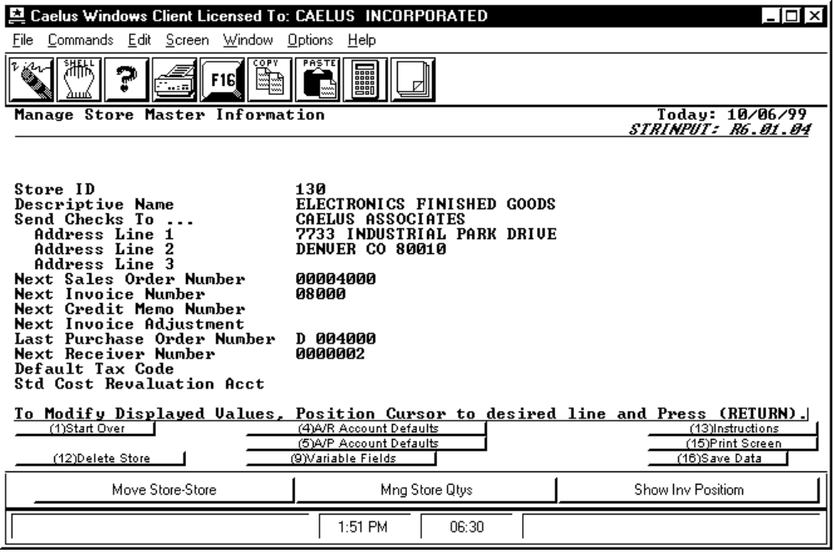

PROCEDURE DISCUSSION

This screen appears when you enter an existing store number in the STORE NUMBER field above. All of the previously entered store information appears on this screen and you can see the default GL account listings for this store by pressing F4 or F5 from this screen. All the document numbers on this screen show the next available document numbers if automatic numbering is in use for the displayed documents

Press F12 to delete the record of this store from the store master file. Pressing F12 causes the following message to appear on the screen.

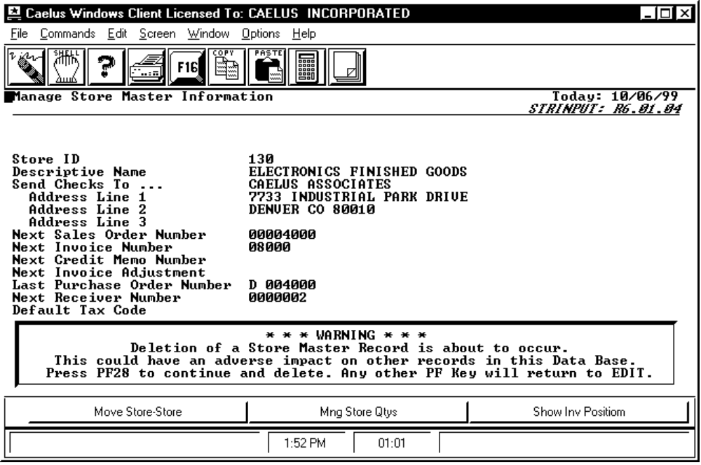
SCREEN EXAMPLE

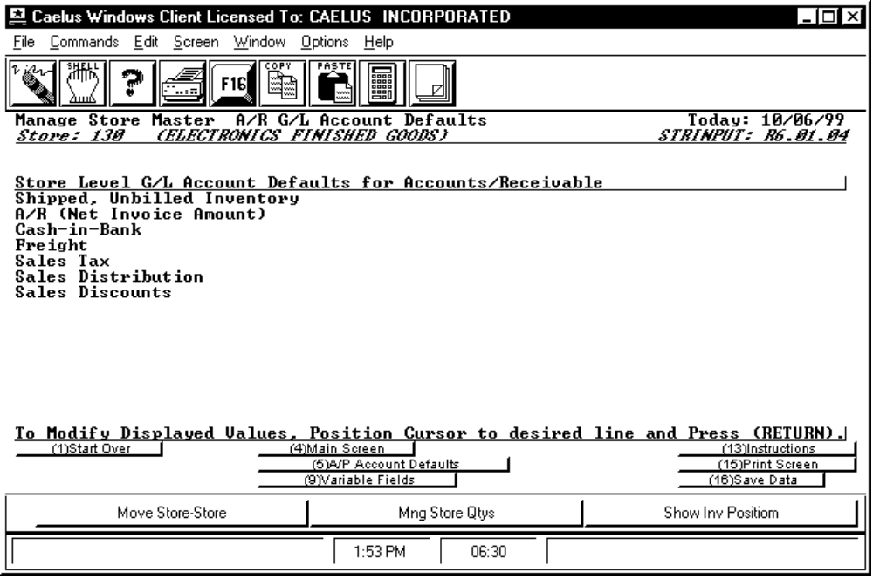

PROCEDURE DISCUSSION

This screen appears after you enter the last field on the Store General Information screen. Use this screen to enter the AR default GL account codes for this store. The accounts you enter on this screen become the lowest level defaults for AR transactions from this store. You can override these defaults through other default GL accounts in the proper files or by entering specific GL accounts to post when entering an AR transaction.

Data Field Definitions

Shipped, Unbilled Inventory Enter a valid GL account to debit with the cost of shipped inventory if you have not yet sent an invoice for the goods. The offsetting credit goes to the Inventory Asset account for the part/store/lot the shipped goods came from. When you send an invoice, the system credits the Shipped, Unbilled Inventory account and posts an offsetting debit to the Cost Of Goods Sold account for the part/store/lot where the shipped goods came from.
AR (Net Invoice Amount) Enter a valid GL account to debit an invoiced item. The Sales account is credited at the same time.

Cash-in-Bank Enter a valid GL account to debit a cash invoice amount is received. The offsetting credit is to the AR (Net Invoice Amount) account.

Freight Enter a valid GL account to credit the customer freight charges when an invoice is created. The offsetting debit is posted to the AR (Net Invoice Amount) account.

Sales Tax Enter a valid GL account to credit the sales tax amount on a newly created invoice. The offsetting debit is posted to the AR (Net Invoice Amount) account.

Sales Distribution Enter a valid GL account to credit the price of a non-stock part specified on a line item of an invoice. The offsetting debit is posted to the AR (Net Invoice Amount) account.

Sales Discounts Enter a valid GL account to debit the line item discount amount indicated on an invoice. The discount amount is subtracted from the invoice amount and the result is posted to the AR (Net Invoice Amount).

SCREEN EXAMPLE

This screen appears when you press F4 from the Store General Information screen in Edit Mode.

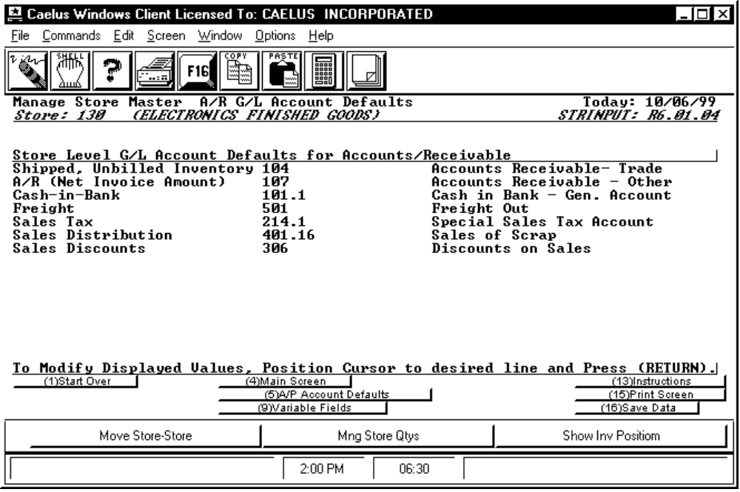

PROCEDURE DISCUSSION

The screen above shows an example of the AR Account Defaults screen in Edit Mode. Press F4 to return to the Store General Information screen or press F5 to view the AP Account Defaults screen for this store. You can also press F9 to define variable fields that the operator needs to enter. The screen that displays when you press F9 and a discussion of how to define variable fields is presented at the end of this document.

SCREEN EXAMPLE

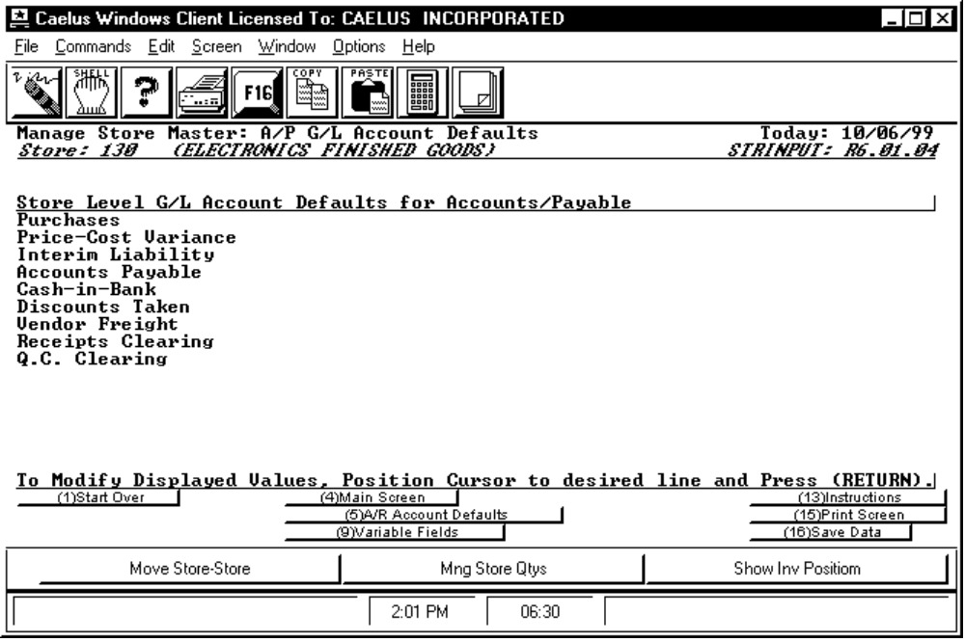

PROCEDURE DISCUSSION

This screen appears after you enter the information on the AR Accounts screen. Enter the AP defaults for the store on this screen. The accounts you enter here are only defaults and can be overridden by default accounts in appropriate master files or by accounts you specify when you create AP, Purchasing, and Receiving documents.

Data Field Definitions

Purchases Enter a valid GL account to debit with the cost of non-stocked purchased goods when the goods are received into the store. The offsetting credit is posted to the Receiver Clearing account, the QC Clearing account, or the Interim Liabilities account.

Price Cost Variance Enter a valid GL expense account to post the difference between the purchased price and the inventory cost of an item. The amount is posted with the variance price when goods are received into inventory.

Interim Liability Enter a valid GL account to credit when purchased goods are received. The offsetting debit is either to the Receiver Clearing account, the QC Clearing account, or the Inventory Asset account of the part/store/lot in the store/lot where the goods are received. This account is debited with the invoice amount when an invoice is received for received goods. The offsetting credit is to the Accounts Payable account.

Accounts Payable Enter a valid GL account to credit with the invoice amount when the vendor invoice is received. The system posts an offsetting debit to the Interim Liabilities account. This account is debited when the payment is made to the vendor. The system performs an offsetting credit to the Cash In Bank account.

Cash-in-Bank Enter a valid GL account to credit the cost of a part when payment is sent to the vendor. The system posts an offsetting debit to the Accounts Payable account.

Discounts Taken Enter a valid GL account to credit the discount amount associated with a purchase.

Vendor Freight Enter the valid GL account to debit the freight charges for delivered parts when the parts are received. This amount is credited to the interim liabilities account at the same time.

Receipts Clearing Enter the valid GL account to debit the cost of goods received into receiver hold. This amount is credited to the interim liability account at the same time. This account is credited with the cost of goods when the goods are sent to either QC or inventory. The system performs and offsetting debit to either the QC Clearing account or the Inventory Asset account where the goods are received.

Q.C. Clearing Enter the valid GL account to debit the cost of goods received into Q.C. This amount is credited to the interim liability account at the same time. This account is credited with the cost of goods when the goods are either sent to inventory or returned to the vendor. If the goods are received into inventory, then the system posts the offsetting debit to the Inventory Assets account of the part/store/lot where the goods are received. If the goods are returned to the vendor, then the offsetting debit of the returned goods is made to the Interim Liabilities account.

SCREEN EXAMPLE

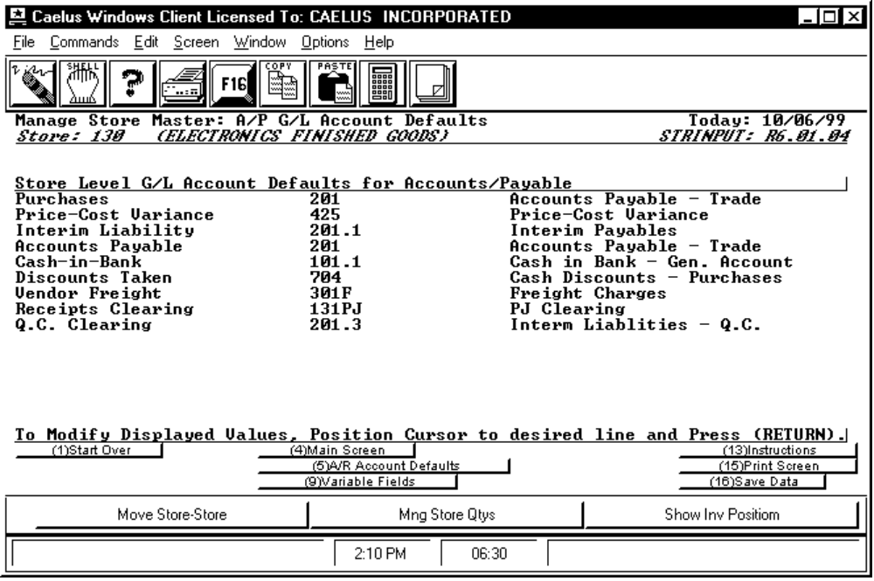

PROCEDURE DISCUSSION

This screen is an example of the AP Account Defaults screen in Edit Mode. Press F4 to return to the Store General Information screen or press F5 to view the AR Account Defaults screen for this store. You can also press F9 to define variable fields that the operator needs to enter; this calls the VFDEFINE program documented in the System Reference manual.
SCREEN EXAMPLE

This screen appears when you press F3 from the Store General Information screen before you enter a store code.

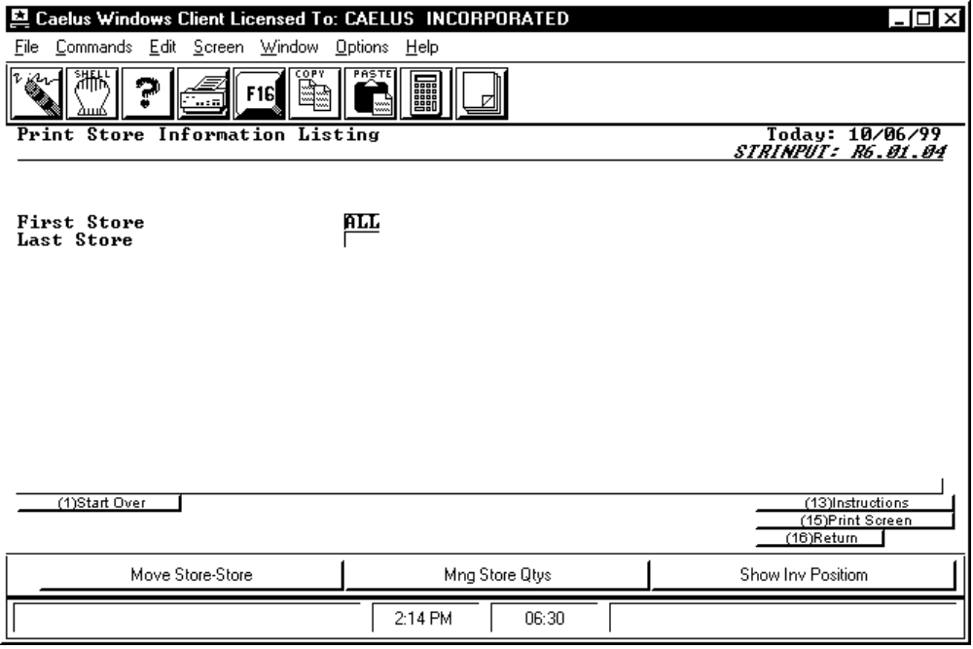

REPORT CONTENT

This screen allows you to select the store codes included on the report. The report shows master information for each store in the specified range. To print the report for a single store, type the desired store code of over the word "ALL" (every character in "ALL" must be replaced with characters or blanks) and press RETURN.

To print the report for a range of stores, specify the range from first to last. (Note: The first store code must be sequentially lower than the last in sort sequence (i.e. ABNN before ABXX)).

