CAELUS


CAELUS WINDOWS CLIENT

Notes on Customizing the Graphical User Interface

As Applied to CMS Version: R6.04.03, April 22, 1997

TABLE OF CONTENTS

Overview:
CMS Host Options
PERSONALITY Settings
Login Script Changes
Videocap Changes
User Settings in CMSUSRIN
Source Code Settings
STARTOVER Window Displaying as a Windows Dialog Box
Windows ListBox for GENCODES Code Selection
Windows Client Options
Button Bars, Toolbars, and Hotspots
Running Other CMS Programs From Within a CMS Program
Running a Windows Program or Viewing a Document
Screen Display Options
Customizing Icons & Bitmaps

Overview:
This document describes how to enable and/or disable many of the new features introduced with the combination of CMS R6.04.03 and the Caelus Windows Client (CWC) version 2.05.xx.

The intended audience is the system administrator responsible for the implementation of CMS at your site. It is assumed that this person is familiar with UNIX, Microsoft Windows, and CMS Administration.

CMS Host Options
This section covers the settings that may be made on the UNIX host which affect a user who is/will be using the Caelus Windows Client.

PERSONALITY Settings
There is one (1) specific setting which should be made to the user’s Wisp personality. This setting affects the terminal configuration and specifically controls whether or not modifiable fields are displayed with the sculpted appearance or not. To change this setting, perform the following steps:
- Login as the user
- Enter the Wisp Command Processor Menu
{From the Unix Command line run wshell}
{From a CMS Menu or program press Control E}
- From the Command Processor Menu select F10 - Configure Terminal
- On the next menu select F2 - PSUEDO Blank Characteristics
- On the next screen change Psuedo blank character to B
change Using psuedo blank rendition to R
press RETURN followed by F1 (function key 1)
- On the Command Processor Menu select F13 - Save environment
- Answer YES to the Are you sure you want to write the usage constants? Question and press RETURN.
- When the enter filename to write prompt appears just press RETURN with the filename field blank.
- Return or exit from the menu shell.

Login Script Changes
- Optionally you may set a shell variable in the login script called CMSTERM to control whether or not CMS will function in GUI mode or not. If this value is not set then CMS will automatically make the determination itself by sending a query to the terminal emulator and waiting 1-2 seconds for a response - the result of which informs CMS whether or not the user is running he CoStar/CWC software or not. Valid values for CMSTERM are:
CMSGUI - forces CMS to think its running in the CoStar/CWC/Windows environment
CMSCHR - forces CMS to think its running on a dumb, character terminal
CMSUNDEF - makes CMS test to see what environment its running in.

- Other changes that should be made in the login script include changing the setting of the TERM and WISPTERM shell variables. TERM should be set to vt220. WISPTERM should be set to costar.

Videocap Changes
A new file called costar should have been added to your /cms/wisp/config/videocap/ directory. Please verify that it is there.

User Settings in CMSUSRIN
There is now a new menu option which contains 11 settings in the Manage CMS User Access Rights program CMSUSRIN that are specific to CWC. These settings may be used to implement site or user specific preferences governing screen presentation.

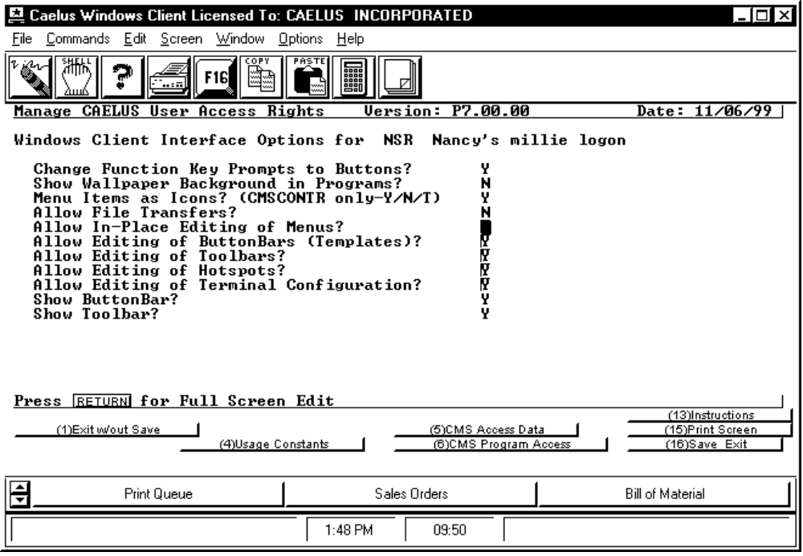

The new settings are:
- Change Function Key Prompts to Buttons?
If the value entered here is Y for Yes then program screens with function keys displayed either on the top 3 lines or bottom 5 lines will be changed to Command Buttons. If the value entered here is N then Function Key Prompts will not be transformed into buttons.
- Show Wallpaper Background
If the value entered here is Y then a wallpaper bitmap picture will be displayed as a backdrop in each program launched from the CMSCONTR menu program. This bitmap image is called cmsbakgr.bmp and is located in the directory as the icons and may be customized as desired as long as the name stays the same. Note that this image is tiled when displayed.
- Menu Items As Icons (Y/N/T)?
If the value entered in this field is N for No then CMS Menus will show Function Keys rather than Icons. If the value is Y then one icon will be displayed for any Menu entries (the folder icon) and one icon for executable entries (a pointing hand icon). If the value is T (type) then menus will have the same icon as Y but executables will show an icon that represents the type of program or procedure script (i.e. report writer, input program, etc). These icons (.ico files) may be found in the ..costar/caelus/images directory located either on a network server or on your local PC hard drive and may be customized if so desired (as long as the names stay the same).
- Allow File Transfers?
If the value entered here is Y then it will allow users to make file transfers. If the value is N then users will not be able to transfer files.
- Allow In-Place Editing Of Menus?
If the value entered here is Y then it will allow users to edit menus. If the value is N then users will not be able to edit menus.
- Allow Editing of Button Bars?
If the value entered here is Y then it will allow users to edit button bars. If the value is N then users will not be able to edit button bars.
- Allow Editing of Toolbars?
If the value entered here is Y then it will allow users to edit toolbars. If the value is N then users will not be able to edit toolbars.
- Allow Editing of Hotspots?
If the value entered here is Y then it will allow users to edit hotspots. If the value is N then users will not be able to edit hotspots.
- Allow Editing of Terminal Configuration?
If the value entered here is Y then it will allow users to edit their terminal configuration. If the value is N then users will not be able to edit their terminal configuration.
- Show Button Bar?
If the value entered here is Y then it will allow users to view the button bar. If the value is N then users will not be able to view the button bar.
- Show Toolbar?
If the value entered here is Y then it will allow users to view the toolbar. If the value is N then users will not be able to view the toolbar.

In addition the names of the Standard Popup Programs and/or Procedures will automatically be displayed on the button bar of the menu program CMSCONTR when menus are being presented. There is no means at present to display a description of the programs instead. This is planned for a future release.

Source Code Settings
Some settings governing GUI behavior may only be changed inside program / sub-program source code. This area documents what those settings are and where you may make changes to disable those features.

STARTOVER Window Displaying as a Windows Dialog Box
If your users do not like the Windows Dialog Box being displayed instead of a charcter mode window you may disable this function by changing the zstartovr.bas subroutine located in the /cms/currel/subsrce3 directory. The procedure for making this change on a standard HP system is:
- Copy the zstartovr.bas file into your /cms/custss3 directory (if you do not have such a directory then create one and issue the command make custss3 while at the /cms/currel/makeutil level).
- Edit zstartover.bas (using whatever editor you are familiar with) and insert the following line immediately following the line that has CALL “CHECKGUI” ADDR(GUI%)
GUI% = 0%
- Save the file and from the UNIX command shell issue the command make zstartov
- Backup one level (cd ..) and issue the command make subsrce3_o
- Your change should now be implemented

Windows ListBox for GENCODES Code Selection
If the use of a Windows ListBox widget for display/selection of valid codes from the GENCODES file is not desired then the following code change may be made to the zplowcod.bas routine (located in subsrce3) to turn off that behavior.
Find the line that has the code
IF PRNAME$ = "GENCODES" AND ARGS%<2% AND GUI%=1% THEN GUI_LIST
and remark it out. Then remake the subroutine using the same procedure described for zstartovr.

Windows Client Options
The below describes the different behavior settings you may employ at the windows client level to customize your implementation of the Caelus Windows Client (CWC).

Button Bars, Toolbars, and Hotspots
Caelus distributes a set of standard Button Bar (.key), Tool Bar (.tbf), and HotSpot (.hsf) files with the installation disks. These files include a standard set for the CMSCONTR menu program as well as a default set for all other programs. The way CWC and CMSCONTR works is as follows.

When cmscontr first runs it looks for and loads (if found) a cmscontr.tbf file, a cmscontr.key file, and a cmscontr.hsf file in the ./caelus subdirectory which is beneath the name of the costar directory you installed CWC into. Whenever a program is run from cmscontr it looks for a .tbf, a .hsf, and a .key file which is prefixed by the name of the program being run. If found these toolbar, hotspot, and button bar files are loaded and displayed. If not found a standard default set of files are loaded which are: cmsprogs.key, cmsprogs.tbf, and cmscontr.hsf. When the program ends and control return back to cmscontr then the set of files specific to cmscontr are reloaded. Iwhen you exit cmscontr a set of default files that begin with costar are loaded (if found).

You can make use of this behavior by creating program specific tool bars and button bars that invoke functionality specific to the program function. For instance you may display a drawing, run other Caelus programs directly from that program, view a word document or excel spreadsheet, . . . (See the Programmer’s Guide for information on the command sequences and full list of functionality which may be invoked). Start by copying an existing file (such as cmsprogs.tbf, or cmsprogs.key) to a new name which is the same as the CMS program.

Some specific command sequences which are commonly used are listed below:

Running Other CMS Programs From Within a CMS Program
In the Keystrokes & Commands field of a Button Bar Template or Tool Bar entry enter the following command:
^F13xxxxxxxx^M where xxxxxxxx represents the name of the program

Running a Windows Program or Viewing a Document
In the Keystrokes & Commands field of a Button Bar Template or Tool Bar entry enter the following command:
!F”x-------------x” where x----------x is the name of the program or document
Some examples:
!F”calc.exe” which would run a calculator applet
!F”c:\wordview\wordview.exe f:\procedures\cleaning.doc”
would display the cleaning procedures document (if you have wordview installed)

Screen Display Options
Using the Screen and Options pull down menus within CWC you may customize the display environment significantly. CWC Windows may also be resized just as any other normal windows application and the size and location of a window may be saved by using the Save Settings option on the File pull down menu. However hiding things such as the toolbar, button bar, status bar, and window caption only stay hidden for the current session.

You may select your own color scheme, font size, etc using the Display option on the Screen pull down menu. We suggest however that you do not change the following:
Reversed Text display attributes
Use of ANSI Colors should stay disabled

We have found the best success by staying with the Costar font. Feel free to experiment with others though if you want to. If you choose a font size that is very small for your screen resolution then the button font used on the function key command buttons will become unreadable.

Customizing Icons & Bitmaps
The Icons and Bitmaps used by CWC are in the ../caelus/images sub-directory. You may replace them with your own icons / bitmaps or edit the existing ones if you have an appropriate editor. There are extra icons and bitmap files which are not currently used but are there for you to use if you desire. The list of icons and bitmap pictures distributed include:

File Name | Where Used | Meaning / Description
Analyze.ico | Menus - cmscontr | Analysis programs.
Arrowdn.ico | ilpman toolbar - ilpman.tbf, display toolbar - display.tbf | Scroll screen down 1 page.
Arrowlt.ico | Print Queue Manager and Display Toolbars - ilpman,tbf & display.tbf | Scroll screen left.
Arrowrt.ico | Print Queue Manager and Display Toolbars - ilpman,tbf & display.tbf | Scroll screen right.
Arrowup.ico | Print Queue Manager and Display Toolbars - ilpman,tbf & display.tbf | Scroll up 1 screen page.
Bakgrnd.bmp | Visual Link Program hnyvlgui.exe | Tiled bitmap wallpaper for chart graph.
Calc.ico | Programs Toolbar - cmsprogs.tbf | Runs Windows Calculator applet.
Cancel.bmp | Send message screen in cmscontr | Cancel sending of message.
Cancel.ico | Print Queue Toolbar - ilpman.tbf | General - Cancel an operation or Function  ILPMAN - Remove file from Queue
Cardfile.ico | Not used at present | Picture of a rolodex cardfile.
Check.ico | Not used at present | Check mark.
Cmsbakgr.bmp | Programs | Tiled bitmap wallpaper.
Cmslogo.bmp | Cmscontr - entry splash | Logo displayed while cmscontr starts up.
Cmsmuhi.bmp | Menus - cmscontr | ‘Caelus Management Systems’ text for hi-res screens.
Cmsmulow.bmp | Menus - cmscontr | ‘Caelus Management Systems’ text for lo-res screens.
Copy.ico | All Toolbars | Copy highlighted selection into the Windows Clipboard.
Delete.ico | Menus - cmscontr  Print Queue Toolbar - ilpman.tbf | Record Delete Programs.  File Deletion.
Dollar.ico | Not used at present | The almighty dollar.
Drill.ico | Menus - cmscontr | Drill down functions - Display and Inquiry programs.
Exit.bmp | Print Queue Toolbar - ilpman.tbf | Exit Print Queue Manager.
Exit.ico | Display Toolbar - display.tbf | Exit function/program.
Factory.bmp | Not used at present | Picture of a factory.
Find.bmp | Display Toolbar - display.tbf | Enter the search string to find
Findnext.bmp | Display Toolbar - display.tbf | Find the next occurrence of the search string
Forklift.bmp | Not used at present | Picture of a forklift.
Gencodes.ico | Menus - cmscontr | All GENCDSIN procedures (procgc**)
Granite.bmp | Not used at present | Granite textured bitmap for use as tiled wallpaper
Grenball.bmp | Not Used at present | 3D picture of a green ball
Insert.ico | Not used at present | Insert an item into a list.
Journal.ico | Menus - cmscontr | G/L Journal update/post programs.
Logoff.bmp | Menus Toolbar - cmscontr.tbf | Return to first Menu / Exit System.
Menu.ico | Menus - cmscontr | Default Menu Icon.
Menuexit.ico | Menus - cmscontr | Return/exit from a menu.
Menuhelp.ico | Menus Toolbar - cmscontr.tbf, Display Toolbar - display.tbf | Display online documentation, in Display shows function key menu window.
Menulo.ico | Not used at present | Small Folder icon.
Message.ico | Menus Toolbar - cmscontr.tbf | Send a message to another user(s).
Open.ico | Print Queue Manager Toolbar - ilpman.tbf | Open a file or document for display or edit..
Paste.ico | Menus and Programs Toolbars, cmscontr.tbf & cmsprogs.tbf | Paste the current contents of the Clipboard (MS Windows functionality)
Pf16.ico | Programs Toolbar - cmsprogs.tbf | Function key 16.
Pick.ico | Not used at present | Pick a record.
Pickitem.ico | Menus Toolbar - cmscontr.tbf | Bring up list of Menus to Pick from (F17)
Proc.bmp | Not used at present | Bitmap alternative to .ico
Proc.ico | Menus - cmscontr | Default Icon for procedure scripts.
Process.ico | Menus - cmscontr | Update and batch processing programs.
Program.bmp | Not used at present | Bitmap alternative to .ico.
program.ico | Menus - cmscontr | Default Icon for programs.
Prtscren.ico | All Toolbars | Print Screen using CoStar/Windows
Purge.ico | Menus - cmscontr | Purge and archive programs.
Question.ico | Programs Toolbar -cmsprogs.tbf | Invoke online documentation.
Refresh.ico | Menus and Programs Toolbars, cmscontr.tbf & cmsprogs.tbf | Refresh/repaint screen.
Remove.ico | Not used at present | Remove an entry from a list.
Report.ico | Menus - cmscontr  Display toolbar - display.tbf | Icon used to identify programs which generate a report.  Display - print current file.
Save.ico | Not used at present. | Save function.
Sdmsgcmd.bmp | Send message screen in cmscontr | Sends message on screen.
Select.ico | Print Queue Manager Toolbar | Generic - Select an entry.  ILPMAN - Release/Hold print file.
Shell.ico | Menus and Programs Toolbars, cmscontr.tbf & cmsprogs.tbf | Invokes WISP Command Processor Shell if enabled for user.
Showprg.ico | Menus Toolbar - cmscontr.tbf | Toggles display of Menu prompts vs. Program/proc/menu names.
Startovr.ico | Programs Toolbar - cmsprogs.tbf | Invokes Function Key 1 - standard program function key for Start Over.
Switch.ico | Menus - cmscontr | Icon used to identify parameter/switch/flag settings programs.
Tools.ico | Not used at present | Toolbox full of tools - may represent utilities, etc.
Tr_input.ico | Menus - comscontr | Icon used to identify transaction entry, data entry, and file/table maintenance programs.
Unknown.ico | Menus - cmscontr | Icon displayed for Menu entries whose SES Dictionary Type in unknown.
Windows.ico | Not used at present. | Microsoft Windows.

